Portfolio thingy

# Relevant files

<https://infocenter.nordicsemi.com/pdf/Thingy_UG_v1.1.pdf>

# Thingy blockdiagram

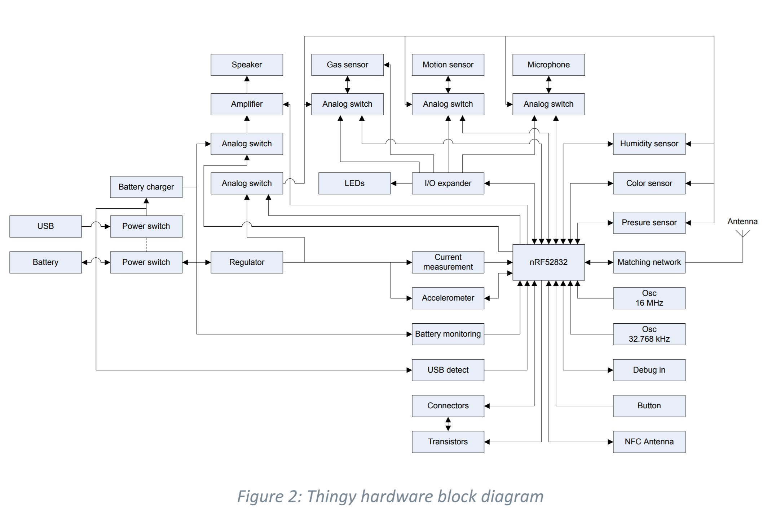

# Functionalities of the thingy

The thingy must do the following things:

* Check if distance is violated
* Make aware that somebody is sitting
* Consume minimal power as possible

# What I’ve done

**Turn off the unnecessary functionalities**

🡺 in main where it is initialized, we comment it out:

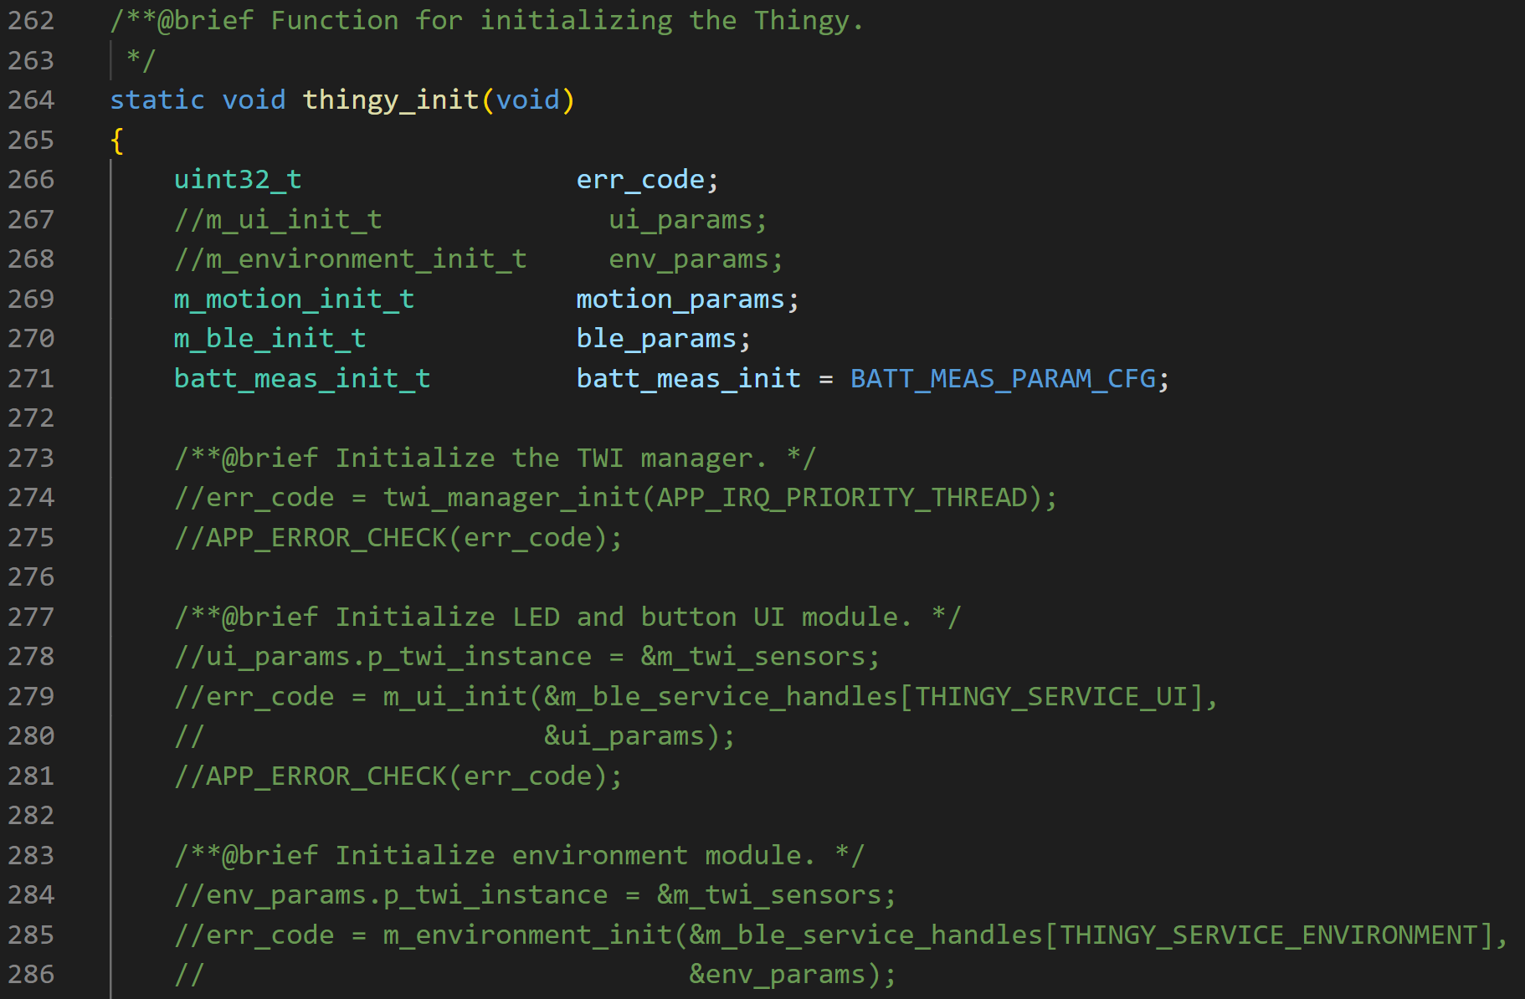

**Check is someone is sitting, else sleep**

To check if someone is sitting, we used a light sensor 🡺 if the p_data-> clear value is high, then no one is sitting on the chair. If it is low, then someone is sitting on the chair. This value should be tested somehow per classroom and see whats the best threshold value to decide when someone is sitting. At the moment, I’ve set it to 200 (but further research should be done to find the optimal value). If the value is lower, the thingy will go in sleep mode and the accelerometer will be prepared so that the thingy will wake up when the device is shaken. In the functions below (added in the “main.c” file) you can see what I just described in the code. Because the light sensor and the accelerometer are part of the internal I2C bus (because of the io expander) a configuration for the I2C settings are also necessary.

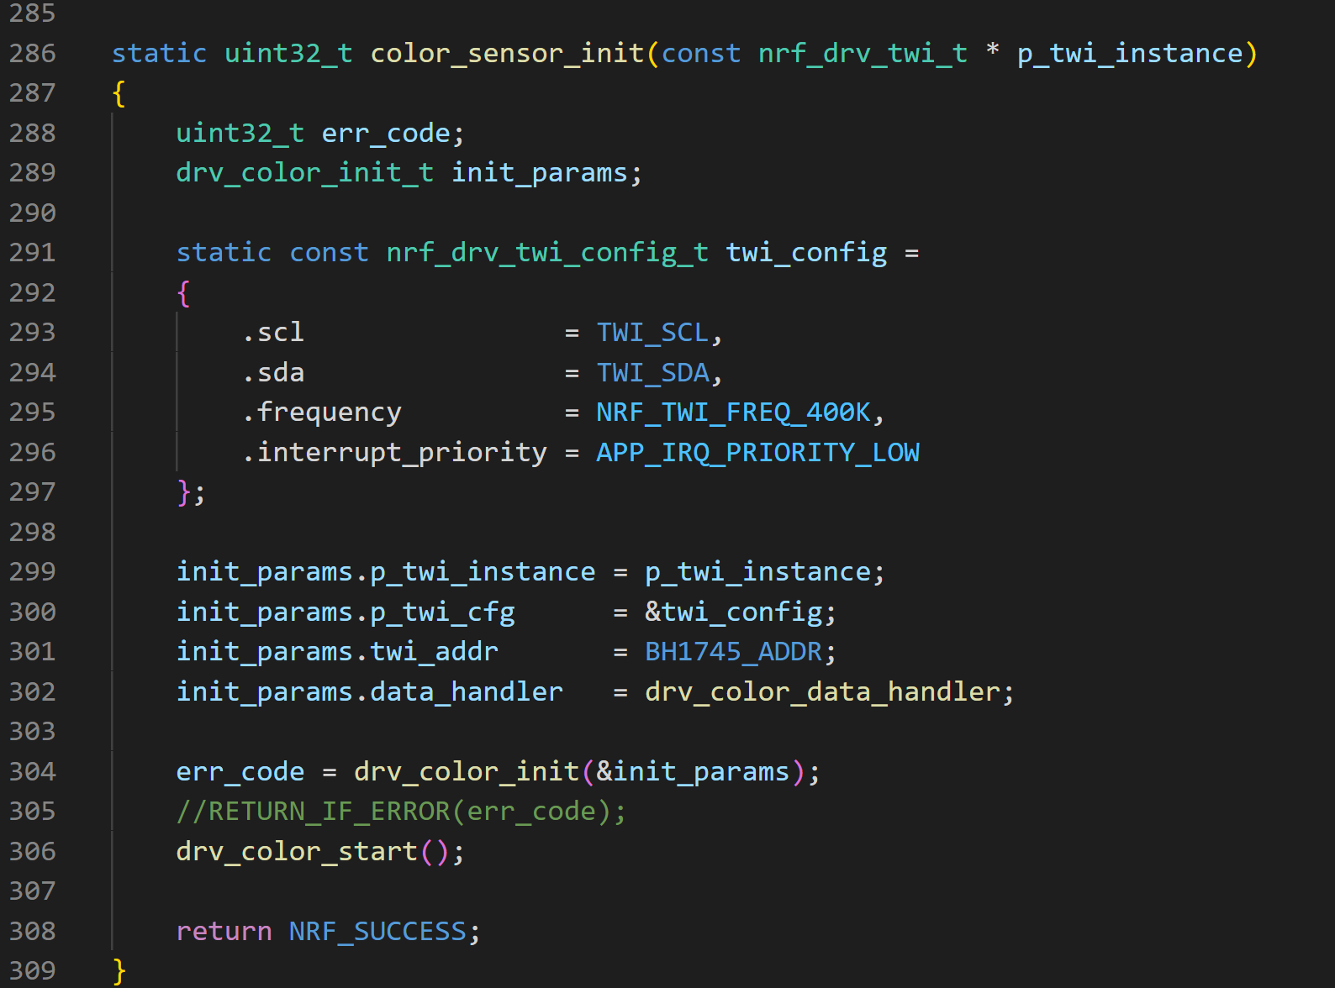

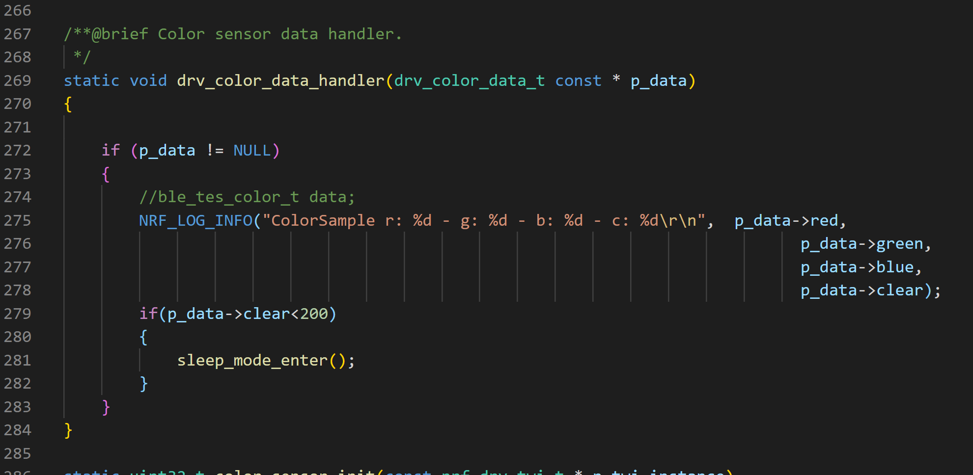

The sleep_mode_enter was already main.c file but the accelerometer needed to be initialized so it could work. The accelero_init() function can be found below (also in the “main.c” file).

**Fixing the right BLE parameters and advertisement packet NOT DONE!!!!!**

🡺

The advertisement interval and timout interval can be adjusted in the thingy_config.h file (as can many other parameters):

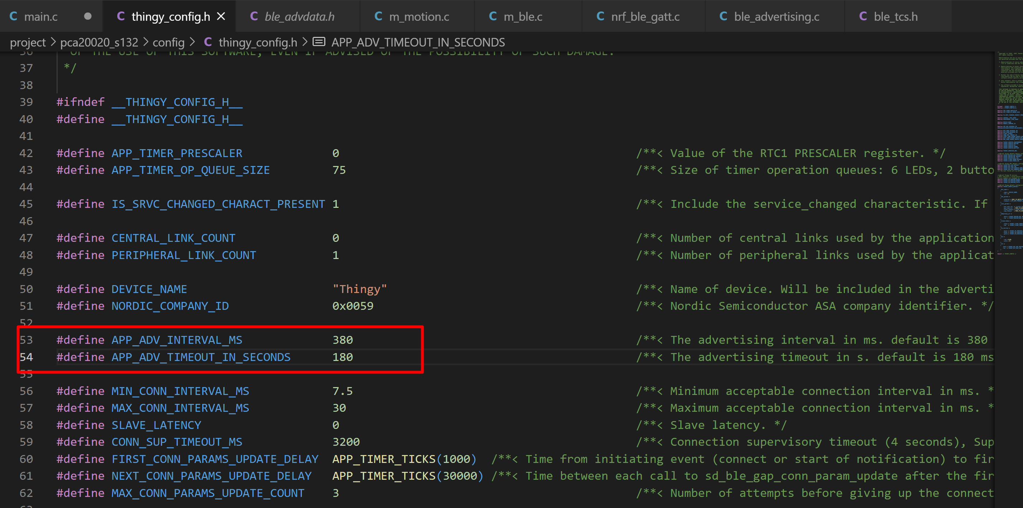

**Power management tests:**

First time measuring the thingy 🡺 nothing is implemented:

