POST and GET:

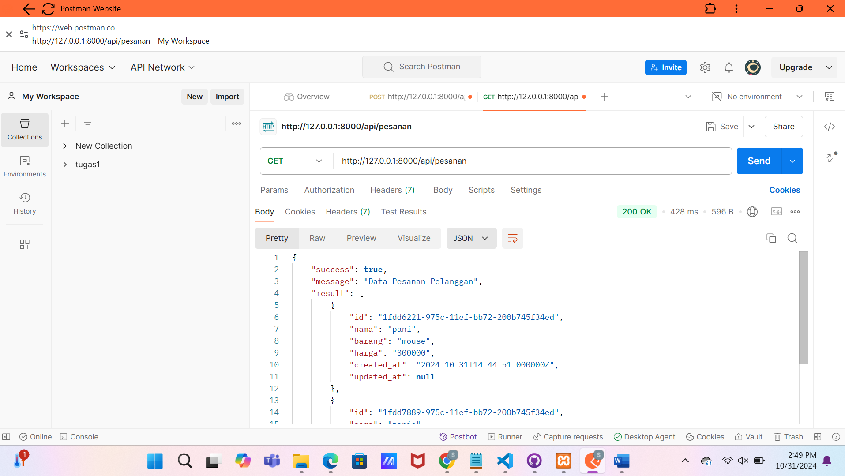

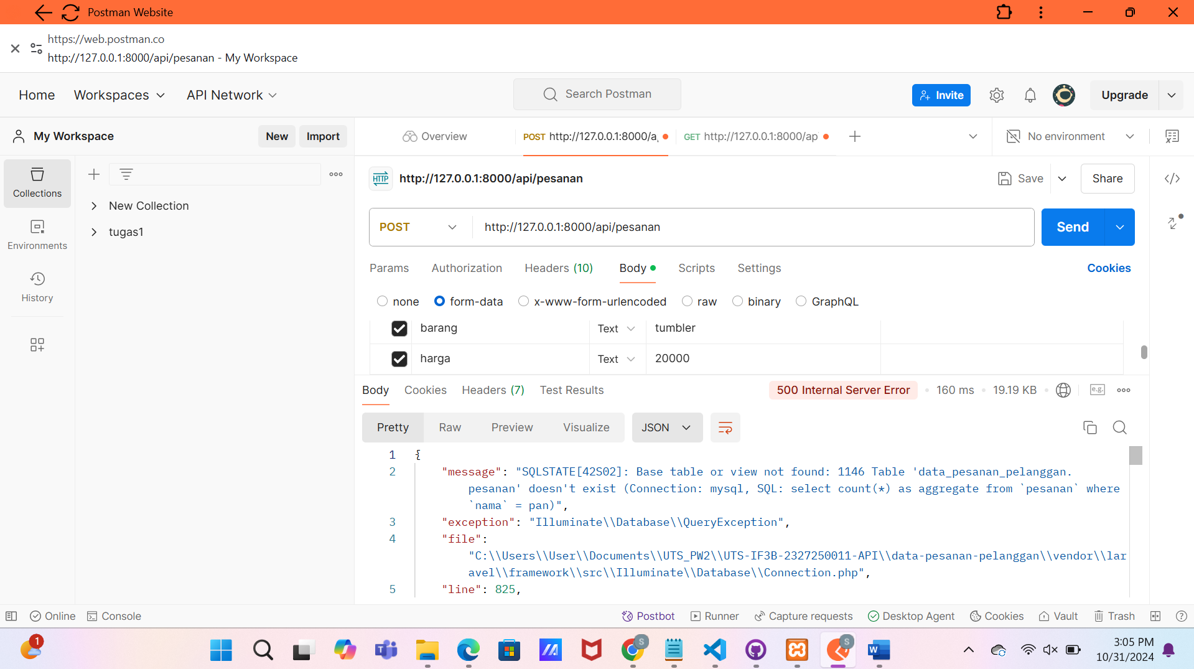

https://uts-if-3-b-2327250011-api.vercel.app/