R Notebook

Steffen Lehmann - 20153945

cordata <- data %>% dplyr::select(-name, -status)  
cordata <- cor(cordata)  
corrplot(cordata, order = "hclust", tl.cex = 0.7)

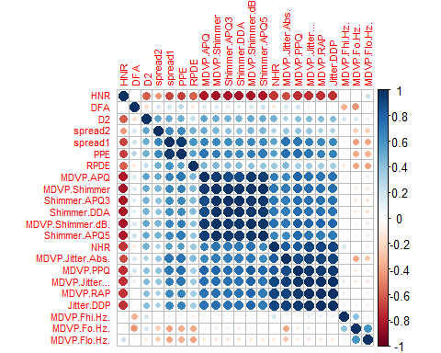

highlyCor <- colnames(data)[findCorrelation(cordata, cutoff = 0.9, verbose = TRUE)]

## Compare row 10 and column 9 with corr 0.987   
## Means: 0.642 vs 0.495 so flagging column 10   
## Compare row 9 and column 13 with corr 0.95   
## Means: 0.621 vs 0.482 so flagging column 9   
## Compare row 7 and column 4 with corr 0.974   
## Means: 0.611 vs 0.467 so flagging column 7   
## Compare row 4 and column 5 with corr 0.936   
## Means: 0.588 vs 0.452 so flagging column 4   
## Compare row 13 and column 12 with corr 0.949   
## Means: 0.564 vs 0.436 so flagging column 13   
## Compare row 14 and column 11 with corr 1   
## Means: 0.541 vs 0.421 so flagging column 14   
## Compare row 11 and column 12 with corr 0.96   
## Means: 0.51 vs 0.407 so flagging column 11   
## Compare row 5 and column 6 with corr 0.923   
## Means: 0.534 vs 0.392 so flagging column 5   
## Compare row 6 and column 8 with corr 1   
## Means: 0.469 vs 0.371 so flagging column 6   
## Compare row 8 and column 15 with corr 0.92   
## Means: 0.425 vs 0.359 so flagging column 8   
## Compare row 22 and column 19 with corr 0.962   
## Means: 0.512 vs 0.337 so flagging column 22   
## All correlations <= 0.9

corcheck <- data[, which(!colnames(data) %in% highlyCor)] # by pair comparation  
  
corcheck <- corcheck %>% dplyr::select(-name)

#Plot histograms of "_mean" variables group by diagnosis  
ggplot(data = melt(corcheck, id.var = "status"), mapping = aes(x = value)) + theme_minimal() +   
 geom_histogram(bins = 10, aes(fill=as.factor(status)), alpha=0.5) + facet_wrap(~variable, scales = 'free_x') + labs(fill="status") +   
 scale_fill_discrete(labels = c("Parkinson's", "Healthy")) + theme(axis.title.x = element_blank(), axis.title.y = element_blank())

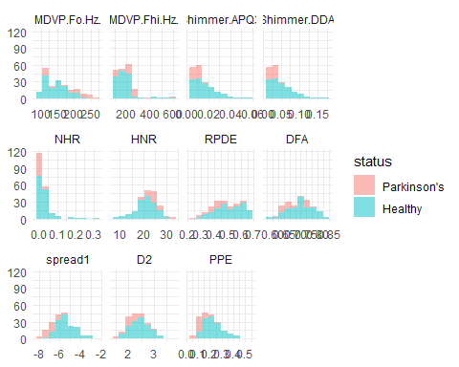

#converting the data frame from R to Python  
#py_data = r.data  
py_data = r.corcheck  
  
#Pre-processing  
# dropping / removing the labels from the data frame   
X = py_data.drop(columns=['status'], axis=1)  
# data frame that is only containing the label  
Y = py_data['status']  
  
  
# splits the data into a test and training test, with 80% of the data being used for training. Shuffles the data twice before spiting   
#https://scikit-learn.org/stable/modules/generated/sklearn.model_selection.train_test_split.html?highlight=train_test_split#sklearn.model_selection.train_test_split  
  
X_train, X_test, Y_train, Y_test = train_test_split(X, Y, test_size=0.2, random_state=2)  
  
#Scaling the data.   
#https://scikit-learn.org/stable/modules/generated/sklearn.preprocessing.StandardScaler.html?highlight=standardscaler#sklearn.preprocessing.StandardScaler   
  
scaler = StandardScaler()  
#Only fit on the training set  
scaler.fit(X_train)  
#Transform both sets

## StandardScaler()

X_train_scaled = scaler.transform(X_train)  
X_test_scaled = scaler.transform(X_test)  
  
k = 5  
kf = KFold(n_splits=k, random_state=None)

#pca with two principal components  
pca = PCA(n_components=2)  
principalComponents = pca.fit_transform(X)  
#first principal component contains 72.89% of the variance and the second principal component contains 21.82% of the variance.   
PCA_variance_n2 = pca.explained_variance_ratio_   
  
principalDf = pd.DataFrame(data = principalComponents, columns = ['PC1', 'PC2'])  
  
#Concatenating DataFrames  
plotDf = pd.concat([principalDf, Y], axis = 1)  
  
#Scaling the data.   
scaler = StandardScaler()  
scaler.fit(plotDf)

## StandardScaler()

X_PCA_scaled = scaler.transform(plotDf)

PCA2 <- py$plotDf  
scal_PCA2 <- py$X_PCA_scaled  
  
scal_PCA2Df <- as.data.frame(scal_PCA2)  
  
scal_PCA2Df['V3'][scal_PCA2Df['V3'] > 0] <- 1  
scal_PCA2Df['V3'][scal_PCA2Df['V3'] < 0] <- 0  
scal_PCA2Df <- scal_PCA2Df %>% rename(PC1 = V1, PC2 = V2, status = V3)  
  
# Scatter plot of PCA(n=2)  
ggplot(PCA2, aes(x=PC1, y=PC2, group=factor(status), colour=factor(status))) + geom_point() + stat_ellipse()

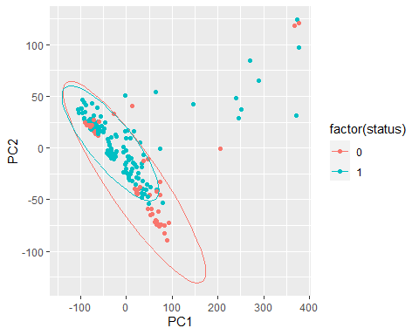

# Shows scatter of scaled dataPCA(n=2)  
ggplot(scal_PCA2Df, aes(x=PC1, y=PC2, group=factor(status), colour=factor(status))) + geom_point() + stat_ellipse()

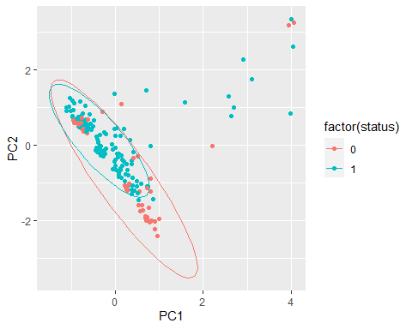

# Show the contour only PCA(n=2)  
ggplot(scal_PCA2Df, aes(x=PC1, y=PC2, group=factor(status), colour=factor(status))) + geom_point() + geom_density_2d()

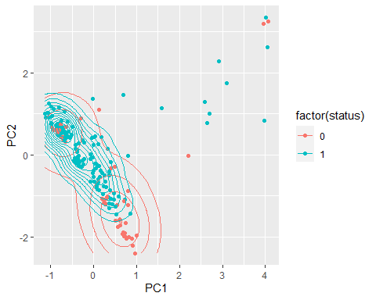

# Show the area only PCA(n=2)  
ggplot(scal_PCA2Df, aes(x=PC1, y=PC2, group=factor(status), colour=factor(status))) + geom_point() + stat_density_2d(aes(fill = ..level..), geom="polygon")

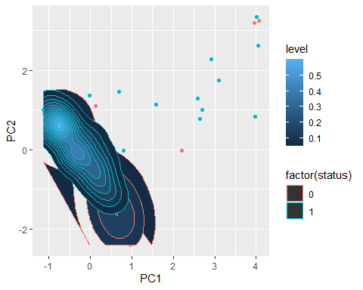

# shows area + contour  
ggplot(scal_PCA2Df, aes(x=PC1, y=PC2, group=factor(status), colour=factor(status))) + geom_point() + stat_density_2d(aes(fill = ..level..), geom="polygon", colour="white")

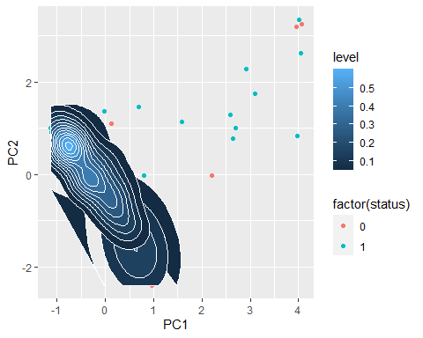

# 0.95 are the components parameter. It means that scikit-learn choose the minimum number of principal components such that 95% of the variance is retained.  
PCA_SVC = PCA(.95)  
PCA_SVC.fit(X_train_scaled)  
#Number of PC's with 95% variance.

## PCA(n_components=0.95)

Number_of_PC = PCA_SVC.n_components_  
#Apply the PCA fit  
PCA_train = PCA_SVC.transform(X_train_scaled)  
PCA_test = PCA_SVC.transform(X_test_scaled)

#Training the Support Vector classifier   
SVM_model = svm.SVC(kernel='linear')  
SVM_model.fit(X_train_scaled, Y_train)  
  
#Training the PCA Support Vector classifier

## SVC(kernel='linear')

SVM_PCA_model = svm.SVC(kernel='linear')  
SVM_PCA_model.fit(PCA_train, Y_train)

## SVC(kernel='linear')

model=svm.SVC(kernel='linear')  
kfold_validation=KFold(10)  
  
results=cross_val_score(model,X_train_scaled,Y_train,cv=kfold_validation)  
print(np.mean(results))

## 0.8583333333333334

#TODO model is over fitted, so the attributes of the model needs to be designed better  
rf_Model = RandomForestClassifier()  
rf_Model.fit(X_train_scaled, Y_train)  
  
  
#With PCA

## RandomForestClassifier()

rf_PCA_Model = RandomForestClassifier()  
rf_PCA_Model.fit(PCA_train, Y_train)

## RandomForestClassifier()

NN = MLPClassifier(activation = 'logistic', solver = 'sgd', hidden_layer_sizes=(100), random_state=1, max_iter=3000)  
NN.fit(X_train_scaled, Y_train)

## MLPClassifier(activation='logistic', hidden_layer_sizes=100, max_iter=3000,  
## random_state=1, solver='sgd')

NN_PCA = MLPClassifier(activation = 'logistic', solver = 'sgd', hidden_layer_sizes=(100), random_state=1, max_iter=3000)  
NN_PCA.fit(PCA_train, Y_train)

## MLPClassifier(activation='logistic', hidden_layer_sizes=100, max_iter=3000,  
## random_state=1, solver='sgd')

gnb = GaussianNB()  
gnb.fit(X_train_scaled, Y_train)

## GaussianNB()

gnb_PCA = GaussianNB()  
gnb_PCA.fit(PCA_train, Y_train)

## GaussianNB()

Models = [SVM_model, rf_Model, NN, gnb]  
PCA_Models= [SVM_PCA_model, rf_PCA_Model, NN_PCA, gnb_PCA]  
Model_name = ['Support Vector Classifier','Random Forest Classifier', 'Neural network', 'Gaussian Naive Bayes']  
AS = []  
AS_PCA = []  
AS_val = []  
  
  
for Model, PCA_Model in zip(Models, PCA_Models):  
 Predicted_labels= Model.predict(X_test_scaled)  
 PCA_Predicted_labels= PCA_Model.predict(PCA_test)  
 AS.append(accuracy_score(Predicted_labels, Y_test))   
 AS_PCA.append(accuracy_score(PCA_Predicted_labels, Y_test))  
  
Accurracy_Store = pd.DataFrame(data=[AS, AS_PCA], columns=Model_name, index=['Standard', 'PCA'])  
  
  
#for Model in Models  
# kfold_validation=KFold(10)  
# results=cross_val_score(Model,X_train_scaled,Y_train,cv=kfold_validation)  
# AS_val.append(np.mean(results))  
  
#Accurracy_Store = pd.DataFrame(data=[AS, AS_PCA, AS_val], columns=Model_name, index=['Standard', 'PCA', 'Kfold'])

dat <- data.frame(y=scal_PCA2Df$status, x1=scal_PCA2Df$PC1, x2=scal_PCA2Df$PC2)  
SVM_X <- scal_PCA2Df %>% dplyr::select(-status)  
SVM_Y <- scal_PCA2Df$status  
SVM_Y <- as.factor(SVM_Y)  
s <- seq(from=-3,to=5,length=400)  
  
# for standard SVM usage, do not set this `C` parameter so high  
# this will be discussed later when we talk about "soft margin" SVM  
tg <- data.frame(C=100)  
fit <- train(SVM_X, SVM_Y, method="svmLinear", tuneGrid=tg)  
alpha <- fit$finalModel@alpha[[1]]  
sv <- as.data.frame(SVM_X[fit$finalModel@SVindex,]) # the "support vectors"  
sv.y <- 2 * (as.numeric(SVM_Y[fit$finalModel@SVindex]) - 1.5)  
w <- colSums(alpha * sv.y * as.matrix(sv))  
b <- fit$finalModel@b  
grid <- expand.grid(x1=s,x2=s)  
grid$y.cont <- (as.matrix(grid[,1:2]) %*% w - b)[,1]  
ggplot(dat, aes(dat$x1,dat$x2,col=dat$y)) + geom_point() +   
 geom_contour(data=grid, aes(x1,x2,z=y.cont), breaks=c(-1,0,1), col="black")

## Warning: Use of `dat$x1` is discouraged. Use `x1` instead.

## Warning: Use of `dat$x2` is discouraged. Use `x2` instead.

## Warning: Use of `dat$y` is discouraged. Use `y` instead.

