**Food Delivery App - Capstone Project**

**View 1: Sales Revenue**

* Build a scorecard showing the Total Sales in $ using the Amount Paid field
* Format as per your choice
* Number should match

**View 2: Average Order** $

* Build a scorecard showing the Average Order $
* Format as per your choice
* Number should match

**View 3: Total Orders**

* Build a scorecard showing the Total Orders
* Format as per your choice
* Number should match

**View 4: ARPU (Average Revenue Per User)**

* Build a scorecard showing the ARPU
* Format as per your choice
* Number should match

**View 5: Area Chart showing Daily Trending Metrics for the above 4 views**

* Build an Area chart showing the Daily trends and  Metrics from the below metrics (Use Parameters)
* Format as per your choice
* Number should match

**View 6: Mins taken on an average for a Delivery or Pick up depending on the selection**

* Build a simple text chart showing mins taken on an average for either pickup or delivery.
* If the value is less than or equal to 15.5, then format mins to green elseif greater, format to red.
* Number should match.

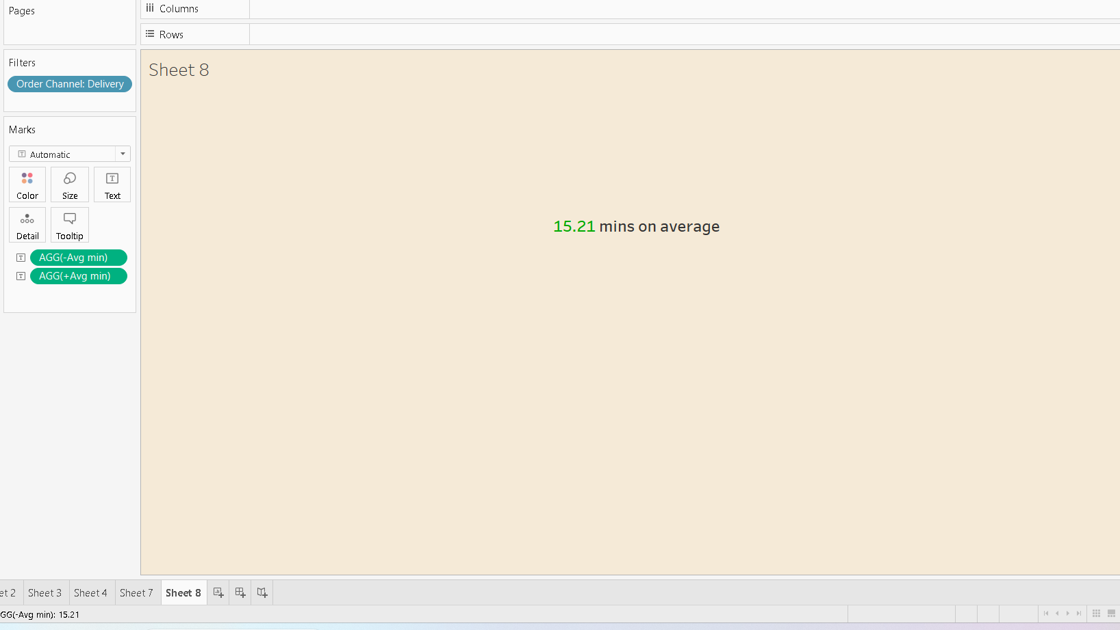

**View 7: Mins taken on an average for a Delivery or Pick up depending on the selection**

* Build the below view showing the Avg mins breakdown by weekday.
* Use red-green diverging with Step size 7.
* If the value is greater than 15, then shades should be running towards red, else, if less, they should be running towards green. If 15, then they should be running towards grey.
* Time should be formatted as shown in the AM/PM format. (Hint: Use the calculated field to get the hour and concatenate with the string field or any other approach you can think of).

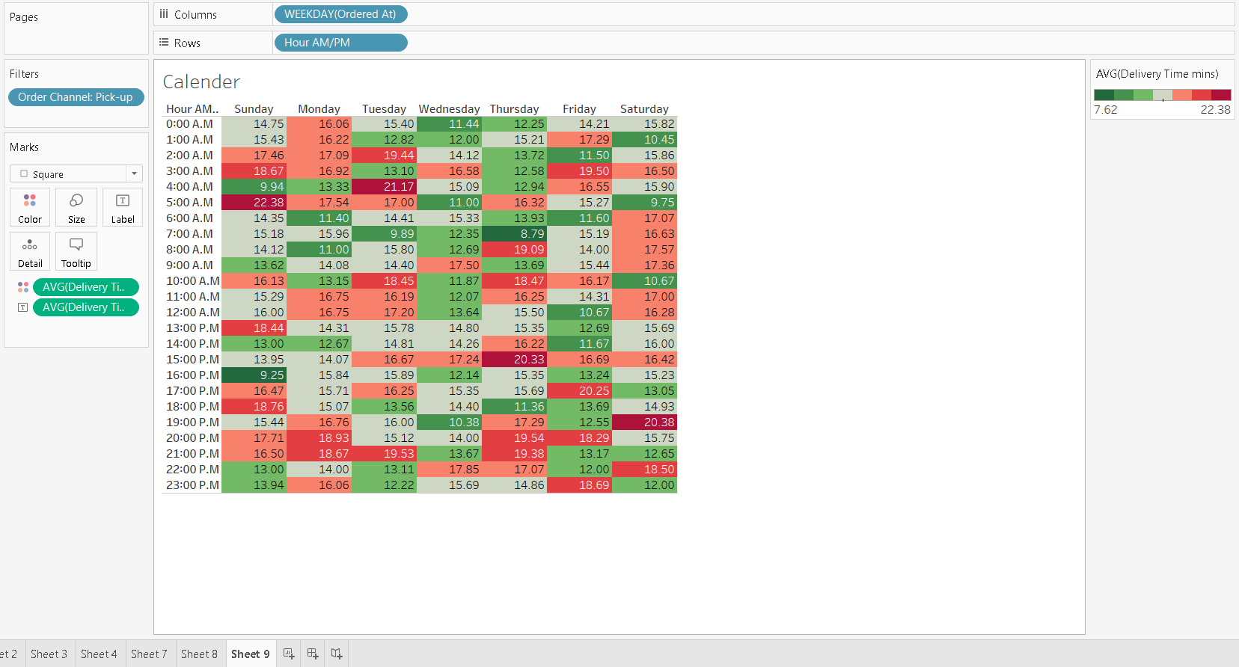

**Dashboard**



