**1. Define a class ‘product’ with data members pcode, pname and price. Create 3 objects of the class and find the product having the lowest price.**

import java.util.Scanner;

class ProductClass{

String pname;

int pcode;

int price;

public ProductClass(String name,int code,int price){

this.pname = name;

this.pcode = code;

this.price = price;

}

}

public class Product {

public static void main(String[] arguments){

System.out.println(" Steffi Antony\n Roll No: 54\n Date: 13-02-2024\n Program title: Product class\n");

Scanner scan = new Scanner(System.in);

System.out.print("Enter the code of the first product : ");

int code1 = scan.nextInt();

System.out.print("Enter the name of the first product : ");

scan.nextLine();

String name1 = scan.nextLine();

System.out.print("Enter the price of the first product : ");

int price1 = scan.nextInt();

System.out.print("Enter the code of the second product : ");

int code2 = scan.nextInt();

System.out.print("Enter the name of the second product : ");

scan.nextLine();

String name2 = scan.nextLine();

System.out.print("Enter the price of the second product : ");

int price2 = scan.nextInt();

System.out.print("Enter the code of the third product : ");

int code3 = scan.nextInt();

System.out.print("Enter the name of the third product : ");

scan.nextLine();

String name3 = scan.nextLine();

System.out.print("Enter the price of the third product : ");

int price3 = scan.nextInt();

ProductClass obj1 = new ProductClass(name1, code1, price1);

ProductClass obj2 = new ProductClass(name2, code2, price2);

ProductClass obj3 = new ProductClass(name3, code3, price3);

int minimum = obj1.price < obj2.price ? obj1.price : obj2.price;

minimum = minimum < obj3.price ? minimum : obj3.price;

System.out.println("Smallest price is : " + minimum);

}

}

**OUTPUT**

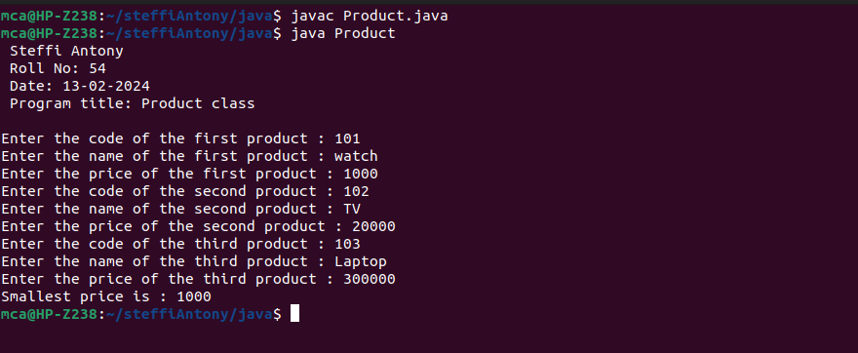

**2. Read 2 matrices from the console and perform matrix addition.**

import java.util.Scanner;

public class Matrix{

public static void main(String[] args){

System.out.println(" Steffi Antony\n Roll No: 54\n Date: 13-02-2024\n Program title: Matrix Addition\n");

Scanner read = new Scanner(System.in);

System.out.println("Enter the rows(m1) and cols(n1) in the first matrix :");

int m1 = read.nextInt();

int n1 = read.nextInt();

int[][] matrix1 = new int[m1][n1];

System.out.println("Enter the first matrix:");

for(int i=0; i<m1; i++){

for(int j=0;j<n1;j++){

matrix1[i][j] = read.nextInt();

}

}

System.out.println("Enter the rows(m2) and cols(n2) in the second matrix :");

int m2 = read.nextInt();

int n2 = read.nextInt();

int[][] matrix2 = new int[m2][n2];

System.out.println("Enter the second matrix:");

for(int i=0; i<m1; i++){

for(int j=0;j<n1;j++) {

matrix2[i][j] = read.nextInt();

}

}

System.out.println("First matrix is: ");

for(int i=0; i<m1; i++){

for(int j=0;j<n1;j++){

System.out.print(matrix1[i][j] +"\t");

}

System.out.print("\n");

}

System.out.println("Second matrix is: ");

for(int i=0; i<m2; i++){

for(int j=0;j<n2;j++) {

System.out.print(matrix2[i][j] +"\t");

}

System.out.print("\n");

}

int add[][] = new int[m1][n1];

if(m1 == m2 && n1 == n2) {

for(int i=0; i<m1; i++){

for(int j=0; j<n1; j++){

add[i][j] = matrix1[i][j] + matrix2[i][j];

}

}

System.out.println("Matrix Addition is: ");

for(int i=0; i<m1; i++) {

for(int j=0;j<n1;j++) {

System.out.print(add[i][j] +"\t");

}

System.out.print("\n");

}

} else {

System.out.println("Addition not possible.");

}

}

}

**OUTPUT**

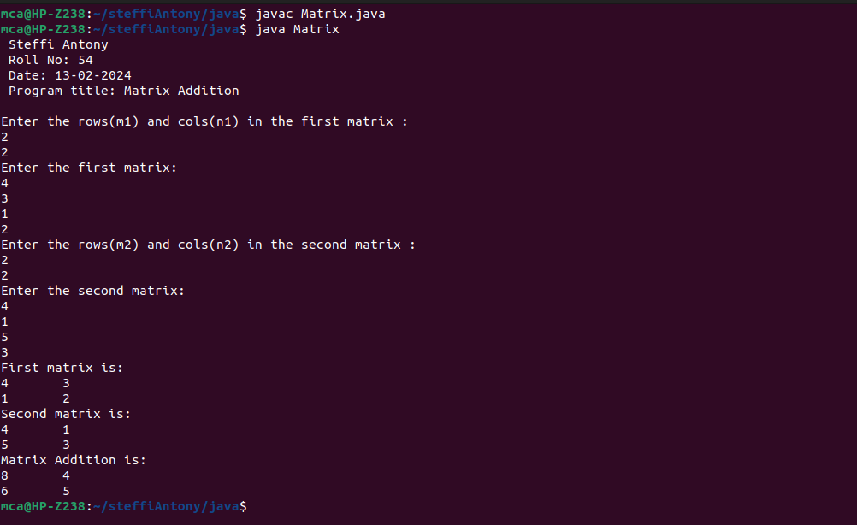

**3. Add complex numbers**

import java.util.Scanner;

public class Complex{

public static void main(String[] args){

System.out.println(" Steffi Antony\n Roll No: 54\n Date:13-02-2024\n Program title: Complex Number\n");

class ComplexClass{

int real;

int img;

public ComplexClass(int r, int i) {

this.real = r;

this.img = i;

}

}

Scanner read = new Scanner(System.in);

System.out.println("Enter the first complex number:");

System.out.print("Real part : ");

int a = read.nextInt();

System.out.print("Imaginary part : ");

int b = read.nextInt();

ComplexClass first = new ComplexClass(a,b);

System.out.println("Enter the second complex number:");

System.out.print("Real part : ");

a = read.nextInt();

System.out.print("Imaginary part : ");

b = read.nextInt();

ComplexClass second = new ComplexClass(a,b);

int real = first.real + second.real;

int img = first.img + second.img;

System.out.println("Sum of the Complex Number is:" + real + " + " + img + "i");

}}

**OUTPUT**

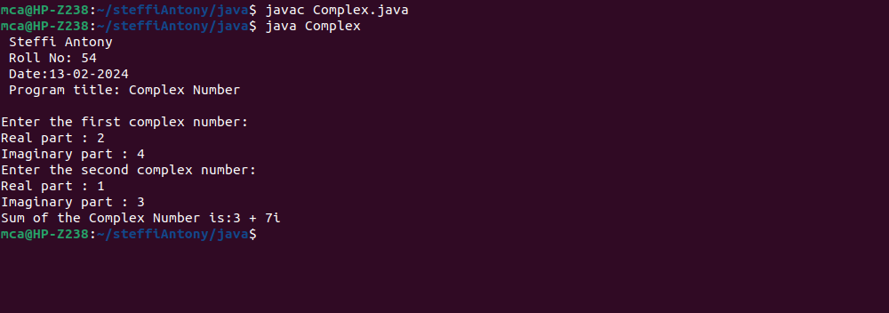

**4. Read a matrix from the console and check whether it is symmetric or not**

import java.util.Scanner;

public class SymmetricMatrix{

public static void main(String[] arg){

System.out.println(" Steffi Antony\n Roll No: 54\n Date: 14-02-2024\n Program title: Symmetric or not\n");

Scanner read = new Scanner(System.in);

System.out.println("Enter the rows and cols of the matrix : ");

int rows = read.nextInt();

int cols = read.nextInt();

int[][] matrix = new int[rows][cols];

System.out.println("Enter the matrix elements : ");

for(int i=0; i<rows; i++){

for(int j=0;j<cols;j++){

matrix[i][j] = read.nextInt();

}

}

System.out.println("\nMatrix is");

for(int i=0; i<rows; i++){

for(int j=0;j<cols;j++){

System.out.print(matrix[i][j] + "\t");

}

System.out.print("\n");

}

if(rows == cols){

int flag=0;

for(int i=0; i<rows; i++){

for(int j=0;j<cols;j++){

if(matrix[i][j] != matrix[j][i]){

flag=1;

break;

}

}

if(flag == 1) break;

}

if(flag == 0){

System.out.println("\nThe matrix is a Symmetric matrix.");

} else {

System.out.println("\nThe matrix is not a Symmetric matrix.");

}

} else {

System.out.println("\nThe matrix is not a Symmetric matrix.");

}

}

}

**OUTPUT**

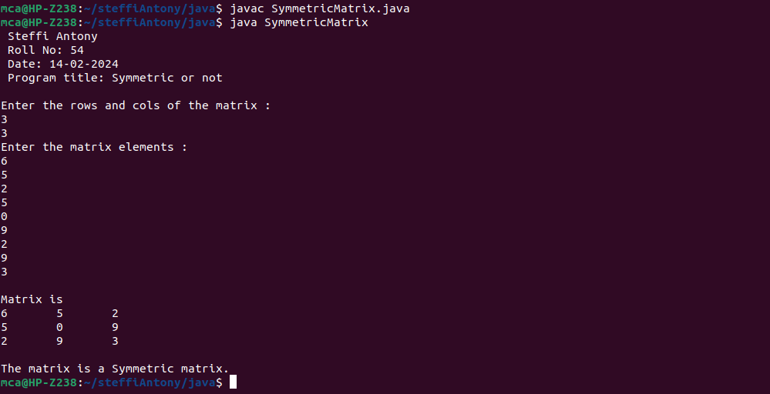

**5. Create CPU with attribute price. Create inner class Processor (no. of cores, manufacturer) and static nested class RAM (memory, manufacturer). Create an object of CPU and print information of Processor and RAM.**

class CPU

{

double price;

class Processor{

double cores;

String manufacturer;

double getCache(){

return 4.3;

}

}

protected class RAM{

double memory;

String manufacturer;

double getClockSpeed(){

return 5.5;

}

}

}

public class CPUDetails{

public static void main(String[] args)

{

System.out.println(" Steffi Antony\n Roll No: 54\n Date:14-02-2024\n Program title: Information of Processor and RAM.\n");

CPU cpu=new CPU();

CPU.Processor processor=cpu.new Processor();

CPU.RAM ram=cpu.new RAM();

System.out.println("Processor Cache=" + processor.getCache());

System.out.println("Ram Clock speed=" + ram.getClockSpeed());

}

}

**OUTPUT**

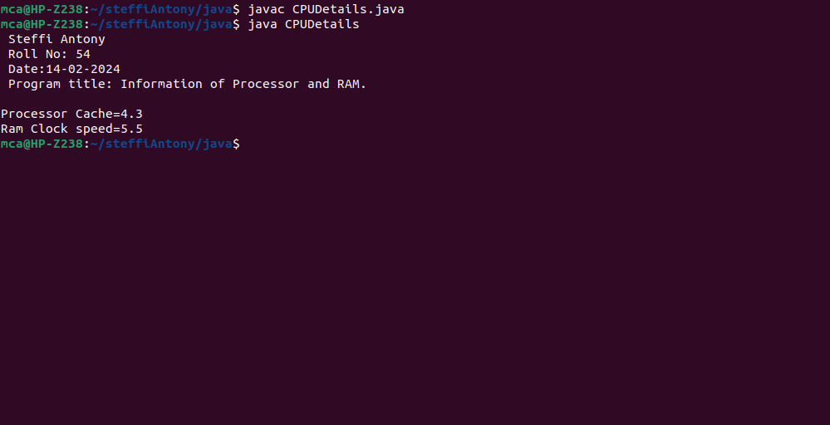

**6. Program to Sort strings.**

import java.util.Scanner;

import java.util.Arrays;

public class Sorting{

public static void main(String arg[]){

System.out.println(&quot; Steffi Antony\n Roll No: 54\n Date:26-02-2024\n Program title:String sorting\n&quot;);

Scanner scan = new Scanner(System.in);

System.out.println(&quot;Enter the no.of Strings: &quot;);

int n = scan.nextInt();

System.out.println(&quot;Enter the strings:&quot;);

String[] str = new String[n];

scan.nextLine();

for(int i=0; i&lt;n; i++){

str[i] = scan.nextLine();

}

System.out.println(&quot;Array before sorting : &quot; + Arrays.toString(str));

for(int i=0; i&lt;n-1; i++){

for(int j=0; j&lt;n-i-1; j++){

if(str[j].compareTo(str[j+1]) &gt; 0){

String temp = str[j];

str[j] = str[j+1];

str[j+1] = temp;

}

}

}

System.out.println(&quot;Array after sorting : &quot; + Arrays.toString(str));

scan.close();

}

}

**OUTPUT**

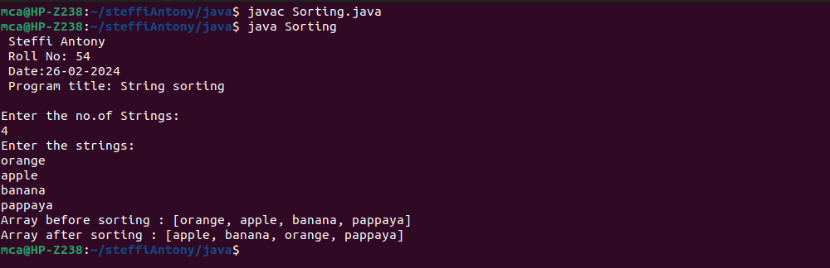

**7. Search an element in an array.**

import java.util.Scanner;

import java.util.Arrays;

class SearchArray{

public static void main(String arg[]){

System.out.println(" Steffi Antony\n Roll No: 54\n Date:26-02-2024\n Program title:

Search an element in an array.\n");

Scanner scanner = new Scanner(System.in);

System.out.print("Enter the size of the array : ");

int n = scanner.nextInt();

int arr[] = new int[n];

System.out.println("Enter the array elements : ");

for(int i=0; i<n; i++){

arr[i] = scanner.nextInt();

}

System.out.println("Array is : " + Arrays.toString(arr));

System.out.print("Enter the value to search : ");

int value = scanner.nextInt();

int flag = 0;

for(int i=0; i<n; i++){

if(value == arr[i]){

flag = 1;

break;

}

}

if(flag == 0)

System.out.println("Element " + value + " not found in the array.");

else System.out.println("Element " + value + " found in the array.");

scanner.close();

} }

**OUTPUT**

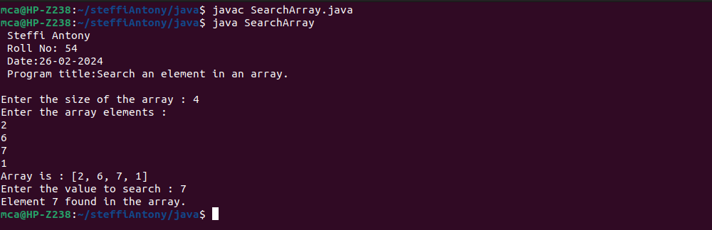

**8. Perform string manipulations.**

import java.util.Scanner;

class Manipulation{

public static void main(String arg[]){

System.out.println(" Steffi Antony\n Roll No: 54\n Date:26-02-2024\n Program title:Perform string manipulations.\n");

Scanner scanner = new Scanner(System.in);

System.out.print("Enter a String : ");

String str = scanner.nextLine();

System.out.println("\nString is : " + str);

System.out.println("Length of the string is : " + str.length());

System.out.println("Character at the first position is : " + str.charAt(0));

System.out.println("LOWERCASE : "+str.toLowerCase());

System.out.println("UPPERCASE : "+str.toUpperCase());

System.out.print("Enter a substring to check : ");

String subStr = scanner.nextLine();

if(str.contains(subStr)) System.out.println("String '" + str + "' contains the substring '" + subStr + "'");

else System.out.println("String '" + str + "' not contains the substring '" + subStr + "'");

scanner.close();

}

}

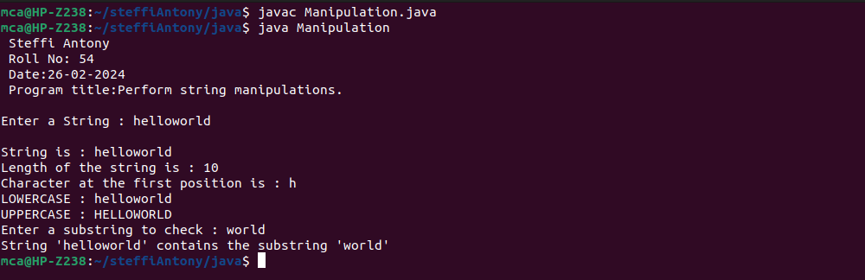**OUTPUT**

**9. Program to create a class for Employee having attributes eNo, eName eSalary. Read n employ information and Search for an employee given eNo, using the concept of Array of Objects.**

import java.util.Scanner;

class Employee{

int eNo, eSalary;

String eName;

public Employee(int no, String name, int salary) {

this.eNo = no;

this.eName = name;

this.eSalary = salary;

}

}

class Main{

public static void main(String arg[]){

System.out.println(" Steffi Antony\n Roll No: 54\n Date:14-03-2024\n Program title: Program to create a class for Employee \n");

Scanner scanner = new Scanner(System.in);

System.out.print("Enter the no of Employees : ");

int n = scanner.nextInt();

Employee arr[] = new Employee[n];

for(int i=0; i<n; i++){

System.out.println("Enter the details of employee " + Integer.toString(i+1));

System.out.print("Enter the employee id : ");

int no = scanner.nextInt();

System.out.print("Enter the employee name : ");

scanner.nextLine();

String name = scanner.nextLine();

System.out.print("Enter the salary : ");

int salary = scanner.nextInt();

arr[i] = new Employee(no, name, salary);

}

System.out.print("\nEnter the employee id to search : ");

int id = scanner.nextInt();

int flag = 0;

for(int i=0; i<n; i++){

if(arr[i].eNo == id){

System.out.println("Employee found.\nid : " + Integer.toString(id) + "\nname : " + arr[i].eName + "\nsalary : " + Integer.toString(arr[i].eSalary));

flag = 1;

break;

}

}

if(flag == 0) System.out.println("Employee not found");

scanner.close();

}

}

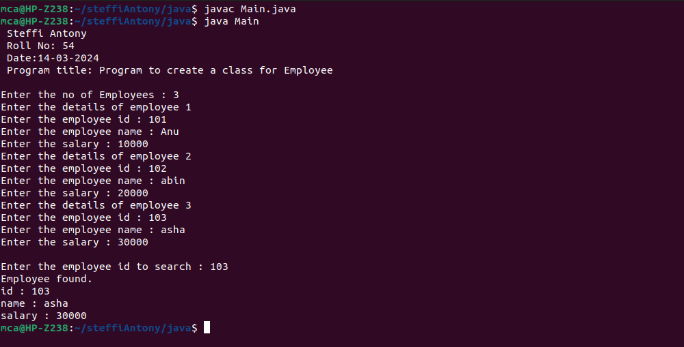**OUTPUT**

**10. Area of different shapes using overloaded functions.**

import java.util.Scanner;

class Area{

float area(float radius){

return (float)Math.PI*(radius*radius);

}

float area(float base, float height){

return (float)0.5*base*height;

}

float area(float length, float breadth, float height){

return length*breadth*height;

}

}

class AreaFunctionOverload{

public static void main(String[] args){

System.out.println(" Steffi Antony\n Roll No: 54\n Date:06-04-2024\n Program title: Area of Shapes using Function Overloading\n");

Scanner scanner = new Scanner(System.in);

float radius, base, length, breadth, height;

Area area = new Area();

System.out.println("Enter the details of the circle");

System.out.print("Radius : ");

radius = scanner.nextFloat();

float areaOfCircle = area.area(radius);

System.out.println("Enter the details of the Triangle");

System.out.print("Base : ");

base = scanner.nextFloat();

System.out.print("Height : ");

height = scanner.nextFloat();

float areaOfTriangle = area.area(base, height);

System.out.println("Enter the details of the Box");

System.out.print("Length : ");

length = scanner.nextFloat();

System.out.print("Breadth : ");

breadth = scanner.nextFloat();

System.out.print("Height : ");

height = scanner.nextFloat();

float areaOfBox = area.area(length, breadth, height);

System.out.println("\nArea of Circle is " + areaOfCircle);

System.out.println("Area of Triangle is " + areaOfTriangle);

System.out.println("Area of Box is " + areaOfBox);

scanner.close();

}

}

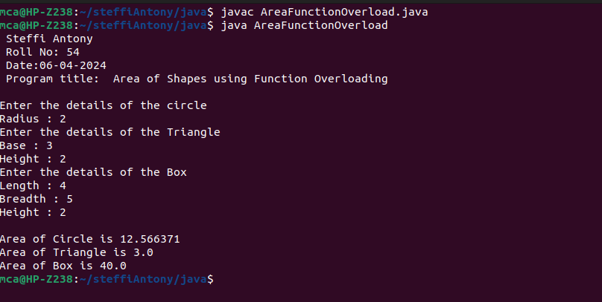**OUTPUT**

**11. Create a class ‘Employee’ with data members Empid, Name, Salary, Address and constructors to initialize the data members. Create another class ‘Teacher’ that inherit the properties of class employee and contain its own data members department, Subjects taught and constructors to initialize these data members and also include display function to display all the data members. Use array of objects to display details of N teachers.**

import java.util.Scanner;

class Employee {

public int Empid, Salary;

public String Name, Address;

public Employee(int Empid, String Name, int Salary, String Address) {

this.Empid = Empid;

this.Name = Name;

this.Salary = Salary;

this.Address = Address;

}

}

class Teacher extends Employee {

String Department, Subject;

public Teacher(int Empid, String Name, int Salary, String Address, String Department, String Subject) {

super(Empid, Name, Salary, Address);

this.Department = Department;

this.Subject = Subject;

}

void Display(){

System.out.println("\nEmpolyee id : " + super.Empid);

System.out.println("Empolyee name : " + super.Name);

System.out.println("Empolyee salary : " + super.Salary);

System.out.println("Empolyee address : " + super.Address);

System.out.println("Department : " + this.Department);

System.out.println("Subject taught : " + this.Subject);

}

}

class MainMethod{

public static void main(String args[]){

System.out.println(" Steffi Antony\n Roll No: 54\n Date:06-04-2024\n Program title: Use array of objects to display details of N teachers.\n");

Scanner scanner = new Scanner(System.in);

System.out.print("Enter the no.of Teachers : ");

int n = scanner.nextInt();

Teacher []arr = new Teacher[n];

System.out.println("Enter the details ");

for(int i=0; i< n; i++){

System.out.println("Enter the details of Teacher " + (i+1) + " : ");

System.out.print("id : ");

int id = scanner.nextInt();

System.out.print("name : ");

scanner.nextLine();

String name = scanner.nextLine();

System.out.print("salary : ");

int salary = scanner.nextInt();

System.out.print("Address : ");

scanner.nextLine();

String address = scanner.nextLine();

System.out.print("Department : ");

String department = scanner.nextLine();

System.out.print("Subject : ");

String subject = scanner.nextLine();

arr[i] = new Teacher(id, name, salary, address, department, subject);

}

System.out.println("\nDetials\n");

for(int i =0; i< n; i++){

arr[i].Display();

}

scanner.close();

}

}

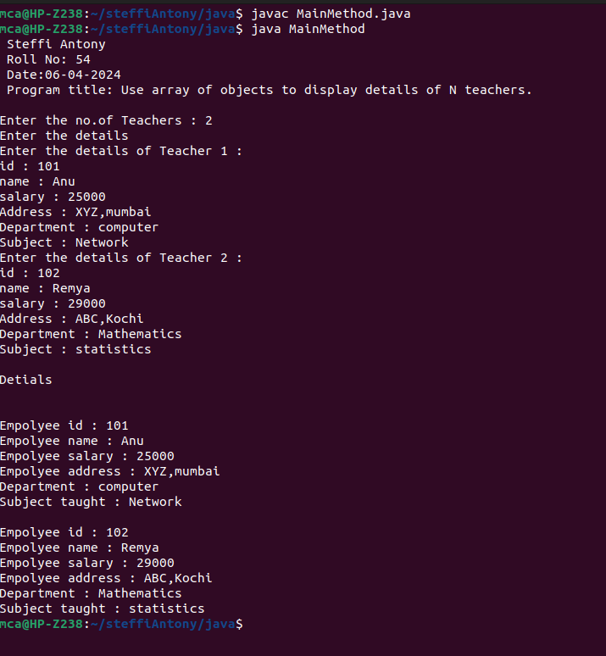**OUTPUT**

**12. Create a class ‘Person’ with data members Name, Gender, Address, Age and a constructor to initialize the data members and another class ‘Employee’ that inherits the properties of class Person and also contains its own data members like Empid, Company_name, Qualification, Salary and its own constructor. Create another class ‘Teacher’ that inherits the properties of class Employee and contains its own data members like Subject, Department, Teacherid and also contain constructors and methods to display the data members. Use array of objects to display details of N teachers.**

import java.util.Scanner;

class Person {

String name, gender, address;

int age;

public Person(String name, String gender, String address, int age){

this.name = name;

this.gender = gender;

this.address = address;

this.age = age;

}

void display(){

System.out.println("Name: " + name + "\nGender: " + gender + "\nAddress: " + address + "\nAge: " + age);

}

}

class Employee extends Person {

int empId, salary;

String companyName, qualification;

public Employee(int empId, String companyName, String qualification, int salary, String name, String gender, String address, int age){

super(name, gender, address, age);

this.empId = empId;

this.companyName = companyName;

this.qualification = qualification;

this.salary = salary;

}

void display(){

System.out.println("Employee Id : " + empId + "\nCompany name : " + companyName + "\nQualification : " + qualification + "\nSalary : " + salary);

super.display();

}

}

class Teacher extends Employee {

int teacherId;

String subject, department;

public Teacher (int teacherId, String subject, String department, int empId, String companyName, String qualification, int salary, String name, String gender, String address, int age){

super(empId, companyName, qualification, salary, name, gender, address, age);

this.teacherId = teacherId;

this. subject = subject;

this.department = department;

}

void display(){

System.out.println("Teacher Id : " + teacherId + "\nDepartment : " + department + "\nSubject : " + subject);

super.display();

}

}

class PersonMain {

public static void main(String[] arg){

System.out.println(" Steffi Antony\n Roll No: 54\n Date:08-04-2024\n Program title: Use array of objects to display details of N teachers.\n");

Scanner scanner = new Scanner(System.in);

System.out.print("Enter the no.of Teachers : ");

int TeacherCount = scanner.nextInt();

Teacher [] Teachers = new Teacher[TeacherCount];

for (int i=0; i<TeacherCount; i++) {

System.out.println("\nEnter the Teacher details");

System.out.print("Enter the Teacher id : ");

int id = scanner.nextInt();

System.out.print("Enter the Subject : ");

scanner.nextLine();

String subject = scanner.nextLine();

System.out.print("Enter the Department : ");

String department = scanner.nextLine();

System.out.print("Enter the Employee id : ");

int empId = scanner.nextInt();

System.out.print("Enter the Company name : ");

scanner.nextLine();

String companyName = scanner.nextLine();

System.out.print("Enter the Qualification : ");

String qualification = scanner.nextLine();

System.out.print("Enter the Salary : ");

int salary = scanner.nextInt();

System.out.print("Enter the Name : ");

scanner.nextLine();

String name = scanner.nextLine();

System.out.print("Enter the Gender : ");

String gender = scanner.nextLine();

System.out.print("Enter the Address : ");

String address = scanner.nextLine();

System.out.print("Enter the Age : ");

int age = scanner.nextInt();

Teachers[i] = new Teacher(id, subject, department, empId, companyName, qualification, salary, name, gender, address, age);

}

for (int i=0; i<TeacherCount; i++){

System.out.println("\nDetails of Teacher " + (i+1));

Teachers[i].display();

}

scanner.close();

}

}

**OUTPUT**

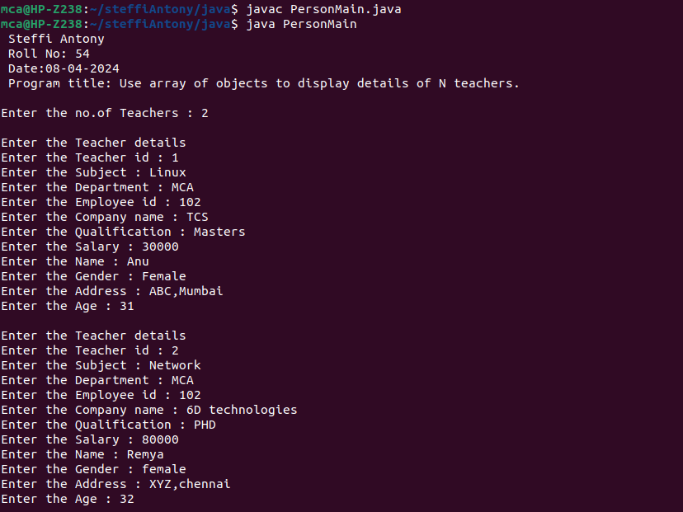

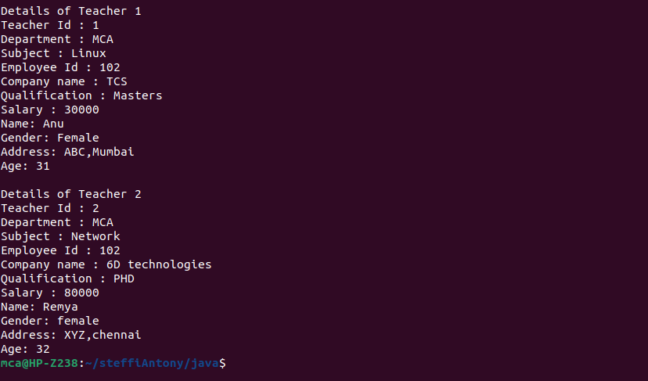

**13. Write a program has class Publisher, Book, Literature and Fiction. Read the information and print the details of books from either the category, using inheritance.**

import java.util.Scanner;

class Publisher {

String name;

Publisher(String name) {

this.name = name;

}

}

class Book extends Publisher {

String title;

String author;

Book(String title, String author, String publisher) {

super(publisher);

this.title = title;

this.author = author;

}

void display() {

System.out.println("Title: " + title);

System.out.println("Author: " + author);

System.out.println("Publisher: " + name);

}

}

class Literature extends Book {

Literature(String title, String author, String publisher) {

super(title, author, publisher);

}

}

class Fiction extends Book {

Fiction(String title, String author, String publisher) {

super(title, author, publisher);

}

}

public class BookDetails {

public static void main(String[] args) {

System.out.println(" Steffi Antony\n Roll No: 54\n Date:06-04-2024\n Program title: Book details\n");

Scanner scanner = new Scanner(System.in);

System.out.print("How many Literature books do you want to add? ");

int numLiteratureBooks = scanner.nextInt();

scanner.nextLine();

System.out.print("How many Fiction books do you want to add? ");

int numFictionBooks = scanner.nextInt();

scanner.nextLine();

Book[] literatureBooks = new Book[numLiteratureBooks];

Book[] fictionBooks = new Book[numFictionBooks];

for (int i = 0; i < numLiteratureBooks; i++) {

System.out.println("\nEnter details for Literature book " + (i + 1) + ":");

literatureBooks[i] = createBook(scanner, "Literature");

}

for (int i = 0; i < numFictionBooks; i++) {

System.out.println("\nEnter details for Fiction book " + (i + 1) + ":");

fictionBooks[i] = createBook(scanner, "Fiction");

}

System.out.println("\nLiterature Books:");

displayBooks(literatureBooks);

System.out.println("\nFiction Books:");

displayBooks(fictionBooks);

scanner.close();

}

private static Book createBook(Scanner scanner, String type) {

System.out.print("Enter the title of the book: ");

String title = scanner.nextLine();

System.out.print("Enter the author of the book: ");

String author = scanner.nextLine();

System.out.print("Enter the publisher of the book: ");

String publisher = scanner.nextLine();

if (type.equals("Literature")) {

return new Literature(title, author, publisher);

} else if (type.equals("Fiction")) {

return new Fiction(title, author, publisher);

} else {

return null;

}

}

private static void displayBooks(Book[] books) {

for (Book book : books) {

book.display();

System.out.println();

}

}

}

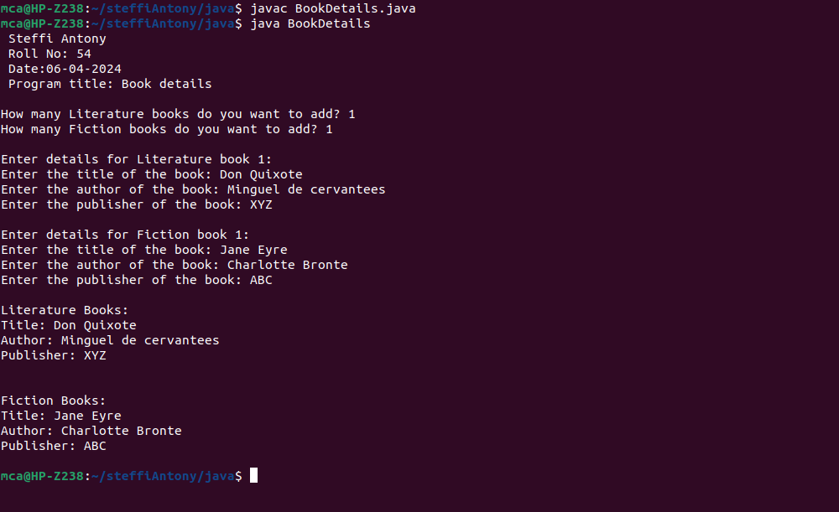**OUTPUT**

**14. Create classes Student and Sports. Create another class Result inherited from Student and Sports. Display the academic and sports score of a student.**

import java.util.Scanner;

class sports{

String sport;

int Rating;

sports(String spo, int ra){

sport = spo;

Rating = ra;

}

}

class student extends sports{

String Grade;

double Overall_per;

student(String spo, int ra,String gd, double per ){

super(spo, ra);

Grade = gd;

Overall_per = per;

}

}

public class Result extends student {

Result(String spo, int ra,String gd, double per ){

super(spo, ra, gd, per);

}

void display(){

System.out.println("\nSports Details of Student");

System.out.println("No. of Sport items:"+sport);

System.out.println("Rating:"+Rating);

System.out.println("\nAcademic Details of Student");

System.out.println("Academic Grade :"+Grade);

System.out.println("Overall percentage :"+Overall_per+ "%");

}

public static void main(String[] args) {

System.out.println("Steffi Antony\n Roll No:54\n Date:06-04-2024\n Program title:Student and sports \n");

Scanner sc =new Scanner(System.in);

System.out.println("Enter the Sports Details of Student");

System.out.println("no. of Sport items: ");

String a =sc.next();

System.out.println("Sport Rating out of 10: ");

int b =sc.nextInt();

System.out.println("\nEnter the Sports Details of Student");

System.out.println("Academic Grade: ");

String c =sc.next();

System.out.println("Overall percentage: ");

double d =sc.nextDouble();

sc.close();

Result obj= new Result(a,b,c,d);

obj.display();

}

}

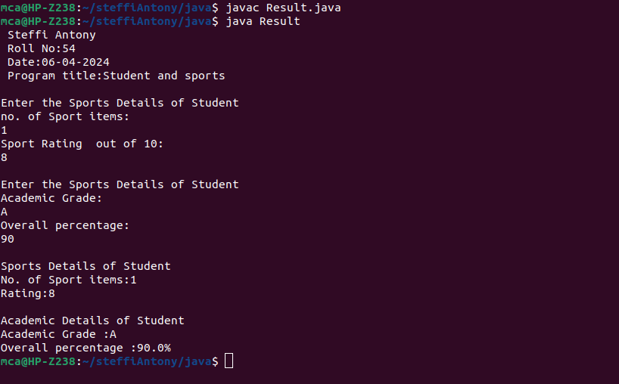**OUTPUT**

**15. Create an interface having prototypes of functions area() and perimeter(). Create two classes Circle and Rectangle which implements the above interface. Create a menu driven program to find area and perimeter of objects.**

import java.util.Scanner;

interface prop{

void getdata();

void area();

void perimeter();

}

class Circle implements prop{

double pi = 3.14;

double r;

Scanner sc = new Scanner(System.in);

public void getdata(){

System.out.println("Enter the radius of the circle:");

r = sc.nextDouble();

}

public void perimeter(){

System.out.println("Perimeter of the circle: "+(2*pi*r));

}

public void area(){

System.out.println("Area of the circle: "+(pi*r*r));

}

}

class Rectangle implements prop{

double l,b;

Scanner sc = new Scanner(System.in);

public void getdata(){

System.out.println("Enter the length of the rectangle:");

l = sc.nextDouble();

System.out.println("Enter the breadth of the rectangle:");

b = sc.nextDouble();

}

public void area(){

System.out.println("Area of a rectangle: "+(l*b));

}

public void perimeter(){

System.out.println("Perimeter of a rectangle: "+(2*(l+b)));

}

}

public class Objects{

public static void main(String[] args) {

System.out.println(" Steffi Antony\n Roll No: 54\n Date:08-04-2024\n Program title: Area and perimeter\n");

int ch;

Scanner sc = new Scanner(System.in);

Circle ob = new Circle();

Rectangle obj = new Rectangle();

do{

System.out.println("\n1.Circle\n2.Rectangle\n3.exit");

System.out.println("Enter your choice:");

ch = sc.nextInt();

switch(ch) {

case 1 :ob.getdata();

ob.area();

ob.perimeter();

break;

case 2 :obj.getdata();

obj.area();

obj.perimeter();

break;

case 3 :System.out.println("Exited...");

System.exit(0);

}

}while(true);

}

}

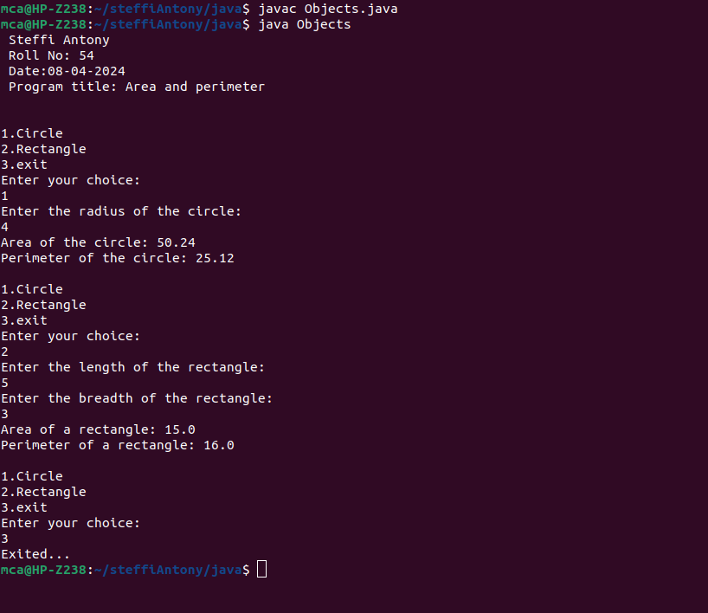**OUTPUT**

**16. Prepare bill with the given format using calculate method from interface.**

**Order No.**

**Date :**

**Product Id Name Quantity Unit Price Total**

**101 A 2 25 50**

**102 B 1 100 100**

**Net Amount 150**

import java.util.Scanner;

interface calc{

void calculate();

}

class bill implements calc{

String date,name,p_id;

int quantity;

double unit_price,total,namount=0;

Scanner sc = new Scanner(System.in);

public void getdata(){

System.out.println("\nEnter product id:");

p_id = sc.nextLine();

System.out.println("Enter product name:");

name = sc.nextLine();

System.out.println("Enter the Quantity:");

quantity = sc.nextInt();

System.out.println("Enter the unit price:");

unit_price = sc.nextDouble();

}

public void calculate(){

total = quantity * unit_price;

}

public void display(){

System.out.println(p_id+"\t\t"+name+"\t\t"+quantity+"\t\t"+unit_price+"\t"+total);

}

}

public class Order{

public static void main(String[] args) {

System.out.println(" Steffi Antony\n Roll No:54\n Date:08-04-2024\n Program title:Order Details\n");

int n,i;

double namount=0,t;

int ran;

String date;

t = Math.random() *1000000;

ran = (int) t;

Scanner sc = new Scanner(System.in);

System.out.println("Order no. #"+ran);

System.out.println("Enter the date:");

date = sc.nextLine();

System.out.println("Enter how many products are there:");

n = sc.nextInt();

bill ob[] = new bill[n];

for(i=0;i<n;i++)

ob[i] = new bill();

for(i=0;i<n;i++){

ob[i].getdata();

ob[i].calculate();

}

System.out.println("Date:"+date);

System.out.println("Product Id \tName\t Quantity\t unit price\t Total ");

System.out.println("-----");

for(i=0;i<n;i++){

ob[i].display();

namount += ob[i].total;

}

System.out.println("-----");

System.out.println("\t\t\tNet.Amount\t"+ namount);

}

}

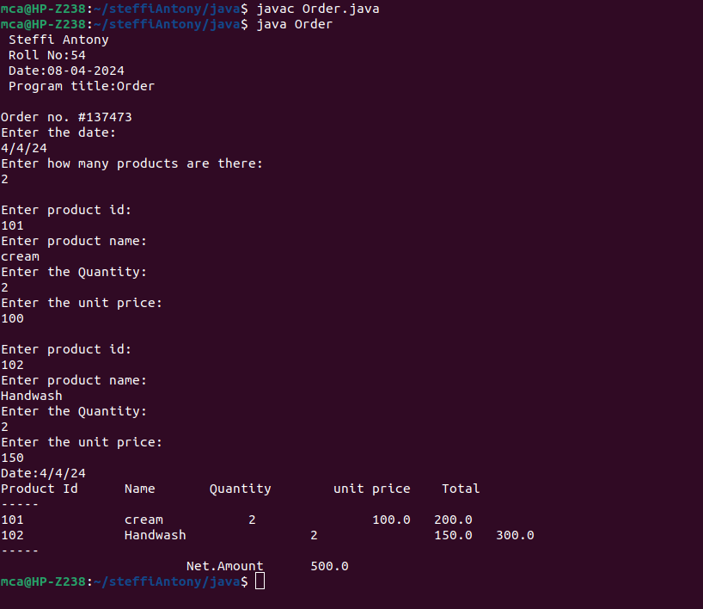**OUTPUT**

**17. Create a Graphics package that has classes and interfaces for figures Rectangle, Triangle, Square and Circle. Test the package by finding the area of these figures.**

**Area.java**

import package_graphics.*;

import java.util.Scanner;

public class Area{

public static void main(String []args){

package_graphics testObj = new package_graphics();

int l,h,r,a,c,d;

Scanner s=new Scanner(System.in);

System.out.println(" Steffi Antony\n Roll No: 54\n Date:09-04-2024\n Program title:Graphics package\n");

System.out.println("Enter the length for rectangle");

l=s.nextInt();

System.out.println("Enter the breadth for rectangle");

h=s.nextInt();

System.out.println("Enter the radius of circle");

r=s.nextInt();

System.out.println("Enter the side for Square");

a=s.nextInt();

System.out.println("Enter the breadth for triangle");

c=s.nextInt();

System.out.println("Enter the height for triangle");

d=s.nextInt();

System.out.println("Area of rectangle="+testObj.recArea(l,h));

System.out.println("Area of circle="+testObj.cirArea(r));

System.out.println("Area of square="+testObj.squArea(a));

System.out.println("Area of triangle="+testObj.triArea(c,d));

}

}

**Package_graphics.java**

package package_graphics;

interface interface_graphics{

public float recArea(int l, int h);

public float cirArea(int r);

public float squArea(int a);

public float triArea(int l, int h);

}

public class package_graphics implements interface_graphics{

public float recArea(int l, int h){

return l*h;

}

public float cirArea(int r){

return r*r*(float)3.14;

}

public float squArea(int a){

return a*a;

}

public float triArea(int l, int h){

return l*h*(float)(.5);

}

}

**OUTPUT**

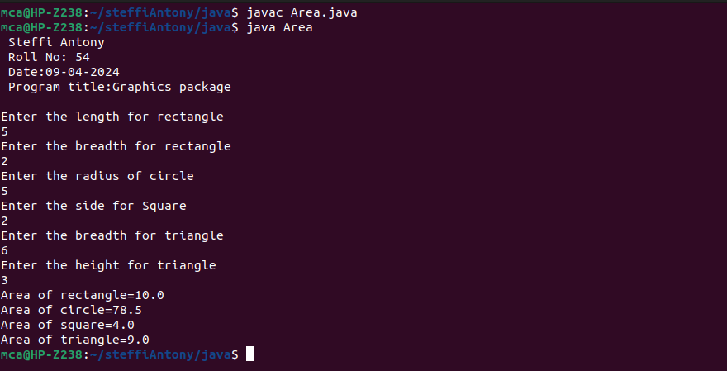

**18. Create an Arithmetic package that has classes and interfaces for the 4 basic arithmetic operations. Test the package by implementing all operations on two given numbers.**

**ArithmeticMain.java**

import arithmetic.ArithmeticOperations;

import java.util.Scanner;

public class ArithmeticMain {

public static void main(String[] args) {

System.out.println(" Steffi Antony\n Roll No: 54\n Date:09-04-2024\n Program title: Arithmetic package\n");

ArithmeticOperations operations = new ArithmeticOperations();

Scanner scanner = new Scanner(System.in);

System.out.print("Enter the first number: ");

double num1 = scanner.nextDouble();

System.out.print("Enter the second number: ");

double num2 = scanner.nextDouble();

System.out.println("Addition: " + operations.add(num1, num2));

System.out.println("Subtraction: " + operations.subtract(num1, num2));

System.out.println("Multiplication: " + operations.multiply(num1, num2));

System.out.println("Division: " + operations.divide(num1, num2));

}

}

**Addition.java**

package arithmetic;

public interface Addition {

public double add(double num1, double num2);

}

**Division.java**

package arithmetic;

public interface Division {

public double divide(double num1, double num2);

}

**Multiplication.java**

package arithmetic;

public interface Multiplication {

public double multiply(double num1, double num2);

}

**Subtraction.java**

package arithmetic;

public interface Subtraction {

public double subtract(double num1, double num2);

}

**ArithmeticOperations.java**

package arithmetic;

public class ArithmeticOperations implements Addition, Subtraction, Multiplication, Division{

public double add(double num1, double num2) {

return num1 + num2;

}

public double subtract(double num1, double num2) {

return num1 - num2;

}

public double multiply(double num1, double num2) {

return num1 * num2;

}

public double divide(double num1, double num2) {

if (num2 == 0) {

throw new ArithmeticException("Division by zero error!");

}

return num1 / num2;

}

}

**OUTPUT**

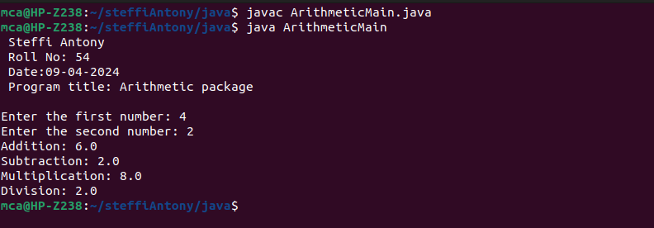

**19. Write a user defined exception class to authenticate the user name and password.**

import java.util.Scanner;

class authException extends Exception{

public authException(String s) {

super(s);

}

}

public class User{

public static void main(String[] args) {

System.out.println(" Steffi Antony\n Roll No: 54\n Date:09-04-2024\n Program title: Write a user defined exception class to authenticate the user name and password.\n");

System.out.println();

String username = "student";

String passcode = "student123";

String user_name,password;

Scanner sc = new Scanner(System.in);

try{

System.out.println("Enter the username:");

user_name = sc.nextLine();

System.out.println("Enter the password:");

password = sc.nextLine();

if(username.equals(user_name) && passcode.equals(password)){

System.out.println("Authentication successful...");

}

else

throw new authException(" Invalid user credentials ");

}

catch(authException e){

System.out.println("Exception caught "+e);

}

}}

**OUTPUT**

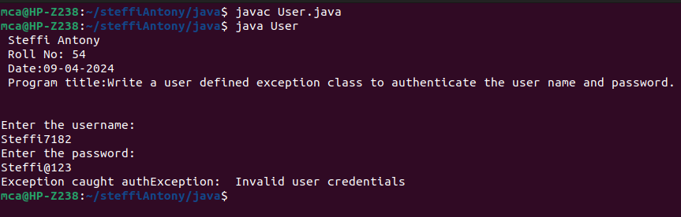

**20. Find the average of N positive integers, raising a user defined exception for each negative input.**

import java.util.Scanner;

class NegException extends Exception{

public NegException(String s){

super(s);

}

}

public class Average {

public static void main(String[] args){

System.out.println(" Steffi Antony\n Roll No: 54\n Date:09-04-2024\n Program title:Find the average of N positive integers\n");

System.out.println();

int i;

double sum=0,avg=0;

Scanner sc=new Scanner(System.in);

System.out.println("Enter n numbers:");

int n=sc.nextInt();

for(i=1;i<=n;i++){

try{

System.out.println("Enter number"+i);

int a=sc.nextInt();

if(a<0){

i--;

throw new NegException("Negative numbers not allowed,Try again");

}

else{

sum=sum+a;

}

}

catch(NegException e){

System.out.println("NEGETIVE EXCEPTION OCCURED:"+e);

}

}

avg=sum/n;

System.out.println("Average is "+avg);

sc.close();

}

}

**OUTPUT**

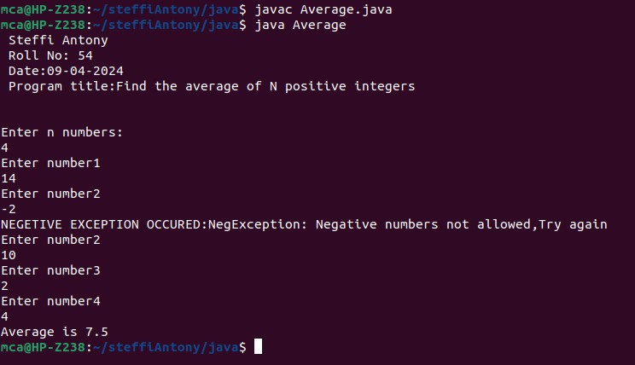

**21. Program to remove all the elements from a linked list.**

import java.util.*;

public class Linked_list {

public static void main(String[] args){

System.out.println(" Steffi Antony\n Roll No: 54\n Date:09-04-2024\n Program title:Program to remove all the elements from a linked list\n");

System.out.println();

LinkedList<String> L=new LinkedList<>();

L.add("Gold");

L.add("Silver");

L.add("Bronze");

L.add(0,"Olympics Medals");

System.out.println(L);

L.remove("Bronze");

System.out.println(L);

L.remove(2);

System.out.println(L);

L.removeLast();

System.out.println(L);

L.removeFirst();

System.out.println(L);

}

}

**OUTPUT**

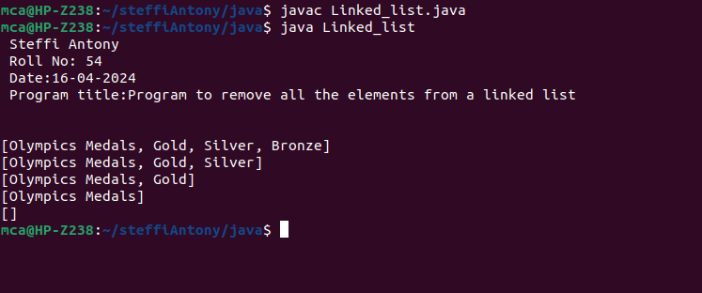

**22. Program to remove an object from the Stack when the position is passed as parameter.**

import java.util.Stack;

public class Q12 {

public static void removeElementAtPosition(Stack<String> stack, int position) {

if (position >= 1 && position <= stack.size()) {

Stack<String> tempStack = new Stack<>();

for (int i = 1; i < position; i++) {

tempStack.push(stack.pop());

}

stack.pop();

while (!tempStack.isEmpty()) {

stack.push(tempStack.pop());

}

System.out.println("Element at position " + position + " removed successfully.");

} else {

System.out.println("Invalid position. Please provide a valid position within the stack range.");

}

}

public static void main(String[] args) {

Stack<String> stack = new Stack<>();

stack.push("Element 1");

stack.push("Element 2");

stack.push("Element 3");

stack.push("Element 4");

stack.push("Element 5");

int positionToRemove = 3;

System.out.println(" Steffi Antony\n Roll No: 54\n Date:16-04-2024\n Program title:Program to remove an object from the Stack\n");

System.out.println("Program 22 : Program to remove an object from the Stack when the position is passed as parameter");

System.out.println("Before removal: " + stack);

removeElementAtPosition(stack, positionToRemove);

System.out.println("After removal: " + stack);

}

}

**OUTPUT**

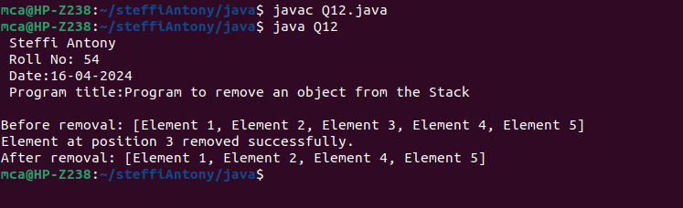

**23. Write a Java program to compare two hash set.**

import java.util.HashSet;

import java.util.Scanner;

import java.util.Set;

public class Compare {

public static void main(String[] args) {

System.out.println(" Steffi Antony\n Roll No: 54\n Date:16-04-2024\n Program title:Write a Java program to compare two hash set\n");

Set<Integer> set1 = new HashSet<>();

Set<Integer> set2 = new HashSet<>();

Scanner scanner = new Scanner(System.in);

System.out.print("Enter the number of elements in Set 1: ");

int numElements1 = scanner.nextInt();

System.out.println("Enter the elements for Set 1:");

for (int i = 0; i < numElements1; i++) {

int element = scanner.nextInt();

set1.add(element);

}

System.out.print("Enter the number of elements in Set 2: ");

int numElements2 = scanner.nextInt();

System.out.println("Enter the elements for Set 2:");

for (int i = 0; i < numElements2; i++) {

int element = scanner.nextInt();

set2.add(element);

}

boolean isEqual = set1.equals(set2);

System.out.println("Set 1: " + set1);

System.out.println("Set 2: " + set2);

if (isEqual) {

System.out.println("Set 1 and Set 2 are equal.");

} else {

System.out.println("Set 1 and Set 2 are not equal.");

}

scanner.close();

}

}

**OUTPUT**

