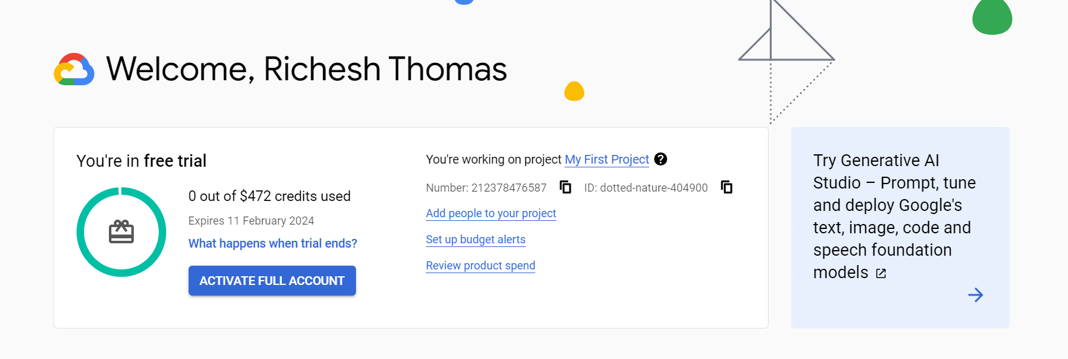

Click Enable

Cloud Composer API Enabled

Go to console

Create Environment -> Composer 1

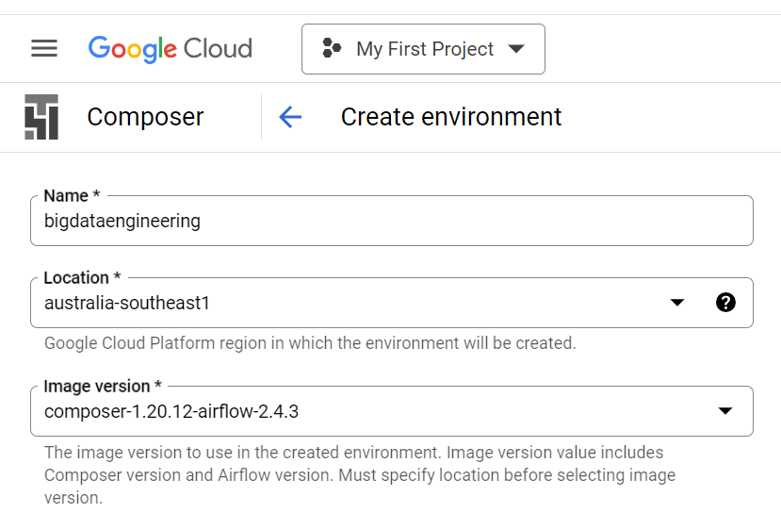

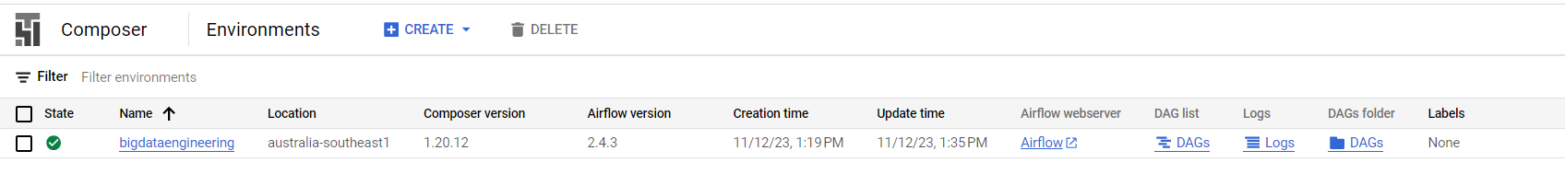

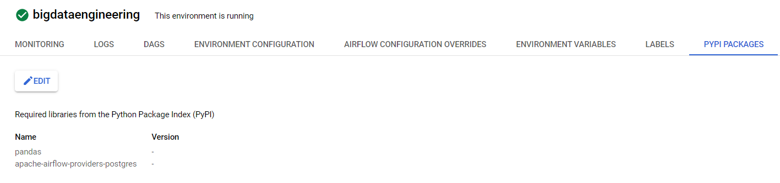

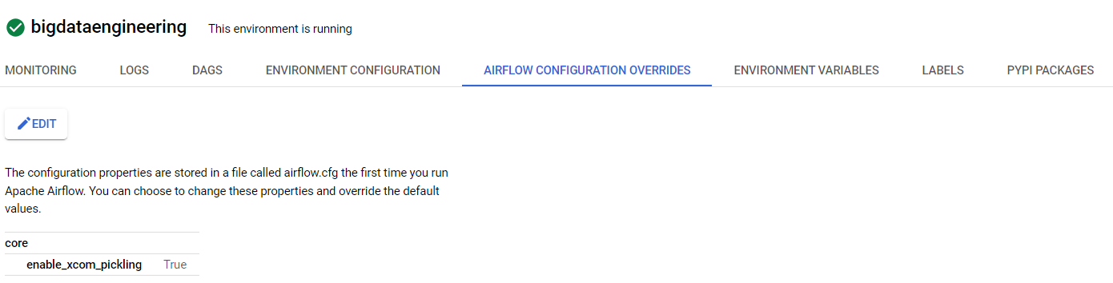

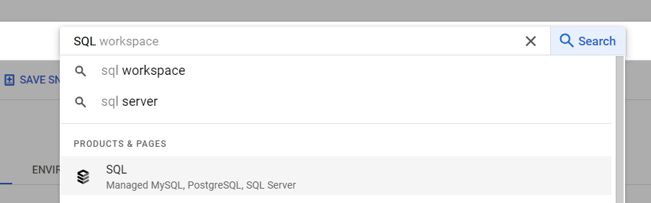

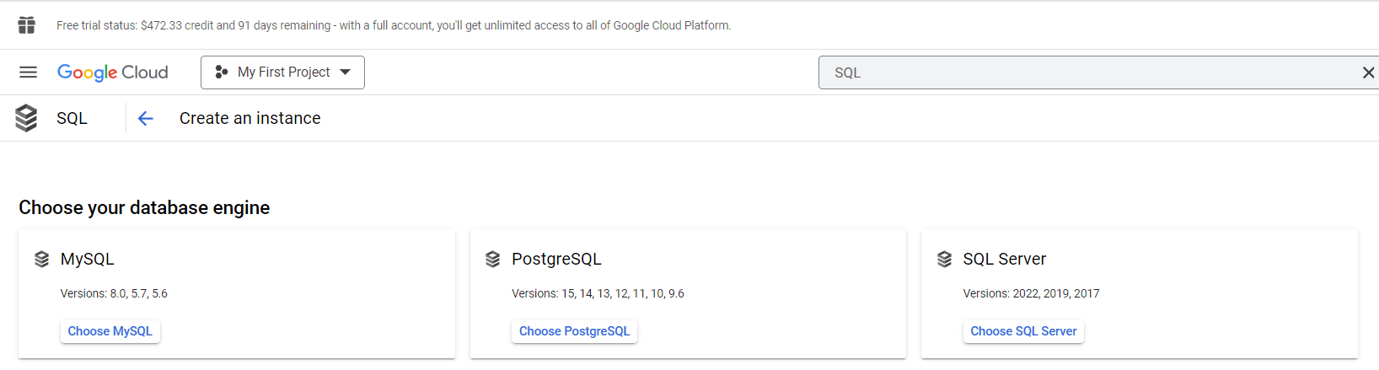

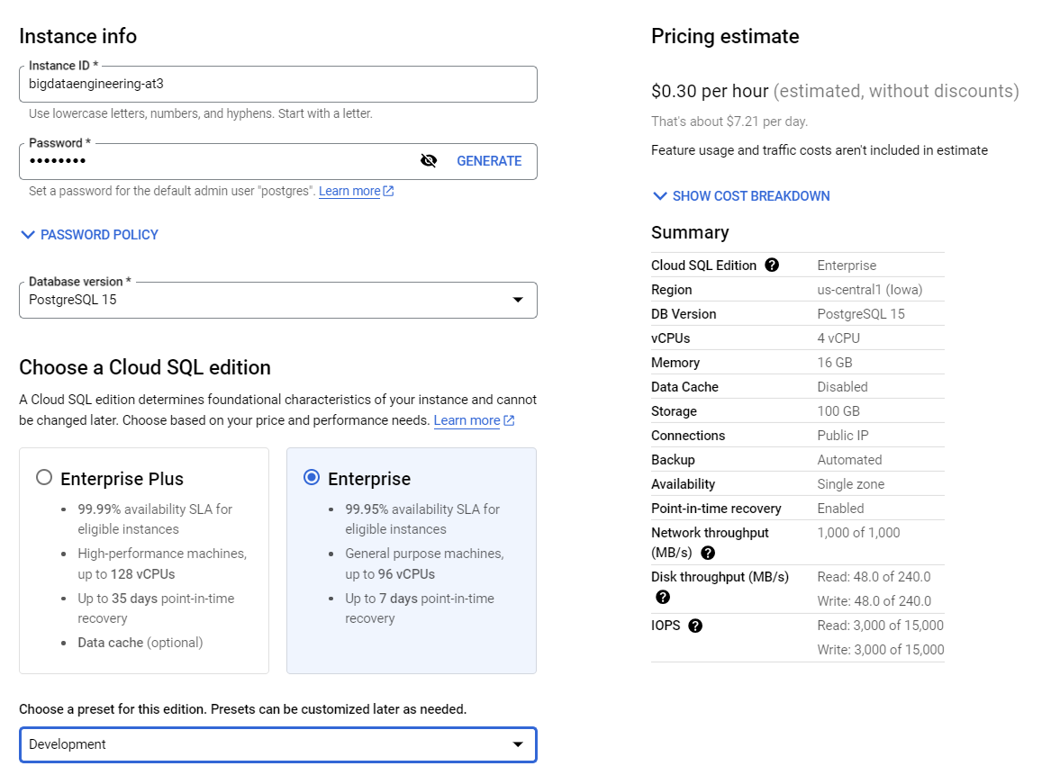

bigdataengineering-at3

May@1990

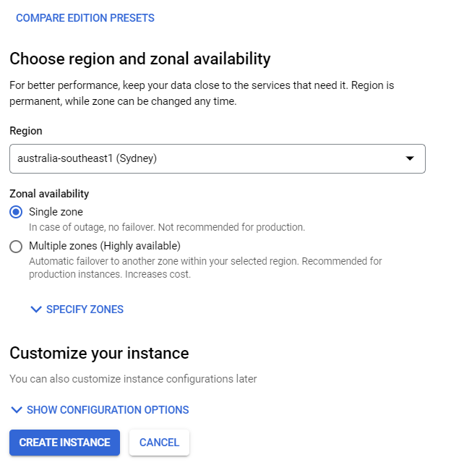

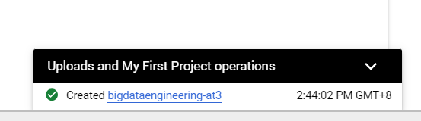

35.201.24.99

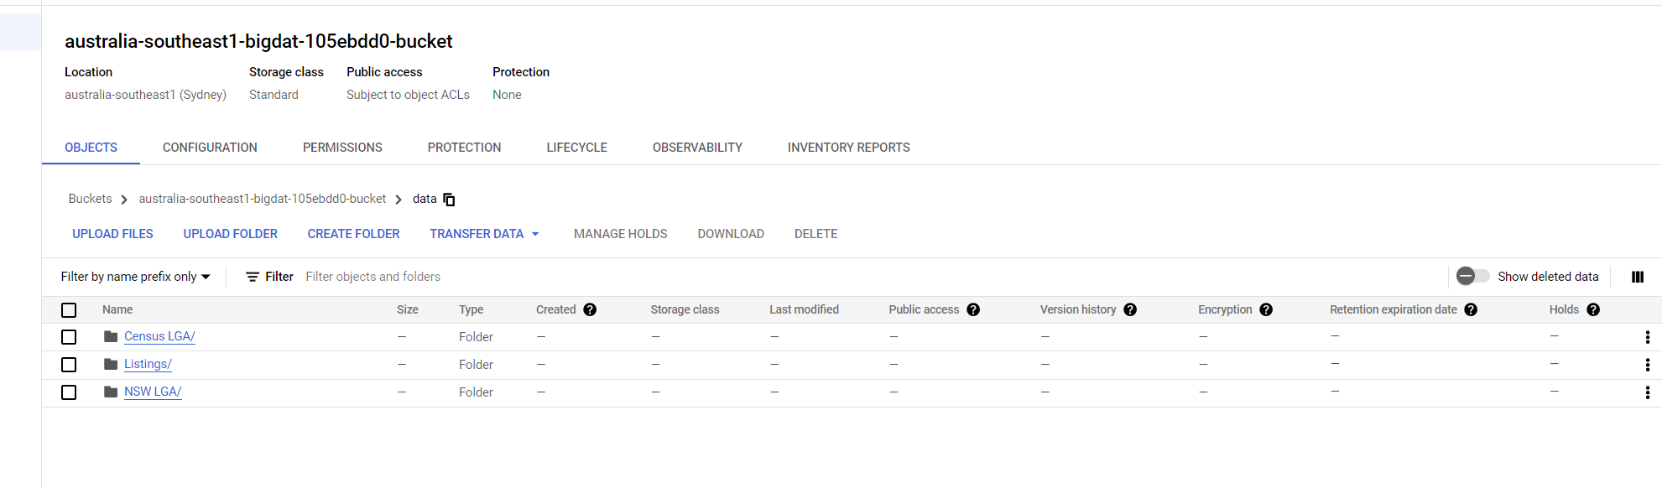

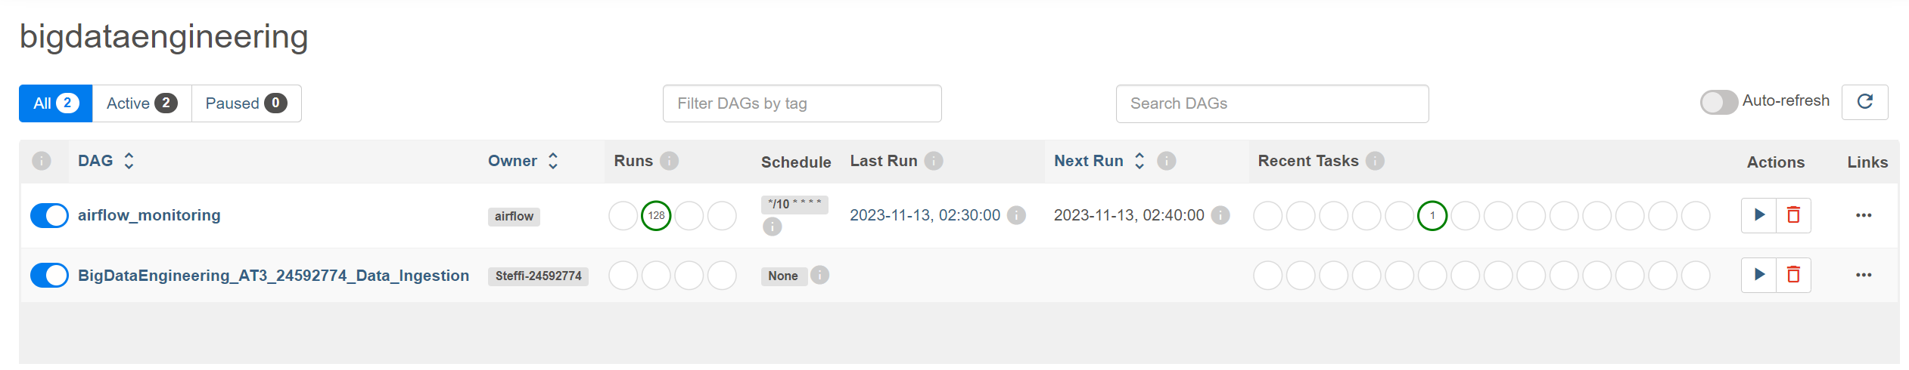

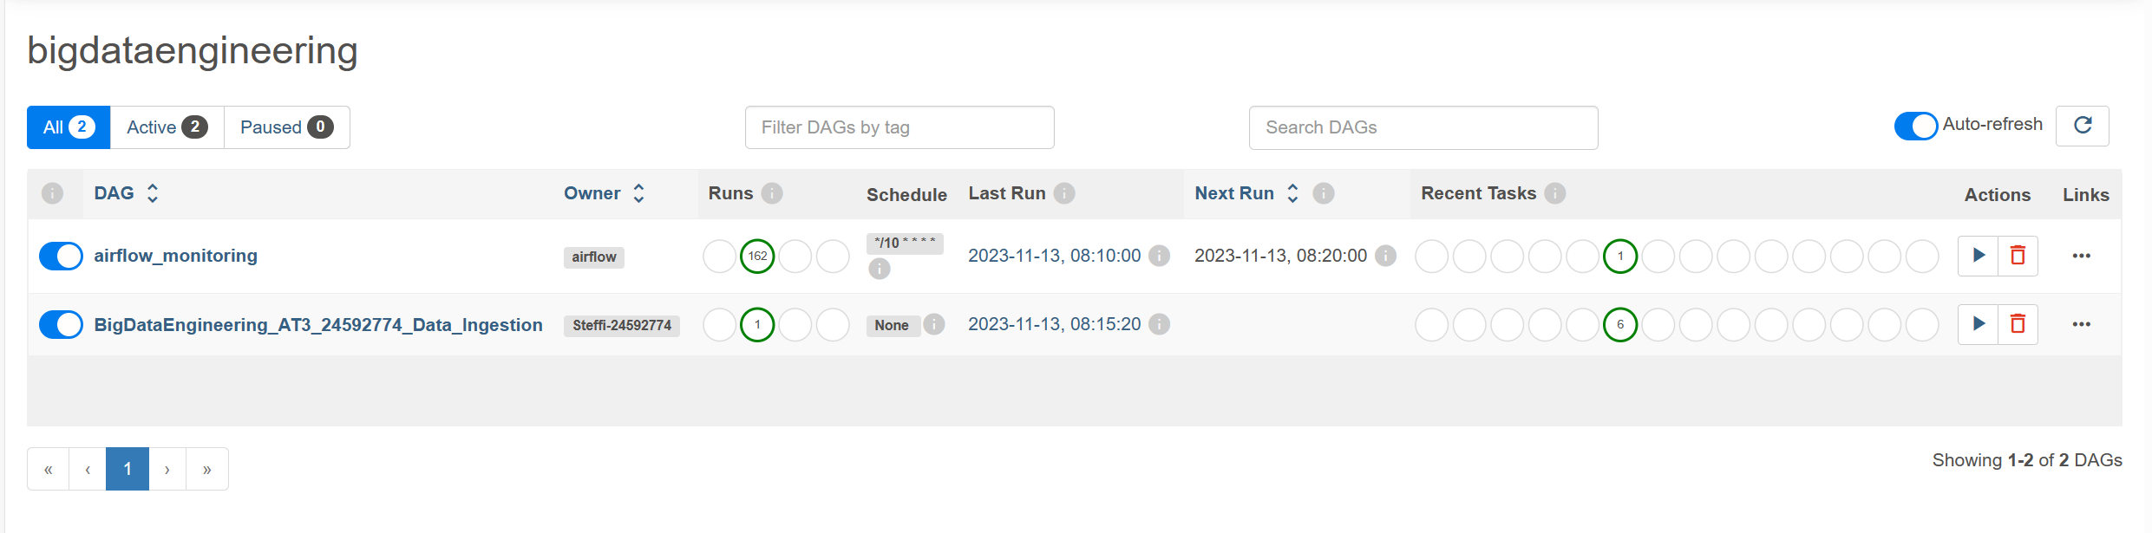

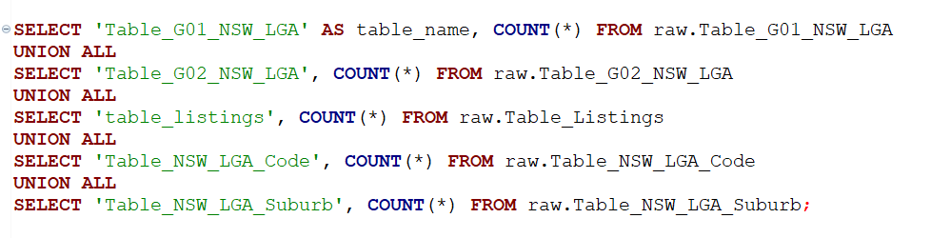

Counts are Tallying with individual CSV







