Program

#include<stdio.h>

#include<conio.h>

Void main()

{

int a[15],i,j=1,n,val,pos=-1;

clrscr();

printf("enter the size of an array:");

scanf("%d",&n);

printf("enter the elements:\n");

for(i=1;i<=n;i++)

{

scanf("%d",&a[i]);

}

printf("ARRAY\n");

for(i=1;i<=n;i++)

{

printf("%d\t",a[i]);

}

printf("\n enter the elements to be search:");

scanf("%d",&val);

while(j<=n)

{

if(a[j]==val)

{

pos=j;

printf("%d found at location %d",val,pos);

}

j=j+1;

}

if(pos==-1)

printf("value is not present in the array");

getch();

}

Output

Program

#include<stdio.h>

#include<conio.h>

void main()

{

int a[20],i,item,n,beg,end,pos=-1,mid;

clrscr();

printf("enter limit of the array:");

scanf("%d",&n);

printf("enter elements(sorted array):");

for(i=1;i<=n;i++)

{

scanf("%d",&a[i]);

}

printf("\nARRAY\n");

for(i=1;i<=n;i++)

{

printf("%d\t",a[i]);

}

printf("\n enter the elements to be search:");

scanf("%d",&item);

beg=1;

end=n;

pos=-1;

while(beg<=end)

{

mid=(beg+end)/2;

if(a[mid]==item)

{

pos=mid;

printf("%d found at %d",item,pos);

break;

}

else

{

if(a[mid]>item)

end=mid-1;

else

beg=mid+1;

}

}

if(pos==-1)

printf("value is not present in the array");

getch();

}

Output

Program

#include<stdio.h>

#include<conio.h>

void main()

{

int a[20],i,n,j,temp;

clrscr();

printf("enter the limit of the array:");

scanf("%d",&n);

printf("enter elements:");

for(i=1;i<=n;i++)

{

scanf("%d",&a[i]);

}

printf("\n ARRAY before sorting\n");

for(i=1;i<=n;i++)

{

printf("%d\t",a[i]);

}

for(j=1;j<=n;j++)

{

for(i=1;i<=n-j;i++)

{

if(a[i]>a[i+1])

{

temp=a[i];

a[i]=a[i+1];

a[i+1]=temp;

}

}

}

printf("\n ARRAY after sorting\n");

for(i=1;i<=n;i++)

{

printf("%d\t",a[i]);

}

getch();

}

Output

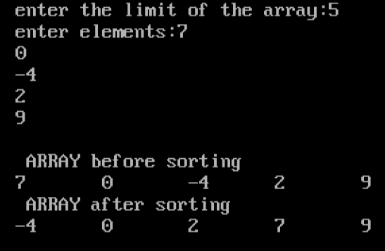

Program

#include<stdio.h>

#include<conio.h>

int smallest(int arr[],int k,int n);

int selection_sort(int arr[],int n);

void main()

{

int arr[10],i,n;

clrscr();

printf("\n enter the number of elements in the array:");

scanf("%d",&n);

printf("\n enter the elements of the array:");

for(i=0;i<n;i++)

{

scanf("%d",&arr[i]);

}

printf("\nthe array before sorting:\n");

for(i=0;i<n;i++)

printf("%d \t",arr[i]);

selection_sort(arr,n);

printf("the sorted array is:");

for(i=0;i<n;i++)

printf("%d\t",arr[i]);

}

int smallest(int arr[],int k,int n)

{

int small,j,pos;

for(j=k+1;j<n;j++)

small=arr[k];

pos=k;

{

if(arr[j]<small)

{

small=arr[j];

pos=j;

}

}

return pos;

}

int selection_sort(int arr[],int n)

{

int k,pos,temp;

for(k=0;k<n;k++)

{

pos=smallest(arr,k,n);

temp=arr[k];

arr[k]=arr[pos];

arr[pos]=temp;

}

getch();

return 0;

}

output

