Minutes for A2MAC1 India Private Limited

|  |  |
| --- | --- |
| Location: | A2MAC1 India Private Limited |
| Date: | 21/09/2022 |
| Time: | 11.30 |
| Attendees: | Prakash S (Developer)  Edward Paulraj W (Business Development) |

# Agenda:

* As we discussed earlier, our team was there on-time at your premises to gather the requirements.
* We have understood the problems you are currently facing with your existing software, and we are keen on developing software that will accommodate all your needs.
* We have also understood the working flow of your company and have prepared a flow that explains the process.

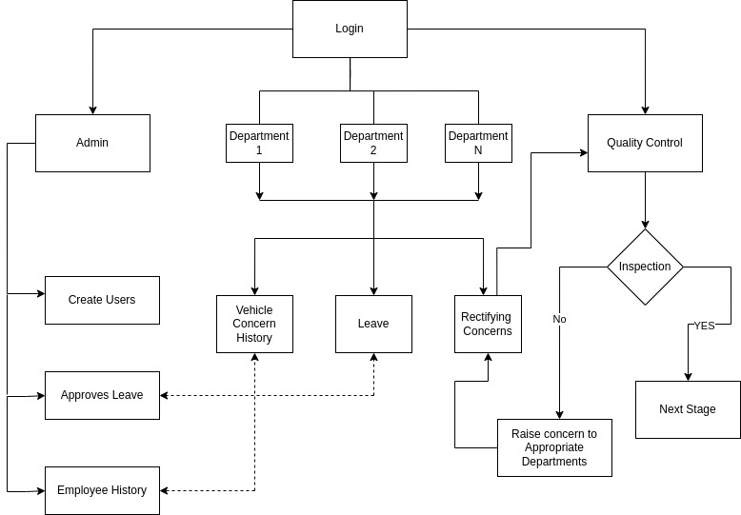**Flow-Chart**