

**CS 1632 Software Quality Assurance**

**Deliverable 4**

Member 1 Name: Stefon Miller

Member 2 Name: Thomas Bednarz

1. **Optimized Feature 1**
   1. Write the name of the feature optimized (the label on the button)  
      The first feature we optimized was the “Run Continuous” feature
   2. Write the name(s) of the method(s) you refactored to optimize this feature  
      To optimize the “Run Continuous” feature, we optimized both the iterateCell and calculateNextIteration methods
   3. Insert a screenshot of VisualVM CPU profiling ***after*** optimizing Feature 1. Please include only the “Hot spots” window in the screenshot.

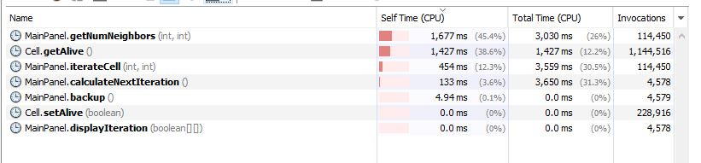

1. **Optimized Feature 2**
   1. Write the name of the feature optimized (the label on the button)  
      The second feature we optimized was the “Write” feature
   2. Write the name(s) of the method(s) you refactored to optimize this feature  
      To optimize the “Write” feature, we refactored the toString method
   3. Insert a screenshot of VisualVM CPU profiling ***after*** optimizing Feature 2. Please show only the profile for Feature 2 (do not invoke Feature 1 while profiling). Please include only the “Hot spots” window in the screenshot, as before.

