Example 1:

Embed Command: - python DWT_QR_STEGO.py hide -m random -c Manatee.png -o stego.bmp

Manatee.png

Stego.bmp

Extraction Command: python DWT_QR_STEGO.py extract -s stego.bmp

Extracted_qr.png



Output

Example 2:

Embed Command: python DWT_QR_STEGO.py hide -m secret-message.txt -f g -c Mantis.bmp

Mantis.bmp

Contents of secret-message.txt: Here is some sample text

stego_output.bmp

Extract Command: python DWT_QR_STEGO.py extract -s stego_output.bmp -f g -o message.txt

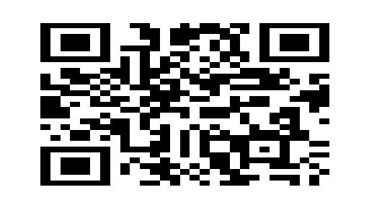

extracted_qr.png

Contents of messge.txt: Here is some sample text

Example 3:

Moose.png

stego_output.png

