0.10.0 更新

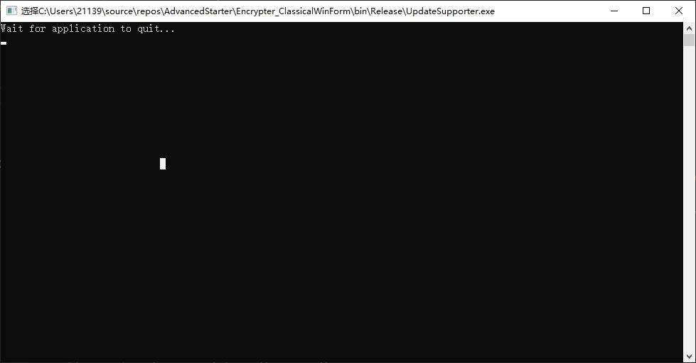
Updating
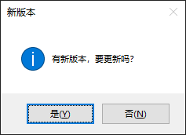
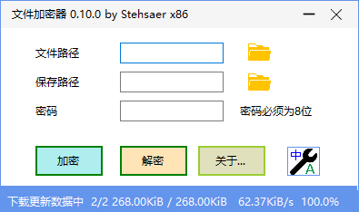
- 应用启动时自动检测更新和下载更新/ Automatically detect new versions and update at
New Version

There is a new version available, do you want to update
Downloading data

