

The Bucharest University of Economic Studies

Interactive Web Platform for the Dance Industry
“FOMO - Fear Of Missing Out”
Design of Informatic Systems

Group: 1107
Student: Stoimenova Stela
Coordinator: Dragomirescu Oana-Alexandra
Contents
The Bucharest University of Economic Studies 1
Presentation of the computer system 3
General description of the information system 3
Requirements specification 4
General + detailed Use case diagrams 5
Textual description of use cases 7
Analysis of the system 11
Activity diagrams 11
Class diagram 13
State diagrams 13
Interaction diagrams 14
Processes and collaboration diagrams in BPMN 16
Design of the system 18
Detailed class diagram 18
Database design 18
User interface design 19
Component diagram 22
Deployment diagram 23
System implementation 23

Presentation of the computer system

General description of the information system

The dance industry has expanded significantly in recent years, especially through social media platforms such as Instagram, TikTok, and YouTube. Dancers and studios promote workshops, classes, and artistic projects primarily through these channels. Although these platforms allow visibility, they do not provide a dedicated environment for managing dance events, selling tickets, or supporting structured economic processes.
Existing platforms such as Eventbrite, Meetup, or Ticketmaster offer event management and ticket purchasing features, but they are general-purpose platforms and do not address the specific needs of dancers, choreographers, or agencies. At the same time, some niche dance websites or Facebook groups share competitions or camps, yet they lack user portfolios, loyalty systems, or integrated economic mechanisms.
This analysis shows that, although partial solutions exist, there is no platform that combines social interaction, event posting, ticket purchasing, and economic processes in a single environment tailored specifically for the dance community. This motivates the development of a dedicated platform that responds to the particular dynamics of the dance industry.
The FOMO platform is an Interactive Web Platform dedicated to the dance community. It functions as a specialized, centralized digital environment combining social networking features with event management and integrated economic processes. The system allows dancers, studios, choreographers, and agencies to create digital portfolios, post workshops and events, sell tickets, earn loyalty points, and view dance activities on a map. The platform also integrates economic mechanisms such as dynamic pricing based on demand, transaction commissions, and a loyalty reward system. The system will be implemented using a standard three-tier client-server architecture (Browser, Application Server, Database). With FOMO there will not be any “Fear Of Missing Out” because the Web application enables bi-directional promotion, where Studios or Agencies search for talents, and Dancers actively promote their portfolios to attract attention from industry professionals.
FOMO’s goal is to offer a single environment where members of the dance industry can interact, promote activities, and manage event participation more efficiently. The Web Platform provides multiple key features as digital portfolios, event management tools, ticket purchasing, map-based interface for geographic discovery of events. Additionally, the platform includes a commission-based fee on transactions, a loyalty points system for discounts, and a simple dynamic pricing mechanism based on event demand.

Requirements specification

The project begins with User Management, allowing individuals to create secure accounts and define their role as a dancer, studio, or agency. Each user profile serves as a Digital Portfolio, encompassing personal information, dance experience, and media (photos/videos).The dancer’s personal account must include unique, easily shareable public links (URLs) that the users can distribute on external social media to drive traffic and visibility from studios and agencies. This foundation is enhanced by social features, enabling users to follow other accounts and view the accounts they follow. A key functionality for community engagement is the ability to highlight the most popular events in a region, ensuring that users can easily stay updated on trending activities and avoid the “FOMO-Fear Of Missing Out”.
The central feature of the platform is comprehensive Event Management. Studios and agencies can effortlessly create various events, including workshops, camps, castings, and regular classes. Event creators define crucial details such as location, date, price, and associated media. For discovery, the system includes a robust search capability, allowing users to filter events by category, date, price, or location. Beside all the features, dancers must have a mechanism to actively promote their account to specific agencies or appear on “Trending Dancers” lists based on profileengagement. Furthermore, a distinguishing feature is the interactive map interface, which geographically displays all posted events based on their coordinates, enabling efficient local event discovery.
FOMO integrates a complex Economic System to support structured financial processes within the dance community. The system allows users to purchase tickets for events through a simulated payment process. Every transaction triggers two primary economic functions, commission applied and loyalty points. These accumulated points can be redeemed for future discounts. In addition, the web project employs a demand-based dynamic pricing mechanism, allowing event prices to adjust automatically based on popularity or scarcity, maximizing revenue and managing event demand.

General + detailed Use case diagrams

General Use Case Diagram of the functionality of the system
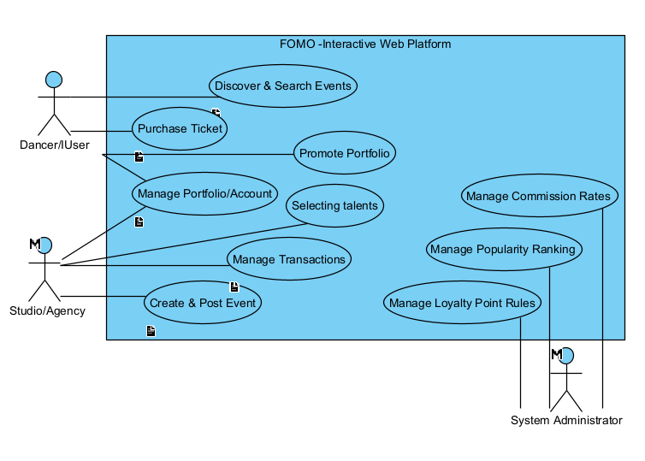

Detailed Use Case Diagram for Purchasing a Ticket
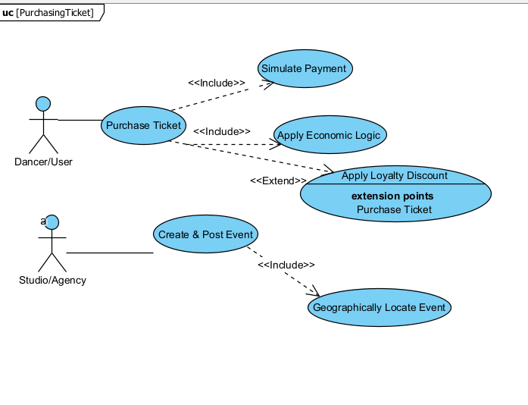

Event Creation & Posting Use Case Diagram
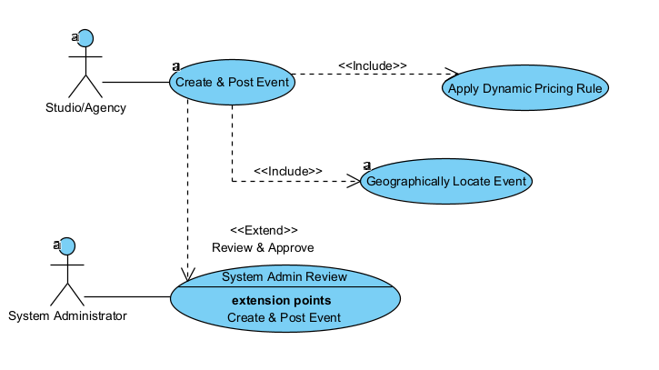

Influencer Promotion & Collaboration
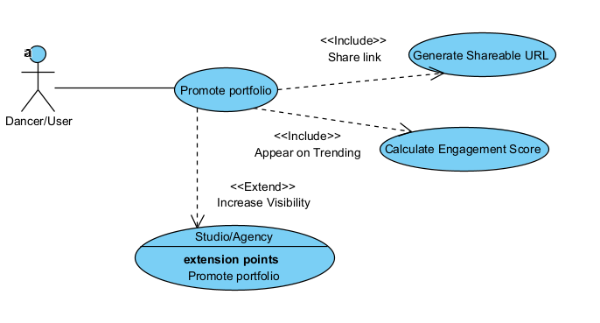

Textual description of use cases

Element of the Use Case | Description
Code | UC02
State | Outline
Purpose | To allow a Dancer/User to simulate purchasing an event ticket while applying the platform’s commission and loyalty system logic
Name | Ticket Purchase and Economic Processing
Main Actor | Dancer/User
Description | This use case covers the user selecting an event, completing the simulated transaction, and the system triggering the core economic rules.
Preconditions | The Dancer/User is logged in and the event has tickets available
Post Conditions | A simulated transaction record is created, the ticket is issued, and the user’s loyalty point balance is updated.
Trigger | The Dancer/User selects the “Buy Ticket” option for an event.
Basic Flows | 1. The User selects an event and specifies the quantity.  2.The system checks availability and applies any demand-based price adjustments (Dynamic Pricing).  3.The system checks if Loyalty Points are available for discount and prompts the user.  4.The User proceeds to the simulated payment gateway.  5. The system confirms payment success. 6.The system records the Commission applied to the sale.  7.The system calculates and credits Loyalty Points to the User's account. 8. The digital ticket is issued.
Alternate Flows | A1: Apply Discount. The User opts to use existing loyalty points for a discount. The system deducts points and recalculates the final price.
Relationships | N/A
Frequency of Use | Frequent
Business Rules | BR1: A commission is applied on every transaction.  BR2: Loyalty points are accumulated and redeemable for future discounts.  BR3: Ticket sales must adhere to the applied demand-based price adjustments.

Element of the Use Case | Description
Code | UC01
State | Outline
Purpose | To allow a Studio or Agency to define, upload, and publish a new event (workshop, camp, casting, class) onto the platform.
Name | Event Creation and Posting
Main Actor | Studio/Agency
Description | This outlines the steps for a provider to input all necessary details, including geographical location, price, and media, and submit the event for sale.
Preconditions | The Studio/Agency account is registered, logged in, and the event creation module is accessed.
Post Conditions | The event details are successfully recorded, and the event is set to the 'Posted' status for public visibility.
Trigger | The Studio or Agency needs to promote a new activity or class.
Basic Flows | 1. The Studio/Agency accesses the Event Creation form.  2.They input event details (name, category, date, price, and media).  3.They provide the geographical location (address).  4. The system Geographically Locates Event by converting the address to coordinates. 5.The system confirms the location can be displayed on the map.  6.The system applies the Dynamic Pricing Rule to the base price.  7. The Studio/Agency confirms and submits the event.  8. The system validates all inputs and successfully publishes the event.
Alternate Flows | A1: Location Error: If the address cannot be converted to valid coordinates, the system prompts the user to correct the address.  A2: Admin Review: The event is placed on hold for System Admin Review before being published.
Relationships | N/A
Frequency of Use | Regular
Business Rules | BR1: All events must include location details for map-based display.  BR2: The event details must adhere to platform standards.

Analysis of the system

Activity diagrams

Event Creation and Posting Flow Activity Diagram
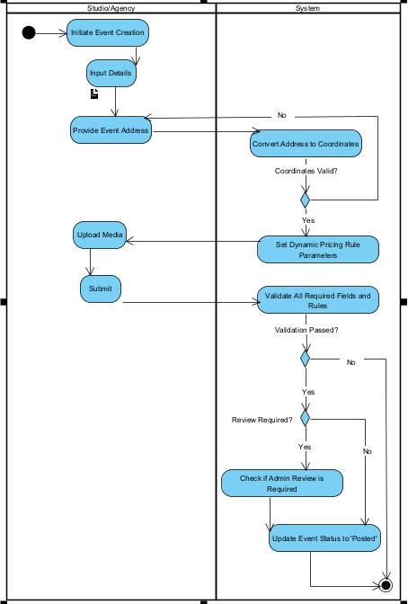
This diagram outlines the sequential and conditional workflow required for Studio/Agency to successfully publish an event, ensuring all mandatory geographic and economic rules are met by the system. The process begins with the Studio/Agency initiating event creation and providing core details, including the physical address. The flow then transitions to the System lane for the critical Geographic Location process. Here, the system attempts to convert the address to map coordinates. If the address is invalid, the flow immediately loops back to the Studio/Agency at the Provide Event Address action, forcing the user to correct the input. Once the coordinates are validated, the system proceeds to automatically Set Dynamic Pricing Rule Parameters. After the Studio/Agency finalizes the input and clicks Submit, the system performs final Validation. A validation failure leads to an error state, while success moves to the final administrative check. If Review is required?, the event is placed in a hold state if its approved, but if not the system immediately proceeds to Update Event Status to ‘Posted’, concluding the successful publishing workflow.
Ticket Purchase and Economic Processing Flow
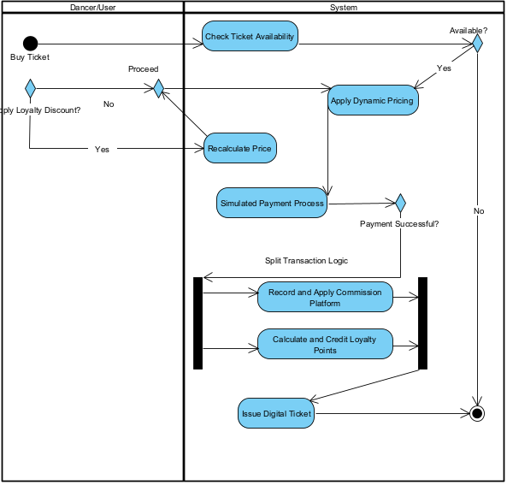
The diagram highlights the sequential steps and parallel economic calculations required for a ticket sale. The process is initiated by the client, which immediately transitions to the System to Check Ticket Availability. If tickets are unavailable, the flow terminates. If available, the system prompts the user to Apply Loyalty Discount?, where both yes and no paths converge at the Proceed Merge Node before the system continues the price setting by executing the Apply Dynamic Pricing logic. After the Simulated Payment Process confirms success, the flow is split by a Fork Node into 2 concurrent, mandatory paths: Record and Apply Commission Platform and Calculate and Credit Loyalty Points. Once both parallel economic actions are completed, they converge at the Join Node, allowing the flow to proceed sequentially to the final step, Issue Digital Ticket, before concluding the process.
Dancer Discovery and Casting Invitation Flow
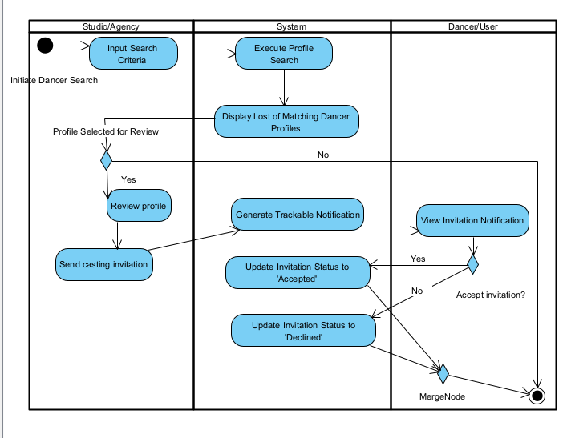
This activity diagram models the social and portfolio management feature, detailing how a Studio/Agency uses the platform to recruit talent. The process begins with the Studio/Agency initiating a Dancer Search based on criteria like style or experience. The System executes the search and displays matching Dancer Profiles. The flow features a key decision point where the Studio/Agency sends a Casting Invitation, which prompts the System to generate a trackable notification directed to the Dancer/User lane. The Dancer/User then views the invitation. Leading to the final decision point: Accept Invitation? The outcome of this decision immediately triggers the System to Update Invitation Status to ‘Accepted’ or ‘Declined’, ensuring a clear record of the casting request is maintained before the process concludes.

Class diagram - specifying the entities, their attributes, and their relationships
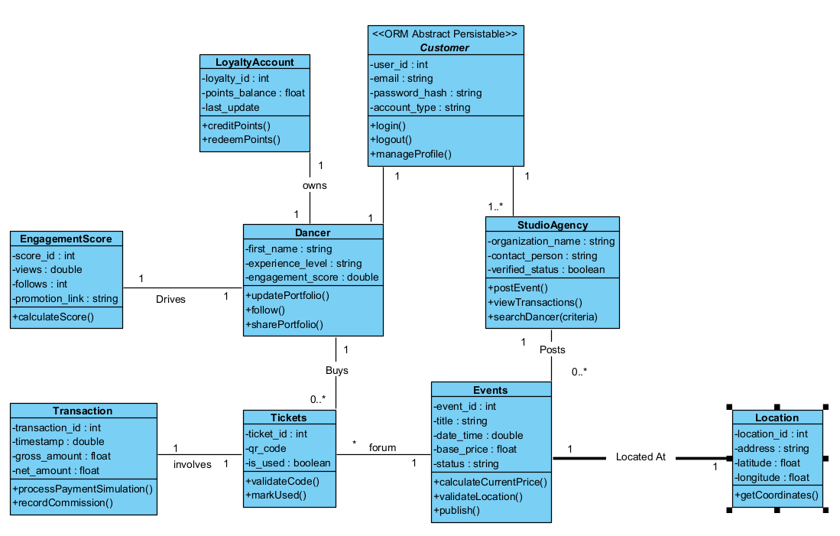

State diagrams

Event Lifecylce
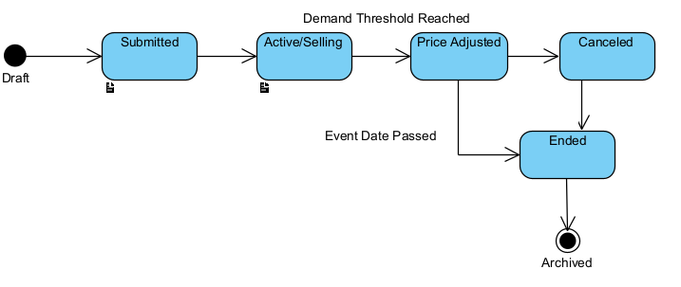

The diagram models the lifecylce of an event within the FOMO platform, starting from the draft state. Upon submission, the event moves to the Submitted state, where it remains until validation success triggers the transition to Active/Selling. This state is critical as it allows for two specialized paths, one triggered by Demand Threshold Reached leading to the Price Adjusted state and another triggered by the Event Date Passed. An event can be pulled from sale at any point via the Canceled state. Both Ended and Canceled states converge into the final, terminal Archived state, where the event data is retained solely for historical and reporting purposes.
Ticket Lifecycle

Interaction diagrams

Client check-in process
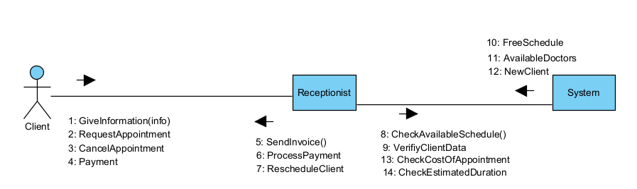
This diagram captures the interaction between a client and the receptionist supported by the system for managing appointments. The client initiates the process by providing information and requesting an appointment. The system offers functionalities to check the available schedule and manage the booking. The receptionist is involved in sending invoices, processing payments, and handling rescheduling as necessary.

Client interaction diagram
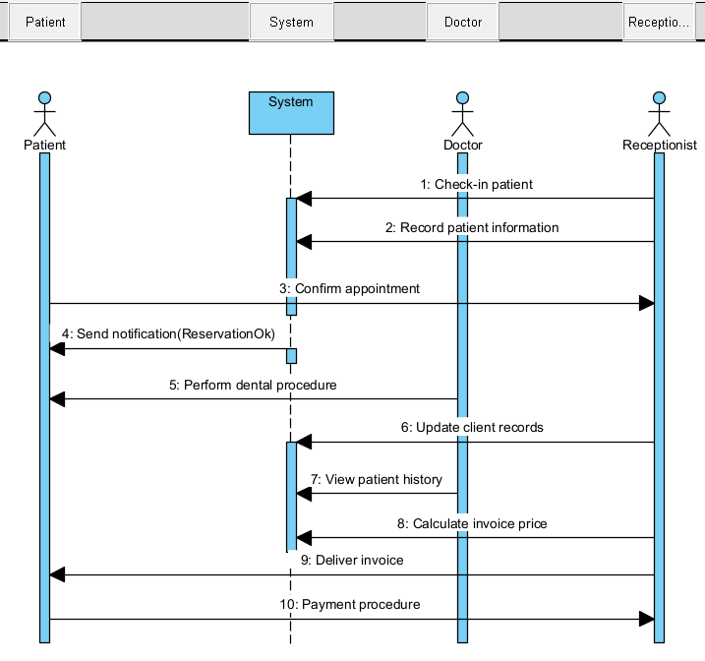

The diagram begins with the patient being checked in by the receptionist and recording the patient’s information into the system. After confirming the appointment, the patient is notified and the dental procedure is performed. Subsequent steps involve updating client records, viewing patient history, calculating the invoice price, delivering the invoice, and completing the payment procedure.

Inventory interaction diagram
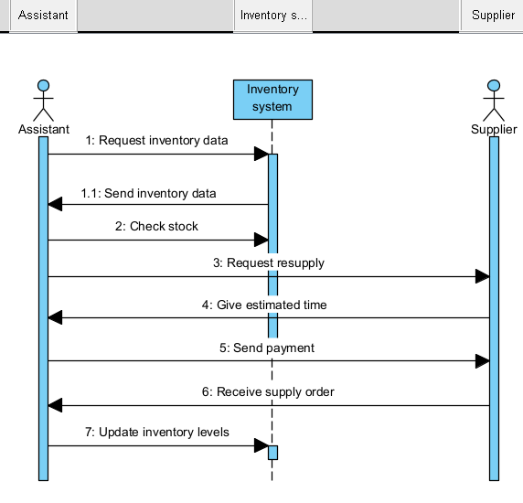
In this diagram, the assistant requests inventory data from the inventory system and checks stock levels. If resupply is needed, the assistant requests it from the supplier, who provides an estimated time for delivery. The assistant then sends payment, and upon receiving the supply order, updates the inventory levels.

Processes and collaboration diagrams in BPMN

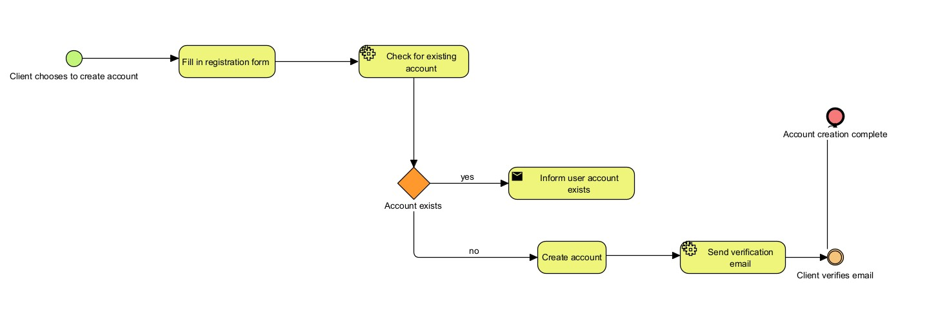
Account creation process diagram

This diagram presents the steps a client takes to create a new account. The process begins with the client initiating account creation and entering their details into a registration form. The system then checks for an existing account. If the account exists, the client is notified; otherwise, a new account is created. The system sends a verification email, and the process concludes once the client verifies the email, marking the successful creation of the account.

Collaboration Diagram: Scheduling an Appointment
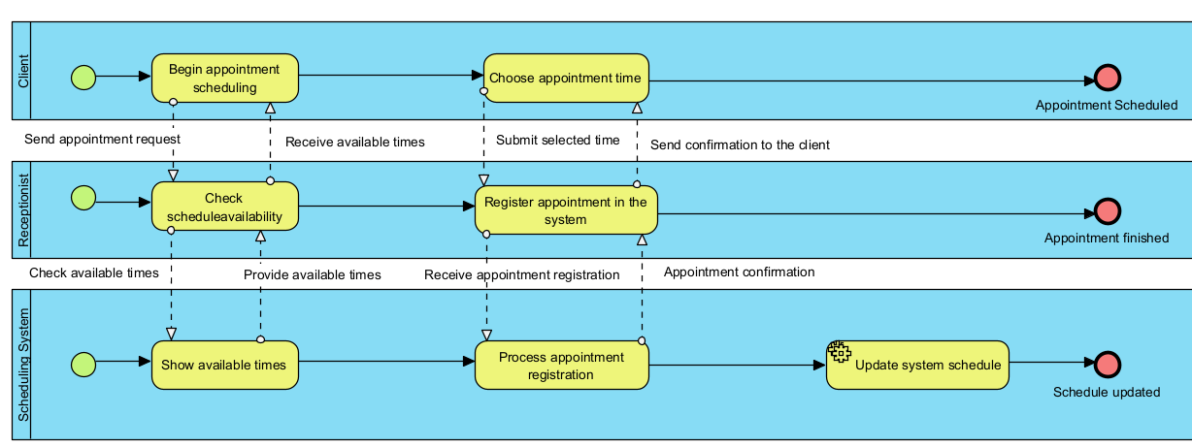

This collaboration diagram depicts the appointment scheduling process across three entities: the Client, Receptionist, and Scheduling System. The Client initiates the process, requesting an appointment, which prompts the Receptionist to check the schedule and relay available times. The Client selects a time, and the Receptionist registers this in the Scheduling System, which then confirms the appointment back to the Client, completing the scheduling cycle.

Design of the system

Detailed class diagram
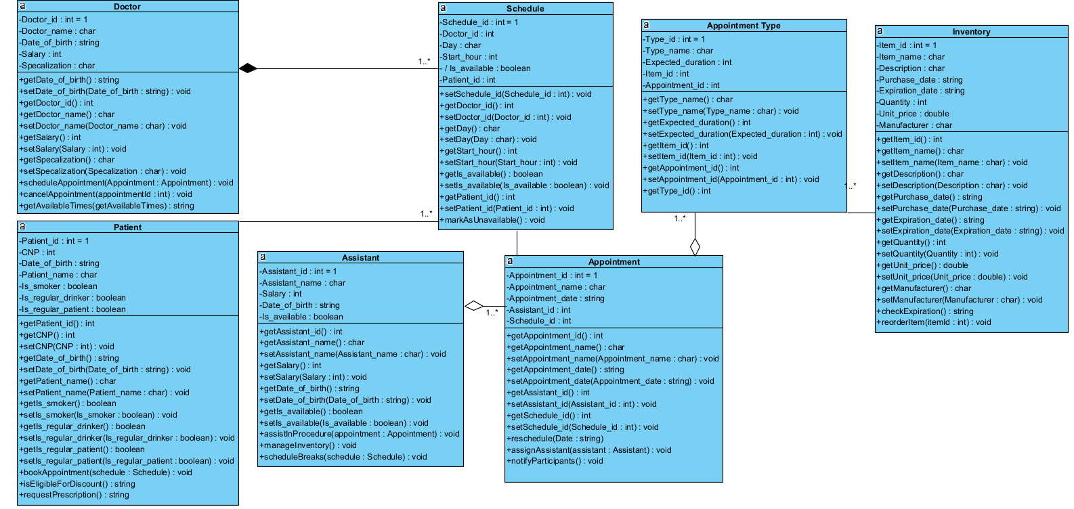

Database design
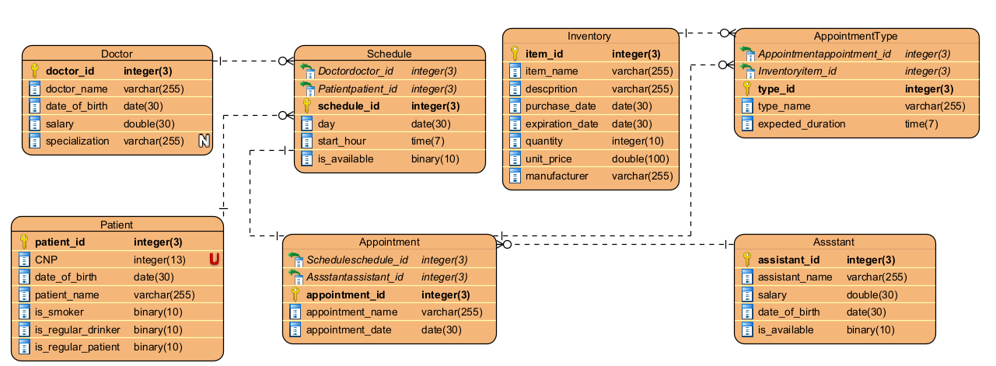
The databases encompasses the ‘Doctor’, ‘Schedule’, ‘Appointment’, ‘Patient’, ‘Inventory’, ‘AppointmenyType’ and ‘Assistant’ tables which are the same as used in the class diagrams since all of the classes necessary will need to be stored in the database. The doctors will be able to utilize the schedule table to make it easier for them the update the hours they are available for work and what patient they have in their schedule. ‘AppointmentType’ is used alongside ‘Appointment’ so we can more easily store the data separated since an appointment is made patient based on available schedule and with the appointment type we can know what inventory items we need. Assistants are not based on the schedule utilizing only an ‘is_available’ column which is made if they checked in for work that day or not, their main role is to help the doctor whenever possible.

User interface design

Patient Account Creation
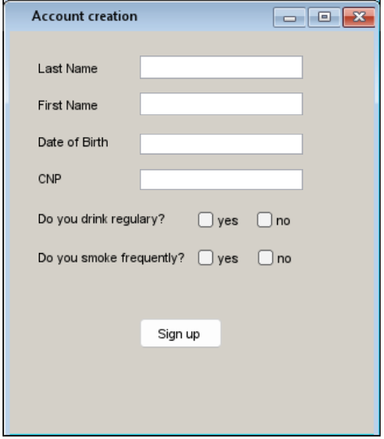

This user interface design is for the account creation process of the patient in the application, it has fields for Last Name, First Name, Date of birth, CNP and asks the patient to confirm if he drinks regularly and/or smokes frequently. These two questions are important since they may cause more frequent dental problems and are also considered when the first consultation happens.

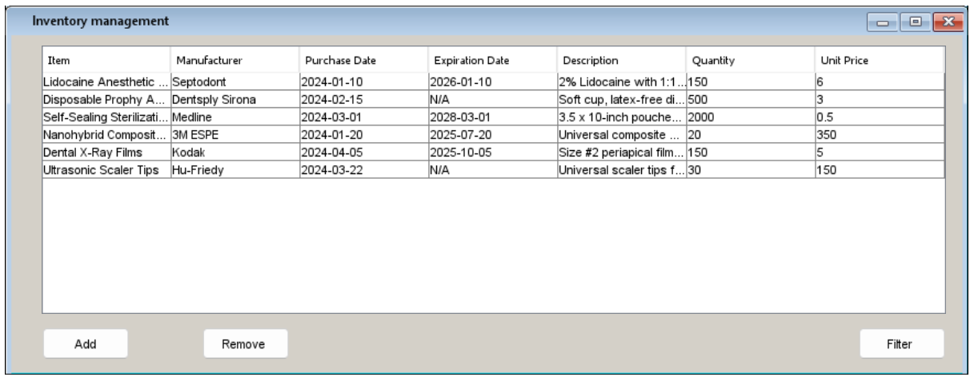
Inventory management
This interface presents a table listing inventory items for a dental clinic. Each entry includes the item name, manufacturer, purchase date, expiration date, a brief description, current quantity, and unit price. Users can add new items to the inventory or remove outdated or depleted items, ensuring effective stock management. A filter function is added quickly locate specific items.

Doctor appointments
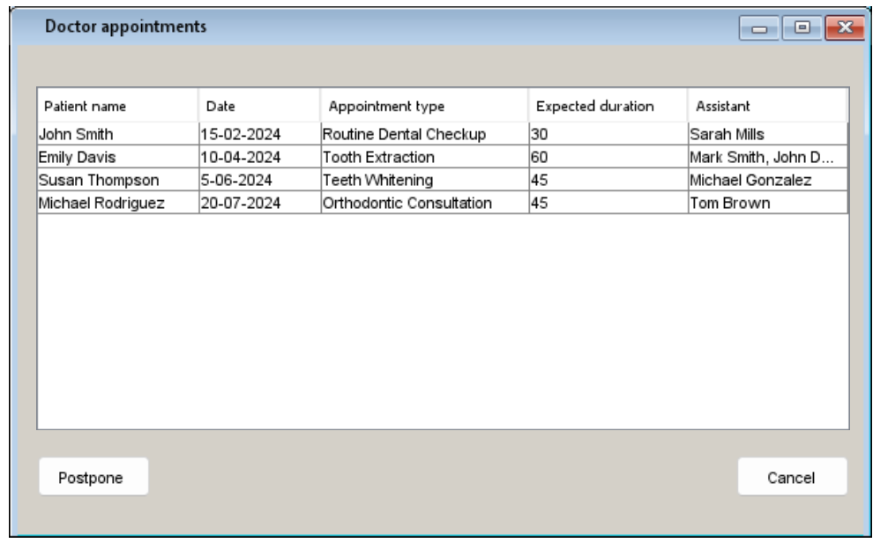
This interface displays a schedule of upcoming appointments for a specific doctor. It shows patient names, appointment dates, types of appointments, expected durations, and assigned assistants. Doctors can use this interface to review their daily schedules. There are options to postpone or cancel appointments if necessary, enhancing the flexibility and efficiency of managing patient consultations
.
Appointment scheduling for patients
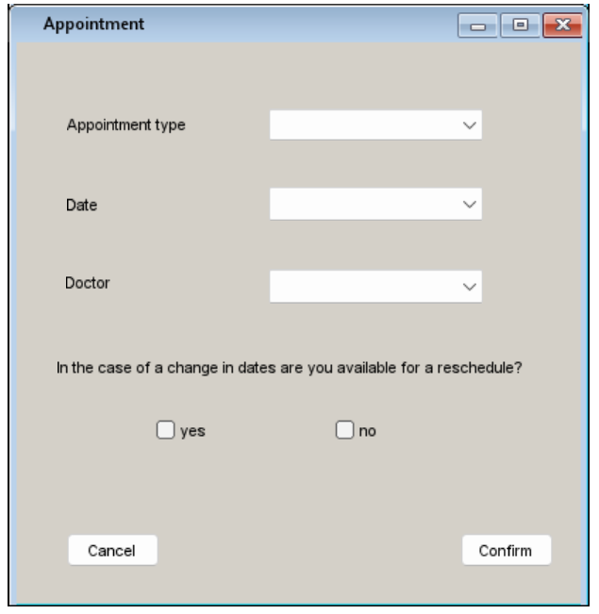
This interface is a form used for scheduling a new appointment. It allows patients to select the appointment type, preferred date, and doctor. Additionally, there's an option for the patient to indicate their availability for rescheduling, which helps the clinic manage the schedule more effectively in case of changes.

Component diagram

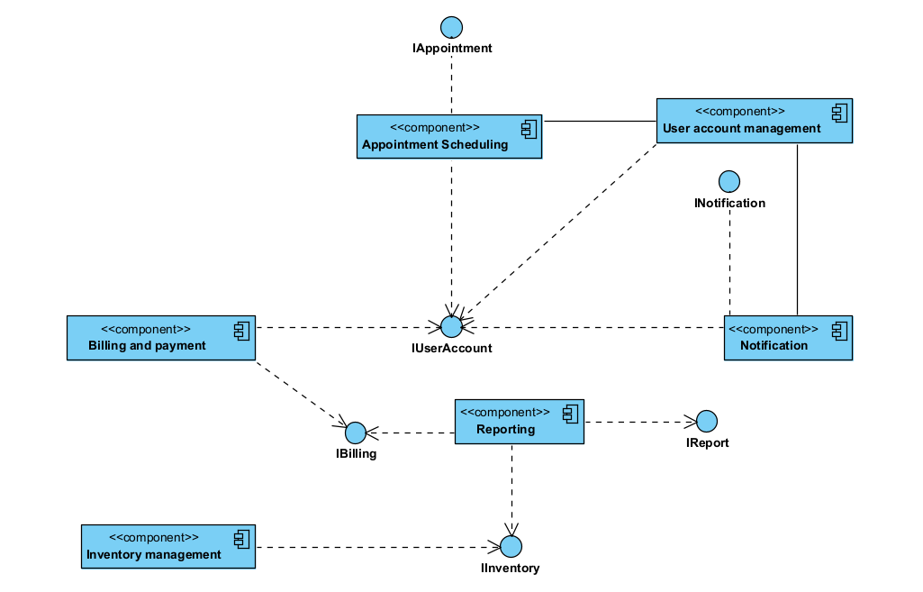
- User Account Management Component: Interfaces with IUserAccount to manage user credentials and profiles.
- Appointment Scheduling Component: Connected to IAppointment, it handles the scheduling of appointments.
- Billing and Payment Component: Through IBilling, it manages financial transactions, invoicing, and payments.
- Inventory Management Component: Uses IInventory to track and manage dental supplies and equipment.
- Reporting Component: Linked with IReport, it generates various operational reports.
- Notification Component: Associated with INotification, it sends alerts and reminders to users.

Deployment diagram
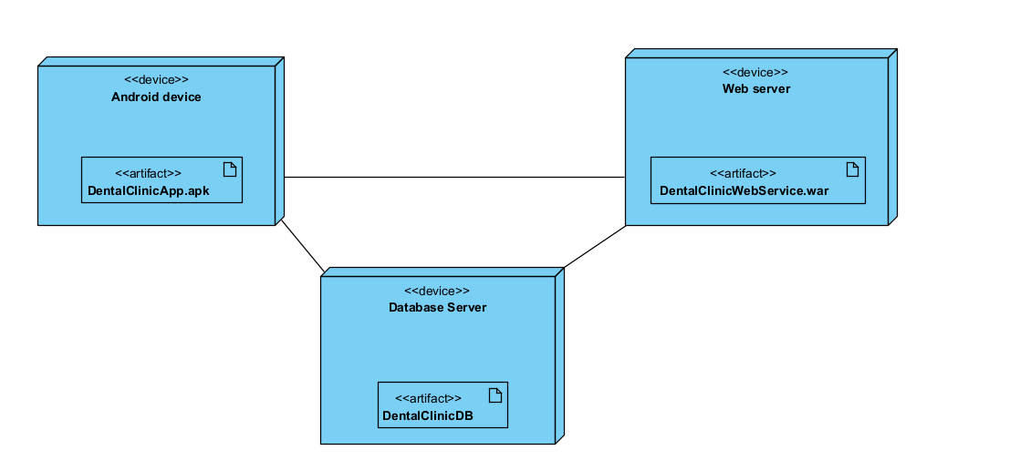
The Android application (DentalClinicApp.apk) is deployed to users’ Android devices, providing the user interface for managing dental appointments and accessing clinic services and also on the doctors and assistant side for them to manage their own schedule and appointments.
The application and the back-end services are deployed on (DentalClinicWebService.war), which processes requests, manages business logic, and interfaces with the database.
The data storage is managed by a database server (DentalClinicDB), which holds all the critical data for the application, ensuring data integrity and security. The diagram demonstrates the flow of information between the user-facing application, the server-side processing, and the data storage system.

System implementation

The application is written in Android Studio IDE with the programming language Java, projected to work from Android 7.0 or API level 24 to API level 34 or Android 14.0. Git will be used for version control, it offers better code management with repository hosting like GitHub. Gradle for managing application dependencies, build configurations, and testing frameworks. SQLite for local data storage, and a cloud based database for cloud data storage and synchronization. The Room database framework from Android is used in realizing this as well.
Hardware requirements wise the app will not be very demanding for the phone of users since it’s designed to be lightweight and optimized for performance. The app efficiently manages resources to ensure smooth operation even on entry-level devices. This way we can have a larger base of potential patients using the application.
To better understand the app, we can see the case of potential patients which will have an easier time understanding the clinic in this app form, where they can see the doctor’s profile, the cost of consultations and what the expected duration of them are offering tangible transparency. In this way they feel more in control and can have a better experience in the appointment process. They familiarize themselves with the clinic at a faster rate than in person.
In the case of current patients, they have a recorded history of their appointments, and can see how many chances they have undertaken, and this can come as motivation to have a better dental care, along with the benefits of being a long term client, that can come in free dental check ups or in the form of discounts along with priority queue.
Furthermore, the doctors will have an easier time knowing their availability, they can postpone or cancel appointments at any time but with reasoning behind it. This way we have a more streamlined approach, doctors can pick who they want as assistants if they are so available and have a better understanding of what is going on without distracting the receptionist which might have other things to deal with.
Alongside this the assistants can take better care of the inventory since everything is stored and easily filtered this way they can know when stuff is expiring or what is in demand so they can start ordering a new batch.
In summary, the dental clinic application is a versatile and user-friendly platform that simplifies clinic processes and patient engagement. Optimized for a range of Android devices, it ensures accessibility for a broad user base. By leveraging the latest in mobile technology, the app aims to provide an efficient, transparent, and connected dental care experience for both patients and healthcare providers. This innovative tool reflects our commitment to enhancing dental health management through smart and accessible solutions.

