

The Bucharest University of Economic Studies

Interactive Web Platform for the Dance Industry
“FOMO - Fear Of Missing Out”
Design of Informatic Systems

Group: 1107
Student: Stoimenova Stela
Coordinator: Dragomirescu Oana-Alexandra
Contents
The Bucharest University of Economic Studies 1
Presentation of the computer system 3
General description of the information system 3
Requirements specification 4
General + detailed Use case diagrams 5
Textual description of use cases 7
Analysis of the system 11
Activity diagrams 11
Class diagram 13
State diagrams 13
Interaction diagrams 14
Processes and collaboration diagrams in BPMN 16
Design of the system 18
Detailed class diagram 18
Database design 18
User interface design 19
Component diagram 22
Deployment diagram 23
System implementation 23

Presentation of the computer system

General description of the information system

The dance industry has expanded significantly in recent years, especially through social media platforms such as Instagram, TikTok, and YouTube. Dancers and studios promote workshops, classes, and artistic projects primarily through these channels. Although these platforms allow visibility, they do not provide a dedicated environment for managing dance events, selling tickets, or supporting structured economic processes.
Existing platforms such as Eventbrite, Meetup, or Ticketmaster offer event management and ticket purchasing features, but they are general-purpose platforms and do not address the specific needs of dancers, choreographers, or agencies. At the same time, some niche dance websites or Facebook groups share competitions or camps, yet they lack user portfolios, loyalty systems, or integrated economic mechanisms.
This analysis shows that, although partial solutions exist, there is no platform that combines social interaction, event posting, ticket purchasing, and economic processes in a single environment tailored specifically for the dance community. This motivates the development of a dedicated platform that responds to the particular dynamics of the dance industry.
The FOMO platform is an Interactive Web Platform dedicated to the dance community. It functions as a specialized, centralized digital environment combining social networking features with event management and integrated economic processes. The system allows dancers, studios, choreographers, and agencies to create digital portfolios, post workshops and events, sell tickets, earn loyalty points, and view dance activities on a map. The platform also integrates economic mechanisms such as dynamic pricing based on demand, transaction commissions, and a loyalty reward system. The system will be implemented using a standard three-tier client-server architecture (Browser, Application Server, Database). With FOMO there will not be any “Fear Of Missing Out” because the Web application enables bi-directional promotion, where Studios or Agencies search for talents, and Dancers actively promote their portfolios to attract attention from industry professionals.
FOMO’s goal is to offer a single environment where members of the dance industry can interact, promote activities, and manage event participation more efficiently. The Web Platform provides multiple key features as digital portfolios, event management tools, ticket purchasing, map-based interface for geographic discovery of events. Additionally, the platform includes a commission-based fee on transactions, a loyalty points system for discounts, and a simple dynamic pricing mechanism based on event demand.

Requirements specification

The project begins with User Management, allowing individuals to create secure accounts and define their role as a dancer, studio, or agency. Each user profile serves as a Digital Portfolio, encompassing personal information, dance experience, and media (photos/videos).The dancer’s personal account must include unique, easily shareable public links (URLs) that the users can distribute on external social media to drive traffic and visibility from studios and agencies. This foundation is enhanced by social features, enabling users to follow other accounts and view the accounts they follow. A key functionality for community engagement is the ability to highlight the most popular events in a region, ensuring that users can easily stay updated on trending activities and avoid the “FOMO-Fear Of Missing Out”.
The central feature of the platform is comprehensive Event Management. Studios and agencies can effortlessly create various events, including workshops, camps, castings, and regular classes. Event creators define crucial details such as location, date, price, and associated media. For discovery, the system includes a robust search capability, allowing users to filter events by category, date, price, or location. Beside all the features, dancers must have a mechanism to actively promote their account to specific agencies or appear on “Trending Dancers” lists based on profileengagement. Furthermore, a distinguishing feature is the interactive map interface, which geographically displays all posted events based on their coordinates, enabling efficient local event discovery.
FOMO integrates a complex Economic System to support structured financial processes within the dance community. The system allows users to purchase tickets for events through a simulated payment process. Every transaction triggers two primary economic functions, commission applied and loyalty points. These accumulated points can be redeemed for future discounts. In addition, the web project employs a demand-based dynamic pricing mechanism, allowing event prices to adjust automatically based on popularity or scarcity, maximizing revenue and managing event demand.

General + detailed Use case diagrams

General Use Case Diagram of the functionality of the system
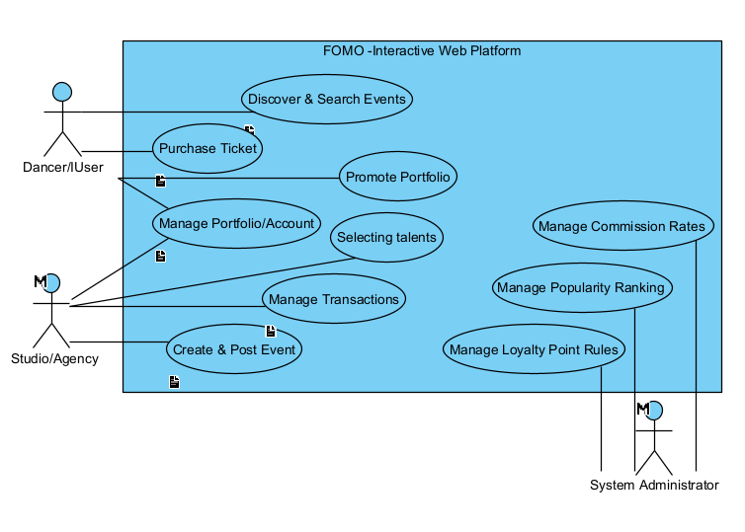

Detailed Use Case Diagram for Purchasing a Ticket
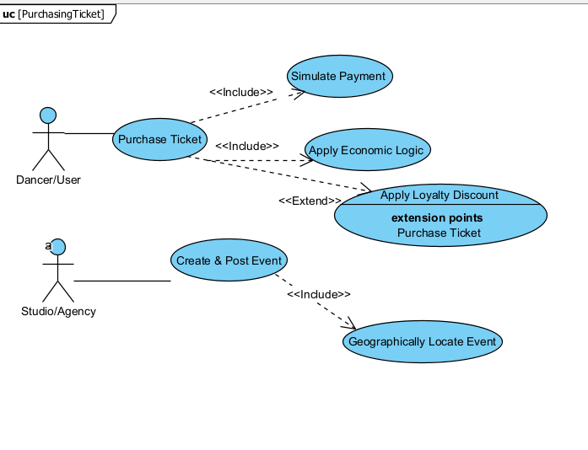

Event Creation & Posting Use Case Diagram
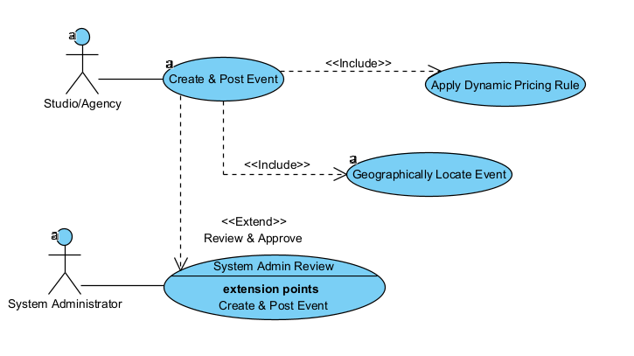

Influencer Promotion & Collaboration
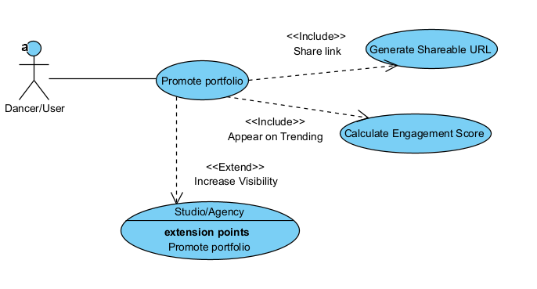

Textual description of use cases

Element of the Use Case | Description
Code | UC02
State | Outline
Purpose | To allow a Dancer/User to simulate purchasing an event ticket while applying the platform’s commission and loyalty system logic
Name | Ticket Purchase and Economic Processing
Main Actor | Dancer/User
Description | This use case covers the user selecting an event, completing the simulated transaction, and the system triggering the core economic rules.
Preconditions | The Dancer/User is logged in and the event has tickets available
Post Conditions | A simulated transaction record is created, the ticket is issued, and the user’s loyalty point balance is updated.
Trigger | The Dancer/User selects the “Buy Ticket” option for an event.
Basic Flows | 1. The User selects an event and specifies the quantity.  2.The system checks availability and applies any demand-based price adjustments (Dynamic Pricing).  3.The system checks if Loyalty Points are available for discount and prompts the user.  4.The User proceeds to the simulated payment gateway.  5. The system confirms payment success. 6.The system records the Commission applied to the sale.  7.The system calculates and credits Loyalty Points to the User's account. 8. The digital ticket is issued.
Alternate Flows | A1: Apply Discount. The User opts to use existing loyalty points for a discount. The system deducts points and recalculates the final price.
Relationships | N/A
Frequency of Use | Frequent
Business Rules | BR1: A commission is applied on every transaction.  BR2: Loyalty points are accumulated and redeemable for future discounts.  BR3: Ticket sales must adhere to the applied demand-based price adjustments.

Element of the Use Case | Description
Code | UC01
State | Outline
Purpose | To allow a Studio or Agency to define, upload, and publish a new event (workshop, camp, casting, class) onto the platform.
Name | Event Creation and Posting
Main Actor | Studio/Agency
Description | This outlines the steps for a provider to input all necessary details, including geographical location, price, and media, and submit the event for sale.
Preconditions | The Studio/Agency account is registered, logged in, and the event creation module is accessed.
Post Conditions | The event details are successfully recorded, and the event is set to the 'Posted' status for public visibility.
Trigger | The Studio or Agency needs to promote a new activity or class.
Basic Flows | 1. The Studio/Agency accesses the Event Creation form.  2.They input event details (name, category, date, price, and media).  3.They provide the geographical location (address).  4. The system Geographically Locates Event by converting the address to coordinates. 5.The system confirms the location can be displayed on the map.  6.The system applies the Dynamic Pricing Rule to the base price.  7. The Studio/Agency confirms and submits the event.  8. The system validates all inputs and successfully publishes the event.
Alternate Flows | A1: Location Error: If the address cannot be converted to valid coordinates, the system prompts the user to correct the address.  A2: Admin Review: The event is placed on hold for System Admin Review before being published.
Relationships | N/A
Frequency of Use | Regular
Business Rules | BR1: All events must include location details for map-based display.  BR2: The event details must adhere to platform standards.

Analysis of the system

Activity diagrams

Event Creation and Posting Flow Activity Diagram
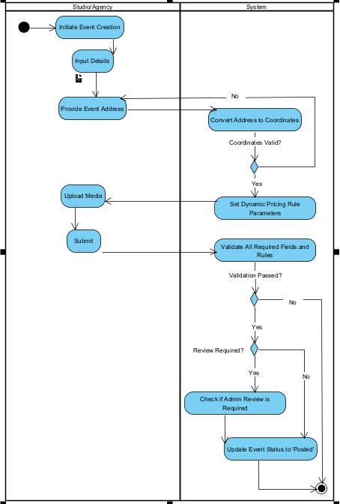
This diagram outlines the sequential and conditional workflow required for Studio/Agency to successfully publish an event, ensuring all mandatory geographic and economic rules are met by the system. The process begins with the Studio/Agency initiating event creation and providing core details, including the physical address. The flow then transitions to the System lane for the critical Geographic Location process. Here, the system attempts to convert the address to map coordinates. If the address is invalid, the flow immediately loops back to the Studio/Agency at the Provide Event Address action, forcing the user to correct the input. Once the coordinates are validated, the system proceeds to automatically Set Dynamic Pricing Rule Parameters. After the Studio/Agency finalizes the input and clicks Submit, the system performs final Validation. A validation failure leads to an error state, while success moves to the final administrative check. If Review is required?, the event is placed in a hold state if its approved, but if not the system immediately proceeds to Update Event Status to ‘Posted’, concluding the successful publishing workflow.
Ticket Purchase and Economic Processing Flow
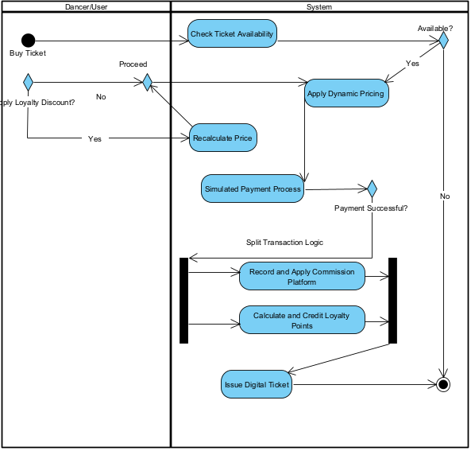
The diagram highlights the sequential steps and parallel economic calculations required for a ticket sale. The process is initiated by the client, which immediately transitions to the System to Check Ticket Availability. If tickets are unavailable, the flow terminates. If available, the system prompts the user to Apply Loyalty Discount?, where both yes and no paths converge at the Proceed Merge Node before the system continues the price setting by executing the Apply Dynamic Pricing logic. After the Simulated Payment Process confirms success, the flow is split by a Fork Node into 2 concurrent, mandatory paths: Record and Apply Commission Platform and Calculate and Credit Loyalty Points. Once both parallel economic actions are completed, they converge at the Join Node, allowing the flow to proceed sequentially to the final step, Issue Digital Ticket, before concluding the process.
Dancer Discovery and Casting Invitation Flow
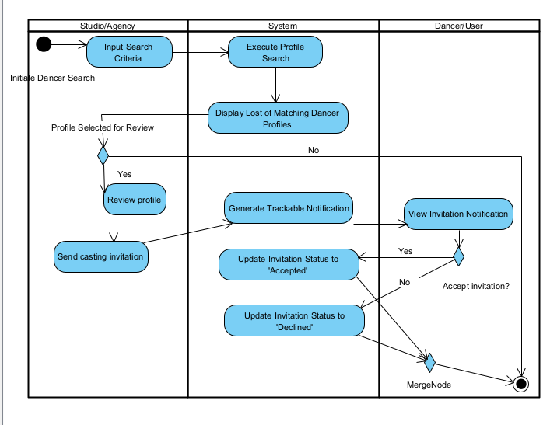
This activity diagram models the social and portfolio management feature, detailing how a Studio/Agency uses the platform to recruit talent. The process begins with the Studio/Agency initiating a Dancer Search based on criteria like style or experience. The System executes the search and displays matching Dancer Profiles. The flow features a key decision point where the Studio/Agency sends a Casting Invitation, which prompts the System to generate a trackable notification directed to the Dancer/User lane. The Dancer/User then views the invitation. Leading to the final decision point: Accept Invitation? The outcome of this decision immediately triggers the System to Update Invitation Status to ‘Accepted’ or ‘Declined’, ensuring a clear record of the casting request is maintained before the process concludes.

Class diagram - specifying the entities, their attributes, and their relationships
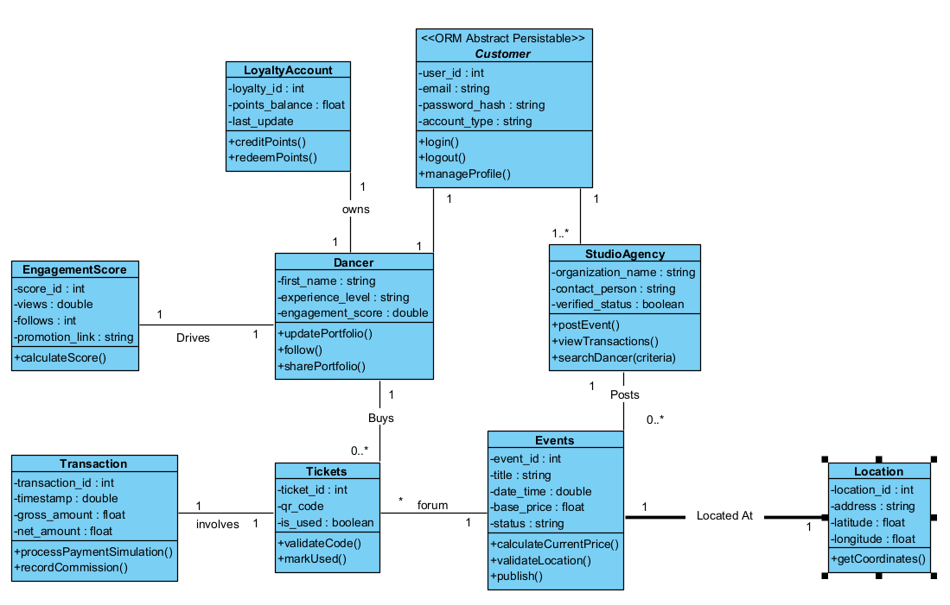

State diagrams

Event Lifecylce
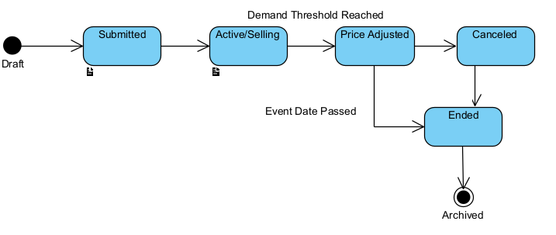

The diagram models the life cylce of an event within the FOMO platform, starting from the draft state. Upon submission, the event moves to the Submitted state, where it remains until validation success triggers the transition to Active/Selling. This state is critical as it allows for two specialized paths, one triggered by Demand Threshold Reached leading to the Price Adjusted state and another triggered by the Event Date Passed. An event can be pulled from sale at any point via the Canceled state. Both Ended and Canceled states converge into the final, terminal Archived state, where the event data is retained solely for historical and reporting purposes.
Ticket Lifecycle

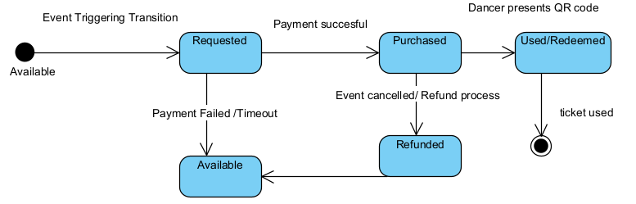
This diagram illustrates the end-to-end workflow for buying a ticket, from checking availability and applying loyalty discounts to parallel tasks for recording commissions and crediting points after a successful payment.

Interaction diagrams

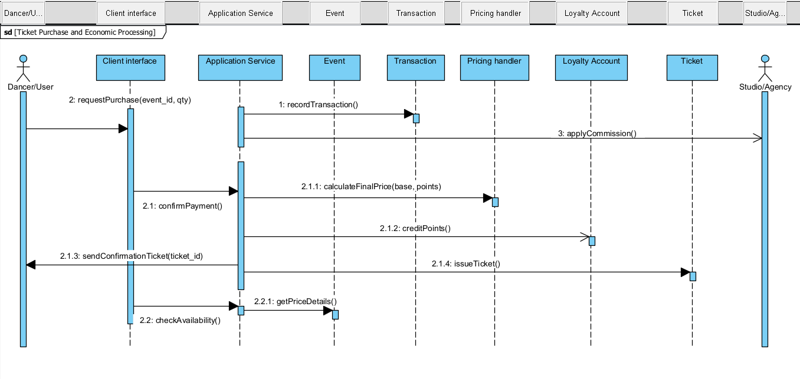
Economic Processing Sequence : Traces the technical steps of a transaction, including calculating the final price via the Pricing Handler, applying platform commissions, and issuing the final digital ticket.

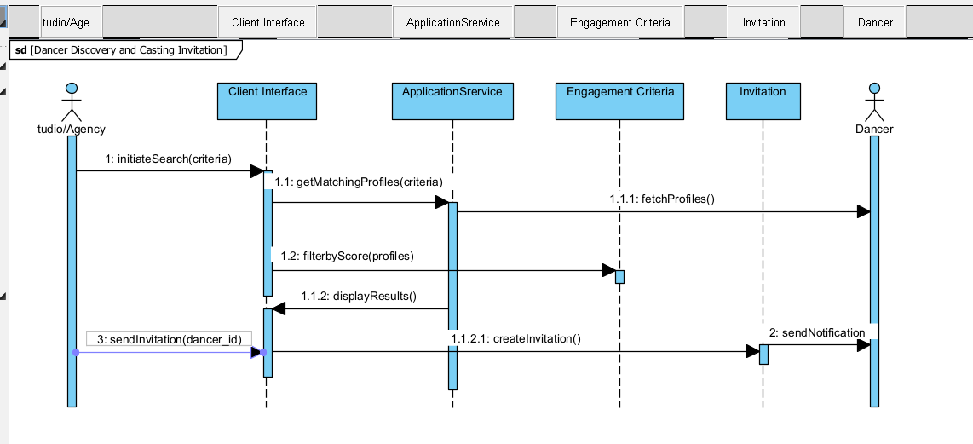
Dancer Discovery Sequence : This sequence details how a Studio/Agency searches for talent through a Client Interface, which communicates with the Application Service to filter profiles by engagement score and send casting invitations.

Processes and collaboration diagrams in BPMN
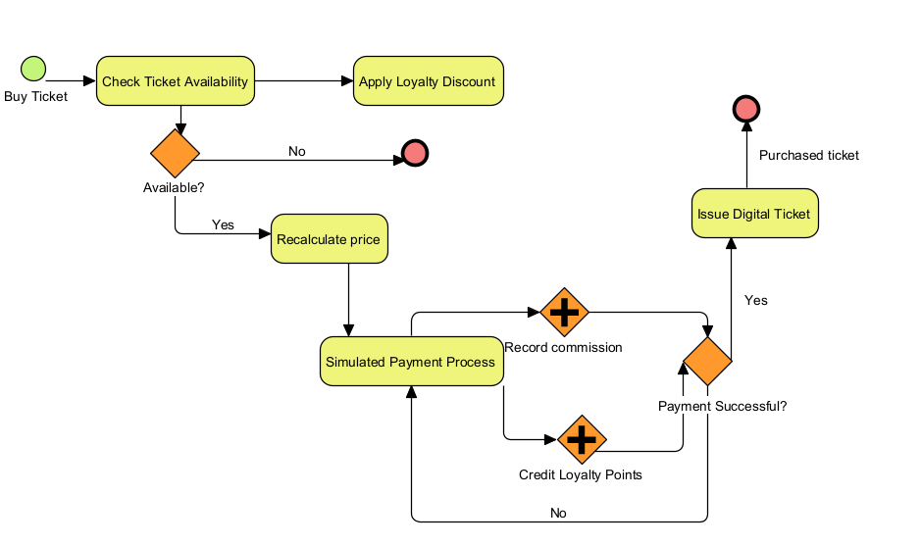
This diagram illustrates the end-to-end workflow for buying a ticket, from checking availability and applying loyalty discounts to parallel tasks for recording commissions and crediting points after a successful payment
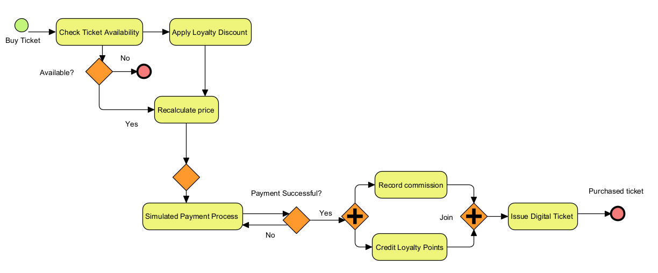
Shows the interaction between the Studio/Agency, System Backend, and an external Location Service to validate an event's address and convert it into usable map coordinates.

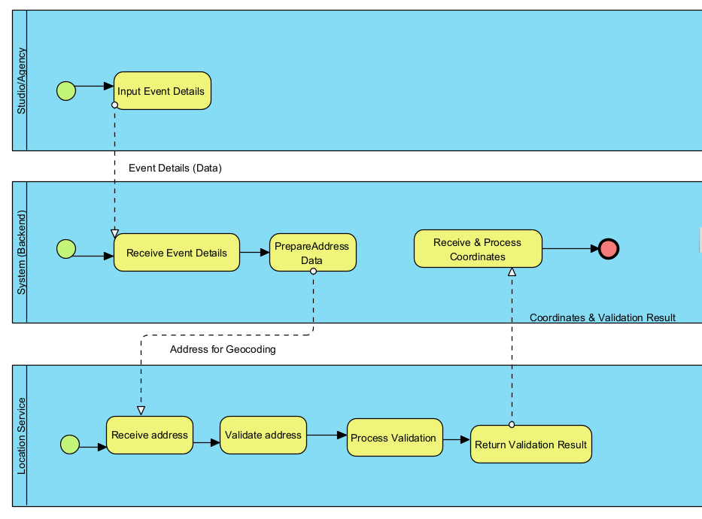

Design of the system

Detailed class diagram

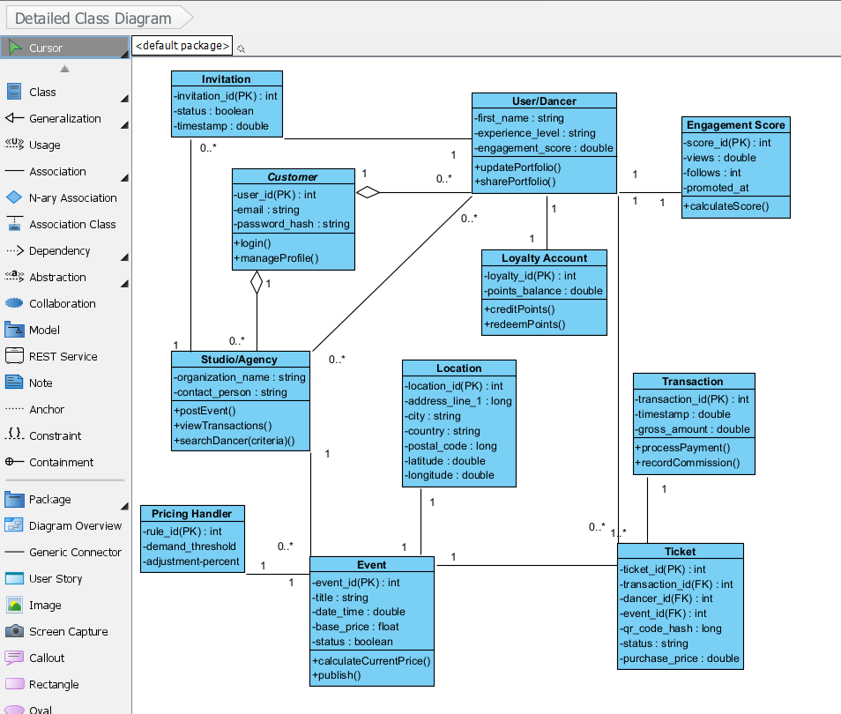
An object-oriented view of the system that defines the attributes (like engagement_score) and operations (like calculateCurrentPrice) for all core entities

Database design
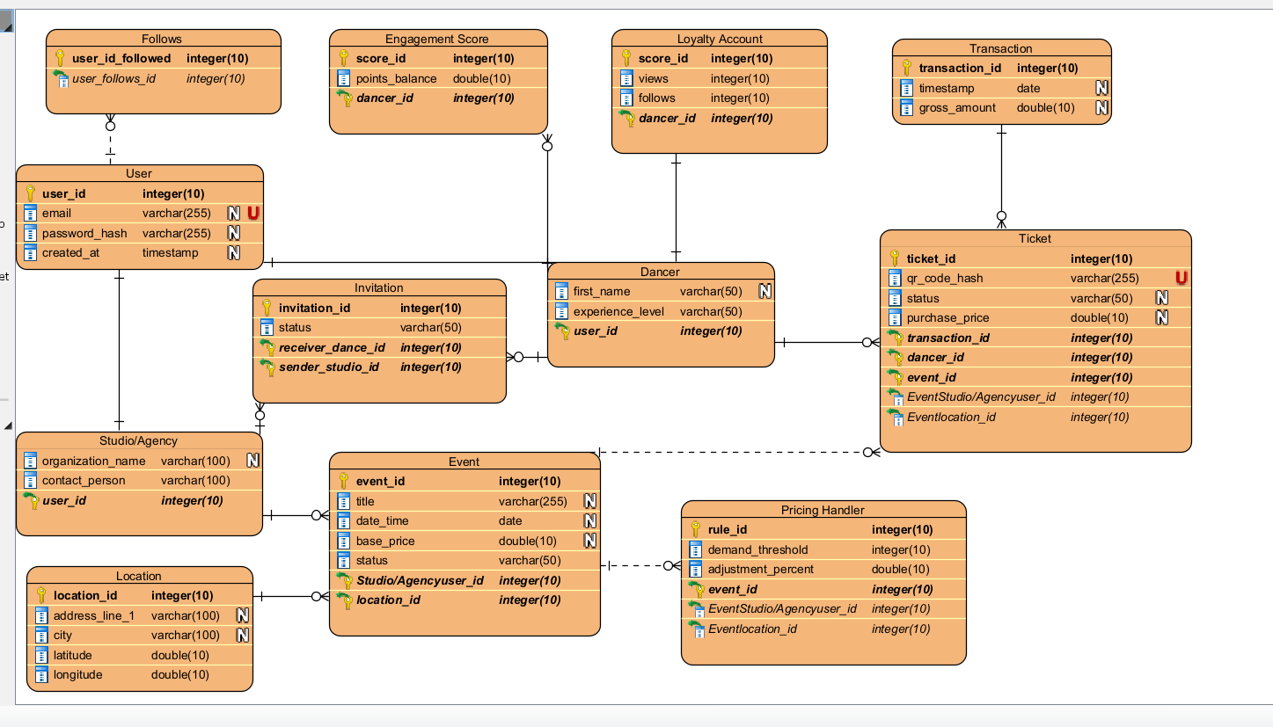
Database Schema : A relational model showing the links between Users, Dancers, Studios, and their associated data like Invitations, Transactions, and dynamic Pricing Rules.

User interface design

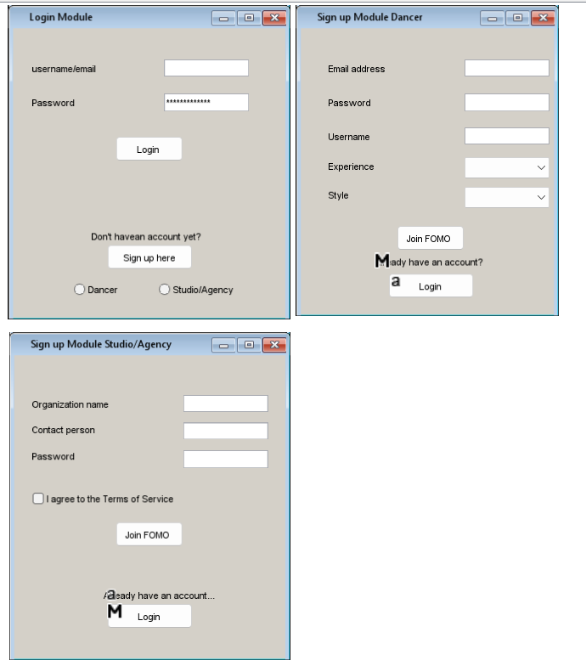
Dancer Dashboard
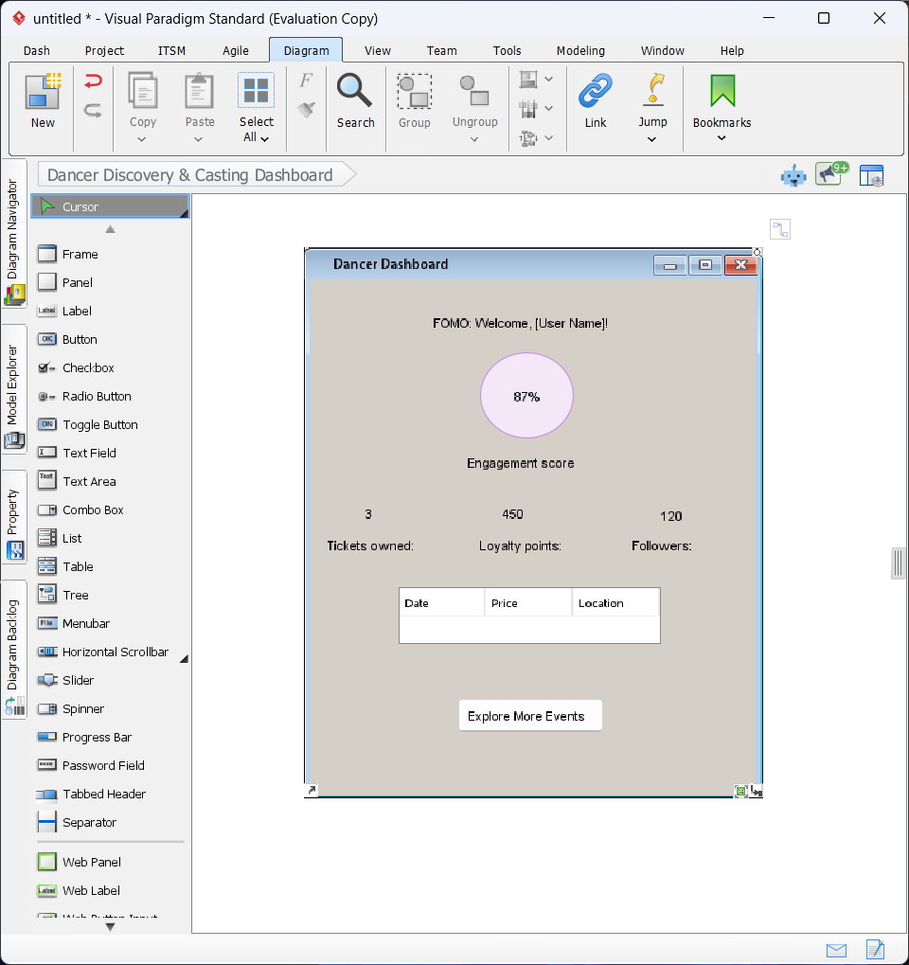
The Dancer Dashboard serves as the personalized landing page for dancer users, providing a centralized view of their social and economic status within the FOMO platform. Social Engagement Metrics: The dashboard prominently features the Engagement Score visualized through a circular gauge, providing immediate feedback on the user's trending status and portfolio performance. Economic Summary: High-level summary labels display real-time data from the database, including the number of Tickets owned, current Loyalty points balance, and total Followers. Activity Tracking: A central data grid lists upcoming events or recent transactions, allowing the user to track their participation schedule at a glance. Navigation: A primary call-to-action button, "Explore More Events," facilitates seamless navigation to the event discovery and purchase module.

Event Discovery & Purchase

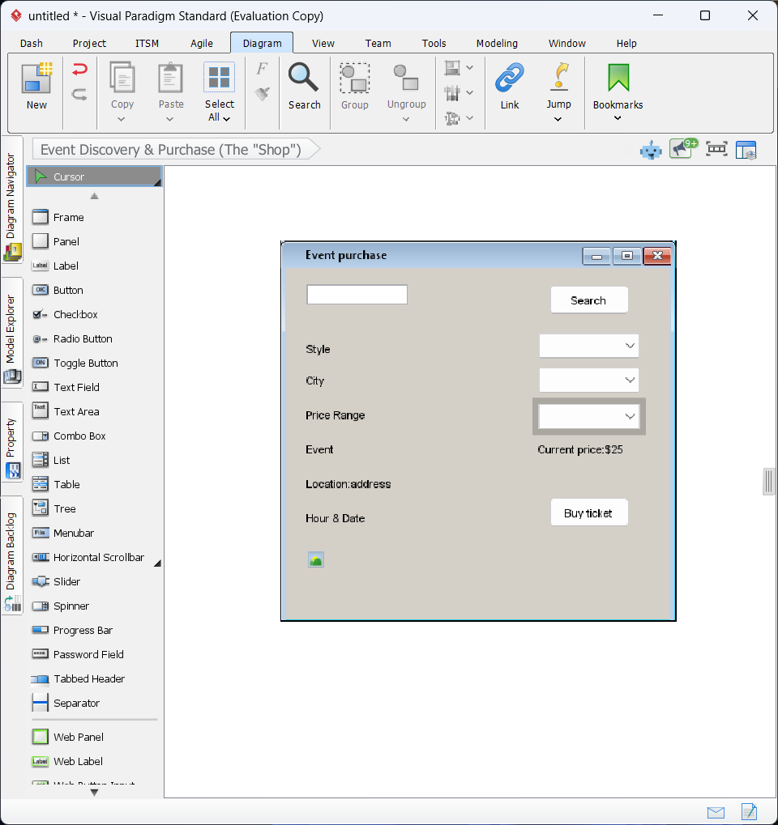
The Event Discovery & Purchase interface is the marketplace for browsing events, integrating the Event, Pricing Handler, and Location entities. Search & Filters: Users search the database via keywords or specific filters like Style, City, and Price Range. Dynamic Pricing: Displays the Current Price, which reflects real-time adjustments from the Pricing Handler based on demand. Event Data: Lists logistical details including the geocoded Address, Hour, and Date alongside a media placeholder. Transaction Entry: The "Buy ticket" button triggers the payment process and ticket issuance logic.
Inventory Management (Studio Dashboard)
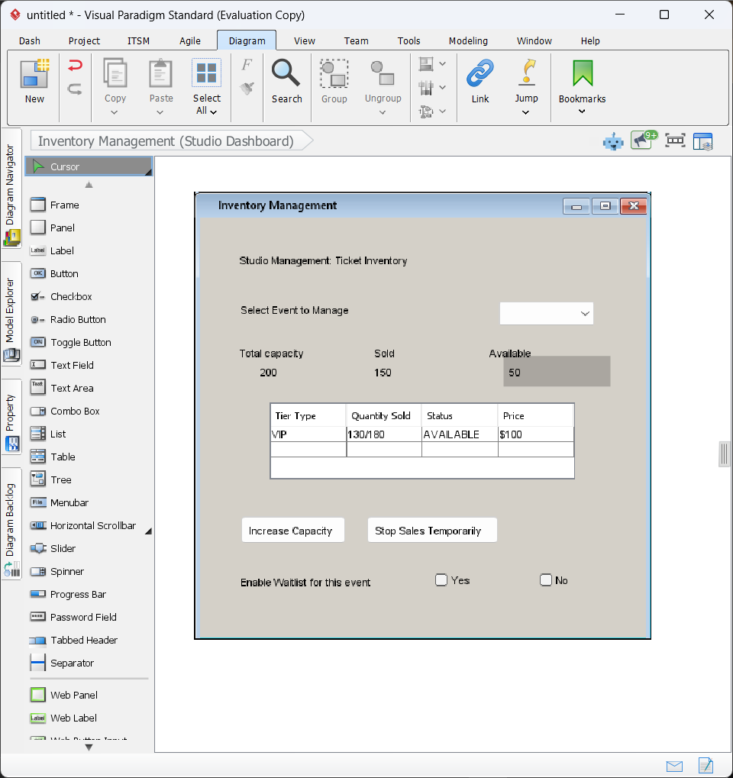
The Inventory Management interface (Figure 7.5) provides Studio/Agency users with real-time control over ticket stock and event capacity. Capacity Metrics: Displays a live overview of Total capacity, Tickets sold, and Available stock to monitor event fill-rates. Tier Tracking: A detailed table tracks sales and availability status for specific ticket tiers, such as VIP or General Admission. Inventory Control: Includes administrative buttons to manually Increase Capacity or Stop Sales based on venue requirements. Waitlist Logic: A toggle feature allows organizers to enable a Waitlist once initial inventory is exhausted.

Component diagram

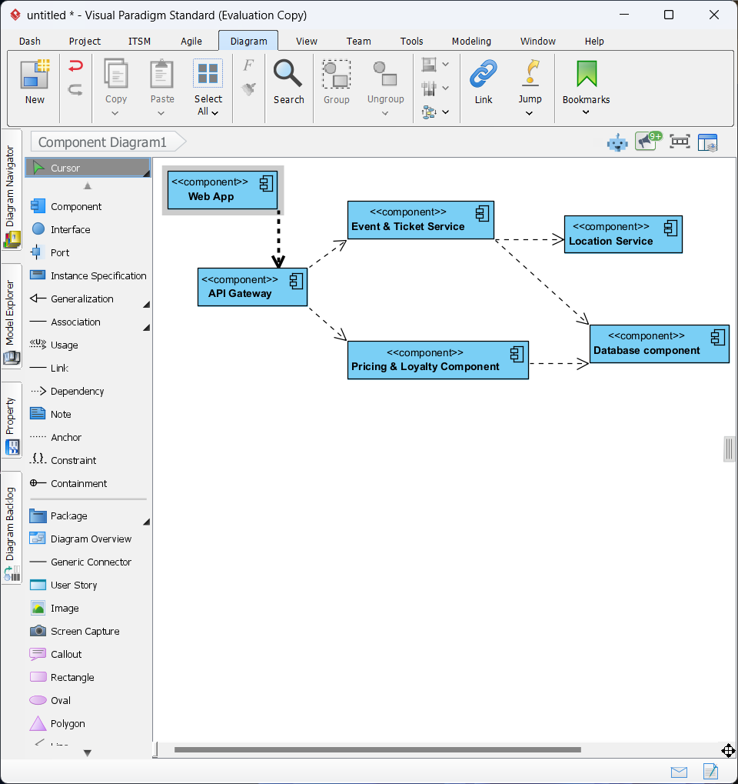
The Component Diagram represents the modular architecture of the FOMO platform. The Web App serves as the user-facing layer, communicating via the API Gateway to ensure secure request routing. Core logic is partitioned into specialized services: the Event & Ticket Service handles inventory and scheduling, while the Pricing & Loyalty Service manages dynamic costs and user rewards. The Location Service provides external geocoding validation. All components persist data through a unified Database component, ensuring transactional integrity across the system.

Deployment diagram

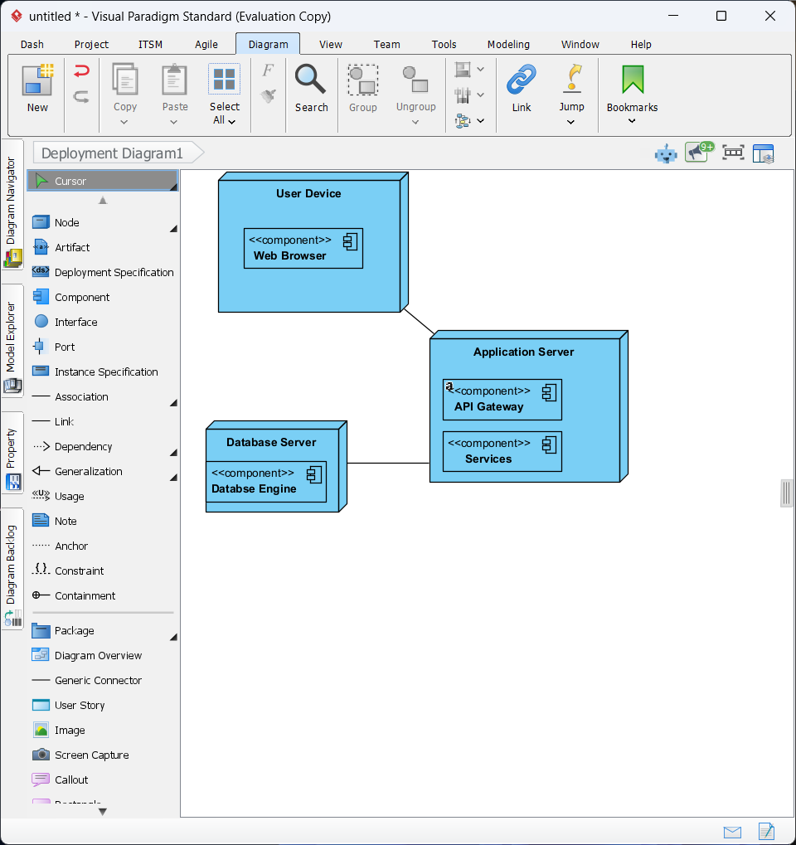
The Deployment Diagram illustrates the physical execution environment of the FOMO platform. The architecture is distributed across three primary nodes: User Device: Represents the client-side environment where the web interface is rendered via a standard browser. Application Server: Hosts the core business logic, API gateway, and specialized services, communicating with the client via secure HTTPS protocols. Database Server: A dedicated node for the relational database management system, ensuring secure and high-performance data persistence for all user and transaction records."

System implementation

The FOMO platform is developed as a Progressive Web App (PWA) using the React Native for Web framework, an architecture that ensures the application is cross-platform by nature and capable of running on any modern web browser while maintaining a native-app feel on mobile devices. The application leverages a modern JavaScript ecosystem to ensure scalability and ease of maintenance, utilizing React Native for Web to allow for a single codebase to target both mobile and desktop users. Git is utilized for robust code management with GitHub serving as the central repository for collaborative development and version tracking, while npm or yarn handles application dependencies and build configurations to ensure a streamlined development workflow. The system uses a dual-layer storage approach where local storage or IndexedDB is used for caching and offline capabilities within the PWA, while PostgreSQL serves as the primary cloud-based database for real-time synchronization of event and user data. The application is designed to be lightweight and performance-optimized, requiring minimal hardware resources from the user's device to ensure a smooth experience even on entry-level smartphones, which is critical for reaching a broad user base of dancers and studios accessing the platform from various hardware tiers. To facilitate better engagement, the system addresses the specific needs of its primary user roles; new users can easily explore the platform's ecosystem to view studio profiles, event costs, and engagement scores, offering a level of transparency that builds trust and allows dancers to feel in control of their career development. Current dancers benefit from a recorded history of their transactions and tickets, and access to the loyalty account system serves as motivation for continued engagement by offering benefits like discounts and priority access to high-demand workshops. Studio owners and agencies have a streamlined approach to managing their availability, allowing them to publish, postpone, or cancel events with documented reasoning to ensure clear communication while utilizing the dashboard to identify and invite talent through the casting invitation flow without administrative bottlenecks. Furthermore, the inventory management module allows for efficient tracking of ticket stock, enabling administrators to filter sales data and capacity levels to proactively manage demand and ensuring they know exactly when tiers are selling out or where demand is highest. In summary, the FOMO platform is a versatile and user-friendly PWA that simplifies complex dance industry processes by leveraging React Native for Web and cloud-based synchronization to ensure high accessibility and transparency for both talent and organizers, reflecting a commitment to enhancing dance health and professional management through smart and accessible mobile technology.

