**Software design document**

**Proof of concept**

**Adnight Instagram Filter**

**Author**: Stela Trencheva

**Student number**: 4520095

**Date**: 09.01.2023

Contents

**1.** **Introduction** 3

**2.** **Process of work** 4

# **Introduction**

The AR Instagram filter created for this POC was part of a bigger story with main goal to test user preferences and desires. This project involved creating an AR filter for Instagram that featured jumping versions of the characters Rick and Morty in the background, with Rick's hair that is placed around a user’s head when detected, on the front camera. The purpose of the filter was to provide a fun way for people at an event to capture memories and to gather data on whether people prefer AR or VR technology. The filter was developed using JavaScript and Meta Spark Studio, and survey data showed that most people prefer Instagram over other platforms for AR experiences. The project was also an opportunity to improve my 3D skills.

# **Process of work**

For this project 3D modelling and AR development were the main aspects. Some 3D models were downloaded from Sketchfab but most of them were modelled by me in Blender. During the short time for development, most of the time was spent modelling the 3D objects. The model of Rick was downloaded. However, the model of Morty was created in Blender by me.

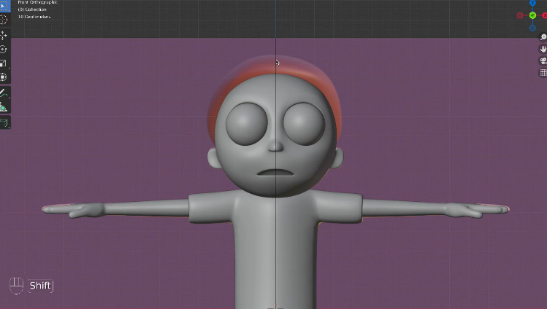First, two pictures were used as background for a reference. One was Morty’s front look and the other one was the side look. Then the modelling of the body from basic shapes like stretched circles, cylinders and rectangles. Starting from the torso, then the legs, feet, arms and head. After that the clothes were modelled over as another layer of stretched geometrical figures. More time was spent modelling the eye sockets with all the small details as well as other elements of the face. After the model was finished, materials were added to it according to the picture.

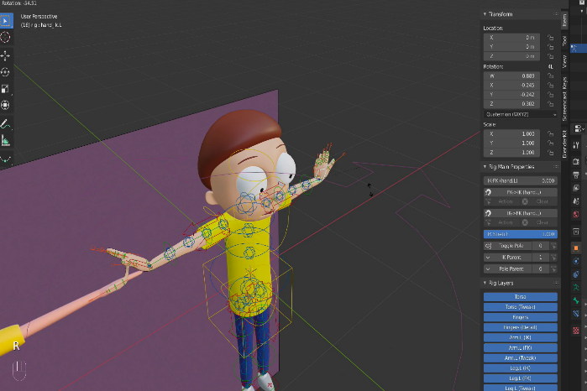The next step of the modelling was the rigging of the body. Rigging in Blender is the process of creating a skeleton for a 3D model, so that it could be animated. This involved creating bones and joints, which were then connected to the model's vertices using weight painting or other techniques. Once the rigging was complete, the bones could be moved and rotated to animate the model.

Blender has a built-in rigging toolset. The rigging process can be done using the "Armature" object, which allowed the creation of bones and joints, and connecting them to the model using constraints. Blender also has a "Weight Paint" mode that enabled controlling how the bones affected the model's vertices. The model of Rick was also rigged by me in Blender so that it can be animated as well. The rigged characters of Rick and Morty were placed in one scene in Blender and animated. An animation in Blender was initialized and then their bones were modified frame by frame so that when played, it looks like they are jumping.

The hair of Rick was also modified in Blender and saved as a separate 3D model for the purpose of the filter on the front camera. Parts of it were cut and a proper ending was added to the edges of the cut parts so that it can fit more faces.

After finishing with the 3D models in Blender all of them were exported as FBX objects.

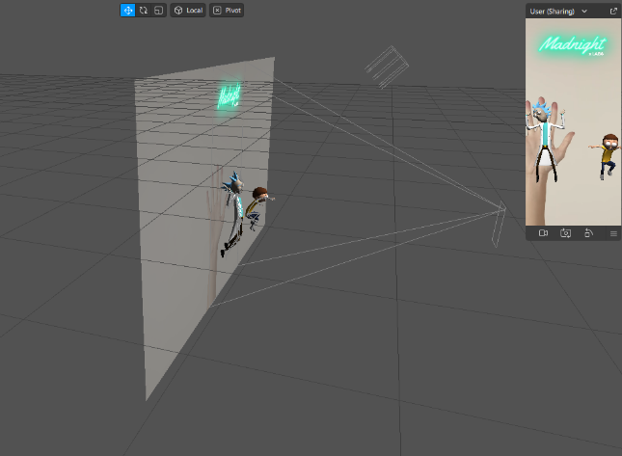For creation of the Instagram filter, Meta Spark Studio was used. which offers an easy way to create immersive effects with audio, depth and occlusion capabilities. The interface allows you to see a phone screen and to place objects on it. All of the 3D models were imported into the program and placed on the screen accordingly.

For the programming of the logic of the filters, Scripting API was used. Itself it is using reactive JavaScript. Another was of creating logic in Meta Spark Studio is using node-based programming. Even though it is easier to use and doesn’t require programming knowledge, I already knew JavaScript and was easy to start working with it directly. This approach makes it more flexible for users to create.

The script checks which camera is active when it starts and displays the appropriate filter.

When using the back camera, it initiates a 3-second timer that starts when the user taps the screen. Once the timer expires, it attempts to locate a flat surface using the *SurfaceTracking* API, and if successful, places the animated models of Rick and Morty on the flat surface. The *SurfaceTracking* API is a feature provided by Meta Spark Studio. The API uses computer vision and machine learning techniques to track surfaces in a video feed, such as a camera. This allows developers to build applications that can track and interact with surfaces in real-time.

On the front camera, it tracks a 3D head and when one is detected, it places a 3D hair of Rick around the face. The head tracking feature in Meta Spark Studio is built using computer vision and machine learning techniques, specifically deep learning-based algorithms. These algorithms are trained on large datasets of images and videos to learn to recognize and track specific features on the user's face, such as the eyes, nose, and mouth. Once the head is detected, the software uses data from the device's sensors, such as the accelerometer and gyroscope, to track the movement of the head in 3D space. The technology uses the device's camera and image processing techniques to detect and track the head. The head tracking feature in Meta Spark Studio is designed to work with a wide range of devices and environments, and can be fine-tuned to improve its performance and accuracy. The team behind Meta Spark Studio continues to improve and update the head tracking feature with new techniques and approaches to make it more robust to changes in lighting, occlusions, and head movements.

After creating the interactions and actions in the filter, it was uploaded for testing to the Instagram app. Usability testing was conducted to colleagues from Greenhouse in order to place the hair in a way that fits the most amount of heads.