

Object Oriented C++
(MOD003197)

<<1820376 >>

Due Date: Turnitin, 2pm, Wednesday 4th of May 2021
Faculty: Science and Technology
Department: Computing & Technology
Academic year: 2020 – 2021
Trimester: 2

Table of Contents
1. Functionality 3
2. Class diagram 4
3. Appendix 5
3.1. Instructions 5
3.2. Source code 5

Functionality

I have been able to implement a good level of functionality, including an enhancement. My fire simulation is composed of 5 header files, 6 source files, one class diagram file, using a varying size vector array for the values of the cells. Each cell can have one of the 4 states: empty (‘ ‘), tree (‘&’), fire (‘X’), and border (‘#’). The border will be white, trees will be green, and the fire will be red using ANSI 8-bit standard colours.
I used the wind and regrowth enhancement, every 15 turns the wind direction will change to one of the following: north, south, east, or west; this will affect the corner cells as well as the side cells. The neighbouring trees have a 50% chance to catch on fire, and 100% chance to regenerate after a random time.
After each turn the grid is redrawn, the user needs to press enter for this to happen, if the user wishes to exit the application he needs to press any key followed by enter. If the user presses a key by accident and does not want to exit, he has the ability to erase that letter by pressing backspace and then enter. The first fire will start at the centre cell as the requirements stated, if the fire dies down, the fire will start again at a random place and in a random amount (can be more than one cell).
I have designed 5 classes:
- Cell – it assigns a x and y location to the cell and a state (tree, fire, etc…);
- Grid – setting the grid size to 21x21, and getting cell positions [x][y];
- Draw – setting colours, displays wind direction, frame number, and draws the state of the cell;
- Display – here we set the border, update the state of each cell, start the fire, regenerate tress, change wind direction, update frame, change wind direction after each 15 frames, and set fire to neighbouring trees;
- Neighbour – automatically starts with north wind, has a switch with the 4 direction and north as default, and another switch with the cells affected by each direction.

These are a few limitations to this application, there is no end of the simulation as the fire keeps being created and the trees keep regrowing. There is no way to save the progress if the user would want to. The amounts of trees on fire, burned down, regrown trees are not kept on the screen, for an update that would be the first thing to add, a table with the amounts.

Class diagram

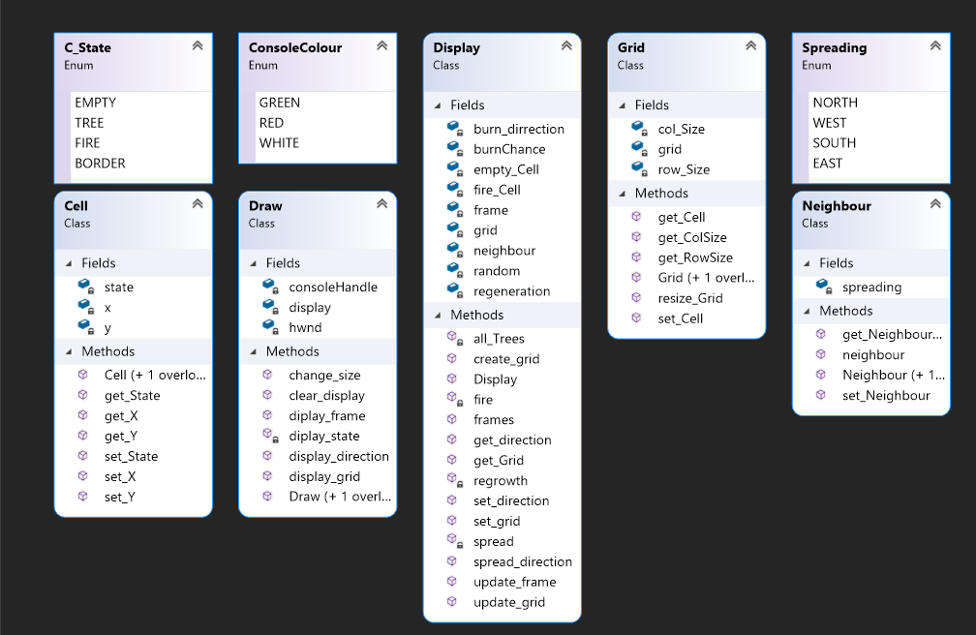

Here is the visual studio class diagram for comparison with the class diagram I have created.

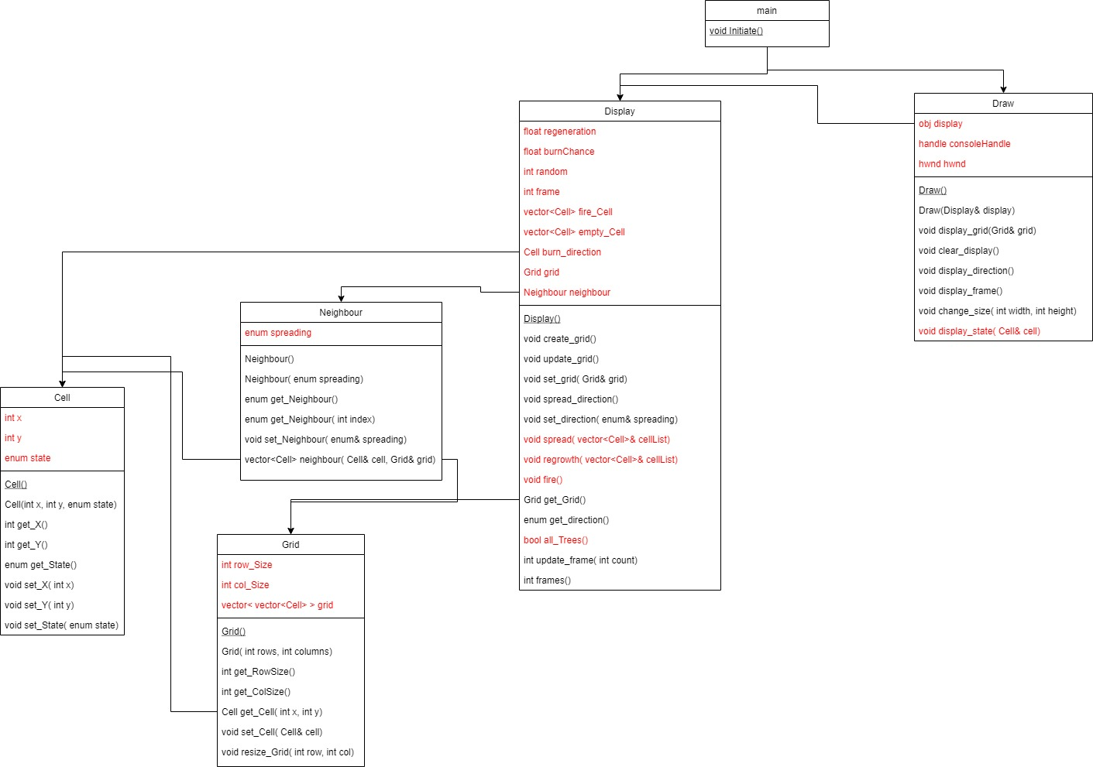

This is the class diagram and its connection between classes and to main.
The red text symbolizes private fields or methods, while the black text are public elements.

Appendix

3.1. Instructions

This application is a turn-based representation of a fire in a 21x21 forest, the user needs to press enter for the fire to spread and go to the next frame. If you would like to exit just press any key followed by enter the program will end.
These instructions are clearly displayed on the application screen. As well as the wind direction and the frame number.

3.2. Source code

#ifndef CELL_H
#define CELL_H

/// <summary>
/// The state of a cell can be TREE, EMPTY, FIRE, and BOARDER.
/// </summary>

enum C_State
{
EMPTY = 0,
TREE = 1,
FIRE = 2,
BORDER = 3
};

/// <summary>
/// Contains the position and state of a Cell.
/// </summary>

class Cell
{
private:

int x;
int y;
C_State state;

public:

//Constructors

explicit Cell(); //empty
explicit Cell(const int x, const int y, const C_State state); //position x, y, and state

//Getters

int get_X() const; //get x position
int get_Y() const; //get y position
C_State get_State() const; //get state out of enumeration

//Setters

void set_X(const int x); //set x position
void set_Y(const int y); //set y position
void set_State(const C_State state); //set state from enumeration
};
#endif
#ifndef DISPLAY_H
#define DISPLAY_H

#include "Cell.h"
#include "Grid.h"
#include "Neighbour.h"
#include <vector>

using namespace std;

/// <summary>
/// Creating, updating the grid and state of cell.
/// </summary>

class Display
{
private:

float regeneration; //trees regrowth rate
float burnChance; //chance neighbour cells catching fire
vector<Cell> fire_Cell; //cells on fire
vector<Cell> empty_Cell; //empty cells
int random;
int frame; //number of frames on one wind direction

Cell burn_direction; //wind direction
Grid grid;
Neighbour neighbour; //surounding cells

bool all_Trees();
void spread(const vector<Cell>& cellList); //setting fire to neighbours
void regrowth(const vector<Cell>& cellList); //regrowing trees
void fire(); //set fire

public:

//Constructors

Display();

//Grid life

void create_grid();
void update_grid();
void set_grid(const Grid& grid);

//Fire direction

void spread_direction();
void set_direction(const Spreading& spreading);

//Getters

Grid get_Grid() const;
Spreading get_direction() const;

//Frames

int update_frame(int count);
int frames() const;
};

#endif
#ifndef DRAW_H
#define DRAW_H

#include "Display.h"
#include <Windows.h>

/// <summary>
/// The colours of the elements.
/// </summary>

enum ConsoleColour
{
GREEN = 2,
RED = 4,
WHITE = 7
};

/// <summary>
/// Controls the display.
/// </summary>

class Draw
{
private:

Display* display;
HANDLE consoleHandle;
HWND hwnd;

void diplay_state(const Cell& cell);

public:

//Constructors

Draw();
Draw(Display& display);

//Print to screen

void display_grid(const Grid& grid);
void clear_display();
void display_direction();
void diplay_frame();

//Console position

void change_size(const int width, const int height);
};

#endif
#ifndef GRID_H
#define GRID_H

#include "Cell.h"
#include <vector>

using namespace std;

/// <summary>
/// 2D array of Cells.
/// </summary>

class Grid
{
private:

int row_Size;
int col_Size;
vector < vector<Cell> > grid; //array of values

public:

//Constructors

Grid(); //empty
Grid(const int rows, const int columns); // size constructor

//Getters

int get_RowSize() const; //get row number
int get_ColSize() const; //get column number

Cell get_Cell(const int x, const int y) const; //get each cell

//Setters

void set_Cell(const Cell& cell); //setting positions

//Resizing

void resize_Grid(const int row, const int col); //changing size
};
#endif
#ifndef NEIGHBOUR_H
#define NEIGHBOUR_H

#include "Cell.h"
#include "Grid.h"

#include<vector>

using namespace std;

/// <summary>
/// Enumeration of compass directions
/// </summary>

enum Spreading
{
NORTH = 0,
WEST = 1,
SOUTH = 2,
EAST = 3
};

/// <summary>
/// Selectiong cells around the fire cell to spread fire to.
/// </summary>

class Neighbour
{
private:

Spreading spreading;

public:

//Constructors

Neighbour();
Neighbour(const Spreading& spreading);

//Get and return direction

Spreading get_Neighbour() const;
Spreading get_Neighbour(const int index) const;

//Setter

void set_Neighbour(const Spreading& spreading);

//Cells affected

vector<Cell> neighbour(const Cell& cell, const Grid& grid);
};

#endif
#include "Cell.h"
#include <iostream>

using namespace std;

//Constructors

Cell::Cell()
{
x = 0;
y = 0;
state = EMPTY;
}
Cell::Cell(const int x, const int y, const C_State state)
{
this->x = x;
this->y = y;
this->state = state;
}

//Getters

int Cell::get_X() const
{
return x;
}
int Cell::get_Y() const
{
return y;
}
C_State Cell::get_State() const
{
return state;
}

//Setters

void Cell::set_X(const int x)
{
this->x = x;
}
void Cell::set_Y(const int y)
{
this->y = y;
}
void Cell::set_State(const C_State state)
{
this->state = state;
}
#include "Display.h"

//Constructors

Display::Display()
{
neighbour = Neighbour();
burnChance = 0.5f;
regeneration = 0.05f;
frame = 0;
}

//Grid life

void Display::create_grid() //setting borders and trees
{
//get size of grid
int rowSize = grid.get_RowSize();
int colSize = grid.get_ColSize();

for (int x = 0; x < rowSize; x++)
{
for (int y = 0; y < colSize; y++)
{
if (x == 0 || x == rowSize - 1) grid.set_Cell(Cell(x, y, BORDER)); //creating border on top row and bottom row
else if (y == 0 || y == colSize - 1) grid.set_Cell(Cell(x, y, BORDER)); //creating border on first column and last column
else grid.set_Cell(Cell(x, y, TREE)); //the rest are set to trees
}
}
grid.set_Cell(Cell(10, 10, FIRE)); //start fire at center position
}

void Display::update_grid()
{
frame = update_frame(frame); //update frame to change wind direction after 15 stages
if (all_Trees()) fire(); //if there is no fire in the forest ignite at random

for (int x = 1; x < grid.get_RowSize() - 1; x++)
{
for (int y = 1; y < grid.get_ColSize() - 1; y++)
{
Cell cell = grid.get_Cell(x, y);
// http://www.cplusplus.com/reference/vector/vector/push_back/ add elements to a vector
if (cell.get_State() == FIRE) fire_Cell.push_back(cell); //if cell on fire add to fire_Cell vector list
else if (cell.get_State() == EMPTY) empty_Cell.push_back(cell); //if cell empty add to empty_Cell vector list
}
}

spread(fire_Cell); //spread fire
regrowth(empty_Cell); //regenerate trees
fire_Cell.clear(); //make sure each frame only the fire cells are on this list
empty_Cell.clear(); //make sure each frame only empty cells are on this list
}

void Display::set_grid(const Grid& grid)
{
this->grid = grid;
}

//Fire direction

void Display::spread_direction()
{
random = rand() % 4 + 1; //randomly chooses out of NORTH SOUTH WEST EAST
Spreading spreading = neighbour.get_Neighbour(random); //spreading to neighbouring cells
set_direction(spreading); //set compass direction
}

void Display::set_direction(const Spreading& spreading)
{
this->neighbour.set_Neighbour(spreading); //considering direction select neighbours that will catch fire
}

//Getters

Spreading Display::get_direction() const
{
return neighbour.get_Neighbour(); //return compass direction
}

Grid Display::get_Grid() const
{
return grid;
}

//Frames

int Display::update_frame(int count)
{
bool enable = false;
if (count == 15) //every 15 frames change wind direction
{
spread_direction();
count = 0; //restart counting each iteration
}
count++; //count iteration each turn
return count;
}

int Display::frames() const
{
return frame;
}

//Private

bool Display::all_Trees() //check if all trees are intact at start
{
bool all_t = true;

for (int x = 1; x < grid.get_RowSize() - 1; x++)
{
for (int y = 1; y < grid.get_ColSize() - 1; y++)
{
Cell cell = grid.get_Cell(x, y);
if (cell.get_State() == FIRE) all_t = false;
}
}
return all_t;
}
void Display::spread(const vector<Cell>& cellList)
{
Cell fire_c;
vector<Cell> cell_v;

for (int i = 0; i < cellList.size(); i++)
{
fire_c = cellList[i]; //list of cells on fire
cell_v = neighbour.neighbour(fire_c, grid); //set neighbour cells on fire

for (int j = 0; j < cell_v.size(); j++)
{
Cell cell = cell_v[j];
random = rand() % 50 + 1; //50% chance to catch fire

if (cell.get_State() == TREE && random < (burnChance * 50)) cell.set_State(FIRE); // set 50% chance to catch fire as a neighbour cell
grid.set_Cell(cell); //update grid next iteration
}

fire_c.set_State(EMPTY); //each fire cell becomes empty after iteration
grid.set_Cell(fire_c); //update grid next iteration
}
}

void Display::regrowth(const vector<Cell>& cellList)
{
Cell cell_new;

for (int i = 0; i < cellList.size(); i++)
{
cell_new = cellList[i];
random = rand() % 100 + 1; //100% to regrow at some point

if (random < (regeneration * 100)) cell_new.set_State(TREE); //100% chance to regrow after the regeneration period
grid.set_Cell(cell_new); //update grid next iteration
}
}

void Display::fire() //when fire dies down reignite at random locations
{
for (int i = 0; i < 20; i++)
{
int x = random = rand() % 20 + 1; //random x location
int y = random = rand() % 20 + 1; //random y location

Cell cell = grid.get_Cell(x, y); //get cells
if (cell.get_State() == TREE) cell.set_State(FIRE); //set cells on fire
grid.set_Cell(cell); //update grid next iteration
}
}
#include "Draw.h"
#include <iostream>

using namespace std;

//Constructors

Draw::Draw()
{
// https://docs.microsoft.com/en-us/windows/console/getstdhandle retrieve handle
// https://docs.microsoft.com/en-us/windows/console/getconsolewindow retrieve window handle
//used for changing size and position of console as well as applying colour to ASCII symbols
consoleHandle = GetStdHandle(STD_OUTPUT_HANDLE);
hwnd = GetConsoleWindow();
}

Draw::Draw(Display& display)
{
consoleHandle = GetStdHandle(STD_OUTPUT_HANDLE);
hwnd = GetConsoleWindow();
this->display = &display;
}

//Console position

void Draw::change_size(const int width, const int height)
{
// https://docs.microsoft.com/en-us/windows/win32/api/winuser/nf-winuser-movewindow how to change position of console
MoveWindow(hwnd, 0, 0, width, height, true);
}

//Print to screen

void Draw::display_grid(const Grid& grid) //print to console all cells
{
cout << endl;
for (int x = 0; x < grid.get_RowSize(); x++)
{
for (int y = 0; y < grid.get_ColSize(); y++)
{
diplay_state(grid.get_Cell(x, y));
}
cout << endl;
}

}

void Draw::clear_display()
{
// http://www.cplusplus.com/forum/beginner/18191/ no more flicker between iterations
COORD position;
position.X = 0;
position.Y = 0;
SetConsoleCursorPosition(consoleHandle, position);
}

void Draw::display_direction() //print wind direction
{
cout << "Wind direction: ";
switch (display->get_direction())
{
case NORTH: cout << "NORTH" << endl; break;
case WEST: cout << "WEST " << endl; break; //added extra blank space at th end to cover H on north and south
case SOUTH: cout << "SOUTH" << endl; break;
case EAST: cout << "EAST " << endl; break; //added extra blank space at th end to cover H on north and south
}
}

void Draw::diplay_frame() //print number of frames
{
int count = display->frames();
cout << "Iteration: " << count << ' ' << endl;
}

//Private

void Draw::diplay_state(const Cell& cell) //print ASCII symbols for each cell and assigning colour
{
ConsoleColour colour; //enumeration of colours and their ANSI codes

switch (cell.get_State())
{
case EMPTY:
std::cout << " "; //empty cell/ burned down cell
break;
case TREE:
SetConsoleTextAttribute(consoleHandle, colour = GREEN); //setting trees to green
std::cout << "&";
break;
case FIRE:
SetConsoleTextAttribute(consoleHandle, colour = RED); //setting fire to red
std::cout << "X";
break;
case BORDER:
SetConsoleTextAttribute(consoleHandle, colour = WHITE); //setting border to white
std::cout << "#";
break;
}
}
#include "Grid.h"

using namespace std;

//Constructors

Grid::Grid()
{
row_Size = 21;
col_Size = 21;
resize_Grid(row_Size, col_Size);
}
Grid::Grid(const int row, const int col)
{
row_Size = row;
col_Size = col;
resize_Grid(row_Size, col_Size);
}

//Getters

int Grid::get_RowSize(void) const
{
return row_Size;
}

int Grid::get_ColSize(void) const
{
return col_Size;
}

Cell Grid::get_Cell(const int x, const int y) const
{
return grid[x][y];
}

//Setters

void Grid::set_Cell(const Cell& cell)
{
grid[cell.get_X()][cell.get_Y()] = cell;
}

//Resizing

void Grid::resize_Grid(const int rows, const int columns)
{
row_Size = rows;
col_Size = columns;
grid.resize(row_Size, vector<Cell>(col_Size));
}

#include "Neighbour.h"
#include <vector>

//Constructors

Neighbour::Neighbour() //first 15 iterations will always start with NORTH direction
{
spreading = NORTH;
}

Neighbour::Neighbour(const Spreading& spreading) //change direction each iteration after the first one
{
this->spreading = spreading;
}

//Get and return direction

Spreading Neighbour::get_Neighbour() const //return direction
{
return spreading;
}

Spreading Neighbour::get_Neighbour(const int index) const //randomly get new direction
{
switch (index)
{
case 1: return NORTH;
case 2: return WEST;
case 3: return SOUTH;
case 4: return EAST;
default: return NORTH;
}
}

//Setters

void Neighbour::set_Neighbour(const Spreading& spreading) //set new direction
{
this->spreading = spreading;
}

//Cells affected

vector<Cell> Neighbour::neighbour(const Cell& cell, const Grid& grid) //due to direction which cells will have a possibility to catch fire
{
vector<Cell> neighbours(3);

switch (spreading)
{
case NORTH: //cell on top and top corners
neighbours[0] = grid.get_Cell(cell.get_X() - 1, cell.get_Y() - 1);
neighbours[1] = grid.get_Cell(cell.get_X() - 1, cell.get_Y());
neighbours[2] = grid.get_Cell(cell.get_X() - 1, cell.get_Y() + 1);
return neighbours;
case EAST: //cell on right and corner rights
neighbours[0] = grid.get_Cell(cell.get_X() - 1, cell.get_Y() + 1);
neighbours[1] = grid.get_Cell(cell.get_X(), cell.get_Y() + 1);
neighbours[2] = grid.get_Cell(cell.get_X() + 1, cell.get_Y() + 1);
return neighbours;
case SOUTH: //cell on bottom and bottom corners
neighbours[0] = grid.get_Cell(cell.get_X() + 1, cell.get_Y() + 1);
neighbours[1] = grid.get_Cell(cell.get_X() + 1, cell.get_Y());
neighbours[2] = grid.get_Cell(cell.get_X() + 1, cell.get_Y() - 1);
return neighbours;
case WEST: //cell on left and corner left
neighbours[0] = grid.get_Cell(cell.get_X() + 1, cell.get_Y() - 1);
neighbours[1] = grid.get_Cell(cell.get_X(), cell.get_Y() - 1);
neighbours[2] = grid.get_Cell(cell.get_X() - 1, cell.get_Y() - 1);
return neighbours;
}
return neighbours;

}
#include "Display.h"
#include "Draw.h"

#include <iostream>
#include <string>

using namespace std;
void Initiate();

int main()
{
Initiate();
return 0;
}

void Initiate()
{
Grid grid = Grid(21, 21); //determine grid size
Display display = Display();
Draw draw = Draw(display);
string input;
bool redraw = true;

display.set_grid(grid);
display.create_grid();
draw.change_size(400, 500); //set console size
draw.display_direction();
draw.diplay_frame();
draw.display_grid(display.get_Grid());

while (redraw) //while exit it not pressed
{
cout << "Press Enter." << endl; //info for user to get to next iteration
cout << "Press any key followed by Enter to Exit." << endl; //exit option
getline(cin, input); //read input

if (input != "" ) redraw = false; //if any key is entered break
else
{
draw.clear_display();
display.update_grid();
draw.display_direction();
draw.diplay_frame();
draw.display_grid(display.get_Grid());
}
}
}

