React / JSX / Redux

**DEADLINE:** 15/03/2019

## TASK

In this homework you need to create your courses list react app. Before starting to write any code, you need to understand the scope of the future work, try to find common (shared) logic between components and figure out how write clear and efficient code. *([Think in React](https://reactjs.org/docs/thinking-in-react.html) article may be useful).*

After dividing the web page into components you are ready to start to write some code.

This homework requires some data to manipulate, you can take it from lectures timetable. Use redux and follow it`s principles.

## FUNCTIONAL REQUIREMENTS

Take a look at the Figure 1.

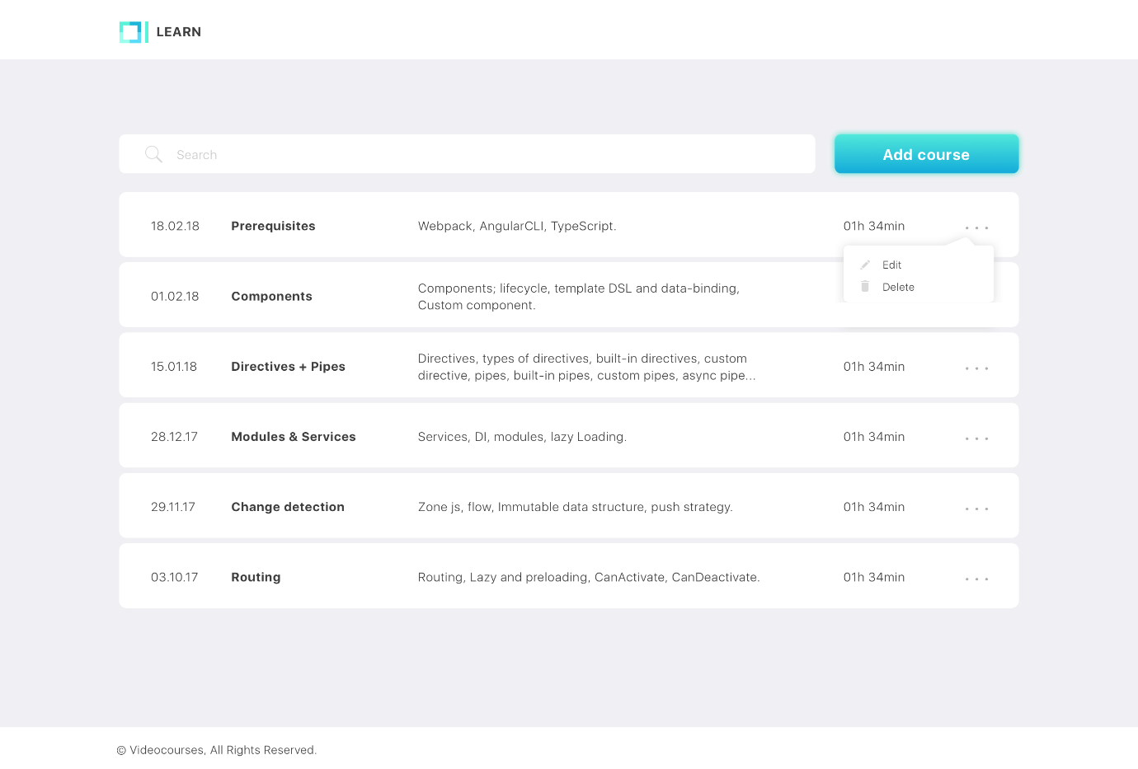

Figure 1 – Courses page

Functional requirements for courses list:

* *List with courses*, each course has the following information: ***date, name, description, duration***. Course panel has “3 dots” button, which opens options dropdown.
* *Options dropdown* has two possible actions: ***Edit*** (opens Figure 2), ***Delete*** (removes course from the list).
* *Search input*. When user types, courses list should be filtered by name.
* *Add course button.* On click opens Figure 2.

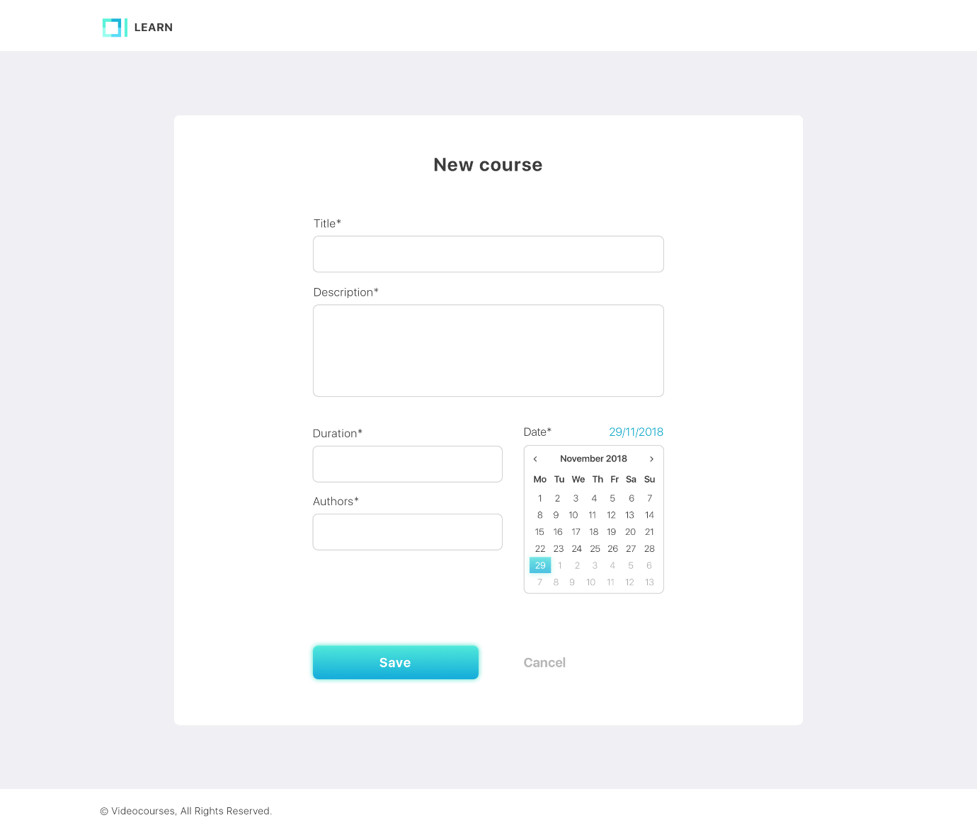

Figure 2 – Add/edit course form

Functional requirements for adding or editing single course:

* *Form header*. Text should differ depending on action. (‘Add course’ button or ‘Edit’ option from dropdown opened form)
* *Title field*. Text input for course name. In case of editing, prefilled with course name.
* *Description field*. Textarea for short course description. In case of editing, prefilled with course description.
* *Duration field*. Text field for course duration info. In case of editing, prefilled with course duration.
* *Authors field*. Text field for course authors info. In case of editing, prefilled with course authors.
* *Date field*. Date input for course date info (use default date input, no need to make it look like on Figure 2) . In case of editing, prefilled with course date.
* *Save button*. Disabled if form fields are empty (all of them are mandatory). Depending on action (add new or edit) on click course is updated with changed info (reflects in courses list) or adds new course to the list.
* *Cancel button*. Course info stays not changed or new course not added. User is redirected to courses list.

## PLEASE NOTE

* Pixel perfect is not required
* Icons for edit/delete actions located in *‘src’* folder

## RESTRICTIONS

* Using 3rd party tools is forbidden
* Using CSS frameworks is forbidden (e.g. Bootstrap, Materialize).

## HOW TO

* To run app on your localhost use `yarn start`

## BEFORE SUBMIT

* Remove all unnecessary files that you might have included by mistake
* Verify that all functionality is implemented according to requirements
* Make sure there are no errors/warnings in the browser console