Module 6.1 Capstone

Stella K Kypton L Julio P
C460 Capstone
Professor Osier
November 14, 2025

Module 6.1 Capstone
Resources:
Team Two Testing Document
KanBan Board
Moffat-Bay Repo
PLEASE WATCH ME to see Navgation tests
https://www.loom.com/share/86d6d38738374bfc8c5ae72f804a5b6f
https://www.loom.com/share/752085f369ae4f6581cb5c8d878821e5
T-1 , T-3 : New User Customers from Login/ Registration Table
User Kyle1 and Seth are accounted for on the bottom of table, and used for screenshots.
Before Creating Kyle1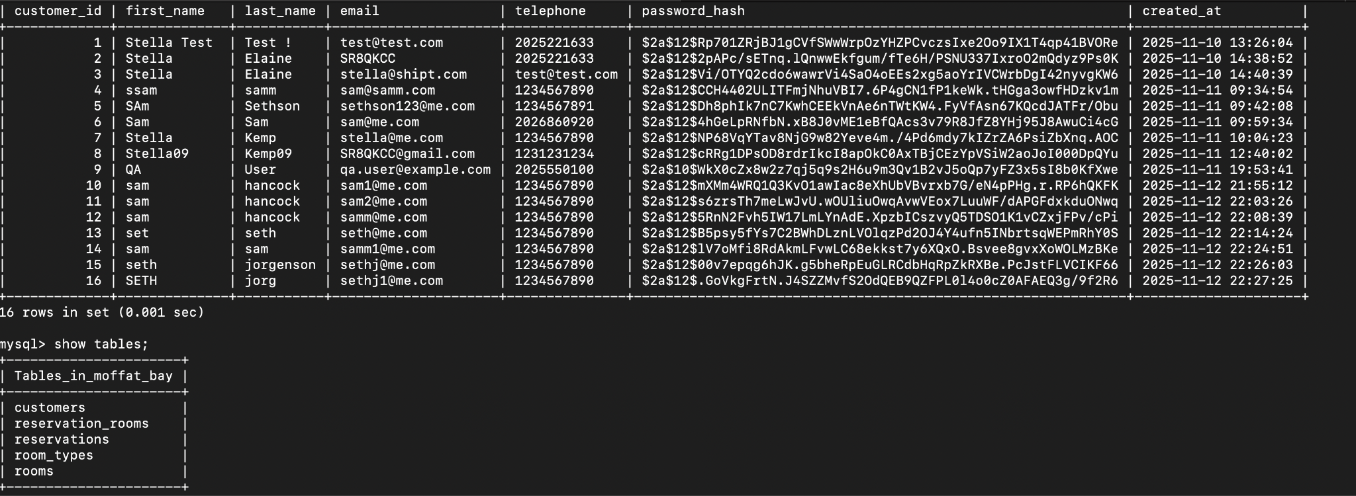
After Creating Kyle1
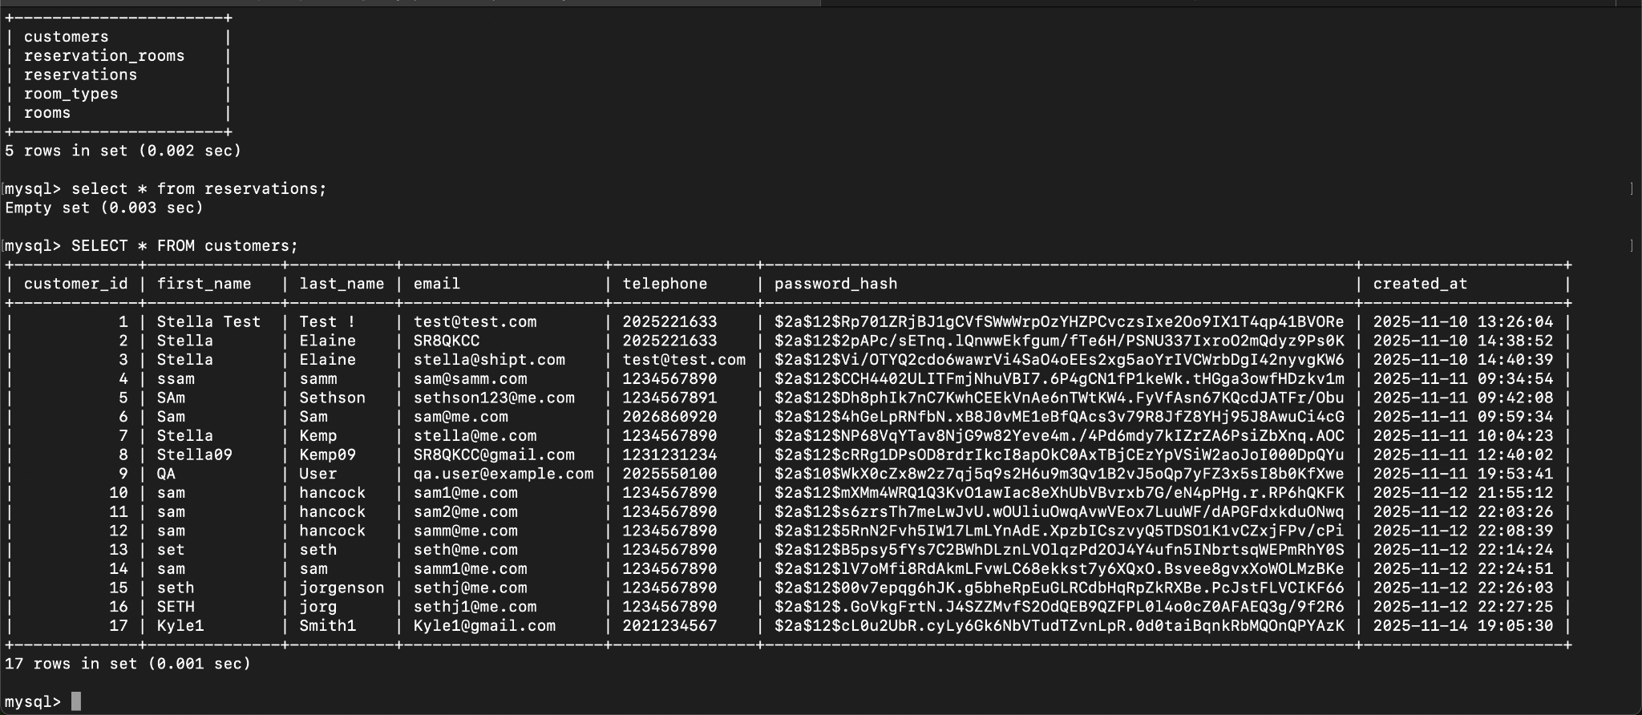

T-4 : Log in with invalid password
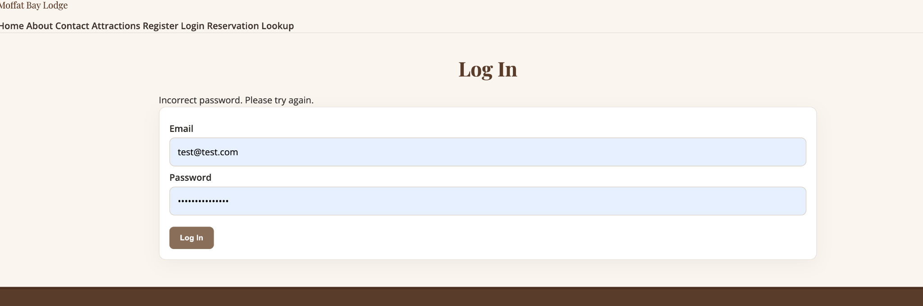
T-2: Account Creation:
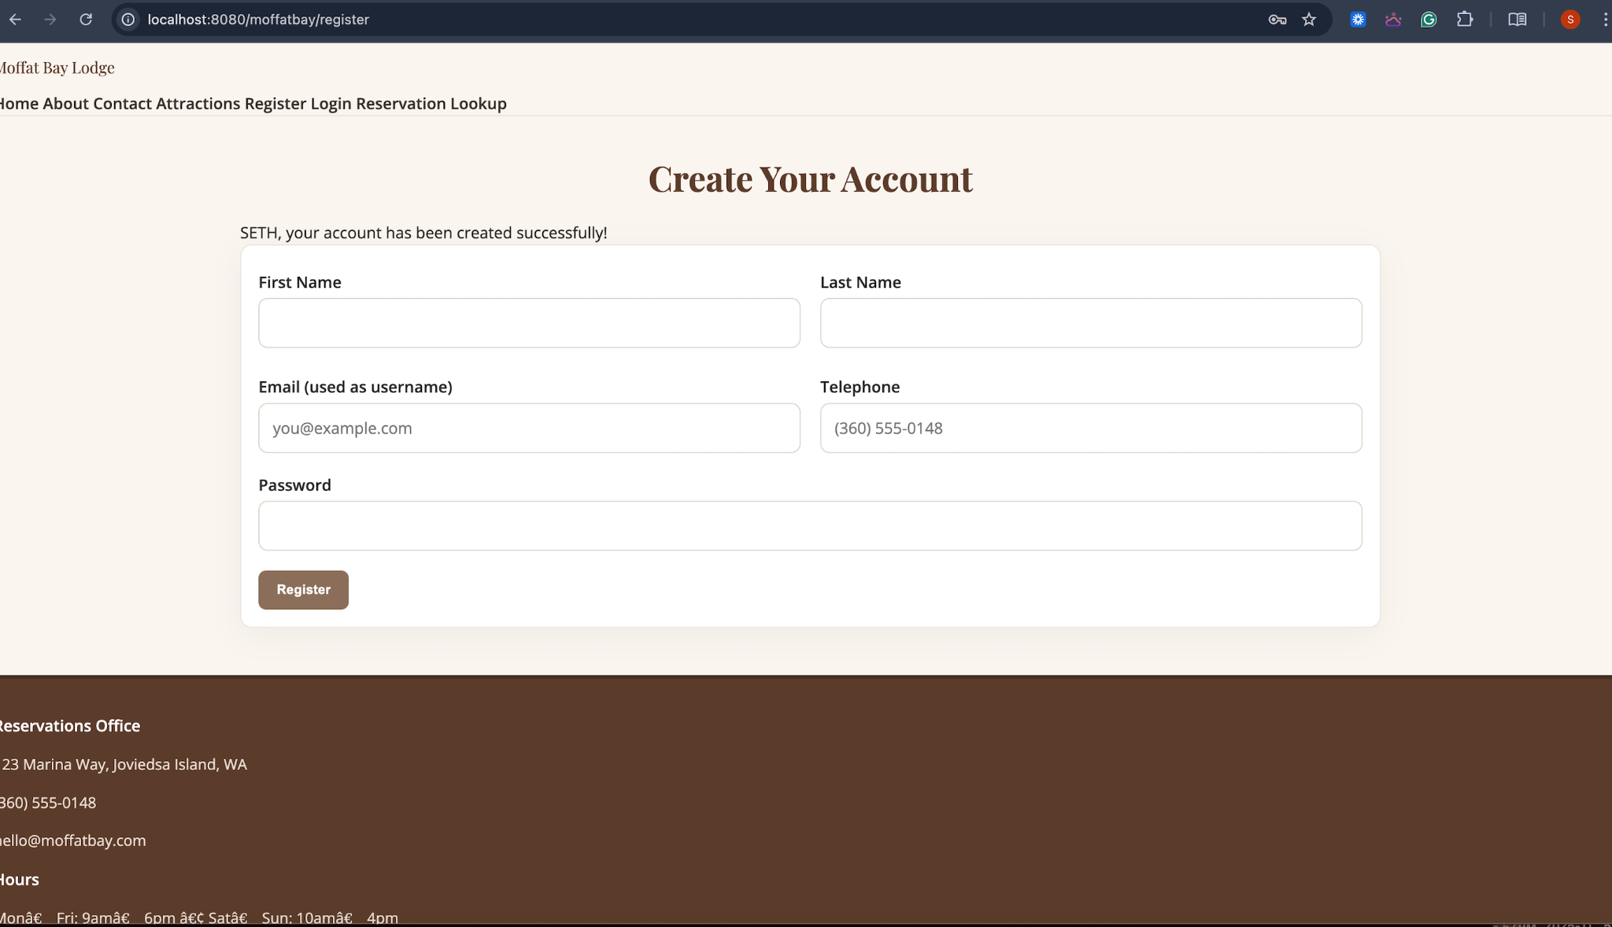
T-2: Duplicate Email Registration:
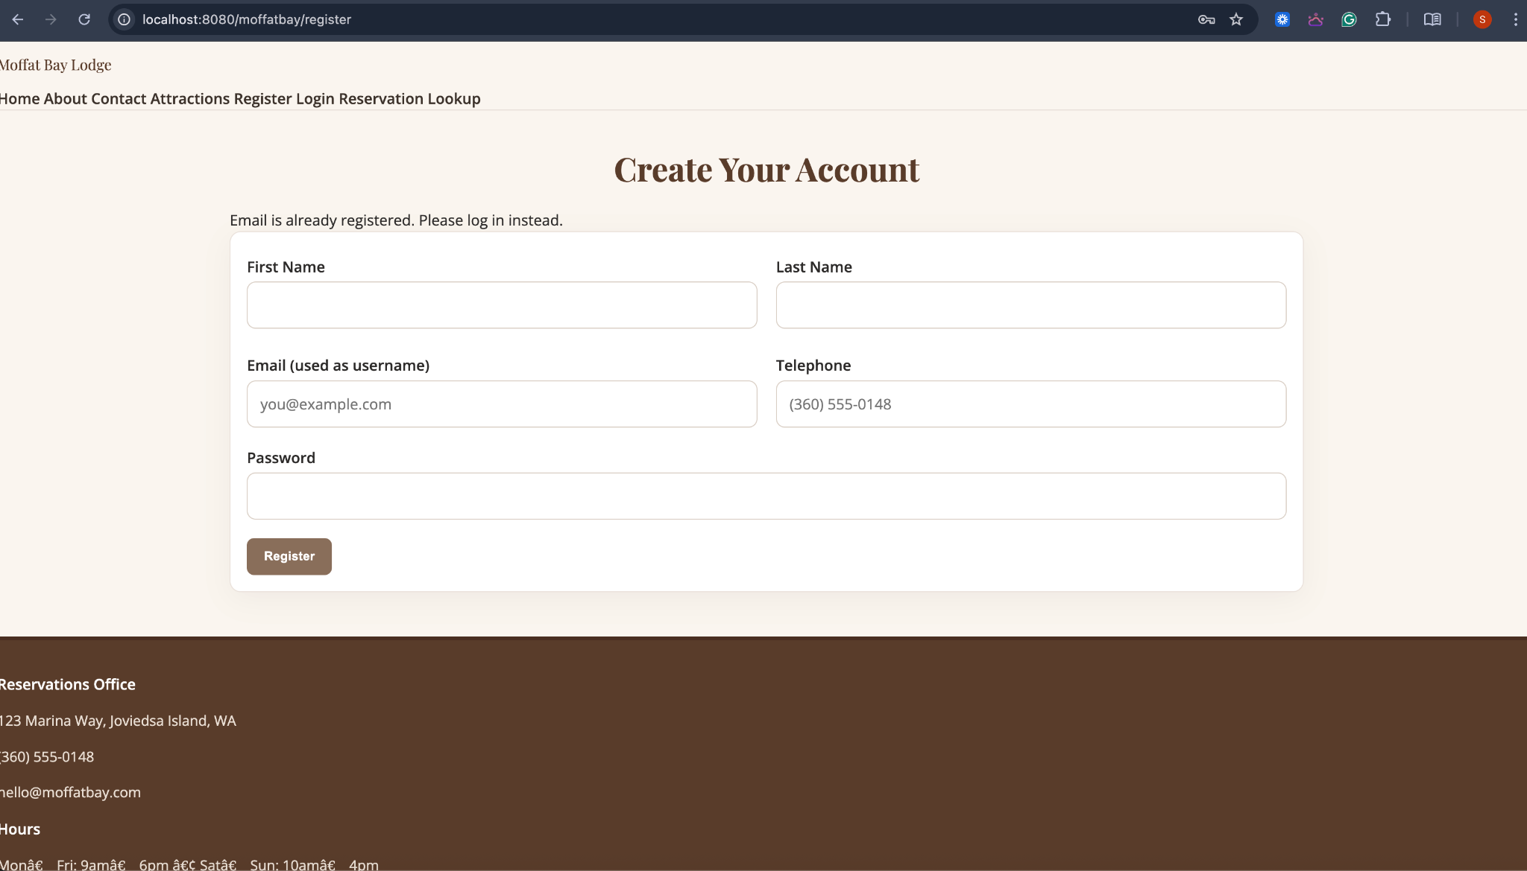
T-3: Login Flash Welcome Back Message under the Navigation Bar.
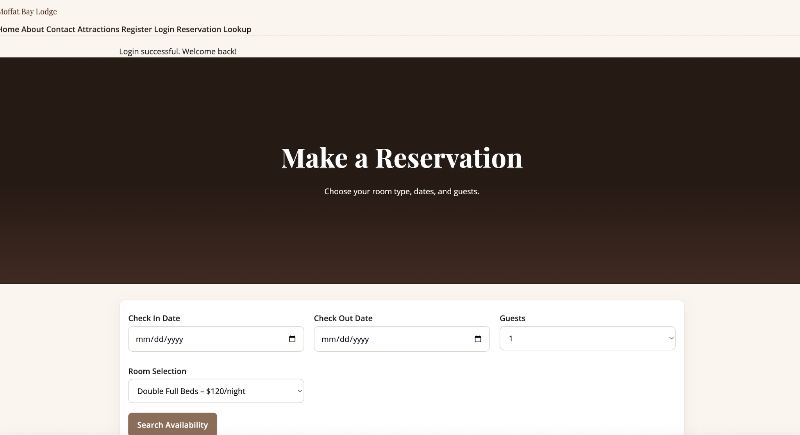
T-5: Landing Page
T-6 : Testing video with navigation
