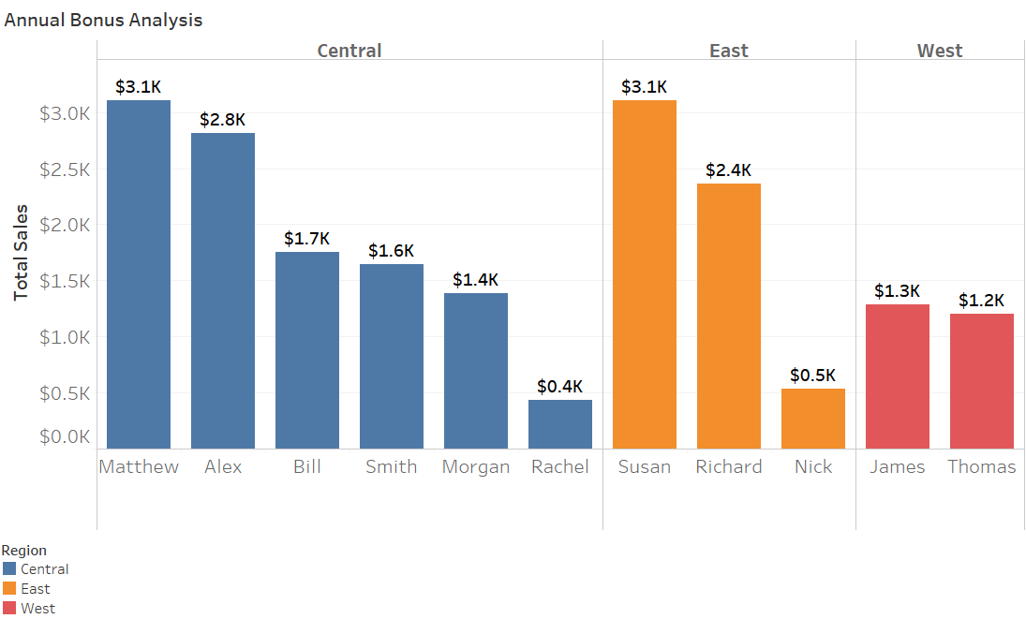***Annual Bonus Analysis Per Region***

***Top Sales Reps:***

Matthew Smith (Central)

Susan Koby (East)

James Lyon (West)