Purpose
Construction of a 20MW solar farm to support UNSW’s 2025 strategy by providing renewable energy, supporting solar research and providing hands-on learning opportunities for students.
WBS
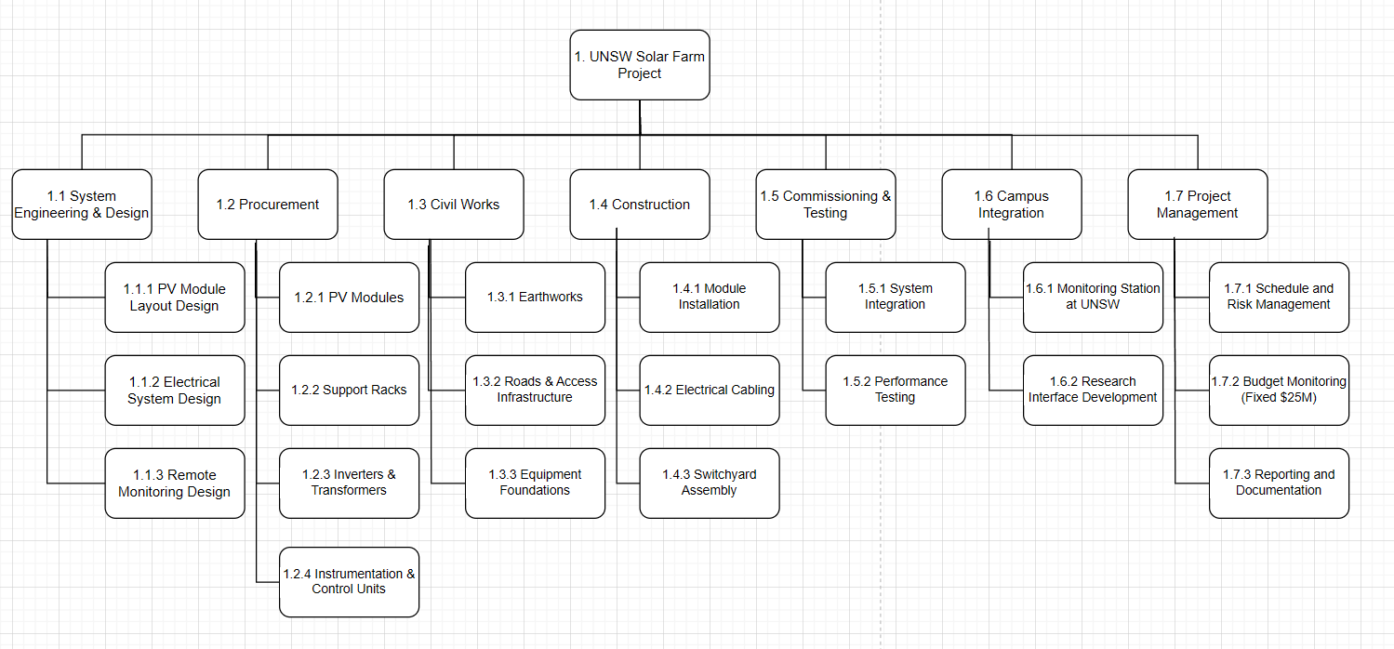Scope statement
The project will build a 20 MW photovoltaic solar farm at the University of New South Wales, which can be expanded to 30 MW. The project covers engineering design, equipment procurement, civil engineering, construction and grid connection. A remote control and monitoring system will also be installed on the UNSW campus to support solar energy research and education. The deliverables include photovoltaic panels, support structures, inverters, switch stations and performance-tested power infrastructure. The project does not include real-time artificial intelligence optimization or battery energy storage. The project budget is fixed at $25 million and is designed to align with the University of New South Wales' 2025 sustainability, academic excellence and innovation goals.

