**Report**

1. Unit test result

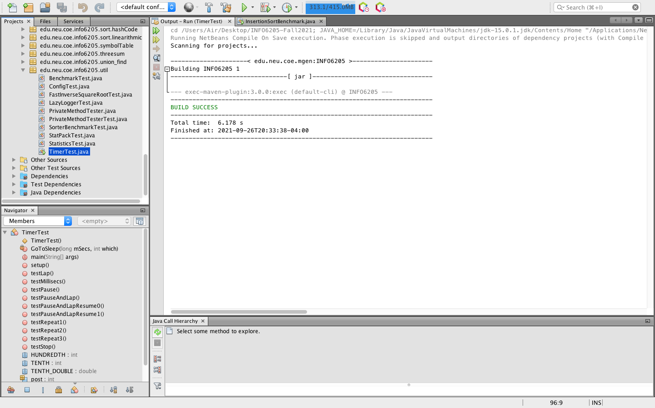

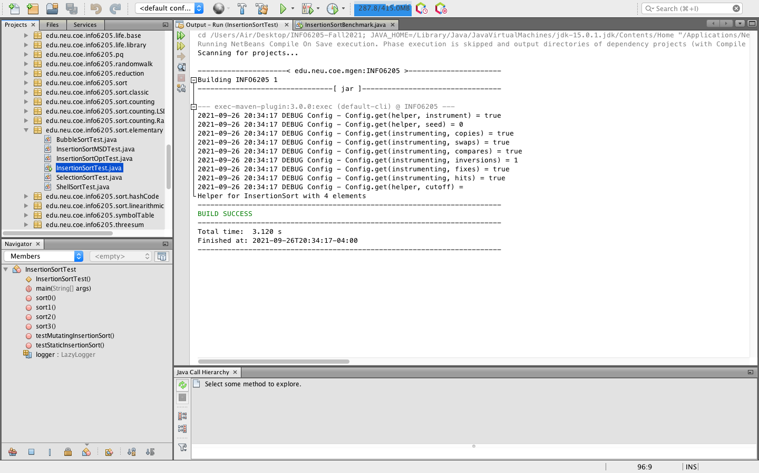

1. Run result

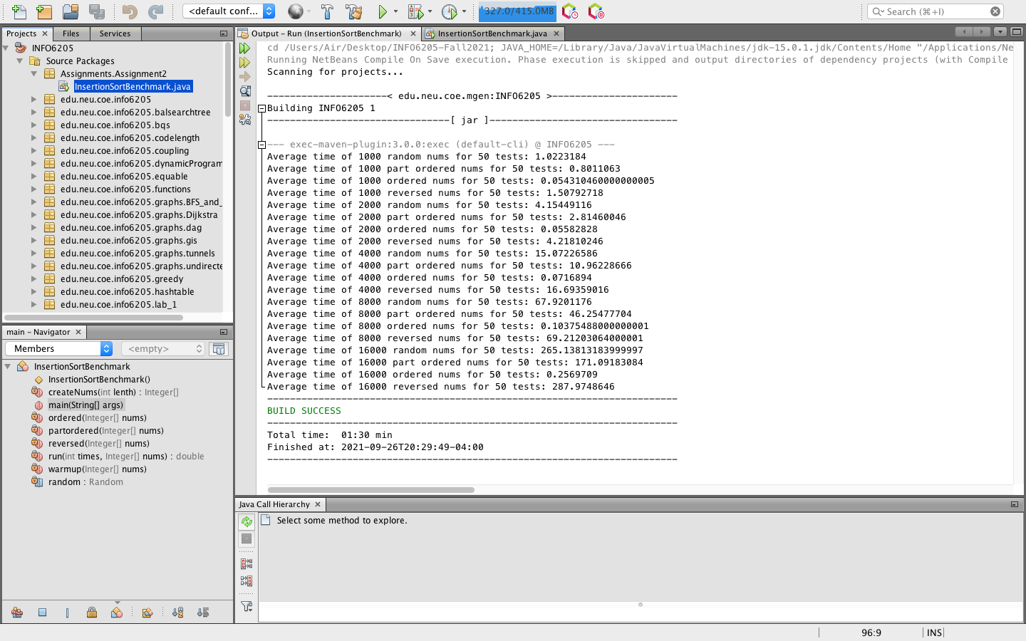

3.analysis

|  |  |  |  |  |
| --- | --- | --- | --- | --- |
| n | Random | PartiallyOrdered | Ordered | Reversed |
| 1000 | 1.022 | 0.801 | 0.054 | 1.508 |
| 2000 | 4.154 | 2.815 | 0.056 | 4.218 |
| 4000 | 15.072 | 10.962 | 0.072 | 16.694 |
| 8000 | 67.920 | 46.255 | 0.104 | 69.212 |
| 16000 | 265.138 | 171.092 | 0.257 | 287.975 |
| O(n) | n^2 | n^2 | n | n^2 |

1. Conclusion

In the best situation (Ordered), the insertion sort’s run time could be O(n). The run time would be doubled if the size of the input were doubled.

In Random, Partially Ordered, or the worst (Reversed) situation, the insertion sort’s run time could be O(n^2). The run time would be quadrupled if the size of the input were doubled.