Unit Test:

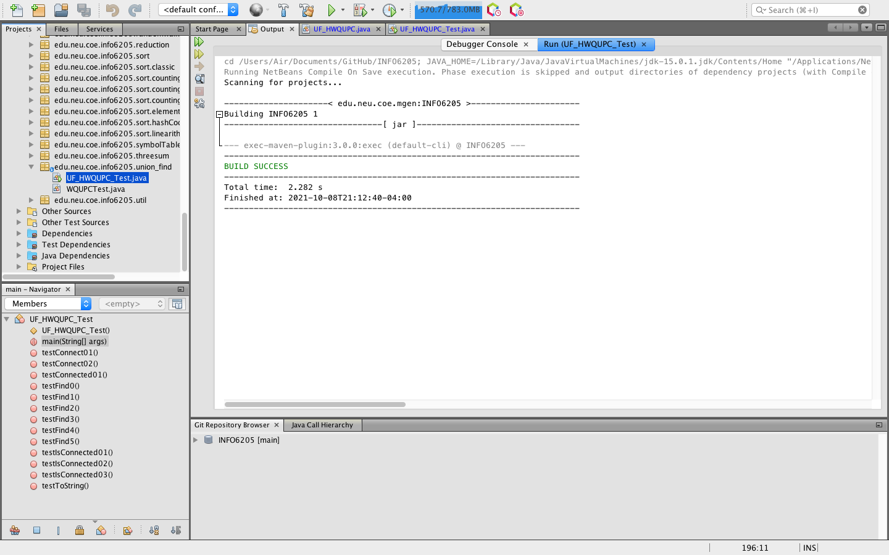

Output:

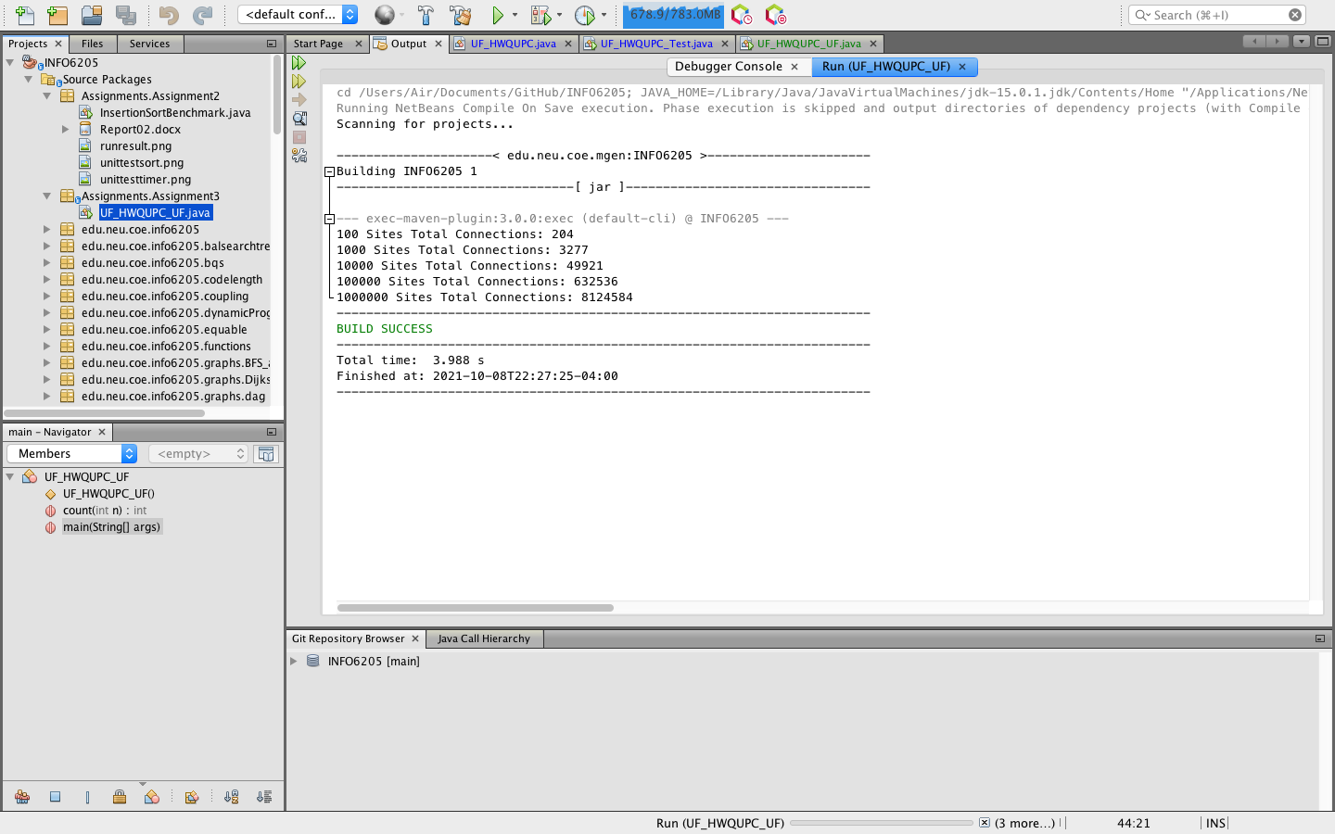

|  |  |  |  |  |  |
| --- | --- | --- | --- | --- | --- |
| N | 100 | 1000 | 10000 | 100000 | 1000000 |
| M | 204 | 3277 | 49921 | 632536 | 8124584 |

Conclusion:

Every time when N is multiplied by 10, M increases by more than 10 but less than 100. Therefore, the relationship between the pairs(M) and sites(N) is:

M=O(Nlog(N))