RETAIL BANKING ANALYTICS PROJECT

1.0 Project Overview

1.1 Title: Retail Banking Business Intelligence and Performance Analytics Using SQL and Excel

1.2 Abstract

This project presents an end-to-end retail banking analytics solution designed to examine customer behavior, transaction activity, loan performance, card usage, merchant trends, and risk distribution. Using SQL as the primary data processing tool and Excel for visualization and dashboarding, the project transforms raw banking data into structured reporting views and interactive insights.

The main objective is to develop a scalable analytical framework that supports business decision-making by providing clear visibility into customer segmentation, financial performance, and credit risk exposure.

Key findings reveal strong customer growth over time, significant concentration of loan exposure among high-risk customers, balanced adoption of banking products such as debit and credit cards, and a small subset of high-value customers and merchants contributing disproportionately to transaction volume.
1.3 Introduction
The banking industry generates large volumes of transactional and customer data that require structured analysis to support strategic decision-making. Financial institutions rely heavily on business intelligence systems to monitor customer activity, assess credit risk, track product performance, and optimize financial operations.
This project is centered on a simulated retail banking dataset covering customer profiles, accounts, transactions, loans, cards, and merchant activity from 2019 to 2025. The goal is to replicate a real-world banking analytics environment by building SQL-based reporting layers and transforming them into meaningful insights through Excel dashboards.
The relevance of this project lies in its ability to demonstrate how raw financial data can be transformed into actionable business intelligence for improved risk management, customer targeting, and revenue optimization.

1.4 Problem Statement
Retail banks often struggle to consolidate fragmented financial data into a unified view that supports decision-making. This leads to limited visibility into customer behavior, loan risk exposure, and product performance across different banking segments.
This project addresses the challenge of transforming raw banking data into structured analytical reports and dashboards that provide clear, actionable insights for business stakeholders.
1.5 Objective
The primary objectives of this project are:
- To design and implement a structured SQL-based data processing layer for retail banking data.
- To create analytical and reporting views that consolidate customer, transaction, loan, and card data.
- To analyze customer behavior trends, including acquisition, retention, and segmentation.
- To evaluate loan portfolio growth and assess risk distribution across customer categories.
- To examine transaction patterns and identify high-value customers and merchants.
- To assess card usage patterns and product adoption rates.
- To build an Excel-based dashboard that visualizes key performance indicators for business decision-making.
1.6 Tools and Technologies

Tool | Purpose
SQL Server | Data cleaning, transformation, aggregation and analysis
Microsoft Excel | Pivot table analysis, visualization, and dashboard creation
Notion | Project planning, documentation and insight management
draw.io | Entity Relationship Diagram

2.0 Data Description

2.1 Data Source
The dataset used for this project was obtained from Kaggle. It is a synthetic retail banking dataset designed for analytical and educational purposes. The dataset includes multiple relational tables representing core banking operations such as customers, accounts, transactions, loans, cards, and merchants.
The data was not collected from a real financial institution, and therefore represents simulated banking behavior structured to mimic real-world banking systems.
2.2 Data Characteristics

2.2.1 Entity Relationship Diagram

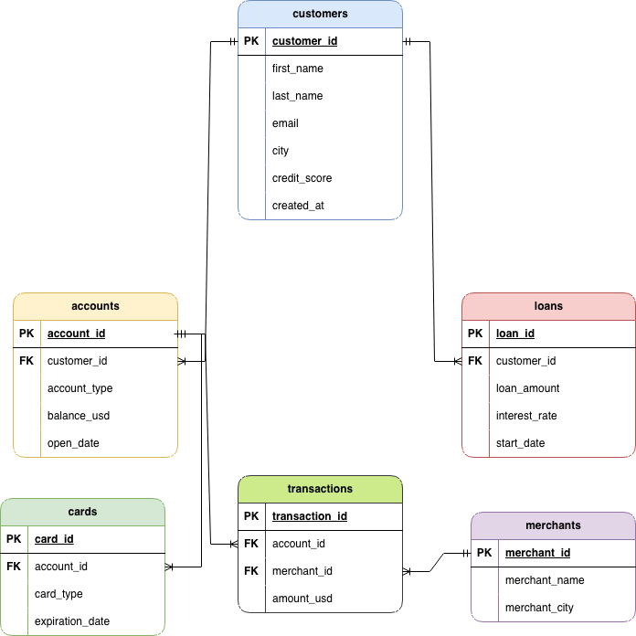
- The Customers table serves as the central entity within the model, containing demographic information, customer profiles, and risk-related attributes. Each customer can own multiple accounts and may also hold multiple loans.
- The Accounts table stores account-specific information, including account type, balances, and opening dates. Accounts act as the primary link between customers and their banking activities.
- The Cards table contains debit and credit card information associated with customer accounts. This enables analysis of card adoption, card status, and customer engagement with payment products.
- The Transactions table captures financial activity conducted through customer accounts. It records transaction values, dates, and merchant interactions, making it the primary fact table for transaction analysis.
- The Merchants table stores information about businesses involved in customer transactions and supports merchant-level performance analysis.
- The Loans table maintains lending records, including loan amounts, interest rates, repayment status, and loan durations. It enables portfolio monitoring and credit risk assessment.
The dataset includes both categorical and numerical variables, with temporal fields used for time-based analysis across 2019–2025.
2.2.2 Analytical Significance
This relation design enables a 360-degree view of customer activity by connecting customer profiles with account balances, loan exposure, card usage, transaction behaviour and merchant interactions.
The structure supports analysis in the following arrears:
- Customer segmentation and profiling
- Credit risk assessment
- Loan portfolio performance
- Transaction behavior analysis
- Card utilization monitoring
- Merchant performance evaluation
- Business intelligence reporting

2.3 Data Limitation
- Geographic Limitation
The dataset contains synthetic city values that do not represent real-world geography, limiting true spatial analysis.

- Branch Data Limitation
Branch data is not reliable for geographic validation and does not support meaningful regional mapping.

3.0 Methodology

3.1 Data Ingestion
Raw data was first loaded into a SQL database without modification. These raw tables were preserved to maintain data integrity and allow traceability.

3.2 Data Staging and Cleaning
To ensure data quality and analytical reliability, a staging layer was created. All data cleaning operations were performed on staging tables rather than raw tables.
Key cleaning steps included:
- Filtering of invalid transactions based on business rules
- Validation of temporal consistency across tables
- Handling of inconsistent or logically incorrect records
Loan Data Cleaning
A validation rule was applied to ensure that loan records were only valid if the loan start date occurred after the customer account creation date.
WHERE loan.start_date >= customer.created_at
This process removed approximately 50.24% of invalid loan records, improving data integrity for credit analysis.

Transaction Data Cleaning
Transactions were validated to ensure they occurred after account creation dates.
WHERE transaction_date >= account.open_date
This removed approximately 40.63% of invalid transactions and ensured accurate revenue and activity reporting.

3.3 Data Transformation & Feature Engineering
Generated Columns
- Risk category: Based on credit score ranges
Credit Score Range | Category
750 - 850 | Low Risk
600-749 | Medium Risk
Below 600 | High Risk

- Customer Type: Based on customer tenure
Customer Creation Date Range | Category
>= 2024/12/31 | New Customer
< 2024/12/31 | Old Customer

- Balance Category: Based on account balance
Balance Range | Category
< $10,000 | Low
< $50,000 | Moderate
< $100,000 | High
< $150,000 | Premium
> $150,000 | Elite

- Loan Category: Based on loan amount
Loan Range | Category
< $50,000 | Small Loan
<= $150,000 | Medium Loan
<= $250,000 | Large Loan
> $250,000 | Very Large Loan

- Card Status: Based on card expiration date
Date Range | Category
2026/06/30 | Active
Between 2026/01/01 & 2026/06/30 | Near Expiry
< 2025/12/31 | Expired

3.4 Exploratory Data Analysis
- CUSTOMER ANALYSIS
- Customer Distribution
WITH city_counts AS (
SELECT
city,
COUNT(customer_id) AS customer_count
FROM customers_staging
GROUP BY city
)
SELECT
customer_count,
COUNT(*) AS number_of_cities,
ROUND(100.0 * COUNT(*) / SUM(COUNT(*)) OVER (), 2) AS percent_of_cities
FROM city_counts
GROUP BY customer_count
ORDER BY customer_count;

Customer distribution across cities is highly fragmented, with 64.57% of cities having only one customer and over 82% having at most two customers. This indicates a widely dispersed customer base with low geographic concentration, while only a small number of cities account for high customer density.

- Customer Growth Trend

SELECT
YEAR(created_at) AS year,
COUNT(customer_id) AS new_customers
FROM customers_staging
GROUP BY
YEAR(created_at)
ORDER BY year;

SELECT
DATENAME(MONTH, created_at) AS month,
COUNT(customer_id) AS new_customers
FROM customers_staging
GROUP BY
DATENAME(MONTH, created_at)
ORDER BY MIN(MONTH(created_at));
The analysis shows that customer acquisition has remained stable over the observed period, with no significant growth spikes or declines. Yearly onboarding figures are relatively consistent, ranging from 6,953 customers in 2021 (the lowest) to 7,323 customers in 2025 (the highest), indicating a steady but slow growth pattern in the customer base.
At a monthly level, customer distribution is also fairly even across the year, with only minor fluctuations. January recorded the highest number of new customers at 4,335, while February had the lowest at 3,845, with all other months remaining close to the 4,000–4,300 range.
Overall, the results indicate that customer acquisition is consistent and evenly distributed over time, with no strong seasonal effects or aggressive growth trends, suggesting stable but non-accelerating expansion in the bank’s customer base.

- Risk Segmentation
SELECT
risk_category,
COUNT(customer_id) AS total_customers,
ROUND(COUNT(customer_id) * 100.0 / SUM(COUNT(customer_id)) OVER(), 2) AS customer_percentage
FROM customers_staging
GROUP BY risk_category
ORDER BY total_customers DESC;
The analysis revealed that the bank’s customer base is heavily concentrated in the High Risk category, with 27,296 customers (54.59%), indicating a higher likelihood of loan default and increased lending exposure.
Customers in the Medium Risk category accounted for 13,665 customers (27.33%), representing borrowers with moderate credit reliability.
The Low Risk category had the smallest share, with 9,039 customers (18.08%), representing the bank’s most financially reliable customers with lower default risk.
- Customer Tenure
SELECT
customer_type,
COUNT(customer_id) AS total_customers,
ROUND(COUNT(customer_id) * 100.0 / SUM(COUNT(customer_id)) OVER(), 2) AS customer_percentage
FROM customers_staging
GROUP BY customer_type
ORDER BY total_customers DESC;
The analysis shows that the majority of customers are long-standing account holders. Old Customers account for 42,659 (85.32%), indicating a highly mature customer base. In contrast, New Customers represent 7,341 (14.68%), showing relatively low recent customer acquisition compared to the existing base. This also shows the bank’s customer base is largely stable and retention-driven rather than growth-driven, with a strong dominance of long-term customers.

2. ACCOUNT ANALYSIS
- Account Type Distribution
SELECT
account_type,
COUNT(account_id) AS total_accounts,
ROUND(COUNT(account_id) * 100.0 / SUM(COUNT(account_id)) OVER (), 2) AS percentage
FROM accounts_staging
GROUP BY account_type
ORDER BY total_accounts DESC;
The analysis shows that account distribution is almost perfectly balanced across all account types. Checking accounts account for 25,090 accounts (33.45%), making them the most common account type, closely followed by Savings accounts with 24,962 accounts (33.28%) and Business accounts with 24,948 accounts (33.26%).
Overall, the results indicate that the bank maintains a highly diversified account portfolio with no single account type dominating customer usage.
- Balance Analysis
SELECT
account_type,
ROUND(AVG(balance_usd), 2) AS avg_balance
FROM accounts_staging
GROUP BY account_type
ORDER BY avg_balance DESC;
The analysis shows that average account balances are relatively similar across all account types, indicating a fairly even distribution of customer funds within the bank. Savings accounts recorded the highest average balance at $100,242.42, followed closely by Business accounts at $100,154.94 and Checking accounts at $100,147.97.
Overall, the minimal variation in average balances suggests that customer deposit behavior is consistent across account categories, with no account type showing significantly higher fund concentration.

- Account Ownership
SELECT
balance_category,
COUNT(account_id) AS total_accounts,
ROUND(COUNT(account_id) * 100.0 / SUM(COUNT(account_id)) OVER (), 2) AS percentage
FROM accounts_staging
GROUP BY balance_category
ORDER BY total_accounts DESC;

The analysis shows that the majority of accounts are concentrated in the higher balance segments. Premium accounts represent the largest category with 18,875 accounts (25.17%), closely followed by High balance accounts with 18,792 accounts (25.06%) and Elite accounts with 18,739 accounts (24.99%).
In comparison, Moderate balance accounts account for 14,854 accounts (19.81%), while Low balance accounts form the smallest segment with 3,740 accounts (4.99%).
Overall, the results indicate that the bank’s account portfolio is heavily weighted toward customers with relatively strong account balances, suggesting a financially healthy customer base with significant fund concentration in higher-value accounts.

- Account Opening Trends
Monthly Account Opening Trend
SELECT
DATENAME(MONTH, open_date) AS opening_month,
COUNT(account_id) AS accounts_opened
FROM accounts_staging
GROUP BY DATENAME(MONTH, open_date)
ORDER BY MIN(MONTH(open_date));

Yearly Account Opening Trend
SELECT
YEAR(open_date) AS opening_year,
COUNT(account_id) AS accounts_opened
FROM accounts_staging
GROUP BY YEAR(open_date)
ORDER BY opening_year;
The analysis shows that account openings remained consistently distributed throughout the year, with only minor monthly fluctuations. May recorded the highest number of account openings with 6,450 accounts, while February had the lowest with 5,778 accounts. Most other months maintained a relatively stable range between approximately 6,100 and 6,400 account openings.
Yearly trends also indicate stable account growth over time. Account openings increased slightly from 10,510 accounts in 2019 to 10,911 accounts in 2025, with no major spikes or declines observed across the period.
Overall, the results suggest that account creation activity is steady and evenly distributed across both months and years, indicating consistent customer onboarding performance without strong seasonal or growth-driven fluctuations.
3. CARD ANALYSIS
- Card Type Distribution
SELECT
card_type,
COUNT(card_id) AS total_cards,
ROUND(COUNT(card_id) * 100.0 / SUM(COUNT(card_id)) OVER(), 2) AS percent_share
FROM cards_staging
GROUP BY card_type;
The analysis shows that card ownership is almost evenly distributed between debit and credit cards. Debit cards account for 50,281 cards (50.28%), slightly exceeding credit cards with 49,719 cards (49.72%).
Overall, the near-equal distribution suggests balanced customer adoption of both transactional banking services and credit-based financial products, indicating a diversified card portfolio within the bank.

- Card Status Analysis
SELECT
card_status,
COUNT(card_id) AS total_cards,
ROUND(COUNT(card_id) * 100.0 / SUM(COUNT(card_id)) OVER(), 2) AS percent_share
FROM cards_staging
GROUP BY card_status
ORDER BY total_cards DESC;
The analysis shows that the majority of cards remain active and usable. Active cards account for 81,153 cards (81.15%), representing the dominant share of the bank’s card portfolio.
In comparison, 12,638 cards (12.64%) are expired, while 6,209 cards (6.21%) are classified as near expiry, indicating a smaller portion of cards that may require renewal or replacement.
Overall, the results suggest that the bank maintains a largely active card base, though the presence of expired and near-expiry cards highlights opportunities for proactive card renewal and customer retention initiatives.

4. LOAN ANALYSIS
- Loan Portfolio Overview
SELECT
SUM(loan_amount) AS total_loan_amount,
ROUND(AVG(loan_amount), 2) AS avg_loan_amount,
MAX(loan_amount) AS max_loan_amount,
MIN(loan_amount) AS min_loan_amount,
MAX(interest_rate) AS max_interest_rate,
MIN(interest_rate) AS min_interest_rate
FROM loans_staging

The analysis shows that the bank issued a total of $2.24 billion in loans between 2019 and 2025, reflecting a substantial lending portfolio over the observed period.
The average loan amount was $150,269.15, indicating moderate-to-high lending activity across customers. Loan values ranged significantly, from a minimum of $1,020.04 to a maximum of $299,967.79, demonstrating a diverse mix of small and large loans within the portfolio.
Interest rates also varied across the loan book, ranging from 2% to 15%, suggesting differentiated pricing strategies based on customer risk profiles and lending conditions.
Overall, the results indicate that the bank maintains a broad and diversified lending portfolio across varying loan sizes and interest rate levels.
- Loan Growth Trends

I. Month-over-Month Loan Growth Analysis
WITH monthly_loans AS (
SELECT
DATEFROMPARTS(YEAR(start_date), MONTH(start_date), 1) AS loan_month_date,
SUM(loan_amount) AS total_loan_amount
FROM loans_staging
GROUP BY DATEFROMPARTS(YEAR(start_date), MONTH(start_date), 1)
)
SELECT
DATENAME(MONTH, loan_month_date) + ' ' + CAST(YEAR(loan_month_date) AS VARCHAR) AS loan_month,
total_loan_amount,
LAG(total_loan_amount) OVER (
ORDER BY loan_month_date
) AS previous_month_amount,
total_loan_amount - LAG(total_loan_amount) OVER (
ORDER BY loan_month_date
) AS month_change,
ROUND(
(total_loan_amount - LAG(total_loan_amount) OVER (ORDER BY loan_month_date))
* 100.0 /
LAG(total_loan_amount) OVER (ORDER BY loan_month_date),
2
) AS mom_growth_percentage
FROM monthly_loans
ORDER BY loan_month_date;
The analysis shows a strong upward trend in the bank’s lending activity between 2019 and 2025, with total monthly loan issuance increasing significantly over time.
Loan disbursement grew from $536.1K in February 2019 to peaks above $54.8M by June 2025, indicating substantial expansion in the bank’s loan portfolio.
Several periods experienced sharp positive growth:
- March 2019 recorded a 316.83% increase compared to February 2019.
- July 2020 showed a 66.03% growth in loan value.
- November 2024 experienced another major increase of 26.91%.
Despite the overall growth trend, the portfolio also showed periods of contraction and volatility:
- August 2023 declined by 18.22% month-over-month.
- October 2024 recorded a 14.25% decrease in lending activity.
- Multiple years showed alternating periods of growth and decline, indicating cyclical lending behavior and possible seasonality in loan demand.
Overall, the analysis highlights sustained long-term growth in loan issuance while revealing short-term fluctuations in monthly lending performance.

II. Year-over-Year Loan Growth Analysis
SELECT
loan_year,
total_loan_amount,
LAG(total_loan_amount) OVER (
ORDER BY loan_year
) AS previous_year_amount,
total_loan_amount
- LAG(total_loan_amount) OVER (
ORDER BY loan_year
) AS yearly_change,
ROUND(
(
(total_loan_amount - LAG(total_loan_amount) OVER (ORDER BY loan_year))
* 100.0
)
/
LAG(total_loan_amount) OVER (ORDER BY loan_year),
2
) AS yoy_growth_percentage
FROM yearly_loans
ORDER BY loan_year;
The analysis reveals consistent year-over-year growth in the bank’s loan portfolio between 2019 and 2025, indicating sustained expansion in lending activity over time.
Total annual loan disbursement increased significantly from $53.3M in 2019 to $602.1M in 2025. The most substantial growth occurred in 2020, where total loan issuance rose by 158.99% compared to 2019, reflecting a period of rapid portfolio expansion.
Although the percentage growth rate gradually declined in subsequent years, the total loan value continued to increase annually:
- 2021: 66.30% growth
- 2022: 36.21% growth
- 2023: 27.90% growth
- 2024: 27.21% growth
- 2025: 18.40% growth
The declining growth percentages do not indicate a reduction in lending activity. Instead, they suggest the bank is transitioning from an early high-growth phase into a more mature and stable expansion stage. Despite the moderation in growth rate, the bank continued to add substantial loan value each year, including $108.8M in 2024 and $93.6M in 2025.
Overall, the analysis highlights strong long-term portfolio growth, increasing lending capacity, and sustained customer demand across the reporting period.
- Customer Loan Exposure (Top borrowers)
SELECT TOP 10
customer_id,
SUM(loan_amount) AS total_borrowed
FROM loans_staging
GROUP BY customer_id
ORDER BY total_borrowed DESC;
The analysis identifies customers with the highest cumulative borrowing amounts across the loan portfolio.
The top borrower, CUS6TIDFXYBMJW1, accumulated total loans of $899.0K, followed closely by other high-value borrowers with loan exposure ranging between $787.8K and $876.2K.
The results indicate that a small group of customers accounts for a significant portion of high-value lending activity, highlighting areas of concentrated credit exposure within the portfolio.
- Loan Category Analysis
SELECT
loan_category,
COUNT(loan_id) AS total_loans
FROM loans_staging
GROUP BY loan_category
ORDER BY total_loans DESC;
The analysis shows that the bank’s loan portfolio is primarily concentrated in medium and large-sized loans. Medium Loans represent the largest segment with 5,032 loans, closely followed by Large Loans with 4,985 loans.
In comparison, Very Large Loans account for 2,468 loans, while Small Loans represent the smallest category with 2,446 loans.
Overall, the results indicate that the bank’s lending activity is heavily focused on moderate-to-high value lending, suggesting a portfolio strategy centered around medium and large loan financing rather than small-scale lending.
5. MERCHANT ANALYSIS
- Merchant Distribution
WITH merchant_city_counts AS (
SELECT
city,
COUNT(merchant_id) AS total_merchants
FROM merchants_staging
GROUP BY city
)
SELECT TOP 10
city,
total_merchants,
DENSE_RANK() OVER (ORDER BY total_merchants DESC) AS city_rank
FROM merchant_city_counts
ORDER BY total_merchants DESC;

This analysis examines the distribution of merchants across cities and ranks cities based on merchant concentration using a dense ranking approach.
The results reveal a highly uneven distribution of merchants across cities, with a small number of cities hosting significantly higher merchant activity compared to others.
The top-ranked cities by merchant count include North Robert (8 merchants), followed by New Michael, Port Michael, and Sarahmouth (6 merchants each). These cities represent the highest concentration of merchant presence in the dataset.
A dense ranking system was applied to group cities with equal merchant counts into the same rank. This helps highlight natural clusters of merchant density rather than treating each city in isolation.
- Rank 1: Cities with 8 merchants
- Rank 2: Cities with 6 merchants
- Rank 3: Cities with 5 merchants
- Rank 4 and below: Gradual decline in merchant concentration
Overall, the analysis shows that merchant activity is concentrated in a limited number of high-density cities, while a long tail of cities contains significantly fewer merchants.
- Top Merchant
SELECT TOP 5
m.merchant_name,
SUM(t.amount_usd) as total_transaction_amount
FROM transactions_staging t
JOIN merchants_staging m
ON t.merchant_id = m.merchant_id
GROUP BY
m.merchant_name
ORDER BY total_transaction_amount DESC;
Analysis of merchant transaction activity identified the top five merchants by total transaction value. Johnson PLC ranked first with $3.45 million in transactions, followed closely by Smith Inc ($3.44 million) and Johnson Inc ($3.39 million). Brown Ltd and Williams LLC completed the top five with $2.82 million and $2.77 million, respectively. The results indicate that a small group of merchants contributes a significant share of overall transaction volume, making them key drivers of transaction activity and valuable targets for merchant relationship and business growth initiatives.

6. TRANSACTION ANALYSIS
- Transaction Overview
SELECT
SUM(amount_usd) AS total_transaction_amount,
COUNT(transaction_id) AS total_transactions,
AVG(amount_usd) AS average_transaction_amount,
MIN(amount_usd) AS minimum_transaction_amount,
MAX(amount_usd) AS maximum_transaction_amount
FROM transactions_staging;
The analysis revealed a total transaction value of $2.38 billion generated from 477,060 transactions recorded during the study period. This indicates a high level of customer transaction activity and demonstrates significant utilization of banking services across the institution.
The average transaction amount was $4,993.97, suggesting that customer transactions were generally of moderate to high value. The transaction values ranged from a minimum of $1.02 to a maximum of $9,999.98, highlighting a broad spectrum of customer spending and transfer behaviors.
These findings provide an overall view of transaction performance and establish a baseline for further analysis of customer behavior, transaction patterns, channel utilization, merchant activity, and revenue-generating opportunities. The substantial transaction volume and value also reflect the scale of operations managed by the bank and underscore the importance of efficient transaction processing systems and customer engagement strategies.
- Top Customers by Transaction Value
SELECT TOP 5
c.customer_name,
SUM(amount_usd) AS total_spent
FROM transactions_staging t
JOIN accounts_staging a
ON t.account_id = a.account_id
JOIN customers_staging c
ON a.customer_id = c.customer_id
GROUP BY c.customer_name
ORDER BY total_spent DESC;

The analysis revealed that Michael Johnson recorded the highest transaction value, generating a cumulative transaction amount of $1.55 million. He was followed by David Brown with $1.33 million, while John Williams, Matthew Johnson, and Joseph Smith contributed transaction values of $1.27 million, $1.23 million, and $1.22 million respectively.
The concentration of transaction activity among these customers highlights a segment of high-value account holders who contribute significantly to the bank's overall transaction volume and value. These customers represent potential candidates for premium banking services, personalized relationship management, wealth management products, and targeted retention strategies.
Monitoring high-value customers is essential for maintaining customer loyalty, identifying cross-selling opportunities, and maximizing long-term customer lifetime value. Understanding the behavior and financial needs of this segment can support the development of tailored banking solutions that enhance both customer satisfaction and revenue generation.
- Identification of Customers with Unusually Large Transactions
SELECT
c.customer_name,
MAX(amount_usd) AS max_transaction,
ROUND(AVG(amount_usd), 2) AS avg_transaction
FROM transactions_staging t
JOIN accounts_staging a
ON t.account_id = a.account_id
JOIN customers_staging c
ON a.customer_id = c.customer_id
GROUP BY c.customer_name
HAVING MAX(amount_usd) > 3 * AVG(amount_usd)
ORDER BY max_transaction DESC;
To detect potentially unusual transaction patterns, customer transaction behavior was analyzed by comparing each customer's maximum transaction amount to their average transaction value. Customers were flagged where the highest recorded transaction exceeded three times their average transaction amount.
The analysis identified a significant number of customers exhibiting transaction behavior that deviated substantially from their normal spending patterns. For example, Rose Bates recorded a maximum transaction of $9,997.05 compared to an average transaction value of $3,119.63, while Ian Garcia and Laurie Norris recorded maximum transactions of $9,964.15 and $9,929.81 respectively, each exceeding three times their average transaction amounts.
A recurring pattern observed across the identified customers was the presence of single high-value transactions close to the upper transaction limit, while their average transaction values remained considerably lower. This suggests occasional spikes in transaction activity that differ from typical customer behavior.
From a business and risk management perspective, these customers may warrant further investigation to determine whether the transactions represent legitimate high-value activities, one-time purchases, investment movements, business-related payments, or potential fraud risks. Such analyses are commonly used in banking institutions to support transaction monitoring, anomaly detection, anti-money laundering (AML) initiatives, and customer behavior profiling.
The findings demonstrate the value of behavioral analysis in identifying customers whose transaction patterns differ significantly from established norms, enabling the bank to strengthen risk controls while gaining deeper insight into customer financial activities.

3.5 Reporting Layer

A reporting layer was created using SQL views to generate structured datasets for analysis. These reporting views were used as input into Excel for further aggregation and visualization.

3.6 Visualization Layer
The final analysis was performed in Excel using:
- Pivot tables
- Charts and visual summaries
- KPI aggregation
- Dashboards
This enabled interactive exploration of banking performance metrics and business insights.

4.0 Dashboard Development

4.1 Executive Summary Dashboard
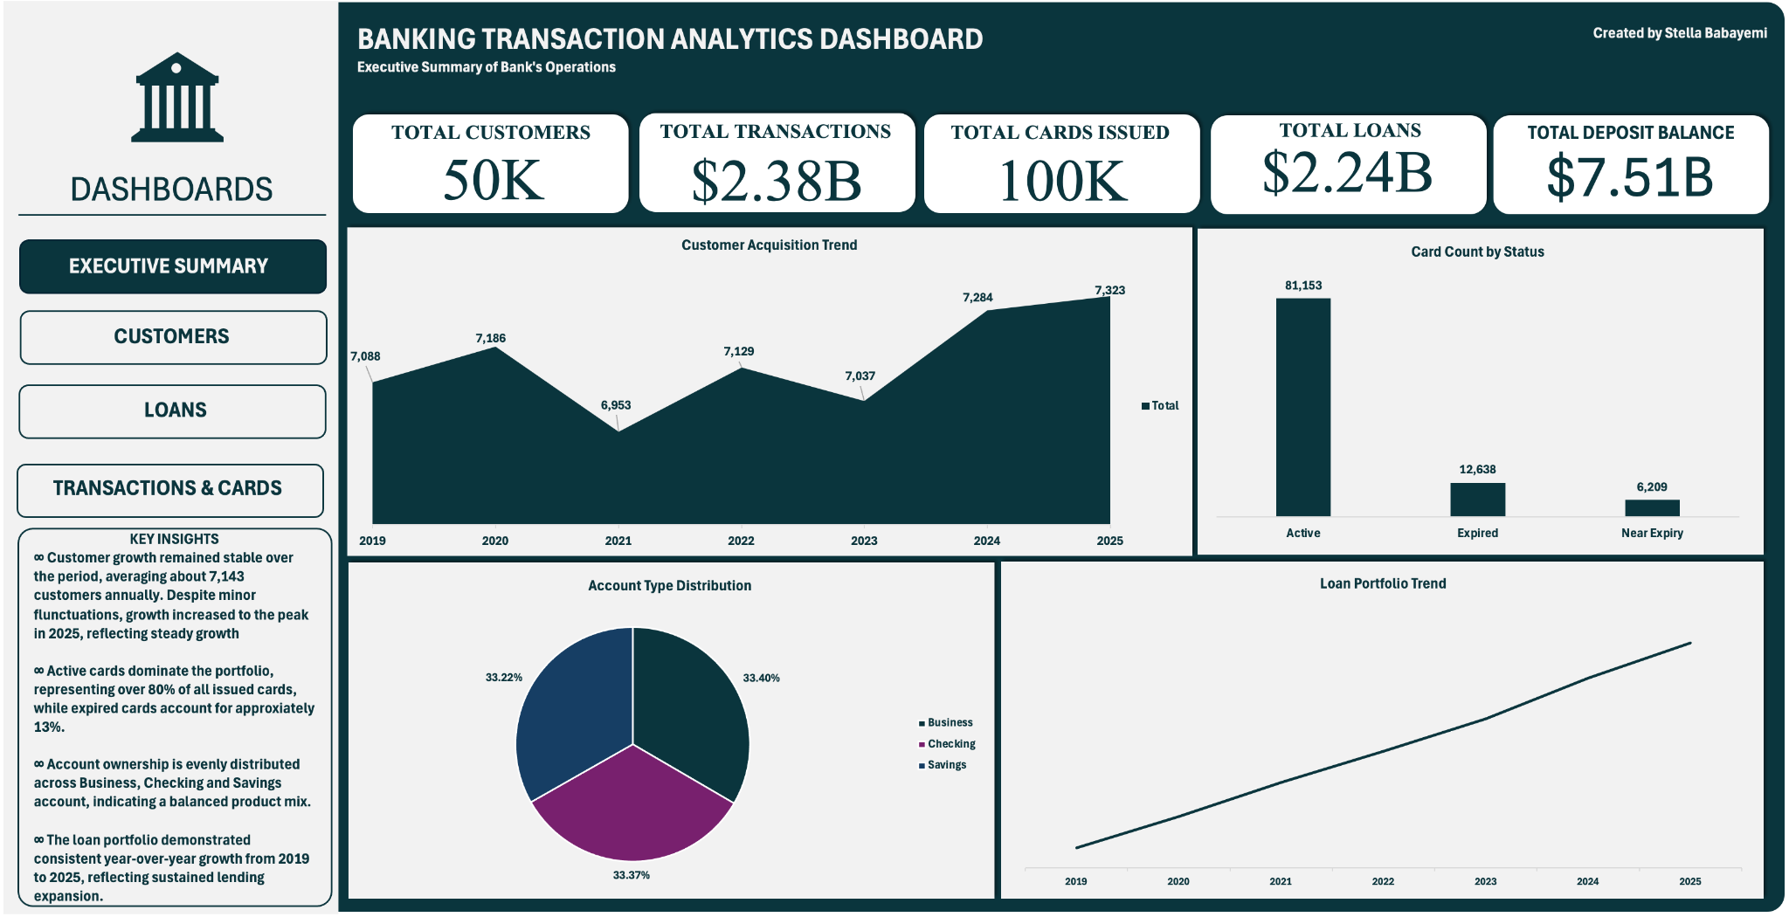
The Executive Summary Dashboard provides a high-level overview of the bank's performance across key customer, transaction, card, deposit, and lending metrics. During the analysis period, the bank served approximately 50,000 customers, processed $2.38 billion in transaction value, issued over 100,000 cards, maintained a $7.51 billion deposit portfolio, and managed a $2.24 billion loan portfolio.
The customer acquisition trend demonstrates consistent growth throughout the period, with annual customer additions ranging between approximately 6,900 and 7,300 customers. Customer onboarding increased from 7,068 customers in 2019 to 7,323 customers in 2025, indicating sustained customer acquisition efforts and a stable expansion of the bank's customer base over time.
Card portfolio analysis shows that the majority of issued cards remain active, with 81,153 active cards, representing strong customer engagement and card utilization. A smaller portion of the portfolio consists of 12,638 expired cards and 6,209 cards nearing expiration, highlighting opportunities for card renewal campaigns and customer retention initiatives.
The account type distribution reveals a well-balanced portfolio across product categories. Business accounts account for 33.4% of all accounts, while Checking and Savings accounts represent 33.37% and 33.22% respectively. This near-equal distribution suggests a diversified customer base and balanced adoption of the bank's core account offerings.
The loan portfolio trend exhibits steady year-over-year growth from 2019 through 2025, reflecting increasing lending activity and continued expansion of the bank's credit operations. The upward trajectory indicates effective loan origination strategies and sustained demand for lending products across the customer base.
Overall, the dashboard highlights a financially healthy institution characterized by consistent customer growth, strong transaction activity, high card engagement, a diversified account portfolio, and an expanding loan book. These indicators collectively demonstrate stable operational performance and continued business growth throughout the reporting period.

4.2 Customer Dashboard
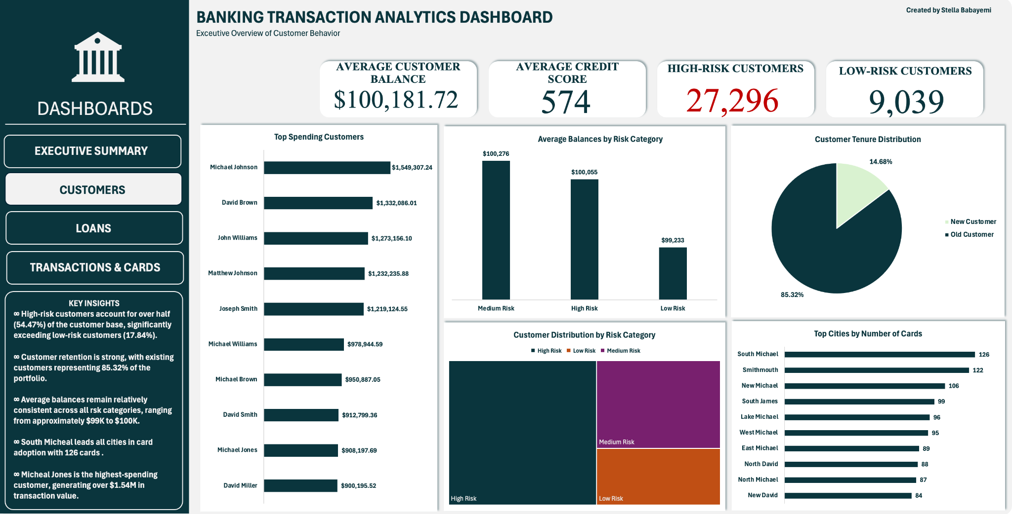
The Customer Dashboard provides insights into customer financial behavior, risk segmentation, account balances, tenure distribution, and geographic card ownership patterns. The analysis shows that customers maintained an average account balance of $100,181.72, while the overall average credit score was 574, indicating a customer base with varying levels of creditworthiness and risk exposure.
Customer risk profiling revealed that 27,296 customers were classified as high risk, compared to 9,039 customers categorized as low risk. This distribution suggests that a significant portion of the customer base may require closer monitoring, enhanced credit assessment procedures, and targeted risk management strategies to mitigate potential default or delinquency risks.
Analysis of customer spending behavior identified a group of high-value customers contributing substantially to transaction activity. Michael Johnson emerged as the highest-spending customer with total transactions exceeding $1.55 million, while all members of the top ten customer segment recorded transaction values approaching or exceeding $900,000. These customers represent valuable opportunities for premium banking services, personalized relationship management, and targeted cross-selling initiatives.
The average balance analysis across risk categories revealed relatively similar balance levels among customer groups. Medium-risk customers maintained the highest average balance at approximately $100,276, followed closely by high-risk customers at $100,055, while low-risk customers recorded an average balance of $99,233. The minimal variation suggests that account balance alone may not be a strong predictor of customer risk within the portfolio.
Customer tenure analysis showed that 85.32% of customers are long-standing customers, while 14.68% are newly acquired customers. This indicates a strong customer retention rate and a stable customer base, while also demonstrating the bank's continued ability to attract new customers.
The customer distribution by risk category further highlights the predominance of high-risk customers within the portfolio, followed by medium-risk and low-risk segments. This concentration reinforces the importance of robust risk assessment frameworks, continuous monitoring, and proactive customer management practices.
Geographic analysis of card ownership identified notable variations in card distribution across cities. South Michael recorded the highest number of issued cards with 126 cards, while New David recorded 84 cards among the top-ranking locations. These findings provide insight into regional customer engagement levels and may support location-based marketing, branch planning, and product expansion strategies.
Overall, the dashboard highlights a customer base characterized by strong account balances, a stable tenure profile, significant contributions from high-spending customers, and a substantial concentration of high-risk customers requiring strategic risk management and customer engagement initiatives.

4.3 Loan Dashboard
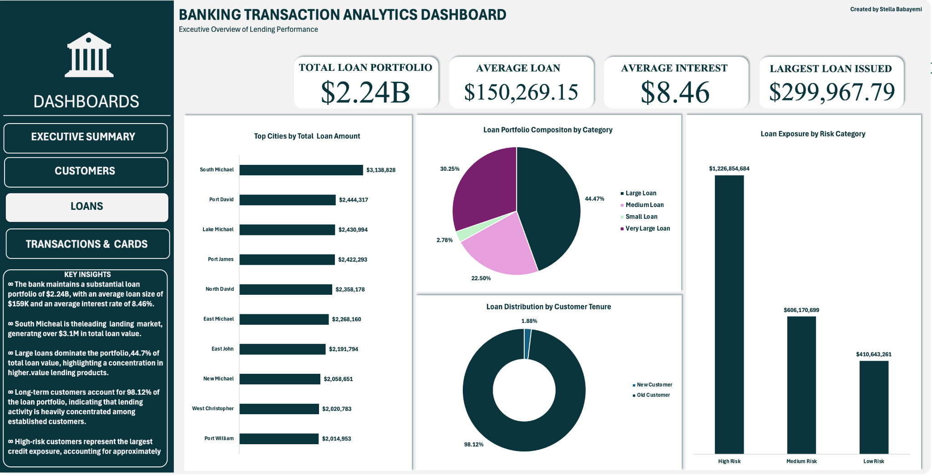
The Loans Dashboard provides a comprehensive overview of the bank’s lending portfolio, including loan value distribution, pricing structure, customer segmentation, geographic exposure, and risk concentration. The total loan portfolio stands at $2.24 billion, with an average loan size of $150,269.15 and an average interest rate of 8.46%. The largest single loan issued amounts to $299,967.79, indicating the bank’s capacity to support both mid-sized and high-value lending activities.
Geographic analysis of loan distribution shows that lending activity is concentrated in specific cities. South Michael recorded the highest total loan value at $3,138,828, while Port William recorded the lowest among the top cities at $2,014,953. This variation highlights differences in regional credit demand and may reflect underlying economic activity, customer density, or market penetration across locations.
The loan portfolio composition by category reveals a diversified structure across multiple loan sizes. Large loans account for the highest share at 44.47%, followed by medium loans at 32.50%, while small loans represent 2.78% of the portfolio. Very large loans also contribute 30.25%, indicating a strong skew toward higher-value lending products. This distribution suggests that the bank’s lending strategy is heavily weighted toward mid-to-large scale credit facilities.
Loan distribution by customer tenure indicates that a significant portion of lending activity is associated with long-standing customers. Old customers account for the majority of loan uptake, while new customers represent a relatively small share of the portfolio at 1.88%. This demonstrates that lending relationships are largely built on established customer trust and historical financial behavior.
Risk-based loan exposure analysis reveals a pronounced concentration of lending within higher-risk segments. High-risk customers account for $1.226 billion of total exposure, followed by medium-risk customers at $666.18 million, while low-risk customers represent a comparatively small portion of the portfolio. This concentration suggests that a significant share of the bank’s credit exposure is tied to customers with elevated risk profiles, highlighting the importance of strengthened credit monitoring, provisioning strategies, and risk mitigation frameworks.
Overall, the Loans Dashboard indicates a large and active lending portfolio with strong reliance on high-risk and long-tenured customers, a diversified loan product mix, and geographically concentrated lending activity across key cities.

4.4 Transaction & Card Dashboard
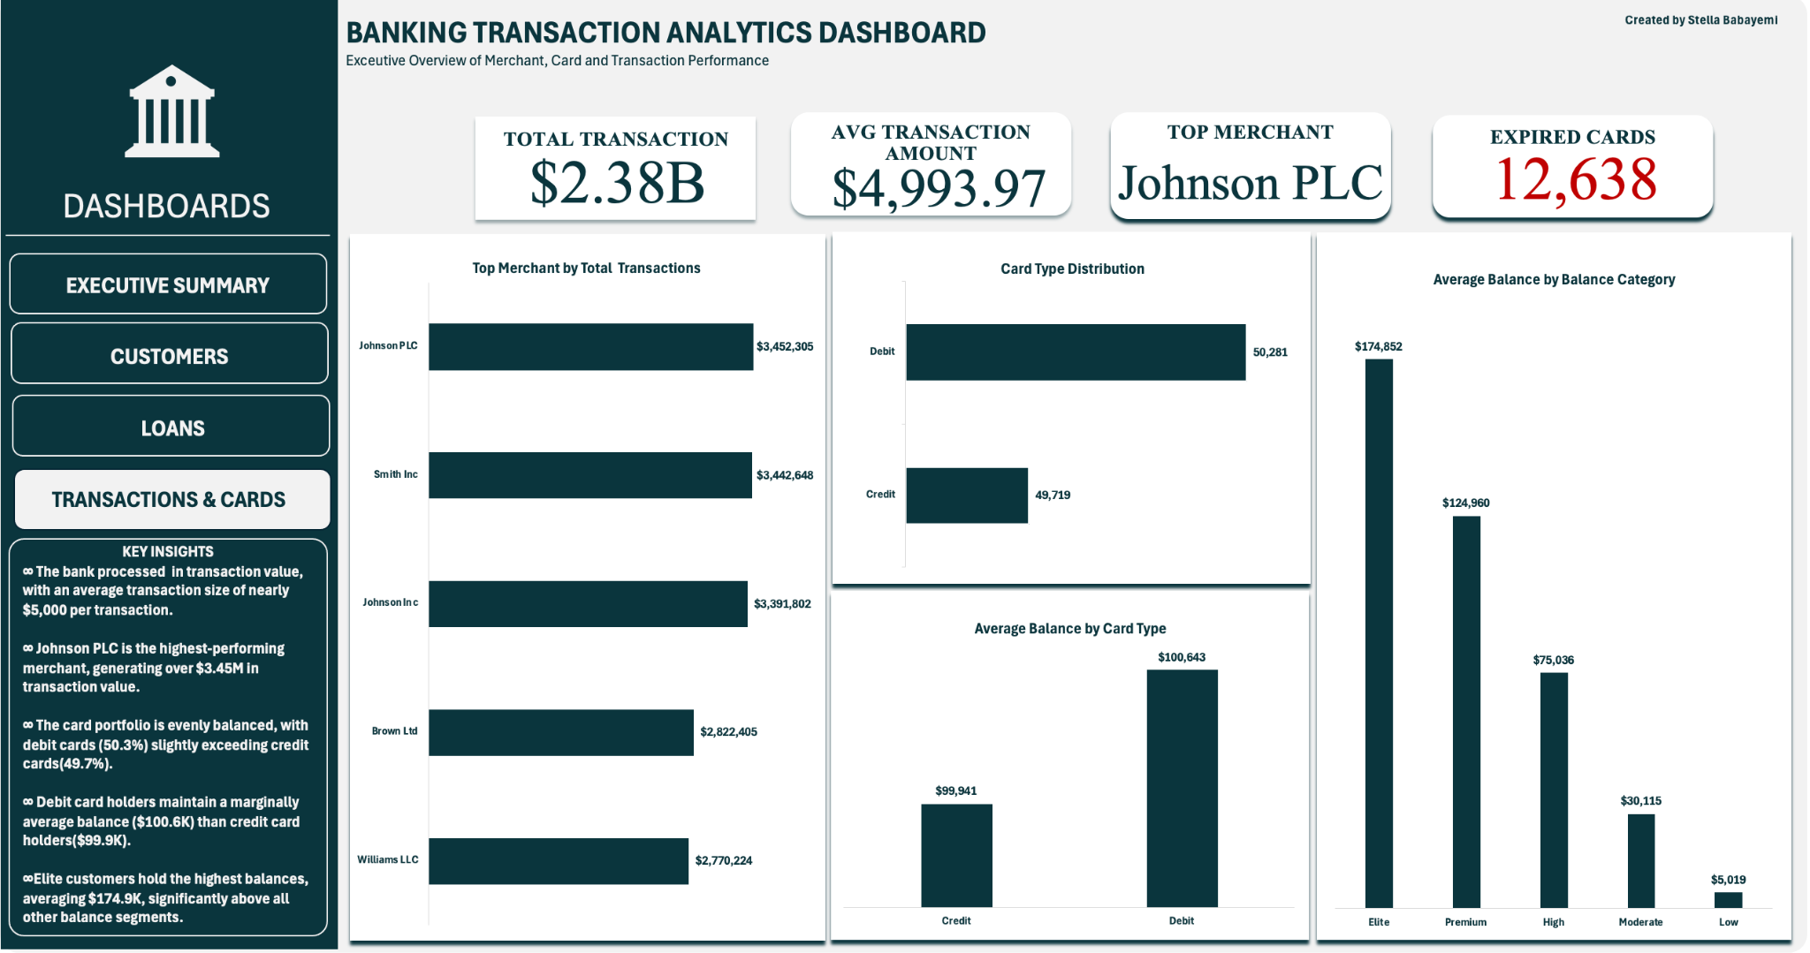
The Transactions and Cards Dashboard provides a detailed view of transaction behavior, merchant activity, card usage patterns, and customer balance segmentation. The total transaction value recorded is $2.38 billion, with an average transaction amount of $4,993.97, indicating a portfolio characterized by consistently high-value financial activity. The dashboard also highlights 12,638 expired cards, pointing to opportunities for card renewal and lifecycle management initiatives.
Merchant analysis shows that transaction activity is concentrated among a small group of high-performing merchants. JohnC Plc leads with total transaction value of $3,452,305, followed by other top merchants such as Williams LLC, which recorded approximately $2,770,224. This distribution suggests that merchant relationships are a key driver of transaction volume, with a limited number of merchants contributing significantly to overall spending.
Card type distribution is relatively balanced between debit and credit usage, with 50,281 debit cards and 49,719 credit cards issued. This near-even split indicates a diversified card portfolio and balanced customer preference between debit-based spending and credit-based borrowing.
Average balance analysis by card type shows minimal variation between debit and credit users. Credit card holders maintain an average balance of $99,941, while debit card holders record a slightly higher average balance of $100,643. This suggests that card type alone is not a strong differentiator of customer balance behavior within the portfolio.
Further segmentation of average balances by balance category reveals a clear stratification of customer wealth levels. The elite balance category records the highest average balance at $174,852, followed by the premium category at $124,960. The high balance category averages $75,886, while moderate and low balance categories show significantly lower averages of $36,115 and $5,019, respectively. This distribution demonstrates a well-defined customer wealth hierarchy and provides a strong foundation for tiered banking products and personalized financial offerings.
Overall, the dashboard highlights a high-value transaction environment supported by balanced card usage, concentrated merchant activity, and clearly segmented customer wealth groups, all of which provide actionable insights for revenue growth, customer targeting, and portfolio optimization.

5.0 Key Business Insights
5.1 Customer Insights
The customer base demonstrates strong overall financial strength, with an average balance of approximately $100,181.72 and a moderately low average credit score of 574, indicating a mixed-risk customer population. A significant portion of the customer base is long-tenured, with 85.32% classified as existing customers, reflecting strong retention and loyalty within the bank’s ecosystem.
Customer spending is highly concentrated among a small segment of high-value individuals, with top customers each generating between $900,000 and $1.55 million in total transaction value. This indicates the presence of a high-value customer tier that contributes disproportionately to overall revenue generation. However, the majority of customers remain relatively evenly distributed across account types, suggesting a balanced product adoption structure across business, checking, and savings accounts.
Overall, the customer base is stable and mature, but growth opportunities exist in converting mid-tier customers into high-value segments and improving credit score profiles across the portfolio.
5.2 Risk Insights
Risk distribution analysis reveals a substantial concentration of customers within the high-risk segment (27,296 customers) compared to 9,039 low-risk customers, indicating a portfolio skewed toward elevated credit exposure. Despite this, average balances across risk categories remain relatively uniform, suggesting that risk classification is not strongly correlated with account balance alone.
A deeper behavioral analysis shows that several customers exhibit transaction patterns where maximum transaction values significantly exceed average spending levels, indicating potential anomalies or irregular financial behavior. This reinforces the need for enhanced monitoring systems and behavioral-based risk scoring models.
Overall, the risk profile suggests moderate-to-high exposure within the customer base, requiring strengthened credit policies, continuous monitoring, and proactive fraud detection mechanisms.
5.3 Lending Insights
The loan portfolio is substantial at $2.24 billion, with an average loan size of $150,269.15 and an average interest rate of 8.46%, reflecting a profitable but moderately risk-sensitive lending environment. Lending activity is heavily concentrated among long-standing customers, indicating that trust and historical behavior are key drivers of credit approval.
Risk exposure is notably concentrated in the high-risk segment, which holds over $1.2 billion in loan exposure, significantly outweighing medium and low-risk segments. This suggests a heightened credit risk concentration within the portfolio, necessitating improved underwriting standards and portfolio diversification strategies.
Additionally, loan distribution is skewed toward large and very large loan categories, which together dominate the portfolio structure. While this supports higher revenue generation, it also increases sensitivity to macroeconomic shifts and borrower default risk.
Geographically, lending activity is uneven, with certain cities such as South Michael dominating loan distribution, indicating opportunities for regional expansion and credit market diversification.
5.4 Transaction Insights
Transaction activity is strong, with a total value of $2.38 billion and an average transaction size of approximately $4,993.97, indicating consistent high-value usage across the customer base. The presence of extreme transaction values near $10,000 suggests frequent upper-limit spending behavior, potentially linked to business transactions or high-value retail activity.
Merchant concentration is high, with a small number of merchants driving a significant share of total transaction volume. This indicates dependency on key merchant relationships and potential exposure to merchant-level risk concentration.
Transaction behavior also shows evidence of irregular spikes among certain customers, where maximum transaction values significantly exceed their typical spending patterns. This highlights the importance of fraud detection systems and real-time transaction monitoring.
Overall, the transaction ecosystem is high-performing but requires ongoing oversight to manage concentration risk and behavioral anomalies.
5.5 Card Insights
The card portfolio is nearly evenly split between debit and credit cards, with 50,281 debit cards and 49,719 credit cards, indicating balanced product adoption. However, the presence of 12,638 expired cards highlights a significant operational opportunity for renewal campaigns and lifecycle optimization.
Card usage patterns suggest strong engagement, with a majority of cards remaining active. This reflects effective utilization of banking products across the customer base. However, card expiration management remains an area for improvement in order to reduce attrition and improve customer retention.
Balance segmentation by card type and wealth category reveals a highly stratified customer base, where elite and premium customers hold significantly higher average balances compared to moderate and low categories. This indicates strong potential for tiered card offerings, premium benefits programs, and targeted rewards strategies.
Overall, the cards ecosystem is healthy and balanced, but can be further optimized through lifecycle management, segmentation-based marketing, and enhanced customer retention strategies.

6.0 Recommendations

6.1 Risk Management
Given the concentration of customers within the high-risk segment and the significant loan exposure tied to these customers, strengthening risk management practices should be a top priority. The bank should enhance its credit scoring models by incorporating behavioral data such as transaction frequency, spending volatility, and account balance fluctuations, rather than relying solely on static credit scores.
Additionally, implementing real-time transaction monitoring systems will help detect unusual spending patterns, particularly customers whose maximum transaction values significantly exceed their average behavior. This can improve early fraud detection and reduce exposure to financial loss.
A periodic portfolio stress-testing framework should also be introduced to assess how macroeconomic changes could impact high-risk loan holders. This will ensure the bank maintains sufficient capital buffers and reduces vulnerability to systemic risk.
6.2 Customer Growth
While customer acquisition remains stable at approximately 7,000 new customers annually, there is an opportunity to accelerate growth through targeted acquisition strategies. The bank should focus on expanding in underpenetrated regions and cities with lower card and loan adoption rates.
Referral programs targeting existing long-tenured customers (who make up over 85% of the base) can also be leveraged to drive organic growth. These customers represent a highly trusted segment and can serve as effective brand ambassadors.
Furthermore, digital onboarding processes should be optimized to reduce friction in customer acquisition, enabling faster account creation and improved conversion rates.
6.3 Product Adoption
The near-equal distribution of account types indicates balanced product usage; however, deeper adoption of premium financial products remains an opportunity. The bank should focus on cross-selling strategies that encourage customers to move from basic accounts into higher-value products such as investment-linked accounts, credit facilities, and savings upgrades.
Segment-based marketing campaigns can be deployed using customer balance categories (low, moderate, premium, elite) to tailor product offerings more effectively. High-balance customers should be targeted with wealth management solutions, while moderate segments can be encouraged to upgrade their account tiers.
Additionally, improving credit score education and financial literacy initiatives may help increase eligibility for advanced financial products across the customer base.
6.4 Card Renewal
The presence of 12,638 expired cards presents a clear opportunity for lifecycle optimization. A structured card renewal strategy should be implemented, including automated renewal reminders, proactive reissuance campaigns, and digital card replacement options.
Customers with expired or near-expiry cards should be prioritized for engagement through personalized communication channels such as SMS, email, and mobile banking notifications.
The bank should also introduce incentives such as cashback offers or reward points for timely card renewal to reduce attrition and maintain active card usage levels.
6.5 Merchant Partnerships
Transaction data shows a high level of concentration among a small group of merchants, indicating strong dependency on key merchant relationships. To reduce concentration risk and enhance revenue stability, the bank should diversify its merchant network by onboarding new partners across retail, e-commerce, and service industries.
Strategic partnerships with high-performing merchants should be strengthened through co-marketing campaigns, transaction-based incentives, and exclusive banking partnerships.
Additionally, expanding merchant analytics capabilities will allow the bank to better understand spending behavior trends and identify high-growth merchant categories for future investment.
Overall, a more diversified and data-driven merchant strategy will enhance transaction volume, reduce risk exposure, and increase customer engagement across multiple spending channels.

7.0 Conclusion
This project provides a comprehensive end-to-end analysis of a simulated retail banking ecosystem, focusing on customer behavior, transactions, cards, loans, risk segmentation, and overall portfolio performance. By integrating multiple datasets and building interactive dashboards, the analysis delivers a holistic view of how customers interact with banking products and how value is generated across different financial dimensions.
The executive summary dashboard established a strong foundation, revealing a financially active institution with 50,000 customers, $2.38 billion in transactions, $7.51 billion in deposits, and a $2.24 billion loan portfolio. Customer acquisition remained stable over time, with consistent annual growth, while card usage demonstrated high activity levels supported by a largely active card base. The loan portfolio showed steady expansion, reflecting sustained demand for credit products and effective lending operations.
The customer analysis further highlighted a financially stable yet diverse customer base, characterized by an average balance of approximately $100,000 and a moderately low average credit score. While the majority of customers are long-tenured, a relatively small proportion of high-value customers contribute disproportionately to transaction volumes, reinforcing the importance of customer segmentation and targeted relationship management. At the same time, the presence of a large high-risk segment underscores the need for stronger credit governance and risk mitigation strategies.
From a risk perspective, the portfolio exhibits concentration challenges, particularly within high-risk customers and loan exposure. Despite relatively stable average balances across risk categories, behavioral and transactional anomalies suggest that risk cannot be evaluated solely on static financial indicators. This reinforces the importance of dynamic, behavior-driven risk models and continuous monitoring systems to strengthen financial stability and reduce exposure to default and fraud risks.
The lending analysis reveals a large and profitable loan book, but one that is heavily skewed toward higher-risk customers and large loan categories. While this structure supports revenue generation, it also introduces significant sensitivity to economic shifts and repayment risks. Geographic concentration in specific cities further highlights the need for diversification in lending strategies to ensure balanced portfolio distribution and long-term resilience.
Transaction and card analysis demonstrated strong operational performance, with high transaction volumes and significant merchant activity driving revenue flow. However, merchant concentration and transaction spikes among certain customers point to potential vulnerabilities that require ongoing monitoring. The card ecosystem remains balanced between debit and credit usage, although card expiry levels present an operational opportunity for improved lifecycle management and customer retention.
Overall, this project demonstrates the value of data-driven decision-making in modern banking environments. By combining transactional data, customer segmentation, risk profiling, and product performance metrics, the analysis uncovers key business insights that can directly inform strategic decisions. The findings emphasize the importance of balancing growth with risk management, strengthening customer relationships, optimizing product offerings, and leveraging data analytics to drive sustainable financial performance.
In conclusion, the bank exhibits strong operational scale, consistent customer growth, and robust financial activity. However, opportunities exist to enhance risk controls, improve product penetration, diversify revenue streams, and strengthen customer lifecycle management. With targeted data-driven strategies, the institution can further optimize performance while maintaining long-term financial stability and competitive advantage.

