Explain My Pain: Bridging Linguistics, NLP, and Pain Communication
White Paper
Stella Bullo, PhD.
October 2025

Executive Summary
Pain is one of the most common yet least understood experiences in healthcare. Numeric scales can measure intensity but overlook the emotional and sensory layers that shape how people describe what they feel. Explain My Pain™ is a digital communication tool that makes the language of pain easier to interpret and understand.
Developed by linguist Stella Bullo, PhD, the system translates patients’ everyday descriptions, such as burning, like a knife, tight, or electric, into structured summaries that help them understand their experiences more clearly and communicate more easily with clinicians.
Grounded in linguistics, particularly Conceptual Metaphor Theory, and informed by Narrative Medicine , the prototype reveals how words carry both sensation and emotion. Built with a Flask backend, a YAML taxonomy, and a Tailwind interface, it processes and organises language transparently. Explain My Pain is guided by open-science ethics and human-centred design. It transforms linguistic research into a bridge between experience and understanding in healthcare.
The live prototype can be explored at https://explain-my-pain.onrender.com.

The Challenge: Communicating Pain Beyond Numbers
This white paper introduces the Explain My Pain™ minimum viable product (MVP), a digital communication tool designed to make the language of pain easier to interpret and understand. It outlines the research, ethical framework, and technical architecture that underpin the platform, showing how linguistic insight can be transformed into a transparent and human-centred digital tool. This approach responds to a long-standing communication gap in healthcare, where patients often struggle to express pain in ways that are recognised and acted upon.
Pain remains one of the most complex phenomena in medicine, difficult to measure, interpret, and communicate. Numeric scales may measure its intensity, but not its mechanism or quality. Because pain, especially chronic pain, is abstract and difficult to express, patients often turn to metaphors and similes in an effort to make their experience visible and believable. Examples of this type of imagery are it feels as if something were twisting, like a burning wire, or a balloon pressing inside me.
Research on endometriosis pain communication in the United Kingdom shows that such figurative descriptions are not random; they reveal both the physical and emotional dimensions of pain experience. Yet patients report that clinicians often overlook or misinterpret them, leaving them feeling dismissed or disbelieved. In studies of doctor–patient communication, doctors themselves acknowledged not always recognising these metaphors as meaningful diagnostic clues and sometimes linking them to unrelated conditions or psychological causes.
Explain My Pain addresses this gap through a structured, linguistically informed system that interprets how people describe pain. It complements traditional pain scales with an evidence-based framework grounded in metaphor research and clinical empathy.

The Solution: Explain My Pain
Building on this research foundation, Explain My Pain transforms linguistic insight into an interactive, rule-based system that makes patterns of expression visible and interpretable. The platform structures language through a controlled taxonomy derived from real data, turning patients’ words into a shared language that bridges experience and care.
Explain My Pain structures and interprets pain descriptions through a controlled taxonomy rather than open-ended text input. The taxonomy was first developed for the Explain My Pain tagger, which encodes linguistic findings from The Language of Endometriosis – see Research Foundation Section below. Using corpus-based linguistic analysis, the most frequent and representative metaphors used to describe pain - such as burning, stabbing, tightening, and spreading - were identified, normalised, and organised into hierarchical categories.
Within the app, users select validated descriptors that represent how pain is experienced. The Flask-based tagger processes each selection through the YAML taxonomy to generate structured summaries across three conceptual dimensions:
- Sensation captures the physical qualities of pain such as stabbing, burning, or tightening.
- Emotion reflects the feelings that accompany pain, including fear, anger, or hopelessness.
- Trigger identifies the perceived cause or context in which pain arises, such as menstruation, ovulation, or physical activity.
The taxonomy also recognises when a metaphor expresses either a sensory or emotional quality, linking both layers into a unified interpretation. Each descriptor is then mapped within the taxonomy to generate a transparent report that reveals the sensory, emotional, and causal patterns of pain language. Rather than diagnosing, Explain My Pain interprets, showing how words convey suffering, agency, and meaning.

Technology and Architecture
Explain My Pain is built on a modular, explainable architecture designed for transparency and ethical use of linguistic data. The system combines a Flask (Python) backend with a Tailwind CSS and Vanilla JavaScript frontend, ensuring a lightweight and accessible interface. Its data layer is defined through a YAML/JSON taxonomy that encodes the linguistic descriptors of pain. The backend is hosted on Render, and the frontend is deployed through Netlify.
The application follows a research-to-application workflow that transforms linguistically annotated data into a structured digital tool (Figure 1). The taxonomy and tagger developed from corpus research are integrated into the Flask API, which processes user selections, validates them, and generates structured summaries for patients and clinicians. Each summary includes links to relevant evidence, allowing pain language to be interpreted with clarity and confidence.
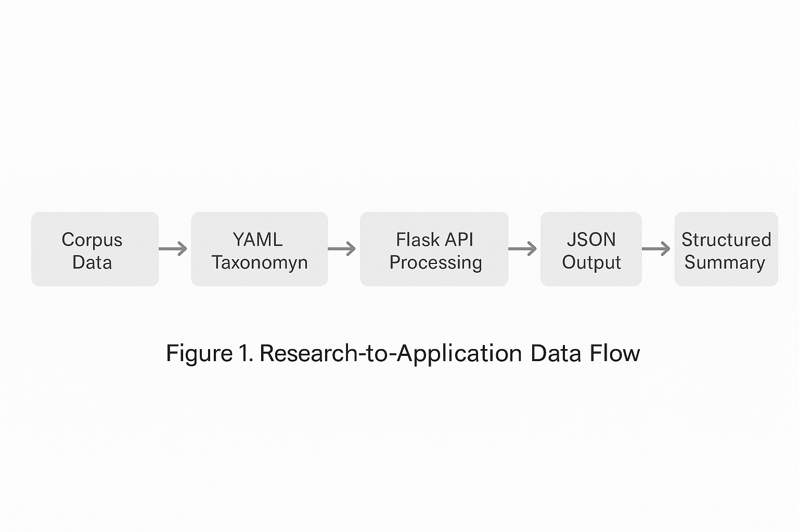
Figure 1. Research-to-Application Data Flow

Research Foundation
Endometriosis is a chronic inflammatory condition in which tissue similar to the uterine lining grows outside the uterus, causing pain, fatigue, and fertility problems. It affects around one in ten women of reproductive age, yet diagnosis often takes years. Because its pain is cyclical, diffuse, and difficult to describe, patients frequently report being dismissed or misunderstood. Endometriosis therefore offers a powerful case study for examining how language can reveal the lived dimensions of pain that numbers cannot capture.
The first dataset powering Explain My Pain originated from The Language of Endometriosis Project, a corpus analysing how people describe menstrual and pelvic pain across interviews, forums, surveys, and social media posts. The study examined real patient language to understand how pain is conceptualised and communicated, and how communication barriers contribute to diagnostic delay.
Quantitative analysis showed that the word pain occurred 2,131 times (≈ 8.8 per 1,000 words), ranking seventeenth across 241,887 words - over 120 times higher than in the British National Corpus (0.07 per 1,000). This confirms that pain dominates the linguistic landscape of Endometriosis narratives.

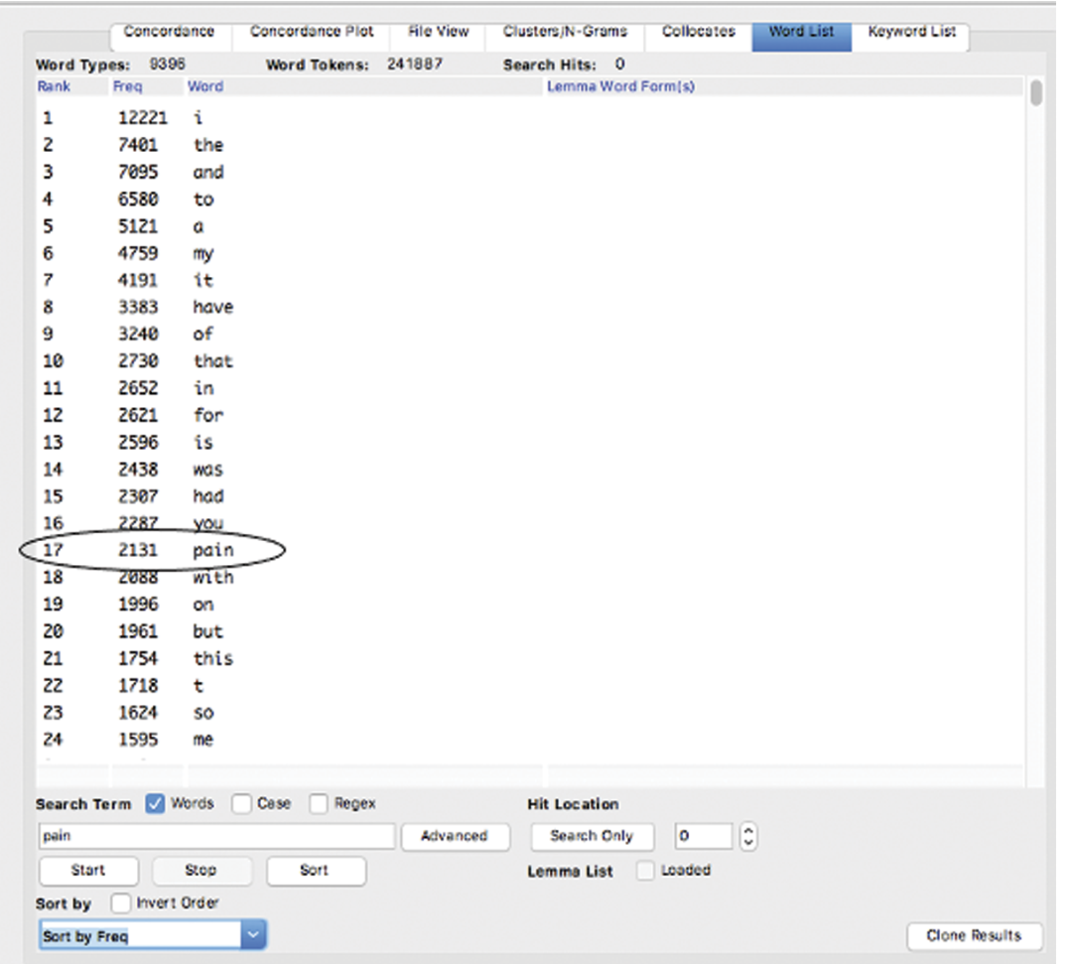

Figure 2: AntCont analysis of word list of The Language of Endometiosis corpus

Of these 2,131 instances, 31 percent were figurative, expressed through metaphors or similes. Figurative collocates such as burning, stabbing, twisting, and tearing describe the quality and mechanism of pain, while literal collocates communicate degree and location (mild, severe, pelvic, abdominal). Together they reveal two complementary communicative strategies: literal expressions tend to measure pain (where, how strong, how often), whereas figurative ones trnd to describe experience or mechanisms (how it feels, how it acts).
Explain My Pain integrates both, recognising that literal descriptors support clinical classification, while figurative ones enrich empathic understanding and mechanistic insight.

Metaphor Category | Example Expressions | Type | Semantic Entailment
Violent Action | attack, ripped apart, stabbed inside | Sensory | Pain as assault or invasion of the body
Cutting Tools | knife, blade, glass shards | Sensory | Pain as cutting or penetration of tissue
Pressure | tight band, crushing weight, clamped | Sensory | Pain as compression or physical restraint
Electric Force | zapping, electric shock, jolt | Sensory | Pain as sudden discharge of energy
Heat | burning, on fire, flames inside me | Sensory | Pain as inflammation or internal heat
Weight | dragging, heavy, weighed down | Sensory | Pain as physical burden or force of gravity
Internal Machinery | gears grinding, drill, engine turning | Sensory | Pain as mechanical malfunction within the body
Entrapment | trapped, locked in, caged | Emotional | Pain as confinement, lack of escape or control
Predator | something biting, clawing, attacking | Emotional | Pain as an external living force or threat
Transformation | alien inside me, twisted, mutating | Emotional | Pain as bodily change, intrusion, or loss of integrity
Labour | contractions, waves, surges | Sensory | Pain as cyclical or productive bodily effort
Lingering Force | throbbing, pulsing, simmering | Sensory | Pain as rhythmic or ongoing internal presence
Table 1. Metaphor Categories, Examples, and Semantic Entailments

The table presents the main metaphor categories identified in the Explain My Pain taxonomy, classified as sensory or emotional. Each includes a semantic entailment defined as the conceptual link that connects the metaphor to the experience of pain. The categories and entailments were derived from a metaphor analysis of the Endometriosis pain corpus, following the Conceptual Metaphor Theory paradigm. These structures underpin the taxonomy’s interpretive framework, showing how language maps patterns of sensation, emotion, and causality.

Use Cases and Value Propositions
Explain My Pain sits at the intersection of linguistics, natural-language processing, and clinical communication, turning qualitative language evidence into structured insight. Traditional health-tech tools measure what can be counted - numbers, scales, and frequencies - but overlook how people express pain and emotion. Explain My Pain reverses that logic: it begins with how language encodes sensation and suffering, and models that knowledge within a transparent digital framework.
By combining linguistic theory with computational methods, the system bridges human narrative and clinical data science. It allows pain descriptors, metaphors, and emotional cues to be analysed with scientific rigour while retaining their human meaning.
For clinicians, this provides clearer understanding of how patients describe pain. For educators, it offers authentic material for empathy training. For researchers, it delivers a reproducible model for translating qualitative evidence into computational form.
Its value lies not only in what it analyses but in how it reframes interpretation: Explain My Pain replaces black-box automation with a linguistically explainable process, giving professionals confidence in both the evidence and the ethics of language-based data.

Sector | Current Challenge | How Explain My Pain Adds Value
Clinicians | Empathy and communication gaps in describing pain | Converts patients’ language into structured summaries that clarify meaning and support dialogue
Medical Educators | Lack of authentic materials for empathy and communication training | Provides real examples of pain narratives for use in narrative-medicine and communication courses
Health Researchers | Difficulty quantifying qualitative data | Offers a transparent linguistic framework for analysing metaphor, emotion, and sensory language
Digital Health Innovators | Dependence on opaque machine-learning models | Demonstrates an ethical, rule-based NLP approach that is interpretable and auditable
Localisation and Cultural Adaptation | Limited cross-language tools for understanding pain communication | Builds a miltilingual framework adaptable to cultural and linguistic contexts
Table 2: Use Cases and Value Propositions

Ethics and Design Principles
Explain My Pain was developed from research that treats language not as raw data but as human expression carrying dignity, context, and emotion. Its design follows clear principles that ensure transparency, interpretability, and respect for participants’ voices, forming an ethical framework for linguistically grounded NLP in healthcare.
Empathy by design guides the system toward listening rather than automation. It does not diagnose or predict; it highlights how people describe pain and how those words connect to emotion and meaning. Each tagged term represents a point of understanding between patient and professional.
Transparency runs through every stage. The taxonomy that categorises language is open and fully traceable to its linguistic sources, allowing every transformation to be followed from corpus to output.
Ethical provenance is ensured through anonymised, ethically approved datasets. The app stores no clinical data and demonstrates that qualitative evidence can be reused responsibly without compromising privacy or consent.
Explain My Pain supports interpretation rather than automation, protecting against algorithmic bias and preserving the clinician–patient relationship as the centre of empathy. Developed under open-science principles and designed to be accessible and bilingual (English–Spanish), it recognises that inclusion and cultural sensitivity must be intentional design choices.
Together, these principles make Explain My Pain a transparent, ethical alternative to opaque medical AI, showing that technology can amplify human understanding rather than replace it

Roadmap and Collaboration
Explain My Pain continues to evolve as a research-to-application platform linking linguistic insight with clinical practice.
- Short Term (2025–2026)
Refine the YAML taxonomy and bilingual templates, optimise the Flask backend, broaden the corpus beyond Endometriosis, and collaborate with Neural Actions on a technical showcase integrating Explain My Pain into mental-health and wellbeing technologies.
- Medium Term (2026–2027)
Integrate spaCy for semantic similarity and metaphor clustering, and expand the localisation app, adapting the taxonomy to multiple languages and cultural contexts. The localisation app will align descriptors and metaphors across English and Spanish and feed into an analytics dashboard for cross-cultural comparison.
Develop the first multimodal layer, allowing users to pair linguistic descriptors with visual representations, mapping sensations, intensity, or emotion on a simple body interface to externalise symptoms and improve clinician–patient communication.
- Long Term (2027 onward)
Scale to multilingual corpora, extend the multimodal framework to new domains such as menopause or post-natal recovery, and link with clinical and wellbeing platforms through open APIs.

Expanding the Explain Women’s Health Family
Vision
From Explain My Pain to a family of tools that help people articulate, visualise, and communicate symptoms across every stage of women’s health.
Each app blends linguistics + NLP + visual expression to transform subjective experience into understanding.

App | Focus | Goal
Explain My Cycle | Menstrual & perimenopausal experiences | Track and express hormonal, emotional, and sensory change through language and imagery.
Explain My Recovery | Post-natal & pelvic-floor health | Help women describe sensations such as heaviness or pressure to support recovery conversations.
Explain My Body | Chronic & diffuse conditions | Map fluctuating pain, fatigue, and discomfort for multidisciplinary care.
Explain My Mood | Mental health & wellbeing | Combine linguistic cues and visual patterns to express mood and cognitive change.
Table 3: The Explain Ecosystem

Shared DNA
All Explain Women’s Health apps share a transparent, explainable NLP foundation that makes their logic visible and auditable. They are bilingual and culturally adaptive, aligning linguistic descriptors across languages through the localisation framework. Each integrates linguistic and visual input, helping users express experience through words and imagery. Built with empathy-by-design, these tools support interpretation rather than automation.

Impact
The Explain ecosystem makes invisible experiences visible. It gives patients clearer language, clinicians deeper insight, and creates an ethical, data-ready foundation for communication in women’s health.

Conclusion
Explain My Pain demonstrates how linguistic research can be transformed into an explainable, ethically grounded NLP framework that listens rather than predicts. By translating both metaphorical and literal expressions of suffering into structured, interpretable data, it preserves the complexity of human experience while making it actionable for care.
The project’s multimodal and localisation layers now open a path toward a broader Explain Women’s Health ecosystem, where language, visuals, and data combine to illuminate invisible experiences across reproductive and chronic health contexts.
Explain My Pain proves that empathy can be designed, that technology can listen, and that language remains one of medicine’s most powerful diagnostic tools. From words to understanding, from understanding to care, this is how digital health can speak human.
About the Author
Dr Stella Bullo is a linguist and researcher specialising in metaphor, health communication, and applied natural-language processing. After completing her PhD in Linguistics at Lancaster University (UK), she worked as a senior lecturer and researcher at Manchester Metropolitan University for 15 years. Upon leaving academia, and the UK, she created a bilingual research and development studio based in Argentina that bridges linguistics, data, and design.
Stella Bullo develops ethically grounded, human-centred digital tools that transform language research into structured insight. Its projects draw on academic research in metaphor and health communication to create transparent, explainable NLP solutions for health, education, and wellbeing. Stella also works as a freelance annotation and evaluation specialist, contributing to international NLP and AI projects focused on data quality and interpretability.
Explain My Pain is the studio’s flagship prototype within the emerging Explain Women’s Health ecosystem, a family of multimodal tools designed to make invisible experiences visible and to build technology that listens as carefully as it analyses.

Explain My Pain · Where Linguistics Meets Digital Health
White Paper · Stella Bullo · 2025
Contact:
- stella.bullo.pro@gmail.com | info@stellabullo.com
- +54 9 358 483 6766 / +44 78 00 767723
- https://stellabullo.com
- Try the app: https://explain-my-pain.onrender.com

Lakoff & Johnson (1980).
Charon (2006).
Unesco (2021).
Gosden et al (2014).
Bullo (2020); Bullo & Heath (2020); Bullo & Weckesser (2021).

