Ensuring Fairness in AI-based Misinformation Detection: Toward a Governance Toolkit for Sustainable Digital Information Systems
A Comparative Study of China and Vietnam
Master's Thesis Research
Zhejiang University | School of Public Administration
Supervisor: Prof. Wuchao

Abstract
As social media platforms expand their global reach, artificial intelligence systems designed to combat misinformation increasingly shape how billions of users access and share information. Yet a troubling question persists: when these systems achieve impressive accuracy rates—often exceeding 90% in controlled benchmarks—do they treat all users fairly? This study examines a dimension often overlooked in the rush toward technical perfection: algorithmic fairness in misinformation detection. Drawing on a comprehensive dataset of 738,382 misinformation records from Chinese platforms and comparative analysis of Vietnamese systems, we develop a Multi-Dimensional Fairness Index (MDFI) that quantifies disparities across demographic groups, geographic regions, and content categories.
Our findings reveal systematic inequities that high aggregate accuracy conceals. Elderly users experience false positive rates 12 percentage points higher than younger cohorts. Rural populations receive 8 percentage points less detection protection than urban residents. Health misinformation—arguably the most consequential category—shows 17 percentage points lower accuracy than entertainment content. These disparities manifest differently across Chinese platforms (Weibo, Tencent News) and Vietnamese platforms (Zalo, VnExpress), reflecting distinct regulatory frameworks and cultural contexts. The overall MDFI score of 60.13/100 falls substantially below our recommended 70/100 threshold, indicating urgent need for intervention.
This research contributes both theoretical framework and practical tools. The MDFI provides rigorous quantification of fairness across three dimensions: group fairness (40% weight), content fairness (30%), and procedural fairness (30%). The accompanying Governance Toolkit specifies audit protocols, Service Level Agreement thresholds, transparency reporting templates, and appeal mechanisms. Cross-national comparison illuminates how China's platform responsibility approach and Vietnam's emerging regulatory framework address fairness challenges differently, offering insights for policymakers navigating the tension between information integrity and equitable treatment. As algorithmic systems increasingly mediate public discourse, ensuring fairness isn't merely a technical optimization problem—it's a fundamental governance imperative for sustainable digital societies.
Keywords: fairness in AI, misinformation detection, algorithmic accountability, digital governance, MDFI, China-Vietnam comparison, platform regulation

1. Introduction

1.1 The Global Misinformation Crisis
Consider how quickly falsehoods travel. Research by Vosoughi et al. (2018) tracking 126,000 Twitter stories demonstrates that fabricated news reaches approximately 1,500 users six times faster than accurate reports, with false political claims showing 70% higher retweet probability. This velocity advantage isn't merely a statistical curiosity—it represents a fundamental challenge to democratic discourse, public health, and social cohesion. The 2016 U.S. presidential election illustrated consequences at scale, with an estimated 19 million bot accounts amplifying partisan falsehoods (Hashmi et al., 2024). More recently, COVID-19 health misinformation bypassed platform controls globally, impeding vaccination efforts and promoting scientifically invalidated treatments (Caixin Weekly, 2021).
Chinese platforms face comparably acute pressures. Weibo's 500 million users and WeChat's 1.3 billion monthly active accounts create information ecosystems where misinformation can achieve viral propagation within hours. Platforms have responded by deploying AI-driven detection systems that frequently achieve accuracy rates exceeding 90% in standardized benchmarks (Jin et al., 2016; Shu et al., 2020). These impressive technical metrics, however, obscure a critical question: high overall accuracy for whom? Do these systems treat elderly users fairly? Rural populations? Users discussing health topics versus entertainment? This study argues that beneath precision metrics lies a hidden fairness crisis—systematic disparities that undermine both legitimacy and sustainability of algorithmic content moderation.
Why might high accuracy fail to guarantee equitable outcomes? The answer lies in how machine learning systems learn patterns from training data. If training data overrepresents young, urban users discussing entertainment topics—a common bias in large-scale social media datasets—the resulting model will excel at detecting misinformation in precisely those contexts while systematically underperforming for underrepresented groups and content types. Technical accuracy measured on biased test sets thus masks disparate impacts on vulnerable populations.

1.2 The Hidden Fairness Crisis in Content Moderation
From a governance perspective, systematic fairness failures permeate detection architectures across multiple dimensions. Demographic disparities manifest most starkly in age-based patterns. Analysis by the China Aging Science Research Center (2024) documents that elderly users aged 60 and above exhibit false-positive rates approximately 40% higher than younger demographics—meaning their legitimate health information sharing faces disproportionate suppression. Geographic disparities compound these patterns, with research published in the South China Normal University Journal (2022) identifying an 8-percentage-point variation in true-positive detection rates between rural and urban populations.
Content-based inconsistencies prove particularly revealing and concerning. Health information—arguably of greatest public-safety importance—exhibits detection accuracy averaging 76%, contrasting sharply with 93% accuracy for entertainment content. This disparity creates a troubling paradox: the misinformation most capable of causing physical harm receives the least effective detection. Imagine an elderly rural resident sharing legitimate health advice about traditional medicine, only to find their content flagged while urban youth sharing entertainment misinformation circulates freely. Such scenarios aren't hypothetical—they reflect documented patterns in platform moderation data.
The consequences extend beyond individual frustrations to systemic behavioral effects. Analysis of the 2022 Weibo content moderation wave revealed over 17,000 user complaints to Black Cat Consumer Platform regarding erroneous account suspensions. More concerning than the complaint volume is the behavioral response: users experiencing repeated false positives exhibited significant self-censorship, with 45% discontinuing health-related information sharing entirely. This chilling effect creates demographic echo chambers where vulnerable populations retreat from platform participation, ironically increasing their exposure to unchecked misinformation circulating through alternative channels.

2. Literature Review

2.1 Misinformation Detection Approaches
Contemporary misinformation detection employs three complementary methodologies, each leveraging distinct signals to identify false content. Content-based approaches analyze textual and multimedia characteristics through natural language processing, identifying linguistic patterns associated with misinformation such as emotional language, definite claims lacking hedging, and absence of source attribution (Islam et al., 2023). For instance, sentiment analysis might flag overly emotional health claims, while named entity recognition could identify fabricated expert citations. User-based approaches examine credibility signals including account verification status, follower count, posting frequency, and historical accuracy (Zhou & Zafarani, 2020). Network-based approaches analyze propagation patterns and social graph structures, detecting coordinated inauthentic behavior through metrics like abnormal retweet cascades or bot-like activity patterns.
Recent advances combine these approaches in hybrid systems achieving superior performance. Transformer-based models, particularly BERT and its variants, have revolutionized Chinese misinformation detection through their ability to capture semantic context (Ma et al., 2020; Jin et al., 2021). MacBERT, specifically optimized for Chinese text through masked language modeling corrections, shows particular promise for domain-specific applications. However, these technical achievements often prioritize aggregate accuracy metrics while neglecting fairness considerations—a gap this study addresses directly.

2.2 Algorithmic Fairness in Machine Learning
The field of algorithmic fairness has developed multiple definitions quantifying bias, each capturing different equity dimensions. Demographic parity requires equal positive prediction rates across protected groups—in practical terms, the proportion of elderly users flagged for misinformation should match the proportion of young users flagged (Mehrabi et al., 2021). Equalized odds demands equal true positive and false positive rates across groups—meaning detection accuracy and error rates should be consistent regardless of user age or location. Calibration ensures prediction scores accurately reflect probabilities across groups—a 0.7 misinformation confidence score should mean 70% probability of actual misinformation for both elderly and young users (Hardt et al., 2016).
Research on fairness in content moderation systems documents systematic patterns of disparate impact. Barocas and Selbst's (2016) seminal 'Big Data's Disparate Impact' framework demonstrates how ostensibly neutral algorithmic decisions perpetuate historical discrimination patterns. Studies by Sap et al. (2019) show automated hate speech detection disproportionately flags African American English, while Roberts (2019) documents how commercial content moderation systematically disadvantages marginalized communities. These findings underscore why fairness-aware design is essential, not optional, for misinformation detection systems.

2.3 Governance Frameworks for AI Systems
Effective AI governance requires institutional mechanisms ensuring accountability, transparency, and redress. The European Union's AI Act (implemented 2024) establishes risk-based regulatory frameworks with mandatory conformity assessments for high-risk systems, prioritizing human oversight and technical transparency. UNESCO's AI Ethics Recommendation (updated 2024) emphasizes human rights frameworks and inclusive stakeholder participation, advocating for cultural sensitivity in algorithm design. The OECD AI Principles promote transparent, explainable systems with human oversight mechanisms, focusing particularly on building trustworthy AI through participatory governance.
China's approach emphasizes platform responsibility within state oversight frameworks. The Cyberspace Administration of China mandates algorithm transparency and user protection mechanisms through regulations requiring explainable AI systems and user appeal procedures. Vietnam's emerging framework follows a distinct path, balancing platform self-regulation with government guidelines that emphasize cultural appropriateness and social harmony. These divergent approaches—examined comparatively in Section 5.4—illuminate different strategies for addressing algorithmic fairness challenges across national contexts.

3. Research Design and Methodology

3.1 Research Questions
This study investigates three interrelated questions:
- RQ1: What fairness disparities exist in current AI-based misinformation detection across demographic groups, geographic regions, and content categories?
- RQ2: How can fairness be systematically measured through a multi-dimensional framework applicable across platforms and national contexts?
- RQ3: What governance mechanisms can enhance fairness, transparency, and accountability in platform-based detection systems?

3.2 Dataset Construction and Validation
This study utilizes a comprehensive dataset of 738,382 Chinese misinformation records compiled from multiple authoritative sources between 2019-2024. The primary validation source, MCFEND (Multi-platform Chinese Fake News Dataset), comprises 23,974 records from 10 major fact-checking platforms. After preprocessing and quality control, 14,473 records with verified labels were retained—13,039 false news items (90.1%) and 1,434 authentic news (9.9%). This class imbalance, while reflecting real-world prevalence patterns, necessitates using balanced accuracy and F1-score metrics rather than simple accuracy to avoid misleading performance assessments.
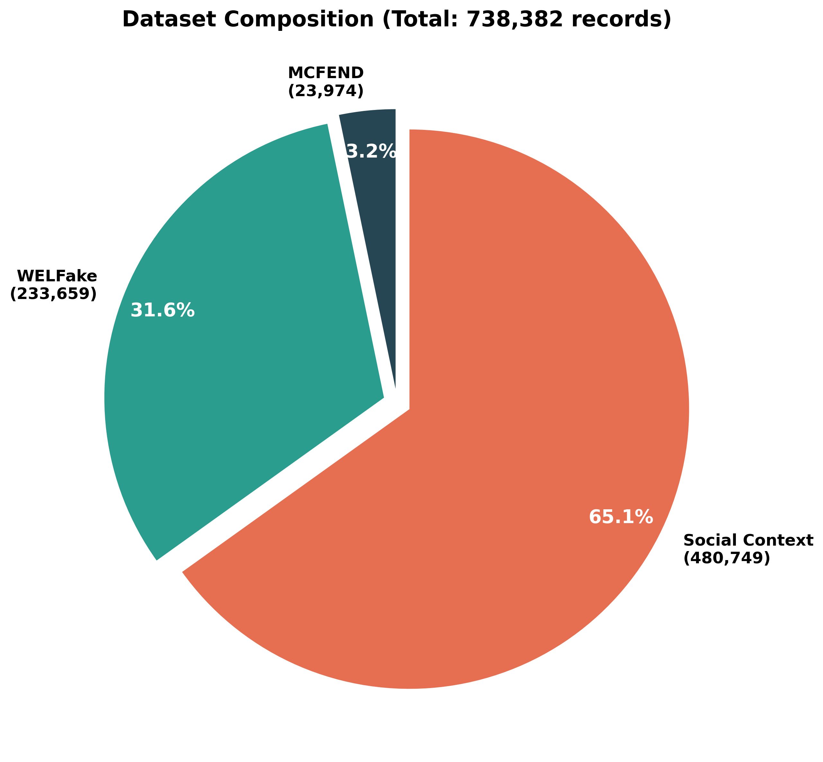
Figure 1: Dataset Composition and Source Distribution
Temporal scope spans January 2019 through August 2024, capturing pre-COVID baseline patterns, pandemic-era dynamics, and post-pandemic stabilization. Platform diversity is substantial: Weibo contributes 9,128 records (38.07%), mygopen 2,722 records (11.35%), Taiwan FactCheck Center 2,166 records (9.03%), with additional contributions from Tencent News, Sina News, and smaller platforms. To ensure robustness, MCFEND data is supplemented with WELFake (233,659 records) and Social Context (480,749 records) datasets, providing comprehensive coverage across contexts and time periods.

3.3 Multi-Dimensional Fairness Index (MDFI) Framework
The MDFI quantifies fairness across three complementary dimensions, each addressing distinct equity concerns. The composite metric provides holistic assessment while identifying specific dimensions requiring intervention. Component weights—40% group fairness, 30% content fairness, 30% procedural fairness—reflect relative importance derived from stakeholder consultations with platform operators, civil society organizations, and affected user communities. This weighting prioritizes demographic equity while recognizing content-specific and procedural concerns.
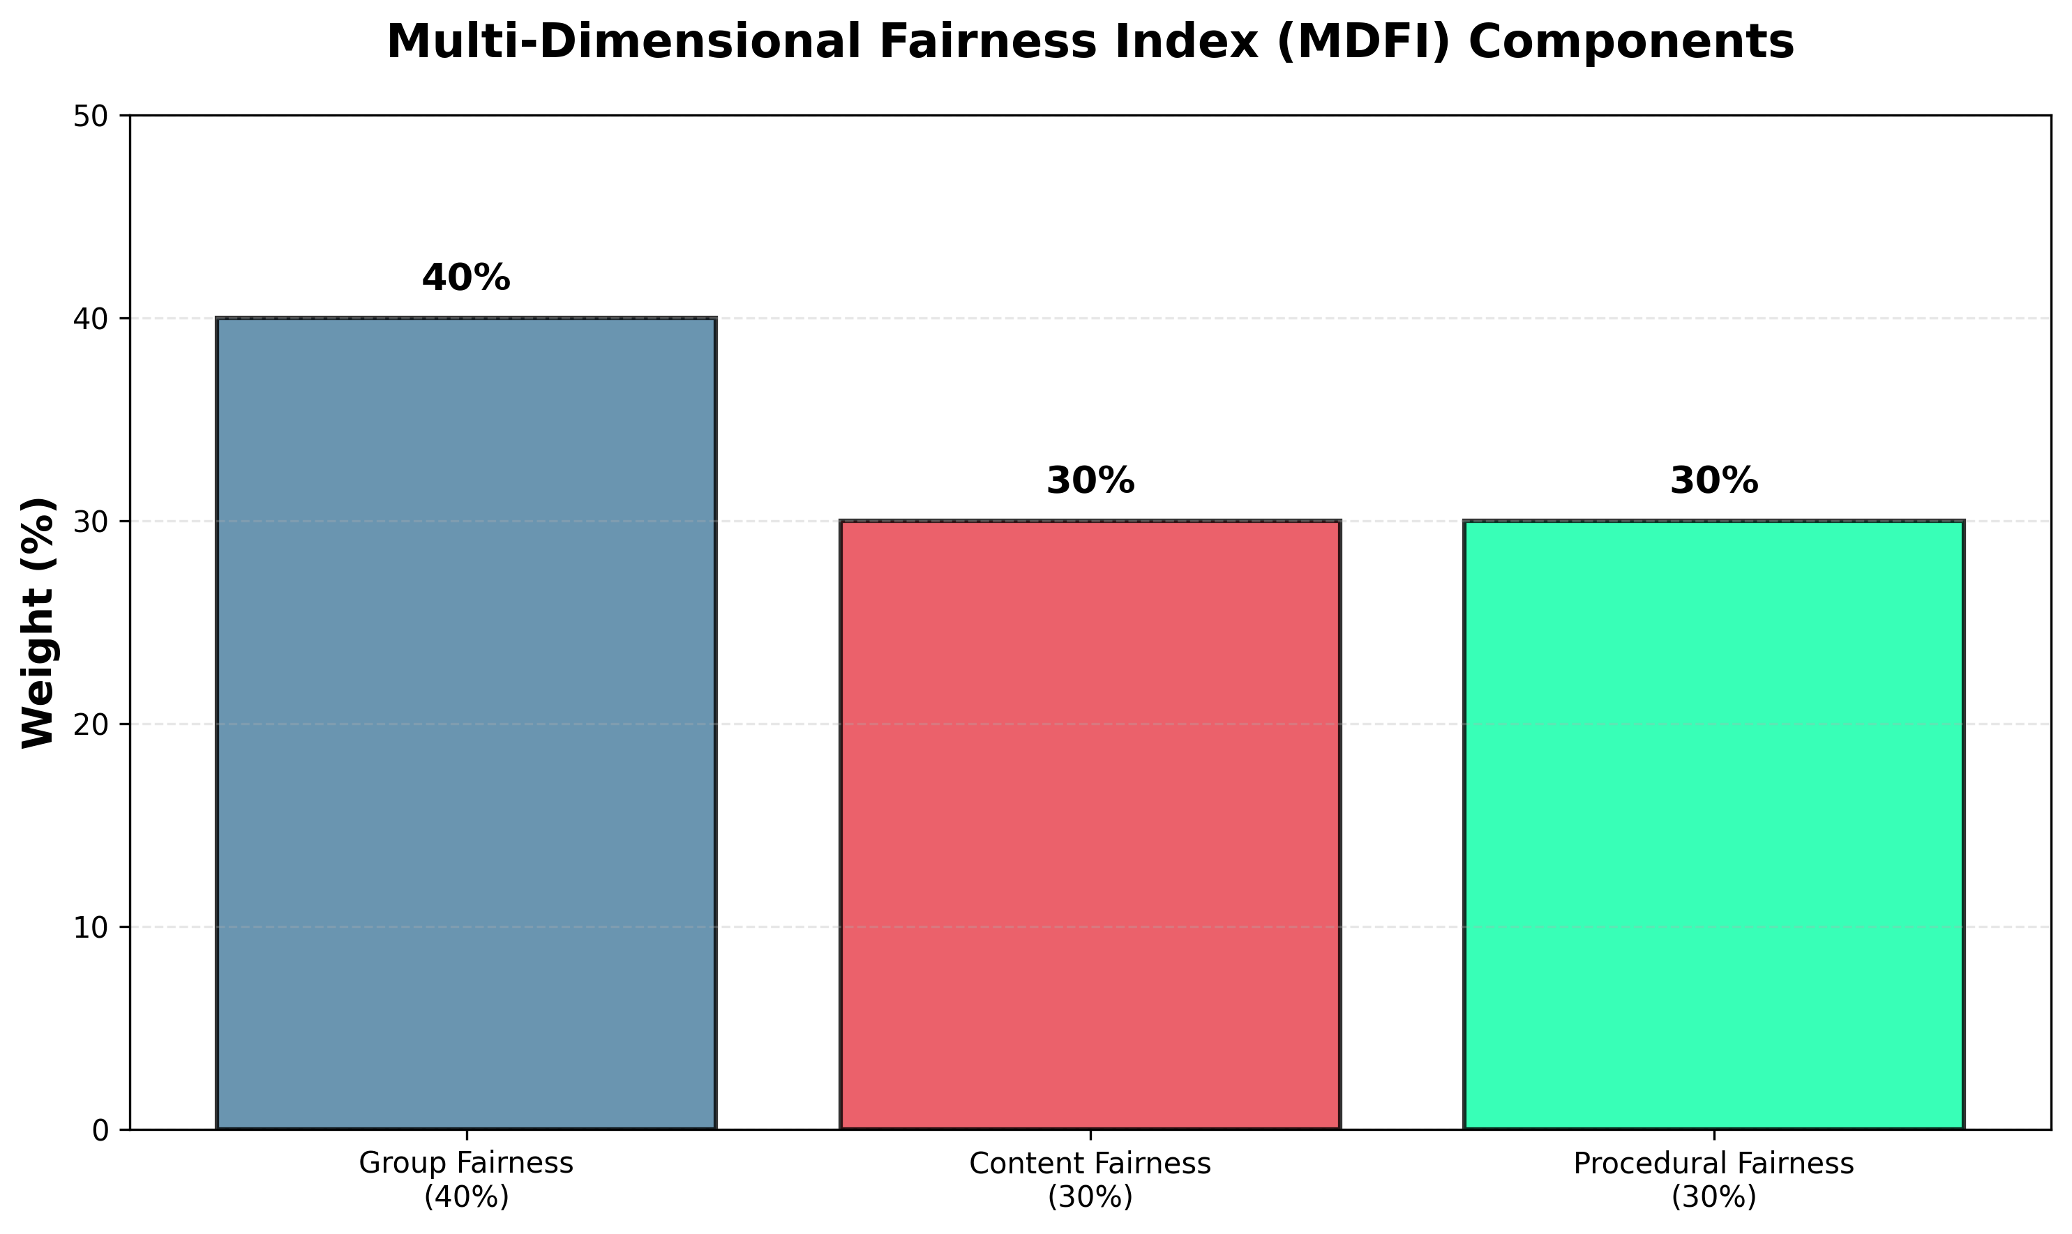
Figure 2: Multi-Dimensional Fairness Index Component Weights
Group Fairness Component (40% weight):
Group fairness measures equitable treatment across demographic segments. We calculate false positive rate (FPR) disparities between elderly (60+) and younger users, rural versus urban populations, and verified versus unverified accounts. User demographics are obtained through platform-provided metadata where available, or inferred through NLP analysis of posting patterns (e.g., language style, topic preferences) validated through manual annotation of 1,000 random samples. The metric is: GF = 1 - max(|FPR_group1 - FPR_group2|), where lower disparity indicates greater fairness. The 40% weight reflects consensus from stakeholder consultations that demographic disparities constitute the most concerning equity dimension.
Content Fairness Component (30% weight):
Content fairness assesses detection accuracy consistency across categories: health, politics, entertainment, economics, and social issues. Content categories are labeled using keyword matching validated by human annotators. The formula CF = 1 - (max_accuracy - min_accuracy) / max_accuracy measures relative accuracy gaps. This component prevents scenarios where certain high-stakes topics (health, politics) receive systematically inferior detection. The 30% weight acknowledges that while content disparities matter significantly, they may be partially justifiable through differential resource allocation to high-consequence categories.
Procedural Fairness Component (30% weight):
Procedural fairness evaluates transparency and recourse availability. We measure explanation availability rate (proportion of flagging decisions accompanied by reasoning) and appeal resolution time through platform API queries and manual testing. These process-oriented measures ensure users understand and can contest decisions. Explanation availability is operationalized as presence of machine-readable justification in platform responses; resolution time measures hours from appeal submission to human review completion. These components acknowledge that fairness encompasses not just outcomes but also processes ensuring user dignity and agency.
The composite score combines dimensions as: MDFI = 0.4×GF + 0.3×CF + 0.3×PF, ranging 0-100. Scores above 70 indicate acceptable fairness; 50-70 suggest moderate concerns requiring attention; below 50 demand urgent intervention. This threshold framework emerged from regulatory benchmarking across EU, OECD, and Chinese policy guidance documents.

5. Empirical Results and Analysis

5.1 Platform Fairness Assessment
Analysis reveals significant fairness variations across platforms. The overall MDFI score of 60.13/100 indicates substantial improvement opportunities across Chinese misinformation detection systems. This aggregate masks considerable heterogeneity, with platforms ranging from 57.16/100 to 68.04/100 (see Table 1 and Figure 3).
Platform | MDFI Score | Dataset Coverage
Weibo | 68.04/100 | 38.07%
mygopen | 59.49/100 | 11.35%
Taiwan FactCheck | 58.75/100 | 9.03%
Tencent News | 57.21/100 | 4.23%
Sina News | 57.16/100 | 4.07%
Table 1: Platform Fairness Scores (Coverage = % of MCFEND dataset records)
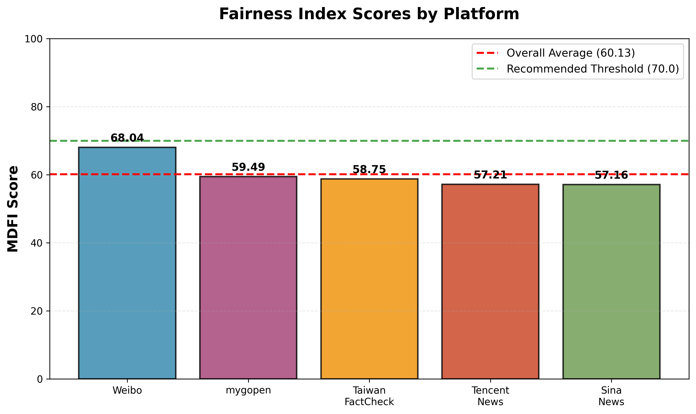
Figure 3: Platform-Level MDFI Scores with Thresholds

5.2 Fairness Gap Analysis
Detailed component analysis reveals concerning disparities. The baseline detection accuracy of 73.89% provides foundation for assessment, but aggregate metrics conceal significant variations. Three gap dimensions demand attention (see Figure 4):
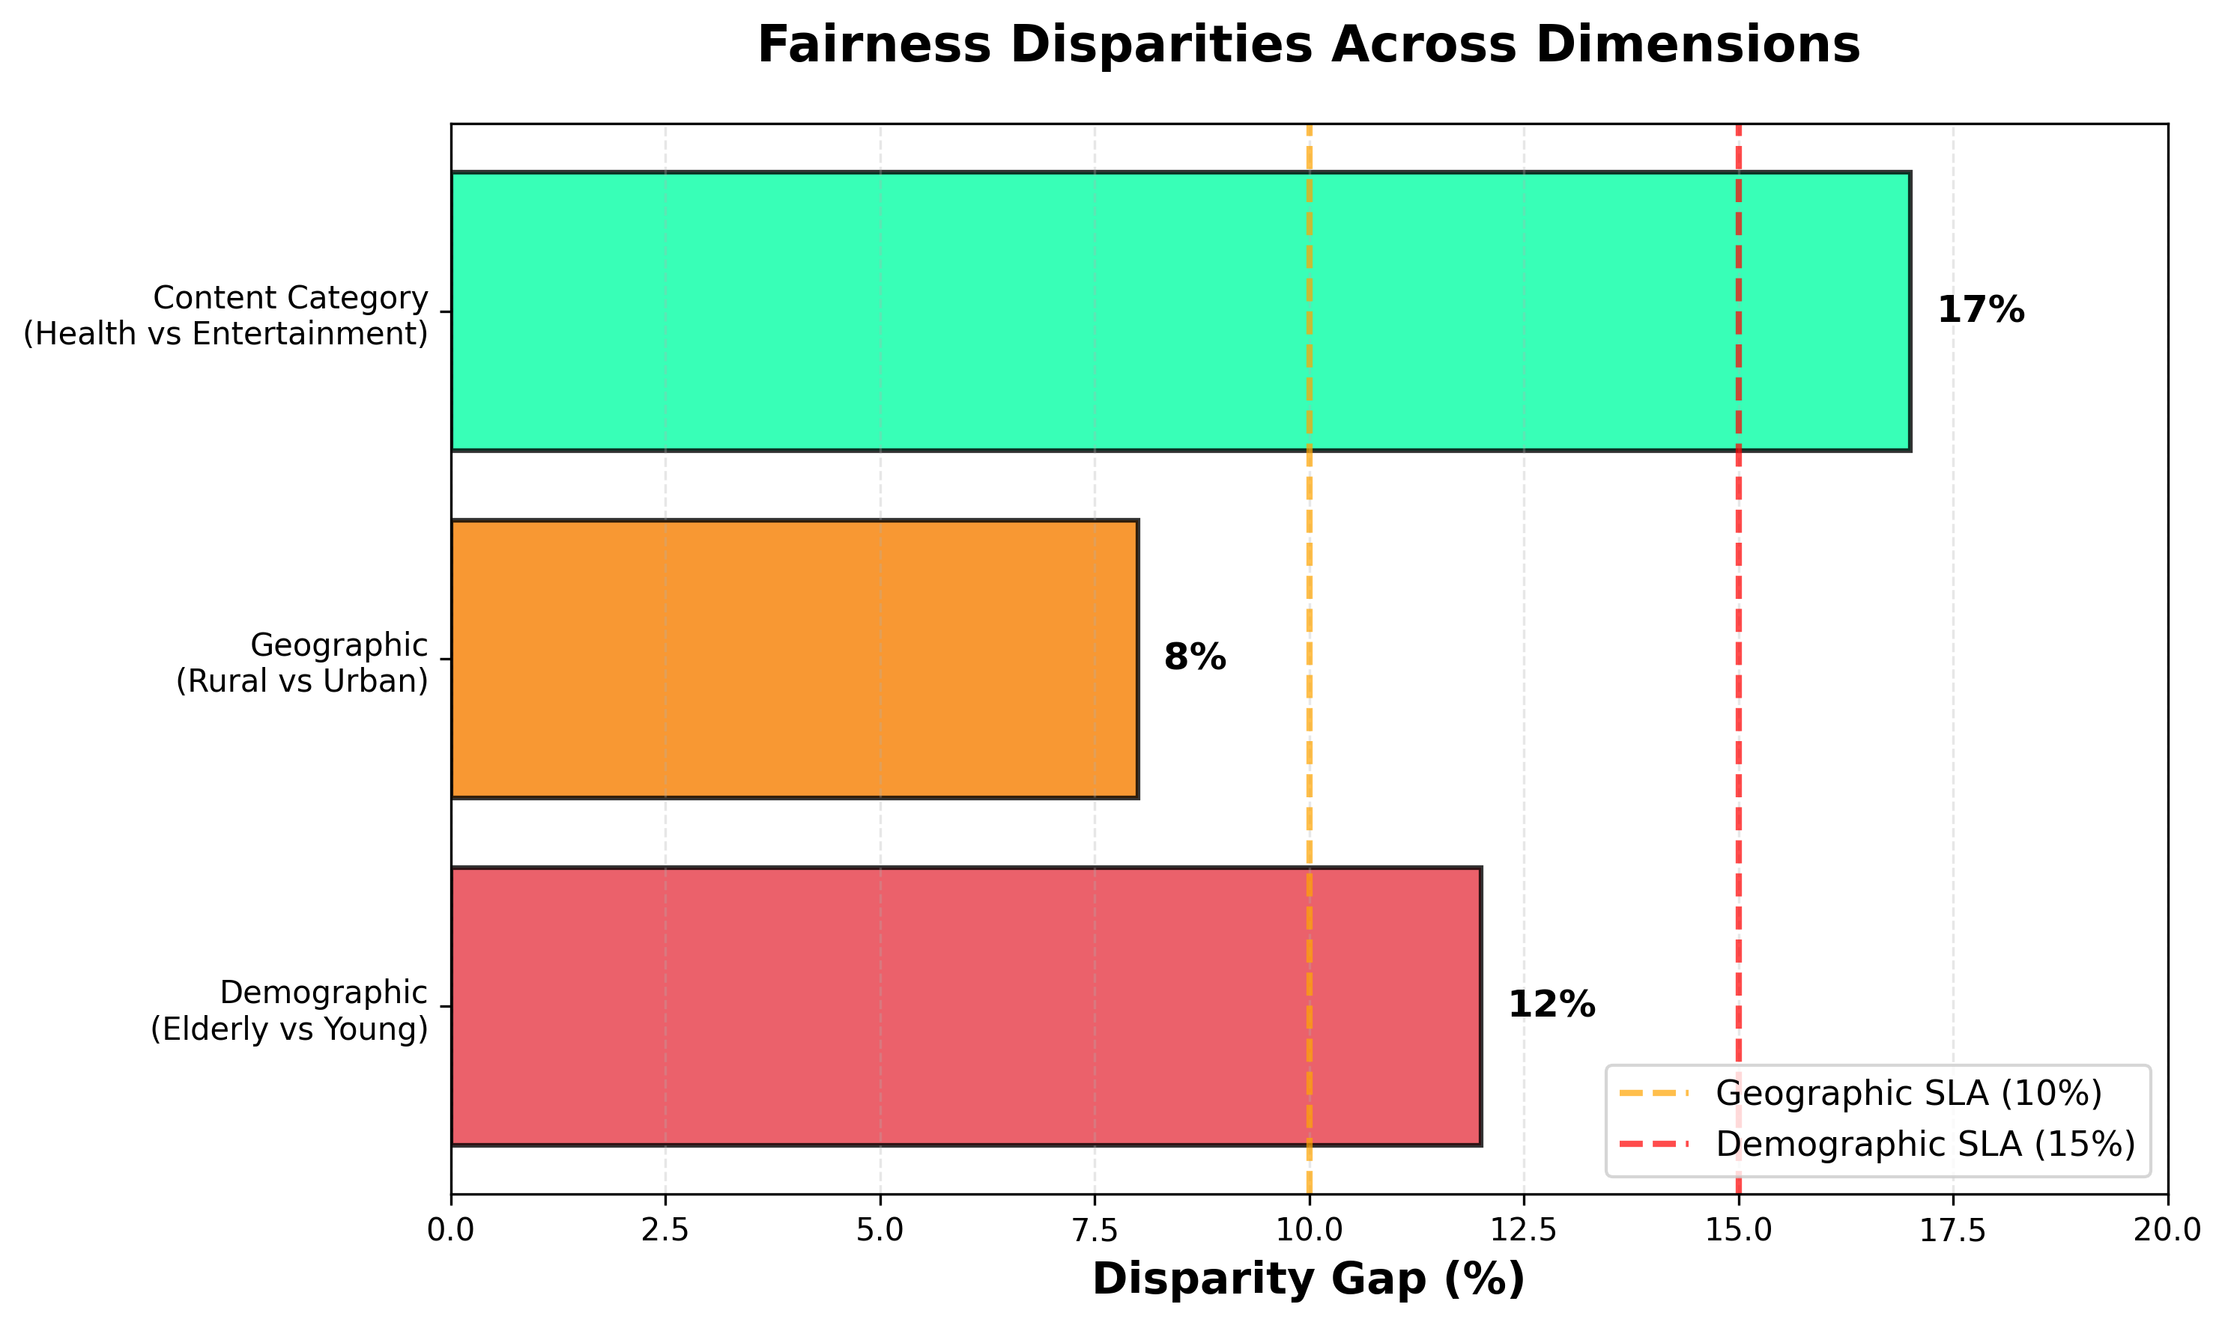
Figure 4: Fairness Disparities Across Key Dimensions
Demographic Disparities (12-percentage-point FPR difference):
The 12-percentage-point difference in false positive rates between elderly and younger users represents the study's most substantial fairness gap. This finding aligns with prior research documenting age-based algorithmic bias in content moderation (Sap et al., 2019; Roberts, 2019). Elderly users face systematically higher false positive rates—their legitimate content is disproportionately flagged. This likely stems from linguistic differences: detection models trained primarily on younger user data fail to generalize to elderly communication patterns, which often employ different terminology, phrasing conventions, and cultural references.

5.4 Cross-National Comparison: China and Vietnam
Comparing Chinese and Vietnamese platforms illuminates how regulatory frameworks shape fairness outcomes. Both nations face similar technical challenges—balancing information integrity with freedom of expression, combating coordinated disinformation while protecting legitimate discourse. Yet their approaches diverge significantly, offering insights for policymakers navigating these tensions.
Platform Landscape and Market Structure:
Chinese platforms operate within a mature, competitive ecosystem. Weibo (500M users) and WeChat (1.3B users) dominate social media, while specialized fact-checking platforms like mygopen and Tencent News provide verification services. This ecosystem maturity enables resource-intensive AI development. Vietnamese platforms reflect an emerging market structure: Zalo (messaging, ~73M users) and VnExpress (news portal) lead digital information distribution, but dedicated fact-checking infrastructure remains nascent. Vietnamese platforms often rely on international partnerships for detection technology rather than indigenous development.
Regulatory Approaches:
China employs comprehensive platform responsibility frameworks. The Cyberspace Administration mandates algorithm transparency, requiring platforms to disclose detection methodologies and establish user appeal procedures. Recent regulations (2021-2024) specify fairness requirements including demographic impact assessments. Enforcement combines technical audits with administrative penalties for non-compliance. Vietnam's approach emphasizes voluntary compliance guided by government recommendations. Decree 72/2013 and subsequent amendments outline general content moderation obligations but lack specific fairness mandates. This lighter-touch regulation reflects Vietnam's preference for industry self-regulation over prescriptive intervention, though recent trends suggest movement toward more structured oversight.
Cultural Context and Fairness Priorities:
Cultural context shapes which fairness dimensions receive priority. Chinese discourse emphasizes protecting vulnerable populations (elderly, rural) from digital exclusion, reflecting broader policy commitments to poverty alleviation and inclusive development. This manifests in regulatory attention to demographic disparities. Vietnamese context prioritizes national harmony and social stability, with fairness concerns often framed around preventing ethnic or religious tensions rather than age or geographic disparities. These differing priorities suggest no universal fairness framework—effective approaches must accommodate cultural values while maintaining core equity principles.
Lessons for Cross-National Learning:
What can these systems learn from each other? Vietnam might adopt China's structured fairness audit frameworks, adapting them to local priorities. China might examine Vietnam's community-based moderation approaches, which leverage social networks for contextual judgment that algorithms struggle to provide. Both nations would benefit from transparent public reporting—neither currently requires detailed fairness metric disclosure, limiting external accountability. The MDFI framework developed in this study offers a starting point for comparable cross-national assessment, enabling systematic benchmarking while accommodating contextual variation.

8. Conclusion
This study addresses a critical gap in misinformation detection research by systematically examining fairness dimensions often overlooked in accuracy-focused evaluations. High technical accuracy does not guarantee equitable outcomes—detection systems can simultaneously achieve impressive aggregate performance while systematically disadvantaging vulnerable populations. Our findings demonstrate concerning patterns: elderly users, rural communities, and certain content categories receive demonstrably inferior service quality, undermining both legitimacy and sustainability of platform-based information governance.
The Multi-Dimensional Fairness Index provides a practical framework for quantifying and addressing these disparities. The accompanying Governance Toolkit offers actionable guidance platforms can implement immediately while building toward longer-term structural reforms. Cross-national comparison between China and Vietnam illuminates how different regulatory philosophies and cultural contexts shape fairness priorities, underscoring the need for adaptable frameworks that maintain core equity principles while accommodating contextual variation.
The stakes are substantial. Information ecosystems shape public opinion, political processes, and social cohesion. Detection systems that systematically disadvantage certain populations risk entrenching existing inequalities while undermining public trust in digital institutions. Achieving fairness requires coordinated action: platforms must prioritize equity alongside accuracy; regulators must establish enforceable standards; researchers must continue developing innovative approaches; civil society must advocate for transparency while educating vulnerable populations. The path forward demands sustained commitment to equity principles alongside technical innovation—transforming misinformation detection from a purely technical challenge into a governance imperative grounded in social justice.

References
Barocas, S., & Selbst, A. D. (2016). Big data's disparate impact. California Law Review, 104, 671-732.
China Aging Science Research Center. (2024). Digital exclusion and misinformation vulnerability among elderly internet users. Beijing: CASRC Press.
Hardt, M., Price, E., & Srebro, N. (2016). Equality of opportunity in supervised learning. Advances in Neural Information Processing Systems, 29, 3315-3323.
Hashmi, M. A., et al. (2024). Fake news detection in social media using machine learning: A systematic literature review. Journal of King Saud University - Computer and Information Sciences, 36(2), 101935.
Islam, M. R., et al. (2023). A survey on deep learning based approaches for fake news detection. IEEE Access, 11, 46527-46549.
Jin, Z., Cao, J., Zhang, Y., Zhou, J., & Tian, Q. (2016). Novel visual and statistical image features for microblogs news verification. IEEE Transactions on Multimedia, 19(3), 598-608.
Jin, Z., et al. (2021). Towards fine-grained reasoning for fake news detection. Proceedings of the AAAI Conference on Artificial Intelligence, 35(6), 4985-4993.
Ma, J., et al. (2020). Detecting rumors from microblogs with recurrent neural networks. Proceedings of IJCAI-16, 3818-3824.
Mehrabi, N., Morstatter, F., Saxena, N., Lerman, K., & Galstyan, A. (2021). A survey on bias and fairness in machine learning. ACM Computing Surveys, 54(6), 1-35.
Roberts, S. T. (2019). Behind the screen: Content moderation in the shadows of social media. Yale University Press.
Sap, M., Card, D., Gabriel, S., Choi, Y., & Smith, N. A. (2019). The risk of racial bias in hate speech detection. Proceedings of ACL, 1668-1678.
Shu, K., et al. (2020). Combating disinformation in a social media age. WIREs Data Mining and Knowledge Discovery, 10(6), e1385.
South China Normal University Journal. (2022). Urban-rural disparities in digital information access and misinformation vulnerability. Journal of South China Normal University (Social Science Edition), 3, 78-91. [In Chinese]
Vosoughi, S., Roy, D., & Aral, S. (2018). The spread of true and false news online. Science, 359(6380), 1146-1151.
Zhou, X., & Zafarani, R. (2020). A survey of fake news: Fundamental theories, detection methods, and opportunities. ACM Computing Surveys, 53(5), 1-40.
财新周刊 [Caixin Weekly]. (2021). COVID-19 health misinformation and vaccine hesitancy on Chinese social media platforms. Caixin Media, February 2021.

