|  |  |  |
| --- | --- | --- |
|  |  | December 2022 |
| LPS Seating Update | | |

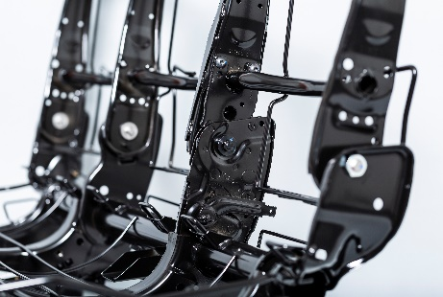

**What’s Inside…**

LPS2 3

Multi-Spindle Support for the PowerMacs Controller 3

Scan Job from Component Accepts Multiple Component Types 6

SFC Binning Operations Can Now be Suspended from the Bin Management Station Menu 7

Image Export Now Available from Requirements and Select Operations 8

Image Save Error Notification Available – Email Interface External Service 9

Requirements Optionally Checked for End of Line Status and Routing 9

LPS Dashboard Bridge 10

System 10

Message Processor Tab 11

LPS Dashboard 12

Dashboard Monitor and Client Windows 12

System Tab 13

Data Sources Tab 13

Message Processors Tab 14

Calculations 17

Dashboard Designer 18

Dashboard Designer Window 18

Charts 19

Tables 21

Primitives 22

Web 22

System 23

Active Reporting 24

Jobs Completed by Job Type 24

Requirements List Filterable by IsChecked Property 25

Torque Statistical Chart 26

Alert Center 27

Destinations 27

Plant Administration 28

Quality Alerts 28

LPS Documentation Repository 30

LPS Support Structure 31

Standard Operating Procedure for LPS Software Upgrades 31

Incident and Service Request Management with Ivanti 31

Levels of Support 32

Moving Through Support Levels 33

Shop Floor Support Contacts by Region 34

# LPS2

## Multi-Spindle Support for the PowerMacs Controller

The **Atlas Copco PF300** controller has a new property called **Multi-Spindle Support.** When this property is set to **True**, multi-spindle support for the PowerMacs controller is enabled. Multi-spindle rundowns, which provide a unique result for each spindle, can be received from the controller.

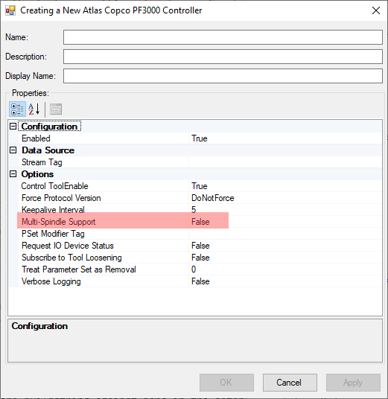

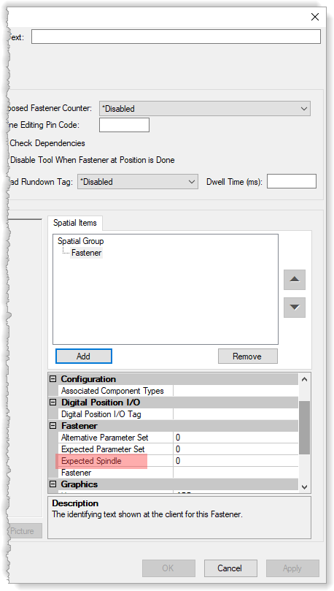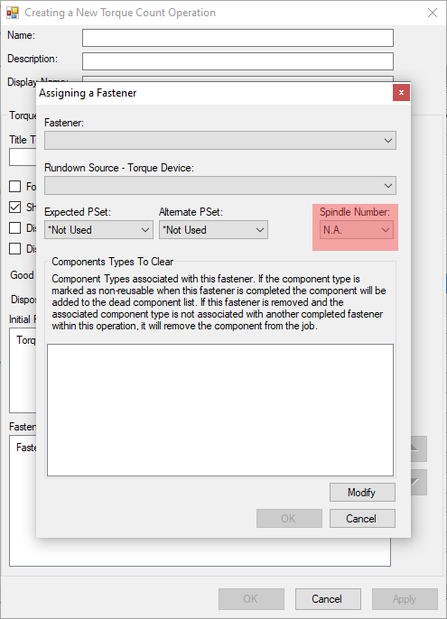An **Expected Spindle** property has been added to the fastener settings in the ***Torque Count*** and ***Spatial Fastening*** operations to identify the torque rundown for the operation.

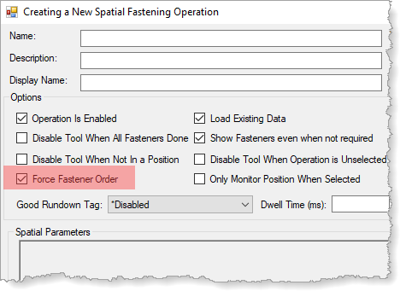If the **Expected Spindle** number is greater than one, the operations match the spindle with the number from the rundown message to assign results to the appropriate fastener. If the Expected Spindle property is zero, the operations won’t find a matching rundown message.

If the operation has **Force Fastener Order** enabled, no matching rundown matches are found.

**Note**: The ***Monitored Spatial Fastening*** operation always enforces the fastener order so multi-spindle fasteners can’t be used.

**Note**: The properties **AlternativeParameterSet** and **ExpectedSpindle** settings have been removed from non-fastener items (Home, Seat Position, and Pallet Crowder ) in the spatial fastening operations.

## Scan Job from Component Accepts Multiple Component Types

The **Component Types** property for ***the Scan Job from Component*** operation now displays a ***Component Types*** list editor window to enable selection of multiple component types.

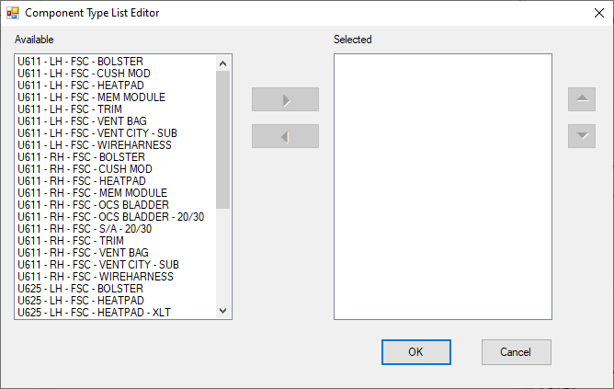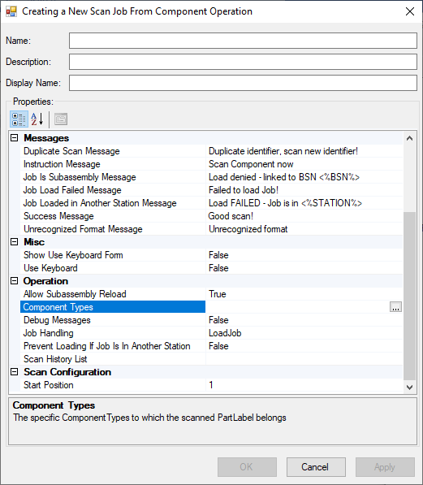

The operation parses the barcode of each configured component type until it finds a match or exhausts the list of component types. If it finds a match, the operation loads the job for that component type.

## SFC Binning Operations Can Now be Suspended from the Bin Management Station Menu

Operators running an ***SFC Binning*** operation can now suspend bins in ***SFC*** using the station’s **Bin Management** dialog available from the station menu, which is displayed by clicking the **Menu** button.

When the operation is suspended from the LPS2 station, the ***SFC Binning*** operation will query ***SFC*** for suspended bins that match the job’s part number and bin type code when it needs to create a new bin. If one or more suspended bins are found, the operator is prompted to resume the suspended bin or create a new bin. If the operator chooses to resume the suspended bin, another window asks the operator to enter a BSN of any part in the bin they are resuming.

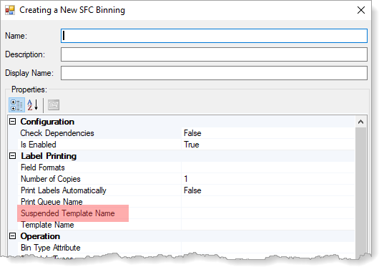**Note**: LPS3 SFC version 3.1.0705.0 or greater must be installed.

A **Suspended Template Name** property has been added to the **SFC Binning** configuration to specify which print label template to use to label the suspended bin. If a value isn’t entered, the template in the Template Name field is used.

## Image Export Now Available from Requirements and Select Operations

An **Export Picture** button has been added to several Job Model requirements and several operations. Clicking the button exports the image to a file you select through a Windows browse window.

The button has been added to the following requirements:

* Attributes (Attribute Item Editor window)
* 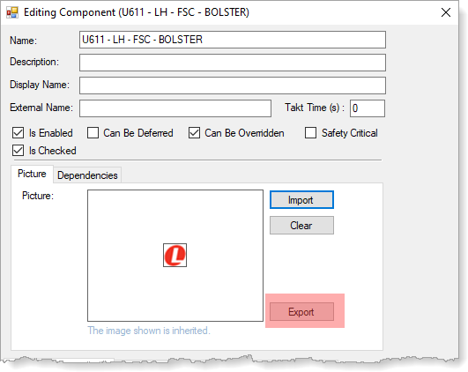Component Types
* Components
* Defects (Corrective Actions tab)
* Fasteners
* Tasks
* Tests

The button has been added to the following operations and resources:

* PLC Poka-Yoke Tester (Poka-Yoke Editor window)
* Digital Spatial Torque
* Monitored Spatial Fastening
* Repair (Fasteners tab)
* Spatial Fastening
* Repair Station (Fasteners tab)
* Visual Aids

## Image Save Error Notification Available – Email Interface External Service

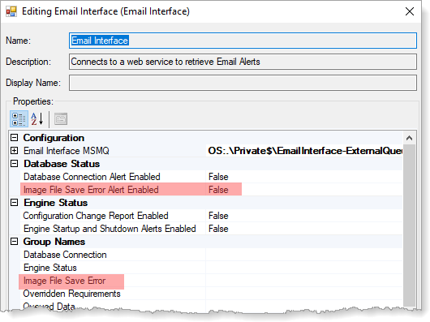Two new properties have been added to the ***Email Interface*** external service to alert the appropriate email group when an image file save error occurs:

* **Image File Save Error**. This property identifies who should be notified when the error occurs.
* **Image File Save Alert Enabled**. This property enables the alert to be sent.

**Note**: This alert indicates that image files are no longer being written to a file directory and instead being written to the LPS database.

## Requirements Optionally Checked for End of Line Status and Routing

An **IsChecked** property has been added to the following requirements:

* 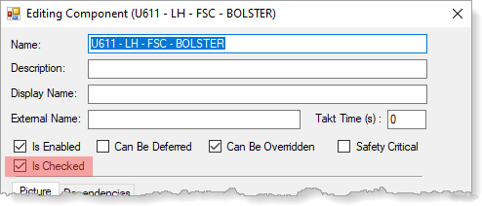Components
* Fasteners
* Tasks
* Tests

When this check box is selected, the ***Checkpoint*** operation considers the requirement when determining the job’s end of line status and routing.

The property is also used in the **Requirements List** to optionally include requirements based on the IsChecked status (**True**, **False**).

# LPS Dashboard Bridge

Several changes have been made to the Dashboard Bridge configuration tool, including new data sources and message processors, and rearranged and new menus. The changes are listed below. If a data source or message processor is new, a description is provided.

## System

The **System** tab now includes a **Service Timeout** property to force a shut down after a specified number of seconds.

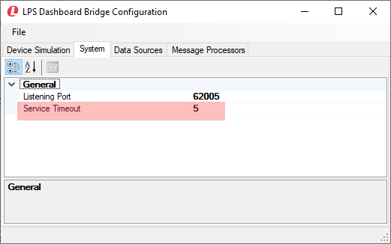

## Message Processor Tab

Several message processors have been added, renamed, moved, or updated with new fields. The changes are listed below by system and menu.

### Hourly Jobs Completed, Hourly Jobs Released

The **LPS2 Hourly Jobs Completed Job Counts** and **LPS2 Hourly Released Job Counts** message processors are now filterable by part number and station.

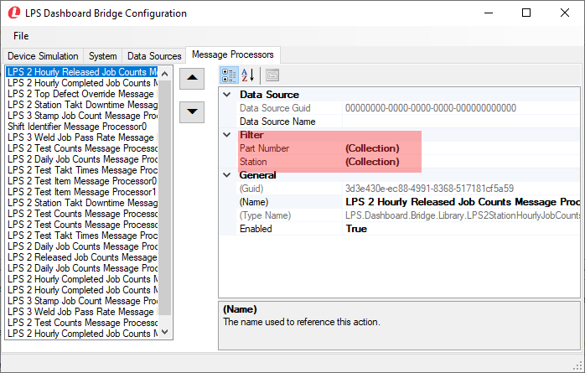

# LPS Dashboard

Several changes have been made to the **LPS Dashboard Configuration** tool. The changes are listed below by tab.

## Dashboard Monitor and Client Windows

### Category Groupings

The **Message Processors**, **Tags**, and **Calculations** tabs in the ***Dashboard Monitor*** and ***Dashboard Client*** windows are now grouped into categories for convenience. Click the plus sign (+) to expand the category.

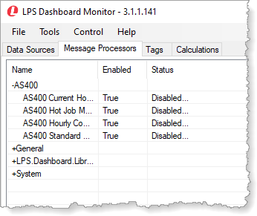

## System Tab

The **System** tab now includes a **Service Timeout** property to force a shut down after a specified number of seconds.

## Data Sources Tab

The following data sources, with the same interface, have been added:

* MSMQ Dynamic Add Data Source
* MSMQ Dynamic Remove Data Source
* MSMQ Dynamic Update Data Source

### MSMQ Dynamic Queue Data Sources

The **MSMQ Dynamic Queue** data sources have been added to add, update, and remove data to and from a dynamic tag. The data is processed with the **XML Document to Dynamic Tag**message processor described below.

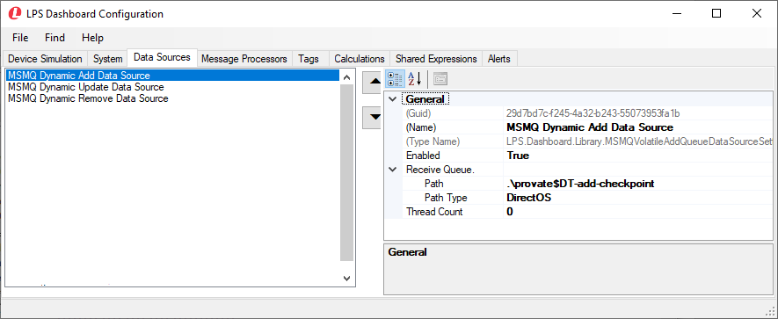

**Note:** The data sources are used by the **XML Transform Calculation** to flatten data from multiple tags into a table. Click [here](http://usdca-lpsdv02/Guides/LPS2/xml_transform_calculation.pdf) for more information about this process.

## Message Processors Tab

The following message processors have been added or updated:

* LPS2 Hourly Completed Job Counts to XML Message Tag
* MSMQ XML Document to Dynamic Tag
* System Clock

### LPS2 Hourly Completed Job Count to XML Message Tag

The **LPS 2 Hourly Completely Job Count to XML Message Tag** message processor has several new tags to collect hourly job counts in different ways by totals jobs, part number, and station.

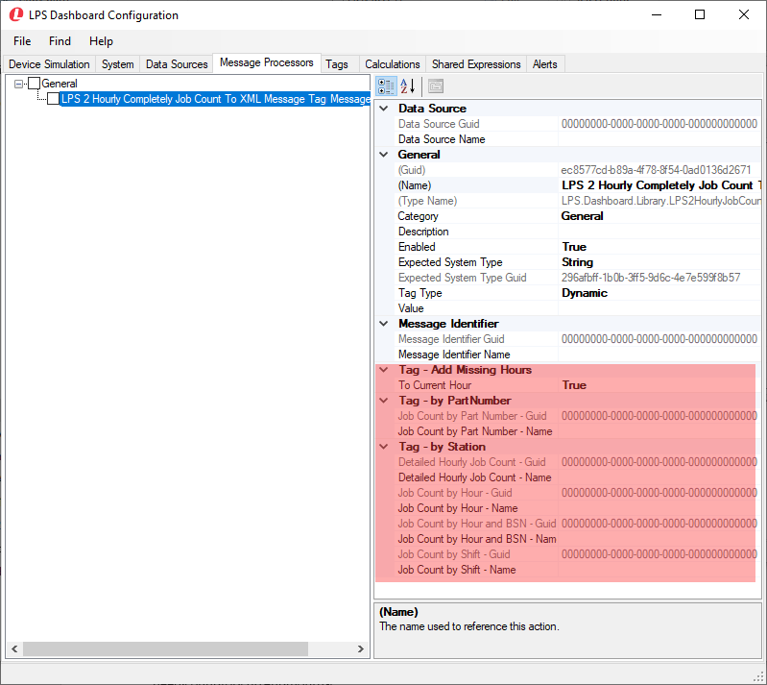

The new tags add greater flexibility in collecting the count data for other uses and calculations.

### MSMQ XML Document to Dynamic Tag

The new MSMQ message processor, **MSMQ** **XML Document to Dynamic Tag,** has been added to collect added, removed, and updated data from a dynamic tag received from the MSMQ Dynamic Add, MSMQ Dynamic Remove, and MSMQ Dynamic Update data sources described above.

This message processor was created in response to a need to see a list of jobs that have passed a certain checkpoint. It enables creation of a dynamic table tag where the header and ID column are defined. The data in the table is added, updated, or removed based on an XML tag or set of tags using the ID column. Corresponding data sources, described above, pass the data to the message processor.

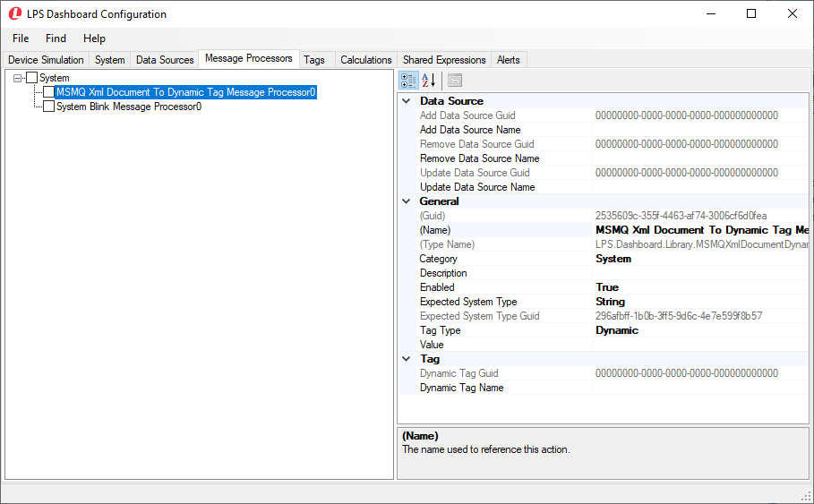

### System Clock Message Processor

The System Clock message processor now contains the ability to separate the time periods (second, minute, hour, day, month, and year) into separate tags.

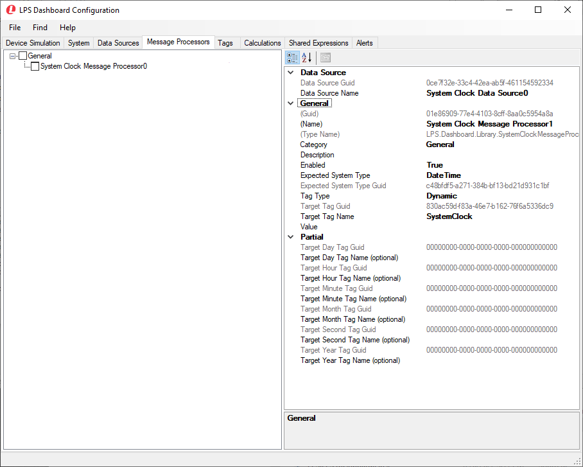

Parsing data into each time period enables OEE calculations for structures.

## Calculations

### Dynamic XML Data Accumulation

A new **Flatten** property has been added to the **XML Transform Calculation**. The property allows you to flatten data from multiple tags into a table. Click [here](http://usdca-lpsdv02/Guides/LPS2/xml_transform_calculation.pdf) for directions for creating a table from dynamic data.

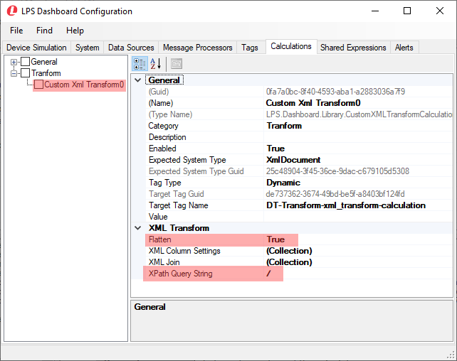

# Dashboard Designer

The following items have been updated:

* Dashboard Designer window
* Chart groupings
* Bar and line charts
* Tables
* Single value XPath control
* Hyperlink control
* System property for Plant Name

## Dashboard Designer Window

The following buttons have been added to the ***LPS Dashboard Designer*** window menu bar:



**Open**. Click to open a project. You are prompted to save the current project before opening a different project.



**Publish**. Click to publish the project to generate views or a slide show. A file called **Published.zip** is created and saved to the folder **LPS.Dashboard.MVC.WebApplication\App_Data\Configuration**.



 **Save** . Click to save the project. A confirmation message is displayed in the Output window.

## Charts

### Sort Order for Chart Groupings

A **Sort Order** property is now available in the ***Chart Grouping Collection*** editor window.

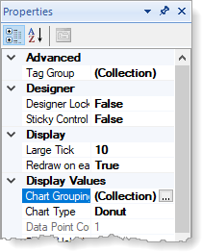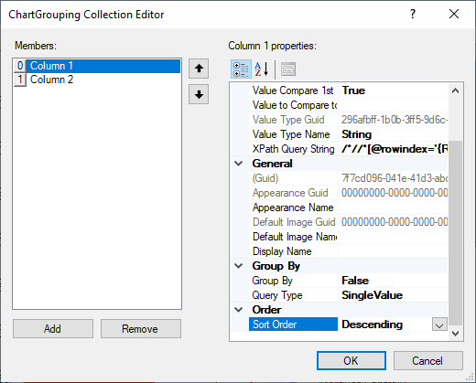

The window is displayed by clicking the ellipsis button in the **Chart Groupings** field in the chart control **Properties** window.

### Bar Charts, Line Charts

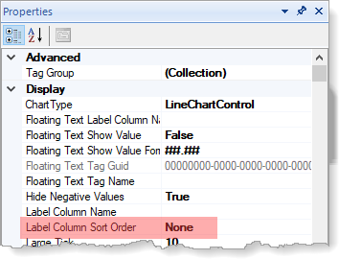The following properties have been added to bar charts and line charts:

* **Label Colum Sort Order**. This property enables you to select how to sort each column. Options are Ascending and Descending.

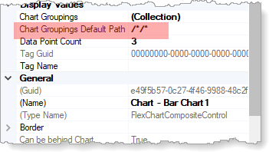

* **Chart Groupings Default Path**. This property enables you to enter an XPath query string to filter XML document data for chart groupings. For example, a string /*/*/* creates a query three levels deep.

## Tables

### Creating Multiple Tables from a Long Table

The following table properties enable you to split a tag with a lot of rows into multiple tables:

* **End Row Index**. Used to enter the index value of the last row to include in the table.
* **Start Row Index**. Used to enter the index value of the first row to include in the table.

These Data section fields are used together with the Max Rows field to define the number of rows to include in the table, starting and ending with the rows specified in the two index fields.

### Colum Name Available for Table Columns

You can now add a column name for each column defined in the Columns collection editor for tables. The **Column Name** property has been added to the **Header** section of the collection editor window, which is available from the Columns field in the table properties window.

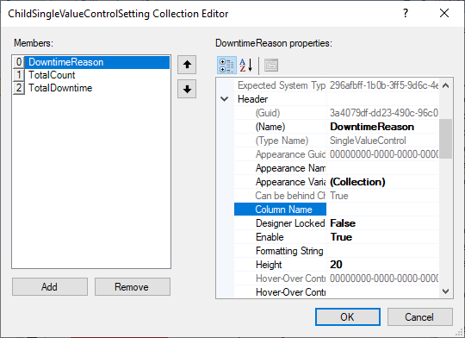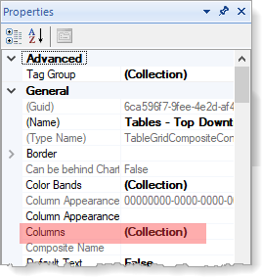

## Primitives

### Single Value XPath Control

The Single Value XPath control now has a Value Type property that enables you to get a count, sum, or value from an attribute retrieved through the query.

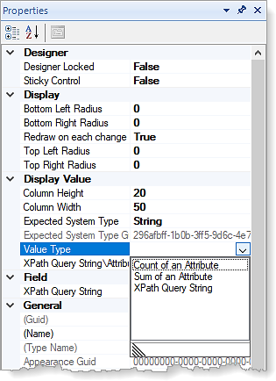

## Web

### Hyperlink Control

The property **Open New Tab** has been added to optionally open a hyperlink in a new tab. A style can also be added to the link text.

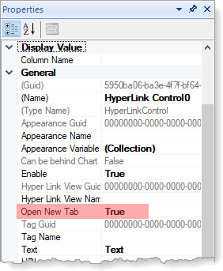

## System

The **System** design element, which defines display properties for the web application, now contains a **Plant Name** property for defining the plant name. When you define the plant name in the System properties, you can include the plant name in the web display.

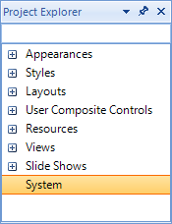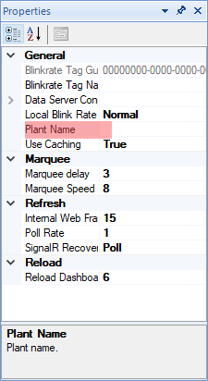

# Active Reporting

The following reports have been updated:

* Jobs Completed
* Requirements List
* Torque Statistical Chart

## Jobs Completed by Job Type

The **Jobs Completed** report now displays the total number of rows for each job type, total jobs completed by job type, and the hourly average for each job type.

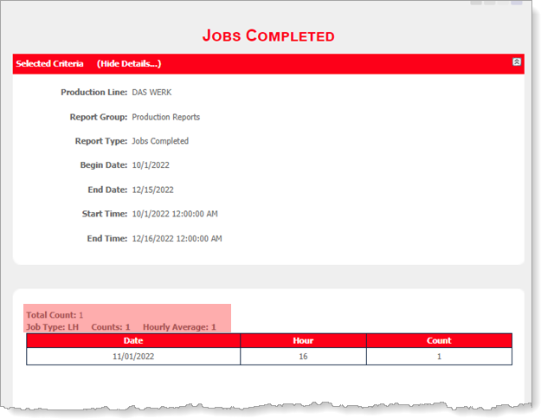

## Requirements List Filterable by IsChecked Property

The **Requirements List** can now be filtered by the new **IsChecked** property.

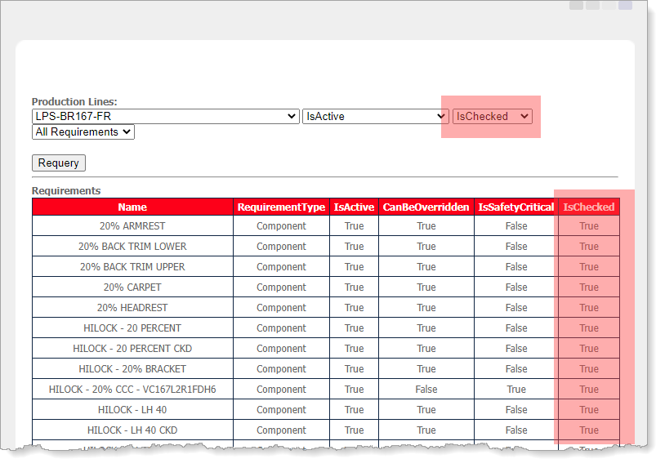

You can use the three filters to include one or all active or inactive requirements that are checked or unchecked for a selected production line.

## Torque Statistical Chart

The **Torque Statistical Chart** can now be generated using the min size or the max size. The choice is made in the Production Lines tab of the ***LPS Active Reporting Plant Configuration Editor***.

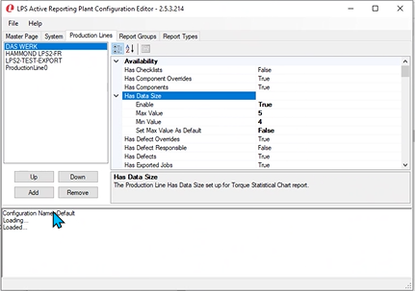

# Alert Center

## Destinations

A new destination type called **Html Email Destination** has been added to the ***Alert Center***. This destination is used to email a screen capture of a dashboard to an email group.

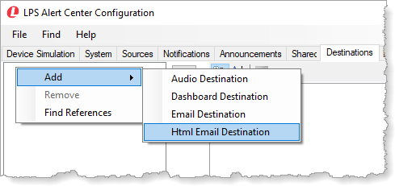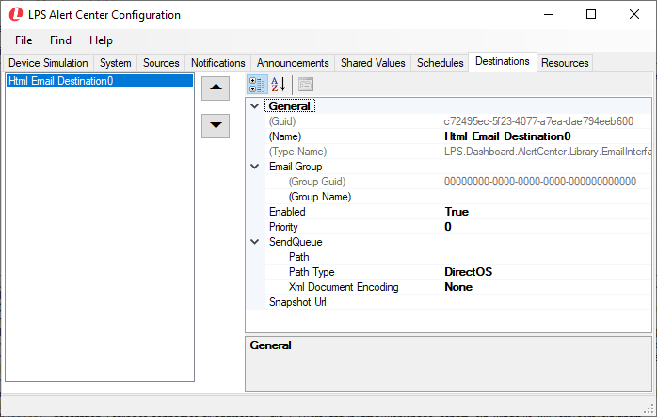

# Plant Administration

## Quality Alerts

The ***Edit Alerts*** page now includes the ability to associate stations with options.

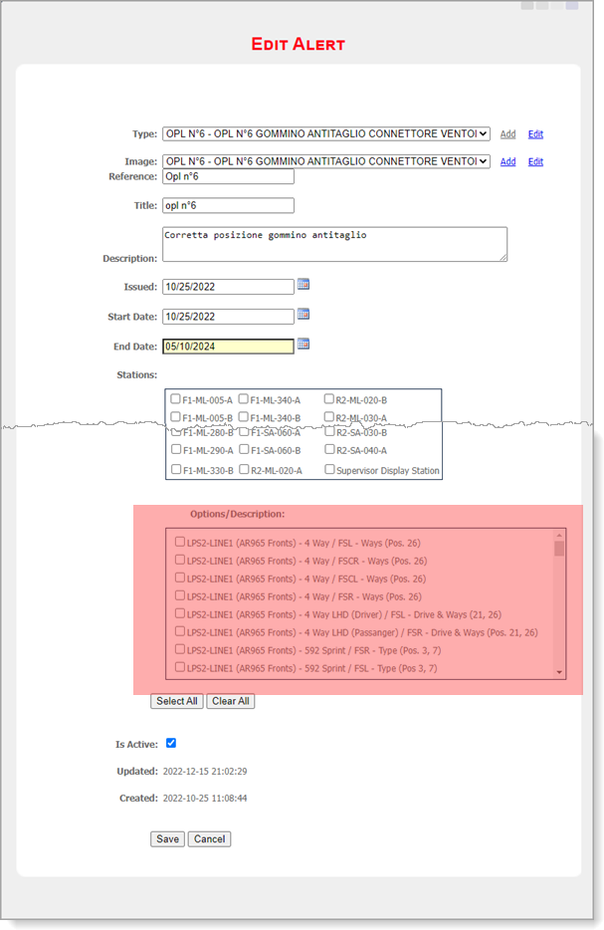

The options for the selected stations are displayed in the ***Quality Alerts*** list window.

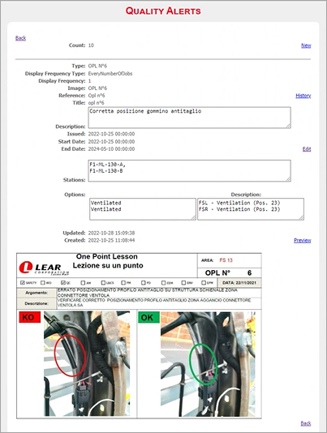

# LPS Documentation Repository

LPS documentation is available from multiple sources, including a documentation repository and embedded online help.

The LPS documentation repository is available at <http://usdca-lpsdv02/Guides/>. It has been revised to include a navigation bar that includes tabs to Shop Floor applications, standards and policies, quarterly updates, knowledge base, and presentations.

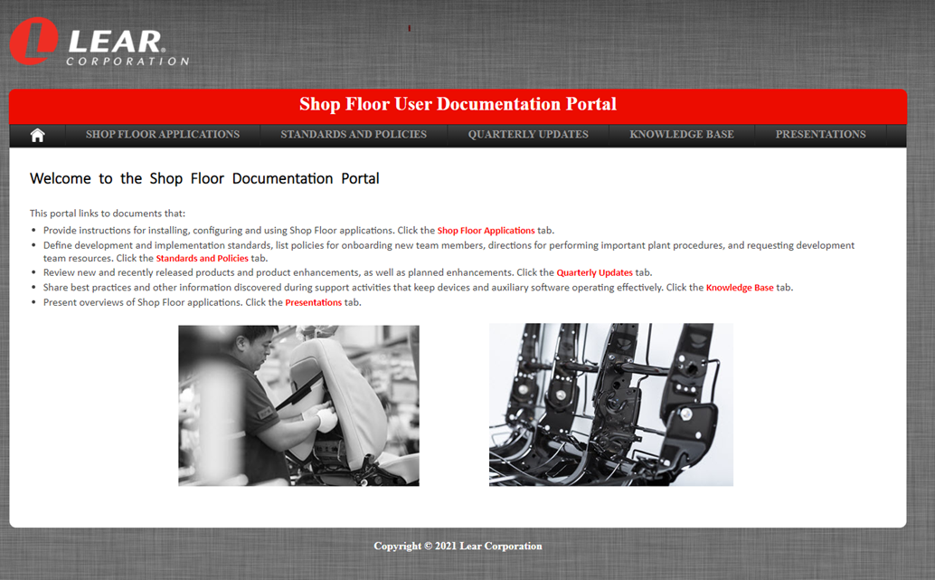

As new documentation becomes available, it will be added to the repository.

# LPS Support Structure

## Standard Operating Procedure for LPS Software Upgrades

The document [***Standard Operating Procedure: LPS Software Upgrades***](http://usdca-lpsdv02/Guides/policies/software_upgrades.pdf), which is available on the LPS Shop Floor Documentation Portal, contains the standard procedures for performing LPS software upgrades. All members of the LPS Team must follow the protocols and procedures defined in the document to maintain the highest level of service to Lear facilities and plant operations.

The following protocols and procedures are defined within ***Standard Operating Procedure: LPS Software Upgrades:***

* LPS software upgrades during production hours
* LPS software upgrades during non-production hours
* LPS configuration change approval process
* Emergency software updates and configuration changes

Before making any changes to LPS software, make sure you have read and understand the expectations, protocols, and procedures defined in the document.

## Incident and Service Request Management with Ivanti

LPS is now using Ivanti (help.lear.com) to manage incidents and service requests.

### Incident Management

Support calls related to urgent issues (i.e., emergencies that will or have already resulted in line/plant stoppage) require an incident to be created and formal incident management to be started through the Service Desk team. The user requesting support, or their local IT team, may log the incident with Service Desk team and should be clear on whether they need formal Incident Management to ensure timely support and incident resolution.

If an LPS team member receives an emergency call, the issue may be addressed and resolved before an incident ticket is logged. The incident must then be entered into the system and closed for the purposes of transparency and traceability.

### Service Request Management

Activities such as upgrades, process changes, and model year changes should be entered as Ivanti service requests. Using Ivanti for these tasks replaces eProj and the legacy Change Approval Process.

Service requests should be entered by the requesting party or their local IT team. Service requests for certain regions must be accompanied with a completed shop floor approval form. After the service request is submitted, the LPS leads are notified, and their approval is required.

* If LPS denies the request, the requestor is notified.
* If LPS approves the request, the ticket then proceeds for plant IT manager approval. The plant IT manager is automatically notified when they have a service request pending their approval.

After a service request is fully approved, the appropriate LPS member will work with the requester to complete the service request. LPS then closes the service request in Ivanti when the work is finished, and all changes are validated.

## Levels of Support

The LPS Team provides three levels of support:

**Level 1** IT and Engineering staff at the plant provide local system support. This person should have knowledge in the following areas:

* + - PLC communication and functionality
    - Windows server environments
    - SQL server
    - Ethernet/network infrastructures and communication protocols
    - OPC communication (RSLinx/Kepware)
    - Electric tooling communication and configuration (Atlas Copco, Cooper)
    - Logical troubleshooting

The plant should identify the local support person, who will work with the LPS team during the installation process to become familiar with LPS.

**Level 2** LPS regional deployment specialists provide second level support for all LPS issues, including hardware and software.

**Level 3** LPS regional deployment specialists may escalate support calls to their regional leads and the global lead to provide third level support.

## Moving Through Support Levels

The following diagram illustrates how to move support issues through the levels:

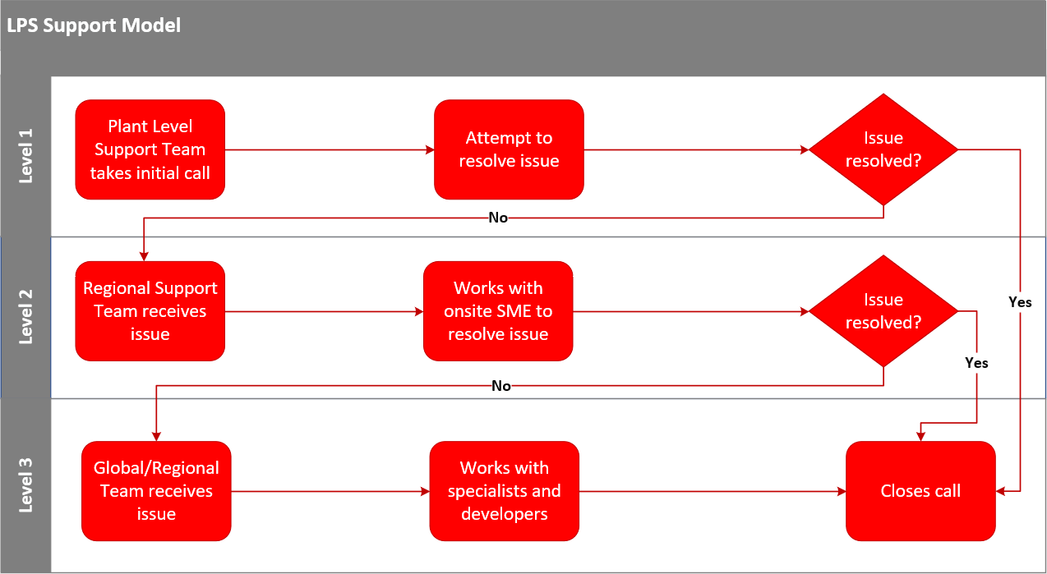

## Shop Floor Support Contacts by Region



**NORTH AMERICA**

**LPS (JIT, Surface Materials, E-Systems)**

* + - Derrick LoCicero +1 248 602 1799
    - Angie Gackstetter +1 313 405 3297
    - Carlos Hines +1 334 391 5871
    - Allen Ku +1 248 238 1502
    - Jessie Genery +1 205 650 2077
    - David Sanchez (MX) +52 1 222 504 4011
    - Raul Lara (MX) +52 1 844 150 1668
    - Daniela Romero (MX) +52 1 878 788 0339
    - Juan Zarate (MX) +52 1 246 168 0952

**LPS (Structures)**

* + - Geoff McNamee +1 248 670 8130
  + Brian Jones +1 248 238 6691
    - Penelope Wu +1 248 508 5177
    - Eric Hunt +1 248 228 6440
    - Ricardo Torres (MX) +52 1 844 103 6641
    - Adriana Bravo Garcia (MX) +52 1 878 788 0339
    - Victor de La Rosa (MX) +52 1 878 703 6958
    - Ulises Sanchez (MX)



**NORTH AMERICA**

**LearPICS**

* Jason Sturmer +1 248 640 9156
* Doug Bell +1 616 213 2223
* Shelle Crusing +1 248 320 8963
* Mike Head +1 248 794 8934
* Tariq Ashraf +1 248 320 2353
* David Ramos (MX) +52 1 844 411 9296
* Luis Garciduenas (MX) +52 1 472 722 9130
* Jorge Rodriguez Martinez (MX) +52 1 844 411 9278
* Ruben Gonzalez (MX) +52 1 722 235 7902

**LFG**

* Brian King +1 248 640 9156
* Jeremy Fuller +1 616 213 2223
* Mike Sagash +1 248 320 8963

**LJS**

* + - Victor Hugo Hernandez (MX) +525 1 656 626 6543

**Database (All Systems)**

* + - Ronnie Sands +1 910 794 5883



**EUROPE**

**LPS2**

* Richard Tonge +44 (0) 795 148 7640
* Adrian Bucur +44 (0) 781 664 1131
* Tomas Vitner +42 (0) 731 535 573
* Goran Rekic +381 (0) 668 891 043
* Aleix Gibert +34 (0) 628 23 7291
* Pablo LaPorta Buil +34 (0) 683 44 23 69
* Patrik Jandl

**LPS3**

* Pavel Hirman +42 (0) 734 644 943
* Robert Rebizant +48 (0) 532 519 505

**LJS**

* Dmitry Borisov +7 (8) 910 599 4478
* Szabolcs Pozsonyi +36 (0) 302 574 467
* Oscar Guillen Garachana +34 (0) 660 290 242
* Xavier Perez Domingo +34 (0) 639 680 462
* Michal Mielnik +48 (0) 532 347 839
* Gabriel Bratu +39 328 757 7581
* Miguel Garcia +34 637 236 682

**LPBS**

* Mateusz Wota +48 (0) 600 478 156

**LFG**

* Sasi Kumar Yabaka +42 (0) 739 055 695



**SOUTH AMERICA**

**LPS2/LPS3**

* Joffer Albuquerque +55 12 99208 9183
* William De Souza +55 11 99335 4090
* Rangel Silva

**LJS/LPBS**

* Paulo Rocha +55 11 99432 8842
* Daniel Silva



**APO**

**LPS2**

* Long Bo +86 139 1602 7561
* Bi Yulong +86 159 9611 0559
* Preetam Patil +91 90110 61263
* Zenny Zhu (Zhengyi) +86 182 2158 7346
* Li Ji +86 188 1738 3378
* Hu Keke

**LPS3**

* Lu Wei +86 139 1820 7163

**LJS**

* Lynn Luo (Linling) +86 177 1758 8509
* Deddy Hoeydiono +62 (0) 811 188 5869
* Abdul Khayi

**APO**

**LPS2**

* Long Bo +86 139 1602 7561
* Bi Yulong +86 159 9611 0559
* Preetam Patil +91 90110 61263
* Zenny Zhu (Zhengyi) +86 182 2158 7346
* Li Ji +86 188 1738 3378
* Hu Keke

**LPS3**

* Lu Wei +86 139 1820 7163

**LJS**

* Lynn Luo (Linling) +86 177 1758 8509
* Deddy Hoeydiono +62 (0) 811 188 5869
* Abdul Khayi