Group members:

1 . Jackeline Cheptanui

2 . Dorothy Akoth

3 . Anastasia Karobia

4 . Stella Chepchumba

5 . Florence kyarikunda

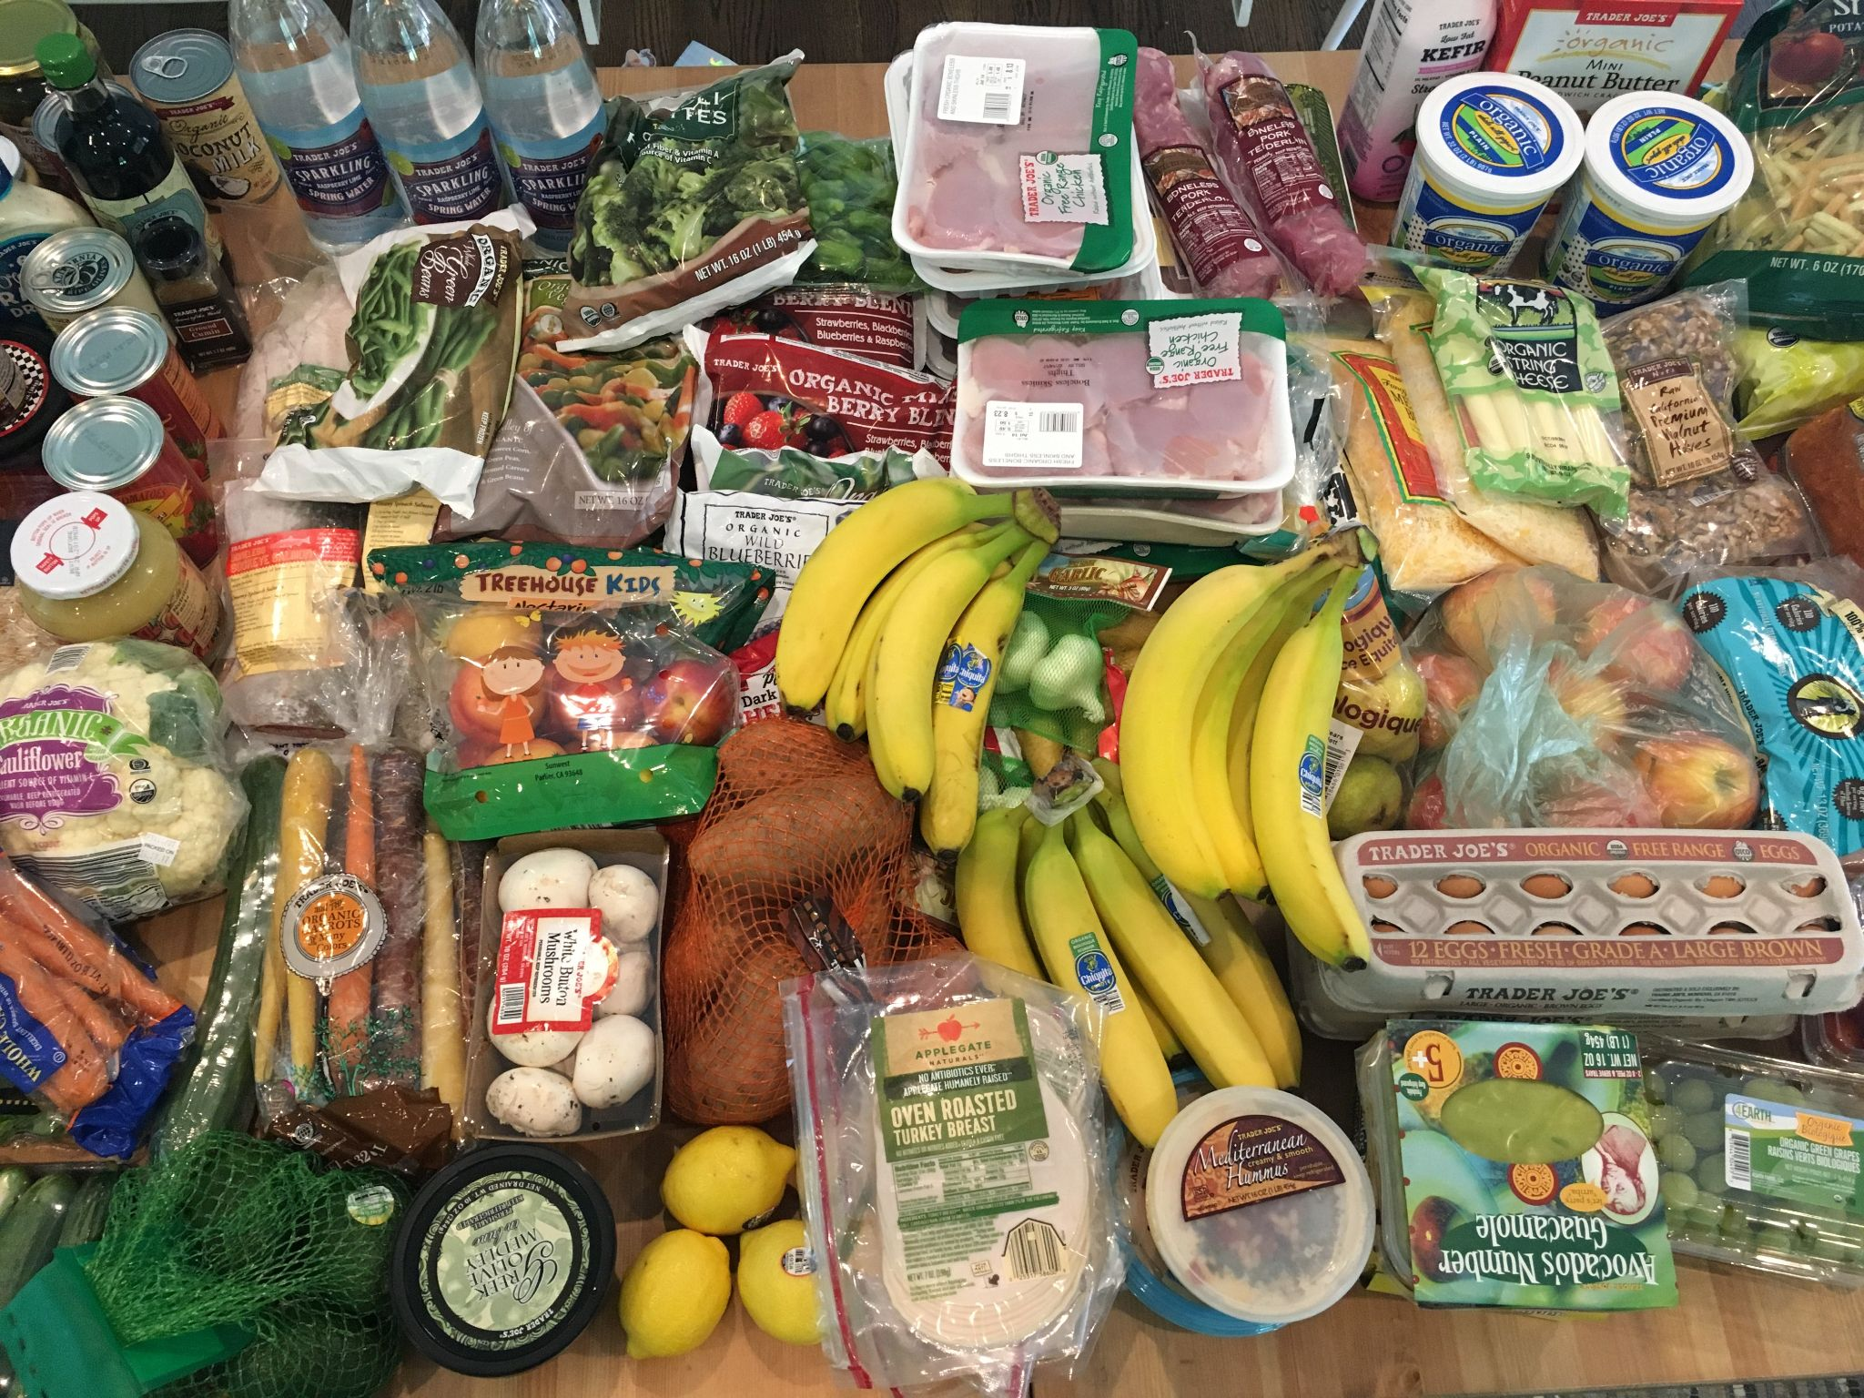

**DESK REVIEW**

**TABLE OF CONTENT**

**Introduction/background** **3**

**Problem Statement** **3**

**Objectives of the research.** **4**

**Methodology** **4**

**Limitations** **5**

**Competitors** **5**

**Findings** **7**

**Conclusions and Recommendations** **8**

# 

# Introduction/background

Currently, AkiraChix kitchen cannot be able to track and monitor stock because food items acquired from the store are recorded in a book, for them to know the stock remaining, they have to do it manually. This book has similar entries for the same items since information cannot be reused. We want to know the challenges they’ve or they’ve encountered when using the booking system when entering the data.

# 

# Problem Statement

How might we help AkiraChix kitchen staff track and monitor the stock in the kitchen to avoid over budgeting?

# 

# Objectives of the research.

1.Find out the ways the kitchen management monitored and tracked stock in the past.

2.To Understand how the kitchen staff avoided understocking and overstocking.

3. To establish the impact of stock tracking and monitoring on financial budgeting.

4.Learn about any pain points the kitchen staff encountered when using their current method of monitoring and tracking stock, and if the kitchen staff would prefer other methods.

# 

# Methodology

We will conduct secondary research which will involve extracting data from already existing research online and this will help us come up with a conclusion and understand the stock management which has been done earlier

# 

# 

# Limitations

During our research, we encountered the following limitations:

1.Lack of adequate information in the online resource

2.There was no/unclear information on the internet

3.Research had not been done properly

# Competitors

**Oracle MICROS POS Systems**

Oracle MICROS provides stable, reliable, and secure point of sale (POS) systems for restaurants, hotels, resorts, casinos, stadiums, arenas, cruise ships, transportation hubs, and retail stores around the globe.

Oracle MICROS

As a global leader in POS hardware, software, open integrations, and innovation, Oracle MICROS also maintains a 40-year tradition of excellence in consultation and support services for its cloud-based and on-premise POS customers across 180+ countries.

easily reorder their favorite menu items at any of your locations and track purchases to deliver rewards they're sure to enjoy. symphony brings your menu and payment processing online. Update menu items and take orders from your website or branded mobile app and send them directly to your restaurant or cloud kitchen. Alert your customers when their orders are ready for curbside pickup or are on their way for delivery.

**JAMIX**

One can purchase orders in the JAMIX Kitchen Intelligence System directly and automatically through the menu. You can also choose items from the product list and add them to your order. All food items on your recipes and finally on your menus are linked to purchase products. Once you have completed your menu, the system automatically creates a purchase order based on the need for ingredients, then sends the purchase orders electronically and directly from the JAMIX system to your suppliers. Once the goods are delivered, you can register the items into the system. You can do it manually or with a mobile app including a barcode scanner. You can add food tracking information or other

info into the system on each delivered item.

# Findings

The Oracle Micros Simphony POS system is built for complete restaurant management. It helps restaurants optimize their online and house operation in real-time from any device.

JAMIX kitchen intelligent system manages inventory and procurement, menu planning, costing, recipe management allergen information, and nutrition analysis.

# 

# Conclusions and Recommendations

# 

# 

What are the ways you have identified to promote efficiency in the kitchen?

* What do you do to keep your teamwork organizers
* How do you normally define quality?
* Tell us about a time you found it hard to follow some procedure or policy in kitchen work.
* What do you consider your greatest weakness when we talk about managerial work?
* Describe how things can go wrong…where money can be lost in the process?