##### RQZJgs

##### School of Engineering and Computer of Science

##### ASSIGNMENT BRIEFING SHEET (2019/20 Academic Year) – ANONYMOUS MARKING

|  |  |  |  |
| --- | --- | --- | --- |
| **Assignment Title** | Blastonbury Pop Festival Table Implementation and Queries | **Submission Date** | 6th December 2019 |
|  |  |  |  |
| **Module Title** | Database Concepts | **Module**  **Code** | 5COM1052 |

|  |  |  |  |
| --- | --- | --- | --- |
| **Tutor** | **Paul Morris** | **GROUP or INDIVIDUAL Assignment** | **Individual** |

|  |  |  |  |
| --- | --- | --- | --- |
| **FOR INDIVIDUAL ASSIGNMENTS – *STUDENT TO COMPLETE***   |  | | --- | | By completing **BOX A** below, I certify that thesubmitted work is entirely mine and that any material derived or quoted from the published or unpublished work of other persons has been duly acknowledged. **[ref. UPR AS12, section 7 and UPR AS14 (Appendix III)]. )].** I also certify, that any work with human participants has been carried out under an approved ethics protocol in accordance with UPR RE01.  *Please* ***ONLY*** *provide your ID (srn) number as this assignment will be anonymously marked* |   **BOX A**   |  | | --- | | **Student ID Number (SRN)** | | **18006731** | |

|  |
| --- |
|  |

**This sheet must be submitted with the assignment, and either BOX A or B filled in.**

**LATE SUBMISSION WILL ATTRACT A STANDARD LATENESS PENALTY.**

1. For undergraduate modules, a score of 40% or above represents a pass mark.
2. For postgraduate modules, a score of 50% or above represents a pass mark.
3. For work submitted up to 5 working days late marked is capped to a bare pass (40% for undergraduate and 50% for postgraduate).
4. For work submitted more than 5 working days a mark of zero will be awarded for the assignment.

**USER ID:** si18aat

Query #1

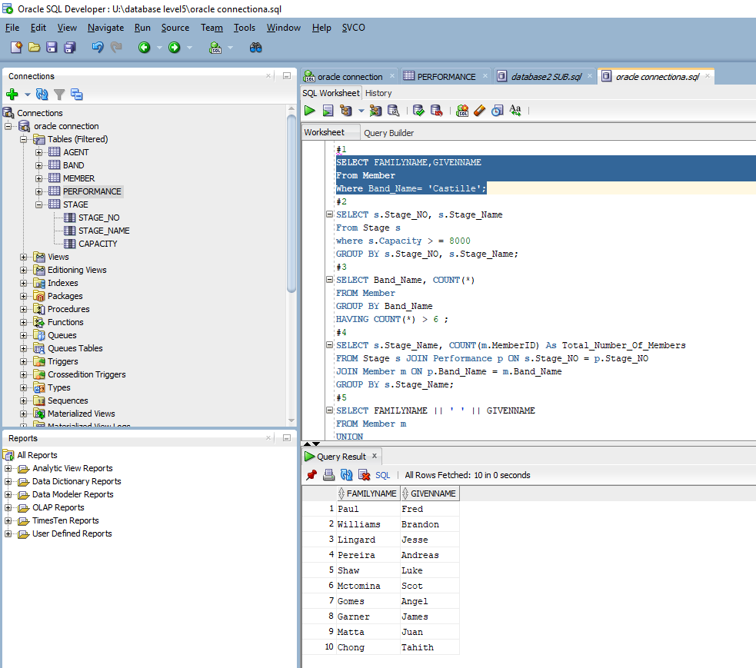

Query #2

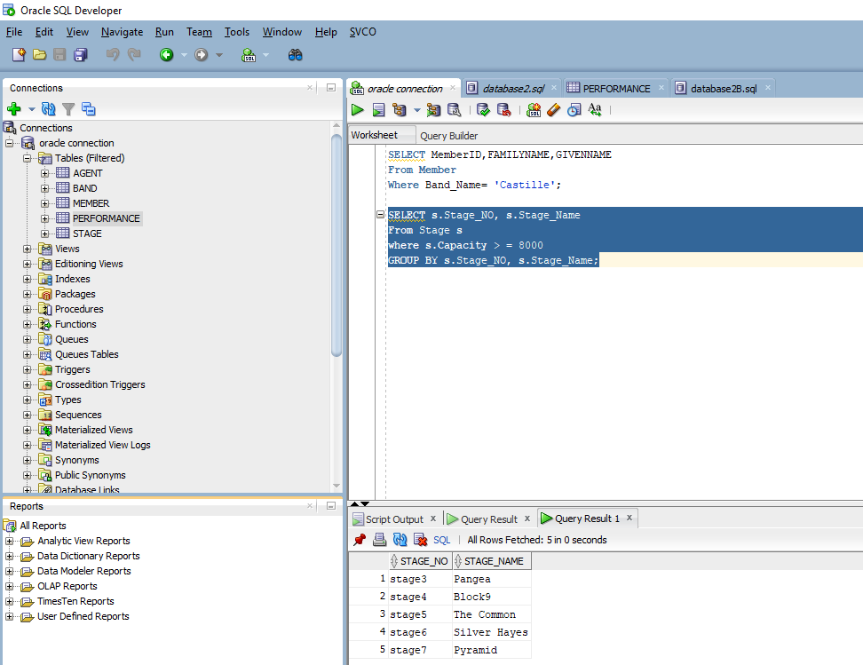

Query #3

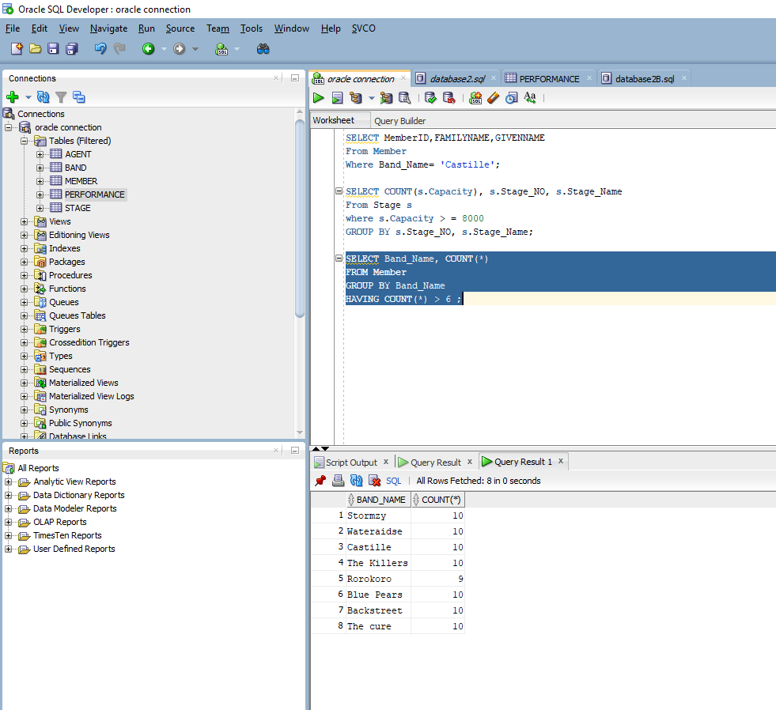

Query #4

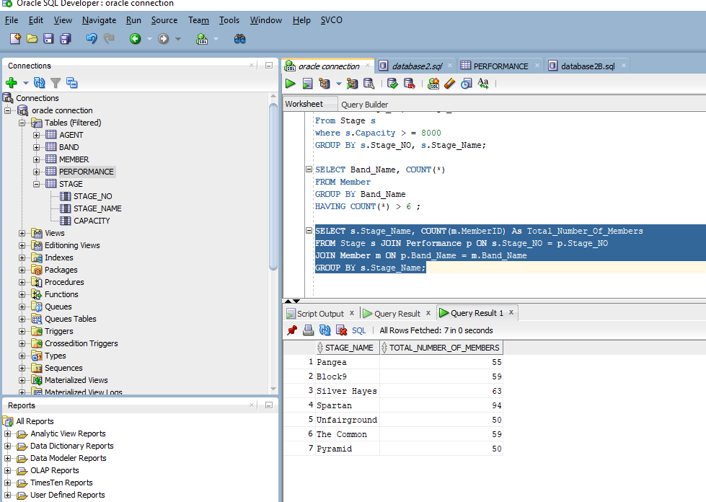

Query #5

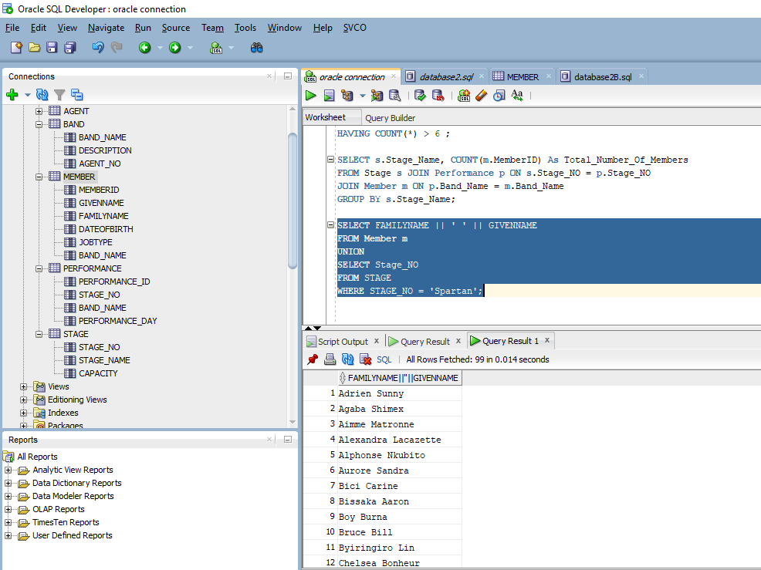

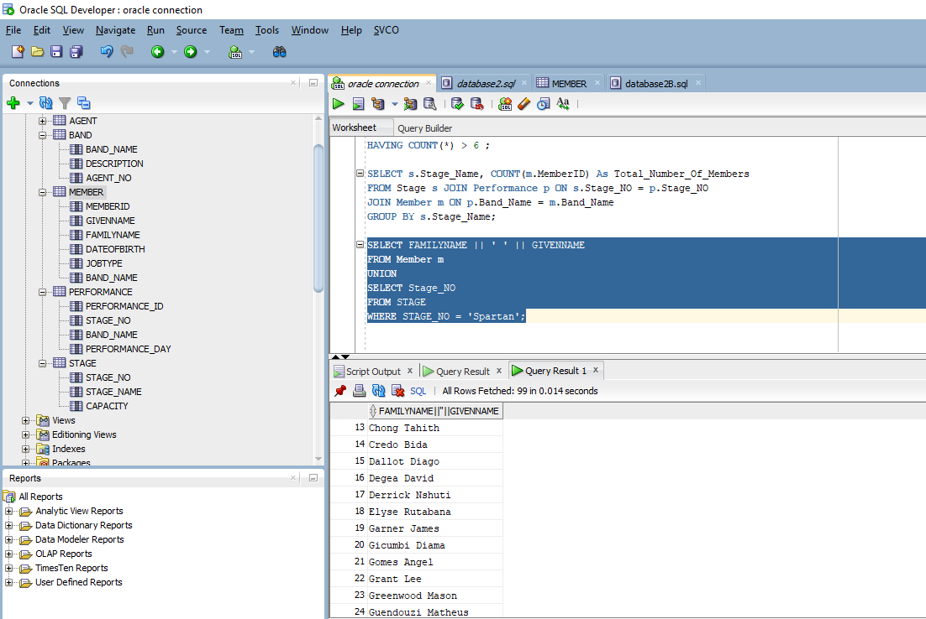  
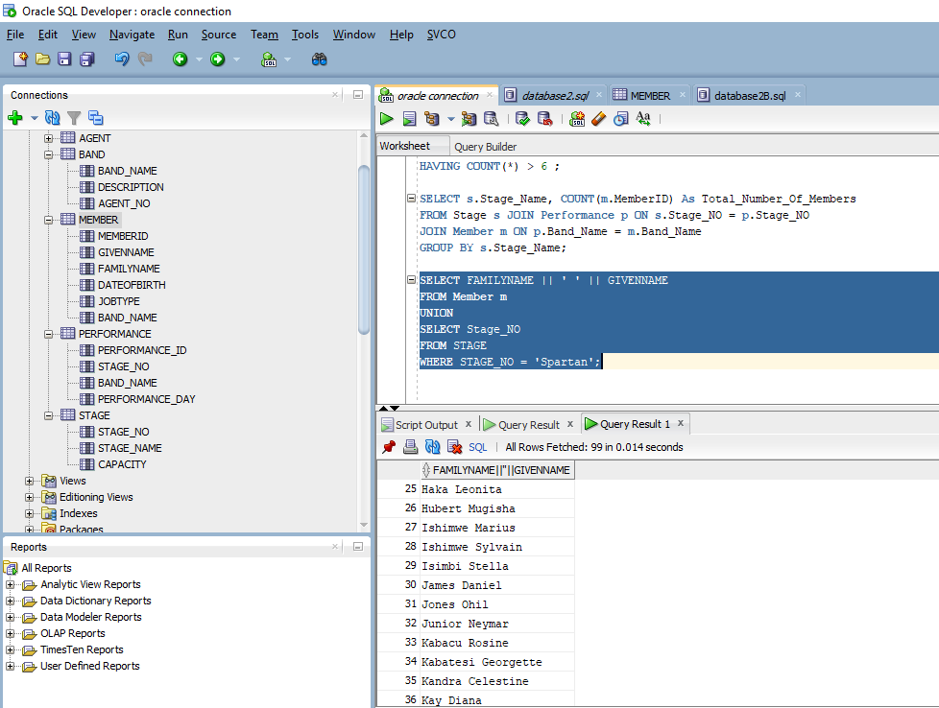

QUERY #6

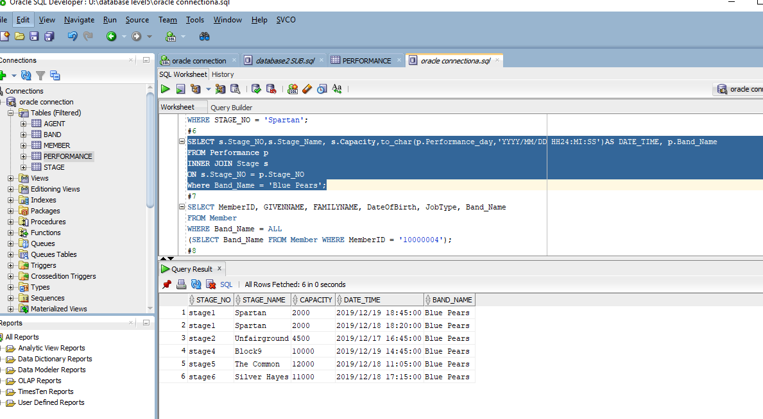

QUERY #7

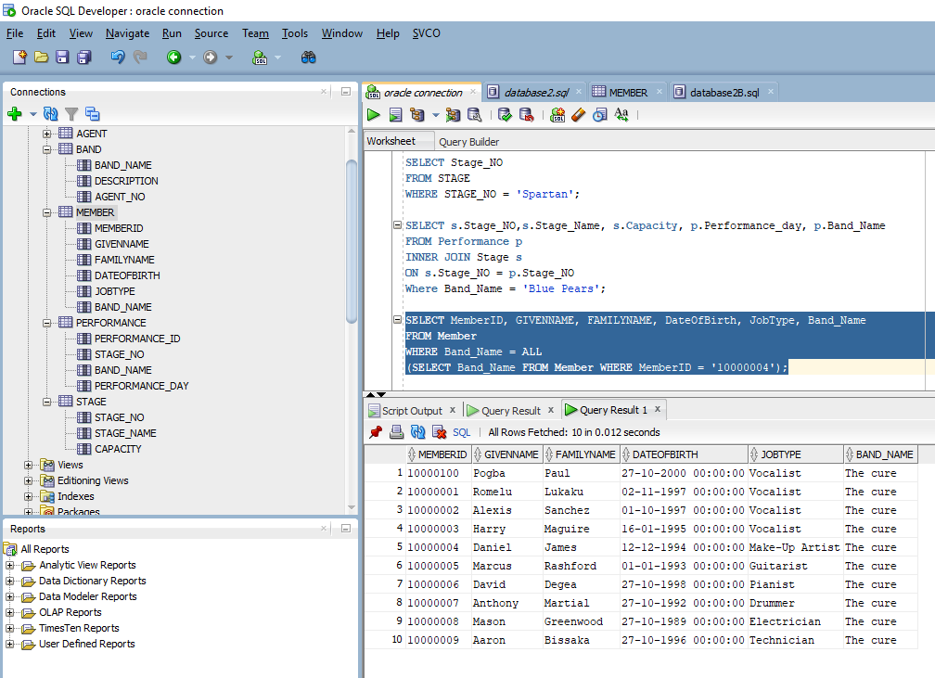

QUERY #8

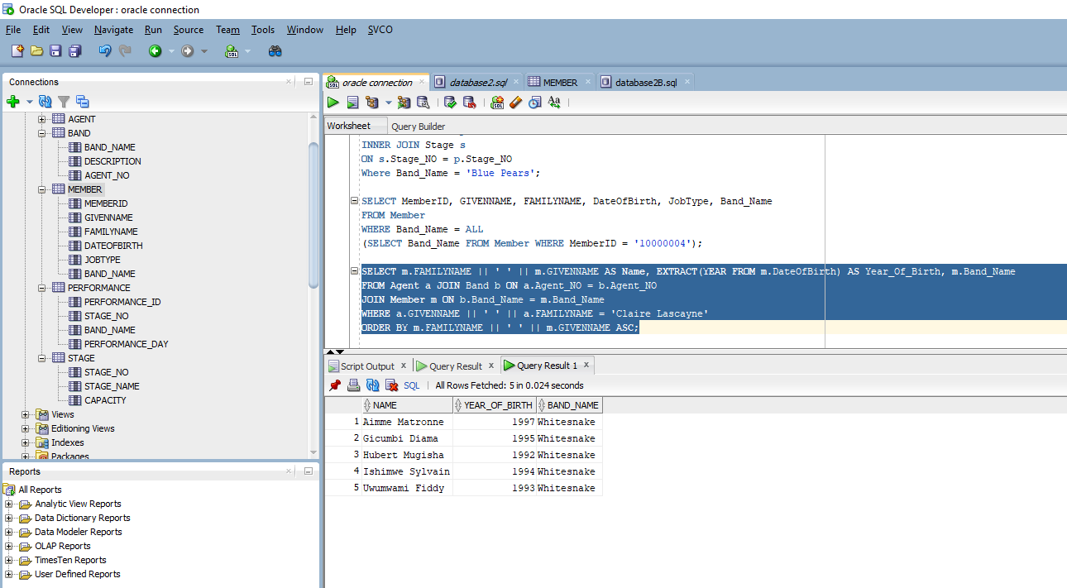

QUERY #9

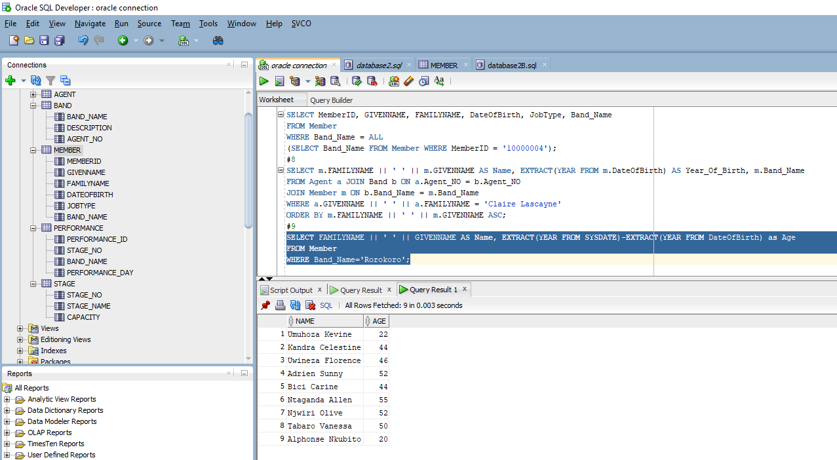

QUERY #10

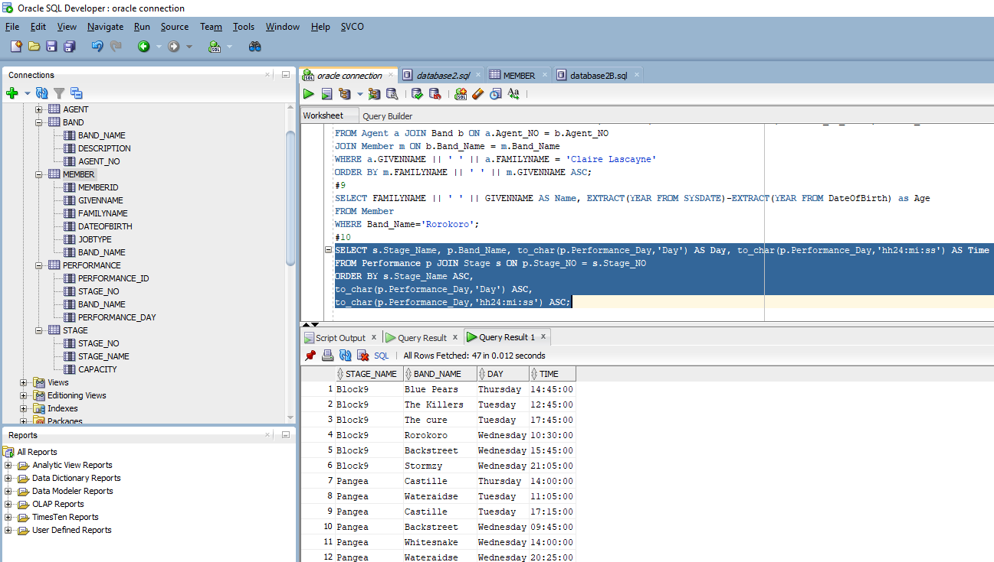

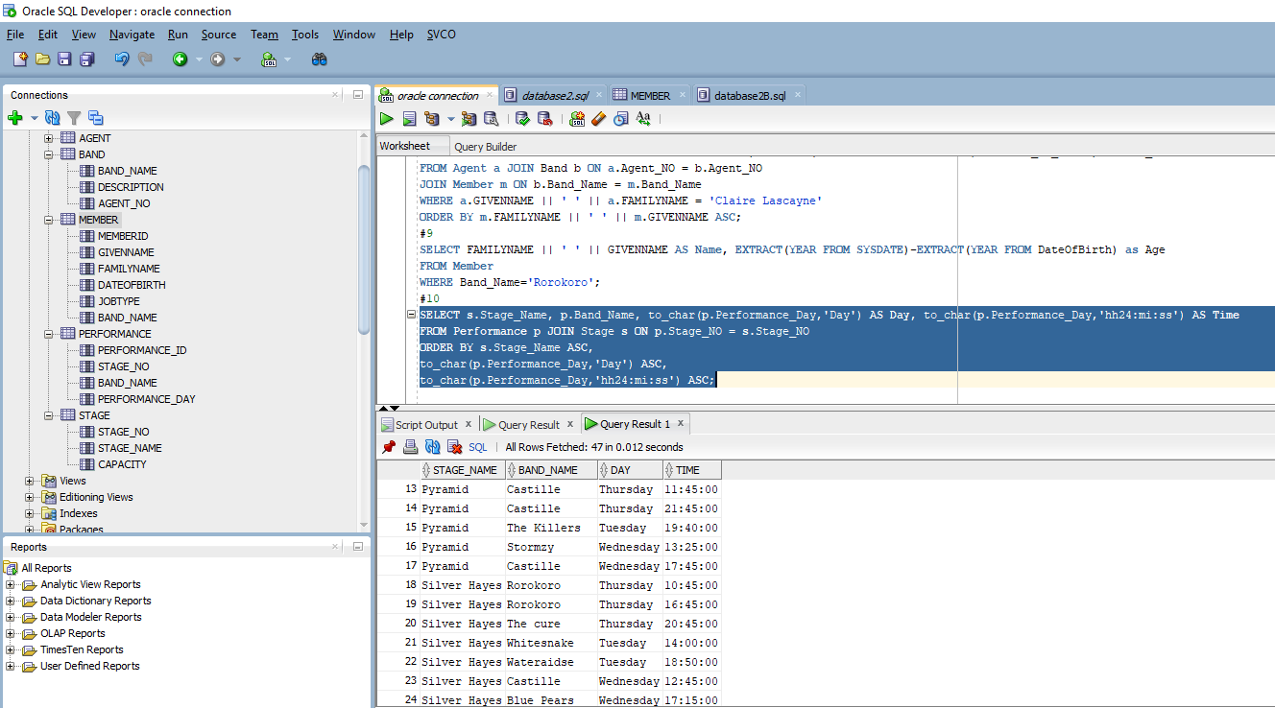

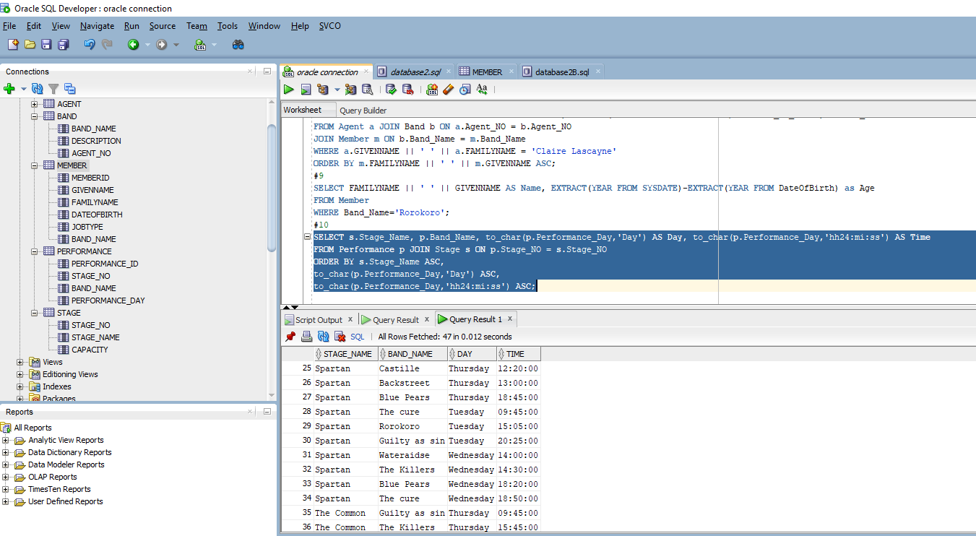

TABLE DESCRIPTION

* AGENT

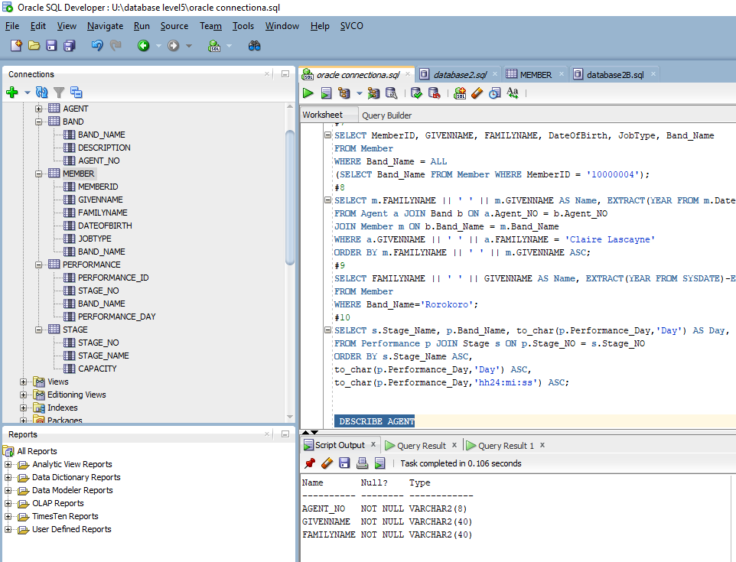

* BAND

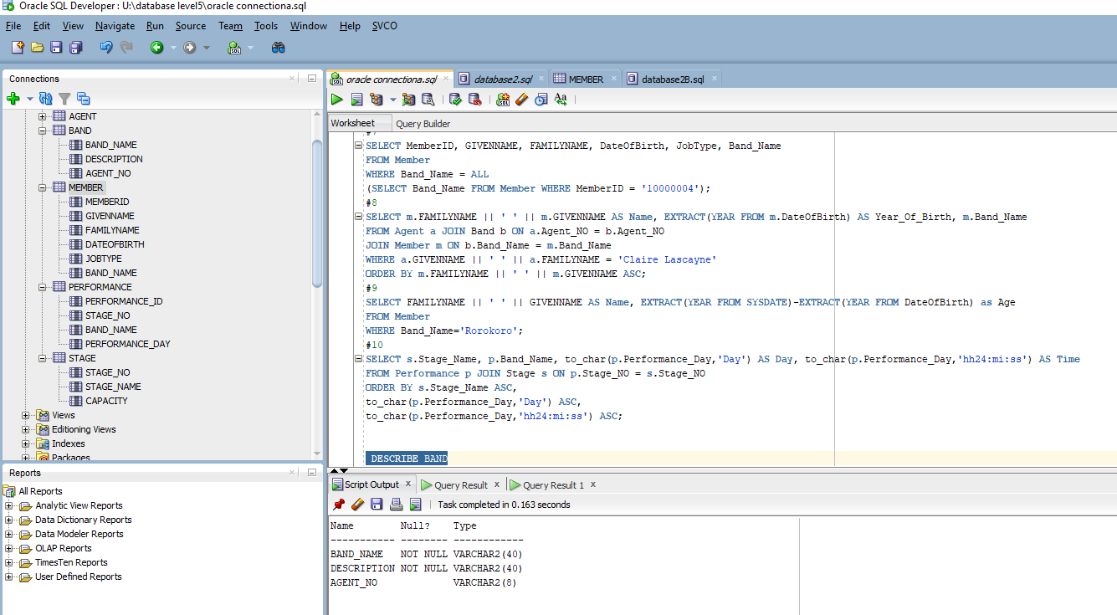

* MEMBERS

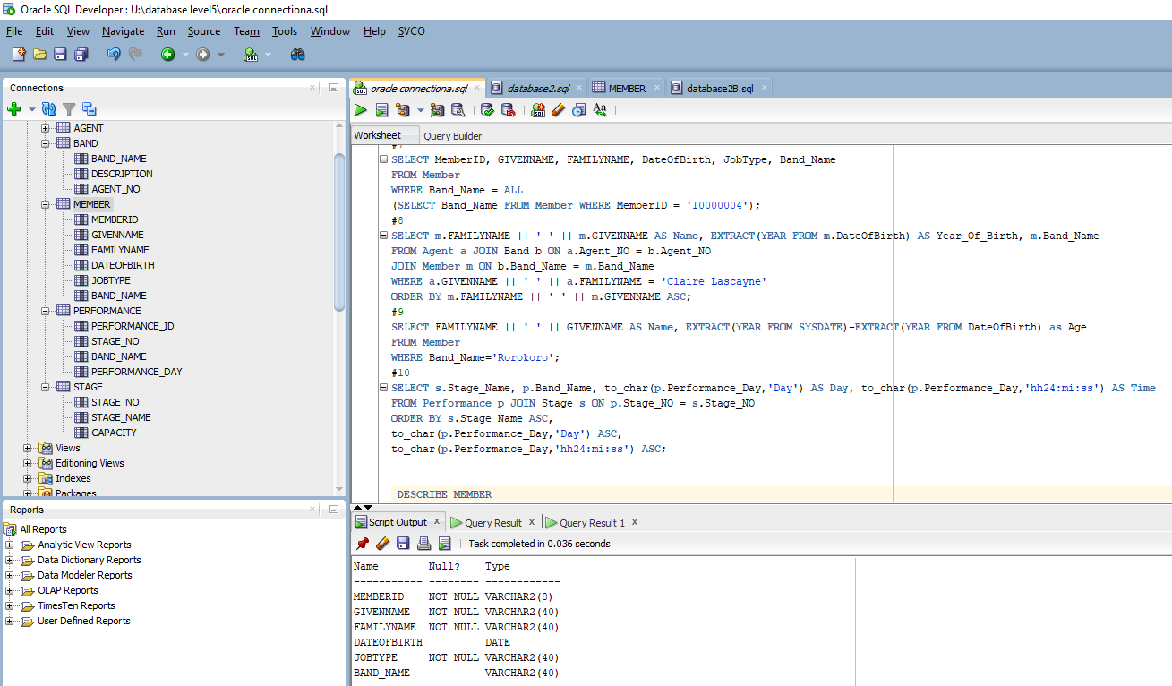

* STAGE

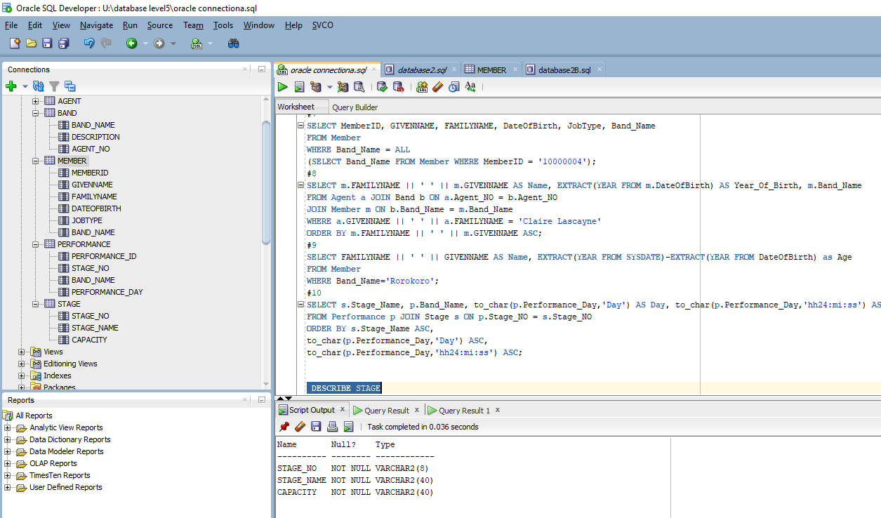

* PERFORMANCE

