**RESULT & DISCUSSION**

This project results show that the accumulated weed biomass, these findings demonstrate that employing E-GP significantly enhances planning performance over the fully observed scenario. The E-GP can proactively prevent growth by prioritizing dense cells before the weeds there grow tall,rather than simply exploiting cells that currently have taller weeds, as was the fully observed case with the previous "greedy" planning index. This is done by utilizing predictive information. This brings down the aggregate gathered weed biomass inside the field, hence expanding the harvest yield and accordingly the monetary addition of the rancher. Hence, conclude that for the parameters we used, four robots will be sufficient to prevent critical weed height failure in steady-state operation. In the transient case where the weeds are given a head start on the robots, we can derive a conservative lower bound on the number of robots necessary. In simulation, we found that in a few cases, five robots could suffice, due to the lower seed bank densities within some cells. In this case, five robots is the critical number, below which it is not possible to succeed under any planning algorithm.

**OUTPUT HARDWARE**

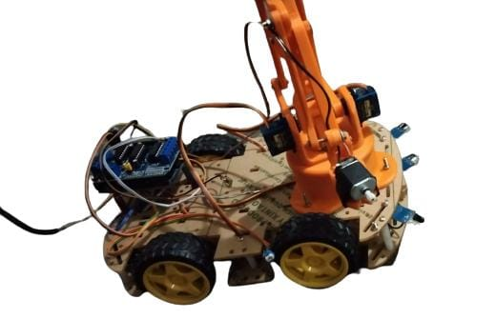

**CONCLUSION**

This project has laid out the major design for the tool head and arm system of a robot, in addition to showing other methods to deliver the tool head to the location of weeds. The tool head has shown it is capable of quickly destroying weeds. The arm is also capable of moving the tool head to the position of weeds quickly enough to allow for the platform to move at the desired speed of 1 foot per second. The five degree of freedom system allows the arm to be used in a wide variety of environments while also reducing energy use by only requiring motor power when it is actuated. The Z axis actuator allows destruction of weeds on curved rows. The counterweighted X axis arm allows for the arm to quickly account for the robot’s walking while not using power unless the arm is moving. The Y axis actuator allows the tool head to move in a circular envelope. The vertical ball screw uses a non-back-drivable system, saving power, while also allowing a variety of heights to be accessible. The horizontal ball screw allows quick lateral movement so the arm can completely cover a row. With two arms on the robot; one for the left and one for the right side, the robot is capable of weeding a row with a quick pass. It is able to traverse the four-foot width of the robot. The horizontal movement allows for up to 29 inches a second of lateral movement, enough to cover the half width of the row. The linear bearings are well within safe operating conditions in regards to stress seen as well as having a resonant frequency far outside of what would be seen. The IMU unit in the lower tool-head provides data to keep the tool head from accidental contact with the ground. Finally, the two mounting plates allow easy arm integration onto the platform. The arm is estimated to weigh thirty pounds and the final cost for purchased parts is estimated at $12000. This gives an idea of the requirements to physically build the design.

# **FUTURE WORK**

# 

This project has laid out the design, manufacturing and assembly methods to create the arm, but for final creation, no doubt, changes will have to be made. This design will doubtlessly need tweaks and changes when being manufactured and created. Work must still be done to fabricate the arm and ensure proper function through physical testing. In addition to the work needed to be done for out of scope systems, during this project’s final design review, concerns were voiced about multiple components. To ensure that the robot can fulfill its task, these concerns will need to be addressed.

During the review process two important problems were found in the design shown earlier. Firstly, the custom shaft, used to hold the lower arm from the lower housing, utilizes a large hole through it. This weakens the shaft and may compromise the components fatigue life. To deal with this, instead of using one hole through the center, two shoulder screws are now used.

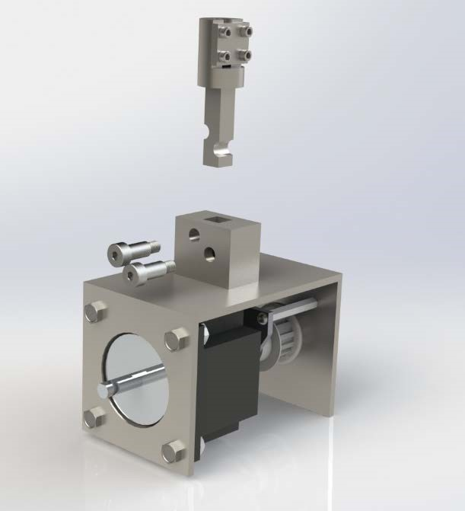

**The new shaft mount. The screws sit in the shaft’s cutaways, removing the weak point in the center of the shaft from the previous design.**

The next section that needed an immediate change was the connection of the vertical ball screw to the lower housing. With the Thomson bought support, the ball screw could freely rotate which would prevent the upper ball nut from being able to move the ball screw. To fix this problem the ball screw needed to be locked in place. A similar method was used to achieve this as was used for the custom shaft.

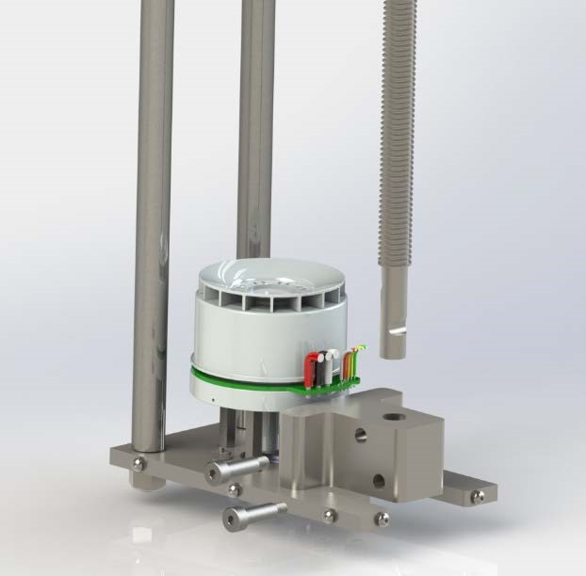

**The new ball screw mounting system. The ball screw's rotation is locked by the two shoulder screws. The shoulder screws also facilitate vertical movement of the unit**

This design change will also reduce the cost of the subassembly as the ball screw support is a large portion of this section’s cost.

Other concerns of the design came from the review board that will need to be worked on in the future. A major one came from the size of the whackers blade compared to the overall size of the housing. If the housing is too large it will knock into the weeds first tipping them over, and preventing them from being properly cut. If the blade is too big however, then the motor may not have the torque to start up. A large blade could also cause problems with safe movement between crops. If the blade is too small, then it will be hard for the tool head to destroy all of the weeds during a pass. The prototype design of a simple four-sided piece of sheet metal worked very well for limited testing. A series of tests and trade studies are needed to find the most efficient size and shape of the whacker head, as well as to find the minimum required motor speed which would help save energy. In addition, no work into the blades life was conducted. A cutter which can better withstand wear will be advantageous.

The control system is a major system of the arm that needs to be designed. For the prototype, a speed controller, small cell battery, and radio transmitter were used. For the final robot, there is no reason to use a remote transmitter for this motor. A full system will need to be designed to control the arm to ensure that it functions properly. Another consideration is the final wire layout of the system. The design currently leaves general space for wires; however, no designated path has been created for them. Special care must be given for the changing height of the lower housing along with the rotation of the lower arm, both of these movements can cause extra stress to wires. Incorporating a cable carrier into these main movement sections would solve this problem.

Along with the control system, the control loop of this system and theory of operations of the arm will need to be decided on. During the final review process, it came to light that the main operational motion of the arm was still under question. The arm could use either the horizontal ball screw for its main movement and the Y axis motor as the secondary fine-tuning motion, or the Y axis motor could be used for the main motion of the arm with little movement coming from the horizontal ballscrew. Each has its own advantages and disadvantages. If the horizontal ballscrew motion is used, then a larger mass will be moved. This could cause swaying to the robot; it would also increase the chance of the arm vibrating at a resonant frequency. If the Y axis motor is the main movement method, then the shaft holding the lower and upper sections together must be tested for fatigue. It will likely need to be increased in size as high loads will often be seen on it. This would cause deformation and failure of the shaft.

Another concern is the DC motor used to turn the arm about the Y axis. This motor will need to repeatedly and accurately change directions; which DC motors are not well suited for. Either a transmission or lever system which allows the motor to continuously rotate will improve the performance of this section. Another solution would be to use a servo motor, but finding one with the required torque will be difficult.

An area of contention on this design was the high use of welded plates. For components where manufacturing accuracy is not required, this would reduce manufacturing costs. The accuracy needed for these components is too high. On main components like the upper housing, the bearings would require highly accurate mounting. This, coupled with the possibility of the weld joints bending and deforming from the heat of welding, would destroy the housing over time; these are major concerns for the current design. To remove these problems, the housing should instead use thicker aluminum plates and be secured together with threaded holes. This would allow for more accurate assembly and increased life of the housing.

During the review, the concern of binding again was touched on. It was recommended to add a second linear bearing support to each of the linear bearings. These would be a few inches from the other linear supports. This would prevent binding as the shaft would now have a greater support structure keeping it straight.

Another section to improve is the horizontal linear bearing. It is currently a 3/8-inch diameter bearing. As the housing moves horizontally this shaft will deform more than the ballscrew, which has a minor diameter of 0.405 inches. This could lead to binding of the horizontal section. This bearing should be increased to 0.5 inches to remove this concern.

A way for the arm to deal with shock absorption is needed. If the blade or arm hits a rock or hard patch of dirt the force will be felt up the arm and will cause extra stress on all connection points. A way of having the lower tool head absorb all shocks would help the longevity of the arm.

Finally, the next designer must decide if each robot will be made specialized for each farm and crop it works on, or if a one size fits all robot is acceptable. No two farms are the same and to meet their specific needed slight changes must be made for soil toughness, crop row height and width and other factors. This robot has been designed to the needs of the CWRU farm. If changes must be made for different farms this needs to be looked into. This also brings up the change of tool head for different weeds. Some weeds grow straight up and some become vine systems that grow across a whole row. To destroy these vines a different style of tool head or blade may be needed. This can only be found after testing and will be the work of the next researcher.