Amin Mossadag 222000055

Advanced AI

12th Assignment

Classification on Full Dataset
The classifiers evaluated were:
- KNN with k = 1, 3, 5, 7
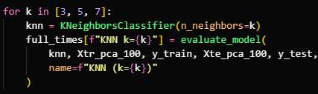
- 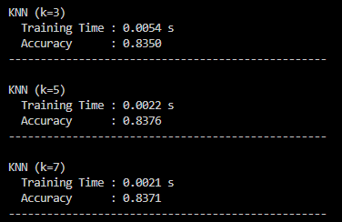
- Decision Tree
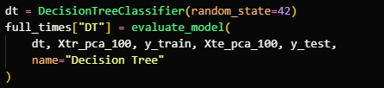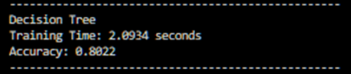
- Support Vector Machine (RBF kernel)
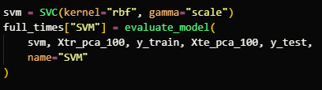ee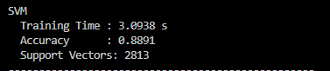
- Model Evaluation Funcion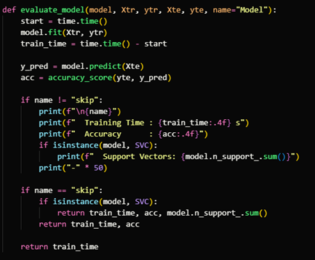

DBSCAN Reduction

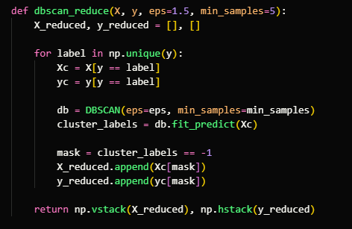

Speed-Up Analysis

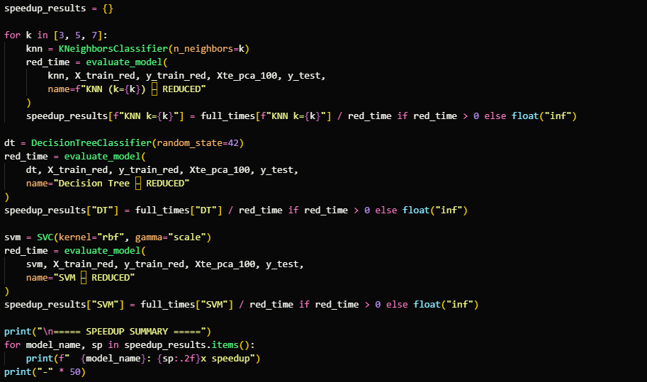

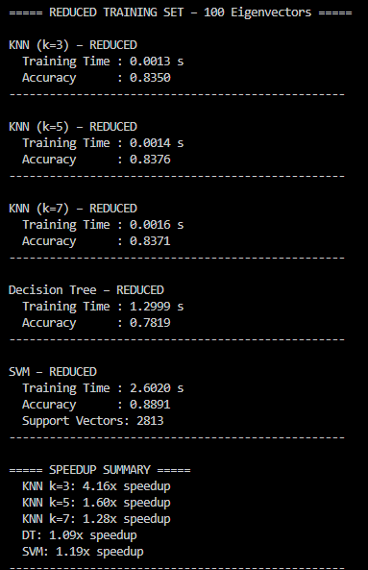

Dimensionality Sweep Results

