## TrueChain development preparation - build the evironment(VSCode & Vim)

Author: Stone Review:

This article mainly told you how to run TrueChain via VSCode and configure Vim to a powerful IDE in Ubuntu. In other Linux system like CentOS, RHEL the steps are familiar.

First of all, you must install GoLangappropriately. To install the GoLang, you can reference the document in go official website: <https://golang.org/doc/install>.

There are many IDEs and editors for development, just choose the one you like.

**System Version: Ubuntu 18.04**

Note:

1. The steps of installation in different Unix like System are a little different, like CentOS, RHEL just use “yum” instead of “apt-get”.
2. In different Ubuntu version, the output may have a little difference.

**Preparation**

Install some tools first:

**$ sudo apt-get install cmake**

**$ sudo apt-get install python-dev python3-dev**

**$ sudo apt-get install build-essential**

**VSCode Installation**

**Tools needed:**

1. Visual Studio Code

**Install VSCode**

First,download the package from <https://code.visualstudio.com/> , the page like this:

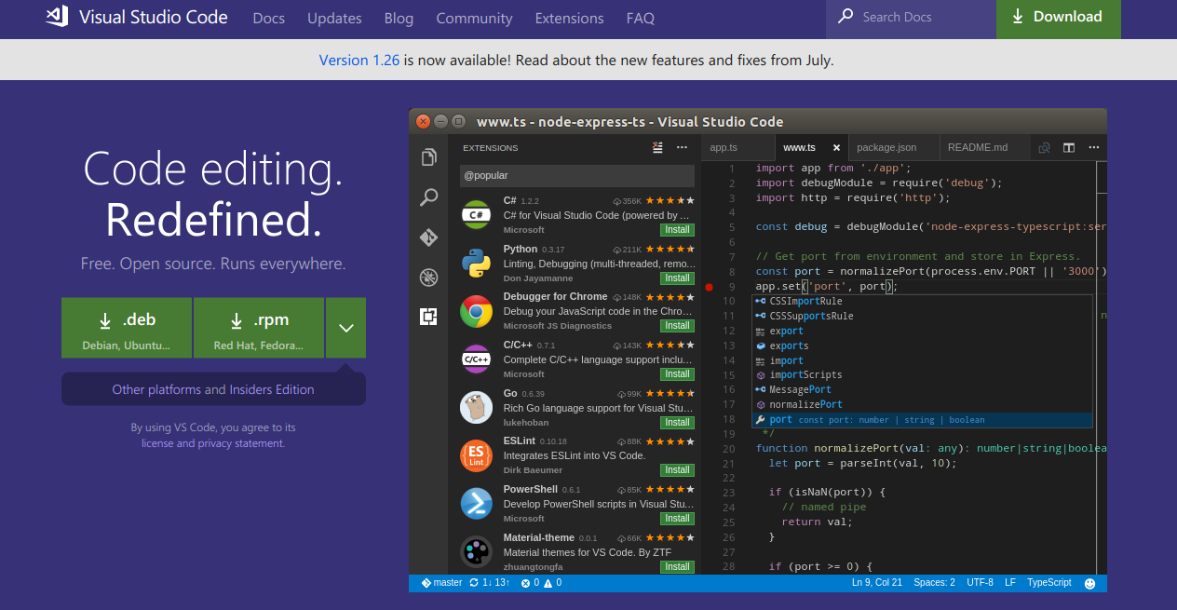

We use Ubuntu, so download .deb package. Then we got a file named “code_1.26.1-1534444688_amd64.deb”(the version could different). Then, we begin to install:

**$ cd path/to/deb_file // change to the direction where contains deb**

**$ sudo dpkg -i code_1.26.1-1534444688_amd64.deb // install**

The installation process like this:

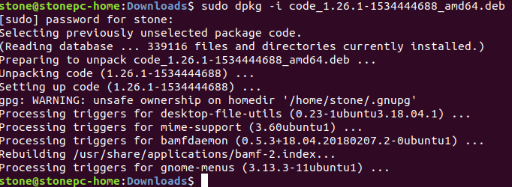

Then, two way to open VSCode:

1. From terminal:

**$ nohup code & // Don’t forget “&”**

1. Press “Win” key, then search “vscode”, you can find it.

Then , you should install some extents. Open “extensions” side bar, then search “Go”, then install.

Now, you finish the VSCode installation.

**Compile TrueChain via VSCode**

This is almost the same as in Windows System, just a little different.

First, download the code:

**$ cd $GOPATH/src/truechain**

**$ git clone <https://github.com/truechain/truechain-engineering-code.git>**

Then open the code by VSCode.

Then VSCode will told you to install same dependents, click “Install All”.

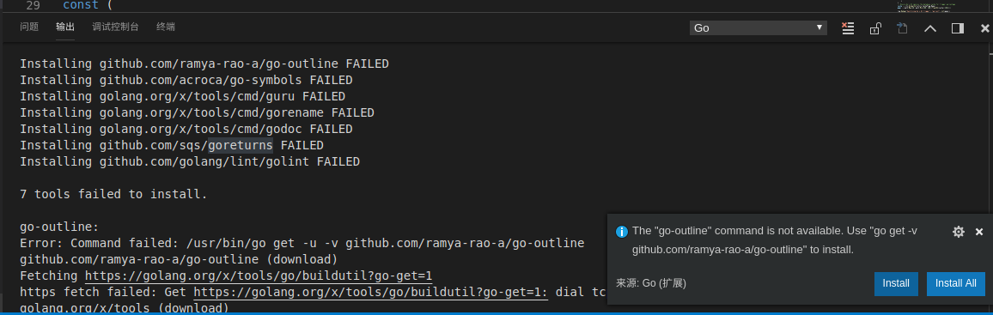

Sometime, some dependents would install failed. You can ignore them, because they have no influence on compile the TrueChain code.

If you are a perfectionist, like me, you can process the FAILED fallow the next section.

**(Option) Process the FAILEDs**

Method: install the failed dependents by hand

1. Process the dependents in “golang.org\x\tools”

Choose a direction you like, then download “tools” source code:

**$ git clone <https://github.com/golang/tools.git>**

Then, fallow the path where the dependents install failed, copy the fold to “$GOPATH/src/golang.org/x/tools”.

Such as, the error message says “Installing golang.org/x/tools/cmd/gorename FAILED”, then copy the folder like this:

**$ cp -r cmd/gorename $GOPATH/src/golang.org/x/tools/cmd/gorename**

Then install the package:

**$ sudo go install golang.org/x/tools/cmd/gorename**

1. Process the dependents in “github.com\”

Actually, it is also download from github and then install. For example, the error message “Installing github.com/ramya-rao-a/go-outline FAILED”, we can process it like this:

**$ cd $GOPATH/src/github.com**

**$ git clone https://github.com/ramya-rao-a/go-outline.git**

// finish download, then

**$ go install github.com/ramya-rao-a/go-outline**

Now, we finish the VSCode installation.

We can have a test now:

Save the program in test.go in VSCode:

**package main**

**import (**

**"fmt"**

**)**

**func main() {**

**fmt.Println("Hello, TrueChain")**

**}**

Then press “F5”, it should print Hello, TrueChain".

**Continue compile TrueChain**

Open TrueChain via VSCode, then open “Debug->Open configurations”, that will open “lanuch.json”, and change the args:

**{**

**// 使用 IntelliSense 了解相关属性。**

**// 悬停以查看现有属性的描述。**

**// 欲了解更多信息，请访问: https://go.microsoft.com/fwlink/?linkid=830387**

**"version": "0.2.0",**

**"configurations": [**

**{**

**"name": "Launch",**

**"type": "go",**

**"request": "launch",**

**"mode": "auto",**

**"remotePath": "",**

**"port": 2345,**

**"host": "127.0.0.1",**

**"program": "${fileDirname}",**

**"env": {},**

**"args": ["init", "./genesis.json"], // ### need to change ###**

**"showLog": false**

**}**

**]**

**}**

Then, open “cmd/getrue/main.go” and press “F5”, that will begin to initialize like this:

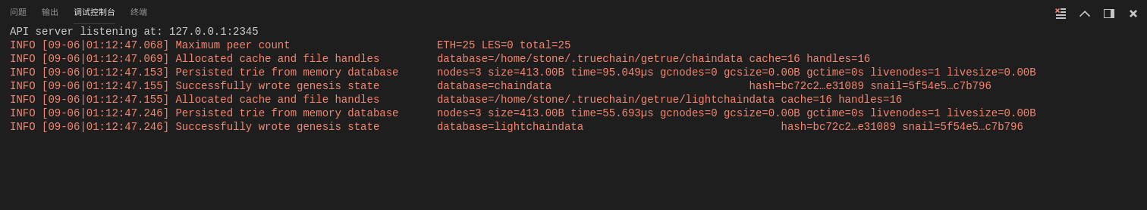

Again, open “Debug->Open configurations”, change the args like this:

**"args": ["--nodiscover", "--singlenode", "--mine", "--etherbase", "0x8a45d70f096d3581866ed27a5017a4eeec0db2a1", "--bftkeyhex", "c1581e25937d9ab91421a3e1a2667c85b0397c75a195e643109938e987acecfc", "--bftip", "192.168.68.43", "--bftport", "10080"],**

Then press “F5”, it will begin minning in a private blockchain, like this:

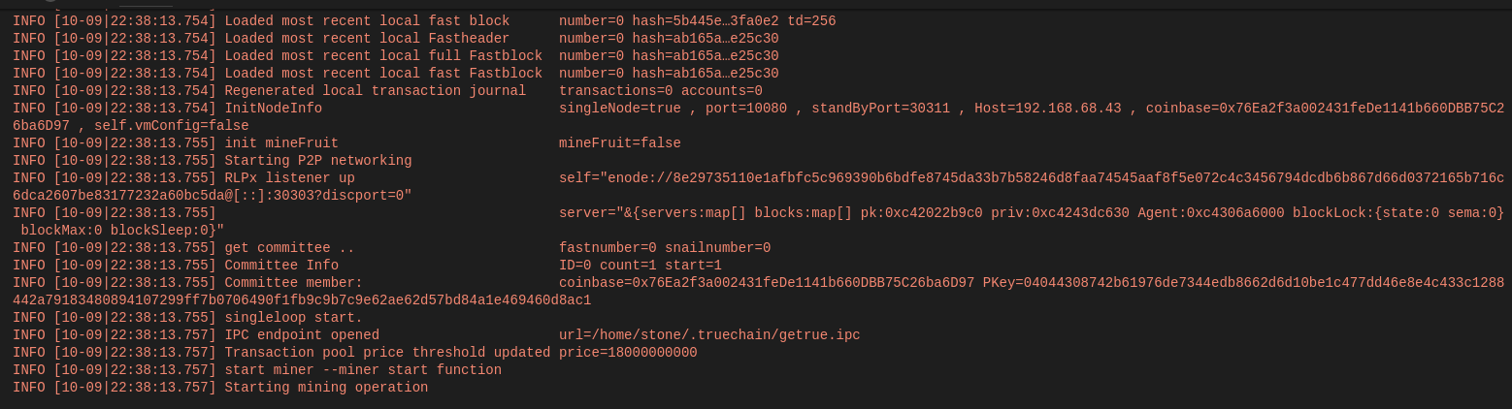

FAQ:

1. Fatal: Failed to write fast genesis block: database already contains an incompatible genesis block (have 1acaa8c23f22e0ae, new bc72c21faf0bc5b9), like this:

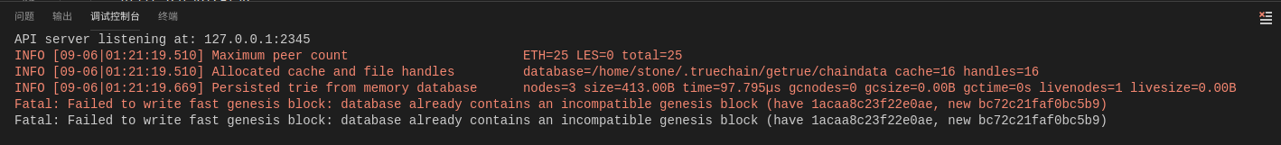

Solution:

**$ rm -rf ~/.truechain/**

**Make Vim to be a powerful IDE**

**CAUTION!!!**

Assuming the reader know the basic usage of Vim.

**Sketch**

Vim called “god of editor”, is the most powerful editor, it is upgraded version of Vi, it has many shortcuts originally, could satisfy most editing needs. You can also make it more powerful by installing various plugins. But, it is hard to learn, if you are not interest in it, just be relax and jump, or you will have a hard time.

Actually, many IDEs provide Linux version, such as GoLand, VSCode, Eclipse. I choose Vim, because it could make me focus on programming, and higher efficiency. And Emacs, called “Editor of God”, it is also powerful, you can have a try if you like.

Again, CAUTION!!!

**Vim configuration**

We will add three function for Vim here:

1. Auto complete
2. Show folder contents
3. Code folding

If you want other function, you will find a plugin somewhere.

**Tools needs**

1. Vim
2. Vundle: A plugin for managing Vim plugin
3. NERDTree: A plugin for showing folder contents
4. YouCompleteMe: A plugin for auto completment

**First, install Vim**

**$ sudo apt install vim**

Vim needs a configuration file, you can copy the example configuration file to “~/.vimrc”, then open Vim and enter “command mode”(press “ESC” then “:”), type in the command:

**:!cp $VIMRUNTIME/vimrc_example.vim ~/.vimrc**

Check “$HOME/.vimrc”, if .vimrc is not exist copy it again. Next we will add some basic configurations.

**" set indent as 4 spaces**

**set tabstop=4**

**set shiftwidth=4**

**set expandtab**

**" show linenumbers**

**set nu**

**" solve messy code for some Chinese files**

**set fileencoding=utf-8**

**set fileencodings=ucs-bom,utf-8,gb2312,gbk,gb18030**

**set termencoding=utf-8**

**set encoding=utf-8**

**" auto fold code when open files**

**set fdm=indent**

Make it effect:

**:source ~/.vimrc // or restart the vim**

**Note: you must make the configuration file effect when you change it.**

Now the basic configuration is finished, we should install some plugins for coding.

**Install Vundle**

The Vundle offical document is here: [https://github.com/VundleVim/Vundle.vim#quick-start](https://github.com/VundleVim/Vundle.vim" \l "quick-start)

Download the source code:

**$ git clone https://github.com/VundleVim/Vundle.vim.git ~/.vim/bundle/Vundle.vim**

Add the configuration at the top of “.vimrc”:

**""""""""""""""" Vundle configuration"""""""""""""""""**

**set nocompatible " be iMproved, required**

**filetype off " required**

**" set the runtime path to include Vundle and initialize**

**set rtp+=~/.vim/bundle/Vundle.vim**

**call vundle#begin()**

**" alternatively, pass a path where Vundle should install plugins**

**"call vundle#begin('~/some/path/here')**

**" let Vundle manage Vundle, required**

**Plugin 'VundleVim/Vundle.vim'**

**" The following are examples of different formats supported.**

**" Keep Plugin commands between vundle#begin/end.**

**" plugin on GitHub repo**

**Plugin 'tpope/vim-fugitive'**

**" plugin from http://vim-scripts.org/vim/scripts.html**

**" Plugin 'L9'**

**" Git plugin not hosted on GitHub**

**Plugin 'git://git.wincent.com/command-t.git'**

**" git repos on your local machine (i.e. when working on your own plugin)**

**Plugin 'file:///home/gmarik/path/to/plugin'**

**" The sparkup vim script is in a subdirectory of this repo called vim.**

**" Pass the path to set the runtimepath properly.**

**Plugin 'rstacruz/sparkup', {'rtp': 'vim/'}**

**" Install L9 and avoid a Naming conflict if you've already installed a**

**" different version somewhere else.**

**" Plugin 'ascenator/L9', {'name': 'newL9'}**

**" All of your Plugins must be added before the following line**

**call vundle#end() " required**

**filetype plugin indent on " required**

**" To ignore plugin indent changes, instead use:**

**"filetype plugin on**

**"**

**" Brief help**

**" :PluginList - lists configured plugins**

**" :PluginInstall - installs plugins; append `!` to update or just :PluginUpdate**

**" :PluginSearch foo - searches for foo; append `!` to refresh local cache**

**" :PluginClean - confirms removal of unused plugins; append `!` to auto-approve removal**

**"**

**" see :h vundle for more details or wiki for FAQ**

**" Put your non-Plugin stuff after this line**

**"""""""""""""""END Vundle configuration"""""""""""""""""**

Then, open Vim:

**$ vim**

It means the configuration file is good if there are no errors.

Install Vundle by type the command in “command mode”:

**:PluginInstall**

It will like this:

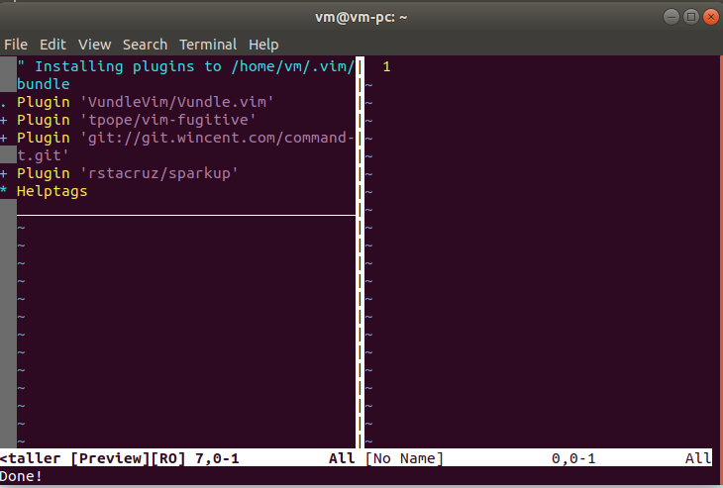

**Then install YouCompleteMe**

Download source code:

**$ git clone https://github.com/Valloric/YouCompleteMe.git ~/.vim/bundle/YouCompleteMe**

**$ cd ~/.vim/bundle/YouCompleteMe**

**$ git submodule update --init --recursive**

Compile:

$ cd ~/.vim/bundle/YouCompleteMe

$ ./install.py --go-completer // you can choose different program language // by different parameter, reference here: [https://github.com/Valloric/YouCompleteMe#ubuntu-linux-x64](https://github.com/Valloric/YouCompleteMe" \l "ubuntu-linux-x64)

Then, add the “YouCompleteMe” configuration to “.vimrc” and make it effect:

**"""""""""""""YouCompleteMe""""""""""""""""""""""""""""""""""**

**set runtimepath+=~/.vim/bundle/YouCompleteMe**

**let g:ycm_collect_identifiers_from_tags_files = 1 " 开启 YCM 基于标签引擎**

**let g:ycm_collect_identifiers_from_comments_and_strings = 1 " 注释与字符串中的内容也用于补全**

**let g:syntastic_ignore_files=[".*\.py$"]**

**let g:ycm_seed_identifiers_with_syntax = 1 " 语法关键字补全**

**let g:ycm_complete_in_comments = 1**

**let g:ycm_confirm_extra_conf = 0**

**"let g:ycm_key_list_select_completion = ['<c-n>', '<Down>'] " 映射按键, 没有这个会拦截掉tab, 导致其他插件的tab不能用.**

**"let g:ycm_key_list_previous_completion = ['<c-p>', '<Up>']**

**let g:ycm_complete_in_comments = 1 " 在注释输入中也能补全**

**let g:ycm_complete_in_strings = 1 " 在字符串输入中也能补全**

**let g:ycm_collect_identifiers_from_comments_and_strings = 1 " 注释和字符串中的文字也会被收入补全**

**let g:ycm_global_ycm_extra_conf='~/.vim/bundle/YouCompleteMe/third_party/ycmd/cpp/ycm/.ycm_extra_conf.py'**

**let g:ycm_show_diagnostics_ui = 0 " 禁用语法检查**

**inoremap <expr> <CR> pumvisible() ? "\<C-y>" : "\<CR>" | " 回车即选中当前项**

**nnoremap <c-j> :YcmCompleter GoToDefinitionElseDeclaration<CR>| " 跳转到定义处**

**let g:ycm_min_num_of_chars_for_completion=2 " 从第2个键入字符就开始罗列匹配项**

**""""""""END YouCompleteMe"""""""""""""""""""""""""""""""""""**

Now the autocomplete function is finished, like this:

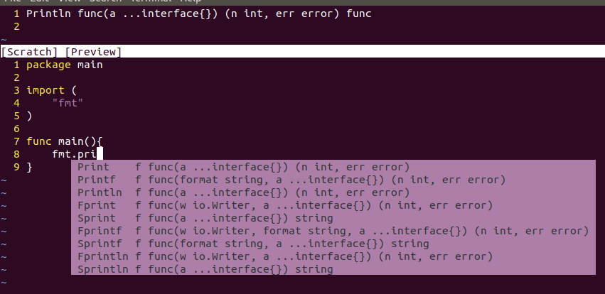

**At last, install NERDTree**

Download source code:

**$ git clone https://github.com/scrooloose/nerdtree.git ~/.vim/bundle/nerdtree**

Add the configuration to “.vimrc” between “call vundle#begin()” and “call vundle#end()”:

**Plugin 'https://github.com/scrooloose/nerdtree.git'**

Add the configuration to the bottom of “.vimrc”:

**""""""""NERDTree""""""""""""""""""""""""""""""""""""""""""""**

**let g:NERDTreeDirArrows = 1**

**let g:NERDTreeDirArrowExpandable = '▸'**

**let g:NERDTreeDirArrowCollapsible = '▾'**

**let g:NERDTreeGlyphReadOnly = "RO"**

**autocm vimenter * NERDTree**

**""""""""END NERDTree""""""""""""""""""""""""""""""""""""""""**

Make “.vimrc” effect, then restart Vim, you will find some thing like this:

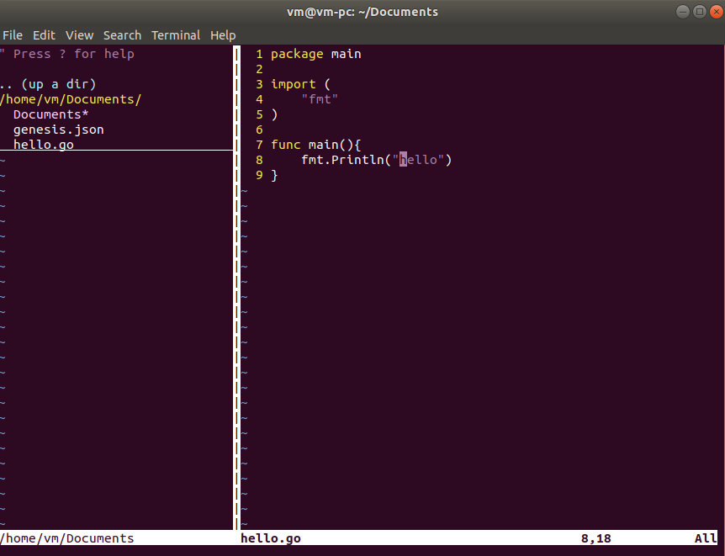

Finished

Complete “.vimrc” file is here <https://github.com/stone-ch/myVIMRC/blob/master/.vimrc>