Wiki文章题目：TrueChain持续集成项目打包（Travis-CI）

作者：邹伟

**TrueChain Continues Integration (Travis-CI)**

Recently, I have been studying TrueChian with a learning attitude, which an open source blockchain on GitHub. Fortunately, I have the chance to participate in the project and fully understood in the whole project process based on the blockchain from the technical principle to the engineering code. The Continues Integration (CI) have highly extendable, and able to realize automatic test and deployment for different program language project, which will take efficiency improvement and the project management security. The CI have a lot of solutions, such as Jenkins, Travis-CI, and so on. We choose Travis-CI solution here, as Travis-CI is closely combined with GitHub, and Travis-CI only supports GitHub projects, so most of GitHub project choose Travis-CI solution.

Author: zouwei

**Environments Prepare**

* GitHub public project(Travis is free for [open source projects](https://travis-ci.org/), and charge for [private projects](https://travis-ci.com/))
* Linux Server (ECS cloud server, CentOS 7.4 System)
* Terminal connect tool(XShell)

**Automatic Deployment Flow**

1. Modify local code and commit to specific branch;
2. Travis listen the repository;
3. Travis performs install and scripts task (e.g some dependencies and test build commands for installation test build tasks)
4. SSH without password login the server in Travis once the task execute successful;
5. Automatic performs the configure scripts in server
6. Complete the automatic deploy

**Project Configuration in Travis**

The aim of CI is, when we need to release newly project, and push to the master branch, Travis will deploy it automatically.

Create GitHub repository and complete the initialization of the project. If there is already a project, you can start the deployment directly. As of I created onela-demo project before, so I take it as an example.

**Active Repositories in Travis**

Log into [Travis-CI](https://travis-ci.org) with GitHub accounts. Travis-CI will synchronize all repositories information on your GitHub. All your repositories will be listed after logging in:

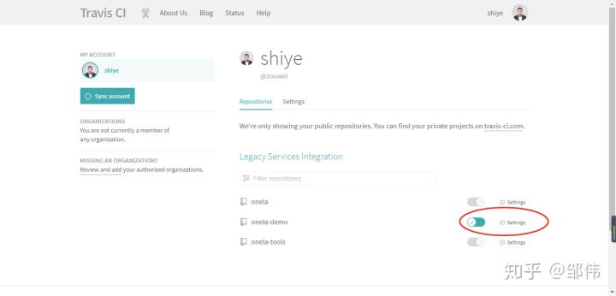

The project not activated by default, click the activation button to activate.

**SSH connect the server**

#Create new account，e.g create account www

useradd www

#change password（it not be demand, but you’d better do it to avoid login require password in the future.）, follow the instructions to set the password。

passwd www

# Add add permissions for the user

vim /etc/sudoers

Find out comment "#Allow root to run any commands anywhere " in file /etc/sudoers, and add a new line as below:

www ALL=(ALL) ALL

[root@trend ~]# su www

[www@trend root]$ cd ~

[www@trend ~]$ ssh-keygen -t rsa

Generating public/private rsa key pair.

Enter file in which to save the key (/home/www/.ssh/id_rsa):

Created directory '/home/www/.ssh'.

Enter passphrase (empty for no passphrase):

Enter same passphrase again:

Your identification has been saved in /home/www/.ssh/id_rsa.

Your public key has been saved in /home/www/.ssh/id_rsa.pub.

The key fingerprint is:

f1:ed:a6:ce:c0:88:13:f2:b9:a8:07:0b:f2:68:06:a1 www@trend

The key's randomart image is:

+--[ RSA 2048]----+

| |

| |

| . |

|. o . |

|... . S . . |

|E o + o . |

|+= = . o o |

|ooo. o o o |

|+o. . .+ |

+-----------------+

[www@trend ~]$

You can find that the key pair generated in the user’s home directory .ssh folder. (/home/www/.ssh).

The Linux OS has permission control rule. The file permissions aren't as big as pxossible, so you need to set the file permission appropriate. Here I define **.ssh directory permissions to 700, and set under **.ssh directory files permissions as 600.

[www@trend ~]$ chmod 700 ~/.ssh/

[www@trend ~]$ chmod 600 ~/.ssh/*

[www@trend ~]$ ls -al

total 24

drwx------ 3 www www 4096 Sep 7 13:55 .

drwxr-xr-x. 5 root root 4096 Sep 7 11:45 ..

-rw-r--r-- 1 www www 18 Dec 7 2016 .bash_logout

-rw-r--r-- 1 www www 193 Dec 7 2016 .bash_profile

-rw-r--r-- 1 www www 231 Dec 7 2016 .bashrc

drwx------ 2 www www 4096 Sep 7 13:55 .ssh

[www@trend ~]$ ls ~/.ssh/ -al

total 16

drwx------ 2 www www 4096 Sep 7 13:55 .

drwx------ 3 www www 4096 Sep 7 13:55 ..

-rw------- 1 www www 1675 Sep 7 13:55 id_rsa

-rw------- 1 www www 394 Sep 7 13:55 id_rsa.pub

[www@trend ~]$

**Add generated public key to trust list (import)**

[www@trend ~]$ cd .ssh/

[www@trend .ssh]$ ls

id_rsa id_rsa.pub

# output the public key content to authorized_keys

[www@trend .ssh]$ cat id_rsa.pub >> authorized_keys

[www@trend .ssh]$ cat authorized_keys

ssh-rsa AAAAB3NzaC1yc**************************************************************** www@trend

**Create new configure file**

Host test

HostName 99.99.99.99(Your server IP address)

#The login username

User www

IdentitiesOnly yes

#The login private key

IdentityFile ~/.ssh/id_rsa

**Test SSH login**

# ssh login test

[www@trend .ssh]$ ssh test

Last login: Sun Sep 9 18:51:57 2018

Welcome to Alibaba Cloud Elastic Compute Service !

If login fail with error: " Permission denied (publickey,gssapi-keyex,gssapi-with-mic) ". Please refer to following operation：

# modify sshd_config configuration file

vim /etc/ssh/sshd_config

# Modify the following content

RSAAuthentication yes

PubkeyAuthentication yes # set RSAAuthentication & PubkeyAuthentication as "yes" to enable public-key model

AuthorizedKeysFile .ssh/authorized_keys # configure the public-key file

PasswordAuthentication yes # open password authentication mode

# save sshd_config file and restart ssh service

/bin/systemctl restart sshd.service

**Install the Travis client tool on the Linux server**

Travis can manually install, but the dependency package is trouble thing, so I choose GEM to install it. GEM is ruby management tool, so the server must install ruby firstly. The ruby installs use the RVM version management tool. The RVM will automatic collection of the server dependencies package and the function very intelligent, because the lack of dependencies packages will be installed automatically.

1. Install rvm

2. Install ruby using RVM

3. Install Travis using the GEM tool

**RVM install**

RVM is a command-line tool which allows you to easily install, manage, and work with multiple ruby environments from interpreters to sets of gems. (<https://rvm.io/>)

Follow commands perform under the user privilege, and it better not to use sudo for any commands.

$ gpg --keyserver hkp://keys.gnupg.net --recv-keys 409B6B1796C275462A1703113804BB82D39DC0E3

$ \curl -sSL https://get.rvm.io | bash -s stable

$ source ~/.bashrc

$ source ~/.bash_profile

# verify rvm install success or not

$ rvm version

rvm 1.29.4 (latest) by Michal Papis, Piotr Kuczynski, Wayne E. Seguin [https://rvm.io]

**Ruby install**

#Using rvm install ruby

$ rvm install ruby

# view installed ruby version

$ ruby --version

ruby 2.5.1p57 (2018-03-29 revision 63029) [x86_64-linux]

[Option]If you cannot access the GEM office mirror source address direct, then follow below operate to change the GEM mirror source address,

# View GEM currently mirror source address

$ gem sources -l

*** CURRENT SOURCES ***

https://rubygems.org/

# View gem version

$ gem -v

2.7.7

# Change gem mirror source address

$ gem sources --add https://gems.ruby-china.org/ --remove https://rubygems.org/

**Install Travis tool**

# install travis

$ gem install travis

# perform travis

travis

# prompt: Shell completion not installed. Would you like to install it now? |y|

# Enter 'y' to install the shell

**Add the encrypted private-key to repository**

After pull the project code from GitHub, login to Travis in the project directory and create the Travis encryption certificate. The id_rsa.enc certificate file is encrypted by Travis, since the private key expose to network is un-safety, so it must be encrypted to ensure security.

# Login Travis using GitHub account firstly

travis login

We need your GitHub login to identify you.

This information will not be sent to Travis CI, only to api.github.com.

The password will not be displayed.

Try running with --github-token or --auto if you don't want to enter your password anyway.

Username:

Password for *********@qq.com:***********

Successfully logged in as zouwei!

# Once login successful，decrypt the private key. The parameter "--add" will inserts the encrypted private key decryption command into .travis.yml file. This is what Travis uses when decrypts it.

$ travis encrypt-file ~/.ssh/id_rsa --add

encrypting /home/www/.ssh/id_rsa for zouwei/onela-demo

storing result as id_rsa.enc

# Since I've generated it before, so here prompt overridden it or not.

DANGER ZONE: Override existing id_rsa.enc? |no| yes

storing secure env variables for decryption

Make sure to add id_rsa.enc to the git repository.

Make sure not to add /home/www/.ssh/id_rsa to the git repository.

Commit all changes to your .travis.yml.

# The encrypted private key file id_rsa.enc have been generated.

$ ls -al

# The private key file appears in the list

……

-rw-rw-r-- 1 www www 1680 Sep 9 17:11 id_rsa.enc

……

-rw-rw-r-- 1 www www 201 Sep 9 17:11 .travis.yml

# Add auto decrypt command to .travis.yml file.

$cat .travis.yml

# The configuration after before_install needs to be added to travis.yml file.

language: node_js

node_js:

- '8'

branchs:

only:

- master

before_install:

# After executing the create command, the encrypted_**** relative file is automatically created on the server. The generated configure need update to the project.

openssl aes-256-cbc -K $encrypted_****_key -iv $encrypted_****_iv

-in id_rsa.enc -out ~/.ssh/id_rsa -d

-in The parameter specific the decrypt file, the file under the root directory of the repository. (When Travis perform a task, Travis will pull code to themselves servers and enter the root directory of the repository.)

-out The parameter specifies that the decrypted private key is store in ~/.ssh/id_rsa on the Travis server.

**Configure after_success hook**

All of the above work was preparation, with some configuration added in.travis.yml, mainly after_success hook configuration. The modified configuration is as follows:

# .travis.yml

language: node_js # Project language，Travis can adapt most languages.

node_js:

- 8.11.3 # version

branchs:

only:

- master

script:

- npm run test # execute scripts，TrueChain project using "make getrue"

addons:

ssh_known_hosts:

- 114.55.249.*** #Server IP address

before_install:

- openssl aes-256-cbc -K $encrypted_0690d495720c_key -iv $encrypted_0690d495720c_iv

-in id_rsa.enc -out ~/.ssh/id_rsa -d

after_success:

- chmod 600 ~/.ssh/id_rsa #Change the file permission

- ssh www@114.55.249.*** -o StrictHostKeyChecking=no '~/update.sh sso' #Using SSH login the server

NOTE:

Using SSH commands login server is required setting StrictHostKeyChecking=no, otherwise you will still be asked to confirm when the first time login. The quotation mark content is the commands that are executed on the Linux server after login, you can also write a script for it. Once login to the server successfully, you can do anything.

* There may be potential issue

# /home/www，The account www must contrlled the permission, even if StrictHostKeyChecking=no.

# the login Password is still required, due to authorization configuration problems.

[www@trend ~]$ chmod 700 ~/.ssh/

[www@trend ~]$ chmod 600 ~/.ssh/*

# Restart ssh service

[www@trend ~]$ /bin/systemctl restart sshd.service

# Restart SSH service with account www, it require enter root password to restart.

**Continue Integration Complete**

Submit the encrypted key file and the modified .travis.yml file to the master branch and access Travis to see the automated build process. Any small detail of the process may lead to building failure, and it really needs the basic skills of Linux. This is a learning process. I hope I can learn from each other and grow together with you.

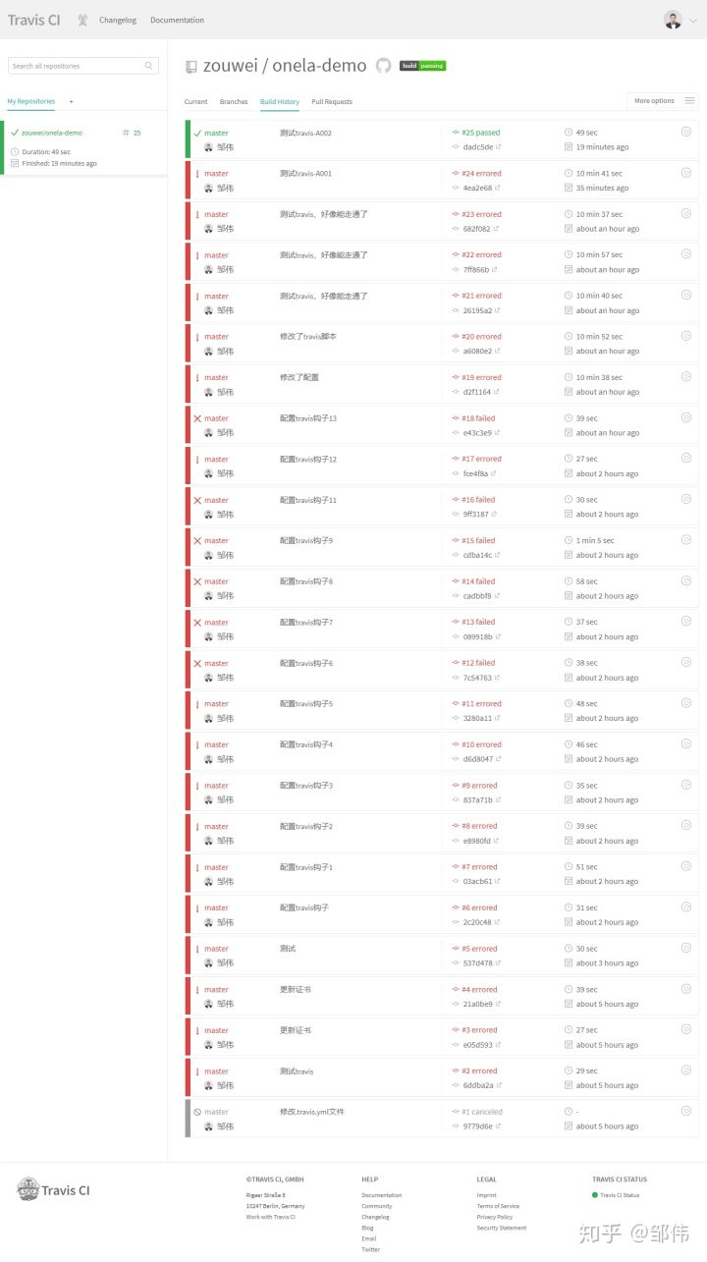

I encountered numerous of configuration problem on Linux, and after a couple of weeks of research (I not particularly familiar with Linux), it was only the last step to debug the Travis service, which was always fail, fail, fail, and difficult all the way.

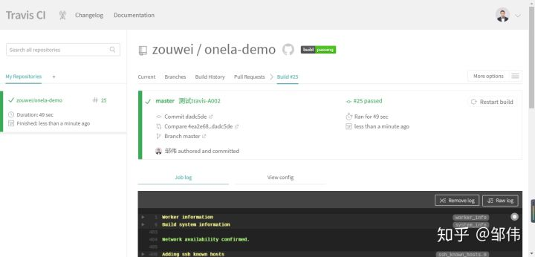

Successful, also grew, continue to strive hard.

**Implement the package automatically builds and automatically starts the program**

We configure the Linux environment in .travis.yml configuration files. After SSH logs in successfully, the project code can be updated to our own server. Next we need to package the project code and start the program. This part is the operational command of Linux, please refer to the TrueChain environment chapter, and it is very complete on each version.

# .travis.yml

language: go # The TrueChain project implement by GO language

go:

- "1.10"

branchs:

only:

- master

script: # Configure the execution scripts, here, I references to the TrueChain environment chapter. Also, you can create a sh scripts file and insert those commands to the file, then to execute it.

- make getrue # Perform packaging build，or using command "make all".

- cd ./build/bin # Enter the compiled directory.

- cp getrue $GOPATH/bin #Copy the compiled files to $GOPATH/bin directory

- getrue init ../../cmd/getrue/genesis.json # Error may be reported, you can execute command "getrue init $GOPATH/src/github.com/truechain/truechain-engineering-code/cmd/getrue/genesis.json" in any directory

- ./getrue --nodiscover --singlenode --mine --etherbase 0x8a45d70f096d3581866ed27a5017a4eeec0db2a1 --bftkeyhex c1581e25937d9ab91421a3e1a2667c85b0397c75a195e643109938e987acecfc --bftip 192.1

68.68.43 --bftport 10080

addons:

ssh_known_hosts:

- 114.55.249.*** # Server IP address

before_install:

- openssl aes-256-cbc -K $encrypted_0690d495720c_key -iv $encrypted_0690d495720c_iv

-in id_rsa.enc -out ~/.ssh/id_rsa -d

after_success:

- chmod 600 ~/.ssh/id_rsa # Modify the file permission.

# Using SSH login the server, it is recommended that the TrueChain package build and program start add to an automatic scripts.

# Example: In the ~/update.sh file of the current login user directory, if the update.sh scripts configured multiple project, it is recommended use the parameter to distinguish(e.g truechain). Then add parameter when running the script, like '~/update.sh truechain'.

- ssh www@114.55.249.*** -o StrictHostKeyChecking=no

**Summarize**

If you have arrived at this step, you should have a basic understanding of continuous integration and practical experience, which will be widely used in your future work. Travis is just one of many continuous integration solution, and there are many continuous integration solution that can achieve similar functionality, waiting for you to be discovered.

OK, I throw out the final question. Building continues integration project release for GitHub, the project permission must be in own account, which leads to a question. How to make sure the project sync with TrueChain open source project, continue integration and publish?

The TrueChain project should assign to oneself GitHub account, then we can fork own version from TrueChain repository, and keep forking TrueChain code synchronization update. This implementation is when official TrueChain project existing update, you only need re-sync the fork TrueChain code. Since your own fork TrueChain has constructed continuous integration, and automatically recompiled package and start the program. Here, it is not perfect that you need manually sync for branch code in official TrueChain. Of cause, you can create a timing script to synchronization the fork code from official TrueChain.