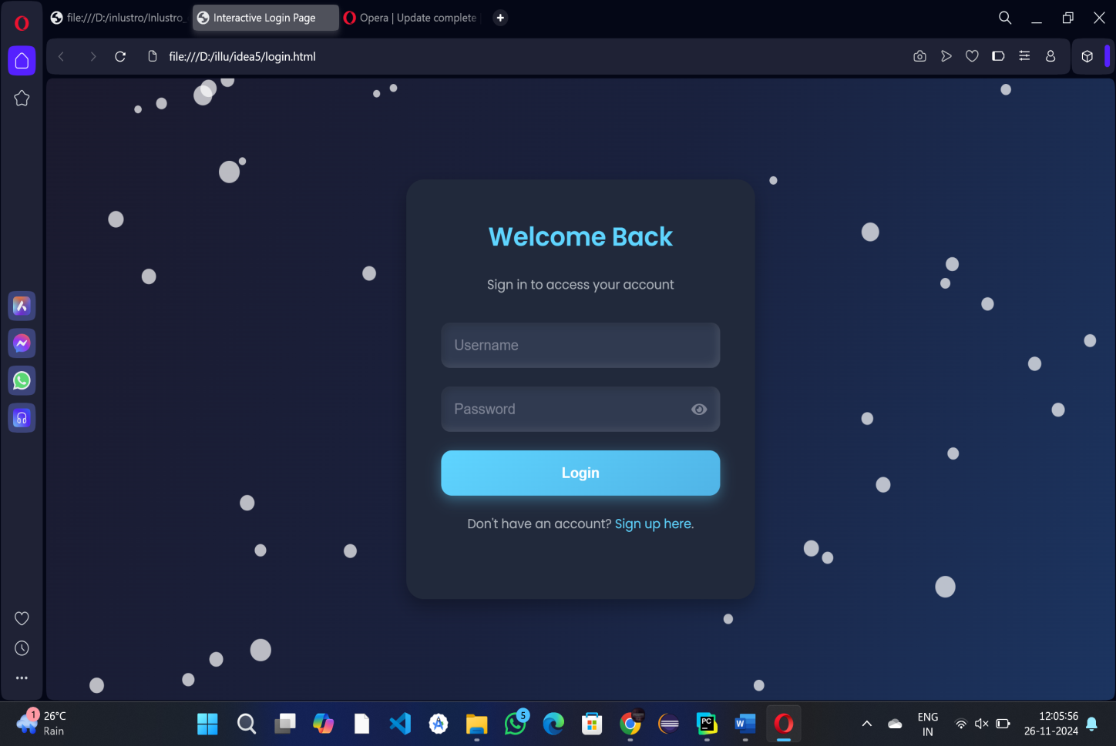

**FIRST PAGE OF PROJECT**

**DESCRIPTION**

This is the Login Page for Admin and Employee , which is created using css and html language. The steps which are followed to create this login page is listed below:

**1.HTML Structure:**

Firstly, we created the HTML structure for the login form. This will include fields for the username, password, a login button, and some optional elements like "Forgot Password?" and a register link.

### 2. ****CSS Styling:****

Now, we added some CSS style to this page, making it more visually appealing.

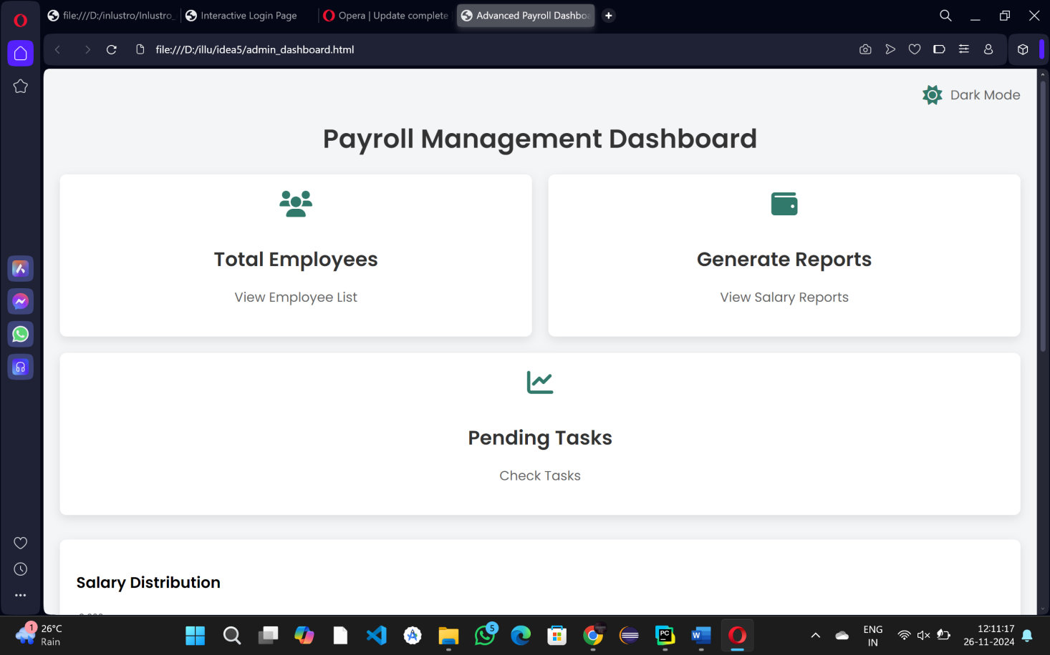

**SECOND PAGE ADMIN DASHBOARD PAGE**

**Description**

* After the Login page , it shows the Main Dashboard (ADMIN LOGIN) which consist of overall details of a company . We made this dashoard as user friendly , where anyone can understand it.It is also create using the html and css language , integrated with python.
* If employee logins ,it shows the dashboard,which contains the overall information of that respective employee.

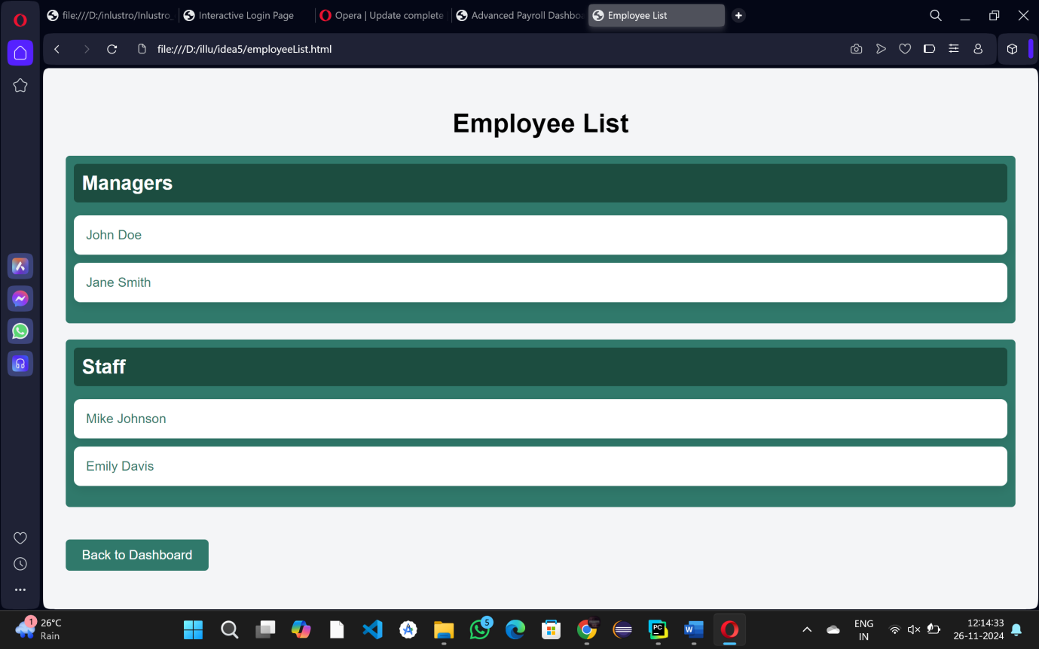

**THIRD PAGE EMPLOYEE LIST HERE**

**DESCRIPTION:**

After selecting the option total employees ,it will redirect to the page where the employee’s details are listed as shown in picture.

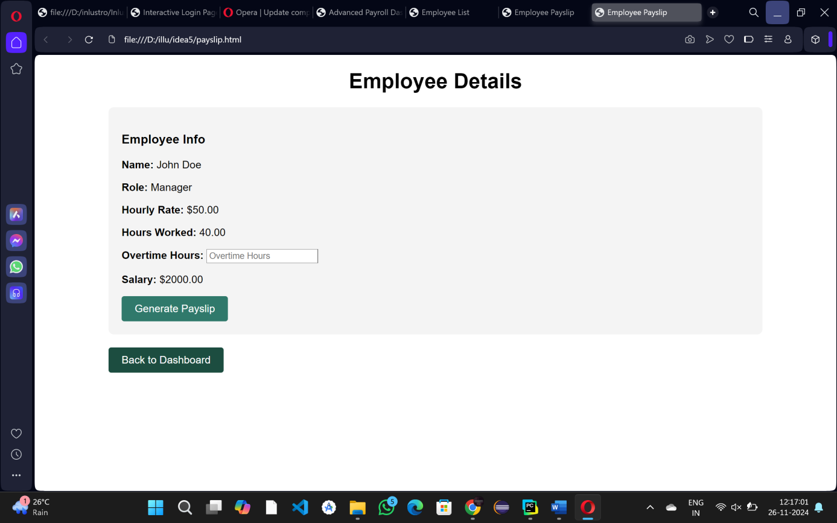

**FOURTH PAGE EMPOLYEE PAYSLIP HERE**

**DESCRIPTION:**

After selecting the particular employee ,it leads to the employee Details page ,which is designed specifically to provide important information and resources related to employees. It serves as a central hub where employees can access relevant company details, tools, and services that enhance their work experience, support their daily tasks, and keep them informed.

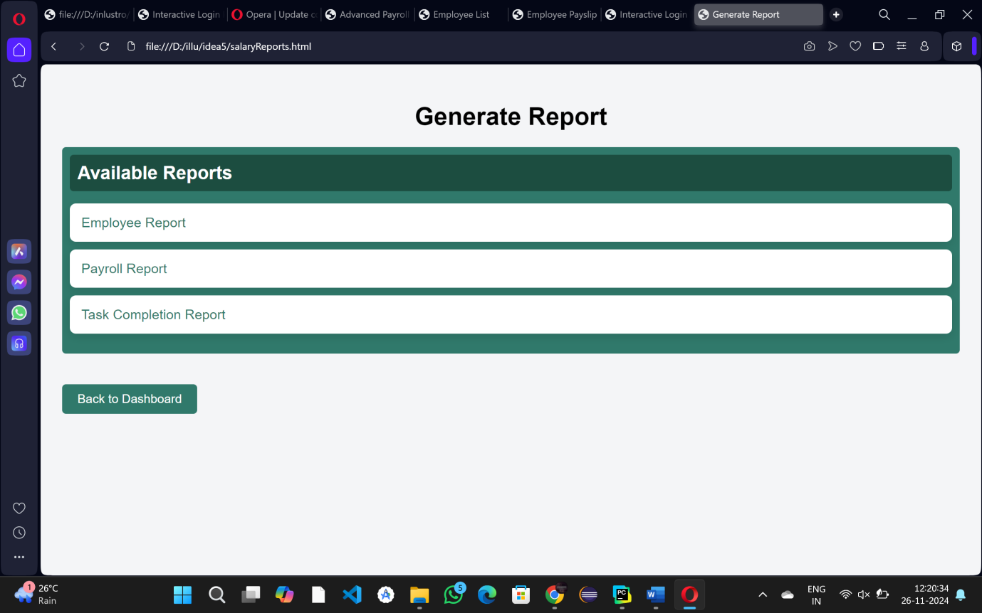

**FIFTH GENERATE REPORT PAGE HERE**

**DESCRIPTION:**

* If admin selects the generate report option , it will redirect to the reporting page ,where a admin can report employees ,who is pursuing their job under his company,wheathe their behaviour is informal.
* This page also facilitates payroll report and task completion report , which is useful for admin to report about his management.

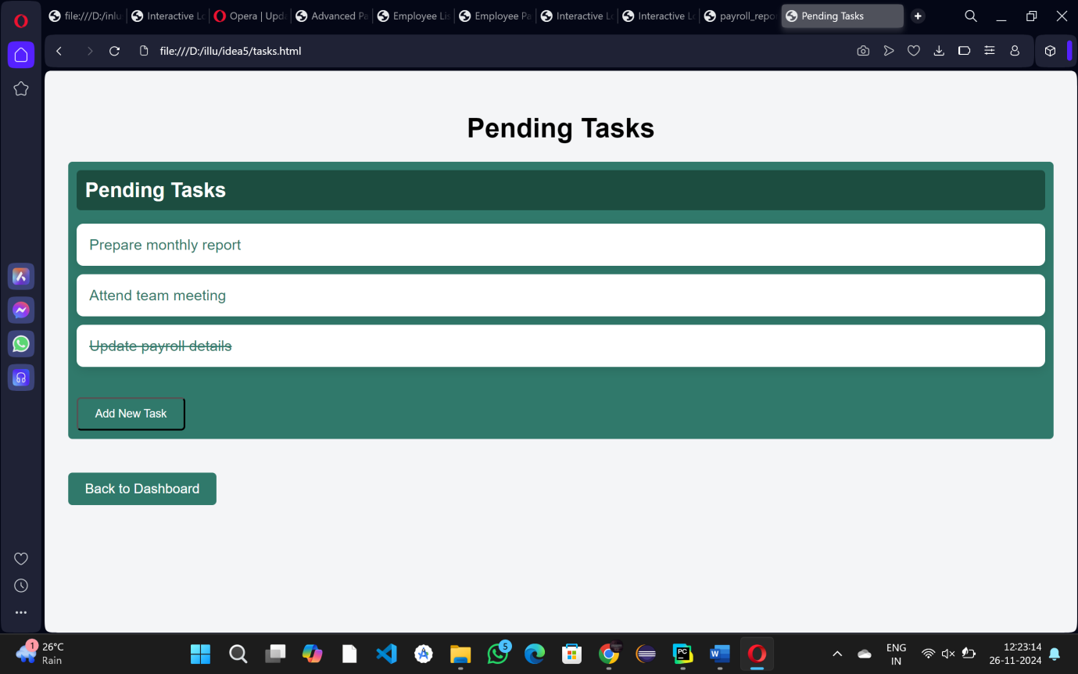

**SIXITH PAGE PENDING TASKS HERE**

**DESCRIPTION:**

* If admin selects the pending task option , it will redirect to the pending tasks which is kept by the employee, if particular team or employee finished that task ,simply he can select the task,which strikes out indicates that work is finished.
* Admin can also add new task for his remainders.

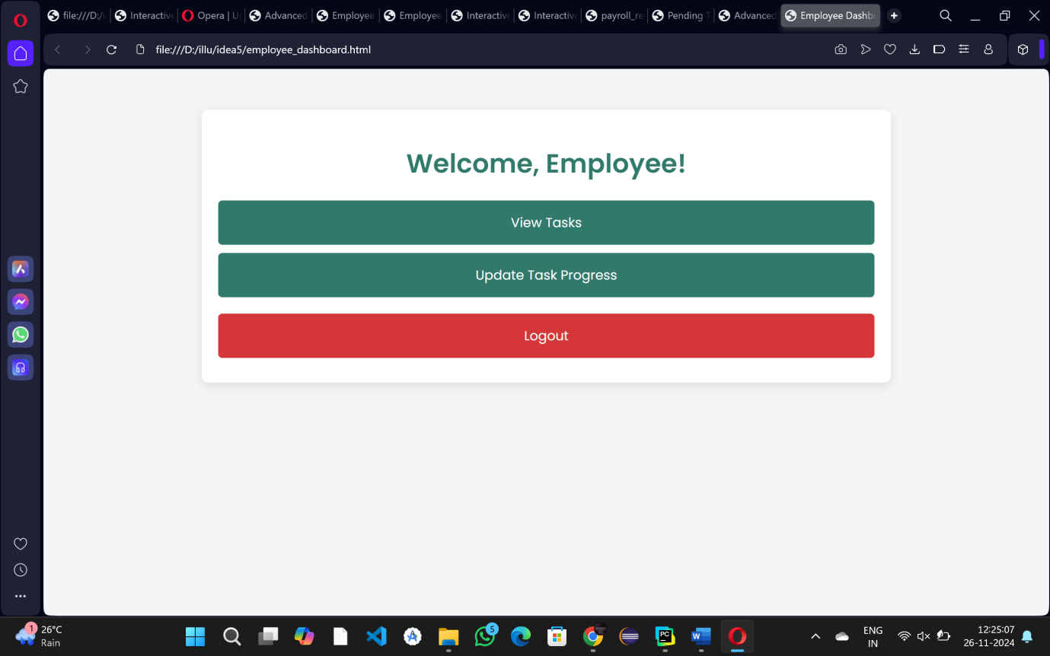

**SEVENTH PAGE EMPLOYEE DASHBOARD HERE**

**DESCRIPTION:**

After the Login process of an Employee, it will redirect to the Main Dashboard(Employee),which consist of the overall work details of the employee.

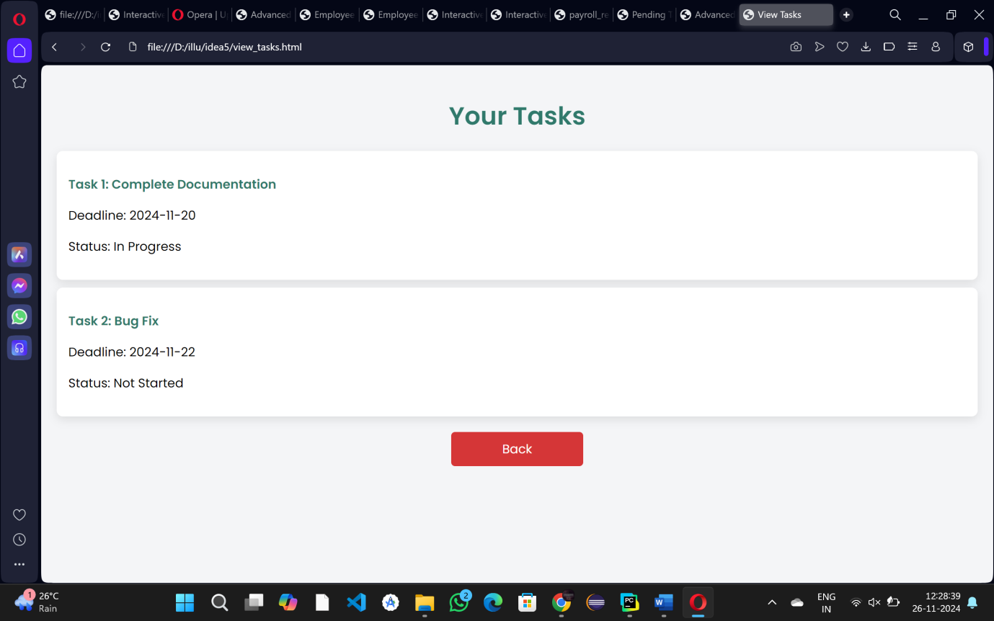

**EIGTH PAGE YOUR TASKS PAGE HERE**

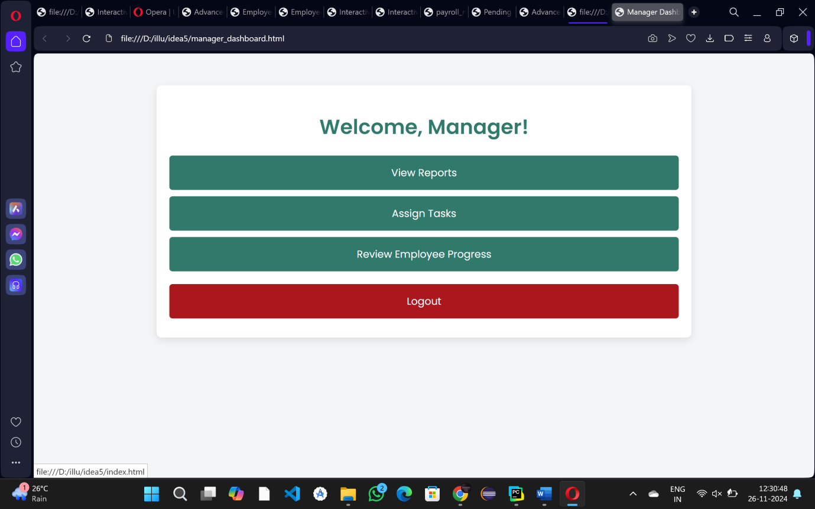

**NINETH PAGE MANAGER DASHBOARD HERE**

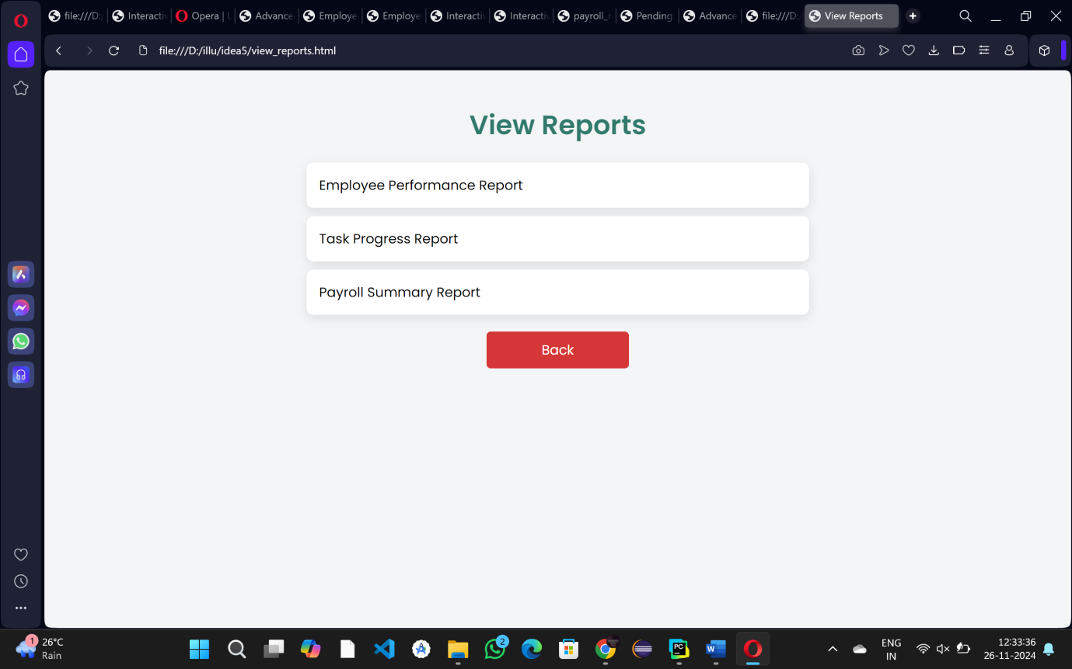

**TENTH PAGE VIEW REPORTS HERE**