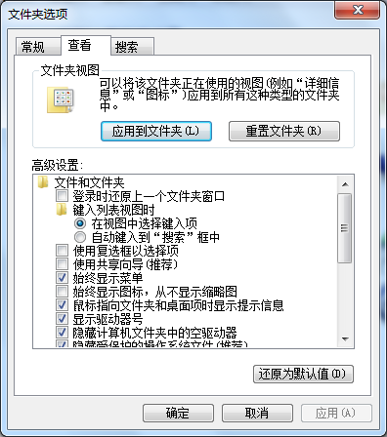去掉使用共享向导（推荐）

关闭防火墙

开始=>运行=>gpedit.msc=>本地计算机策略=>计算机配置=>Windows设置=>安全设置=>本地策略=>安全选项

找到：“网络安全LAN管理器身份验证级别”项，默认值“没有定义”改为“发送LM & NTLM响应”

修改ArcGIS\Server10.0\java\manager\service\lib

#Windows LAN Manager Authentication Level

ARCGIS_LM_COMPATIBILITY_LEVEL=5

Dojo Dijit是一个可更换皮肤、基于模板的WEB UI控件库。

四种不同风格的Esri控件样式：

http://serverapi.arcgisonline.com/jsapi/arcgis/3.5/js/dojo/dijit/themes/claro/claro.css

http://serverapi.arcgisonline.com/jsapi/arcgis/3.5/js/dojo/dijit/themes/tundra/tundra.css

http://serverapi.arcgisonline.com/jsapi/arcgis/3.5/js/dojo/dijit/themes/nihilo/nihilo.css

http://serverapi.arcgisonline.com/jsapi/arcgis/3.5/js/dojo/dijit/themes/soria/soria.css

该连接可查看四种样式的风格：（claro最好看）

<http://archive.dojotoolkit.org/nightly/dojotoolkit/dijit/themes/themeTester.html?theme=claro>

ArcGIS Server for java platform安装文档：

<http://help.arcgis.com/zh-cn/arcgisserver/10.0/install_guide/arcgis_server_java_install_guide/index.html#/na/008m00000003000000/>

ArcGIS plugin for Eclipse:

<http://www.cnblogs.com/mikevictor07/archive/2012/08/27/2659061.html>