|  |
| --- |
| **INSTITUTO SUPERIOR POLITÉCNICO DE TECNOLOGIAS E CIÊNCIAS**  **DEPARTAMENTO DE ENGENHARIAS E TECNOLOGIAS**  **CURSO DE ENGENHARIA INFORMÁTICA**            **REDES DE COMPUTADORES 1**      Memorando          **LAB 4 Ferramentas de Rede, E-mail (SMTP, POP3)**      **AUTOR:** Stélvio Magno Artur Dias  **Número Matrícula:** 20220306  **Turma:** EIN5_M2                                **Novembro, 2024** |

1. **Captura de tela do comando ifconfig com informações sobre a interface ethernet com o endereçamento privado, na máquina cliente.**

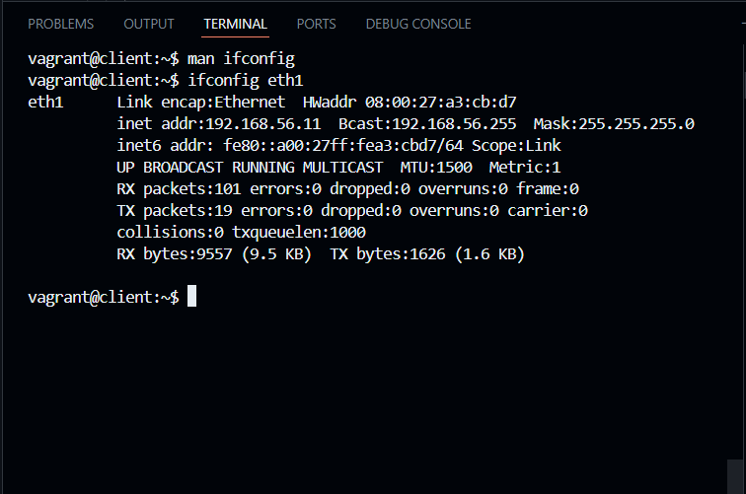

1. **Captura de tela dos resultados do segundo comando nmap**

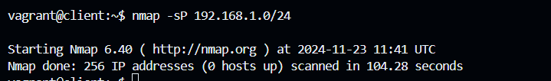

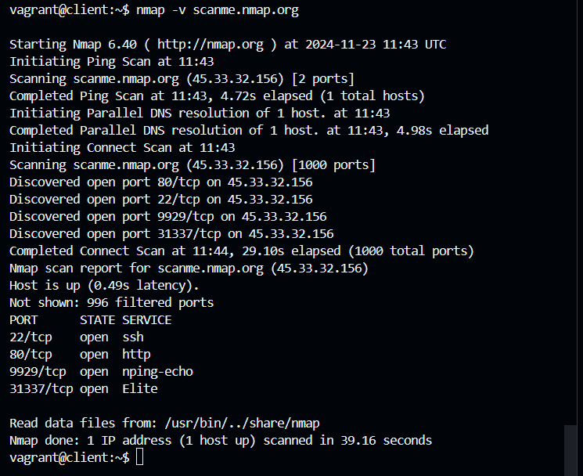

1. **Copie da janela Terminal o texto resultante da interação com o servidor SMTP, para enviar.**

vagrant@client:~$ telnet smtp.mailtrap.io 2525

m.

Escape character is '^]'.

220 smtp.mailtrap.io ESMTP ready

EHLO smtp.mailtrap.io

250-smtp.mailtrap.io

250-SIZE 5242880

250-PIPELINING

250-ENHANCEDSTATUSCODES

250-8BITMIME

250-DSN

250-AUTH PLAIN LOGIN CRAM-MD5

250 STARTTLS

Connection closed by foreign host.

vagrant@client:~$ telnet smtp.mailtrap.io 2525

Trying 18.215.44.90...

Connected to mailsend-smtp-classic-f3a4534c019a3e96.elb.us-east-1.amazonaws.com.

Escape character is '^]'.

220 smtp.mailtrap.io ESMTP ready

AUTH LOGIN

334 VXNlcm5hbWU6

ZTM5OTNkZDg1ZWVhNDU=

334 UGFzc3dvcmQ6

MDU1ODgxNTAxOTQ4YWY=

235 2.0.0 OK

MAIL FROM: <from@smtp.mailtrap.io>

250 2.1.0 Ok

RCPT TO: <to@smtp.mailtrap.io>

250 2.1.0 Ok

DATA

354 Go ahead

To: to@smtp.mailtrap.io

From: from@smtp.mailtrap.io

Subject: Hello world!

This is the test message...

.

250 2.0.0 Ok: queued

quit

221 2.0.0 Bye

Connection closed by foreign host.