MTAT.03.229 Enterprise System Integration (Spring 2026)
Assignment #2 — Domain Model
QuickBite Food Delivery System
Group 7: Elephant-Yankee | Mike-Alfa | Alfa-Kilo | Sierra-Lima

1. System Functionalities
The following requirements describe the main operations supported by the QuickBite microservices, as derived from the architecture defined in Assignment 1.

ID | Service | Requirement
R1 | User Service | The system shall allow a person to create an account as a customer, driver, or restaurant partner.
R2 | User Service | The system shall allow a user to sign in to their account.
R3 | User Service | The system shall allow a user to update their profile information and delivery addresses.
R4 | Order Service | The system shall allow a customer to place an order by selecting a restaurant, menu items, and a delivery address.
R5 | Order Service | When placing an order, the system shall validate the customer, confirm the restaurant is open, and verify item prices.
R6 | Order Service | The system shall allow a customer to cancel a pending order before it is accepted.
R7 | Order Service | The system shall update the order status when payment and delivery progress change.
R8 | Payment Service | The system shall allow an order to initiate a payment charge for the total order amount.
R9 | Payment Service | When a payment is processed, the system shall record the result and update the related order.
R10 | Payment Service | The system shall allow a refund to be issued for a cancelled or failed order.
R11 | Delivery Service | The system shall create a delivery task after payment for an order is confirmed.
R12 | Delivery Service | The system shall assign an available driver to a delivery task.
R13 | Delivery Service | The system shall allow a driver to update the delivery status (Assigned, PickedUp, Delivered).
R14 | Delivery Service | When delivery progress changes, the system shall update the related order and inform the relevant user.
R15 | Notification Service | The system shall send a notification to the relevant user when an order status changes.
R16 | Notification Service | The system shall send notifications to users through supported communication methods.
R17 | Review Service | The system shall allow a customer to submit a review for a completed order only after delivery is confirmed.
R18 | Review Service | The system shall store and aggregate ratings per restaurant.
R19 | Restaurant Service | The system shall allow a restaurant partner to register and manage their restaurant profile.
R20 | Restaurant Service | The system shall allow a restaurant to update its open/closed status and operating hours.
R21 | Menu Service | The system shall allow a restaurant to add, update, and remove menu items with prices and availability.
R22 | Menu Service | The system shall allow customers to browse menu items for a given restaurant.

2. Domain Model Diagram
The diagram below represents the full business-level domain model for QuickBite. It includes all 8 microservices, their domain concepts, DDD tactical elements (entities, value objects, aggregate roots, and repositories), and cross-service relationships via ID references.

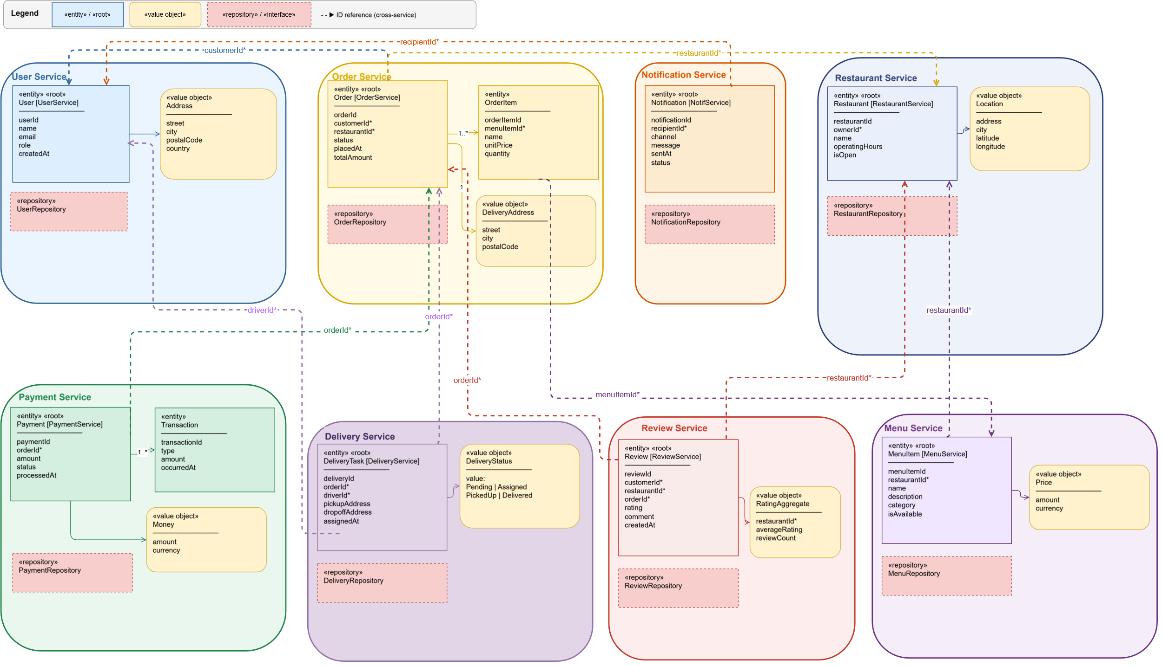

3. Domain Concepts - DDD Reference
The table below documents all domain concepts across the 8 services, their DDD classification, attributes, and aggregate membership. Attributes marked with * are cross-service ID references. They reference the identity of a concept owned by another service without redefining it.

Service | Concept | Kind | DDD Role | Attributes
User Service | User | Entity | Aggregate Root | userId, name, email, role, createdAt
User Service | Address | Value Object | – | street, city, postalCode, country
User Service | UserRepository | Repository | Interface
Order Service | Order | Entity | Aggregate Root | orderId, customerId*, restaurantId*, status, placedAt, totalAmount
Order Service | OrderItem | Entity | – | orderItemId, menuItemId*, name, unitPrice, quantity
Order Service | DeliveryAddress | Value Object | – | street, city, postalCode
Order Service | OrderRepository | Repository | Interface
Payment Service | Payment | Entity | Aggregate Root | paymentId, orderId*, amount, status, processedAt
Payment Service | Transaction | Entity | – | transactionId, type (charge/refund), amount, occurredAt
Payment Service | Money | Value Object | – | amount, currency
Payment Service | PaymentRepository | Repository | Interface
Delivery Service | DeliveryTask | Entity | Aggregate Root | deliveryId, orderId*, driverId*, pickupAddress, dropoffAddress, status: DeliveryStatus, assignedAt
Delivery Service | DeliveryStatus | Value Object | – | value: Pending | Assigned | PickedUp | Delivered
Delivery Service | DeliveryRepository | Repository | Interface
Notification Service | Notification | Entity | Aggregate Root | notificationId, recipientId*, channel, message, sentAt, status
Notification Service | NotificationRepository | Repository | Interface
Review Service | Review | Entity | Aggregate Root | reviewId, customerId*, restaurantId*, orderId*, rating, comment, createdAt
Review Service | RatingAggregate | Value Object | – | restaurantId*, averageRating, reviewCount
Review Service | ReviewRepository | Repository | Interface
Restaurant Service | Restaurant | Entity | Aggregate Root | restaurantId, ownerId*, name, location: Location, operatingHours, isOpen
Restaurant Service | Location | Value Object | – | address, city, latitude, longitude
Restaurant Service | RestaurantRepository | Repository | Interface
Menu Service | MenuItem | Entity | Aggregate Root | menuItemId, restaurantId*, name, description, price: Price, category, isAvailable
Menu Service | Price | Value Object | – | amount, currency
Menu Service | MenuRepository | Repository | Interface

4. Cross-Service Relationships
All cross-service relationships use ID references. A concept belonging to one service does not redefine or embed concepts from another service. It only holds the identifier. This preserves service autonomy while keeping the model coherent.

Relationship | Mechanism | Business Reason
Order → User | Order.customerId references User.userId | An order must identify which customer placed it.
Order → Restaurant | Order.restaurantId references Restaurant.restaurantId | An order must identify which restaurant it belongs to.
OrderItem → MenuItem | OrderItem.menuItemId references MenuItem.menuItemId | An order item must identify which menu item was ordered.
Payment → Order | Payment.orderId references Order.orderId | A payment is made for one specific order.
DeliveryTask → Order | DeliveryTask.orderId references Order.orderId | A delivery task is created for one specific order.
DeliveryTask → User (driver) | DeliveryTask.driverId references User.userId | A delivery task must identify which driver is assigned to it.
Review → Order | Review.orderId references Order.orderId | A review is linked to the order it is based on.
Review → Restaurant | Review.restaurantId references Restaurant.restaurantId | A review must identify which restaurant is being reviewed.
Review → User | Review.customerId references User.userId | A review must identify which customer submitted it.
Restaurant → User (owner) | Restaurant.ownerId references User.userId | A restaurant profile must identify its owner.
MenuItem → Restaurant | MenuItem.restaurantId references Restaurant.restaurantId | A menu item belongs to one restaurant.
RatingAggregate → Restaurant | RatingAggregate.restaurantId references Restaurant.restaurantId | A rating summary is maintained for one restaurant.
Notification → User | Notification.recipientId references User.userId | A notification must identify which user will receive it.

5. Individual Contributions
Each team member is responsible for two microservices as assigned in Assignment 1. The domain concepts, attributes, DDD elements, and cross-service relationships for each member's services are documented in the tables above.

Member | Service 1 | Service 2 | Cross-service relationship
Alfa-Kilo | User Service | Order Service | Order → User (customerId*), Order → Restaurant (restaurantId*)
Elephant-Yankee | Payment Service | Delivery Service | Payment → Order (orderId*), DeliveryTask → User (driverId*)
Mike-Alfa | Notification Service | Review Service | Notification → User (recipientId*), Review → Order (orderId*)
Sierra-Lima | Restaurant Service | Menu Service | Restaurant → User (ownerId*), MenuItem → Restaurant (restaurantId*)

