Data Analytics

1. Join all three tables to create a master view

SELECT r.review_id, r.rating AS review_rating, r.timestamp, r.label, r.review,
p.product_id, p.item_title, p.avg_rating AS product_avg_rating, c.category,
c.avg_rating AS category_avg_rating
FROM reviews r JOIN products p ON r.product_id = p.product_id
JOIN categories c ON r.category_id = c.category_id;

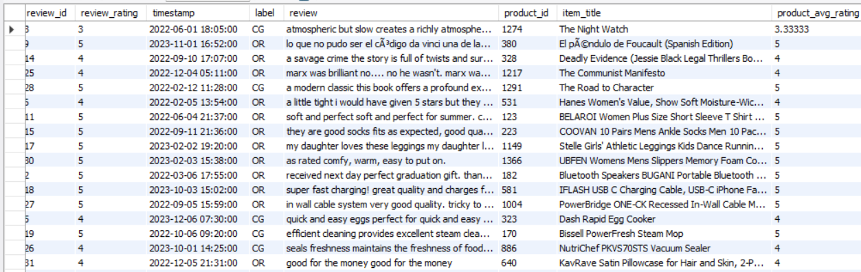

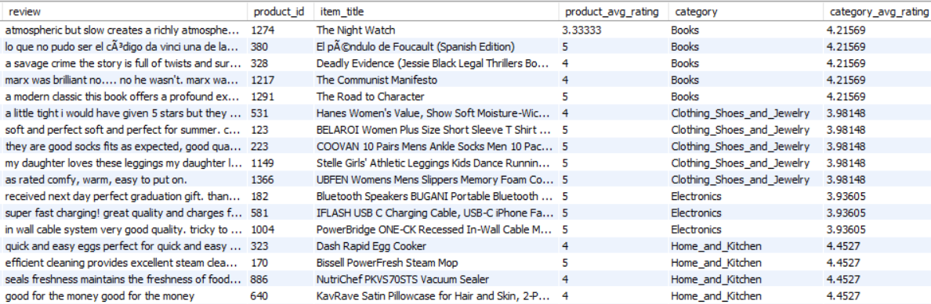

2. Count of reviews per category

SELECT c.category,COUNT(r.review_id) AS total_reviews
FROM reviews r JOIN categories c ON r.category_id = c.category_id
GROUP BY c.category
ORDER BY total_reviews DESC;

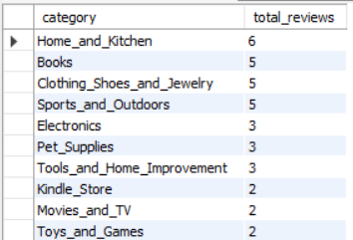

3. Average rating by product and category

SELECT p.item_title,c.category,
AVG(r.rating) AS average_review_rating
FROM reviews r JOIN products p ON r.product_id = p.product_id
JOIN categories c ON r.category_id = c.category_id
GROUP BY p.item_title, c.category
ORDER BY average_review_rating DESC;

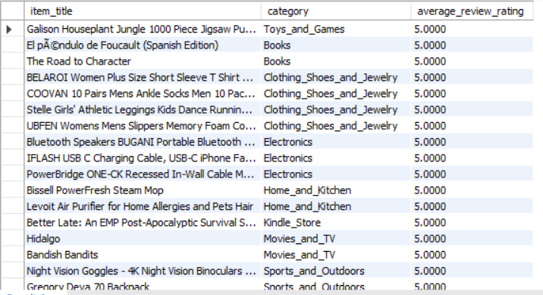

4. Count of Fraudulent vs Genuine Reviews

SELECT label, COUNT(*) AS total_reviews
FROM reviews
GROUP BY label;

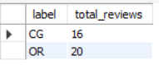

5. Average Rating Given by CG vs OR

SELECT label, AVG(rating) AS avg_rating
FROM reviews
GROUP BY label;

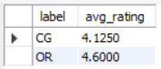

6. Distribution of Reviews by Product & Label

SELECT p.item_title, r.label, COUNT(*) AS review_count
FROM reviews r JOIN products p ON r.product_id = p.product_id
GROUP BY p.item_title, r.label
ORDER BY review_count DESC;

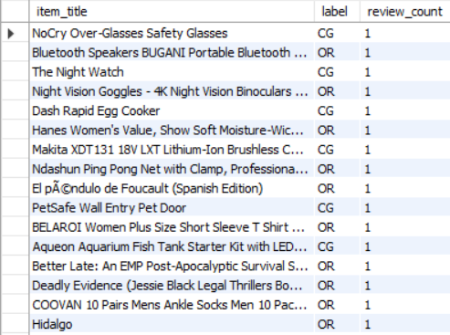

7. Identify Products with Suspicious Review Patterns
For example, if all reviews for a product are CG but it has a high average rating:
SELECT p.item_title, p.avg_rating, COUNT(r.review_id) AS total_reviews,
SUM(CASE WHEN r.label = 'CG' THEN 1 ELSE 0 END) AS cg_reviews,
SUM(CASE WHEN r.label = 'OR' THEN 1 ELSE 0 END) AS or_reviews
FROM products p
JOIN reviews r ON p.product_id = r.product_id
GROUP BY p.item_title, p.avg_rating
ORDER BY cg_reviews DESC;

