SQL Covid19 Analysis

**Input tables:**

* Covid19_tests_performed
* covid19_basic_differences
* lookup_table
* economies
* religions
* life_expectancy
* countries

Results overview

**TABLE t_stepan_holub_projekt_SQL_final**

This final table may take longer to create (3 minutes).

**PRIMARY KEYS:**

*date, country*

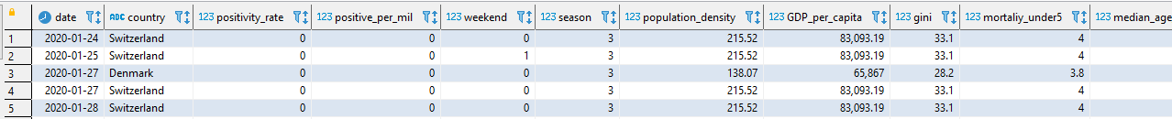

**COVID VARIABLES:**

Column *positivity_rate* represents proportion of positive tests out of all tests performed.

Column *positive_per_mil* represents number of covid19 positive persons in one million citizens.



**DATE VARIABLES:**

Weekend is represented by bool: 0 is weekday, 1 is weekend.

Season is represented by number 0 is spring, 3 is winter.

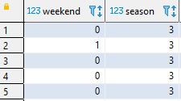

**COUNTRY VARIABLES:**

These columns contain information about given country:

Population density, GDP per capita, Gini coefficient, mortality under 5 years and median age in 2018.

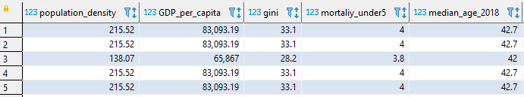

Religion overview shows percentage of each religion for given country.

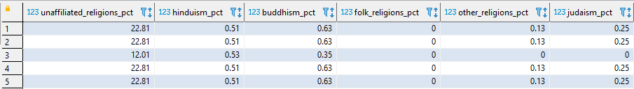

Column *le_diff_1965_2015* shows change of life expectancy between years 1965 and 2015.

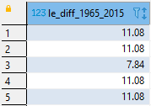

**WEATHER WARIABLES:**

Day temperature (*day_temp_cls*) is an average temperature from hours: '06:00', '09:00', '12:00', '15:00', '18:00' .

Rainy hours (*rainy_hours*)are hours when rain is greater than 0.3 mm/h.

Gusts (*gust_km_h*)are maximum speed of gusts during the day.

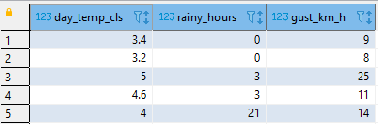

Partial results overview

**TABLE t_stepan_holub_tests**

Country names are converted to those used in table *covid19_basic_differences.*

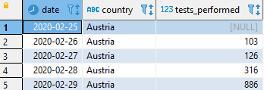

**TABLE t_stepan_holub_covid**

Name of country '*Czechia*' changed to *'Czech Republic'*. Column *positivity_rate* represents proportion of positive tests out of all tests performed. Column *positive_per_mil* represents number of covid19 positive persons in one million citizens.

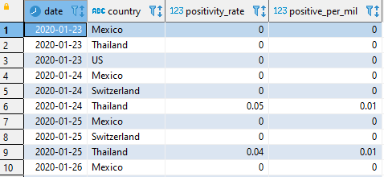

**TABLE t_stepan_holub_economies**

Country names are converted to names from table *covid19_basic_differences*.

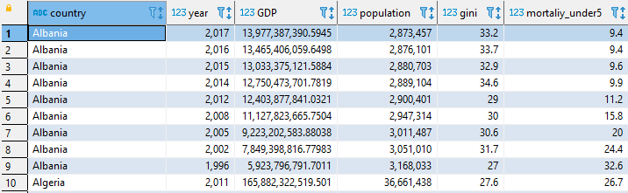

**TABLE t_stepan_holub_gini**

In input data (table *economies*) some gini values are missing. This table stores the most recent value of gini indicator.

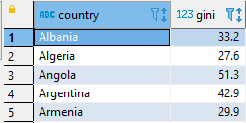

**TABLE t_stepan_holub_economies_2019**

Returns values from year 2019 from table *t_stepan_holub_economies*.

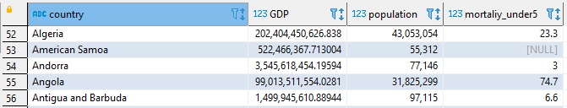

**TABLE t_stepan_holub_religions**

Table contains percentage of each religion. Population sum is calculated as a sum of all religion groups. Country names are converted to names from table *covid19_basic_differences*.





**TABLE t_stepan_holub_le_diff**

Table contains the difference of life expectancy between years 1965 and 2015.

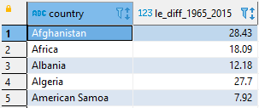

**TABLE t_stepan_holub_weather**

Day temperature is an average temperature from hours: '06:00', '09:00', '12:00', '15:00', '18:00'. Rainy hours are hours when rain is greater than 0.3 mm/h. Gusts are maximum speed of gusts during the day.

