**Barantsev Stepan Ale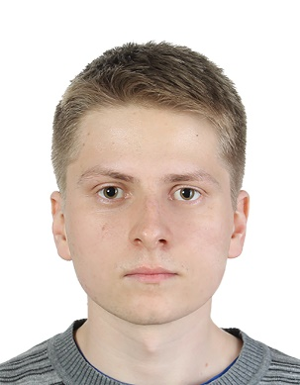xeyevich**

**Birth date: 15.04.1999**

**Cyprus, Limassol**

**Phone number: +79150694904**

**E-mail:** [**stepan.barantsev@gmail.com**](mailto:stepan.barantsev@gmail.com)

* **Education:** Graduated with distinction from Bauman Moscow State Technical University (Department of Computer Systems and Networks). In addition to the main curriculum, several programming and testing courses were finished, e.g.,
  + Python: basics and application (<https://stepik.org/course/512/>)
  + Programming in C++ (<https://stepik.org/course/7>)
  + Web application testing (<http://software-testing.ru/edu/1-schedule/189-web>)
  + Python programming for testers (<http://software-testing.ru/edu/1-schedule/233-python>)
  + Selenium: starting level (<http://software-testing.ru/edu/1-schedule/185-selenium>)
* **Skills:**
* Familiar with the following programming languages:
* Python
* Kotlin
* JavaScript
* C++
* SQL
* Assembler (MASM)
* Ruby (Ruby on Rails)
* Delphi
* In the context of testing, I have experience with:
  + Pytest, JUnit
  + Selenium
  + Appium
  + Allure
  + Selenoid, Github Actions, Docker, MockServer
  + Wireshark, Postman
* Working with relational databases (MySQL, Postgre), and non-relational (faunadb)
* Web programming experience (Express, Flask, Ruby on Rails, JQuery)
* Experience working with major operating systems, both mobile and desktop
* Familiar with design patterns, I have written architecture for UI and API tests several times from scratch, in particular, I know the Page Objects pattern well
* English level is B1-B2
* **Work experience:**
* I have recorded a course “Python for beginners” (for absolute beginners in programming http://pythonforbeginners.ru /) and provide full support for this course (grading homework, consulting students)
* Passed a six month internship at Yandex (trainee tester, took part in testing Yandex.Navigator).
* I worked at RTLabs as a testing engineer. Engaged in automation of the web interface (Python + Selenium + Gitlab CI + Selenoid)
* Now I am working at inDriver as an automated tester. I've been involved in various projects, API testing, Web UI, and Mobile UI. I worked most of all with mobile testing, but only android (Kotlin + Appium + Selenium + Github Actions + Selenoid)
* **Implemented projects:**
* Automatic generation of certificates for a website <http://software-testing.ru> (JavaScript Express + API LMS Moodle + faunadb)
* Python Telegram-bot for my course: <https://github.com/StepanBarantsev/course_bot>
* Course management system as part of the thesis (Flask + pyTelegramBotApi):

<https://github.com/StepanBarantsev/course_management>

* Demonstrational API testing project (Kotlin + Junit + Rest-assured):

<https://github.com/StepanBarantsev/test_api_cotlin>

* Training project related to web automation (Python + Selenium) <https://github.com/StepanBarantsev/adressbook>.
* Game for Android (using the RenPy engine)
* At work, for convenience, I implemented some utilities, e.g., gluing several Allure reports into one master report, automatic Page Objects generator
* **Personal skills:**
* Rapid learning ability, the ability to perceive a large amount of information
* High level of responsibility and diligence
* Attentiveness and perseverance
* Lack of bad habits