Федеральное государственное бюджетное образовательное учреждение высшего образования «Российский экономический университет имени Г.В. Плеханова»

**Московский приборостроительный техникум**

**Отчет**

**о выполнении практической работы №19**

**Дисциплина ОП.04 «Основы алгоритмизации и программирования»**

**Тема: Использование диалоговых окон и печати в проектах**

**Windows Forms на языке C#**

**Специальность: 09.02.07 Информационные системы и программирование**

**Квалификация: Специалист по информационным системам**

Выполнил: Сиротин Степан Дмитриевич

Студент группы: ИС50-3-20

Вариант № 14

Проверил:

Преподаватель: Клопов Д.А. Дата: «___» _________ 202__ г.

Оценка:



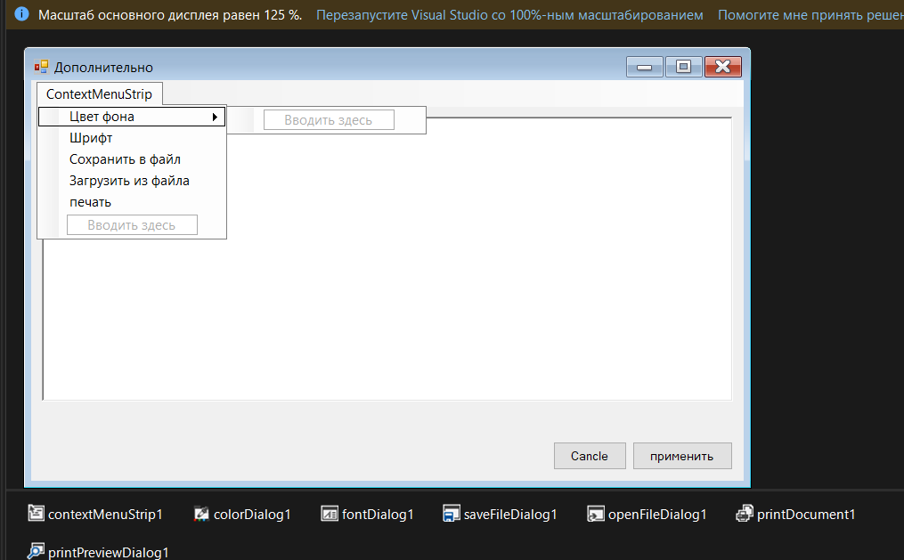

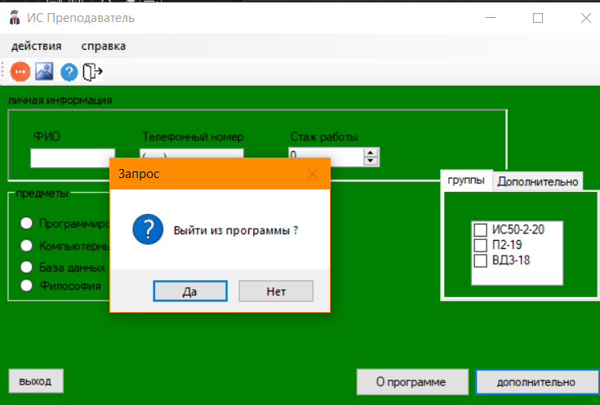

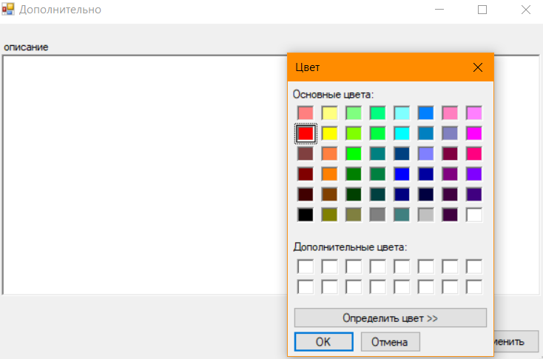

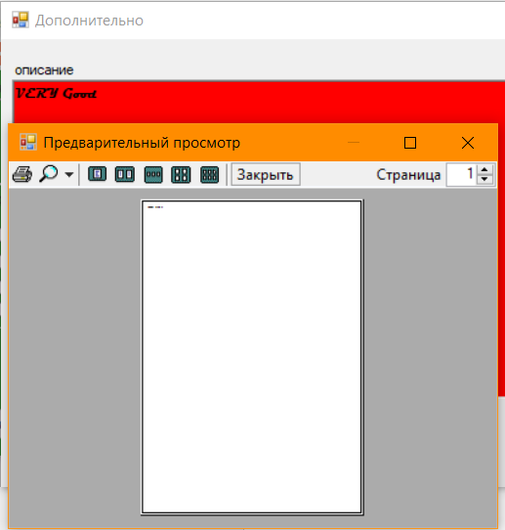

**Form1.cs**

using System;

using System.Collections.Generic;

using System.ComponentModel;

using System.Data;

using System.Drawing;

using System.Linq;

using System.Text;

using System.Threading.Tasks;

using System.Windows.Forms;

namespace WFApp18_14

{

public partial class Form1 : Form

{

Form2 form2 = new Form2();

AboutBox1 aboutBox1 = new AboutBox1();

public Form1()

{

InitializeComponent();

}

private void button1_Click(object sender, EventArgs e)

{

string text;

form2.richTextBox1.Text = aboutBox1.textBoxDescription.Text;

form2.ShowDialog();

if (form2.DialogResult == DialogResult.OK)

{

text = form2.richTextBox1.Text;

aboutBox1.textBoxDescription.Text = text;

}

}

private void button2_Click(object sender, EventArgs e)

{

aboutBox1.ShowDialog();

}

private void button3_Click(object sender, EventArgs e)

{

if (DialogResult.Yes == MessageBox.Show("Выйти из программы ?", "Запрос",

MessageBoxButtons.YesNo,

MessageBoxIcon.Question))

Close();

}

private void Form1_Load(object sender, EventArgs e)

{

}

}

}

**Form2.cs**

using System;

using System.Collections.Generic;

using System.ComponentModel;

using System.Data;

using System.Drawing;

using System.Linq;

using System.Text;

using System.Threading.Tasks;

using System.Windows.Forms;

using System.IO;

using System.Drawing.Printing;

namespace WFApp18_14

{

public partial class Form2 : Form

{

public Form2()

{

InitializeComponent();

}

private void Form2_Load(object sender, EventArgs e)

{

}

private void цветФонаToolStripMenuItem_Click(object sender, EventArgs e)

{

if (colorDialog1.ShowDialog() == DialogResult.OK)

richTextBox1.BackColor = colorDialog1.Color;

}

private void шрифтToolStripMenuItem_Click(object sender, EventArgs e)

{

if (fontDialog1.ShowDialog() == DialogResult.OK)

richTextBox1.Font = fontDialog1.Font;

}

private void сохранитьВФайлToolStripMenuItem_Click(object sender, EventArgs e)

{

if (saveFileDialog1.ShowDialog() == DialogResult.OK)

{

FileStream fs = new FileStream(saveFileDialog1.FileName, FileMode.Create,

FileAccess.Write);

StreamWriter sw = new StreamWriter(fs);

sw.WriteLine(richTextBox1.Text);

sw.Close();

fs.Close();

}

}

private void загрузитьИзФайлаToolStripMenuItem_Click(object sender, EventArgs e)

{

if (openFileDialog1.ShowDialog() == DialogResult.OK)

{

//создаем новый файл для чтения

FileStream fs = new FileStream(openFileDialog1.FileName, FileMode.Open,

FileAccess.Read);

//создаем поток чтения

StreamReader sr = new StreamReader(fs);

richTextBox1.Text = sr.ReadToEnd();

//закрываем стримы

sr.Close();

fs.Close();

}

}

private void печатьToolStripMenuItem_Click(object sender, EventArgs e)

{

// обработчик события печати

printDocument1.PrintPage += PrintPageHandler;

printPreviewDialog1.Document = printDocument1;

// если в диалоге было нажато ОК

if (printPreviewDialog1.ShowDialog() == DialogResult.OK)

printPreviewDialog1.Document.Print(); // печатаем

}

private void PrintPageHandler(object sender, PrintPageEventArgs e)

{

e.Graphics.DrawString(richTextBox1.Text, Font, Brushes.Black, 20, 20);

}

}

}

**Form1.Designer.cs**

namespace WFApp18_14

{

partial class Form1

{

/// <summary>

/// Обязательная переменная конструктора.

/// </summary>

private System.ComponentModel.IContainer components = null;

/// <summary>

/// Освободить все используемые ресурсы.

/// </summary>

/// <param name="disposing">истинно, если управляемый ресурс должен быть удален; иначе ложно.</param>

protected override void Dispose(bool disposing)

{

if (disposing && (components != null))

{

components.Dispose();

}

base.Dispose(disposing);

}

#region Код, автоматически созданный конструктором форм Windows

/// <summary>

/// Требуемый метод для поддержки конструктора — не изменяйте

/// содержимое этого метода с помощью редактора кода.

/// </summary>

private void InitializeComponent()

{

System.ComponentModel.ComponentResourceManager resources = new System.ComponentModel.ComponentResourceManager(typeof(Form1));

this.button1 = new System.Windows.Forms.Button();

this.button2 = new System.Windows.Forms.Button();

this.button3 = new System.Windows.Forms.Button();

this.textBox1 = new System.Windows.Forms.TextBox();

this.panel1 = new System.Windows.Forms.Panel();

this.groupBox1 = new System.Windows.Forms.GroupBox();

this.tabControl1 = new System.Windows.Forms.TabControl();

this.tabPage1 = new System.Windows.Forms.TabPage();

this.tabPage2 = new System.Windows.Forms.TabPage();

this.maskedTextBox1 = new System.Windows.Forms.MaskedTextBox();

this.numericUpDown1 = new System.Windows.Forms.NumericUpDown();

this.checkedListBox1 = new System.Windows.Forms.CheckedListBox();

this.radioButton1 = new System.Windows.Forms.RadioButton();

this.radioButton2 = new System.Windows.Forms.RadioButton();

this.radioButton3 = new System.Windows.Forms.RadioButton();

this.radioButton4 = new System.Windows.Forms.RadioButton();

this.label1 = new System.Windows.Forms.Label();

this.label2 = new System.Windows.Forms.Label();

this.label3 = new System.Windows.Forms.Label();

this.checkBox1 = new System.Windows.Forms.CheckBox();

this.label4 = new System.Windows.Forms.Label();

this.menuStrip1 = new System.Windows.Forms.MenuStrip();

this.дополнительноToolStripMenuItem = new System.Windows.Forms.ToolStripMenuItem();

this.справкаToolStripMenuItem = new System.Windows.Forms.ToolStripMenuItem();

this.дополнительноToolStripMenuItem1 = new System.Windows.Forms.ToolStripMenuItem();

this.выходToolStripMenuItem = new System.Windows.Forms.ToolStripMenuItem();

this.вызовСправкиToolStripMenuItem = new System.Windows.Forms.ToolStripMenuItem();

this.оПрограммеToolStripMenuItem = new System.Windows.Forms.ToolStripMenuItem();

this.toolStrip1 = new System.Windows.Forms.ToolStrip();

this.toolStripButton1 = new System.Windows.Forms.ToolStripButton();

this.toolStripButton2 = new System.Windows.Forms.ToolStripButton();

this.toolStripButton3 = new System.Windows.Forms.ToolStripButton();

this.toolStripButton4 = new System.Windows.Forms.ToolStripButton();

this.panel1.SuspendLayout();

this.groupBox1.SuspendLayout();

this.tabControl1.SuspendLayout();

this.tabPage1.SuspendLayout();

this.tabPage2.SuspendLayout();

((System.ComponentModel.ISupportInitialize)(this.numericUpDown1)).BeginInit();

this.menuStrip1.SuspendLayout();

this.toolStrip1.SuspendLayout();

this.SuspendLayout();

//

// button1

//

this.button1.Anchor = ((System.Windows.Forms.AnchorStyles)((System.Windows.Forms.AnchorStyles.Bottom | System.Windows.Forms.AnchorStyles.Right)));

this.button1.Location = new System.Drawing.Point(621, 403);

this.button1.Name = "button1";

this.button1.Size = new System.Drawing.Size(167, 35);

this.button1.TabIndex = 0;

this.button1.Text = "дополнительно";

this.button1.UseVisualStyleBackColor = true;

this.button1.Click += new System.EventHandler(this.button1_Click);

//

// button2

//

this.button2.Anchor = ((System.Windows.Forms.AnchorStyles)((System.Windows.Forms.AnchorStyles.Bottom | System.Windows.Forms.AnchorStyles.Right)));

this.button2.Location = new System.Drawing.Point(466, 403);

this.button2.Name = "button2";

this.button2.Size = new System.Drawing.Size(149, 35);

this.button2.TabIndex = 1;

this.button2.Text = "О программе";

this.button2.UseVisualStyleBackColor = true;

this.button2.Click += new System.EventHandler(this.button2_Click);

//

// button3

//

this.button3.Anchor = ((System.Windows.Forms.AnchorStyles)((System.Windows.Forms.AnchorStyles.Bottom | System.Windows.Forms.AnchorStyles.Left)));

this.button3.Location = new System.Drawing.Point(12, 403);

this.button3.Name = "button3";

this.button3.Size = new System.Drawing.Size(75, 32);

this.button3.TabIndex = 2;

this.button3.Text = "выход";

this.button3.UseVisualStyleBackColor = true;

this.button3.Click += new System.EventHandler(this.button3_Click);

//

// textBox1

//

this.textBox1.Location = new System.Drawing.Point(26, 44);

this.textBox1.Name = "textBox1";

this.textBox1.Size = new System.Drawing.Size(111, 22);

this.textBox1.TabIndex = 3;

//

// panel1

//

this.panel1.Anchor = ((System.Windows.Forms.AnchorStyles)(((System.Windows.Forms.AnchorStyles.Top | System.Windows.Forms.AnchorStyles.Left)

| System.Windows.Forms.AnchorStyles.Right)));

this.panel1.BorderStyle = System.Windows.Forms.BorderStyle.Fixed3D;

this.panel1.Controls.Add(this.label3);

this.panel1.Controls.Add(this.label2);

this.panel1.Controls.Add(this.label1);

this.panel1.Controls.Add(this.numericUpDown1);

this.panel1.Controls.Add(this.maskedTextBox1);

this.panel1.Controls.Add(this.textBox1);

this.panel1.Location = new System.Drawing.Point(12, 91);

this.panel1.Name = "panel1";

this.panel1.Size = new System.Drawing.Size(652, 86);

this.panel1.TabIndex = 4;

//

// groupBox1

//

this.groupBox1.Anchor = ((System.Windows.Forms.AnchorStyles)(((System.Windows.Forms.AnchorStyles.Top | System.Windows.Forms.AnchorStyles.Bottom)

| System.Windows.Forms.AnchorStyles.Left)));

this.groupBox1.Controls.Add(this.radioButton4);

this.groupBox1.Controls.Add(this.radioButton3);

this.groupBox1.Controls.Add(this.radioButton2);

this.groupBox1.Controls.Add(this.radioButton1);

this.groupBox1.Location = new System.Drawing.Point(12, 183);

this.groupBox1.Name = "groupBox1";

this.groupBox1.Size = new System.Drawing.Size(200, 140);

this.groupBox1.TabIndex = 5;

this.groupBox1.TabStop = false;

this.groupBox1.Text = "предметы";

//

// tabControl1

//

this.tabControl1.Controls.Add(this.tabPage1);

this.tabControl1.Controls.Add(this.tabPage2);

this.tabControl1.Location = new System.Drawing.Point(577, 164);

this.tabControl1.Name = "tabControl1";

this.tabControl1.SelectedIndex = 0;

this.tabControl1.Size = new System.Drawing.Size(211, 159);

this.tabControl1.TabIndex = 6;

//

// tabPage1

//

this.tabPage1.BackColor = System.Drawing.Color.Green;

this.tabPage1.Controls.Add(this.checkedListBox1);

this.tabPage1.Location = new System.Drawing.Point(4, 25);

this.tabPage1.Name = "tabPage1";

this.tabPage1.Padding = new System.Windows.Forms.Padding(3);

this.tabPage1.Size = new System.Drawing.Size(203, 130);

this.tabPage1.TabIndex = 0;

this.tabPage1.Text = "группы";

//

// tabPage2

//

this.tabPage2.BackColor = System.Drawing.Color.Green;

this.tabPage2.Controls.Add(this.checkBox1);

this.tabPage2.Location = new System.Drawing.Point(4, 25);

this.tabPage2.Name = "tabPage2";

this.tabPage2.Padding = new System.Windows.Forms.Padding(3);

this.tabPage2.Size = new System.Drawing.Size(203, 130);

this.tabPage2.TabIndex = 1;

this.tabPage2.Text = "Дополнительно";

//

// maskedTextBox1

//

this.maskedTextBox1.Location = new System.Drawing.Point(169, 44);

this.maskedTextBox1.Mask = "(999) 000-0000";

this.maskedTextBox1.Name = "maskedTextBox1";

this.maskedTextBox1.Size = new System.Drawing.Size(136, 22);

this.maskedTextBox1.TabIndex = 4;

//

// numericUpDown1

//

this.numericUpDown1.Location = new System.Drawing.Point(364, 43);

this.numericUpDown1.Name = "numericUpDown1";

this.numericUpDown1.Size = new System.Drawing.Size(120, 22);

this.numericUpDown1.TabIndex = 5;

//

// checkedListBox1

//

this.checkedListBox1.Anchor = ((System.Windows.Forms.AnchorStyles)(((System.Windows.Forms.AnchorStyles.Top | System.Windows.Forms.AnchorStyles.Bottom)

| System.Windows.Forms.AnchorStyles.Right)));

this.checkedListBox1.FormattingEnabled = true;

this.checkedListBox1.Items.AddRange(new object[] {

"ИС50-2-20",

"П2-19",

"ВД3-18"});

this.checkedListBox1.Location = new System.Drawing.Point(38, 35);

this.checkedListBox1.Name = "checkedListBox1";

this.checkedListBox1.Size = new System.Drawing.Size(120, 89);

this.checkedListBox1.TabIndex = 0;

//

// radioButton1

//

this.radioButton1.AutoSize = true;

this.radioButton1.Location = new System.Drawing.Point(16, 35);

this.radioButton1.Name = "radioButton1";

this.radioButton1.Size = new System.Drawing.Size(158, 20);

this.radioButton1.TabIndex = 0;

this.radioButton1.TabStop = true;

this.radioButton1.Text = "Программирование";

this.radioButton1.UseVisualStyleBackColor = true;

//

// radioButton2

//

this.radioButton2.AutoSize = true;

this.radioButton2.Location = new System.Drawing.Point(16, 61);

this.radioButton2.Name = "radioButton2";

this.radioButton2.Size = new System.Drawing.Size(159, 20);

this.radioButton2.TabIndex = 1;

this.radioButton2.TabStop = true;

this.radioButton2.Text = "Компьютерные сети";

this.radioButton2.UseVisualStyleBackColor = true;

//

// radioButton3

//

this.radioButton3.AutoSize = true;

this.radioButton3.Location = new System.Drawing.Point(16, 87);

this.radioButton3.Name = "radioButton3";

this.radioButton3.Size = new System.Drawing.Size(111, 20);

this.radioButton3.TabIndex = 2;

this.radioButton3.TabStop = true;

this.radioButton3.Text = "База данных";

this.radioButton3.UseVisualStyleBackColor = true;

//

// radioButton4

//

this.radioButton4.AutoSize = true;

this.radioButton4.Location = new System.Drawing.Point(16, 109);

this.radioButton4.Name = "radioButton4";

this.radioButton4.Size = new System.Drawing.Size(104, 20);

this.radioButton4.TabIndex = 3;

this.radioButton4.TabStop = true;

this.radioButton4.Text = "Философия";

this.radioButton4.UseVisualStyleBackColor = true;

//

// label1

//

this.label1.AutoSize = true;

this.label1.Location = new System.Drawing.Point(26, 22);

this.label1.Name = "label1";

this.label1.Size = new System.Drawing.Size(38, 16);

this.label1.TabIndex = 6;

this.label1.Text = "ФИО";

//

// label2

//

this.label2.AutoSize = true;

this.label2.Location = new System.Drawing.Point(169, 22);

this.label2.Name = "label2";

this.label2.Size = new System.Drawing.Size(136, 16);

this.label2.TabIndex = 7;

this.label2.Text = "Телефонный номер";

//

// label3

//

this.label3.AutoSize = true;

this.label3.Location = new System.Drawing.Point(364, 22);

this.label3.Name = "label3";

this.label3.Size = new System.Drawing.Size(91, 16);

this.label3.TabIndex = 8;

this.label3.Text = "Стаж работы";

//

// checkBox1

//

this.checkBox1.AutoSize = true;

this.checkBox1.Location = new System.Drawing.Point(6, 55);

this.checkBox1.Name = "checkBox1";

this.checkBox1.Size = new System.Drawing.Size(173, 20);

this.checkBox1.TabIndex = 7;

this.checkBox1.Text = "Педагог Организатор";

this.checkBox1.UseVisualStyleBackColor = true;

//

// label4

//

this.label4.AutoSize = true;

this.label4.Location = new System.Drawing.Point(9, 72);

this.label4.Name = "label4";

this.label4.Size = new System.Drawing.Size(140, 16);

this.label4.TabIndex = 7;

this.label4.Text = "личная информация";

//

// menuStrip1

//

this.menuStrip1.ImageScalingSize = new System.Drawing.Size(20, 20);

this.menuStrip1.Items.AddRange(new System.Windows.Forms.ToolStripItem[] {

this.дополнительноToolStripMenuItem,

this.справкаToolStripMenuItem});

this.menuStrip1.Location = new System.Drawing.Point(0, 0);

this.menuStrip1.Name = "menuStrip1";

this.menuStrip1.Size = new System.Drawing.Size(800, 28);

this.menuStrip1.TabIndex = 8;

this.menuStrip1.Text = "menuStrip1";

//

// дополнительноToolStripMenuItem

//

this.дополнительноToolStripMenuItem.DropDownItems.AddRange(new System.Windows.Forms.ToolStripItem[] {

this.дополнительноToolStripMenuItem1,

this.выходToolStripMenuItem});

this.дополнительноToolStripMenuItem.Name = "дополнительноToolStripMenuItem";

this.дополнительноToolStripMenuItem.Size = new System.Drawing.Size(86, 24);

this.дополнительноToolStripMenuItem.Text = "действия";

//

// справкаToolStripMenuItem

//

this.справкаToolStripMenuItem.DropDownItems.AddRange(new System.Windows.Forms.ToolStripItem[] {

this.вызовСправкиToolStripMenuItem,

this.оПрограммеToolStripMenuItem});

this.справкаToolStripMenuItem.Name = "справкаToolStripMenuItem";

this.справкаToolStripMenuItem.Size = new System.Drawing.Size(79, 24);

this.справкаToolStripMenuItem.Text = "справка";

//

// дополнительноToolStripMenuItem1

//

this.дополнительноToolStripMenuItem1.Name = "дополнительноToolStripMenuItem1";

this.дополнительноToolStripMenuItem1.Size = new System.Drawing.Size(224, 26);

this.дополнительноToolStripMenuItem1.Text = "дополнительно";

this.дополнительноToolStripMenuItem1.Click += new System.EventHandler(this.button1_Click);

//

// выходToolStripMenuItem

//

this.выходToolStripMenuItem.Name = "выходToolStripMenuItem";

this.выходToolStripMenuItem.Size = new System.Drawing.Size(224, 26);

this.выходToolStripMenuItem.Text = "выход";

this.выходToolStripMenuItem.Click += new System.EventHandler(this.button3_Click);

//

// вызовСправкиToolStripMenuItem

//

this.вызовСправкиToolStripMenuItem.Name = "вызовСправкиToolStripMenuItem";

this.вызовСправкиToolStripMenuItem.Size = new System.Drawing.Size(224, 26);

this.вызовСправкиToolStripMenuItem.Text = "вызов справки";

//

// оПрограммеToolStripMenuItem

//

this.оПрограммеToolStripMenuItem.Name = "оПрограммеToolStripMenuItem";

this.оПрограммеToolStripMenuItem.Size = new System.Drawing.Size(224, 26);

this.оПрограммеToolStripMenuItem.Text = "О программе";

this.оПрограммеToolStripMenuItem.Click += new System.EventHandler(this.button2_Click);

//

// toolStrip1

//

this.toolStrip1.ImageScalingSize = new System.Drawing.Size(20, 20);

this.toolStrip1.Items.AddRange(new System.Windows.Forms.ToolStripItem[] {

this.toolStripButton1,

this.toolStripButton2,

this.toolStripButton3,

this.toolStripButton4});

this.toolStrip1.Location = new System.Drawing.Point(0, 28);

this.toolStrip1.Name = "toolStrip1";

this.toolStrip1.Size = new System.Drawing.Size(800, 27);

this.toolStrip1.TabIndex = 9;

this.toolStrip1.Text = "toolStrip1";

//

// toolStripButton1

//

this.toolStripButton1.DisplayStyle = System.Windows.Forms.ToolStripItemDisplayStyle.Image;

this.toolStripButton1.Image = ((System.Drawing.Image)(resources.GetObject("toolStripButton1.Image")));

this.toolStripButton1.ImageTransparentColor = System.Drawing.Color.Magenta;

this.toolStripButton1.Name = "toolStripButton1";

this.toolStripButton1.Size = new System.Drawing.Size(29, 24);

this.toolStripButton1.Text = "дополнительно";

this.toolStripButton1.Click += new System.EventHandler(this.button1_Click);

//

// toolStripButton2

//

this.toolStripButton2.DisplayStyle = System.Windows.Forms.ToolStripItemDisplayStyle.Image;

this.toolStripButton2.Image = ((System.Drawing.Image)(resources.GetObject("toolStripButton2.Image")));

this.toolStripButton2.ImageTransparentColor = System.Drawing.Color.Magenta;

this.toolStripButton2.Name = "toolStripButton2";

this.toolStripButton2.Size = new System.Drawing.Size(29, 28);

this.toolStripButton2.Text = "Временно не реализованно";

//

// toolStripButton3

//

this.toolStripButton3.DisplayStyle = System.Windows.Forms.ToolStripItemDisplayStyle.Image;

this.toolStripButton3.Image = ((System.Drawing.Image)(resources.GetObject("toolStripButton3.Image")));

this.toolStripButton3.ImageTransparentColor = System.Drawing.Color.Magenta;

this.toolStripButton3.Name = "toolStripButton3";

this.toolStripButton3.Size = new System.Drawing.Size(29, 28);

this.toolStripButton3.Text = "О программе";

this.toolStripButton3.Click += new System.EventHandler(this.button2_Click);

//

// toolStripButton4

//

this.toolStripButton4.DisplayStyle = System.Windows.Forms.ToolStripItemDisplayStyle.Image;

this.toolStripButton4.Image = ((System.Drawing.Image)(resources.GetObject("toolStripButton4.Image")));

this.toolStripButton4.ImageTransparentColor = System.Drawing.Color.Magenta;

this.toolStripButton4.Name = "toolStripButton4";

this.toolStripButton4.Size = new System.Drawing.Size(29, 28);

this.toolStripButton4.Text = "Выход";

this.toolStripButton4.Click += new System.EventHandler(this.button3_Click);

//

// Form1

//

this.AutoScaleDimensions = new System.Drawing.SizeF(8F, 16F);

this.AutoScaleMode = System.Windows.Forms.AutoScaleMode.Font;

this.BackColor = System.Drawing.Color.Green;

this.ClientSize = new System.Drawing.Size(800, 450);

this.Controls.Add(this.toolStrip1);

this.Controls.Add(this.label4);

this.Controls.Add(this.tabControl1);

this.Controls.Add(this.groupBox1);

this.Controls.Add(this.panel1);

this.Controls.Add(this.button3);

this.Controls.Add(this.button2);

this.Controls.Add(this.button1);

this.Controls.Add(this.menuStrip1);

this.Icon = ((System.Drawing.Icon)(resources.GetObject("$this.Icon")));

this.MainMenuStrip = this.menuStrip1;

this.Name = "Form1";

this.Text = "ИС Преподаватель";

this.Load += new System.EventHandler(this.Form1_Load);

this.panel1.ResumeLayout(false);

this.panel1.PerformLayout();

this.groupBox1.ResumeLayout(false);

this.groupBox1.PerformLayout();

this.tabControl1.ResumeLayout(false);

this.tabPage1.ResumeLayout(false);

this.tabPage2.ResumeLayout(false);

this.tabPage2.PerformLayout();

((System.ComponentModel.ISupportInitialize)(this.numericUpDown1)).EndInit();

this.menuStrip1.ResumeLayout(false);

this.menuStrip1.PerformLayout();

this.toolStrip1.ResumeLayout(false);

this.toolStrip1.PerformLayout();

this.ResumeLayout(false);

this.PerformLayout();

}

#endregion

private System.Windows.Forms.Button button1;

private System.Windows.Forms.Button button2;

private System.Windows.Forms.Button button3;

private System.Windows.Forms.TextBox textBox1;

private System.Windows.Forms.Panel panel1;

private System.Windows.Forms.Label label3;

private System.Windows.Forms.Label label2;

private System.Windows.Forms.Label label1;

private System.Windows.Forms.NumericUpDown numericUpDown1;

private System.Windows.Forms.MaskedTextBox maskedTextBox1;

private System.Windows.Forms.GroupBox groupBox1;

private System.Windows.Forms.RadioButton radioButton4;

private System.Windows.Forms.RadioButton radioButton3;

private System.Windows.Forms.RadioButton radioButton2;

private System.Windows.Forms.RadioButton radioButton1;

private System.Windows.Forms.TabControl tabControl1;

private System.Windows.Forms.TabPage tabPage1;

private System.Windows.Forms.CheckedListBox checkedListBox1;

private System.Windows.Forms.TabPage tabPage2;

private System.Windows.Forms.CheckBox checkBox1;

private System.Windows.Forms.Label label4;

private System.Windows.Forms.MenuStrip menuStrip1;

private System.Windows.Forms.ToolStripMenuItem дополнительноToolStripMenuItem;

private System.Windows.Forms.ToolStripMenuItem дополнительноToolStripMenuItem1;

private System.Windows.Forms.ToolStripMenuItem выходToolStripMenuItem;

private System.Windows.Forms.ToolStripMenuItem справкаToolStripMenuItem;

private System.Windows.Forms.ToolStripMenuItem вызовСправкиToolStripMenuItem;

private System.Windows.Forms.ToolStripMenuItem оПрограммеToolStripMenuItem;

private System.Windows.Forms.ToolStrip toolStrip1;

private System.Windows.Forms.ToolStripButton toolStripButton1;

private System.Windows.Forms.ToolStripButton toolStripButton2;

private System.Windows.Forms.ToolStripButton toolStripButton3;

private System.Windows.Forms.ToolStripButton toolStripButton4;

}

}

**Form2.Designer.cs**

namespace WFApp18_14

{

partial class Form2

{

/// <summary>

/// Required designer variable.

/// </summary>

private System.ComponentModel.IContainer components = null;

/// <summary>

/// Clean up any resources being used.

/// </summary>

/// <param name="disposing">true if managed resources should be disposed; otherwise, false.</param>

protected override void Dispose(bool disposing)

{

if (disposing && (components != null))

{

components.Dispose();

}

base.Dispose(disposing);

}

#region Windows Form Designer generated code

/// <summary>

/// Required method for Designer support - do not modify

/// the contents of this method with the code editor.

/// </summary>

private void InitializeComponent()

{

this.components = new System.ComponentModel.Container();

System.ComponentModel.ComponentResourceManager resources = new System.ComponentModel.ComponentResourceManager(typeof(Form2));

this.richTextBox1 = new System.Windows.Forms.RichTextBox();

this.contextMenuStrip1 = new System.Windows.Forms.ContextMenuStrip(this.components);

this.цветФонаToolStripMenuItem = new System.Windows.Forms.ToolStripMenuItem();

this.шрифтToolStripMenuItem = new System.Windows.Forms.ToolStripMenuItem();

this.сохранитьВФайлToolStripMenuItem = new System.Windows.Forms.ToolStripMenuItem();

this.загрузитьИзФайлаToolStripMenuItem = new System.Windows.Forms.ToolStripMenuItem();

this.печатьToolStripMenuItem = new System.Windows.Forms.ToolStripMenuItem();

this.label1 = new System.Windows.Forms.Label();

this.button1 = new System.Windows.Forms.Button();

this.button2 = new System.Windows.Forms.Button();

this.colorDialog1 = new System.Windows.Forms.ColorDialog();

this.fontDialog1 = new System.Windows.Forms.FontDialog();

this.saveFileDialog1 = new System.Windows.Forms.SaveFileDialog();

this.openFileDialog1 = new System.Windows.Forms.OpenFileDialog();

this.printDocument1 = new System.Drawing.Printing.PrintDocument();

this.printPreviewDialog1 = new System.Windows.Forms.PrintPreviewDialog();

this.contextMenuStrip1.SuspendLayout();

this.SuspendLayout();

//

// richTextBox1

//

this.richTextBox1.ContextMenuStrip = this.contextMenuStrip1;

this.richTextBox1.Location = new System.Drawing.Point(12, 41);

this.richTextBox1.Name = "richTextBox1";

this.richTextBox1.Size = new System.Drawing.Size(776, 320);

this.richTextBox1.TabIndex = 0;

this.richTextBox1.Text = "";

//

// contextMenuStrip1

//

this.contextMenuStrip1.ImageScalingSize = new System.Drawing.Size(20, 20);

this.contextMenuStrip1.Items.AddRange(new System.Windows.Forms.ToolStripItem[] {

this.цветФонаToolStripMenuItem,

this.шрифтToolStripMenuItem,

this.сохранитьВФайлToolStripMenuItem,

this.загрузитьИзФайлаToolStripMenuItem,

this.печатьToolStripMenuItem});

this.contextMenuStrip1.Name = "contextMenuStrip1";

this.contextMenuStrip1.Size = new System.Drawing.Size(214, 152);

//

// цветФонаToolStripMenuItem

//

this.цветФонаToolStripMenuItem.Name = "цветФонаToolStripMenuItem";

this.цветФонаToolStripMenuItem.Size = new System.Drawing.Size(213, 24);

this.цветФонаToolStripMenuItem.Text = "Цвет фона";

this.цветФонаToolStripMenuItem.Click += new System.EventHandler(this.цветФонаToolStripMenuItem_Click);

//

// шрифтToolStripMenuItem

//

this.шрифтToolStripMenuItem.Name = "шрифтToolStripMenuItem";

this.шрифтToolStripMenuItem.Size = new System.Drawing.Size(213, 24);

this.шрифтToolStripMenuItem.Text = "Шрифт";

this.шрифтToolStripMenuItem.Click += new System.EventHandler(this.шрифтToolStripMenuItem_Click);

//

// сохранитьВФайлToolStripMenuItem

//

this.сохранитьВФайлToolStripMenuItem.Name = "сохранитьВФайлToolStripMenuItem";

this.сохранитьВФайлToolStripMenuItem.Size = new System.Drawing.Size(213, 24);

this.сохранитьВФайлToolStripMenuItem.Text = "Сохранить в файл";

this.сохранитьВФайлToolStripMenuItem.Click += new System.EventHandler(this.сохранитьВФайлToolStripMenuItem_Click);

//

// загрузитьИзФайлаToolStripMenuItem

//

this.загрузитьИзФайлаToolStripMenuItem.Name = "загрузитьИзФайлаToolStripMenuItem";

this.загрузитьИзФайлаToolStripMenuItem.Size = new System.Drawing.Size(213, 24);

this.загрузитьИзФайлаToolStripMenuItem.Text = "Загрузить из файла";

this.загрузитьИзФайлаToolStripMenuItem.Click += new System.EventHandler(this.загрузитьИзФайлаToolStripMenuItem_Click);

//

// печатьToolStripMenuItem

//

this.печатьToolStripMenuItem.Name = "печатьToolStripMenuItem";

this.печатьToolStripMenuItem.Size = new System.Drawing.Size(213, 24);

this.печатьToolStripMenuItem.Text = "печать";

this.печатьToolStripMenuItem.Click += new System.EventHandler(this.печатьToolStripMenuItem_Click);

//

// label1

//

this.label1.AutoSize = true;

this.label1.Location = new System.Drawing.Point(12, 22);

this.label1.Name = "label1";

this.label1.Size = new System.Drawing.Size(70, 16);

this.label1.TabIndex = 1;

this.label1.Text = "описание";

//

// button1

//

this.button1.Anchor = ((System.Windows.Forms.AnchorStyles)((System.Windows.Forms.AnchorStyles.Bottom | System.Windows.Forms.AnchorStyles.Right)));

this.button1.DialogResult = System.Windows.Forms.DialogResult.OK;

this.button1.Location = new System.Drawing.Point(675, 406);

this.button1.Name = "button1";

this.button1.Size = new System.Drawing.Size(113, 32);

this.button1.TabIndex = 2;

this.button1.Text = "применить";

this.button1.UseVisualStyleBackColor = true;

//

// button2

//

this.button2.Anchor = ((System.Windows.Forms.AnchorStyles)((System.Windows.Forms.AnchorStyles.Bottom | System.Windows.Forms.AnchorStyles.Right)));

this.button2.DialogResult = System.Windows.Forms.DialogResult.Cancel;

this.button2.Location = new System.Drawing.Point(586, 406);

this.button2.Name = "button2";

this.button2.Size = new System.Drawing.Size(83, 32);

this.button2.TabIndex = 3;

this.button2.Text = "Cancle";

this.button2.UseVisualStyleBackColor = true;

//

// openFileDialog1

//

this.openFileDialog1.FileName = "openFileDialog1";

//

// printPreviewDialog1

//

this.printPreviewDialog1.AutoScrollMargin = new System.Drawing.Size(0, 0);

this.printPreviewDialog1.AutoScrollMinSize = new System.Drawing.Size(0, 0);

this.printPreviewDialog1.ClientSize = new System.Drawing.Size(400, 300);

this.printPreviewDialog1.Enabled = true;

this.printPreviewDialog1.Icon = ((System.Drawing.Icon)(resources.GetObject("printPreviewDialog1.Icon")));

this.printPreviewDialog1.Name = "printPreviewDialog1";

this.printPreviewDialog1.Visible = false;

//

// Form2

//

this.AutoScaleDimensions = new System.Drawing.SizeF(8F, 16F);

this.AutoScaleMode = System.Windows.Forms.AutoScaleMode.Font;

this.ClientSize = new System.Drawing.Size(800, 450);

this.Controls.Add(this.button2);

this.Controls.Add(this.button1);

this.Controls.Add(this.label1);

this.Controls.Add(this.richTextBox1);

this.Name = "Form2";

this.Text = "Дополнительно";

this.Load += new System.EventHandler(this.Form2_Load);

this.contextMenuStrip1.ResumeLayout(false);

this.ResumeLayout(false);

this.PerformLayout();

}

#endregion

public System.Windows.Forms.RichTextBox richTextBox1;

private System.Windows.Forms.Label label1;

private System.Windows.Forms.Button button1;

private System.Windows.Forms.Button button2;

private System.Windows.Forms.ContextMenuStrip contextMenuStrip1;

private System.Windows.Forms.ToolStripMenuItem цветФонаToolStripMenuItem;

private System.Windows.Forms.ToolStripMenuItem шрифтToolStripMenuItem;

private System.Windows.Forms.ToolStripMenuItem сохранитьВФайлToolStripMenuItem;

private System.Windows.Forms.ToolStripMenuItem загрузитьИзФайлаToolStripMenuItem;

private System.Windows.Forms.ToolStripMenuItem печатьToolStripMenuItem;

private System.Windows.Forms.ColorDialog colorDialog1;

private System.Windows.Forms.FontDialog fontDialog1;

private System.Windows.Forms.SaveFileDialog saveFileDialog1;

private System.Windows.Forms.OpenFileDialog openFileDialog1;

private System.Drawing.Printing.PrintDocument printDocument1;

private System.Windows.Forms.PrintPreviewDialog printPreviewDialog1;

}

}

**AboutBox1.Designer.cs**

namespace WFApp18_14

{

partial class AboutBox1

{

/// <summary>

/// Обязательная переменная конструктора.

/// </summary>

private System.ComponentModel.IContainer components = null;

/// <summary>

/// Освободить все используемые ресурсы.

/// </summary>

protected override void Dispose(bool disposing)

{

if (disposing && (components != null))

{

components.Dispose();

}

base.Dispose(disposing);

}

#region Код, автоматически созданный конструктором форм Windows

/// <summary>

/// Требуемый метод для поддержки конструктора — не изменяйте

/// содержимое этого метода с помощью редактора кода.

/// </summary>

private void InitializeComponent()

{

System.ComponentModel.ComponentResourceManager resources = new System.ComponentModel.ComponentResourceManager(typeof(AboutBox1));

this.tableLayoutPanel = new System.Windows.Forms.TableLayoutPanel();

this.logoPictureBox = new System.Windows.Forms.PictureBox();

this.labelProductName = new System.Windows.Forms.Label();

this.labelVersion = new System.Windows.Forms.Label();

this.labelCopyright = new System.Windows.Forms.Label();

this.labelCompanyName = new System.Windows.Forms.Label();

this.textBoxDescription = new System.Windows.Forms.TextBox();

this.okButton = new System.Windows.Forms.Button();

this.tableLayoutPanel.SuspendLayout();

((System.ComponentModel.ISupportInitialize)(this.logoPictureBox)).BeginInit();

this.SuspendLayout();

//

// tableLayoutPanel

//

this.tableLayoutPanel.ColumnCount = 2;

this.tableLayoutPanel.ColumnStyles.Add(new System.Windows.Forms.ColumnStyle(System.Windows.Forms.SizeType.Percent, 33F));

this.tableLayoutPanel.ColumnStyles.Add(new System.Windows.Forms.ColumnStyle(System.Windows.Forms.SizeType.Percent, 67F));

this.tableLayoutPanel.Controls.Add(this.logoPictureBox, 0, 0);

this.tableLayoutPanel.Controls.Add(this.labelProductName, 1, 0);

this.tableLayoutPanel.Controls.Add(this.labelVersion, 1, 1);

this.tableLayoutPanel.Controls.Add(this.labelCopyright, 1, 2);

this.tableLayoutPanel.Controls.Add(this.labelCompanyName, 1, 3);

this.tableLayoutPanel.Controls.Add(this.textBoxDescription, 1, 4);

this.tableLayoutPanel.Controls.Add(this.okButton, 1, 5);

this.tableLayoutPanel.Dock = System.Windows.Forms.DockStyle.Fill;

this.tableLayoutPanel.Location = new System.Drawing.Point(12, 11);

this.tableLayoutPanel.Margin = new System.Windows.Forms.Padding(4, 4, 4, 4);

this.tableLayoutPanel.Name = "tableLayoutPanel";

this.tableLayoutPanel.RowCount = 6;

this.tableLayoutPanel.RowStyles.Add(new System.Windows.Forms.RowStyle(System.Windows.Forms.SizeType.Percent, 10F));

this.tableLayoutPanel.RowStyles.Add(new System.Windows.Forms.RowStyle(System.Windows.Forms.SizeType.Percent, 10F));

this.tableLayoutPanel.RowStyles.Add(new System.Windows.Forms.RowStyle(System.Windows.Forms.SizeType.Percent, 10F));

this.tableLayoutPanel.RowStyles.Add(new System.Windows.Forms.RowStyle(System.Windows.Forms.SizeType.Percent, 10F));

this.tableLayoutPanel.RowStyles.Add(new System.Windows.Forms.RowStyle(System.Windows.Forms.SizeType.Percent, 50F));

this.tableLayoutPanel.RowStyles.Add(new System.Windows.Forms.RowStyle(System.Windows.Forms.SizeType.Percent, 10F));

this.tableLayoutPanel.Size = new System.Drawing.Size(556, 326);

this.tableLayoutPanel.TabIndex = 0;

//

// logoPictureBox

//

this.logoPictureBox.Dock = System.Windows.Forms.DockStyle.Fill;

this.logoPictureBox.Image = ((System.Drawing.Image)(resources.GetObject("logoPictureBox.Image")));

this.logoPictureBox.Location = new System.Drawing.Point(4, 4);

this.logoPictureBox.Margin = new System.Windows.Forms.Padding(4, 4, 4, 4);

this.logoPictureBox.Name = "logoPictureBox";

this.tableLayoutPanel.SetRowSpan(this.logoPictureBox, 6);

this.logoPictureBox.Size = new System.Drawing.Size(175, 318);

this.logoPictureBox.SizeMode = System.Windows.Forms.PictureBoxSizeMode.StretchImage;

this.logoPictureBox.TabIndex = 12;

this.logoPictureBox.TabStop = false;

//

// labelProductName

//

this.labelProductName.Dock = System.Windows.Forms.DockStyle.Fill;

this.labelProductName.Location = new System.Drawing.Point(191, 0);

this.labelProductName.Margin = new System.Windows.Forms.Padding(8, 0, 4, 0);

this.labelProductName.MaximumSize = new System.Drawing.Size(0, 21);

this.labelProductName.Name = "labelProductName";

this.labelProductName.Size = new System.Drawing.Size(361, 21);

this.labelProductName.TabIndex = 19;

this.labelProductName.Text = "Название продукта";

this.labelProductName.TextAlign = System.Drawing.ContentAlignment.MiddleLeft;

//

// labelVersion

//

this.labelVersion.Dock = System.Windows.Forms.DockStyle.Fill;

this.labelVersion.Location = new System.Drawing.Point(191, 32);

this.labelVersion.Margin = new System.Windows.Forms.Padding(8, 0, 4, 0);

this.labelVersion.MaximumSize = new System.Drawing.Size(0, 21);

this.labelVersion.Name = "labelVersion";

this.labelVersion.Size = new System.Drawing.Size(361, 21);

this.labelVersion.TabIndex = 0;

this.labelVersion.Text = "Версия";

this.labelVersion.TextAlign = System.Drawing.ContentAlignment.MiddleLeft;

//

// labelCopyright

//

this.labelCopyright.Dock = System.Windows.Forms.DockStyle.Fill;

this.labelCopyright.Location = new System.Drawing.Point(191, 64);

this.labelCopyright.Margin = new System.Windows.Forms.Padding(8, 0, 4, 0);

this.labelCopyright.MaximumSize = new System.Drawing.Size(0, 21);

this.labelCopyright.Name = "labelCopyright";

this.labelCopyright.Size = new System.Drawing.Size(361, 21);

this.labelCopyright.TabIndex = 21;

this.labelCopyright.Text = "Авторские права";

this.labelCopyright.TextAlign = System.Drawing.ContentAlignment.MiddleLeft;

//

// labelCompanyName

//

this.labelCompanyName.Dock = System.Windows.Forms.DockStyle.Fill;

this.labelCompanyName.Location = new System.Drawing.Point(191, 96);

this.labelCompanyName.Margin = new System.Windows.Forms.Padding(8, 0, 4, 0);

this.labelCompanyName.MaximumSize = new System.Drawing.Size(0, 21);

this.labelCompanyName.Name = "labelCompanyName";

this.labelCompanyName.Size = new System.Drawing.Size(361, 21);

this.labelCompanyName.TabIndex = 22;

this.labelCompanyName.Text = "Название организации";

this.labelCompanyName.TextAlign = System.Drawing.ContentAlignment.MiddleLeft;

//

// textBoxDescription

//

this.textBoxDescription.Dock = System.Windows.Forms.DockStyle.Fill;

this.textBoxDescription.Location = new System.Drawing.Point(191, 132);

this.textBoxDescription.Margin = new System.Windows.Forms.Padding(8, 4, 4, 4);

this.textBoxDescription.Multiline = true;

this.textBoxDescription.Name = "textBoxDescription";

this.textBoxDescription.ReadOnly = true;

this.textBoxDescription.ScrollBars = System.Windows.Forms.ScrollBars.Both;

this.textBoxDescription.Size = new System.Drawing.Size(361, 155);

this.textBoxDescription.TabIndex = 23;

this.textBoxDescription.TabStop = false;

this.textBoxDescription.Text = "Описание";

//

// okButton

//

this.okButton.Anchor = ((System.Windows.Forms.AnchorStyles)((System.Windows.Forms.AnchorStyles.Bottom | System.Windows.Forms.AnchorStyles.Right)));

this.okButton.DialogResult = System.Windows.Forms.DialogResult.Cancel;

this.okButton.Location = new System.Drawing.Point(452, 295);

this.okButton.Margin = new System.Windows.Forms.Padding(4, 4, 4, 4);

this.okButton.Name = "okButton";

this.okButton.Size = new System.Drawing.Size(100, 27);

this.okButton.TabIndex = 24;

this.okButton.Text = "&ОК";

//

// AboutBox1

//

this.AcceptButton = this.okButton;

this.AutoScaleDimensions = new System.Drawing.SizeF(8F, 16F);

this.AutoScaleMode = System.Windows.Forms.AutoScaleMode.Font;

this.ClientSize = new System.Drawing.Size(580, 348);

this.Controls.Add(this.tableLayoutPanel);

this.FormBorderStyle = System.Windows.Forms.FormBorderStyle.FixedDialog;

this.Margin = new System.Windows.Forms.Padding(4, 4, 4, 4);

this.MaximizeBox = false;

this.MinimizeBox = false;

this.Name = "AboutBox1";

this.Padding = new System.Windows.Forms.Padding(12, 11, 12, 11);

this.ShowIcon = false;

this.ShowInTaskbar = false;

this.StartPosition = System.Windows.Forms.FormStartPosition.CenterParent;

this.Text = "О программе";

this.tableLayoutPanel.ResumeLayout(false);

this.tableLayoutPanel.PerformLayout();

((System.ComponentModel.ISupportInitialize)(this.logoPictureBox)).EndInit();

this.ResumeLayout(false);

}

#endregion

private System.Windows.Forms.TableLayoutPanel tableLayoutPanel;

private System.Windows.Forms.PictureBox logoPictureBox;

private System.Windows.Forms.Label labelProductName;

private System.Windows.Forms.Label labelVersion;

private System.Windows.Forms.Label labelCopyright;

private System.Windows.Forms.Label labelCompanyName;

public System.Windows.Forms.TextBox textBoxDescription;

private System.Windows.Forms.Button okButton;

}

}