Без индекса

**Запрос**

Select *

From [Order] o Inner Join (Select wr.[Name], wr.Surname, w.IDWork, wr.Salary

from [Worker] wr Inner Join Work w ON wr.IDWorker= w.IDWorker) wkr ON wkr.IDWork = o.IDWork

Where o.Cost > 1500 AND [Name] = 'Илья' AND Surname = 'Чередников'

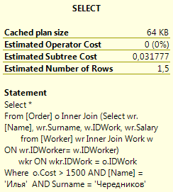

**План выполнения**

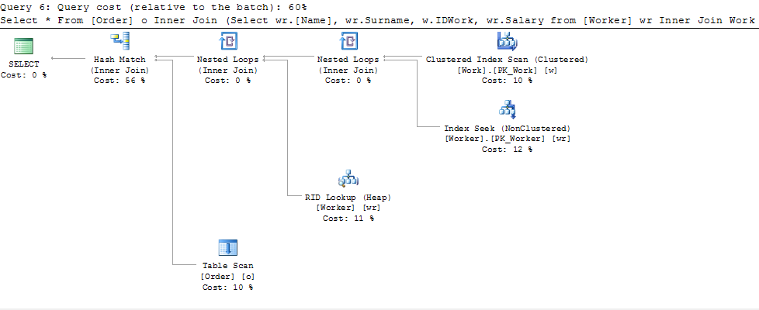

**Кластерный составной индекс**

**CREATE CLUSTERED INDEX CL_INDEX_Worker_COMPOSITE**

ON [dbo].Worker([Name], [Surname], [Salary])

CREATE CLUSTERED INDEX CL_INDEX_Order

ON [dbo].[Order]([Cost])

Ускорение

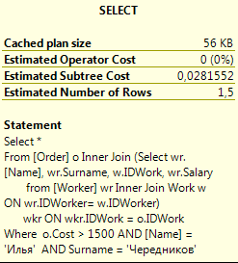

Кластерный уникальный индекс

**Запрос**

Select *

From [MaterialOrder] mo inner join [Model_Material_Quantity] mm On mo.IDModel_Material_Quantity = mm.IDModel_Material_Quantity

Where Quantity Between 1 and 3

**Индекс**

create clustered index CL_INDEX_Order_material

ON [dbo].[MaterialOrder]([IDMaterialOrder])

**План выполнения**

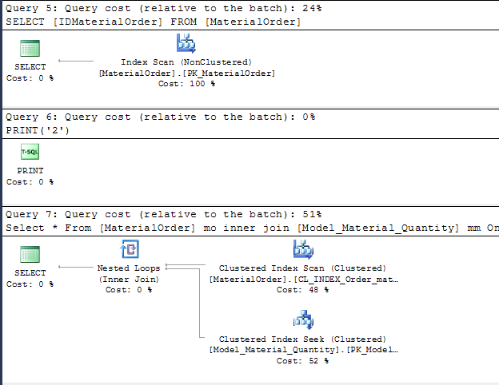

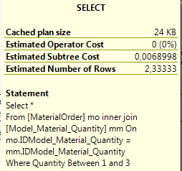

Покрывающий индекс

**Запрос**

**SELECT MMQ.Quantity, MO.StartDate, MO.EndDate**

FROM ([MaterialOrder] as MO

INNER JOIN [Model_Material_Quantity] as MMQ ON MO.IDModel_Material_Quantity = MMQ.IDModel_Material_Quantity)

INNER JOIN [Material_Provider] as MP ON MO.IDMaterial_Provider = MP.IDMaterial_Provider

ORDER BY Cost DESC

**План выполнения**

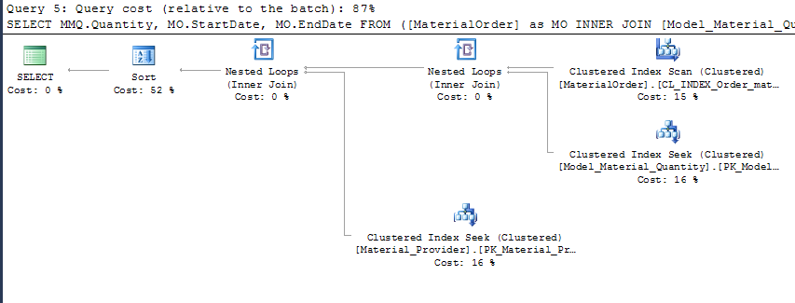

**Индекс**

CREATE NONCLUSTERED INDEX NonCL_INDEX_Order_material_COVERING --ПОКРЫВЫАЮЩИЙ

ON [dbo].[MaterialOrder]([IDModel_Material_Quantity],[IDMaterial_Provider])

**План выполнения с индексом**

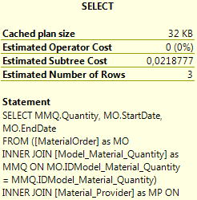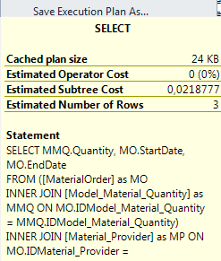

Индекс с фильтрацией

**Запрос**

SELECT MO.StartDate, MO.EndDate, MMQ.Quantity, MP.Cost

FROM ([MaterialOrder] as MO

INNER JOIN Model_Material_Quantity as MMQ ON MO.IDModel_Material_Quantity = MMQ.IDModel_Material_Quantity)

INNER JOIN Material_Provider as MP ON MO.IDMaterial_Provider = MP.IDMaterial_Provider

WHERE MMQ.Quantity >= 2 AND MP.Cost < 400

**План выполнения**

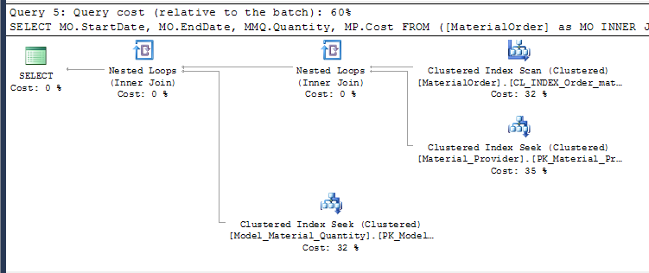

**Индекс**

**CREATE NONCLUSTERED INDEX NonCL_INDEX_Order_material_Filter --с включёнными строками**

ON [dbo].[MaterialOrder]([IDModel_Material_Quantity], [IDMaterial_Provider])

WHERE ([IDMaterial_Provider] < 20 AND [IDMaterial_Provider] > 3) AND ([IDModel_Material_Quantity] IN (3,5,7))

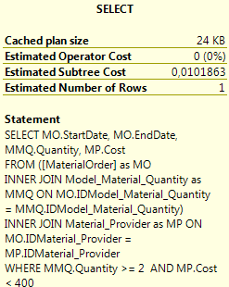

Индекс с включенными столбцами

**Запрос**

SELECT MO.StartDate, MO.EndDate

FROM ([MaterialOrder] as MO

INNER JOIN Model_Material_Quantity as MMQ ON MO.IDModel_Material_Quantity = MMQ.IDModel_Material_Quantity)

INNER JOIN Material_Provider as MP ON MO.IDMaterial_Provider = MP.IDMaterial_Provider

WHERE MMQ.Quantity >= 2 AND MP.Cost < 400

**План выполнения**

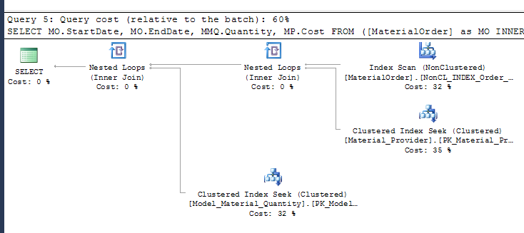

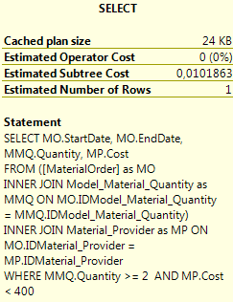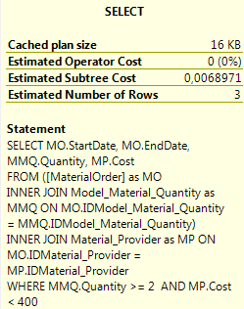

**Индекс**

CREATE NONCLUSTERED INDEX NonCL_INDEX_Order_material_Column --с включёнными таблицами

ON [dbo].MaterialOrder([IDModel_Material_Quantity], [IDMaterial_Provider])

INCLUDE([StartDate], [EndDate])