when choosing the style and size of the text, you need to consider the future audience. We must not forget about people with disabilities, vision problems, color blind people, etc.

**Web Design Best Practices: Minimalism & Typography**

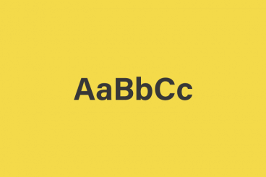

|  |  |
| --- | --- |
| ON: | 5 APR 2016 |
| BY: | [JERRRY CAO](https://designshack.net/author/jerry-cao/) |
| FEATURE: | [MINIMALIST GRAPHIC DESIGN](https://designshack.net/minimalist-graphic-design/) |
| CATEGORY: | [LAYOUTS](https://designshack.net/category/articles/layouts/) |
| LENGTH: | 5 MIN READ |

**When talking about design we need to consider text from a designer’s perspective. Text must be**[**legible and readable**](http://webdesign.tutsplus.com/articles/typographic-readability-and-legibility--webdesign-12211)**while fitting nicely with the website’s style. But it also must relate to a hierarchy of content.**

Building hierarchies is the “big picture” of a website’s composition. But as you move into typography, you also must create hierarchies related to specific text on the page. In this piece, we’ll explain creating relationships with your headers and how to use white space to make lengthy paragraphs visually digestible.

**Headings & Spacing**

[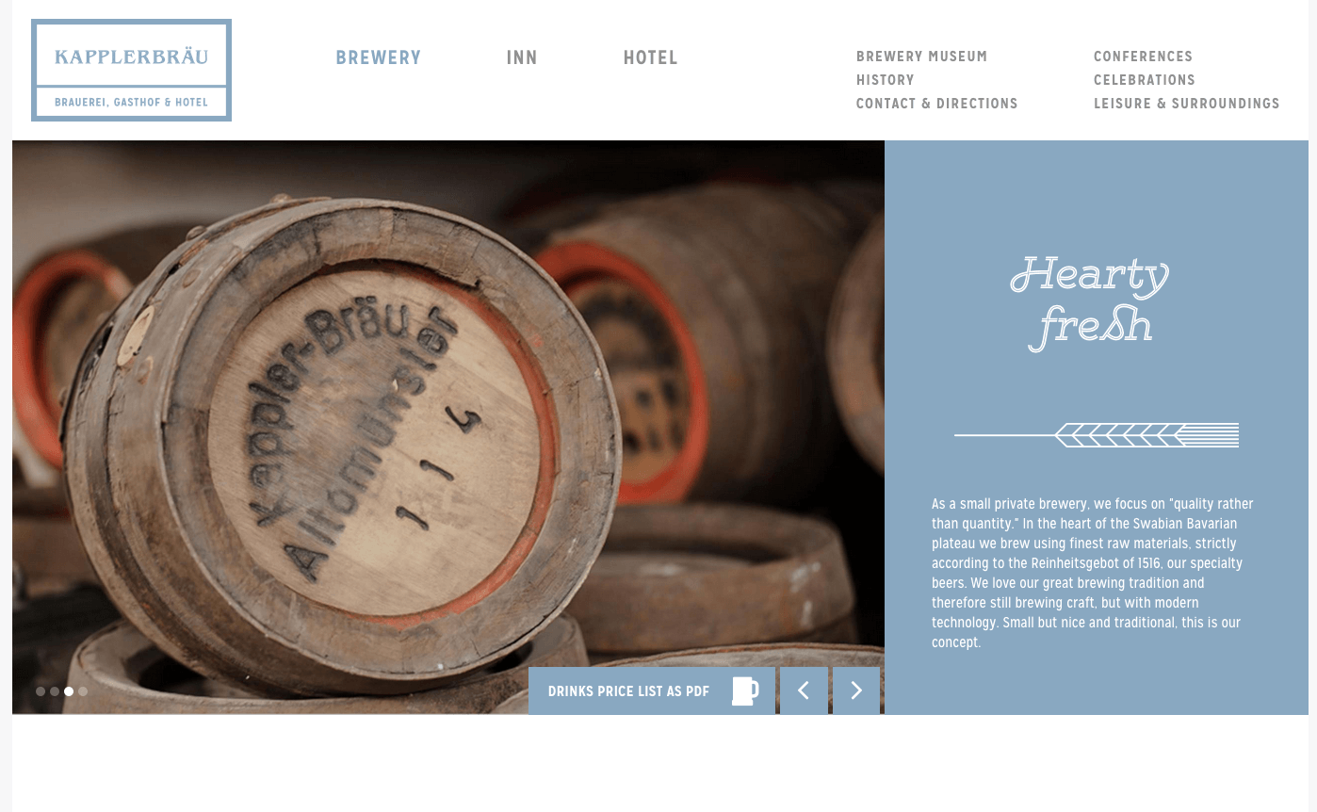](http://kapplerbraeu.de/brauerei/)

Web content typically focuses around just a couple of different text elements. Headings range from H1-H6, but most websites only use H1-H4 at most. Regardless of how many heading styles are used, it’s your job as a designer to craft them so that the hierarchy is clearly established.

Space between text is important because it helps to define the page content itself. When users find a new header, they expect to recognize if content is switching to a brand new subject or if it’s within an existing subject. The right combination of size, color, and style of heading text helps to create the right expectations for users.

Negative space between text shows how page content is related. Headers with plenty of space are seen as more dominant while headers closer to paragraphs are seen as related via context. Bottom margins after paragraphs show the relationship between lines of text and where they belong in the hierarchy. It all relates back to [crafting a hierarchy of content](https://designshack.net/articles/typography/every-design-needs-three-levels-of-typographic-hierarchy) to visually distinguish between text on the page.

**Heading Relationships**

Each heading should reflect it’s own unique style, which also complements other styles of text on the page. Crafting brilliant headers gets easier with practice, but white space values should generally behave the same regardless of heading styles.

[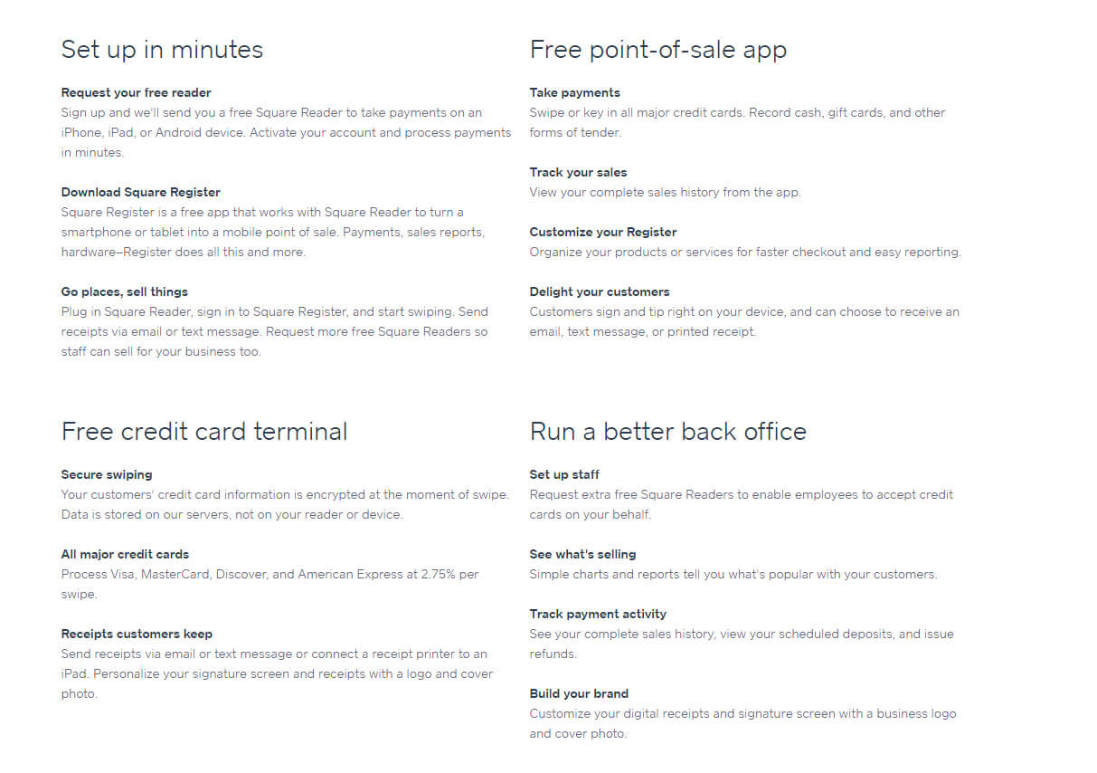](https://squareup.com/)

[Square](https://squareup.com/) uses a traditional startup homepage layout with plenty of imagery and blocks of text. Headings are a particularly interesting segment of the design because they range from oversized to infinitesimally small. Yet the size doesn’t really matter as much as the relationship to other text on the page.

Notice in the screenshot above how large headings use extra spacing above and below the text. These section headings visually convey a sense of being “on their own,” yet also naturally group together into larger blocks of subheadings and paragraphs.

Each inner block uses subheader text that is much smaller. These internal headers are about the same size as paragraph text, but they stand out with bold text & a darker color. Visually, it’s crystal-clear that these bolded lines of text are still headings (just lower on the visual totem pole).



The amount of space between headers & paragraphs also defines which paragraphs belong to which headers. Similarly, you should insert plenty of space between smaller headers and larger headers. Again, negative space defines hierarchy both in visual design and in typography.

As explained in the free guide [Web UI Design Best Practices](https://studio.uxpin.com/ebooks/web-ui-design-best-practices/), remember these points when crafting page headers:

* A visual hierarchy should be apparent through the use of space, size, color, and/or text style. This should be visible even when standing 3-5 feet away from the monitor. You can also use the [5-second Gaussian blur test](http://www.leemunroe.com/visual-hierarchy/) to check hierarchy.
* Keep each subheader close to its first child paragraph.
* Place pithy headers in close proximity to convey ideas more quickly and clearly.

**Lengthy Paragraphs**

On the topic of contextual white space, there lies the question of how to design around the common paragraph. Firm, reliable, and found pretty much everywhere, the paragraph is the backbone of every website’s content strategy.

But how content is written varies based on how content is styled. For example, an online news magazine will use different paragraph styles than a smaller gardening blog. The amount of content, length of content, and level of detail all come into play when styling paragraphs.

Try to design with large enough text so that it’s clearly readable 3 feet away from the screen. Text size is very similar to white space in that it’s usually better to design larger than smaller. However, exercise moderation and restraint.

If the text size is too large, then it’ll just take up more screen space and require more scrolling. But if it’s too small it could be unreadable, or visitors will experience difficulty with [vertical rhythm](http://webdesign.tutsplus.com/articles/improving-layout-with-vertical-rhythm--webdesign-14070) as they move their eyes from line-to-line.

Two important things to keep in mind are paragraph margins and line height (the space between each line). The size of text in your paragraphs dictates both of these values because white space depends on size.

[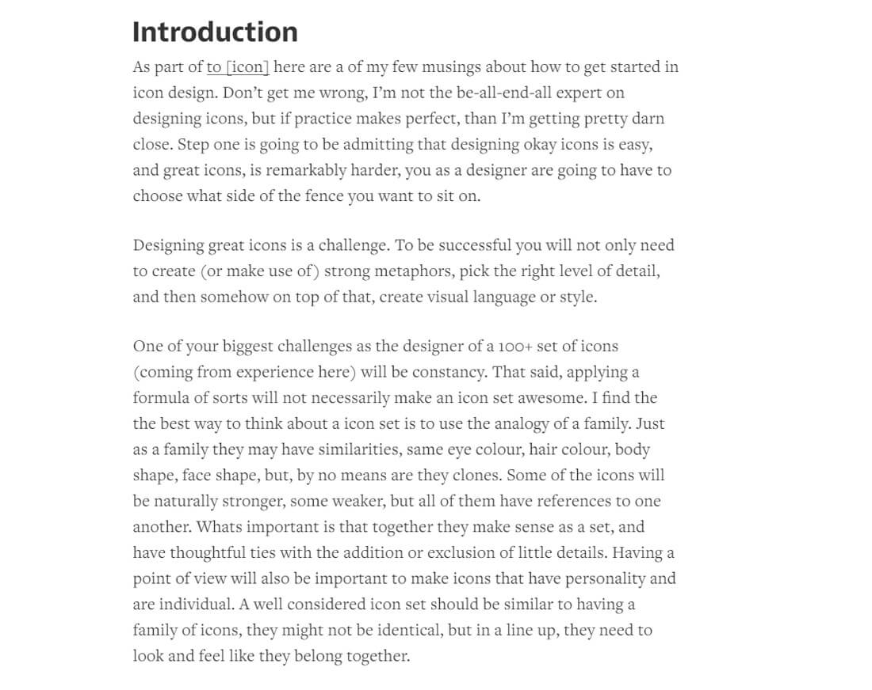](https://medium.com/@szczpanks/so-you-call-yourself-an-icon-designer-b67223e9d36f)

Medium is an online blogging platform that does paragraph design right. The text is crisp, readable, and spaced perfectly. As their paragraph design shows, line height values must be large enough to connect to the next line without feeling excessive.

As recommended in the [Web Design Trends 2016 ebook](http://studio.uxpin.com/ebooks/web-ui-design-trends-2015-2016/), here are some good rules of thumb to follow:

* Avoid making the line height larger than a typical line of text.
* The [em font unit](http://www.impressivewebs.com/understanding-em-units-css/) is perfect for creating uniform sizes across all browsers.
* Line height should often be a tad larger than font size.
* Try a font size of 1em combined with a line height of 1.5em-1.75em.

Paragraph spacing can be tricky but it’s an important topic, especially for text-heavy websites. The bottom paragraph margin should be much larger than a typical line of text. Bottom paragraph margins should be large enough that you can visually determine when a paragraph has ended.

Once you figure out a website’s text size, it becomes much easier to play with line height values and figure out margins for spacing. The goal here is clarity and structure. Each new paragraph should be obvious without any doubt. The key is proportional space between each block of text.

As mentioned before, it’s generally safer to have “too much” white space rather than not enough. Just avoid using colossal amounts of space or you’ll end up with a very shallow content density. Keep enough content on the page to be interesting, but not so much that it’s overwhelming.

To learn more about designing for content in web interfaces, check out this piece on [how to design the perfect paragraph](http://www.smashingmagazine.com/2011/11/29/the-perfect-paragraph/).

**Takeaway**

Negative space in typography directly affects the overall composition and smaller page elements at the same time. When designing typography, context is king.

Paragraphs found in the page may need larger margins than paragraphs found in the sidebar. Links in the header could look smoother with extra padding, but links in the footer could look tidier with very little padding. There are no solid rules, only best practices to keep in mind.

Also remember that typography follows along with its own hierarchy just like page structure. Lots of practice will be the optimal way to improve your eyes for quickly recognizing spatial values that fit best into any given web project.

When it comes to designing with space, remember that space as an aesthetic quality takes a backseat to space as a design tool. Space creates relationships, defines hierarchies, and emphasizes content – always keep these in mind when considering how to reduce visual noise.

You can learn more actionable design techniques in the free [Web Design Trends 2016 ebook](http://studio.uxpin.com/ebooks/web-ui-design-trends-2015-2016/) by [UXPin](https://www.uxpin.com/). The 185-page guide explains 10 best practices in great detail. You’ll find 165 analyzed examples from today’s top companies.

<https://designshack.net/articles/layouts/web-design-best-practices-minimalism-typography/>

Communication plays a vital role in design —it’s essential to establish a clear connection between the website and user and to help your users accomplish their goals. When we talk about communication in web design context, we usually mean text. Typography plays a vital role in this process:

More than 95% percent of information on the web is in the form of written language.

Good typography makes the act of reading effortless, while poor typography turns users off. As Oliver Reichenstein states in his article “[Web Design is 95% Typography](https://ia.net/topics/the-web-is-all-about-typography-period/)”:

*Optimizing typography is optimizing readability, accessibility, usability(!), overall graphic balance.*

In other words: optimizing your typography also optimizes your user interface. In this article, I will provide a set of rules that help you improve readability and legibility of your text content.

**1. Keep The Number of Fonts Used At a Minimum**

Using more than 3 different fonts makes a website look unstructured and unprofessional. Keep in mind that too many type sizes and styles at once can also wreck any layout.



In order to prevent situation like this one try to limit the number of font families to a minimum

In general, limit the number of font families to a minimum (two is plenty, one is often sufficient) and stick to the same ones through the entire website. If you do use more than one font, ensure the font families complement each other based on their character width. Take the example of fonts combinations below. The combination of Georgia and Verdana (left) share similar values that creates a harmonious pairing. Compare that to the pairing of Baskerville and Impact (right) where the heavy weight of Impact vastly overshadows Baskerville.



Ensure the font families complement each other based on their character width

2. Try To Use Standard Fonts

Font embedding services (like [Google Web Fonts](https://fonts.google.com/) or [Typekit](http://typekit.com/)) have a lot of interesting fonts that can give your designs something new, fresh, and unexpected. So what can go wrong? Actually, this approach has one serious problem— interesting fonts can distract users from reading. Users can spend time thinking about the fonts that designers used rather then reading the text.

Unless your website has a compelling need for a custom font, such as for branding purposes or to create an immersive experience, it’s usually best to stick with the system fonts. Keep in mind that good typography draws the reader to the content, not to the type itself.

3. Limit Line Length

Having the right amount of characters on each line is key to the readability of your text. It shouldn’t be your design that dictates the width of your text, it should also be a matter of legibility. Consider this advice on readability and line length from the [Baymard Institute](https://baymard.com/blog/line-length-readability):

“You should have around 60 characters per line if you want a good reading experience. Having the right amount of characters on each line is key to the readability of your text.”



If a line is too short, the eye will have to travel back too often, breaking the reader’s rhythm. If a line of text is too long, the user’s eye will have a hard time focusing on the text. Image credit: Material Design

For mobile devices, you should go for [30–40 characters per line](https://designshack.net/articles/typography/tips-for-designing-better-mobile-typography/) . Below is an example of two sites viewed on a mobile device. The first one uses 50–75 characters per line (optimum number of characters per line for print and desktop), while the second one uses the optimal 30–40 characters.

Image credit: Usertesting

In web design you can achieve an optimal number of characters per line by restricting the width of your text blocks [using em](http://www.maxdesign.com.au/articles/em/) or pixels.

4. Choose a Typeface That Works Well In Various Sizes

Users will access your site from devices with different screen sizes and resolutions. Most user interfaces require text elements of various sizes (button copy, field labels, section headers, etc). It’s important to choose a typeface that works well in multiple sizes and weights to maintain readability and usability in every size.



Roboto typeface by Google

**Make sure that the typeface you choose is legible on smaller screens**! Try to avoid fonts that use cursive script, such as Vivaldi (in the example below): although they are beautiful, they are difficult to read.



Vivaldi typeface will be difficult to read on the small screen

5. Use Fonts With Distinguishable Letters

Many typefaces make it too easy to confuse similar letterforms, specifically with “i”s and “L”s (as seen in the image below). So when choosing your type, be sure to check your type out in different contexts to make sure it won’t cause an issue for your users.



6. Avoid All Caps

All caps text *—*meaning text with all the letters cap­i­tal­ized *— is fine in contexts that don’t involve reading (*such as acronyms or logos), but when your message involves reading, don’t force your users to read all caps text. As mentioned by [Miles Tinker](http://en.wikipedia.org/wiki/Miles_Tinker), in his work, Legibility of Print, all-capital print greatly retards the speed of scanning and reading in comparison with lower-case type.



7. **Don’t Minimize Spacing Between Lines**

In typography, we have a special term for the spacing between two lines of text — leading (or line height). By increasing the leading, you increase the vertical white space between lines of text, generally improving readability in exchange for screen real estate. As a rule, leading should be about 30% more than the character height for good readability.



*Good spacing aids readability*. Image credit: [Microsoft](https://blogs.windows.com/buildingapps/2016/03/24/understanding-typography-and-ux-design/#78qpMU4EK0v2YuDC.97)

Properly using white space between paragraphs has been proven to increase comprehension up to 20%, as pointed out by Dmitry Fadeyev. The skill of using white space lies in providing your users with a digestible amount of content, then stripping away extraneous details.



Left: Almost overlapped text. Right: Good spacing aids readability. Image credit: Apple

8. Make Sure You Have Sufficient Color Contrast

Don’t use the same or similar colours for text and background. The more visible the text, the faster users are able to scan and read it. The W3C recommends the following contrast ratios for body text and image text:

* *Small text* should have a contrast ratio of at least *4.5:1 against its background*.
* *Large text* (at 14 pt bold/18 pt regular and up) *should have a contrast ratio of at least 3:1 against its background*.



These lines of text do not meet the color contrast ratio recommendations and are difficult to read against their background colors.



These lines of text meet the color contrast ratio recommendations and are easy to read against their background colors.

Once you’ve made your color choice, it’s absolutely necessary to test it out with real users on most devices. If any of the test show a problem with reading your copy, then you can be sure that your users’ll have exactly the same problem.

9. **Avoid Coloring Text In Red or Green**

Color blindness is a common condition, especially amongst men (8% of men are colour blind), it’s recommended to use other cues in addition to color to distinguish important information. Also avoid using red and green colors alone to convey information because red and green colour blindness is the most common form of colour blindness.



10. Avoid Using Blinking Text

Content that flashes or flickers can trigger seizures in susceptible individuals. Not only can it cause seizures, but it’s likely to be annoying or distracting for users in general.



Avoid blinking text!

Conclusion

Typography is a big deal. Bad typography choices can distract users from reading. It’s essential to make typography *readable*, *understandable*, and *legible.*

Typography exists to honor content

Typography should honor the content in a way that never adds to the user’s cognitive load.

<https://uxplanet.org/10-tips-on-typography-in-web-design-13a378f4aa0d>

Typography design is a key element of a designer's skill set. The typeface you choose and how it works with your layout, grid, colour scheme and more can make or break a design.

The art and technique of arranging type involve much more than merely making words legible, but the field of typography design is packed with jargon, which can sometimes make it seem rather arcane to outsiders. There's terminology for everything from the correct names for the different parts of letterforms to terms related to their arrangement within a design. To help make things clearer for newcomers to the field – and even more experienced designers who might want a refresher – this is our complete glossary of typography design terms and concepts.

This first page covers some of the basic concepts that every typography designer needs to understand. You can [jump to page 2](https://www.creativebloq.com/typography/what-is-typography-123652/2) to see our full glossary of typography design terms. For more advice, see our roundup of great [typography tutorials](https://www.creativebloq.com/graphic-design-tips/typography-tutorials-1232719), or explore these perfect [font pairings](https://www.creativebloq.com/typography/20-perfect-type-pairings-3132120), and see these [free wallpapers for typography lovers](https://www.creativebloq.com/graphic-design/free-wallpapers-typography-lovers-12121451).

[Sponsored Links](https://popup.taboola.com/en/?template=colorbox&utm_source=futureplc-creativebloq&utm_medium=referral&utm_content=thumbnails-a-mid:Mid%20Article:)

[**You Should Try This GameTotal Battle**](https://totalbattle.com/en/lp/parallax1_webgl_dark_po_2/3?crt=btb034&adgp=ads&prtr=taboola&acc=main&site=futureplc-creativebloq&cpn=11912238&iid=3021733375&clickid=GiBqUFp0vQneXpwLsfR6kO2YlpDY0PP32iOOjJFAYtdAXCCakUMonur2kaTBxNUw#tblciGiBqUFp0vQneXpwLsfR6kO2YlpDY0PP32iOOjJFAYtdAXCCakUMonur2kaTBxNUw)[Play Now](https://trc.taboola.com/futureplc-creativebloq/log/3/click?pi=%2Ftypography%2Fwhat-is-typography-123652&ri=5a2b64e67d1bba470b6053df60b7c4ba&sd=v2_d887a91088de84510711c5b63fe99e75_3fba6d45-4b11-46c8-bd68-da8c0cb2ee0a-tuct26ab966_1646432118_1646432118_CP600QwQ19A9GLbSgbj1LyABKAMwpgE4rIMMQL-XEEjI89sDUJLoIVgAYIQCaIOKwqy8h6-FcXAB&ui=3fba6d45-4b11-46c8-bd68-da8c0cb2ee0a-tuct26ab966&it=text&ii=~~V1~~-8869280828513751332~~yzxUXut20TM72UDfxh3frwqkQM2oAO1mH7APYtj7HO3TxvAnL2wqac4MyzR7uD46gj3kUkbS3FhelBtnsiJV6MhkDZRZzzIqDobN6rWmCPA3hYz5D3PLat6nhIftiT1l4BhVWu1Dsh65N_xRLXJJdCVePkSDvpXJ2CTyivM3XECBUvKq_n-d7w24kEDDMrNu5AAwtso1zxPm32Aon55pDTCoAPFN8H1EDCqIJIrXLBJhdTKWcN4Ld2K3JtsK7gMmaOfYH4yAgUB5bD1EAOj-erz6B6ouO1nkW2d_uYNBSB1yuIp_8yKkok8Bga-XGskQ&pt=text&li=rbox-t2m&sig=33361a8ce6696c3c66661820575c1356eb44343d2101&redir=https%3A%2F%2Ftotalbattle.com%2Fen%2Flp%2Fparallax1_webgl_dark_po_2%2F3%3Fcrt%3Dbtb034%26adgp%3Dads%26prtr%3Dtaboola%26acc%3Dmain%26site%3Dfutureplc-creativebloq%26cpn%3D11912238%26iid%3D3021733375%26clickid%3DGiBqUFp0vQneXpwLsfR6kO2YlpDY0PP32iOOjJFAYtdAXCCakUMonur2kaTBxNUw%23tblciGiBqUFp0vQneXpwLsfR6kO2YlpDY0PP32iOOjJFAYtdAXCCakUMonur2kaTBxNUw&vi=1646432119094&p=scorewarrior-totalbattle-sc&r=29&lti=new-trigger-no-next-up&ppb=CKMD&cpb=ElQyMDIyMDIyMC0yMF9iMS1QUi00MjcxMC1ERVYtMTAwODI4LXRlc3QtbmV3LXRyaWdnZXItZm9yLW5leHQtdXAtOTgyM2VmNmU4NzktU05BUFNIT1QYl48eIJz__________wEqGXNnLnRhYm9vbGFzeW5kaWNhdGlvbi5jb20yCHRyYzMwMTQ0OIDC2dQMQKyDDEi_lxBQyPPbA1iS6CFjCNcWENUfGCNkYwjbJhCdNBgkZGMI0gMQ4AYYCGRjCJYUEJgcGBhkYwj3__________8BEPf__________wEYCWRjCKEoEJM2GApkYwj0BRCLChgLZGMI6yQQzjMYHWRjCPQUEJ4dGB9kYwikJxCKNRgvZHgBgAECiAGw9-zFAZABHA&cta=true)

## Key concepts for typography design

## 01. Font selection

There's a vast selection of typefaces to choose from

Font design is a lengthy, detailed process. Typefaces are created by craftspeople over a long period of time, using talent honed through years of experience. The best, professionally designed fonts come with various weights and styles to form a complete family, along with carefully considered kerning pairs, multi-language support for international characters and expressive alternate glyphs to add character and variety to typesetting.

So while there's an astonishing array of [free fonts](https://www.creativebloq.com/graphic-design-tips/best-free-fonts-for-designers-1233380) to choose from online, you'll need to check the one you choose includes all the variations you need for your design. Even within paid-for fonts, the amount of choice can be overwhelming – and it can be tempting to stick to the classics. If you're keen to expand your repertoire a little and need some, see our selection of [inspired alternatives to Helvetica](https://www.creativebloq.com/typography/alternatives-helvetica-7133649).

## 02. Size

Not all typefaces are created equal. Some are fat and wide; others thin and narrow. This means that words set in different typefaces can take up a very different amount of space on the page.

The height of each character is known as its 'x-height' (quite simply because it's based on the 'x' character). When pairing different typefaces, it's usually wise to pair those that share a similar x-height. The width of each character is known as the 'set width'. This spans the body of the letter, plus the space that acts as a buffer between one letterform and the next.

The most common method used to measure type is the point system, which dates back to the 18th century. One point is 1/72 inch, and 12 points make one pica, a unit used to measure column widths. Type sizes can also be measured in inches, millimetres, or pixels.

## 03. Leading

(Image credit: Alys Tomlinson via Getty )

Leading describes the vertical space between each line of type. It takes its name from the practice of using strips of lead to separate lines of type in the days of metal typesetting. For body text that's legible and comfortable to read, a general rule is that your leading value should be between 1.25 and 1.5 times greater than the font size.

## 04. Tracking and kerning

(Image credit: Bortonia via Getty)

Advertisement

Kerning is the process of adjusting the space between characters to create a harmonious pairing. For example, where an uppercase 'A' meets an uppercase 'V', their diagonal strokes are usually kerned so that the top left of the 'V' sits above the bottom right of the 'A'.

Kerning is similar to tracking, but they're not the same thing. Tracking is applied evenly to adjusts the spacing of all characters in a word.

## 05. Measure

The term 'measure' describes the width of a text block. If you're seeking to achieve the best reading experience, this is clearly an important consideration. If your lines are too long, your reader can easily get lost, while a too-short measure breaks up the reading experience unnecessarily.

There are a number of theories to help you define the ideal measure for your typography. One rule of thumb is that your lines should be 2-3 alphabets in length (so 52-78 characters, including spaces).

## 06. Hierarchy and scale

If all the type in a layout looks the same, it can be difficult to know which is the most important information, or what to read first. Size is one key way through which typographers create hierarchy and guide their readers. Headings are usually large, sub-headings are smaller, and body type is smaller still. But size isn't the only way to define hierarchy; it can also be achieved with colour, spacing and weight.

https://www.creativebloq.com/typography/what-is-typography-123652