At least 1000 words on the accepted theory or methodology, well referenced from relevant professional standard or Body of Knowledge. Show critical awareness of the weaknesses of the methodology.

At least 1000 words that describes the industrial practice that was observed while carrying out the project, include examples of your own work and examples of other professionals you are working with.

At least 1000 words that compares and contrasts the theory and observed practice and shows critical reflection.

Has related extensively referenced accepted theory to the industrial practice observed while carrying out the project and reflected upon this, to an exceptional standard.

OR

Has correctly identified and completely explained the problems encountered while trying to relate accepted theory to the industrial practice observed and reflected upon this while carrying out the project.

* Написать про то что проэкт маленький очень, а в компании нет явной методологии.
* Скрам особо не использовался и спринты не создавались, потому что митинг репортов типа было достаточно чтобы что-то запланировать.
* Мало народу поэтому нахер скрам спринты и тд, если я с боссом рядом работаю и мы постоянно беседуем про прогресс.регресс.проблемы
* Сам проэкт гибкий, поэтому эта часть хорошо совпала с методологией. Менялась последовательность выполнения деливераблс,например. Менялся подход, так как находились новые решения.
* Канбан постоянно использовался для визуализации, но это инструмент а не методология!!!
* Эджайл отличная методология и я ей симпатизирую, но это для проэктов побольше.
* Дисадвантеги были как раз те которые прописал в начале. А именно

Недостаточная документированность. На это не было особо внемени, желания и нужды. Скорее времени конечно, потому что иногда это было бы очень полезно,чтобы не пытатся вспомнить что откуда приходит и тд. Еще у студента нет опыта в документации, не проходили на учебе.

Скоп не закрипился, так как клиент не был вовлечен и ничего не менял. Сами же мы старались следовать четко прописанному плану и доставить деливерабл ин тайм.

Неопытность в работе с этой методологией привела к тому что ей мало уделялось времени и не было совсем понятно как граммотно использовать ее.

Человеческий фактор тоже конечно хорошо сыграл здесь, было просто лень! Не хотелось тратить на это время тиак как хотелось сделать как можно больше именно кодирования,чтобы начальник не думал,что я бестолковый.

Трудно самому все делать, так как только я был заинтересован в этом

В общем и в целом, я зафейлил использование методологиии как таковой

Тестирование входило в цикл и проводилось сразу же,чтобы проверить все ли работает. Затем в будущем обнаруживалисть какие-то баги, которые не были устранены заранее и фиксились снова на месте. Документация не делалась

* Примеры привести и показать

### Основные ошибки

Которые имеются и которые я совершил. Расписать все попонятнее и примеры привести, например – не достаточно обцчения или опыта. В терории все легко и просто, я все знал

<https://www.mjvinnovation.com/blog/seven-common-mistakes-in-adopting-agile-methodologies/>

<https://www.netsolutions.com/insights/mistakes-in-agile-software-development/>

* Как все исправить в будущем, чтобы я сделал по-другому.

# Methodology

This section will describe the main production methodology that was used to carry out the project. Its pros and cons will be described.

## Overview

There is no specific declared methodology for production in PFR, but based on conversations with employees and a mentor, as well as personal experience at rallies, it was concluded that the closest methodology is Agile and Scrum.

The most popular methodology today is **Agile**, because often the production in IT is iterative, which coincides perfectly with the Agile process. Another important criterion for choosing a methodology is constant testing of the prototype, and agile is better suited to this role.

For reporting and evaluating progress to industry, the Scrum methodology will be used, which is an integral part of the Agile framework, this combination is one of the most popular at the moment in the IT field (Peek, 2023).

Due to the difficulty of performing and uselessness of the daily stand-up (for this project), it was decided to exclude the daily stand-ups from Scrum. This choice is also logical, because the team working on a particular project consists of two people.

## Literature Review

**Agile** is a methodology based on continuous improvement through an iterative process and cross-functional collaboration through the participation of several parties, one of which is the client. The main idea of the methodology is the division of large phases or one large phase into smaller phases both in terms of time and volume. Due to this separation, each sub-phase or iteration goes through one cycle, which includes planning, execution, and evaluation (Arun, 2023).

To successfully use Agile, the following steps should be followed (Brush, 2022):

* Project definition: Customer and the team define scope, deliverables, timeframe, goals and requirements.
* Creation of a backlog: The client, the development team and the product owner create a prioritized list of tasks for further execution.
* Sprint planning: The team will have to prepare a sprint that will include the highest-priority tasks from the backlog and how quickly the team can complete it, as well as how much the team can complete in this sprint.
* Sprint execution: The workflow, the execution of tasks in a given period of time. Daily meetings will help to solve the revealed problems.
* Review and demonstration: This step is intended to demonstrate the result of the sprint and get feedback from the customer.
* Retrospect: The team discusses the last sprint in this step and thinks about what went right and what went wrong, how to improve the situation.
* Repeat: The whole process should be put on repeat and the steps should be carried out until the product is delivered to the customer in small portions.
* Continuous improvement. It is important to follow the process and make the necessary adjustments in time in each sprint in order to achieve the best result.

Below is a diagram of the classic use of Agile for production. It can be seen from the diagram that each iteration or sprint begins with planning, then comes design, development, testing, deployment, each sprint ends with a review of the past sprint. This cycle will continue until the product meets the customer's requirements.

Figure 13

*Diagram of Agile Methodology Process*

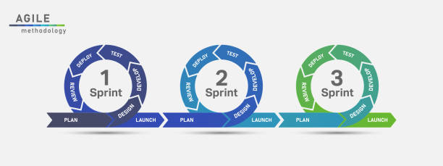****

*Note:* AdaptedFrom *iStock (*[*https://www.istockphoto.com/vector/agile-development-process-infographic-gm1264320878-370268788?phrase=agile+process+diagram*](https://www.istockphoto.com/vector/agile-development-process-infographic-gm1264320878-370268788?phrase=agile+process+diagram)*).* Upload date: August 06, 2020. Copyright: Ztaro.

**Scrum** was created to make methodologies like Waterfall more successful by adding flexibility to the methodology. This framework is designed to facilitate project management, team member collaboration, and to help teams naturally adapt to changing conditions and user requirements (Malsam, 2023).

Scrum consists of such components as artifacts. Artifacts are :

* Product backlog: The volume of work, structured by importance, is performed by the product owner and looks like a list.
* Sprint backlog: a plan for the next tasks that developers have to complete. It can also be identified as a set of user stories for one single sprint. Sprint is a predetermined period of time in which a pre-selected amount of work from the backlog must be completed.
* Product increment: This includes all the work done or all the tasks done. This artifact can be described as the summation of everything done (Chandana, 2023).

Below is an example of a classic Scrum Sprint with all possible components.

Figure 14

*Diagram of Scrum Framework Process*

*Note*: From *Techtarget (*<https://www.techtarget.com/searchsoftwarequality/definition/Scrum> *)* By Ben Lutkevich, Technical Features Writer.

As for those responsible for the sprints and all its components, as a rule, the composition of the sprint team is as follows.

* **Product owner**. The position speaks for itself, as a rule it is a stakeholder who is not part of the company. Can be names as at the link between clients and developers.
* **Scrum Master**. As a rule, a person from the same company as the developers, but there may be outsourcing. The primary responsibility of the Scrum Master is to ensure Scrum best practices are followed. Good leadership and human skills are a must have for this position.
* **Development team**. All those who will be responsible for the implementation of the tasks at a certain time - the workforce. In some cases, the Scrum Master is also part of the development team (Lutkevich, 2021).

Below is a diagram of a Scrum Team.

Figure 15

*Diagram of Scrum Team*

*Note*: From *Techtarget (*<https://www.techtarget.com/searchsoftwarequality/definition/Scrum> *)* By Ben Lutkevich, Technical Features Writer.

## Critique (Pros and Cons)

This subsection will present the advantages and disadvantages of the chosen methodology. It is important to be aware of such nuances before using the methodology. Only aspects of Agile methodology will be considered here, as it is the basis for the process.

|  |  |
| --- | --- |
| **Advantages** | **Disadvantages** |
| * Popular methodology (Sufficiency of information) * Collaboration * Flexibility * Improved performance and product quality. * Customer oriented * Acceptance of uncertainty * Immediate Feedback (Qualium Systems, 2017). | * Lack of Documentation * Possible scope creep * It takes a lot of time to prepare. * Lack of Prediction * Customer oriented (might be a disadvantage too) * The need for experience * Human factor – It can be hard for people to follow the rules. |

For better visualization of project tasks, and the distribution of tasks by time and significance, for simplicity, it was decided to use **Kanban** (Shore Labs, n.d.), as well as a paper journal to describe the process, tasks, work done, feelings, fears, and just notes.

Figure 16

*Example of Creating a Task in Kanban Board*

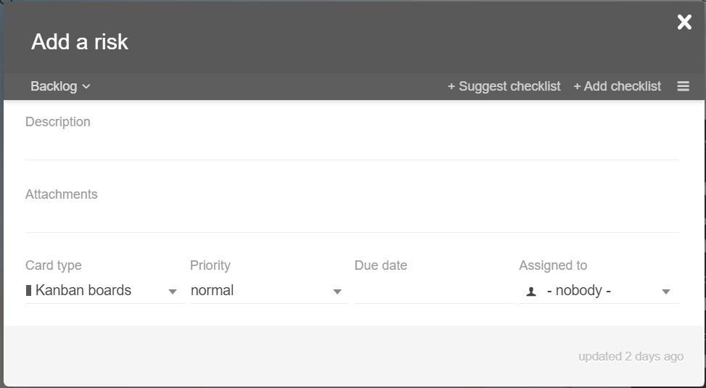

Figure 17

*Example of Kanban Board*

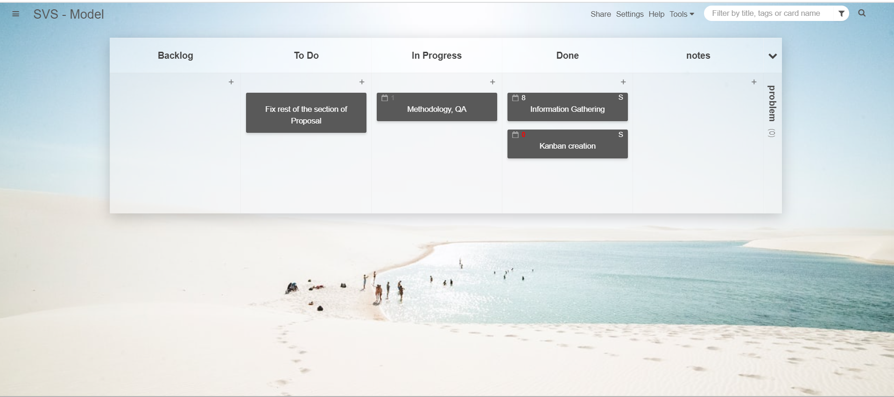

**In conclusion**

This project will use a modernised version of Agile, which will be carried out through the Scrum framework, since Scrum is a subset of Agile (Cprime, n.d.). The chosen methodology and framework fit perfectly together and will help in achieving the goal, namely the successful completion of the project. It is worth noting that the chosen methodologies add flexibility to the project, iterations can be added and changed. Also, the process of using and the framework itself can change and adapt along the course of the project. For example, due to the limited size of the team (two people), the industrial supervisor will act as the owner of the product and the sprint master. This is due to the fact that the customer or the real owner of the product is the State, since the entire project is sponsored by them. But to simplify the situation, the supervisor will be the owner of the product.

Another example of how the methodology may change in the future as the project progresses is the elimination of an Agile weakness such as missing or insufficient documentation. Documenting the progress and the entire process as a whole is an indispensable and important part of the project, so it will be given special attention.

## Halfway Report

This section will contain all the necessary information regarding updates to the methodology used in the project at the time of writing the halfway report. And also, an analysis of what went well, what didn’t go well, improvements that will be actioned during the remainder of the project.

During the first half of the project, a kanban board was used daily. This turned out to be a very convenient tool for visualizing and managing work as it moves through a process in this project.

Kanban was used for both the academic part and the industrial part. In academic work, it was used to break large tasks into smaller ones, which could later be broken into even smaller ones. This helped get rid of procrastination and focus on the process and progress. Quite common personal problems of postponing work on writing reports and project proposals are fear of the amount of work, not knowing where to start, as well as an excessive amount of task. This is where the student helped me. Another important advantage of using Kanban is the visible result in the form of completed tasks. This gives additional motivation and creates the feeling that work has been done, even if sometimes a small one.

Below is an example of using a Kanban board for academic purposes.

Figure 18

*Usage of Kanban Board – Halfway Report Stage*

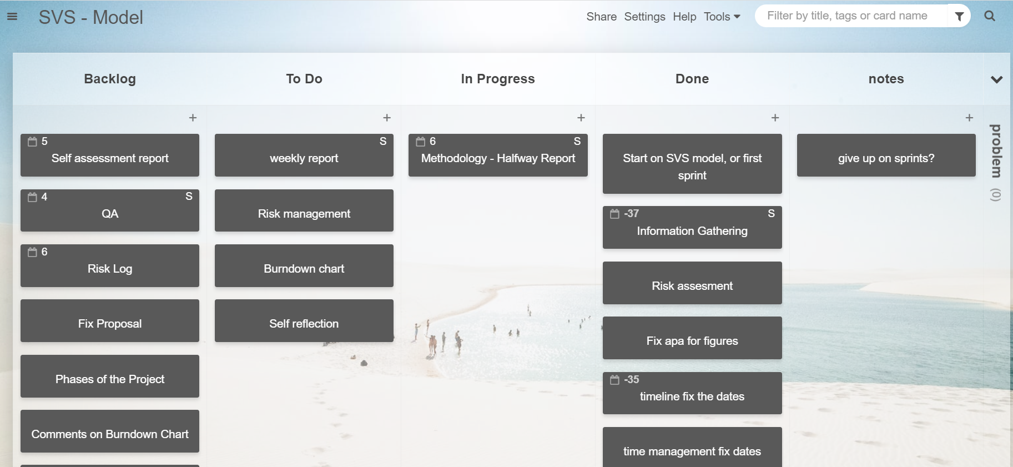

Kanban is also convenient because you can set a due date, which will be indicated on the task in the form of the remaining days until the deadline. It is also possible to indicate to whom this task was assigned; in this project this feature is rudimentary since the kanban was used by one person.

This Kanban board is a limited free version, since you can only create two boards, but it is ideal for this project.

Below is an example of using a Kanban board for industrial purposes.

Figure 19

*Usage of Kanban Board – Halfway Report Stage*

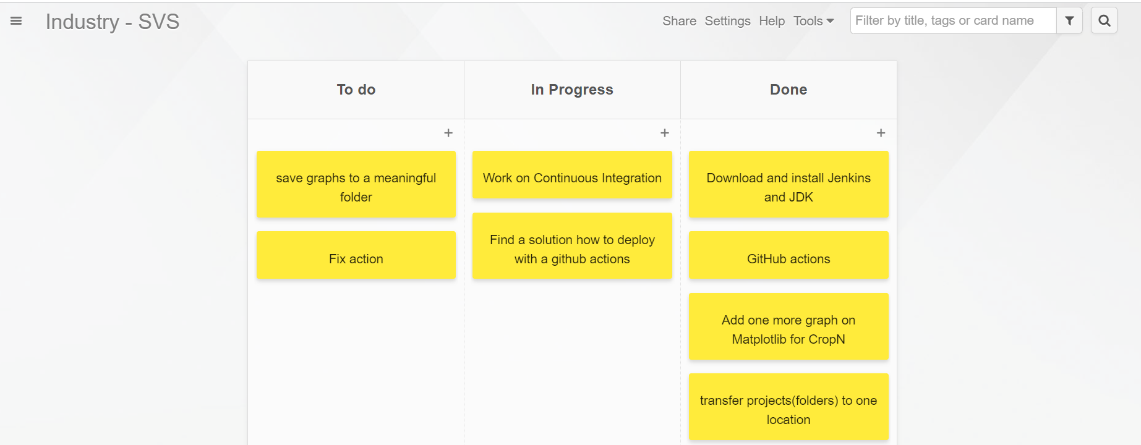

Kanban is used daily, but not all of its features are used or used to their fullest, specifically priority and due date. Instead of giving priority to tasks in digital terms, the student moved tasks from the Backlog to the To Do column, which was an indicator of the high priority of the task for the student. The due date is a very useful feature, and, in the future, it is worth using it much more often in order to have a structured approach to completing project tasks.