1)**Burndown chart title name** – I do not think I should change it to an actual date as it is very self-explanatory already as it actually stops on that date



2) **Risk Assessment Reference.** I have searched on the internet for a while but could not find a reference to it, I can write down that this Template was given by Ara. In addition, I asked several students and none of the respondents made a reference to the Risk Assessment Template. A close-up of a white background

It might be because it is from 2002.



3)**Risk assessment** - Condition. Personal health problems and Covid and New Viruses are different events.

Personal health problems include problems with sleep, with my sleep, so these are personal health problems.

Covid and new viruses include a nationwide epidemic, a great example is 2020 when we were all in lockdown. Therefore, these are not wild health problems.

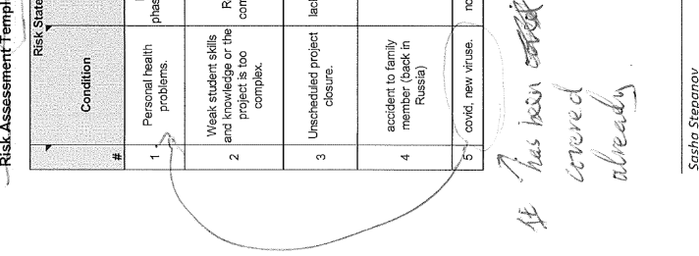

4) **APA reference.** 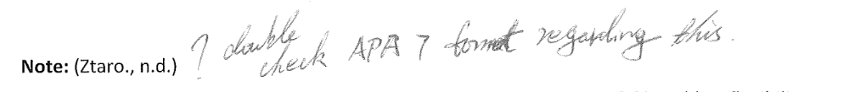

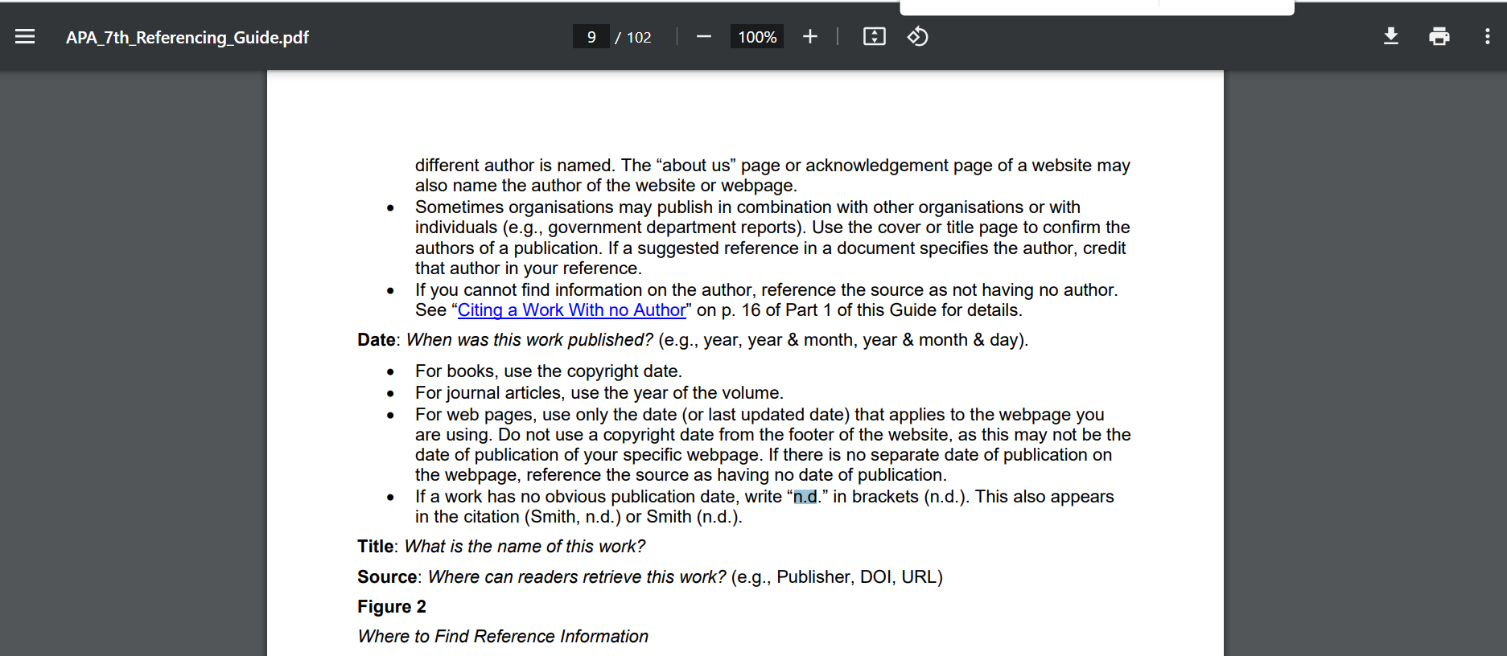



5) **Kanban** – I added an extra figure to back up my point.

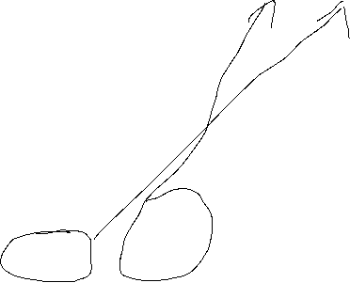

6) **Self-Assessments.**

Here I also used a template and I don’t quite understand what kind of content I should write if the project has just started.

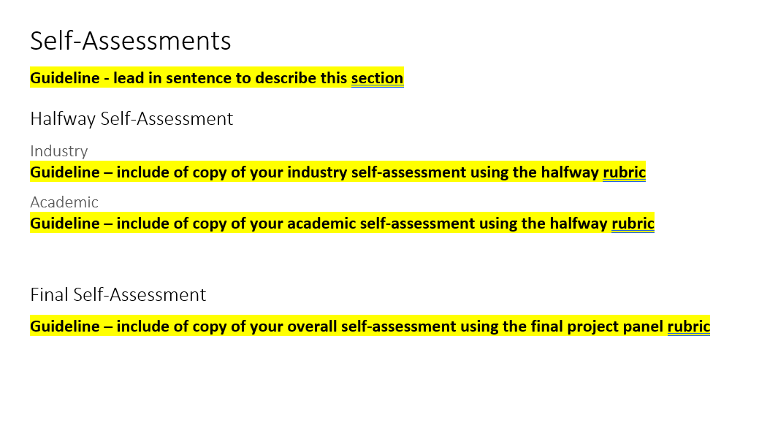

7) **Not required** - I didn't plan to do this.

8) **APA-Reference.**

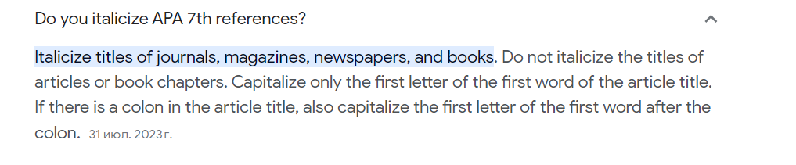

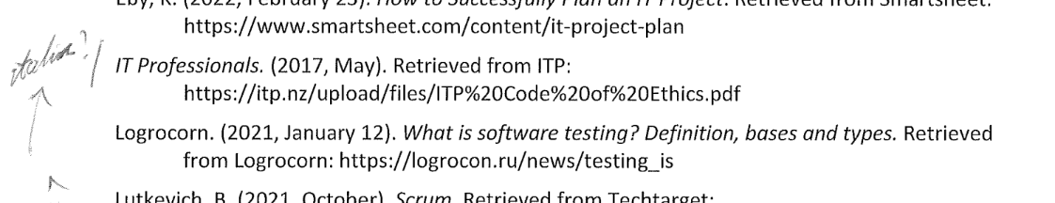



9) **The full version of Project Plan**. I am using a template

