Sasha stepanov

BCDE311 – Software Development PROJECT

Semester 1, 2023

<Project NAME> for <CLIENT NAME>

Project Proposal

Version <version number>

Contents

Introduction 5

Project Details 6

Project Name 6

Overview of Industry Client 6

Project Background 6

Information Gathering 7

Documentation 7

Project Scope 10

Project Goal(s) 10

Benefits of Project 10

Project Requirements 10

Expected Deliverables 10

User Personas 10

Project Plan – High Level 12

Project Management Framework adopted 12

Phases 12

Timetable 12

Burndown Charts 13

Resources/Access Required 13

Risk Management 15

Approach 15

Risk Table 15

Quality Assurance 16

Approach 16

Quality Assurance Table 16

Test Plans – Functional and Usability 16

Project Management Framework Methodology 17

Overview 17

Literature Review 17

Critique (Pros and Cons) 20

Ethics 21

Relevance of ITP Code of Ethics 21

Relevant Legislation 24

Reflections 25

Approach 25

Specifications 26

References 27

Appendices 28

Appendix A – Detailed Project Plan 28

Appendix B – Risk Management Tables 28

Appendix C – Quality Assurance Tables 28

Appendix D – Interview Transcription and Notes 29

Document Control

|  |  |  |  |
| --- | --- | --- | --- |
| Date | Author | Version | Status of Document/Updates Made |
| 05/03/2023 | Sasha Stepanov | v0.1 | Document Creation and Scope checking |
| 06/03/2023 | Sasha Stepanov | v0.2 | The initial stage of preparation of proposal and documents. |
| 25/03/2023 | Sasha Stepanov | v0.3 | 75 percent of the proposal is done |
| 30/03/2023 | Sasha Stepanov | v0.4 | Completed All Sections |
| 04/04/2023 | Sasha Stepanov | v0.5 | Correction of some sections, preparation for submission |
| 07/04/2023 | Sasha Stepanov | v0.6 | Signed Off, Submitted |

# Introduction

This proposal provides information about software development project for an IT industry client. Proposal contains all the information and documentation regarding the project and its components that has been collected to meet the projects goals. The document is divided into several parts which will provide information about the project, specifically:

• Project details, scope size, information about the project client and future users

• Client interview and interview transcription

• Timeline and phases of a project

• Risk management plan

• Details of the chosen methodology and framework

• Quality assurance plan for functional and usability testing

• Ethics overview.

# Project Details

This section will help to understand the basics of the future project and the desires of the client.

## Project Name

“FollowAra” – Virtual orientation.

## Overview of Industry Client

Currently, the client has a team for results processing, marketing and only developers are missing. The client hires developers to create a successful Ara Virtual Tour.

## Project Background

### The main idea of the project is an informative resource for existing students and attracting new applicants.

### Overview

Leaping into the unknown is not an easy task, so visualization comes to the rescue. A professionally made virtual tour will not only help you navigate the area, but also help you advertise your business. It helps to create the effect of presence, the illusion of an excursion. Bright, memorable visual images will help to leave a good impression of the product or service.

The second equally important part of the project is the display of students' work in the form of posters.

### Current Situation

At the moment, there are already virtual tours for Ara, which are used for new students. The time has come to update them, as interest in the virtual tour, as well as in the Faculty of ICT, is declining. It is planned that a new improved version of the tour will help attract new students.

### Future Situation

After the completion of the project, the client will be able to launch this virtual tour to help newly arrived students, as well as promote Ara in schools. Due to the fact that photos and text are easily interchangeable, the project can be used for other purposes, such as advertising colleges.

# Information Gathering

The interview was conducted with the client in a healthy environment in the territory familiar to the client, in a room with comfortable sofas. Below is an analysis of the interview with the main points and plans for the project. Original word-document, signed consent and picture of notes of an interview can be found in the Appendix D.

## Documentation

|  |  |
| --- | --- |
| **Date** | Wednesday 8th March, 2023 |
| **Interviewee(s)** | Philip Roxborough |
| **Audio Recorded (Y/N)** | y |
| **Video Recorded (Y/N)** | Y |

Introduction, purpose of the interview, general questions. Asking for permission to record. Signing of a consent.

1. **First question blah blah blah**

* Some key point
* Maybe some more key point
* Some comment about something

1. **Second question blah blah blah**

We need it because :

* It will help
* It might help
* Blah blah

1. **Second question blah blah blah**

We need it because :

* It will help
* It might help
* Blah blah

1. **Second question blah blah blah**

We need it because :

* It will help
* It might help
* Blah blah

1. **Second question blah blah blah**

We need it because :

* It will help
* It might help
* Blah blah

1. **Second question blah blah blah**

We need it because :

* It will help
* It might help
* Blah blah

1. **Second question blah blah blah**

We need it because :

* It will help
* It might help
* Blah blah

1. **Second question blah blah blah**

We need it because :

* It will help
* It might help
* Blah blah

1. **Second question blah blah blah**

We need it because :

* It will help
* It might help
* Blah blah

1. **Second question blah blah blah**

We need it because :

* It will help
* It might help
* Blah blah

1. **Second question blah blah blah**

We need it because :

* It will help
* It might help
* Blah blah

1. **Second question blah blah blah**

We need it because :

* It will help
* It might help
* Blah blah

1. **Second question blah blah blah**

We need it because :

* It will help
* It might help
* Blah blah

1. **Second question blah blah blah**

We need it because :

* It will help
* It might help
* Blah blah

1. **Second question blah blah blah**

We need it because :

* It will help
* It might help
* Blah blah

1. **Second question blah blah blah**

We need it because :

* It will help
* It might help
* Blah blah

1. **Second question blah blah blah**

We need it because :

* It will help
* It might help
* Blah blah

1. **Second question blah blah blah**

We need it because :

* It will help
* It might help
* Blah blah

1. **Second question blah blah blah**

We need it because :

* It will help
* It might help
* Blah blah

1. **Second question blah blah blah**

We need it because :

* It will help
* It might help
* Blah blah

1. **Second question blah blah blah**

We need it because :

* It will help
* It might help
* Blah blah

# Project Scope

This section will summarize all collected and analysed data from interviews from the last section.

## Project Goal(s)

Create a virtual tour for daily use.

Show poster of ICT students projects ICT.

more

## Benefits of Project

After the completion of the project, a positive outcome is expected in the following form:

* More interested high school students who want to study as an IT specialist.
* More enlightened Ara students about ICT with subsequent potential transfer to this faculty
* Familiarization of all comers with posters - projects.
* Positive advertising of the faculty of ICT

## Project Requirements

Only after analysis!!!!!!!!!!!!!!!!!

**Guideline – list the high-level requirements (if known at this stage)**

## Expected Deliverables

The deliverables of this project are:

1. Project proposal
2. Interview questions and notes and Analysis
3. Project plan
4. Risk management analysis
5. Quality Assurance plan
6. Functional usability testing plans
7. Usability and functional testing records for each iteration of development
8. Low-fidelity prototypes (wireframes with an optional storyboard, guided tour)
9. interactive low-fidelity prototype and presentation (storyboard)
10. High-fidelity prototypes
11. Final report
12. Final product
13. Presentation of a Virtual tour to public.

## User Personas

This subsection describes the target user personas of the project. Template was created via Figma.

Sample of persona picture

# Project Plan – High Level

All phases of the project and also the planned and actual deadlines for the implementation of these phases can be found in this section.

## Project Management Framework adopted.

The decision was made to combine the Agile methodology with the Design Thinking process. Thus, the project will proceed in an iterative manner, user-focused, with revision, testing at each stage or iteration.

## Phases

The implementation of the project will take place in several phases: Planning, Design, Development, and Delivery. It is worth noting that each phase will consist of several iterations, which are based on the Design Thinking methodology which involves going back to the beginning and revisiting ideas. The phases are:

1. **Planning.** The first and most important phase of the project. It will outline the main idea, the scope, the timeline of the project, and the risks associated with the project. It will also collect information (interview) from the client.
2. **Design**. The phase of brainstorming ideas, implementing these ideas in the form of prototypes (low- and high-fidelity), testing these prototypes on potential users and collecting feedback from them.
3. **Development.** The most voluminous and time-consuming phase in which the direct development of the product will take place. The development will be based on collected data from previous phases. This process is iterative and will consist of several iterations (minimum 3). These iterations include such tasks as translating ideas into reality or developing itself, functional and usability testing, and processing feedback and criticism from users. The process will be repeated until the achieved result meets the stated standards and desires of the client and users.
4. **Delivery.** This is the final phase, which includes the completion of the product, documentation, and delivery (presentation) of the product to the client.

## Timetable

The initial timetable outlines show planned tasks and the hours allotted for these tasks. Also in the timetable will be presented due dates. The timetable will be updated and filled in as the project progresses, hours and tasks can and will change. At the end of the project, the difference between the total volume of the planned hours and the actual ones will be calculated in order to understand whether the project has kept within the allotted time frame.

Example of an initial Timeline table

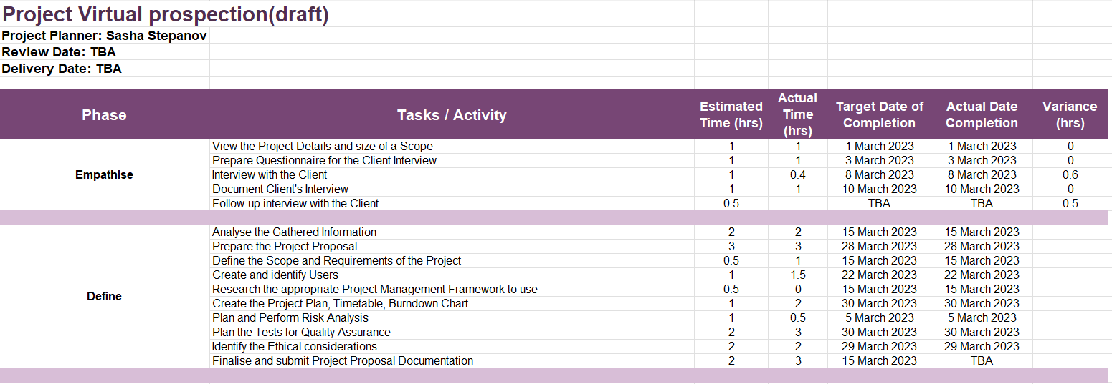

## Burndown Charts

An example of a WIL Capstone Project Academic Burndown Chart

**Figure 7**   
*Academic Burndown Chart*

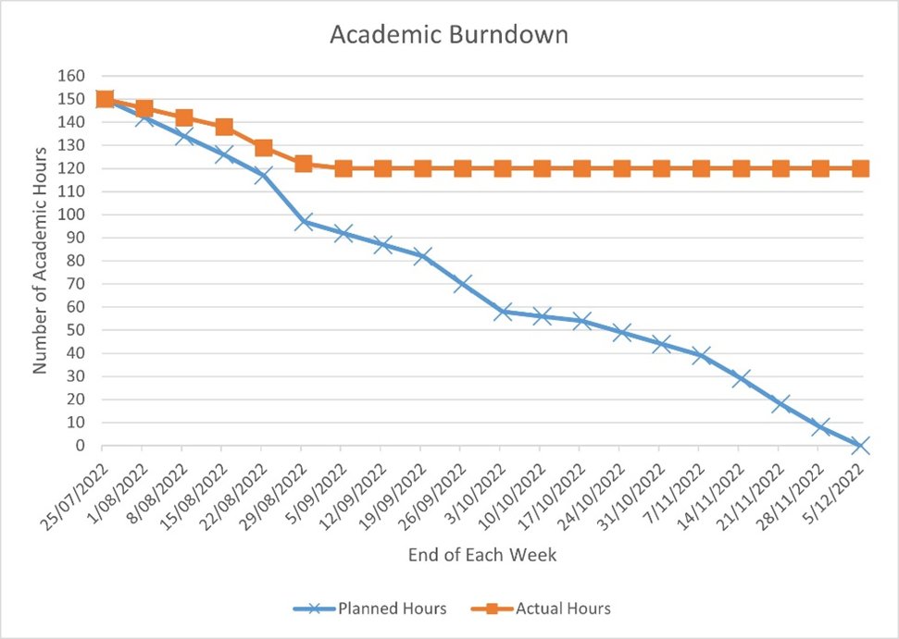

## Resources/Access Required

Hardware:

* PC
* GoPro 360 camera with a tripod, power bank.
* Smartphone/recorder.

Software:

* Visual Studio Code
* A server (cloud-based or local)
* Lapentor Virtual Tour Software
* Adope Photoshop
* [Figma: the collaborative interface design tool.](https://www.figma.com/)

Assets and Resources required:

* 360 photos of Ara campuses
* Various pictures and icons from free sources
* Images of student Posters
* Ara Institute of Canterbury brand specifications,guidelines,map.

# Risk Management

This section will present the five main risks that are associated with the project, ways to mitigate and manage these risks to successfully complete the project.

## Approach

The chosen risk management approach is the Risk Management tool by Microsoft Corporation, which is presented a table in an Excel spreadsheet. Risk review is a very important and integral part of any project, so the review will take place after each phase, with a minimum number of revisions: 3.

The table consists of 8 main columns. Below is the information about the contents of these columns:

1. Risk Conditions or in other words the Name of the Risk (what must happen for the risk of an unsuccessful outcome of the project to appear).
2. Risk consequences. Result of the risk, should it happen.
3. Probability. The “likelihood” that the risk will happen is expressed as a percentage. Must be greater than zero but less than 100.
4. Impact. Amount of severity for project if risk is happened. In this case, it is measured on a scale from 1 to 100.
5. Exposure. Calculated automatically by multiplying two columns of Impact and Probability. Used to identify the most serious risk.
6. Mitigation. Includes an action plan to prevent or reduce the risk impact.
7. Contingency. Backup plan in case if risk became reality.
8. Triggers. Represents the reason for using a backup plan.

Top five risks table - capture

## Risk Table

# Quality Assurance

This section will provide information about the Quality Assurance of the product and its support, plans for functional and usability testing will also be provided.

## Approach

To properly track the quality of a product, need a certain system, method. In this project, it was decided to use the Virginia Tech template. This method will consider:

* Deliverables of the project.
* Stakeholder expectations and standards of quality processes.
* Activity itself. It can be evaluation, code review. In general, measures should be taken to control a certain phase in order to avoid poor product quality.
* Frequency of the process (phase) of the project.
* Who is responsible for the procedure.
* Date the Deliverable was accepted.

Some deliverables are reviewed several times during the course of a project due to the chosen methodology, which includes iteration.

## Quality Assurance Table

Capture table

| **Project Process (Deliverable)** | **Process Quality Standards/ Stakeholder Expectations** | **Quality Assurance Activity** | **Frequency/Interval** | **Who is Responsible** | **Date of Acceptance** |
| --- | --- | --- | --- | --- | --- |
| Create a project proposal. | A thorough collection and processing of all the necessary data for a high-quality and correct start of the project was carried out. | Evaluation each version of a project by Course Tutor. | Proposal work will be carried out regularly during the planning phase and revised at the end of the phase for final processing. | Project owner | TBA |
| Create interview questions, do interview record it and take notes during the interview. | Information gathering stage; Team have come up with proper questions that clarify clients' requirements and project itself. | Questions are created in a team, all devices for recording are turned on, records are created in real time, data are summarized at the end. | Before the date of the initial interview; during the interview; after the interview | Class team, project owner | TBA |
| Analysing the interview, summarising into sense. | Transcription of audio recordings, full analysis of interviews/recordings/audio recordings. Certification that there are no gaps for the project proposal. | Comparison of the analysis and project scope with other participants of the interview, confirmation by the client of the project plan and goals. | After the interview | Project owner | TBA |
| Creating a project plan/timeline | The timeline is regularly updated with accurate information | Evaluation of the plan and timeline will be carried out by the tutor, an important factor is not to go beyond the "budget - 150 hours". | Created during the planning phase, updated and filled in throughout the project. | Project owner | TBA |
| Risk analysis and management | Risks are regularly assessed and updated during the project | Submitting the risk management tool for assessment by tutor | At least 3 times. Initial, median, towards the end. | Project owner | TBA |
| Carrying out Functional Testing | Functional testing of low/med/high-fi prototypes product will be carried out after each iteration and **before** the usability testing | Documentation of all testing, submission for evaluation to the tutor. | During Design and Development Phases; 3 times at least | Project owner | TBA |
| Carrying out Usability Testing | Usability testing of low/med/high-fi prototypes product will be carried out after each iteration. Results from the usability testing is used for improving product. | Documentation of all testing, submission for evaluation to the tutor. | During Design and Development Phases; 3 times at least | Project owner, potential users | TBA |
| Review the Product design | Design specification. Product design satisfied the client's needs and made suggestions are considered | Getting feedback from client and users on product design | After each Iteration | Project owner, Lecturer, class, client | TBA |

## Test Plans – Functional and Usability

#### Functional testing

Functional testing is a necessary step to accomplish a good quality IT product. This testing is necessary in order to make sure that the product behaves exactly as the ball is programmed, it is important to understand that this testing has nothing to do with testing of a design part of a product. Testing usually involves using a different input data to discover that a feature is not working properly.

First, functional testing is carried out, then, if any shortcomings or errors are identified, these errors are eliminated, or in other words bugs are fixed. Then usability testing is carried out already on a working product, since if you conduct a usability test on a product that has problems with the functional part, this will only add difficulties and confusion for the user.

Example of the template used

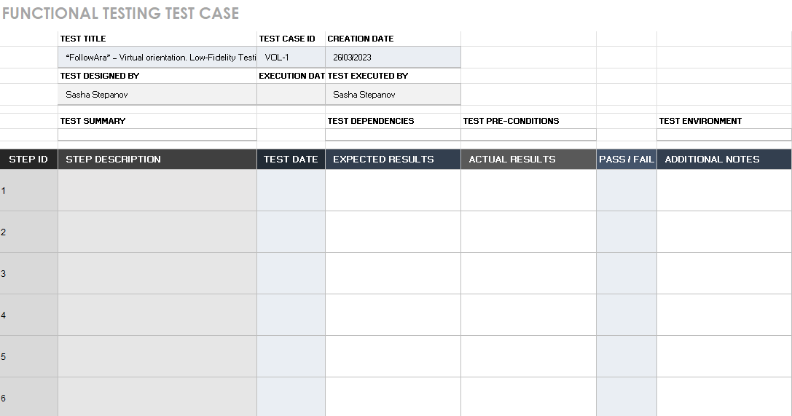

#### Usability testing process

Usability testing is responsible for ease of use by the customer. It is important that the user himself performs the entire procedure and the desired result is obtained without any external assistance. This testing includes such aspects as: testing the overall structure, the arrangement of elements on the page, content clarity, game play and overall behavior of the product.

The user must complete a certain number of steps in order to complete some action or use of the product. After each completed action, the user answers certain questions related to the task. Questions should be of a different nature and structure. For example, multiple choice questions should be used to make it easier for the participant to answer them without feeling pressure from outside. Often participants are asked to comment on what is happening and think out loud, while describing their emotions is welcome. It is very important to get a full review with comments about the test after usability testing (Qualitestgroup, 2022).

**Ten simple rules for a proper usability testing:**

* Keep feedback with a user.
* User speaks, not programmer.
* Make sure there is an undo and quick get-aways for a user.
* Make sure testing is based on standards and consistency.
* Keep error alerts away from customer.
* Users need to learn, not to memorise.
* Provide a user with a shortcut key, access key and other helpful tips if necessary.
* Minimum design - maximum functionality.
* Document all answers, behaviour, all help that have been provided.
* Show a user how to recognize, diagnose and recover from mistakes.

Testing will take place in a certain order and will include several forms. In terms of duration, it is important that the testing takes place in a time interval of 5-10 minutes. If testing such a simple product takes more than 10 minutes, then the user will lose all interest and the testing itself will turn into a burden, which can adversely affect the correctness of test results.

List of forms to fill out:

* The first is my evaluation of how well or poorly the subject is doing with the product.
* The second is the likert.
* The third is user comments on process and product.
* The fourth form is Feedback Capture Grid: I like…I wish….What if…

Example of likert chart

# Project Management Framework Methodology

This section will present the framework's chosen methodology for implementing the project and the reasons for the choice.

## Overview

For the successful implementation of the project, it is very important to choose the right framework and methodology. There are several main frameworks that are successfully used in the IT world right now. After a thorough analysis of the available methodologies and frameworks, it was decided to focus on combining Agile and Design Thinking. It is very important to choose a methodology and framework in the centre of which is the user.

## Literature Review

### Design Thinking

When creating an app or game or website - one of the most important aspects must not be forgotten it is to design a user-centred product. Companies often believe that they can develop the best solution for their customers and want to start development process before asking themselves - “Is this really what my customers users want?” Design thinking process based on problem-solving process with creativity and is the key to how new project should be started. Design thinking makes very clear that it is a bad idea to start with an assumption and build product on them before testing their validity. Instead of that, Design process teach the team focus on the people product will be created for. This will ultimately lead to better, more useful apps (Brisbin, 2019).

#### The Five Phases of Design Thinking

From these four principles 5 stages of design thinking follow. There are Empathize, Define, Ideate, Prototype, Test and the sixth is Implement, but sixth one is not going to happen until product is ready passed all stages, sometimes more than ones.

Figure 13 Design Thinking steps

While these steps may seem linear, it's important to understand that design thinking does not follow a strictly sequential process. Every step of the process can make new changes, it means that one of the previous steps/task is not relevant anymore and needs to be revised. Every step can and should be done more than once.

**Stage 1: Empathize**

Research and process the user's needs and wishes, you need to gain an empathy to a future user usually through user research. One of the keys of this step is leaving all assumptions behind and let a customer to speak. This way you gain real insight about users and their needs (Canvas, 2022).

**Stage 2. Define**

The next step is to identify what is a problem that needs to be solved? That step is based on what have been learned on Empathise step. Problem statement identifies the specific challenge needs to be solve. The entire design process will depend on it from now on, give a fixed GOAL to strive for. When crafting problem statement, it is necessary to pay attention on the customer rather than the needs of company (Stevens, 2020).

**Stage 3. Ideation**

In this step Challenge Assumptions and idea creation is happening

The knowledge base learnt from the first two stages now can be used "thinking outside", looking for alternative ways of looking at problems, and identifying creative problem solution statement. Brainstorming is especially helpful at this stage (Canvas, 2022).

**Stage 4: Prototype**

After all ideas have been narrowed down to a few, next step is to create a prototypes or "miniature" versions of the product that needs to be tested. This phase gives a chance to “build” something touchable that could be tested on real people. It is important to maintain a user-centric direction. There are few different types of prototypes depending on product and what will be tested. It could be paper prototype or advanced media prototype. Before creating a prototype, it is crucial to set a clear goal and purpose of a prototype, otherwise it will be very hard to test it (Stevens, 2020).

**Stage 5: Test**

Improve the product During this phase, by running/making tests for the product by implementing the discoveries and solutions that have been found during the prototype phase. Because it is technically the last stage of design thinking, it's important to understand that this is not the final stage where whole process stops. The design thinking process contain of iterations. What have been discovered during the test phase often leads to redefine the problems that needs to be solved. It is possible and necessary to go back regularly and review all design stages to refine the product to be as efficient as possible. Thorough testing can really give a deep understanding of a product and customer (The Design Thinking Process – How does it work?, 2020).

By using Design Thinking method natural flow is created, which makes process of idea and research to rollout faster and easier.

Dive into “customer head” can produce a very important data which can be transformed into insights, which might lead to change of a design.

### AGILE

Agile is a group of methodologies for flexible project management in a development team. The workflow with this approach is divided into small time intervals, they are also called sprints or iterations. During each sprint, the development team creates a piece of the product that can be tested and evaluated. This approach allows you to make significant changes to the project, even when development is in full swing.

#### Phases of Agile

The principles of Agile focused on the product is built according to a different logic:

* Drawing up a complete technical task.
* Design.
* Development.
* Testing.
* Final result.

Development processes in this methodology cannot be rolled back, the team returns to the previous stages only if something does not work correctly and works according to the terms of reference.

#### Types of Agile Methodologies

Agile is the general name of several methods united by the idea of work flexibility. This group includes various methods, for example:

* **Scrum**. The work in this technique is based on iterations. All tasks necessary to complete the product are formed into a special list - the backlog, and the main role is assigned to the customer, who determines the type and functionality of the product.
* **Kanban**. It focuses on visualizing tasks on boards and optimizing the workflow. Kanban teams strive to reduce project time and improve efficiency.
* **Extreme Programming** is based on practices such as pair programming, test-driven development and continuous integration, that is, the constant addition of new elements to the main project.

#### Agile Principles

The Agile approach to development is based on several principles:

People and interaction are more important than processes and tools. Therefore, the methodology is suitable for both small startups and large corporations. It doesn’t matter where communication takes place and tasks are set – in the Telegram chat or in the task manager – the main thing is that all participants in the process understand the goals of the project and know what is happening at the current stage.

A working product is more important than comprehensive documentation. Thanks to this principle, Agile development starts faster - already at the first stages, instead of compiling a voluminous technical task, prototypes are created and tested on which hypotheses are tested.

Cooperation with the customer is more important than agreeing on the terms of the contract. Work according to the Agile methodology involves the active participation of the client, so it is not suitable for customers who are not ready to delve into the work, devote enough time to the project and experiment on their part.

Being ready for change is more important than sticking to the original plan. This principle is the foundation of agile development. It is impossible to plan everything perfectly in advance, and some bright ideas come just in the process of working on a product. Agile allows you to focus on tasks that are important now, and not waste resources on thinking two or three steps ahead.

https://blog.skillfactory.ru/glossary/agile/

capture …

https://www.youtube.com/watch?v=4nTh3AP6knM

## Critique (Pros and Cons)

|  |  |
| --- | --- |
| **Advantages** | **Disadvantages** |
| * User oriented * Collaboration * Flexibility * No restrictions on delivering product, iteration can be done earlier. * Circle(iteration) can be broken anytime. * Planning happening continuously. * Regular delivery of product features, prototypes. * New Ideas (brainstorming) * Continuous reflection on completed work to improve efficiency or eliminate flaws. * Waste reduction. No over or under-producing, even workload allocation * Easy, straightforward, popular   https://ccaps.umn.edu/story/agile-methodology-advantages-and-disadvantages | * User/client might be involved too much/ * Not updating documentation for plans/backlogs, testing can lead to issues with prioritizing the right thing. * Lack of testing is quite common for this methodology. * Not suitable for dynamic environment where things change too fast. * Scope creeping is very big problem * Lacks processes to check on less experienced developers and team members. * It is difficult to predict at the beginning of a project how many resources are needed. * Constant meeting can lead to difficulty to maintain due to unavailability of team members or users/clients * Less predictable |

## Summary

The stages of Design Thinking described above will be combined with an Agile management method -Kanban. This means that by combining Kanban with Design Thinking next advantages cab be achieved:

* Task transparency of a project.
* Easier to organize tasks in time and space.
* Easier to break into smaller tasks.
* Easier to determine and notice the priority of execution.
* Visualization helps to focus on the execution of specific tasks.
* Helps Illuminate procrastination.

# Ethics

This section will provide information and documents regarding ethical and legal regulation, how it relates to the project and how it will be carried out.

## Relevance of ITP Code of Ethics

In order for the project to be legal and ethically correct, so that there are no legal problems in the future, certain dogmas and laws should be followed. These tenets will be presented below.

### Good Faith

This Principle is relevant to this project. I shall treat people with dignity, good faith, and equality; without discrimination; and have consideration for the values and cultural sensitivities of all groups within the community affected by my work.

For example, when creating an interview questionnaire, the opinion of each team member was taken into account.

### Integrity

This Principle is relevant to this project. I shall act in the execution of my profession with integrity, dignity, and honour to merit the trust of the community and the profession, and apply honesty, skill, judgement, and initiative to contribute positively to the well-being of society.

### Community Focus

This Principle is relevant to this project. Responsibility for the welfare and rights of the community shall come before my responsibility to my profession, sectional, or private interests or to other professionals.

For example, the final product is aimed at attracting new students, which in turn reflects well on the general level of education in New Zealand.

### Skills

This Principle is relevant to this project. As a student I shall apply my skills and knowledge in the interests of the project’s client or employers for whom I will act without compromising any other of these Tenets.

### Continuous Development

This Principle is relevant to this project. I shall develop knowledge, skills, and expertise continuously through the project.

### Informed Consent

This Principle is relevant to this project. I shall take reasonable steps to inform myself or my client of the economic, social, environmental, or legal consequences which may arise from my actions.

Capture…

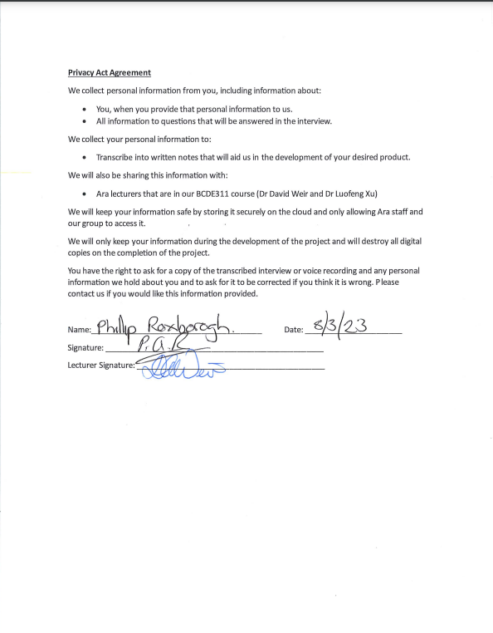

### Conflicts of Interest

This Principle is not relevant as I do not have a conflict of interest in this project. However, I shall inform my clients of any interest which may be, or may be perceived as being, in conflict with the interests of my clients, or which may affect the quality of service or impartial judgement, if such ever arise during the duration of the project.

**Guideline - students shall inform their clients or employers of any interest which may be, or may be perceived as being, in conflict with the interests of their clients or employers, or which may affect the quality of service or impartial judgement;**

### Competence

This Principle is relevant. I shall follow recognised professional practice and provide services and advice carefully and diligently only within my areas of competence, which is in the case of this project is solely software/web development/taking a 360 picture.

## Relevant Legislation

**Guideline – see** [**https://www.privacy.org.nz/**](https://www.privacy.org.nz/) **and** [**https://www.iponz.govt.nz/**](https://www.iponz.govt.nz/)

### Privacy/Confidentiality

All collected information from users as well as from the client will be used only for the purposes of a specific project and only with permission. No personal data that could identify a specific person will be collected. All storage will be privately accessible to unauthorized persons and will be deleted after the completion of the project.

While it is not planned to use personal data, best practice is to be safe and follow the New Zealand Privacy Act 2020.

**Privacy Act**

The Privacy Act 2020 stays about rules that user’s information can be collected, stored, shared, or viewed.

It guarantees that:

If you want - you can get an access to your information.

You must be notified if and when your information is collected.

All information that have been collected is used in shared in an appropriate way.

All information is secure and safe.

There are twelve main principles that create a whole act about privacy.

1. Principle is about reason for collection.
2. Principle is staying that information that collected must be from a source.
3. Principle saying that organization should be open for the reason of gathering information.
4. Principle is about way of collecting information.
5. Principle is about security and the way is information is going to be stored.
6. Principle is about person’s right to access his own information.
7. Principle staying that person is allowed to correct it in a right way.
8. Principle staying that organization must check for correctness of information they are collecting.
9. Principle staying that all information that has been gathered should have an expiration day.
10. Principle says that there are limits of the ways collected information can be used.
11. Principle states that the information collected may only be used for the purposes for which it was originally collected.
12. Principle states that the information collected may only be used for the purposes for which it was originally collected and do not leave New Zealand.
13. Principle states that organizations cannot assign an ID to a customer, unless specified.

Following these principles will help avoid any legal issues (Office of the Privacy Commissioner, 2020).

### Copyright

Copyright applies to a Virtual Tour after it will be completed. Almost all the resources used are free and in the public domain. The photos taken by the development team are the intellectual property of the team, but no one planned to claim this property, but no official documents were signed in this regard.

As for the directly completed product, all rights to it go to Ara and his staff, since the project is part of the course.

If desired, the final product can become Joint Ownership, as this is possible thanks to **Corporate Policies & Procedures General Administration - Document CPP106**

IP Rights – Learners mention it?

https://www.ara.ac.nz/siteassets/documents---home/about-us/policies/general-administration/cpp106-intellectual-property.pdf

### Patents

This legislation is not relevant to this project, as Idea is not new and widely open for everyone.

# Reflections

This section will describe my opinion on the project, its successes and failures. Will be discussed what could have been done better and what worked out very well. In order to keep some kind of record of the experience gained and my attitude towards the project, a special approach recommended by the Asana website will be used.

## Approach

This approach consists of 5 steps:

* Identify. To accomplish this step three questions, need to be answered: What went wrong? What went right? What can be improved?
* Document. Report it in some form of documentation: summury, notes, recommendations.
* Analyse. Analysis and drawing conclusions. It can take place both in the middle of the project, and at the very end, so to make sure not to make the same mistakes in the future.
* Store. Analysis and drawing conclusions. It can take place both in the middle of the project, and at the very end, so as not to make the same mistakes in the future.
* Retrieve. In the event of a foreseen repeated error or difficulty, it is necessary to retrieve the documentation to mitigate this error.

**https://asana.com/resources/lessons-learned**

# Specifications

**Guideline - this is a placeholder to indicate you will be creating specification documentation derived from your initial low-fidelity wireframe / story board processes and submitting them in an appropriate manner here.**

# References

**Guideline – APA v7, supported by in-text references.**

# Appendices

**Guideline - lead in sentence to describe this section**

## Appendix A – Detailed Project Plan

**Guideline – work breakdown structure including phases, tasks, deliverables, time allocated, completion dates, resources.**

## Appendix B – Risk Management Tables

Guideline -Use this to give provide updates of the risk tables and other evidence that may not be suitable to display in the main report section – example of a table from WIL Capstone Project Risk Management

**Table B4**   
*Risk Issues Management - 3 October 2022*

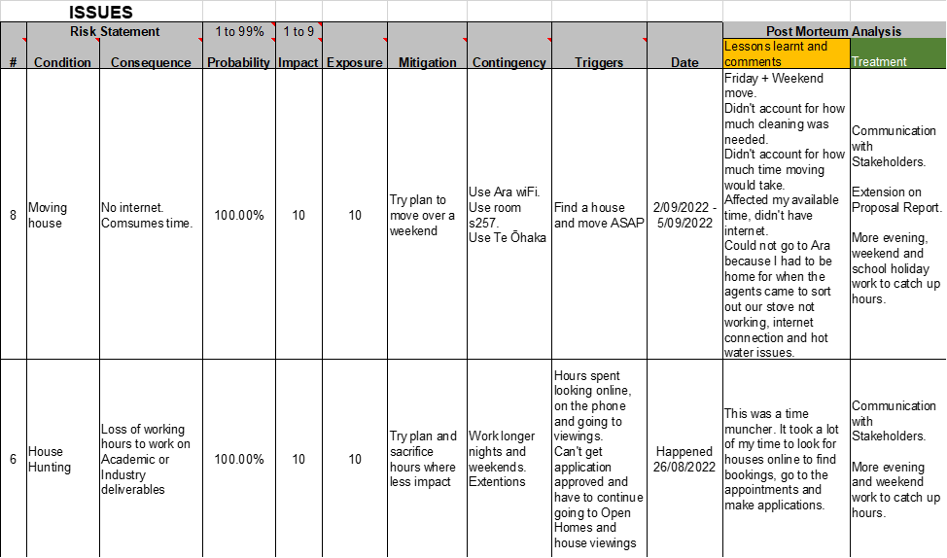

## Appendix C – Quality Assurance Tables

Guideline -Use this to give provide updates of the QA table and other evidence that may not be suitable to display in the main report section

## Appendix D – Interview Transcription and Notes

### Audio file

Original audio file can be found in **resources** folder.

### Transcript

Discover any additional information resources that need to be included in the tour or on the website. Yeah, find the target audience of interest for the product so we can produce a better experience for them. Discover the main purpose of the four for. Example is it for advertisement purposes or an informative guide and find out about you and your company to get a better. Understanding of what you're looking for.

Right.

We were going to record. This interview, if that's OK with that, we can. Using that you can record and transcribe.

More on with safety secured than about and going to destroy all digital copies.

OK, sure, fine.

OK, that's cool.

Now I'm copy of that needs to. Be given to. And for all of you.

Yeah. So you talked about.

Sure. What is what is the tour that? You think I'm going to be talking to you about?

We're assuming that it's just going to be a tour through the campus, yeah.

Is this the virtual orientation? Yes. So the reason why I asked that question is as a client I have a number of things on the go and so I'm busy, busy, busy from meetings and I just want to make sure that I'm. Talking about the right thing, so the virtual orientation. Cool, it's gone.

OK. Can you first tell us about yourself and your company?

OK. So my company have been contracted by other to create a virtual orientation experience for students.We are marketing people. We don't have the technical expertise, which is why we're getting you guys to do. The project It's made-up of myself and a team of three people who, as I said, do marketing, do research, put together the key. Messages and things like.

OK, what is the main purpose of the project? Is it to be informative or is it for marketing purposes?

OK, not to be a pain, but it's actually both. OK. So it's informative because it's going because it's going to give information and an experience to students who need to be oriented. But it also means that outside of orientation it's available for anybody to look at. And utilise so it's back.

OK. What Target's target audience is going to be seeing this virtual tour?

OK, so based on what I said before, it's a combination of students who are new to the programme. So they might be coming into the digital technologies computing programme. They may have done something, they may know a bit about other or they may not know a bit about other so. But new students to the programme. And experience tells me that those could be students that come out of high school fresh out of high school. Or it could be or they could be students who are looking to change careers. So they don't know a lot about it, but they know that they want to go into it. So there's a bit of a range there. And that I. Guess that also follows that they may some of the students may be very familiar with using technology. And maybe some mature students or students who are changing careers may not be so familiar with technology. So that means that your solution that you come up with. Can't be too complex.

Right. What devices will the users use primarily like? Will it be mostly mobile users or more like desktop?

Yeah, I can imagine it's mostly mobile, but it's likely to be tablet and iPad, desktop, laptop, anything that can go through a browser. OK. But the majority of students will probably end up seeing it on their phone.

How many people are roughly going to view this?

Just thinking about the last orientation we did. There was probably about. 50 to 100 new students. We'll we'll view it. Have the potential to view it at the beginning of each semester, but because it's marketing, it would be more as well. I can imagine that we would take this out or we would make this available to students in their last year at high school. And and do that as well. And maybe make it available. Through IT professionals or? Canterbury Tech or something like that. So it has the potential to have a large audience, which I which. Suggest to me that you could there could be a number of people using it at the same time I. Don't know if that's an issue.

Just to expand on that question, I'm just wondering you say it's from students from coming out from high school. Does this also involve international students?

That's a good point. It could involve. International students as.

Well, so would you suggest that we would have to find like some sort of translation for students have difficulty understanding the English language?

I think. Translation is is on the list of requirements, but let's prioritise it a bit lower. Let's get the content sorted and the look and feel sorted. But as you're doing that, think about is there any smarts that?

I have no idea how that how, whether you have to hold.

You can put. In to do with translation, I have no.

Idea OK.

The text in different languages or whether you would just make access, you know how how you can go on onto a website. And it says do you wanna translate this from Japanese to English? And that's? I assume that's a Google thing. OK.

Do you have a particular like look and feel of the application?

So. So we're talking about a virtual tour type concept. So that means that. Look, they it looks and feels as if they're on campus, and if they can move around on campus. And that there will be, I mean the the the typical things of a virtual tour there could be. Places of interest. That would be places that that would be that we can link in resources to do with that place of interest. So maybe we might say a place of interest in the virtual tour. Is enrollments. And so when they when they go to enrollments in the location then. I can imagine that they might have access to the enrollment form and the the website and the programme handbook. About things. Maybe when I go to. The reception area or the home of the IT programme? Maybe I've got an ability to see the faces of the tutors. OK. A timetable, something like that. As well. So it's yeah, OK.

You see that you'd want to maybe be able to click, click, and go to the website you're talking about our website, right?

Or any other relevant.

Websites. And do you? The colour schemes to be similar to the rural website.

And might be something. Else you want to think about. In terms of the way you organise. The information. You will need to have, I'm sure. With the landing site. Before you take people into virtual.

Yeah. Thank you, David. Yeah.

Environments, right? So you, you'll need to be thinking about how you construct that as a starting point so that people can then choose to get the information and to see things that are appropriate. I'm going to talk about this. A bit more, but problem marketing. Is what is the cool stuff that people do? In the BRCT. Programme. Yeah. OK.

Let's link. Let's link on to that. Let's launch onto that. So as part of the virtual orientation, it would be good if the people going on the tour could have access to work that students have done in the past. And the way that we show our work in the past is with posters. So there is this thing called an Emerge exhibition, which happens at the end of each semester where third year project students. A A poster and A1 poster and a short couple, a couple of a short paper, which which is a real showcase of what they've done, but also what our students can get involved with so that so that takes us more into that, that idea of the marketing side of it. So maybe maybe in the virtual tour they go to a location which is, I don't know, showcase or emerge exhibition or or something. I'd like you to sort of think about this where they can see the posters.

What about accessibility? Do we have to like for example have a high contrast mode for people that have vision impairment? OK.

So so I don't know the specifics of all the accessibility, but. The more people. That can utilise it. The solution? The more chance we have of reaching them as potential students and helping them as orientating them so 100%.

Do you want it to be like free Run, or do you want it to be structured?

Just just give me a little bit more. What's the difference between free?

Runs and like the users can go in whatever order they want to anywhere. Or is it like we are making them go through some track?

Free run.

So do you want like a? Map 2D map of click on those points.

I to be a typical user, I actually want both want both. I want my I I I want the free roam so it's just it's just like a a game. We want story mode. But we want, we want. We want. Free roam as. Well, because the the story mode or the structure is that, hey, I'm. A new student. I'm going through orientation. There are certain places that we want them to know about and therefore I want them to go with that. Now I don't know if you can do that, but then there's also. I want them to be able to free roam so they can go and and drill down further. Or something like that. So so both as the ideal, but you give me feedback. When you're working on. This as to which one is easier. OK, they're both easy, OK.

So where would you like to start? The virtual tour? Is there like a particular place?

That's a good question, David. What do?

We consider the entry point for.

And there are. More than 9. Gate entry points, whatever. People will arrive at Para from different directions.

OK.

You need to be thinking about how you might give them. Appropriate virtual start points depending on where they choose. To arrive, and if so, you might. Choose the main gate #7, but then up here. We've got gate number. Nine. And then you've got. Out the back with the student car parking a. Little more house. You might have some key places that will. So where are you going to arrive from? And when I click on it. That's the starting point, yeah. Where you where you're trying to get to. From there you know you you you need to think about that are. You are you going to live? People an appropriate starting book because not everybody. Just as you know out here in game #6 and walks into the main entrance.

At this point.

And we don't. Going forward, we don't we we don't know where our hub or our home is going to be for the ICT programme. OK, it's currently it's in the. Place that you guys are familiar with where Sandy and meeting normally, Sir. But that's not gonna be the place.

It will move.

It will move, so if we.

Absolutely. Moving, yeah.

So if so, if we want to use this beyond what you create and and use it going forward, then it needs to be a bit flexible about that. So yeah, cater. For all the all the multiple entry points.

How much of the campus do you? Want to be covered?

Yeah. The main facility, the the main area, the main. Facilities which which? What map have you got there?

Oh my goodness.

Got the point here, everything.

What I'm going to say is that we've done this orientation just recently and we put them on a scavenger hunt to find different places come to me and I'll show and I'll show you that map. Yeah, OK, I'll. I'll show you. OK. I think I think the real answer is not everything. Here will be key things, but we want to be flexible enough because we're starting to teach in different locations. That we haven't talked to taught in the last five or six years, so. We almost need a map, but a map which has certain locations, so I'll make a note and I'll give. You the orientation then.

thanks for not everything. Yeah.

Is it like the orientation design for some specific courses or is it like for everyone studying at ARA?

It's for every it's in the middle, it's. Everybody's. Studying in the ICT programme so it could be diploma students or degree students, but it's only in that area, OK yeah.

Is there any information you want us to like show in the virtual tour of FAQs? Student residences?

Yes and yes.

OK.

And I don't have a complete list so. In my head at the moment, but I'd like you to think about so again, we'll OK. So I'll also make a note to ask me for what we included in the orientation pack. So we have a series of slides. So that will give you an idea of what orientation capped as well. But also I want you to think about yourselves as students and what you think is important, so utilise your own experience because that would be useful for me.

That concludes the.

Yeah, I know. I teach you to ask that question. But it's a really hard question. I'm gonna. I'm gonna turn it back on you to, to be fair. Do you have enough? OK, first of all, what is the next step? You're gonna come back to me. Give me some stuff. But what's the next step when you? When? Will you come? Back to me with something.

In the weekend. Often for us, there's no you're doing. After we finish the log file.

And the Lofi prototype.

I suspect that you will be wanting more specific orientation information and lists of things from your client. By the end of the. Week so you can start to actually. Thinking about and leading yours. In your write ups.

All the information. You require beyond that orientation map.

We will be making available. Those folder in the E311. And in that we'll put 2 examples of what has been used for orientation in the past, including the PowerPoint and the maps and things that were relatable. To the students.

Yeah, and the emerge posters.

And the the image person, I think that. That's a big base, but what we'll. Do is review the ones that were made available. This different conference probably is a subset of. A place to start because this is a. Proof of concept.

Yeah, going off that that it's a proof of concept. So we. Can't we don't have enough time to deliver? What? You know everyone would like, but azuni stretch goals.

That if we.

Do have time. Like would you like?

Does it? Can you do searching? Keyword searching.

What about loading? New virtual tours on top or new posters? For strict yeah.

Yeah, that's a stretch goal. Yeah. The ability to rather than coming back to you and saying can you load these posters being? Able to do it ourselves. Yep, sure. So when I come back to when do? I get to see something. Do I see lofi?

Yes. Yeah.

OK.

And they are happy to give you their love for stuff.

Yeah, not good. OK. So I'd like to treat this, that you that you. You keep me in the loop along the way so I can see what you're putting together. So if there's any corrections or any not corrections as you've done anything wrong. But if I come up with any ideas. Or you guys? Have come up with some amazing ideas. Then we can. We don't need to wait until we get.

Let me reiterate processes. This is a group activity. With regards to your information requirements. Would be a group opportunity with regards to assets acquisition of what each one of you produces is your individual interpretation. And So what? The client is. Going to get. Is 7 interpretations.

All right.

Which is great because then because they would. I I hope that will give me a variation. Rather than 7.

Know what he might say? So I don't remove them.

I don't want seven things exactly the same.

Yeah. What you work on individually? Is important.

So it's your.

If what you think. There will be. Some hearing amongst the group because there will be some. Technologies that you'll be. Using in common, perhaps in terms of how do you make things happen? What do you do? What you make happen is your interpretation. Yeah, yeah.

Just, just just. To reiterate, this is a wrong play, so I'm not full up the IT person. I'm not Phillip the tutor. I'm Phillip, the client. OK, so and what I said at the beginning is that you guys are the experts from a technical perspective. You may not feel like experts, but you are the experts. I'm the experts from the content and the fact that I want to. Market it and I want to. Look after my students and all that sort of stuff. And deliver a solution to ADA but. Don't assume I know things technically.

OK.

Also, I forgot this question but. How old browsers do we have to support?

I don't know how old, but all the common browsers Chrome and reset the edge and. Firefox, all the all the common.

The most important question how big is the budget?

How big is the budget?

Thank you.

Yeah. Work for prayer.

Getting a qualification out of this? So priceless. Priceless. OK, so, let's see, we talk about locations, resources, target audience. Main purpose in the company. Yep.

OK, OK.

Thank you very much for your attention for your time.

That's all right. Thank you.

Maybe you have any questions do you have? Any questions to ask? OK.

Just deliver. Deliver me something amazing.

Oh, yeah, what's your e-mail?

You can find it.

It's a standard format Phillip dot boxberg. Yeah, that's that's the e-mail.

Could be a different e-mail.

Would be using.

Alright, are all phones.

Turned off now.

**END OF INTERVIEW**

Notes from Interview.

