# Sequence diagram

Sequence diagrams are a popular dynamic modelling solution in UML because they specifically focus on, or the processes and objects that live simultaneously, and the messages exchanged between them to perform a function before the lifeline ends.

UML Sequence Diagrams are interaction diagrams that detail how operations are carried out. They capture the interaction between objects in the context of a collaboration. Sequence Diagrams are time focus and they show the order of the interaction visually by using the vertical axis of the diagram to represent time what messages are sent and when. (What is Sequence Diagram?, 2021)

# Benefits of sequence diagrams

Sequence diagrams can be useful references for businesses and other organizations. Try drawing a sequence diagram to:

* Represent the details of a UML use case.
* Model the logic of a sophisticated procedure, function, or operation.
* See how objects and components interact with each other to complete a process.
* Plan and understand the detailed functionality of an existing or future scenario. (UML Sequence Diagram Tutorial, 2021)

# Disadvantages of sequence diagrams

* Sequence diagrams can become complex when too many lifelines are involved in the system.
* If the order of message sequence is changed, then incorrect results are produced.
* Each sequence needs to be represented using different message notation, which can be a little complex.
* The type of message decides the type of sequence inside the diagram. (Interaction, Collaboration and Sequence Diagrams with Examples, 2021)

# Example of a vending machine

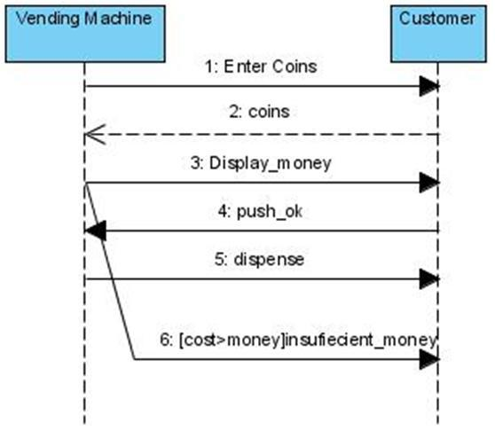

Iteration 2

|  |  |  |  |  |
| --- | --- | --- | --- | --- |
| **Checklist items** | **Worked** | **Failed** | **Example** | **can be improved?** |
| Message Arrows | yes |  | See above | Works fine, very useful |
| Activation Bars | yes |  | See above | Works fine, very useful |
| Lifeline Notation | yes |  | See above | Works fine, very useful |
| Comment |  | yes | not necessary | Could be implemented for more information |
| **Alternatives** | yes |  | See above | Works fine, very useful |
| **Loops** |  | yes | not necessary or not applicable | not applicable |
| Duration and Time Constraints |  | yes | not necessary or not applicable | not applicable |
| Gate |  | yes | not necessary or not applicable | not applicable |
| **Reference Fragment** |  | yes | not necessary or not applicable | not applicable |

# Personal reflection

Helped me do model a flowchart, operations, and logic. By logic I mean Sequence of actions and operations. Sequence diagram also helped me to see how objects and components interact with each other to complete a process. I found that sequence diagram the most useful type of diagram for myself. Because it clearly shows the flow of an operation of a Vending Machine, how customer interact with it and see all outcomes.

What could have been improved: particularly in my diagrams – colours could be added for better visualization.

In general: Sequence diagrams can become complex when too many lifelines are involved in the system. It might get very hard for person who have not compose this diagram to follow what is going on.

# References

*Interaction, Collaboration and Sequence Diagrams with Examples*. (2021, 08 06). Retrieved from guru99: https://www.guru99.com/interaction-collaboration-sequence-diagrams-examples.html

*UML Sequence Diagram Tutorial*. (2021, 08 06). Retrieved from lucidchart: https://www.lucidchart.com/pages/uml-sequence-diagram

*What is Sequence Diagram?* (2021, 08 06). Retrieved from visual-paradigm: https://www.visual-paradigm.com/guide/uml-unified-modeling-language/what-is-sequence-diagram/