ADNI
Prediction of Alzheimer’s Diagnosis from Perfusion MRI Using Machine Learning
Stephanie Araki
Health Informatics and Data Science, Georgetown University, Washington, DC, USA

1. Introduction
Alzheimer’s Disease (AD) is a progressive neurodegenerative disorder that leads to cognitive decline, loss of independence, and considerable healthcare burden. Despite extensive research, early and accurate diagnosis of AD remains difficult due to overlapping symptoms between cognitively normal aging, mild cognitive impairment (MCI), and AD. The current diagnostic gold standards include positron emission tomography (PET) imaging for amyloid and tau deposition and cerebrospinal fluid (CSF) biomarker analysis. However, these approaches are invasive, costly, and not widely accessible, limiting their use in early screening and diagnosis efforts.

There is an urgent need for non-invasive, cost-effective alternatives. Arterial Spin Labeling (ASL) MRI is an emerging, non-contrast imaging technique that quantitatively measures cerebral blood flow (CBF). ASL labels inflowing arterial blood water as an endogenous tracer, allowing perfusion imaging without the use of gadolinium contrast agents. Given that hypoperfusion is observed in early AD, ASL-based measurements may serve as a promising biomarker. Previous studies, including Alsop et al. (2010), have demonstrated that regional alterations in CBF precede overt structural atrophy, making ASL a potential candidate for early disease characterization.

This project investigates whether machine learning (ML) models can effectively classify cognitive status—cognitively normal (CN), mild cognitive impairment (MCI), or AD—using CBF-derived features from ASL MRI in combination with demographic, genetic, and cognitive data. The goal is to support early-stage diagnosis using a widely available, non-invasive imaging sequence and interpretable ML models.

2. Methods

2.1. Data Source and Population
Data were obtained from the Alzheimer’s Disease Neuroimaging Initiative (ADNI), specifically the ADNIGO (2009–2011) and ADNI2 (2011–2016) cohorts. Inclusion criteria for this study included:
- Complete ASL MRI scan acquired on a 3 Tesla Siemens Prisma scanner.
- Availability of demographic information (age, sex, race, ethnicity, education).
- Completed baseline clinical evaluations including diagnosis and cognitive testing.
Subjects were excluded if they lacked critical diagnostic, imaging, or clinical data required for machine learning integration.
The cerebral blood flow (CBF) features were extracted from FreeSurfer-segmented ASL MRI scans processed through the Center for Imaging of Neurodegenerative Diseases (CIND) Arterial Spin Labeling pipeline at the University of California, San Francisco (UCSF).
The final dataset comprised 666 individuals, split into:
- Training set: 215 unique subjects
- Testing set: 54 unique subjects

2.2. Feature Extraction and Processing
Datasets were merged on unique subject identifiers (RID) and visit code (VISCODE). The following features were extracted:

Feature Category | Features
Demographic | - Age: Patient age at baseline  - Gender: Patient gender  - Race: Patient race  - Ethnicity: Patient ethnicity  - Years of Education: Patient years of education
Clinical | - APOE4: Status of APOE4 allele (0, 1, or 2 copies)  - Baseline diagnosis: Patient baseline diagnosis  - Visit diagnoses: Patient diagnosis at visit
Cognitive | - MMSE: Mini Mental State Exam  - CDR-SB: Clinical Dementia Rating  - MOCA: Montreal Cognitive Assessment  - ADAS11/13: Alzheimer’s Disease Assessment Scale  - LDEL: Logical Memory Delayed  - ECogPt: Patient-reported Everyday Cognition  - ECogSP: Study partner-reported Everyday Cognition
Neuroimaging  (ASL MRI) | - ST##CT: Count of CBF voxels in FreeSurfer ROI  - ST##MIN: ml / 100g tissue / min Min CBF value for FreeSurfer ROI  - ST##MAX: ml / 100g tissue / min Max CBF value for FreeSurfer ROI  - ST##MD: ml / 100g tissue / min Median CBF value for FreeSurfer ROI  - ST##AVG: ml / 100g tissue / min Mean CBF value for FreeSurfer ROI  - ST##SD: ml / 100g tissue / min Standard Deviation CBF value for FreeSurfer ROI  ## corresponds to a FreeSurfer ROI

Preprocessing steps included:
- Handling Missing Data: Imputation using median (for continuous variables) or mode (for categorical variables).
- Scaling: Standardization of continuous features to zero mean and unit variance.
- Encoding: One-hot encoding of categorical variables.
- Labeling: Diagnostic classes were encoded as CN=0, MCI=1, and AD=2.

2.3. Model Training and Tuning
Six classification models were initially trained using stratified group 5-fold cross-validation:
- Logistic Regression
- Support Vector Machine (SVM, RBF kernel)
- K-Nearest Neighbors (KNN)
- Random Forest
- Gradient Boosting
- XGBoost
Models were trained using an 80:20 stratified train-test split to preserve class balance. To address mild class imbalance (MCI > CN > AD), the Synthetic Minority Oversampling Technique (SMOTE) was applied. After initial evaluation, the three highest-performing models – Random Forest, Gradient Boosting, and XGBoost – underwent hyperparameter optimization using a randomized search approach. Final model evaluation was conducted on the independent test set.

2.5. Model Evaluation and Interpretation
Evaluation focused on both overall and class-specific performance. Accuracy, Precision, macro- and weighted F1 scores, and multiclass ROC-AUC were calculated. Confusion matrices enabled analysis of misclassification trends. To enhance interpretability, Feature Importance was calculated for tree-based models (Random Forest, Gradient Boosting) and SHAP Analysis (SHapley Additive exPlanations) was conducted to evaluate individual feature contributions toward predictions and detect feature interactions, providing transparency into the classification rationale.

3. Results
The top three models achieved the following performance on the test set:

Model | Accuracy | Precision | Recall | F1-Score | AD Recall
Random Forest | 0.867 | 0.863 | 0.861 | 0.862 | 0.84
Gradient Boosting | 0.858 | 0.851 | 0.853 | 0.852 | 0.78
XGBoost | 0.867 | 0.859 | 0.854 | 0.856 | 0.81

The final cohort comprised 210 CN, 257 MCI, and 120 AD participants. Random Forest outperformed other models primarily because of its superior recall for the AD class, an important consideration for minimizing false negatives in clinical applications.
Confusion matrix analysis revealed that MCI-AD misclassifications were most frequent in the Random Forest model, consistent with the clinical overlap in early cognitive symptoms.
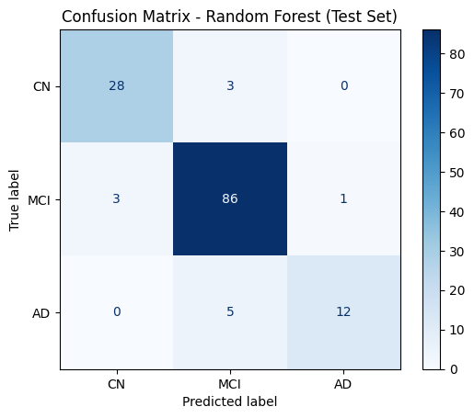
Feature importance analyses for Random Forest identified the following:
- Top Cognitive Features: CDR-SB, MMSE, FAQ, ADAS11/13.
- Top Neuroimaging Features: CBF statistics from FreeSurfer ROIs related to memory and temporal lobe functions (e.g., hippocampus, entorhinal cortex, inferior temporal gyrus).
SHAP analysis demonstrated that CBF features provided additive diagnostic information, especially in differentiating MCI from AD, beyond what cognitive test scores alone could achieve. Importantly, the SHAP plots confirmed model reliance on clinically plausible features, bolstering model credibility for translational use.
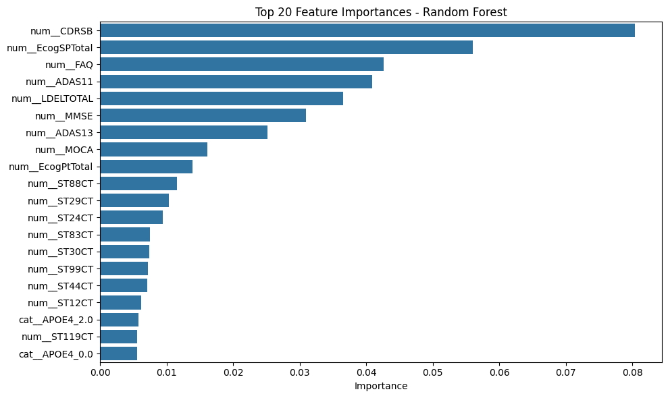
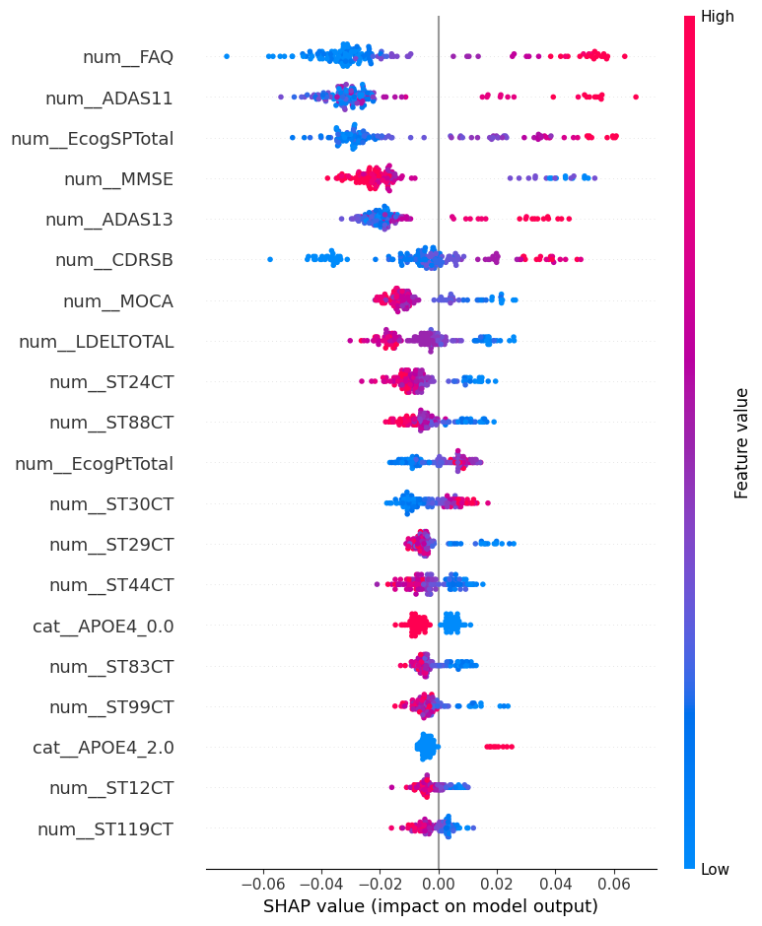

4. Discussion
This project successfully developed and validated machine learning models capable of classifying mental state (CN, MCI, AD) based on non-invasive ASL MRI-derived CBF features supplemented by clinical and cognitive data. The Random Forest model demonstrated the best overall performance, particularly excelling in identifying AD cases, which has high clinical relevance for early diagnosis and patient triage.
However, distinguishing MCI from AD remains a significant challenge. Several factors contribute to this difficulty:
- Variability in Clinical Diagnosis: Diagnosis of MCI and AD relies heavily on cognitive assessments, which can be subjective and influenced by demographic factors, comorbidities, or test administration differences.
- Symptom Overlap: MCI is not a single entity but a spectrum, ranging from early MCI (EMCI) to late MCI (LMCI). Some individuals classified as MCI may exhibit prodromal AD pathology, while others may remain stable or even revert to normal cognition.
- Condensed Labels: For this project, diagnostic classes were consolidated into three groups (CN, MCI, AD) even though ADNI originally distinguishes between seven groups. This simplification was necessary for sample size and model training considerations but may have masked subtler transitions within the MCI population.

These factors underscore the inherent challenges in achieving high classification accuracy between MCI and AD and highlight areas for future model refinement.

Limitations of this study include:
- Class imbalance, despite SMOTE augmentation.
- Potential variability in ASL data across acquisition sites and protocols.
- Lack of voxel-wise spatial analysis; perfusion maps might offer even finer diagnostic information.
Future directions include:
- Employing convolutional neural networks (CNNs) using full CBF maps for voxel-level spatial analysis.
Incorporating longitudinal trajectories (e.g., MCI conversion to AD).
- External validation on independent datasets to assess model robustness and generalizability.

5. Conclusions
Using a multimodal dataset combining ASL MRI-derived cerebral blood flow metrics with cognitive and demographic data, this study demonstrated that machine learning models—especially Random Forests—can accurately classify Alzheimer’s disease states with high interpretability. These results highlight the promise of ASL MRI as a non-invasive biomarker for early AD detection and suggest a path forward for clinical implementation of machine learning-aided diagnostic decision support tools.
The methodological framework developed here lays the foundation for more comprehensive, non-invasive, and accessible diagnostic pathways in Alzheimer’s disease research and clinical care.

References
[1] Alsop, D. C., Dai, W., Grossman, M., & Detre, J. A. (2010). Arterial spin labeling blood flow MRI: Its Role in the early characterization of Alzheimer’s disease. Journal of Alzheimer’s Disease, 20(3), 871–880. https://doi.org/10.3233/JAD-2010-091699,
[2] Böhle M, et al. Layer-wise relevance propagation for deep neural networks in MRI-based AD classification. Front Aging Neurosci. 2019.
[3] Maserejian N, et al. Algorithms for amyloid probability in MCI. Neurobiol Aging. 2019.
[4] Johnson K, et al. Brain imaging in Alzheimer’s disease. Cold Spring Harb Perspect Med. 2012.
[5] ADNI Study Design. https://adni.loni.usc.edu/data-samples/adni-data/
[6] Knesaurek K, et al. SUVR calculations in amyloid PET imaging. World J Nucl Med. 2018.
[7] Gidicsin C, et al. Cerebral hypoperfusion is associated with tau pathology in early Alzheimer’s disease. Brain. 2020.
[8] Iturria-Medina Y, et al. Early role of vascular dysregulation in late-onset Alzheimer’s disease. Nature. 2016.

