Report
Araki, Atluri, Peot, Shorish
HIDS 7009
5 May 2026
Task 5
Brain Cancer Radiomics Analysis
Introduction

The brain is among the most complex and vital organs in the body, yet it remains vulnerable to a range of serious illnesses, including cancer. Accurate classification of brain tumor types is critical for guiding treatment decisions and improving patient outcomes. In this project, we aim to build machine learning models capable of classifying brain cancer types using quantitative features extracted from Magnetic Resonance Imaging data. Machine learning approaches are appropriate to apply to this task because of their diagnostic speed, accuracy, and improved efficiency. Through the course of the project, we as a team wanted to figure out if radiomics features extracted from MRI scans may accurately predict brain cancer type.

The data that was used came from The Cancer Genome Atlas and the REMBRANDT Cancer Imaging Archive. We used MRI scan data from TCGA to train our machine learning model and tested our model on the REMBRANDT MRI data. The approach was to train on one dataset and test on another, which is reminiscent of the real world: applying the model on new patient data is key for understanding how a model will perform outside of the data it has learned from. In the following portions of this report, we will touch on the methods, results and biological interpretation of results from our machine learning model.

Methods

Study Design and Data Sources
This study developed and evaluated radiomics-based machine learning models for brain tumor classification using magnetic resonance imaging (MRI). Radiomics features were extracted from a cohort of 64 brain cancer patients from the REMBRANDT dataset, which served as the external test set. Model development and training were performed using a separate TCGA glioma dataset with precomputed radiomics features. The TCGA dataset consisted of 102 glioblastoma (GBM), 26 oligodendroglioma, and 21 astrocytoma cases, demonstrating substantial class imbalance (Figure 1). The TCGA dataset initially contained a fourth tumor subtype (Oligoastrocytoma), which was excluded due to insufficient sample size, leaving 149 patients across three classes. The objective was to train models on TCGA data and evaluate their generalizability on an independent REMBRANDT cohort. Ground truth tumor subtype labels for REMBRANDT were obtained from a separate clinical dataset, with 58 patients included in the final evaluation after preprocessing.

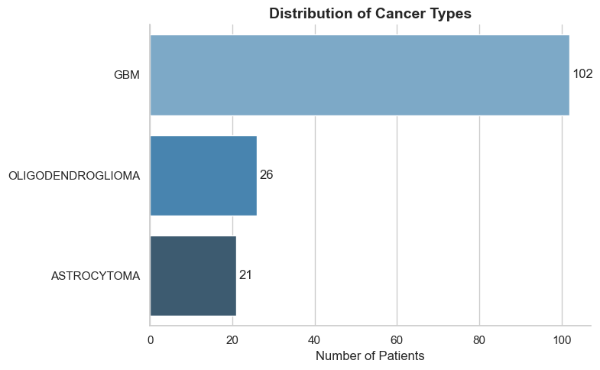
Figure 1. Distribution of tumor subtypes in the TCGA training dataset. The dataset is highly imbalanced, with glioblastoma (GBM) representing the majority class (n = 102), compared to oligodendroglioma (n = 26) and astrocytoma (n = 21). This class imbalance motivated the use of weighted evaluation metrics and informed model performance interpretation.

Image Data and Tumor Segmentation
MRI data consisted of T1-weighted images and corresponding tumor segmentation masks. The segmentation masks were generated using the GlisterBoost algorithm, which utilizes all four MRI modalities to produce accurate tumor region-of-interest (ROI) delineations. Although segmentation was derived from multimodal inputs, radiomics feature extraction was performed using only the T1-weighted images in combination with the segmentation masks, as recommended for consistency and feature interpretability across datasets.

Radiomics Feature Extraction
Radiomics features for the REMBRANDT dataset were extracted using the PyRadiomics library. For each of the 64 patients, T1-weighted MRI images and corresponding segmentation masks in NIfTI format were used as inputs. The feature extraction process computed a comprehensive set of quantitative imaging features, including first-order intensity statistics, shape-based descriptors, and higher-order texture features derived from matrices such as the gray-level co-occurrence matrix and gray-level run length matrix. Feature extraction was performed iteratively across all patients, and the resulting features were aggregated into a multi-sample feature matrix in which each row represented a patient and each column corresponded to a radiomic feature. Patient identifiers were retained separately to enable linkage with clinical labels and downstream evaluation.
Radiomics features for the TCGA dataset were provided as a precomputed feature matrix generated using the same T1-weighted modality, ensuring methodological consistency between training and test datasets.
Pre-Processing and Feature Selection
To ensure compatibility between the TCGA training dataset and the REMBRANDT test dataset, consistent preprocessing steps were applied. Non-feature columns, including patient identifiers and diagnostic metadata fields, were removed from the feature matrices prior to model input. Two metadata fields, VoxelNum and VolumeNum, were intentionally retained due to biological relevance. Only numeric radiomic features were retained, and feature names were standardized to remove modality-specific prefixes. The REMBRANDT feature matrix was then aligned to the TCGA feature space by reindexing columns to ensure identical feature ordering and dimensionality between datasets.The REMBRANDT ground truth dataset required additional preprocessing, including cleaning of column names, standardization of patient identifiers, and removal of samples with missing tumor subtype labels. After preprocessing, 58 patients with valid labels were available for evaluation.
To mitigate the effects of non-Gaussian feature distributions and potential outliers, we applied a QuantileTransformer (in place of the StandardScaler used initially) to map the data into a uniform distribution. To reduce dimensionality while preserving the most discriminative features, we implemented SelectKBest feature selection based on mutual information, narrowing the input space from 112 to 14 features.
Model Development and Optimization
To improve robustness, multiple machine learning algorithms-Random Forest (RF), SVM (RBF), Gradient Boosting Classifier (GBC), K-Nearest Neighbors (KNN), Logistic Regression (LR) and Decision Tree (DT) were benchmarked using stratified cross-validation (k=5) on the TCGA dataset. Model performance during cross-validation was assessed primarily using accuracy, with additional consideration of precision, recall, and F1-score. The training model’s initial cross validation results are below:

Type of Model | CV Accuracy on Training Data
Random Forest (RF) | 0.77 (+/- 0.0350)
SVM (RBF) | 0.68 (+/- 0.0151)
Gradient Boosting Classifier (GBC) | 0.74 (+/- 0.0868)
Logistic Regression | 0.69 (+/- 0.0767)
K-Nearest Neighbors (KNN) | 0.64 (+/- 0.0467)
Decision Tree (DT) | 0.71 (+/- 0.0428)
Among the evaluated models, Random Forest demonstrated the best baseline performance, achieving a mean accuracy ≈ 0.77.

Recognizing class imbalance in the training data, we applied SMOTE (Synthetic Minority Over-sampling Technique) to generate synthetic samples for underrepresented tumor classes (Astrocytoma and Oligodendroglioma), resulting in balanced class distributions of 102 samples each. A GridSearchCV procedure optimized Random Forest hyperparameters, yielding best-fit values of max_depth = 10, min_samples_leaf = 1, min_samples_split = 2, and n_estimators = 200. The resulting cross-validation accuracy on TCGA rose to 0.945. Similarly, the best SVM model trained on TCGA achieved a strong internal accuracy of 0.897.
However, when applied to the external REMBRANDT dataset, models’ performance degraded substantially. Random Forrest accuracy dropped to 0.36 whereas SVM accuracy dropped to 0.38.

Ensemble Modeling and Domain Adaptation
To combine the strengths of individual learners, a VotingClassifier ensemble was constructed integrating RF, GBC, and SVM, later expanded with an Elastic Net Logistic Regression component. To reduce the dataset shift between TCGA and REMBRANDT, a domain adaptation approach was implemented by fine-tuning the ensemble on a hybrid dataset composed of SMOTE-balanced TCGA samples and 20% of REMBRANDT-labeled data. This fine-tuned ensemble achieved an initial accuracy of 0.4255 on the held-out REMBRANDT evaluation set.

To further optimize ensemble performance, Bayesian optimization (via scikit-optimize’s gp_minimize) was used to learn optimal voting weights for each classifier, aiming to maximize accuracy on the REMBRANDT evaluation set. The final optimized weights were RF: 0.0744, GBC: 0.0267, SVC: 0.4993, and LR: 0.3996, giving higher importance to nonlinear and regularized models that better captured the subtle class boundaries in the external cohort.

Results
Baseline Model Validation
The initial model trained on TCGA achieved strong internal accuracy (89.7%) but failed to generalize to the REMBRANDT dataset, reaching only 38% accuracy across 58 evaluable patients. Analysis of the confusion matrix revealed heavy bias toward the GBM phenotype, with a recall of 1.00 and precision of 0.44, suggesting the model over-predicted this class at the expense of Astrocytoma and Oligodendroglioma cases. Astrocytoma achieved a precision of 0.40 but a recall of 0.07, while Oligodendroglioma demonstrated both low precision and recall (0.17), confirming a strong dataset shift effect caused by different imaging protocols and feature distribution disparities between cohorts.
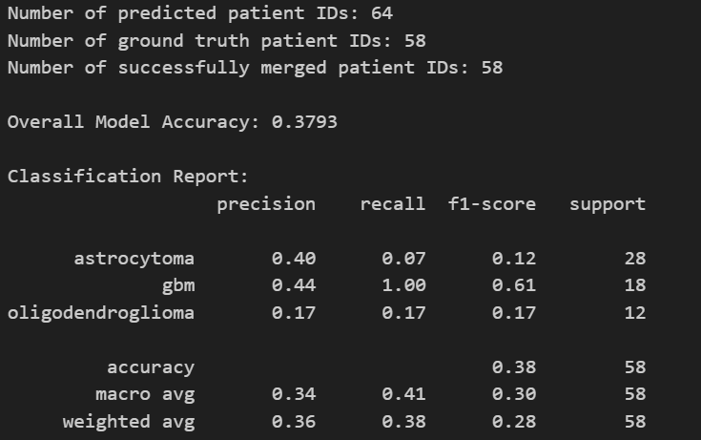
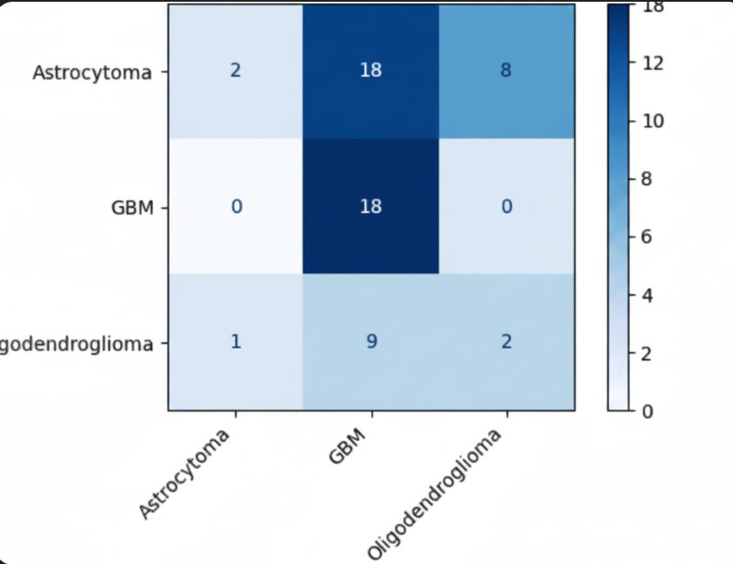

Improved Generalization via Ensemble Learning
Subsequent model refinement substantially improved generalization to the REMBRANDT cohort. After class balancing, feature selection, fine-tuning, and Bayesian optimization, the optimized ensemble achieved an external validation accuracy of 0.5106.
A 5-fold stratified cross-validation on the full REMBRANDT evaluation set produced an average accuracy of 0.5733 ± 0.1284, demonstrating moderate robustness despite persistent inter-cohort variability. Similarly, cross-validation performed on the combined fine-tuning dataset (SMOTE-balanced TCGA + Rembrandt samples) achieved an accuracy of 0.8108 ± 0.0427, indicating the ensemble’s stable performance when partial domain adaptation was applied.
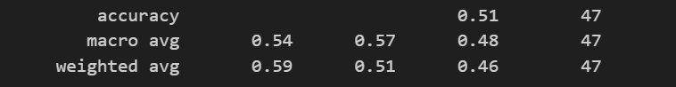
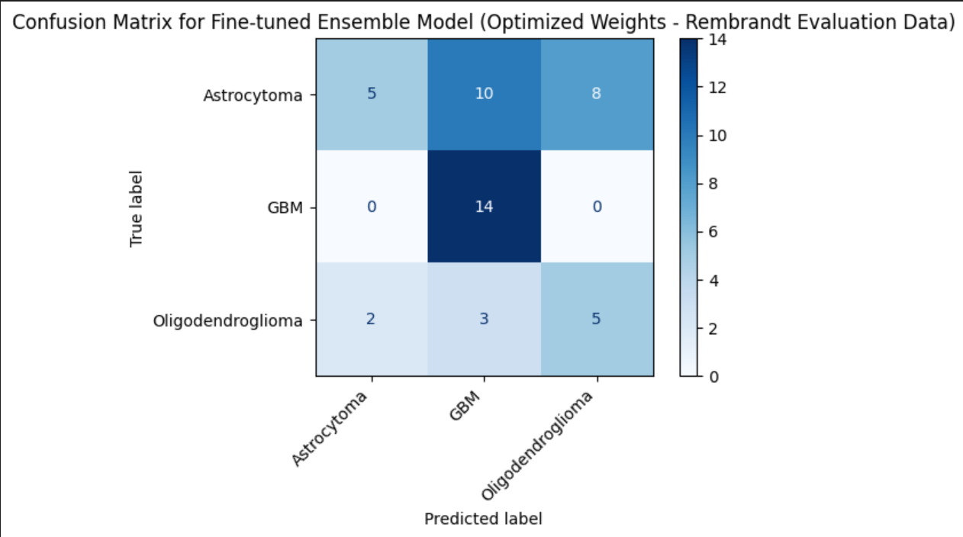

Feature Relevance and Observed Trends
The SelectKBest analysis identified the top 14 discriminative features contributing most strongly to model performance. These spanned the following main radiomic categories:
Morphological Shape Features: MeshVolume, VoxelVolume, Sphericity, SurfaceVolumeRatio Texture Features from the Gray Level Co-occurrence Matrix: ClusterProminence, MaximumProbability
Texture Features from the Gray Level Run Length Matrix: GrayLevelNonUniformity, HighGrayLevelRunEmphasis, LongRunHighGrayLevelEmphasis, RunEntropy, RunLengthNonUniformity, ShortRunLowGrayLevelEmphasis
Mask-level volumetric descriptors: VolumeNum, VoxelNum.
The dominance of shape features such as Sphericity and SurfaceVolumeRatio aligns with known biological differences between tumor types i.e. GBM tumors tend to be larger and morphologically irregular, while oligodendrogliomas are often more compact and well-defined. The strong representation of GLRLM texture features reflects inter-tumoral heterogeneity in gray-level intensity patterns, which is characteristic of the differing cellularity and infiltration behavior across GBM, astrocytoma, and oligodendroglioma subtypes. Together, these features reinforce the biological plausibility of radiomic predictors in distinguishing brain tumor subtypes based on structural and textural MRI characteristics.
Overall, the transition from a single-model SVM or RF to a fine-tuned, Bayesian-optimized ensemble significantly enhanced external generalizability, elevating classification accuracy from 0.38 to 0.57 while reducing overfitting to the GBM phenotype.
Biological Interpretation, Next Steps

The 14 features that SelectKBest isolated all fell into four distinct categories: morphological shape descriptors, mask-level volumetric measures, GLCM texture features, and GLRLM texture features. The four shape descriptors (MeshVolume, VoxelVolume, Sphericity, SurfaceVolumeRatio) and two mask-level volumetric measures (VolumeNum, VoxelNum) describe the tumor's geometric phenotype. GBM tumors tend to grow rapidly and reach larger volumes than astrocytomas or oligodendrogliomas at diagnosis, and they expand by infiltrating surrounding tissue rather than as a single contained mass. The result is an irregular shape with high SurfaceVolumeRatio and low Sphericity, while lower-grade gliomas more often present as compact, well-defined masses. Sphericity has been identified in prior brain tumor radiomic studies as a key discriminator between aggressive gliomas and other intracranial lesions, with low sphericity values consistently associated with high-grade tumor phenotypes (Felfli et al., 2023).

ClusterProminence and MaximumProbability are gray-level co-occurrence matrix (GLCM) features that quantify the spatial relationships between voxel intensity pairs. ClusterProminence captures asymmetry in the gray-level distribution and reflects how heterogeneously bright and dark voxels are clustered together within the tumor, while MaximumProbability captures the most frequent intensity transition and reflects whether the tumor has a dominant texture pattern. GLCM features are foundational to radiomics-based tumor characterization and have been shown to capture intra-tumoral heterogeneity that visual inspection alone cannot detect (Scalco and Rizzo, 2017), with ClusterProminence in particular emerging as a high-importance feature in prior brain tumor classification models (Felfli et al., 2023).

The six GLRM features (GrayLevelNonUniformity, HighGrayLevelRunEmphasis, LongRunHighGrayLevelEmphasis, RunEntropy, RunLengthNonUniformity, ShortRunLowGrayLevelEmphasis) all collectively show how consecutive voxels in the tumor of similar intensity are distributed. Dark patches are flagged by shortRunLowGrayLevelEmphasis, while bright, continuous tissue regions are indicated by HighGrayLevelRunEmphasis and LongRunHighGrayLevelEmphasis. The disorder of these patterns is quantified by the entropy and non-uniformity features, which together reflect within-tumor heterogeneity and infiltration behavior. The internals of GBM notoriously reflect this as well. The cancer type will often have mixed regions of necrosis, dense tumor, infiltrative edges, and more. Lower grade gliomas tend to possess a much more uniform texture (Wang et al., 2024). Prior studies have isolated LongRunHighGrayLevelEmphasis and HighGrayLevelRunEmphasis as features that can be used to predict survivability (Kim et al., 2020). Recent radiomics neural network frameworks have similarly shown that texture-heterogeneity features contain predictive signaling across a variety of brain tumor types, which indicates they possess some biological property that exists beyond any single cancer class (Mehrabian et al., 2025).

The next steps for the project include training and testing our model on different modalities of brain scan imaging, like T2 and FLAIR images. Including these data would assist in creating a model that is more robust, and more equipped to facilitate the prediction of brain cancer type when using other common image types. Additionally, it would be beneficial to retrain and retest our model on a dataset with balanced classes of cancer types. The dataset used in our current model has outnumbered Glioblastoma cases when compared to Astrocytoma and Oligodendroglioma cases. Iterating our model using a more even dataset could help improve performance and prediction accuracies. The observed bias towards Glioblastoma likely reflects both on the class imbalance in training data, and an inherent limitation of the T1 images: research shows that GBM’s characteristic blood brain barrier breakdown produces strong T1 enhancements. Astrocytoma and Oligodendroglioma, as lower-grade tumors, though, have less pronounced T1 signal characteristics. Finally, testing on data from different institutions or countries would test true clinical generalizability, as the cohort data from TCGA and REMBRANDT are US-based.

Conclusion
In this project, we built and evaluated a machine learning model that classified brain tumor subtypes - Glioblastoma, Astrocytoma, and Oligodendroglioma, by using radiomics features that were extracted from T1 MRI scans. We trained our model on TCGA data and tested it on REMBRANDT data, and found that the cross validation accuracy was strong when testing on TCGA data but weaker when testing on the REMBRANDT data. We iterated on the model using several methods- class balancing using SMOTE, used ensembling learning models, and utilized Bayesian optimization, and doing so improved our accuracy from .38 to .57. A consistent limitation we recognized was the model's bias towards Glioblastoma, due to both the class imbalance and the inherent advantages that T1 imagined provides when detecting that tumor type. The top predictive features, including sphericity, skewness and texture-based measures aligned with biological differences in tumor subtypes. These results demonstrate both strong potential and constraints of our radiomics-based classification model and point us in a direction for future work: using multi-modal images and larger balanced datasets in order to make this approach clinically viable.

Citations
Felfli et al., Journal of Imaging Informatics in Medicine, 2023. DOI: 10.1007/s10278-023-00886-x
Kim et al., Scientific Reports, 2020. DOI: 10.1038/s41598-020-61178-w
Louis et al., Neuro-Oncology, 2021. DOI: 10.1093/neuonc/noab106
Mehrabian et al., BMC Medical Imaging (hybrid CNN-radiomics study), 2025. PMC: PMC12866514
Mitchell-Hay, R. N., Ahearn, T. S., Murray, A. D., & Waiter, G. D. (2022). Investigation of the inter- and intrascanner reproducibility and repeatability of radiomics features in T1-weighted brain MRI. Journal of Magnetic Resonance Imaging, 56(6).
Scalco & Rizzo, British Journal of Radiology, 2017. DOI: 10.1259/bjr.20160642
Wang et al., Insights into Imaging, 2024. DOI: 10.1186/s13244-024-01664-1

