COPUS:
Classroom Observation Protocol for Undergraduate STEM

A Capstone Project
Presented to the Faculty of the
College of Information Technology Education
PHINMA University of Iloilo

In Partial Fulfillment
of the Requirements for the degree
Bachelor of Science in Information Technology

By:
Marvin M. Agudines
John Mark L. Failanza
Kishia O. Laubenia

June 2026
Approval Sheet
In partial fulfillment of the requirements for the Bachelor of Science in Information Technology, this Capstone Project entitled “COPUS: Classroom Observation Protocol for Undergraduate STEM” prepared and submitted by Marvin M. Agudines, John Mark L. Failanza and Kishia O. Laubenia, who are hereby recommended for corresponding final evaluation.

Zesty Kein Mondia
Adviser

Approved by the Panel of Evaluators with a grade of PASSED

Dr. Arnold M. Fuentes, Ph. D, MPA, MMIT
Chairman

Ryan C. Valeriano
Member

Accepted in partial fulfillment of the requirements of the degree Bachelor of Science in Information Technology

Seth dA. Nono, MSCS
CITE, DEAN OF DEAN

ACKNOWLEDGEMENT

We would like to extend our sincere gratitude and appreciation for all the hard work and dedication of many individuals have given us.
First, we would like to thank the Almighty God for His enduring grace, guidance and protection that He has bestowed upon us during this capstone project.
To our adviser, Ms. Zesty Kein Mondia, whose valuable guidance has been the ones that helped us patch this project and make it successful, her suggestions and instructions have served as the major contributor towards the completion of the project.
To Mr. Ryan C. Valeriano, for his invaluable guidance, patience, and unwavering support throughout this journey. Your expertise, constructive feedback, and encouragement have been instrumental in shaping our research and pushing us to strive for excellence.
To our past teachers, whose dedication, patience, and wisdom have played a significant role in shaping our knowledge and character. Their unwavering support and commitment to education have inspired us to strive for excellence and continue our pursuit of learning.
To our families who have helped us with their valuable suggestions and ideas has been helpful in various phases of the completion of the project.
To our friends who we have shared our work for the whole session of completing this project. Thank you for the entire laugh and every stressful day that brightens up our day.
ABSTRACT
Instructors and the teaching practices they employ play a critical role in improving student learning in college science, technology, engineering, and mathematics (STEM) courses. In a paper-based classroom observation protocol, this idea of collecting information on teaching practices across departments or institutions is often still done manually. Evaluators or observers would fill out paper forms or observation sheets to record what the instructor is doing and how students are engaging in the classroom. This process is labor-intensive, often requiring multiple rounds of data entry and manual aggregation of results across classes, departments, or institutions. To help facilitate this process, the proponents present COPUS (Classroom Observation Protocol for Undergraduate STEM), a web-based system designed to simplify classroom observation and feedback collection.
COPUS centralizes feedback and communication, reducing the administrative burden on instructors and enhancing data accessibility and accuracy. COPUS enables real-time monitoring of teaching practices while ensuring secure storage of sensitive student data. Built with PHP, COPUS provides a user-friendly platform that allows teachers to efficiently manage feedback and track their progress. This system offers an organized, transparent alternative to traditional paper-based observation protocols and email-based communication, ultimately improving teacher-student interactions and promoting effective teaching practices.

TABLE OF CONTENTS

Title page ----------------------------------------------------i

Approval Sheet------------------------------------------------ii

Acknowledgement--------------------------------------------- iii

Abstract------------------------------------------------------iv

Table of Contents----------------------------------------------v

List of Figures----------------------------------------------vii

List of Tables----------------------------------------------viii

CHAPTER I
Introduction--------------------------------------------------1
Technical Background of the Study-----------------------2
Statement of the Problem--------------------------------3
Objectives of the Study---------------------------------4
Significance of the Study-------------------------------4
Scope and Limitation------------------------------------5
Definition of Terms ------------------------------------6

CHAPTER II
Literature Review---------------------------------------------7
Overview-------------------------------------------------7
Traditional VS Modern System-----------------------------8
Technology Use-------------------------------------------9
Case Studies---------------------------------------------10

CHAPTER III
Methodology---------------------------------------------------13
Research and Development Stage----------------------------14
Research Design-------------------------------------------15
Data Collection Techniques--------------------------------18
Justification for Selecting the Agile Methodology---------19
System Architecture and Design--------------------------- 20
System Components and Modules---------------------------- 22
Use Case Diagram----------------------------------------- 25
Data Flow Diagram---------------------------------------- 26
Entity Relationship Diagram------------------------------ 27
Security Considerations---------------------------------- 29
Technology Stack----------------------------------------- 29
Data Gathering Techniques-------------------------------- 30
System Repository---------------------------------------- 33
CHAPTER IV
Result and Interpretations-------------------------------------34
Summary of the Data Sources and Analysis Methods Used--------- 34
Task Manager-------------------------------------------------- 36
Presentation of Results--------------------------------------- 37

CHAPTER V
Summary, Conclusion, and Recommendation----------------------- 38
Summary--------------------------------------------------- 38
Conclusion------------------------------------------------ 38
Recommendation-------------------------------------------- 39
Final Thoughts--------------------------------------------40

CHAPTER VI
References----------------------------------------------------41
Appendices----------------------------------------------------42

LIST OF FIGURES

Figure Page

Figure 1. Agile Methodology 15
Figure 2. Three-tier Architecture 20
Figure 3. Landing Page 22
Figure 4. Account Type Selection Interface 22
Figure 5. Login Interface of the System 23
Figure 6. Admin Dashboard 23
Figure 7. Observation Recording Module 24
Figure 8. Report Generation Module 24
Figure 9. Use Case Diagram 25
Figure 10. DFD Level 0 26
Figure 11. DFD Level 1 26
Figure 12. Entity Relationship Diagram 27
LIST OF TABLES

Table Page

Table 1. Justification for Selecting 19
the Agile Methodology

Table 2. Project Timetable 37
CHAPTER 1
Introduction to the Study
In today’s educational landscape, technology plays a transformative role in improving teaching and learning outcomes. However, despite widespread technological advancements, many institutions still rely on manual classroom observation protocols to assess teaching practices. These traditional systems require evaluators to manually record an instructor’s activities and student engagement, which is both time-consuming and prone to human error. This process often involves multiple rounds of data entry, leading to inefficiencies that hinder accurate, reliable feedback and make it difficult to track teaching performance consistently across departments or institutions.
To address these challenges, the proponents introduce the COPUS (Classroom Observation Protocol for Undergraduate STEM) System, a system designed to simplify the classroom observation process and improve feedback collection. COPUS provides a centralized, efficient platform that enables real-time monitoring of teaching practices, allowing instructors to track their progress and engage with feedback more effectively. Unlike traditional manual methods, COPUS eliminates the administrative burden of paper forms and enhances data accuracy, providing both faculty and administrators with a clear, actionable overview of teaching performance.
With its user-friendly interface and secure data storage, COPUS offers a scalable and transparent solution for improving classroom observation, making it easier for educators to adapt and refine their teaching strategies based on actionable insights.
Technical Background of the Study
In recent years, educational institutions have increasingly embraced technology to enhance teaching and learning. Traditionally, classroom observations are conducted using paper forms or observation sheets where evaluators manually record an instructor's activities and student engagement. These observations are typically based on fixed periods of class time and the feedback gathered is often collected later for analysis. The reliance on manual data entry introduces several inefficiencies, such as the possibility of human error, delayed feedback, and inconsistent data collection across multiple sessions. To address these issues, the Classroom Observation Protocol for Undergraduate STEM (COPUS) System was developed to simplify the observation and feedback process.
The system is primarily web-based and follows a three-tier architecture composed of the presentation layer, application layer, and data layer. The presentation layer handles user interaction through an intuitive graphical user interface (GUI), while the application layer processes business logic and user requests. The data layer, on the other hand, manages the storage and retrieval of observation data using a relational database.
The COPUS System was developed using PHP as the main programming language for backend processing, while Bootstrap were utilized for frontend development to ensure responsiveness and accessibility across different devices. The system was tested and executed in a XAMPP environment, which integrates Apache server, MySQL database, and PHP interpreter.
The system employs role-based access control (RBAC) to ensure secure user authentication and authorization, allowing only registered users to access designated modules.
The implementation of CRUD (Create, Read, Update, Delete) operations ensures that users can efficiently manage records without compromising data security.
Statement of the Problem
In many educational institutions, especially in STEM (Science, Technology, Engineering, and Mathematics) courses, the assessment of teaching practices through classroom observation is an essential method for improving teaching quality and student learning outcomes. However, the current reliance on manual, paper-based classroom observation protocols create significant challenges. Evaluators are tasked with filling out paper forms or observation sheets to record an instructor's activities and student engagement. This process is not only time-consuming but also prone to human error, as data must be manually. Consequently, this approach limits the ability to capture accurately and delays the provision of actionable insights for instructors.
Traditional methods are particularly problematic in STEM education, where teaching practices are often diverse, dynamic, and interactive. STEM disciplines demand that instructors employ a variety of teaching strategies—ranging from lectures to hands-on experiments and collaborative problem-solving activities—that are difficult to assess accurately through static, paper-based systems. Without a streamlined, efficient system to monitor and record these teaching practices, instructors struggle to receive timely feedback, hindering their ability to improve and adapt their teaching methods.
Objectives of the Study
The primary aim of this study was to design and develop the Classroom Observation Protocol for Undergraduate STEM (COPUS) system in improving classroom observation and feedback collection processes. Specifically, this study intended to:
- Streamline the classroom observation process by providing a digital alternative to traditional paper-based methods.
- Ensure the system is user-friendly and accessible for teachers, administrators, and evaluators.
- Support better communication between teachers and students through consistent, actionable feedback.
Significance of the Study
This study is significant as it examines the role of the Classroom Observation Protocol for Undergraduate STEM (COPUS) in enhancing teaching quality, feedback mechanisms, and classroom observation processes. By identifying the benefits and potential areas for improvement, this research contributes to the ongoing advancement of digital tools in education.
1. Teachers. COPUS supports educators by providing timely, structured feedback on teaching practices, helping them identify strengths and areas for improvement.
2. Students. With improved teaching practices informed by COPUS feedback, students benefit from more engaging and effective learning environments.

3. School Administrators. COPUS enhances administrative oversight by offering reliable, consistent data on classroom dynamics and instructional quality. This aids in professional development planning, curriculum review, and institutional decision-making based on concrete observational data.
4. Proponents. The development and implementation of COPUS offer valuable insights into the functional needs of educators and administrators. These insights guide future refinements, ensuring the system remains relevant, user-friendly, and aligned with evolving educational goals.

Scope and Limitation of the Study
This study was designed to assist teachers, students, and administrators solely within a single educational institution. The scope includes classroom observations in STEM courses, data collection and analysis using the COPUS system, and feedback interpretation by educators and administrators. The system is intended to assist teachers in improving instructional practices, help students indirectly through enhanced learning environments, and support administrators in decision-making related to teaching quality. Limitations may include:
• Internet Dependency - the system requires an active internet connection, which may pose accessibility issues for users with unstable or limited connectivity.
• Technological Constraints – the effectiveness of the system depends on the available hardware. Older devices or outdated systems may hinder optimal performance.
Definition of Terms
- Classroom Observation Protocol for Undergraduate STEM (COPUS) - is a tool for systematically documenting student and teacher behaviors as one means of assessing instructor effectiveness in STEM classrooms. Student and teacher behaviors are classified into activities and are logged in two-minute intervals.
- COPUS System - a system designed to simplify the classroom observation process and improve feedback collection.
- PHP - PHP stands for Hypertext Preprocessor. It is an open source, widely used language for web development.
- Bootstrap - is a free and open-source front-end framework that uses pre-written HTML, CSS, and JavaScript to let developers build responsive, mobile-first websites quickly.
- Data Analytics - The process of collecting, analyzing, and interpreting large sets of data to uncover patterns, trends, and insights that help in decision-making, such as forecasting inventory needs.
- Role-based Access Control (RBAC) – a model for authorizing end-user access to systems, applications and data based on a user's predefined role.
- Internet Dependency - describes how much the system’s core functions require an active internet connection to operate.
- Technological Constraints - refer to the limitations in the tools, platforms, or infrastructure used to design and deploy the system.
CHAPTER II
LITERATURE REVIEW
Overview of Classroom Observation Protocol for Undergraduate STEM System
Instructors and the teaching practices they employ play a critical role in improving student learning in college science, technology, engineering, and mathematics (STEM) courses. Consequently, there is increasing interest in collecting information on the range and frequency of teaching practices at department-wide and institution-wide scales. To help facilitate this process, we present a new classroom observation protocol known as the Classroom Observation Protocol for Undergraduate STEM or COPUS. This protocol allows STEM faculty, after a short 1.5-hour training period, to reliably characterize how faculty and students are spending their time in the classroom. Researchers present the protocol, discuss how it differs from existing classroom observation protocols, and describe the process by which it was developed and validated. Researchers also discuss how the observation data can be used to guide individual and institutional change.
To collect information about the nature of STEM teaching practices to support institutional change, faculty at both the University of British Columbia (UBC) and the University of Maine (UMaine) created classroom observation programs. The results of such observations were needed to: 1) characterize the general state of STEM classroom teaching at both institutions, 2) provide feedback to instructors who desired information about how they and their students were spending time in class, 3) identify faculty professional development needs, and 4) check the accuracy of the
faculty reporting on the Teaching Practices Survey that is now in use at UBC (CWSEI Teaching Practices Survey, 2013).
To achieve these goals, the programs needed an observation protocol that could be used by faculty member observers to reliably characterize how students and instructors were spending their time in undergraduate STEM classrooms. A critical requirement of the protocol was that observers who were typical STEM faculty members could achieve those results with only 1 or 2 hours of training, as it is unrealistic to expect they would have more time than that available. In the quest for a suitable observation protocol, multiple existing options were considered and ultimately rejected.
Traditional VS Modern System
According to Lalla et al. (2011), the collection of teaching evaluation questionnaires in the traditional paper‐and‐pencil format is a costly and time‐consuming process and yet it is a common assessment practice in many university systems. Web‐based data collection would reduce costs and significantly increase the efficiency of the overall evaluation process in numerous ways. Results for both types of surveys are reported from two years of progressive introduction of the web‐based survey by the University of Modena and Reggio Emilia, Italy. In the first year, two faculties representing scientific and humanistic fields were selected for a web‐based survey. In the second year, eight out of 12 faculties took part in the web survey. This data collection strategy allowed for responses from non‐attending students and facilitated a comparison of attitudes between attending and non‐attending students.

Technology Use
The Classroom Observation Protocol for Undergraduate STEM (COPUS) is a structured observation tool developed by Smith et al. (2013) to objectively document student and instructor activities in real-time. While initially designed for paper-based data collection, recent efforts in digitalization have enabled more efficient and accurate implementation of COPUS in classroom settings. This literature review explores existing technologies and platforms that support the digital transformation of COPUS and similar observation protocols.
Several institutions have developed Excel-based tools and analyzers to automate the interpretation of COPUS data. The University of British Columbia (UBC), where COPUS was first developed, offers a spreadsheet tool that allows manual entry of observation codes which are then automatically summarized into frequency tables and pie charts (Smith et al., 2013). While this approach enhances analysis, it still relies on post-observation data input, which limits real-time usability.
To address this, researchers and developers have explored web-based platforms and mobile applications to facilitate live observations. These systems commonly utilize frontend technologies for interactive user interfaces, allowing observers to log instructor and student activities with just a few clicks.
In terms of backend infrastructure, most modern observation tools are powered by PHP to manage session data, user accounts, and analytics. Data is typically stored in relational databases like MySQL, enabling real-time data syncing and collaborative observations.
For data visualization and analysis, Apexjs was used to present observation summaries through interactive charts. These tools allow educators to interpret patterns in instructional practice quickly and compare sessions over time.

Case Studies
Effectiveness. According to Agari et al. (2021), classroom observation tools are used to evaluate teaching and learning activities, and to provide constructive feedback to instructors. To help instructors with selecting a suitable tool based on their needs and available resources, in this study, a group of observers assessed lectures of an introductory biology course using three, broadly cited classroom assessment tools in the STEM field: the Classroom Observation Protocol for Undergraduate STEM (COPUS); the Practical Observation Rubric to Assess Active Learning (PORTAAL); and the Decibel Analysis for Research in Teaching (DART). From a user’s perspective, they evaluated 1) the type and extent of information each tool provides, and 2) the time investment and difficulty of working with each tool. The assessment result of each tool was compared, with a list of expected outcomes generated by surveying a group of college instructors and with the result of a self-teaching assessment tool, Teaching Practices Inventory (TPI). Our findings conclude that each tool provided valuable assessment with a broad range of outcomes and time investment: PORTAAL offered the most detailed information on the quality of teaching practices and students’ engagement, but it demanded the greatest time investment. DART provided a basic estimation of active learning proportion with the least effort. The level of assessment outcome and the time investment when using COPUS was

found to be less than PORTAAL, and more than DART. The TPI self-assessment outcome was found to be slightly optimistic regarding the proportion of active learning practices used in the studied course. This comparative study can help instructors in selecting a tool that suits their needs and available resources for a better assessment of their classroom teaching and learning.
Strategy for Improving Student Learning. According to Daher et al. (2018), Classroom Observation Protocol for Undergraduate STEM (COPUS) has demonstrated the potential of this tool for systematically documenting student and teacher behaviors as one means of assessing instructor effectiveness in STEM classrooms. Their study found that within STEM education, the Classroom Observation Protocol for Undergraduate STEM (COPUS) has demonstrated potential to be successful at systematically documenting student and teacher behaviors in the classroom. Few studies to date have focused specifically on the potential effectiveness of the COPUS instrument within engineering classrooms. As has become clear, they believe COPUS, the Teaching Practices Inventory, and other tools for measuring and improving instructional teaching practices can and should be employed to better realize our shared goals of offering a better education to today’s engineering students.
References:
Pusey, T. S., Presas Valencia, A., Signorini, A., & Kranzfelder, P. (2023). Breakout rooms, polling, and chat, oh COPUS! The adaptation of COPUS for online synchronous learning. Research & Practice in Assessment, 18(1), 62–80.
Asgari, M., Miles, A. M., Lisboa, M. S., & Sarvary, M. A. (2021). COPUS, PORTAAL, or DART? Classroom observation tool comparison from the instructor user’s perspective. Frontiers in Education, 6, 740344.
Lalla, M., & Ferrari, D. (2011). Web-based versus paper-based data collection for the evaluation of teaching activity: Empirical evidence from a case study. Journal of Educational Technology, 5(2), 45–59.
Daher, T., Pérez, L. C., Babchuk, W. A., & Arthurs, L. A. (2018). Exploring engineering faculty experiences with COPUS: Strategies for improving student learning. ASEE Press.

CHAPTER III
METHODOLOGY
This chapter outlines the research methodology that was employed in the development of the "Classroom Observation Protocol for Undergraduate STEM System". The primary aim of this study was to design and develop the COPUS system to improve classroom observation and feedback collection processes. This chapter will detail the research approach, data collection methods, system design, tools, and techniques that will be used to achieve this objective.
The research adopts a systematic approach to provide the effective development and implementation of the proposed system. To gather valuable insights on user requirements and expectations, surveys and interviews were conducted with key respondents, including the dean, observers and teachers. These respondents play a crucial role in providing the necessary data for the system’s design and functionality. Their feedback will guide the development process, ensuring the system meets the practical needs of users.
Once the system is developed, it will undergo rigorous testing to assess its performance, usability, and efficiency. This chapter will provide a clear understanding of the research methods and processes that will guide the study, ensuring that the project is executed in a structured and effective manner, leading to meaningful results.
Research and Development Stage
The Research and Development (R&D) stage is a critical phase in the creation of the Classroom Observation Protocol for Undergraduate STEM (COPUS) System. During this stage, the development process is guided by insights and feedback gathered from respondents, including teachers and observers. Their input plays an important role in shaping the system’s design, functionality, and usability to ensure that the final product effectively supports classroom observation and feedback collection.
The R&D stage begins with an analysis of data collected through interviews. The responses help identify the main challenges encountered in conducting classroom observations, such as delayed feedback and inefficient data management. These findings guide the system’s improvement areas, focusing on automation, accuracy, and accessibility.
Based on this research, the development team proceeds with the design and structure of the COPUS System. The system architecture integrates web-based technologies that support real-time recording, data storage, and report generation. The feedback from respondents is used to refine features and user interfaces, ensuring that the system is intuitive, functional, and aligned with the users’ needs in academic settings.
During the development phase, the system is built in stages, with continuous testing and evaluation to ensure it meets performance and usability standards. Feedback from users is gathered throughout the process to make adjustments and improvements.
Research Design
This study follows a Quasi-Experimental Research Design to gather comprehensive data on the implementation of Classroom Observation Protocol for Undergraduate STEM System (COPUS). A quasi-experimental approach is appropriate as it allows for evaluating the effectiveness of COPUS compared to traditional methods. This study measures changes in efficiency, accuracy, and security after the system’s implementation by comparing before-and-after data on academic processes.

Model Used
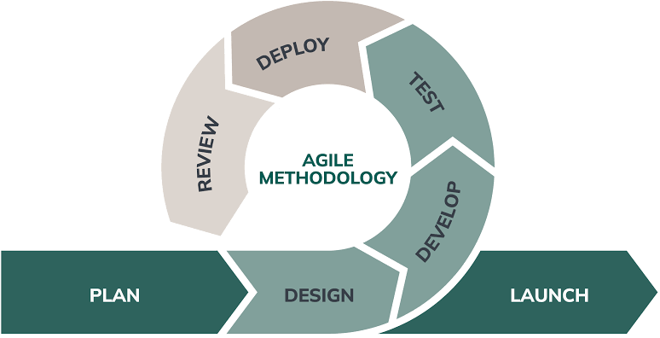
Figure 1. Agile Methodology

The project follows the Agile Methodology, ensuring a structured and systematic approach to the development and deployment of the COPUS. The agile process consists of the following phases:
● Plan – In this phase, the proponents identified the system requirements, set the project goals, and define the project scope. They also conducted an initial interview to one of the representatives of the client to understand their needs.
● Design – In this phase, the proponents designed the system architecture, database structures, and user interface. In this phase, they focused on the system flow, data security measures, and usability to ensure an intuitive and efficient experience.
● Develop – In this phase, the proponents are in the process of making the system meet the client’s requirements.
● Test – In this phase, the proponents did a dry run to the user to identify errors and bottlenecks in the system and what features should be added.
● Deploy – In this phase, the developed COPUS System was deployed online through a web hosting service, making it accessible via the internet to authorized users within the CITE Department. This deployment involved uploading the system to a live server, configuring the domain and database, and ensuring that all system functionalities operated correctly in an online environment. the system was monitored after deployment to identify and resolve any technical issues, ensuring its reliability, performance, and continuous availability for end-users.

● Review – In this phase, the deployed COPUS System was evaluated based on its performance, usability, and overall effectiveness within the CITE Department. Feedback was gathered from the client regarding their experience in using the system, including any difficulties encountered and suggestions for improvement. The proponents analyzed this feedback alongside system performance data to identify issues, bugs, and areas that required enhancement. Necessary revisions and updates were then planned to address these concerns and to further improve the system’s functionality and user experience.

Data Collection Techniques
To gather the necessary insights for developing the "COPUS System", a variety of data collection techniques was employed. These techniques help the system meet the needs of users, particularly the dean, observers and the teachers. The following data collection methods was used:
- Survey
The survey was used as a primary method for collecting quantitative data from the respondents. The survey questions were structured to gather their satisfactory rate and specific feedback on key features, system requirements, and performance expectations. This provided valuable insights into the features that should have been prioritized in the COPUS system.
- Interview
In-depth interviews were with selected respondents to collect qualitative data. These respondents were chosen based on their role in the COPUS system. The interviews allowed for a deeper understanding of the challenges faced by observers and teachers, their workflow, and how the COPUS system could improve efficiency and accuracy. During these interviews, open-ended questions were encouraged with detailed responses, offering insights that may not be captured through surveys alone.

Justification for Selecting the Agile Methodology
The decision to adopt Agile over other SDLC models, such as Waterfall, was based on several critical factors:
Criteria | Agile Methodology | Waterfall Model
Flexibility | High – accommodates changes at any stage | Low – changes are difficult post-design
User Involvement | Continuous feedback and collaboration | Limited to initial and final stages
Development Speed | Faster delivery through iterative sprints | Slower due to sequential phases
Risk Management | Early detection and resolution of issues | Risks may surface late in the process
Project Suitability | Ideal for evolving requirements | Best for well-defined, static projects
Table 1. Justification for Selecting the Agile Methodology

System Architecture and Design
Overview
The COPUS System was designed to improve classroom observation and feedback collection processes. The architecture follows the three-tier architecture, to ensure scalability, reliability, and efficient data management for classroom observation and analysis. This architecture separates the system into three logical layers—Presentation Tier, Application Tier, and Data Tier—each responsible for distinct functions that work together seamlessly.

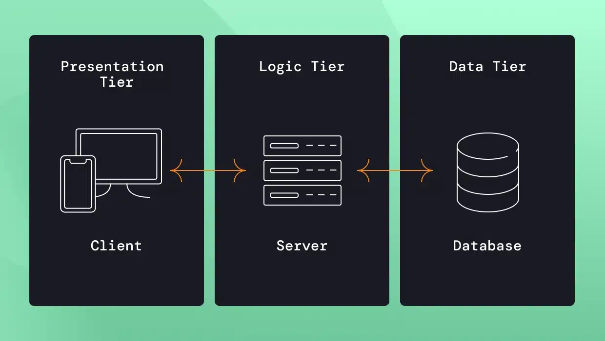
System Architecture

Figure 2. Three-tier Architecture
The system architecture is divided into three main layers:
- Presentation Layer (Presentation Tier) - This layer serves as the user interface where observers and administrators interact with the system. It provides tools for real-time observation entry, data visualization dashboards, and reporting features.
- Application Layer (Logic Tier) - The middle layer handles the core logic of the COPUS system. It processes observation inputs, manages session data, and coordinates interactions between the user interface and the database. This tier also includes authentication, data validation, and generation of analytics for classroom activity patterns.
- Data Layer (Data Tier) - This layer is responsible for securely storing all observation data, user profiles, and activity logs. It uses a MySQL to maintain data integrity and support efficient retrieval for analysis and reporting. Backup and access control mechanisms ensure reliability and data protection.
System Components and Modules
Landing Page
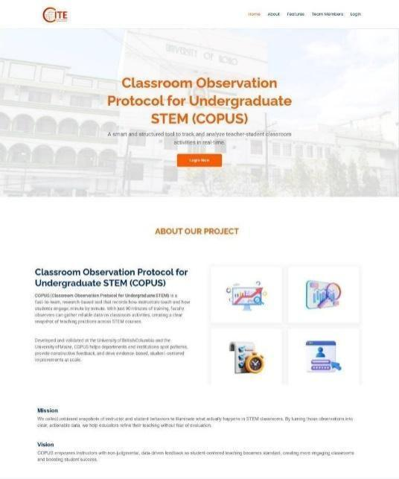
Figure 3 serves as the first point of interaction between the user and the application.
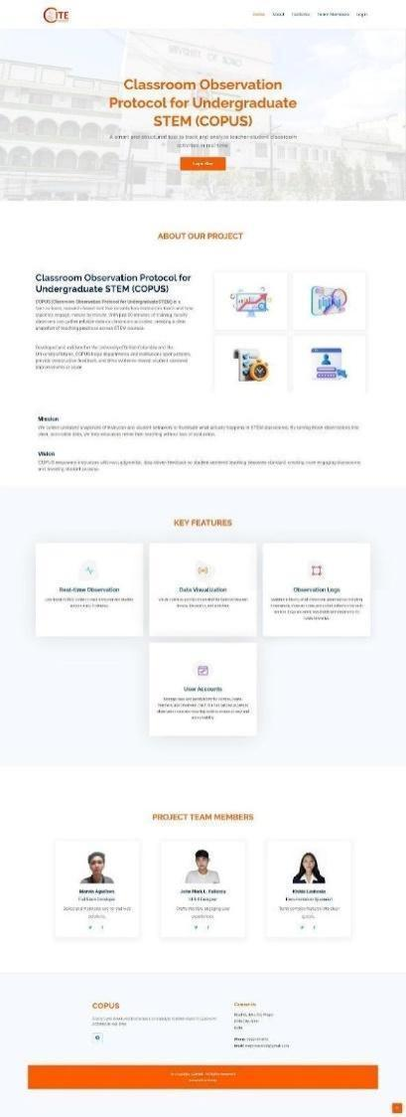

Figure 3. Landing Page

Type Selection Interface
Figure 4 serves as a user role gateway. It ensures that users are directed to the correct dashboard based on their selected role.
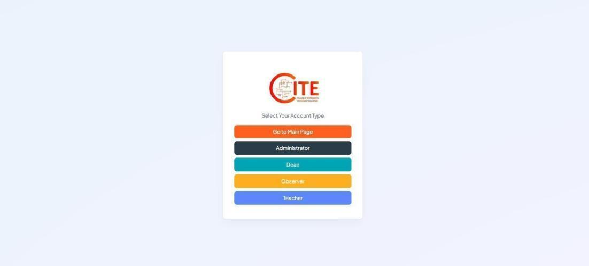

Figure 4. Account Type Selection Interface
Login Module
Figure 5 shows the login interface of the COPUS System. This allows the user to securely access the system using their credentials.
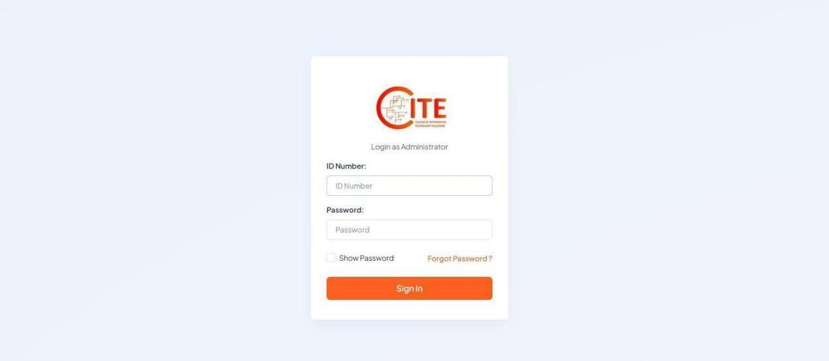

Figure 5. Login Interface of the System

User Dashboard
Figure 6 is the main interface presented after a successful login. Each type of user has a unique dashboard tailored to their responsibilities within the system.
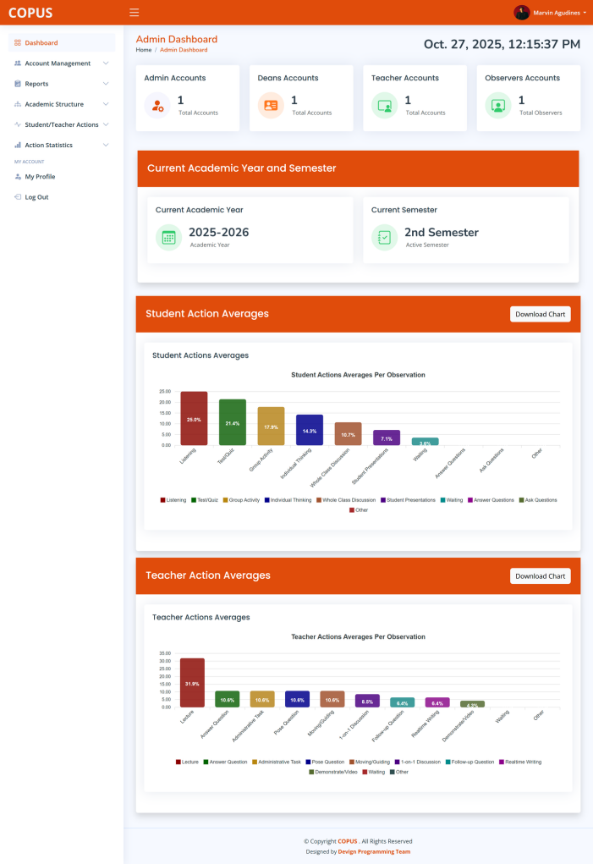

Figure 6. Admin Dashboard
Observation Recording Module
Figure 7 displays the module where the user can record classroom observations in real-time.
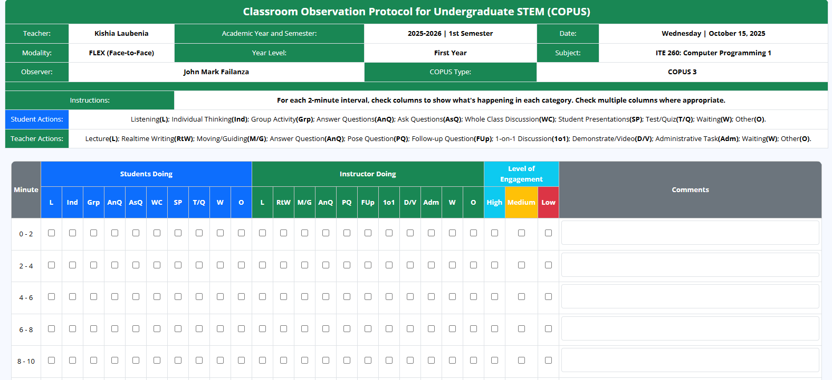

Figure 7. Observation Recording Module

Report Generation Module
Figure 8 presents the report generation feature, which summarizes observation data and generates easy-to-interpret results.
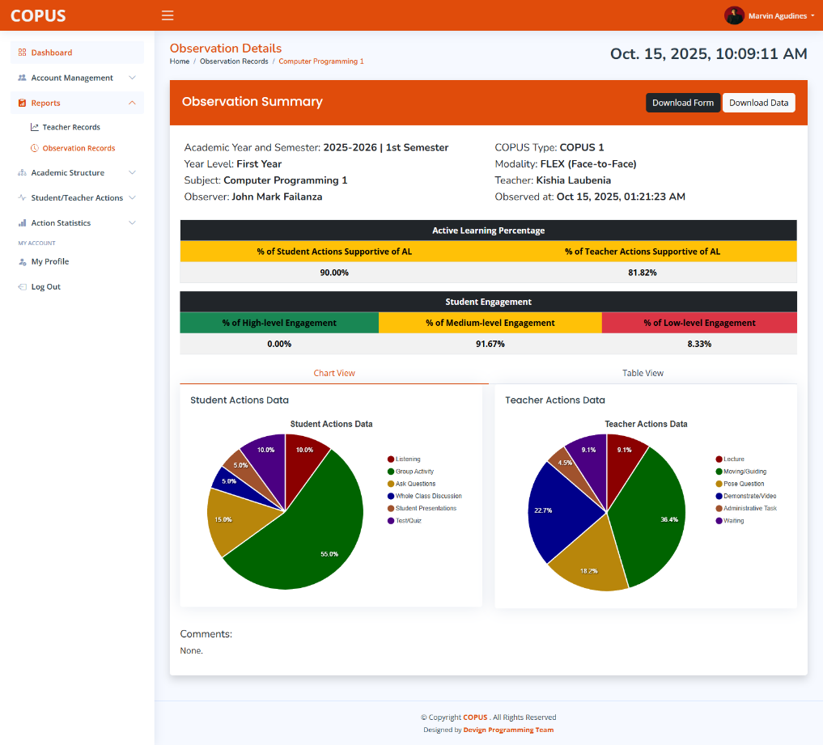

Figure 8.
Report
Generation Module

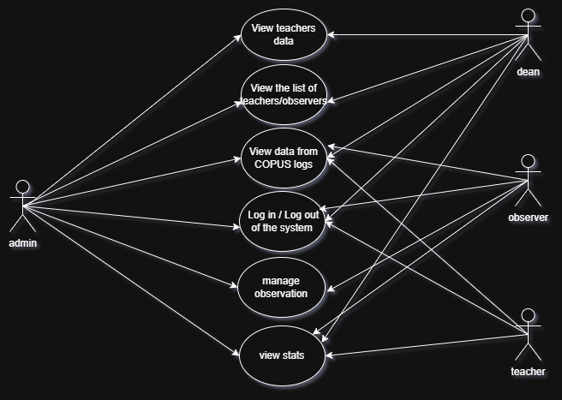
Use Case Diagram

Figure 9. Use Case Diagram

The diagram shows that the admin acts as the system’s main controller, having the widest access. The Dean focuses on viewing and monitoring data, while the Observer performs classroom evaluations. The Teacher interacts with the system primarily to view results and feedback.
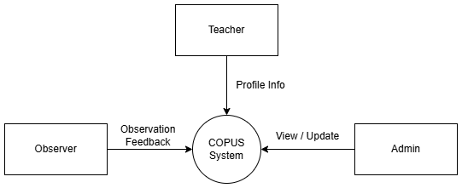
Data Flow Diagram

Figure 10. DFD Level 0

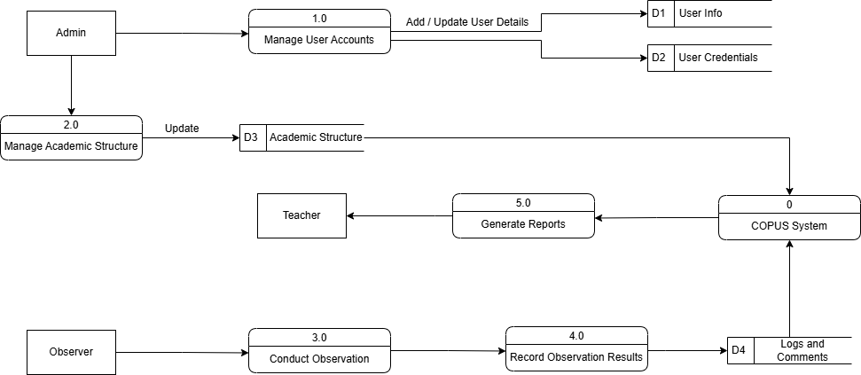

Figure 11. DFD Level 1
The figures above show the way information flows through the system. Figure 10 shows the overview of the entire system. Figure 11 shows what happens inside the system and how data moves between processes.

The Data Flow Diagram (DFD) and Use Case Diagram play crucial roles in understanding and designing the COPUS System. The Use Case Diagram outlines the system’s functional scope by identifying the interactions between users and various system features. In contrast, the DFD provides a more detailed view of how data moves within the system, showing the processes, data stores, and data inputs/outputs. Together, these diagrams offer a comprehensive perspective—while the Use Case Diagram clarifies what the system does, the DFD explains how it processes and manages data to fulfill those functions. Their integration ensures a well-structured and user-centered system design.

Database Design
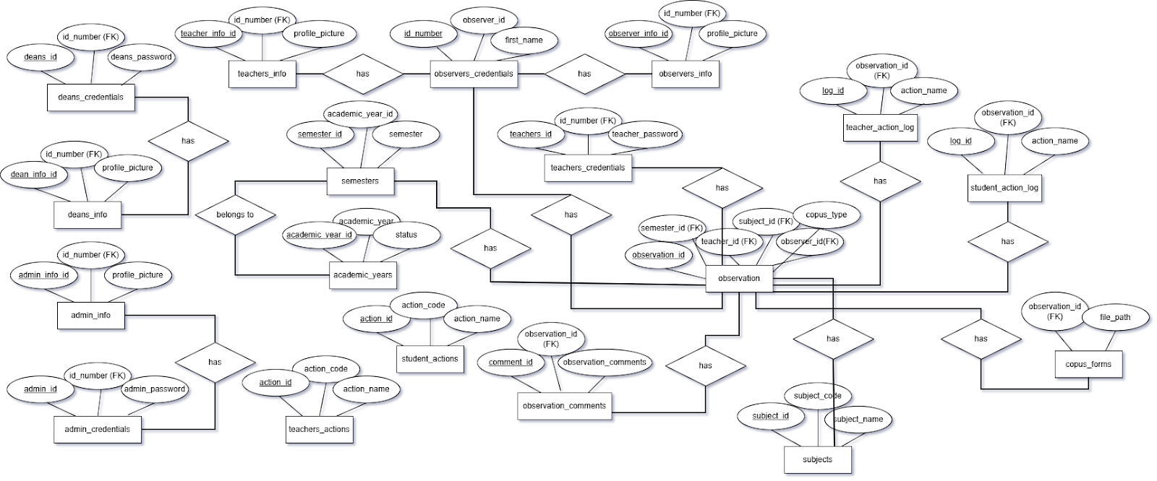
Entity Relationship Diagram

Figure 12. Entity Relationship Diagram

The database design of the Classroom Observation Protocol for Undergraduate STEM (COPUS) system is centered on several key tables that support the system’s core functions. The primary table is the observation table, which serves as the central component of the database. It connects the teacher being observed, the assigned observer, the subject, and the academic semester. This table also links to other entities such as observation_comments, teacher_action_log, student_action_log, and copus_forms, making it the foundation of the observation process.
The teachers_info and observers_info tables store profile information for teachers and observers, respectively, while their corresponding credentials tables (teachers_credentials and observers_credentials) manage authentication details such as ID numbers and passwords. These pairs of tables ensure that both personal and account-related data are stored separately for better data security and organization.
The academic_years and semesters tables define the academic structure where each semester belongs to a specific academic year. Observations are linked to semesters to maintain accurate tracking of when each observation takes place. The subjects table contains details such as subject codes and names, which identify the specific courses being observed.
Finally, the copus_forms table stores the digital forms or files generated after each classroom observation, while the observation_comments table holds qualitative feedback provided by observers. Together, these key tables form the backbone of the COPUS system, allowing it to efficiently manage users, academic data, and observation records in a structured and relational manner.
Security Considerations
The security mechanisms implemented in the COPUS System are the following:
- User Authentication (OTP and Reset Token) - Ensures that only verified users can access their accounts by using one-time passwords (OTP) and secure reset tokens for account recovery.
- Input Validations - Prevents malicious data entry and system vulnerabilities by verifying and sanitizing all user inputs before processing.
- Password Encryption/Hashing - Protects user credentials by encrypting or hashing passwords so that they cannot be easily read or retrieved even if the database is compromised.
- Role-based access control - Restricts system access according to user roles, ensuring that users can only perform actions and access data relevant to their level of authorization.

Technology Stack
These are the list of all the tools, platforms, and technologies used in the development:
● Frontend: Bootstrap, JavaScript
● Backend: PHP
● Database: MySQL
Data Gathering Techniques
Survey Questionnaire for System Assessment
The survey is designed to gather feedback from users regarding their satisfaction from using the "Classroom Observation Protocol for Undergraduate STEM System". The data collected from this survey helped in designing a system that meets the needs of users and addresses existing challenges in COPUS observation. Please rate the following statements based on your experience with the system: (1 – Strongly Disagree, 2 – Disagree, 3 – Neutral, 4 – Agree, 5 – Strongly Agree)
A. Usability
1. The system is easy to navigate and user-friendly.
- 1
- 2
- 3
- 4
- 5
2. The layout and design are clear and intuitive.
- 1
- 2
- 3
- 4
- 5
3. I was able to use the system with minimal or no assistance.
- 1
- 2
- 3
- 4
- 5
B. Functionality
4. The system performs the intended functions accurately.
- 1
- 2
- 3
- 4
- 5
5. Features of the system meet the requirements of classroom observation.
- 1
- 2
- 3
- 4
- 5
6. The system provides reliable and consistent results.
- 1
- 2
- 3
- 4
- 5
C. Efficiency
7. The system processes data quickly and efficiently.
- 1
- 2
- 3
- 4
- 5
8. It reduces the time and effort needed to conduct classroom observations.
- 1
- 2
- 3
- 4
- 5
9. The system is responsive and free from major errors.
- 1
- 2
- 3
- 4
- 5
D. Usefulness
10. The system improves the process of classroom observation compared to the traditional method.
- 1
- 2
- 3
- 4
- 5
11. The generated reports are clear and helpful for analysis.
- 1
- 2
- 3
- 4
- 5
12. The system supports better decision-making based on observation data.
- 1
- 2
- 3
- 4
- 5
E. Overall Satisfaction
13. I am satisfied with the overall performance of the system.
- 1
- 2
- 3
- 4
- 5
14. I would recommend using this system for classroom observation.
- 1
- 2
- 3
- 4
- 5
15. I would continue using this system in future evaluations.
- 1
- 2
- 3
- 4
- 5

System Repository
CHAPTER IV
Results and Interpretation
This chapter presents the outcomes of the development and testing phases of the Classroom Observation Protocol for Undergraduate STEM (COPUS) System. It explains the key results and evaluates whether the system met its main objectives such as improving classroom observation efficiency, feedback accuracy, and data management. The findings are based on system testing, user evaluation, and performance analysis conducted during the implementation phase. This chapter also discusses how the COPUS System addressed the problems identified in earlier chapters and contributed to achieving the overall goals of the study.

Summary of the Data Sources and Analysis Methods Used
The data used for analysis in this study was collected from different sources, including system logs, observation records, and user testing sessions. The main data source was the COPUS System’s database, which stored classroom activity data, user interactions, and recorded feedback entries during the testing period. Additional information was gathered through surveys and interviews with teachers and observers to evaluate the system’s usability and performance.
Both quantitative and qualitative methods were used in analyzing the data. Quantitative results such as the accuracy and speed of observation recording before and after the system’s use—were examined to measure performance improvements. Meanwhile, qualitative feedback from users was organized and interpreted to assess the system’s usability, design, and reliability. These
combined methods provided a complete understanding of how well the COPUS System functioned in real classroom conditions and how effectively it supported observation and feedback processes.

Task Manager
Gantt Chart / Project Timetable – COPUS System
Week | Task | Programmer | UI/UX Designer | Documenter
1 | Project planning & requirement gathering | ✅ | ✅ | ✅
2 | Research & system design planning | ✅ | ✅ | ✅
3 | Use Case & DFD creation | ✅ |  | ✅
4 | Database design & structure creation | ✅ |  | ✅
5 | UI wireframes & prototype mockups |  | ✅
6 | Frontend development begins | ✅ | ✅
7 | Backend development begins | ✅
8 | Integration of frontend and backend | ✅ | ✅

9 | System testing & debugging | ✅ | ✅
10 | User testing & feedback collection | ✅ | ✅ | ✅
11 | Final revisions (code, UI, documentation) | ✅ | ✅ | ✅
12 | Documentation finalization & formatting |  | ✅ | ✅
 | Final project submission | ✅ | ✅ | ✅
Table 2. Project Timetable

Legend:
● ✅ = Active role/task in that week

Presentation of Results
The COPUS System was designed, developed, and tested to automate and simplify classroom observation in STEM education. The testing phase focused on evaluating the system’s performance in recording activities, generating feedback, and managing observation data. Results were collected through actual user testing and analysis of the system’s performance logs. The findings revealed that the system improved the speed and accuracy of classroom observations compared to the manual, paper based method. Users reported that data recording was easier, feedback was more organized, and observation reports were generated faster. These outcomes confirmed that the COPUS System effectively met its goals of enhancing observation processes and supporting efficient feedback delivery.
CHAPTER 5
Summary, Conclusion, and Recommendation
Summary
This study aimed to design and develop the Classroom Observation Protocol for Undergraduate STEM (COPUS) System, a web-based platform that improves the efficiency and accuracy of classroom observation. The system automates the process of recording instructor and student activities, provides real-time data storage, and generates reports for feedback and evaluation.
The project followed a structured development process, starting from data gathering, system design, development, testing, and evaluation. Results showed a significant improvement in observation accuracy, feedback speed, and user satisfaction. The COPUS System successfully met its objectives and proved to be an effective tool for enhancing classroom observation and teaching assessment in STEM education.

Conclusion
Based on the findings, the COPUS System is an efficient and reliable tool for automating classroom observation and feedback collection. It reduces manual work, minimizes recording errors, and helps users document classroom activities faster and more accurately. User feedback confirmed that the system was easy to use and made the observation process more organized and convenient.
The system also shows the value of combining web technologies with educational tools to improve teaching evaluation. Overall, the COPUS System achieved its intended purpose and contributes positively to enhance classroom observation, especially in STEM courses where accurate and timely feedback is essential.
Recommendations
Based on the development and evaluation of the COPUS System, the following recommendations are suggested for future improvement and wider application:
- System Enhancement – Future updates may include interactive analytics, automated summary charts, and customizable observation templates for different class types.
- Mobile Accessibility – Developing a mobile-friendly version or app can help observers conduct real-time recording directly from handheld devices.
- Cloud Integration – Incorporating cloud storage will improve data accessibility, enable multi-user collaboration, and ensure secure backup of observation records.
- User Training – Providing orientation or training sessions will help new users understand the system’s features and promote consistent use across departments.
- Broader Testing – Further evaluation is recommended in other institutions or larger academic programs to assess the system’s scalability, reliability, and long-term effectiveness.
FINAL THOUGHTS
The development and deployment of the COPUS System marked a significant step toward improving the efficiency and organization of processes within the CITE Department. By leveraging a web-based platform, the system provided users with convenient access, streamlined workflows, and enhanced data management capabilities. Throughout the Agile development process, continuous feedback and iterative improvements ensured that the system remained aligned with the actual needs of its users.
The COPUS System demonstrated its effectiveness in addressing existing challenges and contributing to a more systematic and reliable approach to handling departmental operations. While the system has successfully met its initial objectives, there is still room for future enhancements, such as expanding its features, improving user interface design, and strengthening system security. With continuous maintenance and development, the COPUS System has the potential to further evolve and provide long-term value not only to the CITE Department but also to other departments within PHINMA–University of Iloilo.
References:
Asgari, M., Miles, A. M., Lisboa, M. S., & Sarvary, M. A. (2021). COPUS, PORTAAL, or DART? Classroom observation tool comparison from the instructor user’s perspective. Frontiers in Education, 6, 740344.
Daher, T., Pérez, L. C., Babchuk, W. A., & Arthurs, L. A. (2018). Exploring engineering faculty experiences with COPUS: Strategies for improving student learning. ASEE Press.
Lalla, M., & Ferrari, D. (2011). Web-based versus paper-based data collection for the evaluation of teaching activity: Empirical evidence from a case study. Journal of Educational Technology, 5(2), 45–59.
Pusey, T. S., Presas Valencia, A., Signorini, A., & Kranzfelder, P. (2023). Breakout rooms, polling, and chat, oh COPUS! The adaptation of COPUS for online synchronous learning. Research & Practice in Assessment, 18(1), 62–80.
Appendices:

Appendix A: System Interface Screenshots

- Landing Page



- Account Type Selection Page


- Login Page


- Dashboard


- Observation Recording Page


- Report Generation Page

Appendix B: Use Case Diagram


Appendix C: Data Flow Diagram


Level 0 DFD


Level 1 DFD

Appendix D: User Survey Form and Summary
- Survey Questions
A. Usability
1. The system is easy to navigate and user-friendly.
- 1
- 2
- 3
- 4
- 5
2. The layout and design are clear and intuitive.
- 1
- 2
- 3
- 4
- 5
3. I was able to use the system with minimal or no assistance.
- 1
- 2
- 3
- 4
- 5
B. Functionality
4. The system performs the intended functions accurately.
- 1
- 2
- 3
- 4
- 5
5. Features of the system meet the requirements of classroom observation.
- 1
- 2
- 3
- 4
- 5
6. The system provides reliable and consistent results.
- 1
- 2
- 3
- 4
- 5
C. Efficiency
7. The system processes data quickly and efficiently.
- 1
- 2
- 3
- 4
- 5
8. It reduces the time and effort needed to conduct classroom observations.
- 1
- 2
- 3
- 4
- 5
9. The system is responsive and free from major errors.
- 1
- 2
- 3
- 4
- 5
D. Usefulness
10. The system improves the process of classroom observation compared to the traditional method.
- 1
- 2
- 3
- 4
- 5
11. The generated reports are clear and helpful for analysis.
- 1
- 2
- 3
- 4
- 5
12. The system supports better decision-making based on observation data.
- 1
- 2
- 3
- 4
- 5
E. Overall Satisfaction
13. I am satisfied with the overall performance of the system.
- 1
- 2
- 3
- 4
- 5
14. I would recommend using this system for classroom observation.
- 1
- 2
- 3
- 4
- 5
15. I would continue using this system in future evaluations.
- 1
- 2
- 3
- 4
- 5

Appendix E: Sample Cover Page
PHINMA University of Iloilo
CITE

COPUS:
Classroom Observation Protocol for Undergraduate STEM

A Capstone Project
Presented to the Faculty of the College of Information
Technology Education

In Partial Fulfillment of the Requirements
For the Degree of Bachelor of
Science in Information Technology

By:

Agudines, Marvin M.
Laubenia, Kishia O.
Failanza, John Mark L.

June 2026
Appendix F: Grammarian CV
Name:
Address:
Contact Number:
Email:
Position Applied:

Personal Information
Date of Birth:
Place of Birth:
Civil Status:
Nationality:
Languages:

Educational Background

Skills

Experience

Seminars and Trainings

Character References

