RQ2 Results: Event-Driven Sentiment Shift Analysis
Reference notes for the results and discussion chapters — sentiment trajectory analysis of Dota 2 team chat

1. Purpose of this document
This document records the full RQ2 pipeline and results: PELT penalty selection, shift-point detection at scale, event alignment and ranking, and the manually-coded qualitative characterisation of communication types. It explains the reasoning behind each methodological choice and provides ready-to-adapt language for the results and discussion chapters.

2. What RQ2 tests
RQ2 asks: “Which gameplay events are most strongly associated with shifts in team-level sentiment, and what types of player communication characterise these sentiment shifts?” (proposal, RQ2). Unlike RQ1, which treats sentiment as match-level or phase-level aggregates, RQ2 looks for localised, sudden shifts in a team's sentiment and asks what was happening in the game at that moment. RQ2 does not depend on the early/mid/late phase boundaries used elsewhere in the pipeline — shift points are detected directly from each team's raw, chronologically-ordered message sequence.
The analysis proceeds in three steps, matching the proposal's methodology (section 4.5.3):
- Step 1: select PELT's penalty parameter via a pilot sensitivity analysis.
- Step 2: detect shift points at full scale and align each to the nearest gameplay event within a 2-minute window.
- Step 3: manually examine the chat surrounding a sample of shift points to characterise communication type.

3. Step 1: PELT penalty selection
PELT (Pruned Exact Linear Time) change-point detection identifies statistically significant shifts in a team's sentiment sequence. Its penalty parameter controls sensitivity: too low over-segments noise as if it were signal; too high misses genuine shifts. The proposal specifies selecting this empirically via a pilot on a held-out sample, targeting a plausible 1–3 shift points per trajectory.
A pilot of 300 randomly held-out team-trajectories (each with ≥15 messages, the minimum needed for PELT to detect anything meaningful) was tested across a fine-grained range of penalty values:
Penalty | Mean shift points | Median | % landing in 1–3 (target) | % with 0 (under-segmented)
0.25 | 3.30 | 3.0 | 48.3% | 14.3%
0.35 | 2.75 | 2.0 | 53.0% | 17.0%
0.40 | 2.51 | 2.0 | 55.3% | 19.0%
0.45 | 2.34 | 2.0 | 54.0% | 22.0%
0.50 | 2.07 | 2.0 | 56.0% | 24.7%
0.55 | 1.86 | 1.0 | 57.7% (peak) | 27.0%
0.60 | 1.70 | 1.0 | 55.3% | 31.3%
0.70 | 1.35 | 1.0 | 54.3% | 38.3%
0.80 | 1.11 | 1.0 | 51.7% | 43.7%
1.00 | 0.71 | 0.0 | 40.7% | 57.7%

Penalty = 0.55 was selected: it sits at the peak of the “% landing in 1–3 shift points” curve, within a stable plateau spanning roughly 0.5–0.6 (not a fragile, cherry-picked single point), with the mean comfortably inside the target range. This value was independently re-run and reproduced exactly on a second machine, confirming the pipeline is deterministic and correctly implemented.

4. Step 2: Shift-point detection and event alignment

4.1 Scale
- Team-trajectories with ≥15 messages (eligible for PELT): 31,711 of 77,620 total.
- Total shift points detected: 51,940.
- Mean shift points per trajectory: 1.64 (within the 1–3 target range).
- Shift points matched to a gameplay event within the 2-minute proximity window: 46,090 / 51,940 (88.7%).
- Shift points with no event nearby: 5,850 (11.3%).
The high match rate (88.7%) is itself an important finding: if sentiment shifts were unrelated to gameplay, this rate would be close to whatever baseline density of events makes a chance match likely. An 88.7% match rate indicates team sentiment shifts are substantially tied to real, identifiable gameplay moments rather than arbitrary chat noise.

4.2 Event ranking — two complementary metrics
Two rankings are reported. The proposal's stated metric is raw co-occurrence frequency (how often each event type is the nearest matched event, in absolute terms). A supplementary base-rate-adjusted association rate was added because raw counts are dominated by how often an event type occurs at all — tower kills happen far more often than Roshan kills, so a raw ranking conflates “frequent” with “strongly associated.” The adjusted rate instead asks: of every occurrence of this event type, what fraction had a shift point nearby?
Event type | Raw count | Raw % | Rank (raw)
Tower kill | 31,726 | 68.8% | 1
Barracks kill | 8,755 | 19.0% | 2
Roshan kill | 2,557 | 5.5% | 3
Tower deny | 1,304 | 2.8% | 4
Aegis (pickup) | 965 | 2.1% | 5
First blood | 741 | 1.6% | 6
Aegis stolen | 42 | 0.1% | 7

Event type | Association rate | Total occurrences | Rank (adjusted)
Tower kill | 13.88% | 228,655 | 1
Aegis stolen | 10.19% | 412 | 2
Tower deny | 9.88% | 13,199 | 3
Roshan kill | 9.54% | 26,803 | 4
Barracks kill | 9.38% | 93,312 | 5
First blood | 4.45% | 16,653 | 6
Aegis (pickup) | 3.70% | 26,111 | 7

Tower kills rank first under both metrics — genuinely the strongest driver of sentiment shifts, not merely the most common event. Notably, Roshan kills and barracks kills swap order once adjusted: barracks appear more often in the raw ranking simply because they occur more frequently, but Roshan kills are proportionally more likely to trigger a nearby shift. Aegis stolen's high adjusted rate (10.19%) should be read cautiously in isolation — its small pilot-stage sample (n=8, 25% rate) was unstable and only became trustworthy once the full-scale run grew it to n=412.

5. Step 3: Qualitative characterisation of communication type
A stratified sample of 15 matched shift points per event type (105 total excerpts, 1,047 individual messages) was extracted — filtered to exclude non-Latin-script content (this dataset retains ~6% non-English chat, mostly Cyrillic) so every sampled excerpt was readable for manual coding. Each excerpt (all chat within ±120s of the shift point) was read as a whole and assigned a single dominant category: toxicity/hostility, humor/banter, disengagement, encouragement, frustration/venting, tactical/callout, or other/unclear.

5.1 Overall distribution (n=105 excerpts)
Category | Count | %
Toxicity/hostility | 33 | 31.4%
Humor/banter | 23 | 21.9%
Disengagement | 16 | 15.2%
Other/unclear | 14 | 13.3%
Encouragement | 10 | 9.5%
Frustration/venting | 6 | 5.7%
Tactical/callout | 3 | 2.9%

Toxicity/hostility is the single most common reaction to a sentiment-shifting moment, ahead of humor/banter and well ahead of encouragement — an honest, notable finding: teams are more likely to turn on each other than rally together at these moments.

5.2 Composition by event type
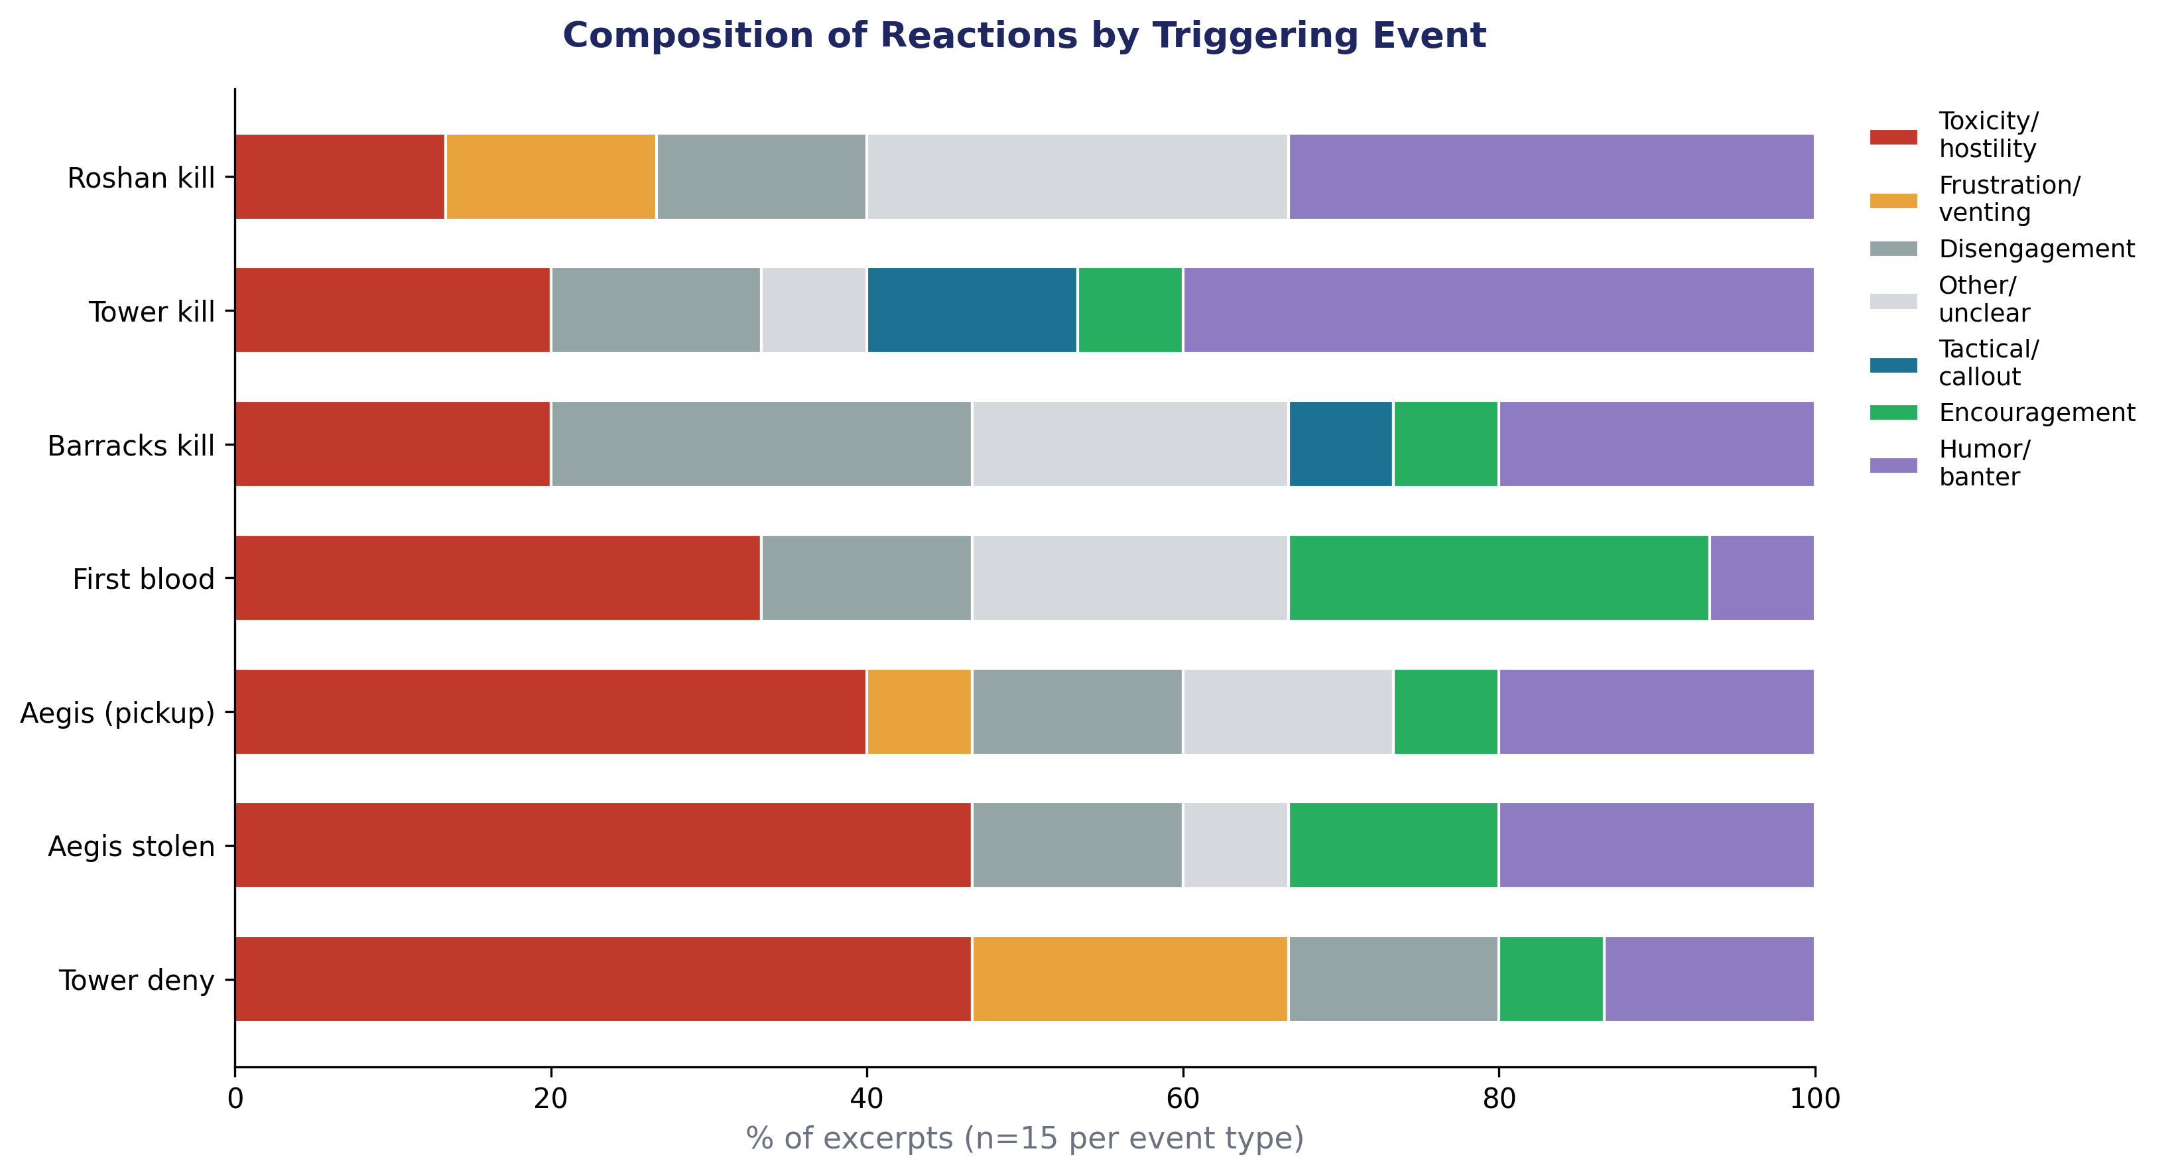
Figure 1. Composition of manually-coded reaction types by triggering event (n=15 excerpts per event type).
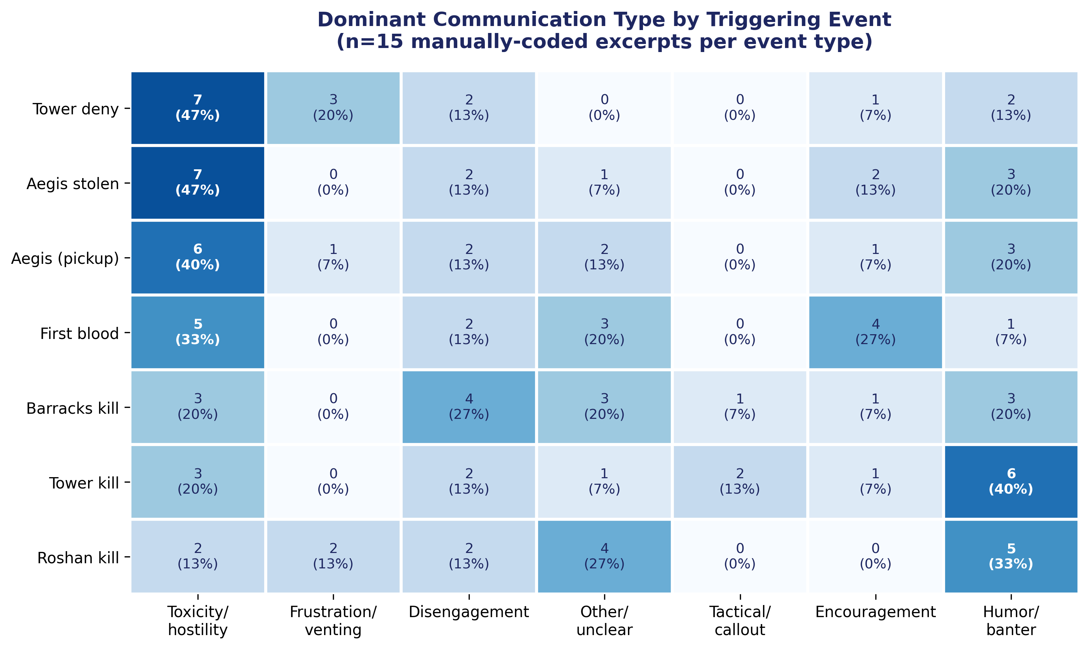
Figure 2. Counts and percentages of each reaction type by triggering event.
Key patterns:
- Tower deny and Aegis stolen show the highest toxicity rates (47% each) — both are moments of visible, unambiguous setback (a team destroying their own tower rather than defending it; the enemy claiming Roshan's buff outright).
- Aegis pickup also skews heavily toxic (40%) despite being nominally a positive event for the team — suggesting reactions here may reflect disagreement over who received the item, not the item itself.
- Tower kill shows the highest humor/banter rate of any event (40%) and comparatively low toxicity (20%) — consistent with towers falling routinely throughout a match, provoking lighter reactions than rarer, higher-stakes events.
- First blood is the only event where encouragement is the joint-most-common category (27%, tied with toxicity at 33% as the excerpt's true dominant) — early-game momentum appears to draw some teams together rather than apart.
- Roshan kill shows the lowest toxicity rate of any event (13.3%) alongside the highest humor/banter rate (33.3%) — despite being the most “momentum-defining” neutral objective, it does not provoke the strongest negative reactions; a coordinated, successful Roshan attempt may leave less to blame anyone for.
- Barracks kill shows the most evenly-spread reaction profile of any event, with disengagement (27%) narrowly the most common single category.

5.3 Illustrative excerpts
One representative excerpt per event type, matched to its own dominant category:
Tower deny (toxicity/hostility): “rlx” → “we have sf am doom” → “Ez game”
Aegis stolen (toxicity/hostility): “THIS FUCKING IDIOT” … “man its not mad he has didnt make slot to take rosh”
First blood (toxicity/hostility): “u fucked up not daz” → “u went in too deep mate”
Tower kill (humor/banter): “LULZ” → “YOLO LIFE” → “yeah i'm high” → “deal with it”
Roshan kill (humor/banter): “He is from NASA :D” → “XD” → “ROFL” → “this game gave me ebola”
Barracks kill (disengagement): “0 wards” → “i have to deard by myself” → “so stupids :/”
Aegis pickup (toxicity/hostility): “push retard, push” → “SHUT THE FUCK UP” → “COUNTER PICKER”

6. Combined interpretation
RQ2's results pair meaningfully with RQ1's null-to-negligible finding on aggregate trajectory shape. RQ1 showed that whole-match sentiment slope, volatility, and phase delta are, at most, weakly related to match outcome. RQ2 shows why an aggregate view may miss the real signal: sentiment does respond strongly to specific gameplay moments (88.7% of detected shifts align with a real event), but this responsiveness is highly localised and event-specific rather than a steady trend across the whole match. A team's overall trajectory shape may look unremarkable while still containing sharp, meaningful, event-triggered reactions — exactly the kind of structure RQ1's whole-match features are not designed to detect, and RQ2's shift-point approach is.
The qualitative layer adds a further dimension: not all events provoke the same kind of reaction. Events representing unambiguous, self-inflicted setbacks (tower deny) or humiliating swings (Aegis stolen) provoke the most toxicity; routine, frequent events (tower kills) provoke the lightest reactions; and early-game momentum events (first blood) are the only category where encouragement rivals toxicity as the dominant response.

7. Ready-to-adapt text for the write-up
“Using PELT change-point detection (penalty = 0.55, selected via pilot sensitivity analysis), 51,940 sentiment shift points were detected across 31,711 team-trajectories (mean 1.64 per trajectory). 88.7% of shift points occurred within two minutes of an identifiable gameplay event, indicating that team sentiment shifts are substantially tied to real match events rather than arbitrary variation. Tower kills were the strongest associated event type under both raw co-occurrence (68.8%) and a base-rate-adjusted association rate (13.88% of all tower kills triggered a nearby shift), confirming this is a genuine association rather than an artefact of tower kills being the most frequent event type. A manually-coded qualitative sample (n=15 excerpts per event type) found toxicity/hostility to be the single most common reaction overall (31.4% of excerpts), with tower deny and Aegis stolen — both moments of unambiguous, visible setback — showing the highest toxicity rates (47% each), while routine tower kills provoked predominantly humor/banter (40%).”

8. Notes and caveats for the write-up
- Qualitative sample coverage varies enormously by event type: the 15-excerpt sample represents 35.7% of all Aegis-stolen-matched shift points (15 of 42) but only 0.05% of tower-kill-matched shift points (15 of 31,726). This asymmetry should be stated explicitly — rarer event types are sampled far more exhaustively than common ones.
- The corpus contains genuine slurs and explicit hate speech. A small number of excerpts identified during quote selection contained an explicit racial slur; this was excluded from direct quotation. An explicit content-handling policy (e.g. redacting slurs as “[slur]” in any directly quoted excerpt) should be stated in the ethics section before finalising which quotes appear in the thesis text.
- The qualitative coding (n=105 total) was performed by a single rater, consistent with the validation study's single-rater design (section 4.5.2) — worth noting as a limitation on inter-rater reliability, as already acknowledged for the VADER/RoBERTa annotation.
- RQ2 operates independently of the early/mid/late phase boundaries used for RQ1 and RQ3 — shift points are detected from each team's continuous message sequence, not segmented by phase. This is worth stating explicitly so the methodology chapter doesn't imply phase segmentation is a shared dependency across all three RQs.
- The residual non-English-but-Latin-script limitation (e.g. Filipino/Tagalog messages) noted elsewhere in this project also applies to the qualitative sample — the Latin-script filter used here catches different alphabets but not different languages using the same alphabet.

