RQ2 Walkthrough: Event-Driven Sentiment Shift Analysis
A step-by-step guide to what was done, why, and what it found — sentiment trajectory analysis of Dota 2 team chat

1. Purpose of this document
This document walks through the full RQ2 pipeline in the order it was actually carried out, explaining the reasoning behind each step before presenting its results. It is written to be followed from start to finish, and also to serve as a source of ready-to-adapt language and figures for the results and discussion chapters.

2. What RQ2 tests
RQ2 asks: “Which gameplay events are most strongly associated with shifts in team-level sentiment, and what types of player communication characterise these sentiment shifts?” (proposal, RQ2). Unlike RQ1, which looks at whole-match or whole-phase sentiment averages, RQ2 looks for sudden, localised changes in a team's mood and asks two questions about each one: what was happening in the game right then, and what did the team actually say.

3. The RQ2 pipeline at a glance
Six steps were carried out, in this order. Each is explained in full in its own section below.
1. Select PELT's penalty parameter — a pilot test to find the right sensitivity setting before touching the real data.
2. Detect shift points at full scale — run the tuned algorithm across every eligible team in the dataset.
3. Align shift points with nearby gameplay events — for each detected shift, check what happened in the match within two minutes of it.
4. Build a readable sample — automatically pull out a manageable, English-language sample of real chat around a selection of shift points.
5. Manually code the sample — read each sampled excerpt and classify the type of communication it contains (this is the one step done by hand, not by code).
6. Analyse the coded results — turn the hand-assigned categories into tables, figures, and a written interpretation.

4. Understanding PELT and the penalty parameter
Before describing Step 1 in detail, it is worth explaining what the underlying method actually does, since the penalty parameter it depends on is not self-explanatory.

4.1 What problem PELT solves
Each team produces a sequence of sentiment scores over time — one VADER score per chat message, in order. Somewhere in that sequence, a team's mood genuinely changes: calm for a while, then a sharp turn negative, then perhaps calm again. PELT (Pruned Exact Linear Time) is a change-point detection algorithm whose job is to find the specific timestamps where the sequence's character genuinely shifts — comparable to segmenting a long audio recording into “scenes” by tone, except here the recording is a stream of sentiment numbers rather than sound.

4.2 Why this is harder than it sounds
The naive approach — try every possible way of splitting the sequence and keep whichever split fits best — does not work, because there are far too many possible splits to check exhaustively, and because “fits best” is a trap: allowing unlimited change points lets the algorithm draw a boundary around literally every single message, trivially fitting the data perfectly while finding nothing meaningful. PELT is an efficient algorithm for finding the mathematically optimal set of change points without either problem — “pruned” and “linear time” in its name refer to how it discards unpromising candidate splits early, rather than checking every possibility.

4.3 What the penalty actually controls
PELT balances two competing costs when deciding where to place change points:
total cost = (how badly each segment fits its own data) + penalty × (number of change points)

The penalty is the price PELT must pay every time it declares a new shift point. A low penalty makes shift points cheap, so even small, possibly-random wobbles get treated as “real” shifts — the result is far too many detected shifts, mostly noise. A high penalty makes shift points expensive, so only dramatic, unmistakable changes get flagged — the result is very few detected shifts, likely missing real but moderate mood changes.
A useful analogy is a smoke detector's sensitivity dial. Set it too sensitive (low penalty) and it triggers on burnt toast — constant false alarms. Set it too insensitive (high penalty) and it only triggers on a raging fire, missing smaller-but-real fires. The goal is the sweet spot that reliably catches genuine events without crying wolf on nothing — and, critically, there is no universal correct value; it depends entirely on how noisy the specific data is, which is why the proposal calls for tuning it empirically rather than picking a textbook default.

Step 1: Selecting the Penalty Parameter
The proposal specifies selecting PELT's penalty via “a pilot sensitivity analysis on a held-out subset of matches to identify a value that yields a plausible number of shift points per trajectory, typically one to three per match.” This target — 1 to 3 shift points per team, on average — became the yardstick every candidate penalty was measured against.

1.1 A coarse first pass, to find the right neighbourhood
Rather than guess a penalty value, the first pass cast a wide net: a broad, spread-out range of candidate penalties (from 0.1 up to 50) was tested against 150 randomly held-out teams. This was reconnaissance only — its purpose was to find roughly where the useful values live before spending effort narrowing in further. It showed the expected pattern: very low penalties produced far too many shift points per team, very high penalties collapsed to almost none, and the transition zone worth focusing on sat somewhere around 0.5.

1.2 A finer, larger pass to pin down the exact value
With the right neighbourhood identified, a second pass tested a tightly-spaced range around it (0.25 through 1.0), this time using a larger sample of 300 held-out teams for more statistically stable results:
Penalty | Mean shift points | Median | % landing in 1–3 (target) | % with 0 (under-segmented)
0.25 | 3.30 | 3.0 | 48.3% | 14.3%
0.35 | 2.75 | 2.0 | 53.0% | 17.0%
0.40 | 2.51 | 2.0 | 55.3% | 19.0%
0.45 | 2.34 | 2.0 | 54.0% | 22.0%
0.50 | 2.07 | 2.0 | 56.0% | 24.7%
0.55 | 1.86 | 1.0 | 57.7% (peak) | 27.0%
0.60 | 1.70 | 1.0 | 55.3% | 31.3%
0.70 | 1.35 | 1.0 | 54.3% | 38.3%
0.80 | 1.11 | 1.0 | 51.7% | 43.7%
1.00 | 0.71 | 0.0 | 40.7% | 57.7%

1.3 Why 0.55, specifically
The decisive metric was the percentage of teams landing in the target 1–3 range — a better guide than simply looking at the average, since an average can look fine while hiding lots of teams sitting at 0 and lots at 4–5. 0.55 produced the single highest percentage (57.7%) of any candidate tested.
Just as important: 0.55's neighbours scored almost as well (0.50 at 56.0%, 0.60 at 55.3%), forming a smooth, stable plateau rather than one value spiking out of nowhere. This mattered for trusting the choice — if only 0.55 scored well while its neighbours scored badly, that would suggest the result was a fluke of sampling noise rather than a genuine, reliable sweet spot. A stable plateau means the choice is robust to small variation.

1.4 Confirming it wasn't a coincidence
This exact pilot was independently re-run on a separate machine, using the same random seed, and reproduced every value in the table above to the decimal point. This confirmed the result was a genuine, reproducible property of the dataset itself, not an artefact of one particular run.

Step 2: Detecting Shift Points at Full Scale
With the penalty fixed at 0.55, PELT was run for real — not on a 150- or 300-team pilot sample, but across every eligible team in the full dataset. A team needed at least 15 messages to be eligible; PELT cannot say anything meaningful about a handful of data points regardless of penalty, so shorter trajectories were excluded from this specific analysis (note this eligibility threshold is unique to RQ2 — it is unrelated to the ≥6-message, both-teams-present filter used to build the core dataset for RQ1).
Metric | Value
Team-trajectories eligible (≥15 messages) | 31,711 of 77,620 total
Total shift points detected | 51,940
Mean shift points per trajectory | 1.64 (within the 1–3 target)

Step 3: Aligning Shift Points with Nearby Events
For every one of the 51,940 detected shift points, the objectives log (which records timestamped Roshan kills, tower kills, barracks kills, and similar events) was checked for anything happening within two minutes of that shift — the proximity window specified in the proposal. Where more than one event fell within the window, the closest one in time was treated as the associated event, also per the proposal's stated rule.
Result | Value
Shift points matched to a nearby event | 46,090 / 51,940 (88.7%)
Shift points with no event nearby | 5,850 (11.3%)

This 88.7% match rate is itself a meaningful finding. If sentiment shifts were unrelated to gameplay — just random chat noise — this rate would be much lower. A rate this high indicates team sentiment shifts are substantially tied to real, identifiable gameplay moments.

3.1 Two rankings, because raw counts can be misleading
The proposal's stated metric is raw co-occurrence: how often each event type is the nearest matched event, in absolute terms. This metric has a blind spot — it is dominated by how often an event type happens at all. Tower kills occur roughly 8.5 times more often than Roshan kills in this dataset, so a raw ranking will always favour towers even if Roshan kills are, individually, just as “triggering.” A second, supplementary metric was added to correct for this: for each event type, what fraction of its own total occurrences had a shift point nearby? This answers a fairer question — not “which event shows up most,” but “which event is most likely, per occurrence, to provoke a reaction.”
Event type | Raw count | Raw % | Rank (raw)
Tower kill | 31,726 | 68.8% | 1
Barracks kill | 8,755 | 19.0% | 2
Roshan kill | 2,557 | 5.5% | 3
Tower deny | 1,304 | 2.8% | 4
Aegis (pickup) | 965 | 2.1% | 5
First blood | 741 | 1.6% | 6
Aegis stolen | 42 | 0.1% | 7

Event type | Association rate | Total occurrences | Rank (adjusted)
Tower kill | 13.88% | 228,655 | 1
Aegis stolen | 10.19% | 412 | 2
Tower deny | 9.88% | 13,199 | 3
Roshan kill | 9.54% | 26,803 | 4
Barracks kill | 9.38% | 93,312 | 5
First blood | 4.45% | 16,653 | 6
Aegis (pickup) | 3.70% | 26,111 | 7

Tower kills rank first under both metrics — genuinely the strongest driver, not merely the most common event. Roshan and barracks kills swap order once adjusted: barracks appear more often in the raw ranking simply because they occur more frequently, but Roshan kills are proportionally more likely, per occurrence, to trigger a nearby shift. Aegis stolen's high adjusted rate should be read cautiously in isolation — the pilot-stage version of this same calculation, run on a much smaller sample, gave an unstable 25% based on only 8 occurrences; it only became trustworthy once the full-scale run grew that sample to 412.

Step 4: Building a Readable Sample
51,940 shift points is far too many to read by hand, and the proposal's qualitative step — examining the actual chat around each shift to characterise the type of communication — is inherently manual, not something to automate. This step prepared a manageable, genuinely readable sample: for each of the seven event types, 15 matched shift points were randomly selected (105 excerpts total), and every chat message within the same ±120-second window used for event alignment was pulled out and laid in chronological order.
One filter was applied during sampling: this dataset retains roughly 6% non-English chat (mostly Cyrillic), which would be unreadable to an English-speaking coder. Candidate excerpts were checked for majority Latin-script content and skipped if they failed this check, with additional candidates drawn to backfill until each event type reached its full target of 15 readable excerpts.

Step 5: Manually Coding the Sample
This is the one step in the whole pipeline performed by hand rather than by code. The 105-excerpt spreadsheet produced in Step 4 was read excerpt by excerpt — all messages belonging to one shift point, together, in order — and each excerpt was assigned a single dominant category describing the type of communication it contained: toxicity/hostility, humor/banter, disengagement, encouragement, frustration/venting, tactical/callout, or other/unclear. Coding was done at the excerpt level (one judgement per shift-point moment, not per individual message), and consistent with the validation study's single-rater design (proposal section 4.5.2), this coding was carried out by one rater.

Step 6: Analysing the Coded Results
Once every excerpt had a category, the results were cross-tabulated against event type to see whether different events provoke different kinds of reactions.

6.1 Overall distribution (n=105 excerpts)
Category | Count | %
Toxicity/hostility | 33 | 31.4%
Humor/banter | 23 | 21.9%
Disengagement | 16 | 15.2%
Other/unclear | 14 | 13.3%
Encouragement | 10 | 9.5%
Frustration/venting | 6 | 5.7%
Tactical/callout | 3 | 2.9%

Toxicity/hostility is the single most common reaction to a sentiment-shifting moment overall — ahead of humor/banter and well ahead of encouragement. Teams are more likely to turn on each other than rally together at these moments.

6.2 Composition by event type
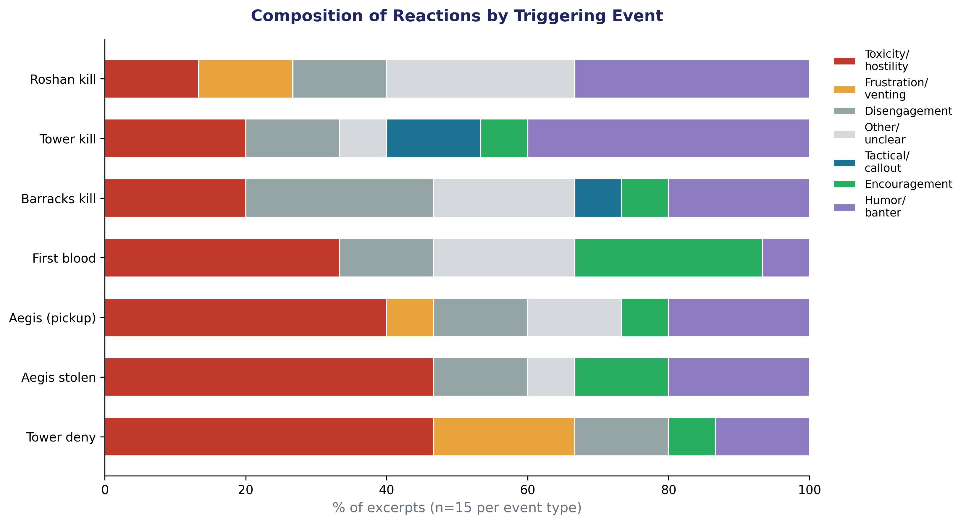
Figure 1. Composition of manually-coded reaction types by triggering event (n=15 excerpts per event type).
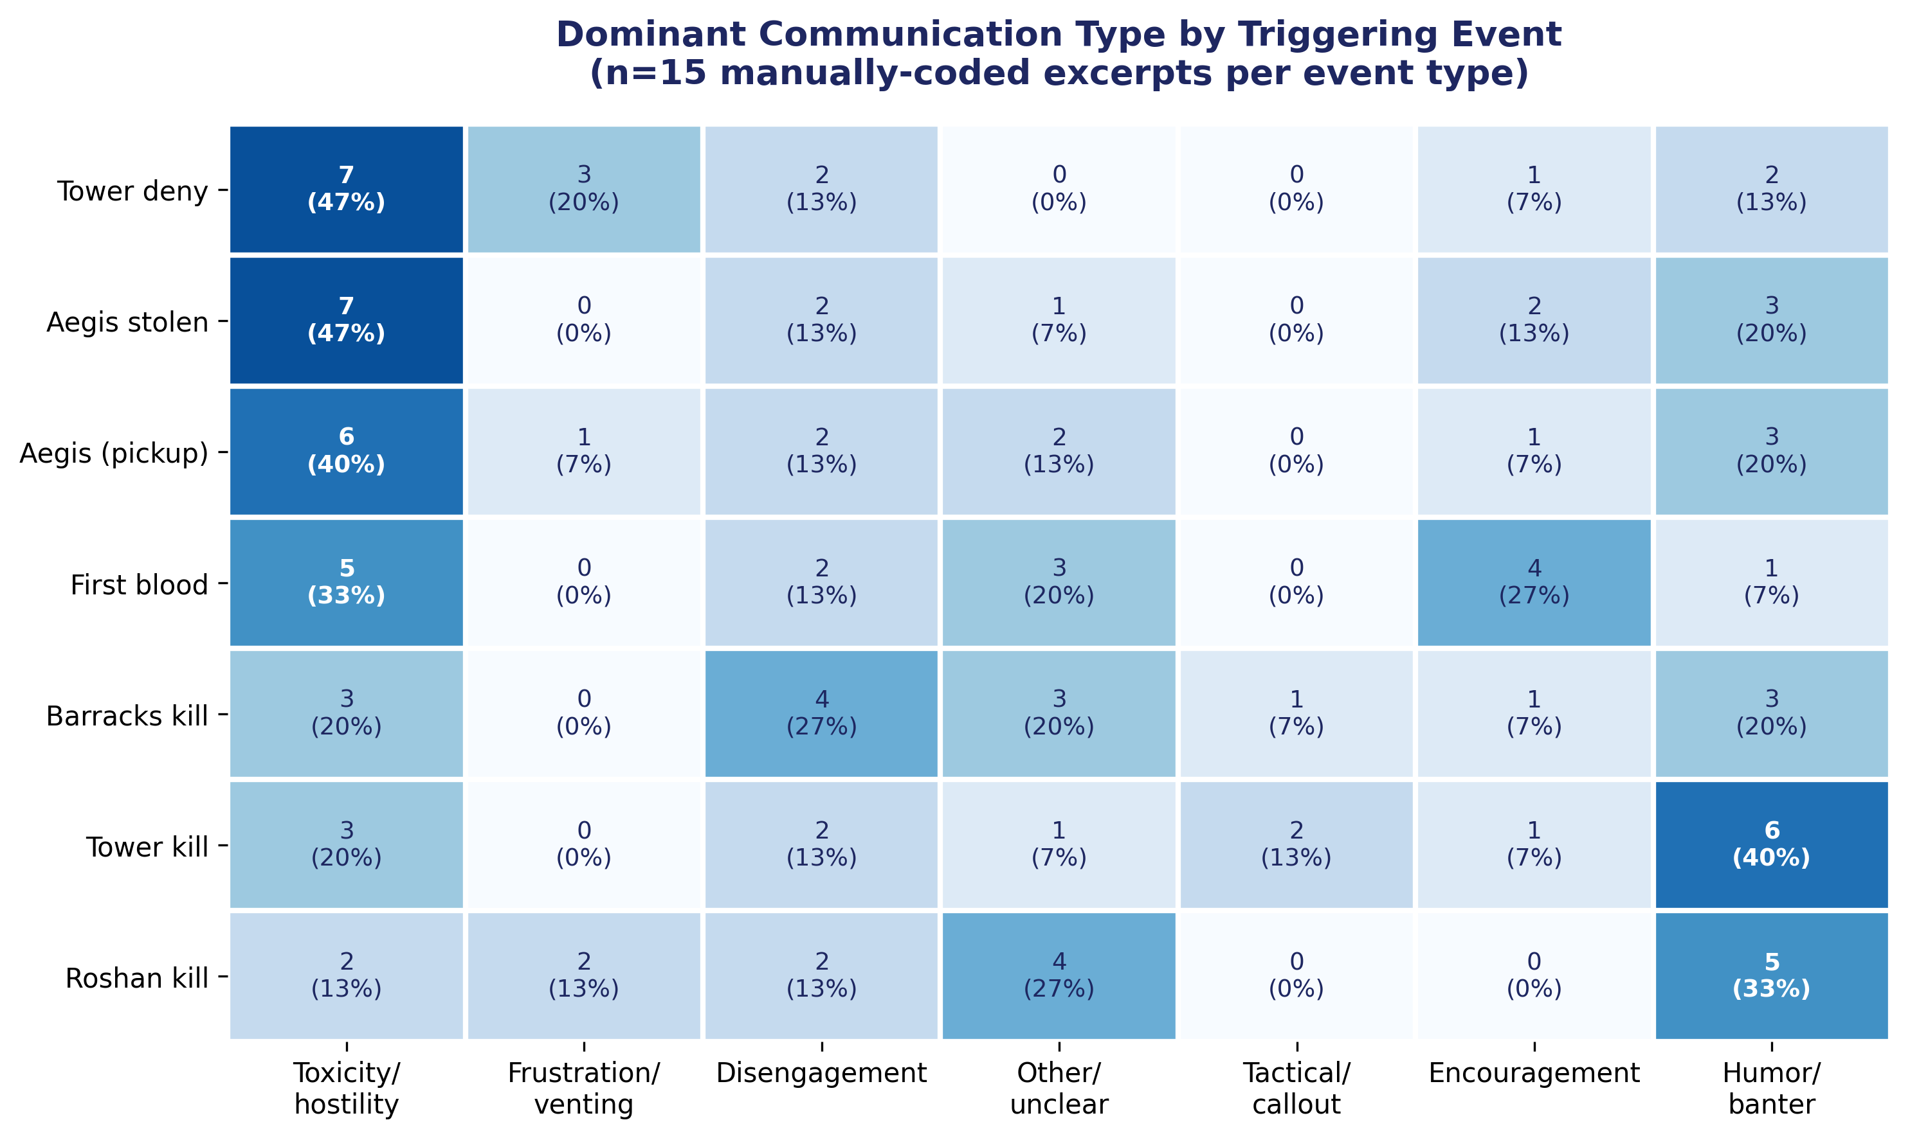
Figure 2. Counts and percentages of each reaction type by triggering event.
Key patterns:
- Tower deny and Aegis stolen show the highest toxicity rates (47% each) — both are moments of visible, unambiguous setback (a team destroying their own tower rather than defending it; the enemy claiming Roshan's buff outright).
- Aegis pickup also skews heavily toxic (40%) despite being nominally a positive event for the team — suggesting reactions here may reflect disagreement over who received the item, not the item itself.
- Tower kill shows the highest humor/banter rate of any event (40%) and comparatively low toxicity (20%) — consistent with towers falling routinely throughout a match, provoking lighter reactions than rarer, higher-stakes events.
- First blood is the only event where encouragement is a joint-most-common category (27%, alongside toxicity at 33%) — early-game momentum appears to draw some teams together rather than apart.
- Roshan kill shows the lowest toxicity rate of any event (13.3%) alongside the highest humor/banter rate (33.3%) — despite being the most “momentum-defining” neutral objective, it does not provoke the strongest negative reactions; a coordinated, successful Roshan attempt may leave less to blame anyone for.
- Barracks kill shows the most evenly-spread reaction profile of any event, with disengagement (27%) narrowly the most common single category.

6.3 Illustrative excerpts
One representative excerpt per event type, matched to its own dominant category:
Tower deny (toxicity/hostility): “rlx” → “we have sf am doom” → “Ez game”
Aegis stolen (toxicity/hostility): “THIS FUCKING IDIOT” … “man its not mad he has didnt make slot to take rosh”
First blood (toxicity/hostility): “u fucked up not daz” → “u went in too deep mate”
Tower kill (humor/banter): “LULZ” → “YOLO LIFE” → “yeah i'm high” → “deal with it”
Roshan kill (humor/banter): “He is from NASA :D” → “XD” → “ROFL” → “this game gave me ebola”
Barracks kill (disengagement): “0 wards” → “i have to deard by myself” → “so stupids :/”
Aegis pickup (toxicity/hostility): “push retard, push” → “SHUT THE FUCK UP” → “COUNTER PICKER”

7. Combined interpretation
RQ2's results pair meaningfully with RQ1's null-to-negligible finding on aggregate trajectory shape. RQ1 showed that whole-match sentiment slope, volatility, and phase delta are, at most, weakly related to match outcome. RQ2 shows why an aggregate view may miss the real signal: sentiment does respond strongly to specific gameplay moments (88.7% of detected shifts align with a real event), but this responsiveness is highly localised and event-specific rather than a steady trend across the whole match. A team's overall trajectory shape may look unremarkable while still containing sharp, meaningful, event-triggered reactions — exactly the kind of structure RQ1's whole-match features are not designed to detect, and RQ2's shift-point approach is.
The qualitative layer adds a further dimension: not all events provoke the same kind of reaction. Events representing unambiguous, self-inflicted setbacks (tower deny) or humiliating swings (Aegis stolen) provoke the most toxicity; routine, frequent events (tower kills) provoke the lightest reactions; and early-game momentum events (first blood) are the only category where encouragement rivals toxicity as the dominant response.

8. Ready-to-adapt text for the write-up
“Using PELT change-point detection (penalty = 0.55, selected via a two-stage pilot sensitivity analysis targeting 1–3 shift points per trajectory), 51,940 sentiment shift points were detected across 31,711 team-trajectories (mean 1.64 per trajectory). 88.7% of shift points occurred within two minutes of an identifiable gameplay event, indicating that team sentiment shifts are substantially tied to real match events rather than arbitrary variation. Tower kills were the strongest associated event type under both raw co-occurrence (68.8%) and a base-rate-adjusted association rate (13.88% of all tower kills triggered a nearby shift), confirming this is a genuine association rather than an artefact of tower kills being the most frequent event type. A manually-coded qualitative sample (n=15 excerpts per event type) found toxicity/hostility to be the single most common reaction overall (31.4% of excerpts), with tower deny and Aegis stolen — both moments of unambiguous, visible setback — showing the highest toxicity rates (47% each), while routine tower kills provoked predominantly humor/banter (40%).”

9. Notes and caveats for the write-up
- Qualitative sample coverage varies enormously by event type: the 15-excerpt sample represents 35.7% of all Aegis-stolen-matched shift points (15 of 42) but only 0.05% of tower-kill-matched shift points (15 of 31,726). This asymmetry should be stated explicitly — rarer event types are sampled far more exhaustively than common ones.
- The corpus contains genuine slurs and explicit hate speech. A small number of excerpts identified during quote selection contained an explicit racial slur; this was excluded from direct quotation. An explicit content-handling policy (e.g. redacting slurs as “[slur]” in any directly quoted excerpt) should be stated in the ethics section before finalising which quotes appear in the thesis text.
- The qualitative coding (n=105 total) was performed by a single rater, consistent with the validation study's single-rater design (section 4.5.2) — worth noting as a limitation on inter-rater reliability, as already acknowledged for the VADER/RoBERTa annotation.
- RQ2 operates independently of the early/mid/late phase boundaries used for RQ1 and RQ3 — shift points are detected from each team's continuous message sequence, not segmented by phase. This is worth stating explicitly so the methodology chapter doesn't imply phase segmentation is a shared dependency across all three RQs.
- The residual non-English-but-Latin-script limitation (e.g. Filipino/Tagalog messages) noted elsewhere in this project also applies to the qualitative sample — the Latin-script filter used here catches different alphabets but not different languages using the same alphabet.
- The 15-messages-per-team eligibility threshold used for shift detection is specific to RQ2 and distinct from the ≥6-messages/both-teams-present filter used to build the core RQ1/RQ3 dataset — worth stating clearly so the two are not conflated in the methodology chapter.

